In Summary:
- ESD delivered RC2I2S2 ESD tag on September 7, 2010. QA found this tag untestable and raised a priority defect (ESD-1147) against it.
- ESD fixed the bug and delivered RC2I2S2_2 on September 9, 2010.
- 4 operations (createReferralOrder, withdrawReferralOrder , queryReferralOrderStatus and reviseReferralOrder) were delivered to QA.
- Regression testing was performed for createReferralOder , withdrawReferralOrder and queryReferralOrderStatus based on the Priority Levels:
  - All Level 1 and Level 2 test cases were executed
  - All test cases affected by fixed defects and release notes were executed
- L1 and L2 testcases for reviseReferralOrder operation were executed
- The sprint had a failure rate of 6.8%
- 32 new defects were raised in this sprint
The test case distribution by category for this sprint is as follows:
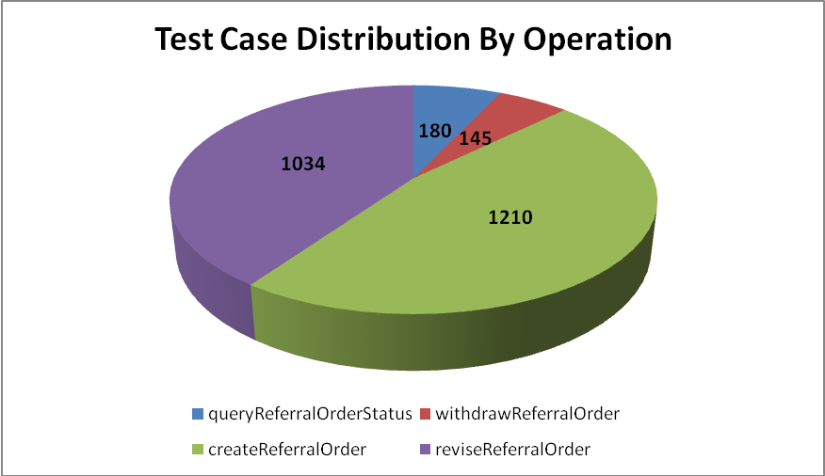
Operation | queryReferral  OrderStatus | withdrawReferral  Order | createReferral  Order | reviseReferral  Order | Total
Cardinality | 21 | 14 | 160 | 145 | 341
Does not exist | 19 | 20 | 165 | 144 | 349
Invalid value | 48 | 21 | 333 | 279 | 683
Multiple values | 15 | 14 | 91 | 14 | 134
Null value | 54 | 61 | 288 | 304 | 711
Valid value | 23 | 15 | 173 | 148 | 360
Total | 180 | 145 | 1210 | 1034 | 2578

The test case distribution by priority for this sprint is as follows:
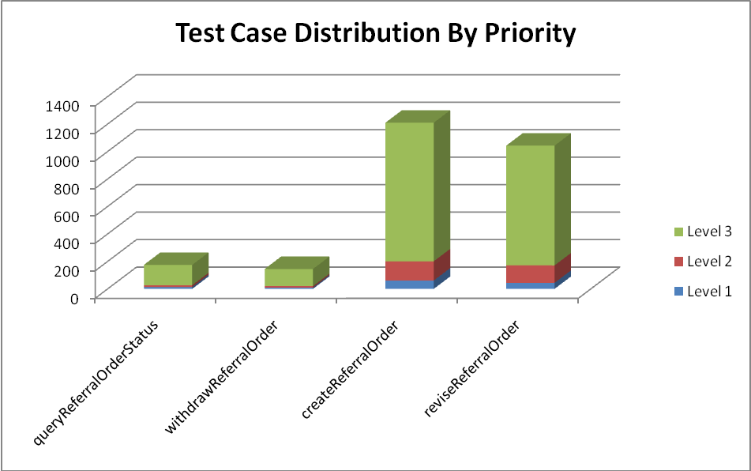
Operation | Level 1 (High) | Level 2 (Medium) | Level 3 (Low) | Total
queryReferralOrderStatus | 13 | 14 | 148 | 180
withdrawReferralOrder | 9 | 11 | 125 | 145
createReferralOrder | 61 | 140 | 1009 | 1210
reviseReferralOrder | 44 | 127 | 872 | 1043
Total | 127 | 292 | 2154 | 2578

The test case execution summary for the sprint is as follows:
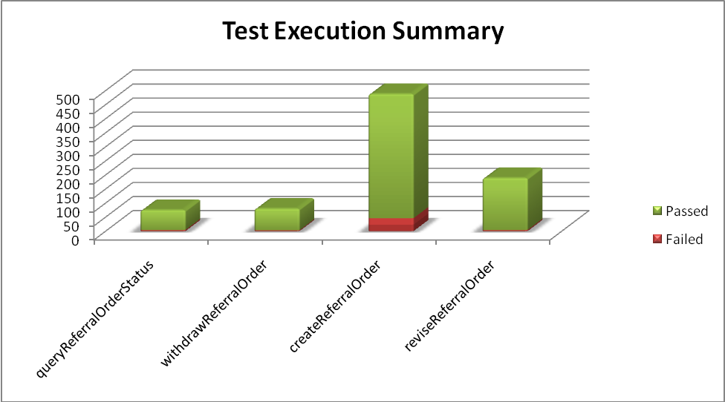
Operation | Failed | Passed | Total
queryReferralOrderStatus | 4 | 71 | 75
withdrawReferralOrder | 3 | 77 | 80
createReferralOrder | 46 | 442 | 488
reviseReferralOrder | 4 | 185 | 189
Total | 57 | 775 | 832

The defects for this sprint are listed below:
Key | Summary | Reporter | Priority | Status | Resolution
ESD-1226 | uncertaintyCode nullFlavor test results in errors | Pradeep Dharmavarapu | Minor | Open | UNRESOLVED
ESD-1225 | effectiveTime element fails nullFlavor validation | Pradeep Dharmavarapu | Minor | Open | UNRESOLVED
ESD-1221 | nullFlavor validation on ReferralOrder-serviceDeliveryLocation creates exception | Pradeep Dharmavarapu | Minor | Open | UNRESOLVED
ESD-1220 | nullFlavor validation on ReferralOrder-component-pcpr-location creates exception | Pradeep Dharmavarapu | Minor | Open | UNRESOLVED
ESD-1219 | No errors for an empty referralOrder-component-pcpr-reasonCode element | Pradeep Dharmavarapu | Minor | Closed | Duplicate
ESD-1218 | Schematron validation error for nullFlavor test on referralOrder-component-pcpr-text | Pradeep Dharmavarapu | Minor | Open | UNRESOLVED
ESD-1216 | Server Rollback Exception in reviseReferralOrder with caEHR order ID and root | Amrut Rao | Major | Open | UNRESOLVED
ESD-1213 | patient-addr attribute errors on nullFlavors | Pradeep Dharmavarapu | Minor | Open | UNRESOLVED
ESD-1212 | REPC_MT000003US.ClusterIntent.code has incorrect nullFlavor validation | Amrut Rao | Major | Open | UNRESOLVED
ESD-1211 | REPC_MT000003US.Component.sequenceNumber does not accept nullFlavor | Amrut Rao | Major | Open | UNRESOLVED
ESD-1210 | REPC_MT000003US.ActIntent.reasonCode accepts null tag | Amrut Rao | Major | Closed | Won't Fix
ESD-1209 | nullFlavor on REPC_MT000003US.ActIntent.text throws an error | Amrut Rao | Major | Open | UNRESOLVED
ESD-1208 | II.root validation for caEHR Root cause errors for null value in representedOrganization COCT_MT090108US | Aviva Mordetsky | Major | Open | UNRESOLVED
ESD-1201 | provider-telecom errors for null value for the value | Aviva Mordetsky | Major | Open | UNRESOLVED
ESD-1200 | II.root validation for caEHR Root occuring incorrectly in REPC_MT000003US | Amrut Rao | Major | Open | UNRESOLVED
ESD-1199 | Mismatched error message for empty patient-subjectOf object containing nil=true | Pradeep Dharmavarapu | Minor | Open | UNRESOLVED
ESD-1198 | Mismatched error message for an empty patient-subjectOf-observationEvent-value | Pradeep Dharmavarapu | Minor | Open | UNRESOLVED
ESD-1197 | nullFlavor validation of patient-patientPerson-birthTime yields - "Unexpected exception during isValid call" | Pradeep Dharmavarapu | Major | Open | UNRESOLVED
ESD-1196 | patient-patientPerson-administrativeGenderCode nullFlavor errors | Pradeep Dharmavarapu | Major | Open | UNRESOLVED
ESD-1195 | provider-telecom null value for "use" does not return error | Aviva Mordetsky | Minor | Open | UNRESOLVED
ESD-1193 | queryReferralOrderStatus - nullFlavor fails for telecom in Provider | Brian Bell | Minor | Closed | Fixed
ESD-1189 | patient-patientPerson attribute errors on nullFlavors | Pradeep Dharmavarapu | Minor | Open | UNRESOLVED
ESD-1188 | patient-telecom attribute errors on nullFlavors | Pradeep Dharmavarapu | Minor | Closed | Won't Fix
ESD-1186 | patient-addr attribute errors on nullFlavors | Pradeep Dharmavarapu | Minor | Closed | Incomplete
ESD-1183 | Error when reasonCode omitted from REPC_MT000001US | Brian Bell | Minor | Open | UNRESOLVED
ESD-1182 | Degraded performance of service affecting ability to test | Kevin Gann | Major | Open | UNRESOLVED
ESD-1180 | Unable to determine write method for Field message in fault | Kevin Gann | Major | Open | UNRESOLVED
ESD-1177 | valueSet not being checked for validity in REPC_MT000003US.ActIntent.reasonCode | Amrut Rao | Major | Open | UNRESOLVED
ESD-1168 | Correct value of REPC_MT000002US.ConcernEvent.effectiveTime returns a Schematron error | Amrut Rao | Major | Closed | Duplicate
ESD-1157 | REPC_MT000001US.PatientCareProvisionRequest.reasonCode does not enforce [0..*] cardinality in createReferralOrder | Amrut Rao | Major | Open | UNRESOLVED
ESD-1151 | createReferralOrder fails if reasonCode is not included in REPCMT000001USPatientCareProvisionRequest | Kevin Gann | Major | Open | UNRESOLVED
ESD-1147 | Large amount of white space between strings in createReferralOrderFault | Kevin Gann | Blocker | Closed | Fixed

The deliverables for this Sprint are available at the below locations:
Test Summary Report - http://gforge.nci.nih.gov/svnroot/ent-services/tags/caEHR/ReleaseCycle2/Iteration3/QA/Sprint1/caBIGClinicalInformationSuite_RC2I3S1_Test_Summary_Report.doc
Test Cases - http://gforge.nci.nih.gov/svnroot/ent-services/tags/caEHR/ReleaseCycle2/Iteration3/QA/Sprint1/caBIGClinicalInformationSuite_TestCases_RC2I3S1.xls
Test Execution Report – http://gforge.nci.nih.gov/svnroot/ent-services/tags/caEHR/ReleaseCycle2/Iteration3/QA/Sprint1/caBIGClinicalInformationSuite_TestExecutionReport_RC2I3S1.mht
Soap Test Scripts - http://gforge.nci.nih.gov/svnroot/ent-services/tags/caEHR/ReleaseCycle2/Iteration3/QA/Sprint1/caBIGClinicalInformationSuite_RC2I3S1_TestScripts.zip

