In Summary:
- ESD delivered RC2-I3-S1 ESD tag on September 20, 2010
- 5 operations (createReferralOrder, withdrawReferralOrder , queryReferralOrderStatus, queryReferralResult and reviseReferralOrder) were delivered to QA.
- Regression testing was performed for createReferralOder , withdrawReferralOrder, queryReferralOrderStatus and reviseReferralOrder based on the Priority Levels:
  - All Level 1 and Level 2 test cases were executed
  - All test cases affected by fixed defects and release notes were executed
- The sprint had a failure rate of
- 13 new defects were raised in this sprint
The test case distribution by category for this sprint is as follows:
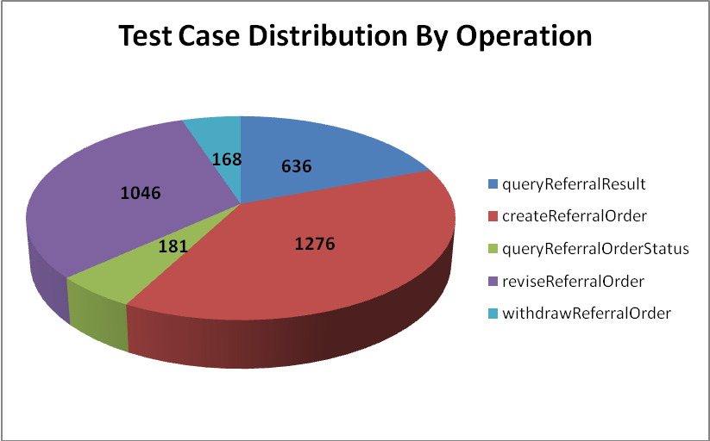
Category | queryReferral  Result | createReferral  Order | queryReferral  OrderStatus | reviseReferral  Order | Withdraw  ReferralOrder | Total
Cardinality | 84 | 166 | 21 | 146 | 21 | 438
Does not exist | 79 | 165 | 19 | 145 | 20 | 428
Invalid value | 184 | 373 | 48 | 284 | 32 | 921
Multiple values | 24 | 91 | 15 | 14 | 14 | 158
Null value | 186 | 308 | 55 | 308 | 62 | 919
Valid value | 79 | 173 | 23 | 149 | 19 | 443
Total | 636 | 1276 | 181 | 1046 | 168 | 3307

The test case distribution by priority for this sprint is as follows:
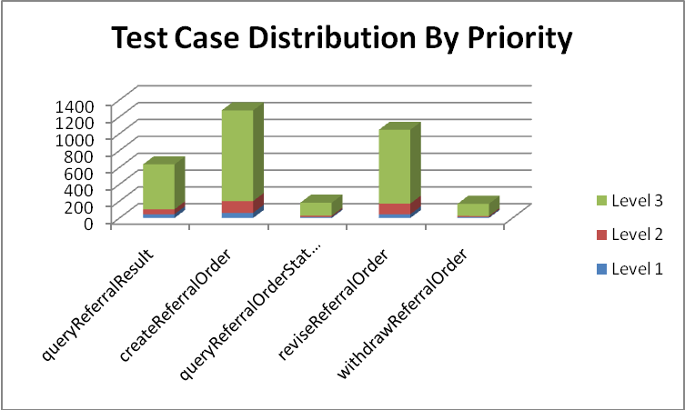
Operation | Level 1 (High) | Level 2 (Medium) | Level 3 (Low) | Total
queryReferralResult | 45 | 58 | 533 | 636
createReferralOrder | 61 | 140 | 1075 | 1276
queryReferralOrderStatus | 13 | 14 | 154 | 181
reviseReferralOrder | 44 | 127 | 875 | 1046
withdrawReferralOrder | 11 | 13 | 144 | 168
Total | 174 | 352 | 2781 | 3307

The test case execution summary for the sprint is as follows:
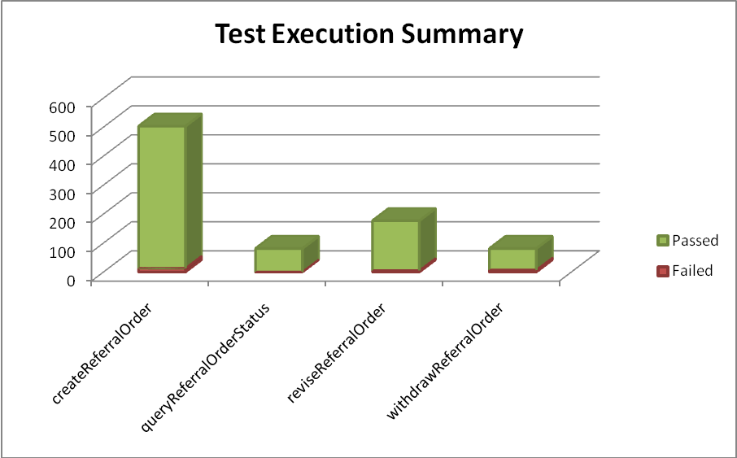
Operation | Failed | Fail % | Passed | Pass % | Total
createReferralOrder | 13 | 3% | 490 | 97% | 503
queryReferralOrderStatus | 0 | 0% | 81 | 100% | 81
reviseReferralOrder | 5 | 3% | 172 | 97% | 177
withdrawReferralOrder | 7 | 9% | 74 | 91% | 81
Total | 25 | 3% | 817 | 97% | 842

The defects for this sprint are listed below:
Key | Summary | Reporter | Priority | Status | Resolution
ESD-1279 | Fault returned for reviseReferralOrder differs from createReferralOrder for invalid provider name parts. | Kevin Gann | Major | Open | UNRESOLVED
ESD-1278 | Server Rollback Exception in reviseReferralOrder when testing telecom-item cardinality under COCT_MT090108US when expecting limit message | Aviva Mordetsky | Major | Open | UNRESOLVED
ESD-1276 | queryReferralResult throws exception for same patient ID | Amrut Rao | Major | Resolved | Fixed
ESD-1273 | Out of bounds length (256 chars) for Represented Organization Name performs differently in REPCMT000001USOrder versus REPCMT000004USOrder | Kevin Gann | Major | Open | UNRESOLVED
ESD-1272 | invalid valueset for reasonCode in  REPCMT000004USOrder doesn't cause error | Kevin Gann | Major | Open | UNRESOLVED
ESD-1269 | nullFlavor validation treated differently for name in REPCMT000004USLocation over REPCMT000001USLocation | Kevin Gann | Major | Open | UNRESOLVED
ESD-1262 | Name Part validation for revise appears to be working differently than create. | Kevin Gann | Major | Resolved | Fixed
ESD-1255 | If effectiveTime isn't included in actIntent the displayed fault is returned | Kevin Gann | Major | Resolved | Fixed
ESD-1251 | CD.valueSet not validated in REPC_MT000002US.ConcernEvent | Amrut Rao | Major | Resolved | Fixed
ESD-1250 | reviseReferralOrder returns original II in fault message | Kevin Gann | Major | In Progress | UNRESOLVED
ESD-1245 | REPC_MT000003US.ActIntent.reasonCode accepts incorrect valueSet in createReferralOrder | Amrut Rao | Major | Resolved | Duplicate
ESD-1241 | Output of Stream closed for cardinality testing of classcode and determinercode | Aviva Mordetsky | Major | Resolved | Won't Fix
ESD-1240 | subjectOf only reports first instance of invalid code in fault | Kevin Gann | Major | Resolved | Won't Fix
ESD-883 | No Errors for incorrect or invalid Cardinality of payload elements | Pradeep Dharmavarapu | Major | Resolved | Fixed
ESD-869 | telecom cardinality [0..5] fails | Aviva Mordetsky | Major | Closed | Fixed

The deliverables for this Sprint are available at the below locations:
Test Summary Report - http://gforge.nci.nih.gov/svnroot/ent-services/tags/caEHR/ReleaseCycle2/Iteration3/QA/Sprint3/caBIGClinicalInformationSuite_RC2I3S2_Test_Summary_Report.doc
Test Cases - http://gforge.nci.nih.gov/svnroot/ent-services/tags/caEHR/ReleaseCycle2/Iteration3/QA/Sprint3/caBIGClinicalInformationSuite_TestCases_RC2I3S2.xls
Test Execution Report – http://gforge.nci.nih.gov/svnroot/ent-services/tags/caEHR/ReleaseCycle2/Iteration3/QA/Sprint3/caBIGClinicalInformationSuite_TestExecutionReport_RC2I3S2.mht
Soap Test Scripts - http://gforge.nci.nih.gov/svnroot/ent-services/tags/caEHR/ReleaseCycle2/Iteration3/QA/Sprint3/caBIGClinicalInformationSuite_RC2I3S2_TestScripts.zip

