In Summary:
- ESD delivered RC2-I3-S2 ESD tag on October 4, 2010
- This was a short sprint of only 6 working days.
- 5 operations (createReferralOrder, withdrawReferralOrder , queryReferralOrderStatus, queryReferralResult and reviseReferralOrder) were delivered to QA.
- Regression testing was performed for createReferralOder , withdrawReferralOrder, queryReferralOrderStatus and reviseReferralOrder based on the Priority Levels:
  - All Level 1 and Level 2 test cases for queryReferralResult were executed
  - All test cases affected by fixed defects and release notes were executed
- 9 new defects were raised in this sprint
The test case distribution by category for this sprint is as follows:
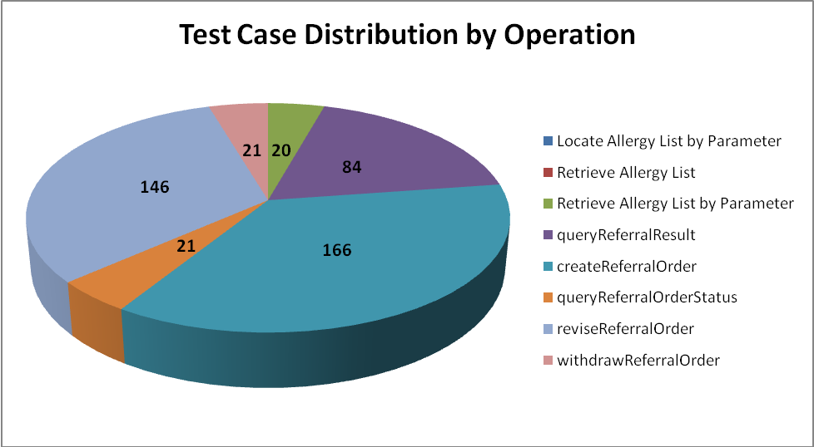
Operations | Cardinality | Does Not Exist | Invalid Value | Multiple Values | Null Value | Valid Value | Total
Allergy Service
Locate Allergy List by Parameter |  |  | 3 |  |  | 3 | 6
Retrieve Allergy List |  |  | 2 |  |  | 2 | 4
Retrieve Allergy List by Parameter | 20 | 20 | 61 | 10 | 36 | 22 | 169
Referral Consult Service
queryReferralResult | 84 | 79 | 184 | 24 | 186 | 79 | 636
createReferralOrder | 166 | 165 | 373 | 91 | 333 | 173 | 1301
queryReferralOrderStatus | 21 | 19 | 48 | 15 | 51 | 22 | 176
reviseReferralOrder | 146 | 145 | 284 | 14 | 308 | 149 | 1046
withdrawReferralOrder | 21 | 20 | 32 | 14 | 62 | 19 | 168
Total | 458 | 448 | 987 | 168 | 976 | 469 | 3506
The test case distribution by priority for this sprint is as follows:
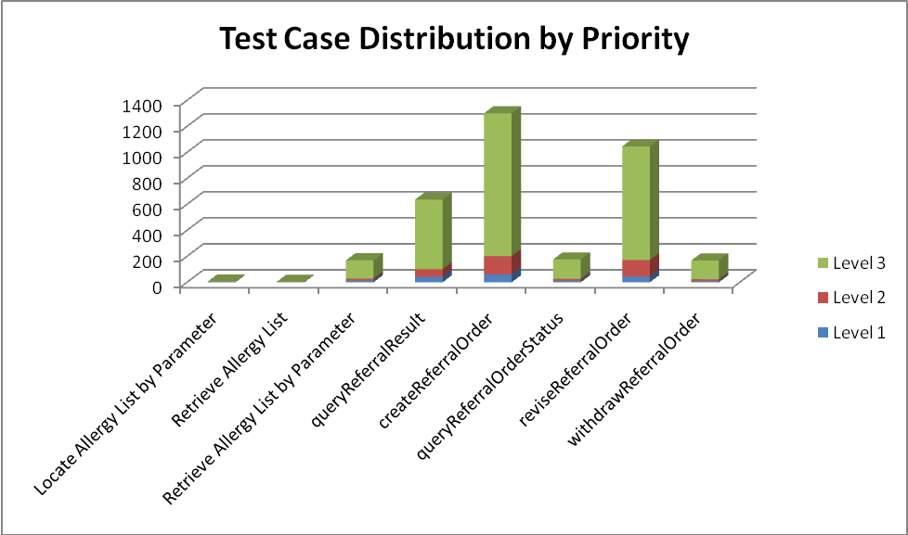
Operations | Level 1 (High) | Level 2 (Medium) | Level 3 (Low) | Total
Allergy Service
Locate Allergy List by Parameter | 4 |  | 2 | 6
Retrieve Allergy List | 1 | 1 | 2 | 4
Retrieve Allergy List by Parameter | 15 | 14 | 140 | 169
Referral Consult Service
queryReferralResult | 43 | 58 | 535 | 636
createReferralOrder | 61 | 140 | 1100 | 1301
queryReferralOrderStatus | 13 | 14 | 149 | 176
reviseReferralOrder | 44 | 127 | 875 | 1046
withdrawReferralOrder | 11 | 13 | 144 | 168
Total | 192 | 367 | 2947 | 3506

The test case execution summary for the sprint is as follows:
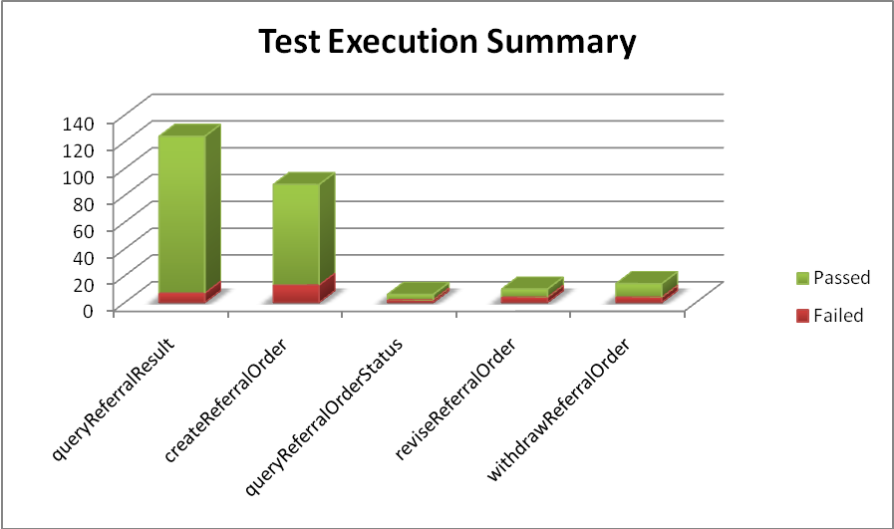
Operation | Failed | Failed % | Passed | Passed % | Total
queryReferralResult | 7 | 6% | 117 | 94% | 124
createReferralOrder | 13 | 15% | 75 | 85% | 88
queryReferralOrderStatus | 2 | 33% | 4 | 67% | 6
reviseReferralOrder | 4 | 40% | 6 | 60% | 10
withdrawReferralOrder | 4 | 29% | 10 | 71% | 14
Total | 30 | 12% | 212 | 88% | 242

The defect summary is:
Defects Fixed for this Sprint | Defects Closed in this Sprint | Defects Re-opened in this Sprint
32 | 30 | 2

The defects for this sprint are listed below:
Key | Summary | Reporter | Priority | Status | Resolution
ESD-1341 | nullFlavor validation in createReferralOrder throws an exception for REPC_MT000003US.ClusterIntent2 | Amrut Rao | Major | Open | UNRESOLVED
ESD-1337 | nullFlavor validation in queryReferralResult throws an exception for POCD_MT000001US.ActEvent | Amrut Rao | Major | Open | UNRESOLVED
ESD-1336 | nullFlavor validation in queryReferralResult throws an exception for POCD_MT000001US.ClinicalDocumentDefinition | Amrut Rao | Major | Open | UNRESOLVED
ESD-1335 | "Source Object must not be null" error in response while testing nullFlavor for clinicalDocumentEvent | Pradeep Dharmavarapu | Minor | Open | UNRESOLVED
ESD-1334 | set the Telecom tag to a null value | Aviva Mordetsky | Major | Open | UNRESOLVED
ESD-1333 | Tel.use set to a null value does not cause an exception | Aviva Mordetsky | Major | Closed | Duplicate
ESD-1313 | Errors when a patient-subjectOf-observationEvent contains nil and nullFlavor attributes set | Pradeep Dharmavarapu | Minor | Open | UNRESOLVED
ESD-1312 | queryreferralorderstatus provider-telecom 0..5 cardinality does not receive error | Aviva Mordetsky | Major | Resolved | Fixed
ESD-1303 | valueSet not being checked for validity in reasonCode in reviseReferralOrder | Amrut Rao | Major | Open | UNRESOLVED
ESD-1204 | nullFlavor validation in createReferral throws an exception | Amrut Rao | Major | Resolved | Won't Fix
ESD-1199 | Errors when patient-subjectOf object contains nil=true and nullFlavor set | Pradeep Dharmavarapu | Minor | Open | UNRESOLVED

The deliverables for this Sprint are available at the below locations:
Test Summary Report – http://caehrorg.jira.com/svn/CACIS/trunk/documents/QA/Test_Reports/caBIGClinicalInformationSuite_RC2I3S3_Test_Summary_Report.doc
Test Cases - http://caehrorg.jira.com/svn/CACIS/trunk/documents/QA/Test_Cases/caBIGClinicalInformationSuite_TestCases_RC2I3S3.xls
Test Execution Report – http://caehrorg.jira.com/svn/CACIS/trunk/documents/QA/Test_Cases/caBIGClinicalInformationSuite_TestExecutionReport_RC2I3S3.mht
Soap Test Scripts - http://caehrorg.jira.com/svn/CACIS/trunk/documents/QA/soapUI_test_scripts/caBIGClinicalInformationSuite_RC2I3S3_TestScripts.zip

