In Summary:
- ESD delivered RC2-I3-S3 ESD tag on October 14, 2010
- 5 operations (createReferralOrder, withdrawReferralOrder, queryReferralOrderStatus, queryReferralResult and reviseReferralOrder) were delivered to QA.
- Regression testing was performed for createReferralOder , withdrawReferralOrder, queryReferralOrderStatus and reviseReferralOrder based on the Priority Levels:
  - All Level 1 and Level 2 test cases for createReferralOrder were executed
  - All test cases affected by fixed defects and release notes were executed
- 15 new defects were raised in this sprint

The deliverables for this Sprint are available at the below locations:
Test Summary Report – http://caehrorg.jira.com/svn/CACIS/trunk/documents/QA/Test_Reports/caBIGClinicalInformationSuite_RC3I1S1_Test_Summary_Report.doc
Test Cases - http://caehrorg.jira.com/svn/CACIS/trunk/documents/QA/Test_Cases/caBIGClinicalInformationSuite_TestCases_RC3I1S1.xls
Test Execution Report – http://caehrorg.jira.com/svn/CACIS/trunk/documents/QA/Test_Cases/caBIGClinicalInformationSuite_TestExecutionReport_RC3I1S1.mht
Soap Test Scripts - http://caehrorg.jira.com/svn/CACIS/trunk/documents/QA/soapUI_test_scripts/caBIGClinicalInformationSuite_RC3I1S1_TestScripts.zip
The test case distribution by category for this sprint is as follows:
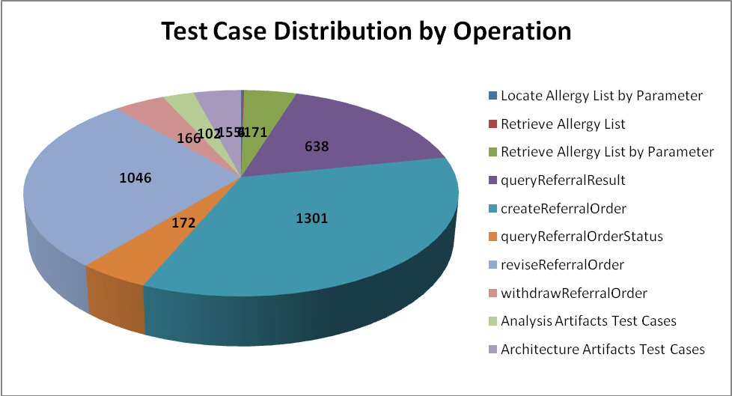

Operations/Sections | Cardinality | Does not exist | Invalid value | Multiple values | Null value | Valid value | Total
Allergy Service
Locate Allergy List by Parameter |  |  | 3 |  |  | 3 | 6
Retrieve Allergy List |  |  | 2 |  |  | 2 | 4
Retrieve Allergy List by Parameter | 22 | 20 | 61 | 10 | 36 | 22 | 171
Referral Consult Service
queryReferralResult | 86 | 79 | 184 | 24 | 186 | 79 | 638
createReferralOrder | 168 | 165 | 373 | 91 | 333 | 171 | 1301
queryReferralOrderStatus | 21 | 19 | 46 | 15 | 49 | 22 | 172
reviseReferralOrder | 146 | 145 | 284 | 14 | 308 | 149 | 1046
withdrawReferralOrder | 21 | 20 | 33 | 14 | 59 | 19 | 166
Analysis Artifacts Test Cases |  |  |  |  |  |  | 102
Architecture Artifacts Test Cases |  |  |  |  |  |  | 155
Total | 464 | 448 | 986 | 168 | 971 | 467 | 3761

The test case distribution by priority for this sprint is as follows:
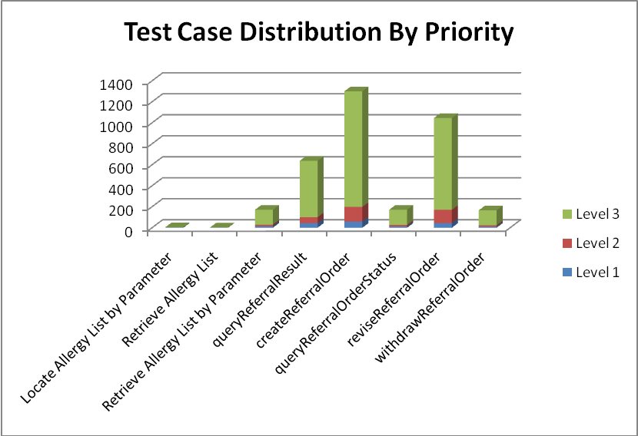
Operations | Level 1 (High) | Level 2 (Medium) | Level 3 (Low) | Not Applicable | Total
Allergy Service
Locate Allergy List by Parameter | 4 |  | 2 |  | 6
Retrieve Allergy List | 1 | 1 | 2 |  | 4
Retrieve Allergy List by Parameter | 15 | 14 | 142 |  | 171
Referral Consult Service
queryReferralResult | 43 | 58 | 537 |  | 638
createReferralOrder | 59 | 140 | 1102 |  | 1301
queryReferralOrderStatus | 13 | 14 | 145 |  | 172
reviseReferralOrder | 44 | 127 | 875 |  | 1046
withdrawReferralOrder | 11 | 13 | 142 |  | 166
Analysis Artifact Test Cases |  |  |  | 102 | 102
Architecture Artifact Test Cases |  |  |  | 155 | 155
Total | 190 | 367 | 2947 |  | 3761

The test case execution summary for the sprint is as follows:
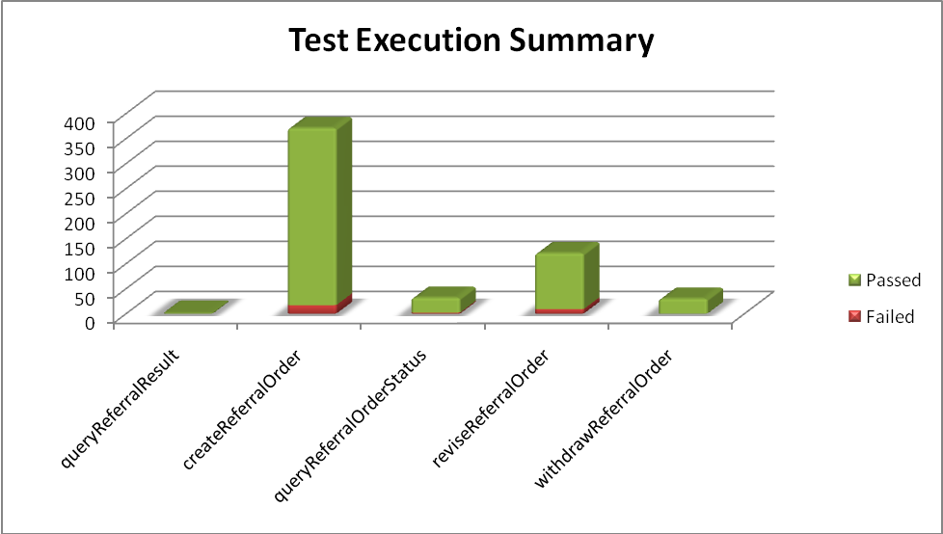
Operation | Failed | Failed % | Passed | Passed % | Total
queryReferralResult | 0 | 0% | 2 | 100% | 2
createReferralOrder | 17 | 5% | 354 | 95% | 371
queryReferralOrderStatus | 2 | 6% | 30 | 94% | 32
reviseReferralOrder | 7 | 6% | 114 | 94% | 121
withdrawReferralOrder | 0 | 0% | 30 | 100% | 30
Total | 26 | 5% | 530 | 95% | 556

The defect summary is:
Defects Fixed for this Sprint | Defects Closed in this Sprint | Defects Re-opened in this Sprint
11 | 11 | 0

The defects for this sprint are listed below:
Key | Summary | Reporter | Priority | Status | Resolution
ESD-1465 | Error "There was a problem merging the new referralOrder object" during revise transaction. | Kevin Gann | Major | Open | UNRESOLVED
ESD-1464 | II attributes on Patient Identifier do not appear to be validated for content. | Kevin Gann | Major | Open | UNRESOLVED
ESD-1460 | invalid II root attribute has for representedOrganization doesn't fail | Kevin Gann | Major | Open | UNRESOLVED
ESD-1458 | nullFlavor allowed within items within code clusterIntent>Code for revise operation | Kevin Gann | Major | Open | UNRESOLVED
ESD-1457 | nullFlavor allowed within items within reasonCode list of PatientCareProvisionRequest for revise operation | Kevin Gann | Major | Open | UNRESOLVED
ESD-1448 | Incorrect nullFlavor validation for COCT_MT090108US.AssignedOrganization in createReferralOrder | Amrut Rao | Major | Open | UNRESOLVED
ESD-1447 | Incorrect nullFlavor validation for COCT_MT090108US.Organization in createReferralOrder | Amrut Rao | Major | Open | UNRESOLVED
ESD-1445 | Incorrect nullFlavor validation for COCT_MT090108US.AssignedOrganization in queryReferralOrderStatus | Amrut Rao | Major | Open | UNRESOLVED
ESD-1444 | Incorrect nullFlavor validation for COCT_MT090108US.Organization in queryReferralOrderStatus | Amrut Rao | Major | Open | UNRESOLVED
ESD-1388 | Incorrect nullFlavor Validation for REPC_MT000003US.Component2 in createReferral | Amrut Rao | Major | Open | UNRESOLVED
ESD-1386 | Incorrect nullFlavor validation for COCT_MT090102US.Organization in createReferralOrder | Amrut Rao | Major | Open | UNRESOLVED
ESD-1382 | Incorrect nullFlavor validation for REPC_MT000003US.WorkingListEvent in createReferralOrder | Amrut Rao | Major | Closed | QA Trunk Verified
ESD-1381 | Incorrect nullFlavor validation for REPC_MT000003US.ClusterIntent in createReferralOrder | Amrut Rao | Major | Reopened | UNRESOLVED
ESD-1380 | Incorrect nullFlavor validation for REPC_MT000003US.ActIntent in createReferralOrder | Amrut Rao | Major | Closed | QA Trunk Verified
ESD-1376 | Entering a Null Value for Id and Extension does not provide an error code | Aviva Mordetsky | Major | Open | UNRESOLVED

