
Center for Biomedical Informatics and Information Technology

caBIG® Clinical Information Suite
QA Test Summary Report
Sprint: RC3-I1-S2
November 10, 2010
Table of Contents

Summary 3
i. Code Validation 3
ii. Specification Validation 3
iii. Sprint Deliverables 3
Test Case Creation 4
Referral Management Business Capability 4
1. Referral Consult Service 5
2. Allergy Service 6
3. Common Artifact Test Cases 7
Test Case Execution 8
Referral Management Business Capability 8
1. Referral Consult Service 9
2. Allergy Service 10
Defect Summary 11

Summary

Code Validation
  - ESD delivered RC3-I1-S2 ESD tag on October 25, 2010
  - The new artifacts from the Architecture drop of RC2-I2 was used in this tag
  - 5 operations (createReferralOrder, withdrawReferralOrder , queryReferralOrderStatus, queryReferralResult and reviseReferralOrder) were delivered to QA.
  - Regression testing was performed for createReferralOder , withdrawReferralOrder, queryReferralOrderStatus, queryReferralResult and reviseReferralOrder based on the Priority Levels:
  - All Level 1 and Level 2 test cases were executed
  - All test cases affected by fixed defects and release notes were executed
  - 3 new defect was raised in this sprint

Specification Validation
- The Architecture specification/artifact documents for the following services were validated from the RC2-I3 drop
  - Referral Consult
  - Allergy
- The analysis artifacts for the Referral Consult service were validated from the RC3-IT1
- 120 new defects were raised in this sprint

Sprint Deliverables
Test Summary Report
http://caehrorg.jira.com/svn/CACIS/trunk/documents/QA/Test_Reports/caBIGClinicalInformationSuite_RC3I1S2_Test_Summary_Report.doc
Test Cases
http://caehrorg.jira.com/svn/CACIS/trunk/documents/QA/Test_Cases/caBIGClinicalInformationSuite_TestCases_RC3I1S2.xls
Test Execution Report
http://caehrorg.jira.com/svn/CACIS/trunk/documents/QA/Test_Cases/caBIGClinicalInformationSuite_TestExecutionReport_RC3I1S2.mht
Soap Test Scripts
http://caehrorg.jira.com/svn/CACIS/trunk/documents/QA/soapUI_test_scripts/caBIGClinicalInformationSuite_RC3I1S2_TestScripts.zip

Test Case Creation

Referral Management Business Capability
Total test case distribution for this business capability
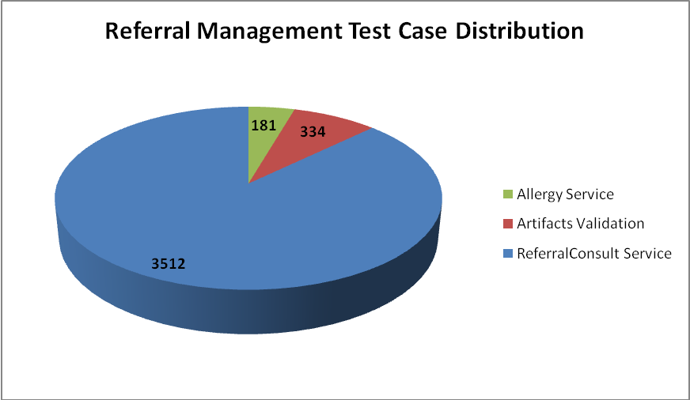
Sections | Total
Referral Consult Service | 3317
Allergy Service | 181
Artifacts Validation | 334
Total | 4027

Referral Consult Service
The test case distribution by category for this sprint is as follows:
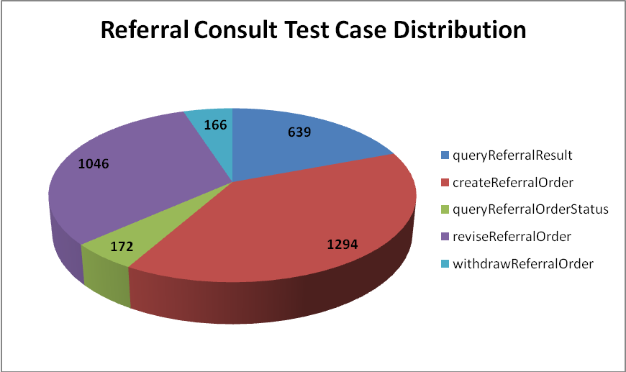
Operations | Cardinality | Does Not Exist | Invalid Value | Multiple Values | Null Value | Valid Value | Total
queryReferralResult | 86 | 79 | 185 | 24 | 186 | 79 | 639
createReferralOrder | 170 | 165 | 362 | 91 | 335 | 171 | 1294
queryReferralOrderStatus | 21 | 19 | 46 | 15 | 49 | 22 | 172
reviseReferralOrder | 146 | 145 | 284 | 14 | 308 | 149 | 1046
withdrawReferralOrder | 21 | 20 | 33 | 14 | 59 | 19 | 166
Total | 444 | 428 | 910 | 158 | 937 | 440 | 3317

Allergy Service
The test case distribution by category for this sprint is as follows:
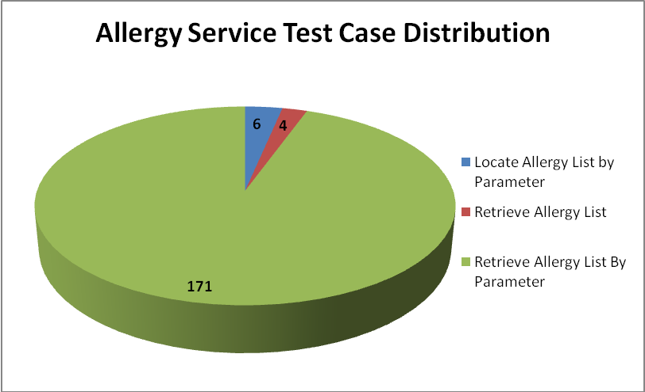
Operations | Cardinality | Does not exist | Invalid value | Multiple values | Null value | Valid value | Total
Locate Allergy List by Parameter |  |  | 3 |  |  | 3 | 6
Retrieve Allergy List |  |  | 2 |  |  | 2 | 4
Retrieve Allergy List By Parameter | 22 | 20 | 61 | 10 | 36 | 22 | 171
Total | 22 | 20 | 66 | 10 | 36 | 27 | 181

Common Artifact Test Cases
The test case distribution by artifacts for this sprint is as follows
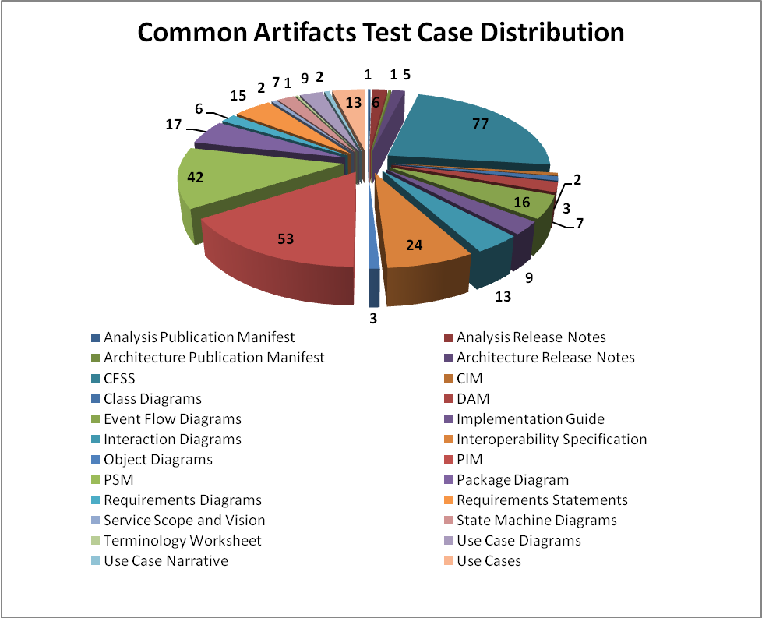
Artifacts | Count | Artifacts | Count
Analysis Publication Manifest | 1 | Object Diagrams | 3
Analysis Release Notes | 6 | PIM | 53
Architecture Publication Manifest | 1 | PSM | 42
Architecture Release Notes | 5 | Package Diagram | 17
CFSS | 77 | Requirements Diagrams | 6
CIM | 2 | Requirements Statements | 15
Class Diagrams | 3 | Service Scope and Vision | 2
DAM | 7 | State Machine Diagrams | 7
Event Flow Diagrams | 16 | Terminology Worksheet | 1
Implementation Guide | 9 | Use Case Diagrams | 9
Interaction Diagrams | 13 | Use Case Narrative | 2
Interoperability Specification | 24 | Use Cases | 13
Total |  |  | 334

Test Case Execution

Referral Management Business Capability
The test execution summary for this business capability:
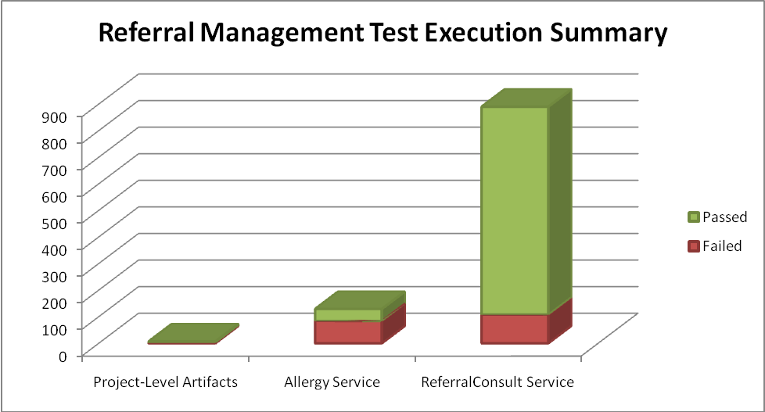
Sections | Failed | Fail % | Passed | Pass % | Total
Project-Level Artifacts | 2 | 29% | 5 | 71% | 7
Allergy Service | 84 | 65% | 45 | 35% | 129
Referral Consult Service | 108 | 12% | 782 | 88% | 890
Total | 194 | 19% | 832 | 81% | 1026

Referral Consult Service
The test execution summary for this service is:
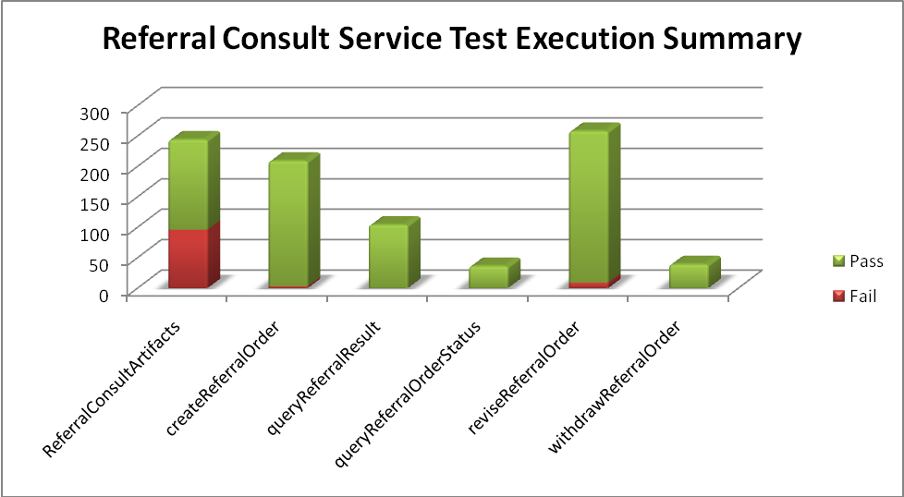
Sections | Failed | Fail % | Passed | Pass % | Total
Operations
createReferralOrder | 3 | 1% | 206 | 99% | 209
queryReferralResult |  | 0% | 104 | 100% | 104
queryReferralOrderStatus |  | 0% | 36 | 100% | 36
reviseReferralOrder | 9 | 3% | 249 | 97% | 258
withdrawReferralOrder |  | 0% | 39 | 100% | 39
Artifacts
CFSS | 33 | 43% | 43 | 57% | 76
CIM |  | 0% | 2 | 100% | 2
Class Diagrams | 2 | 67% | 1 | 33% | 3
DAM | 3 | 43% | 4 | 57% | 7
Event Flow Diagrams | 5 | 31% | 11 | 69% | 16
Interaction Diagrams | 5 | 38% | 8 | 62% | 13
Object Diagrams |  | 0% | 3 | 100% | 3
PIM | 23 | 43% | 30 | 57% | 53
Package Diagram | 6 | 35% | 11 | 65% | 17
Requirements Diagrams | 2 | 33% | 4 | 67% | 6
Requirements Statements | 8 | 53% | 7 | 47% | 15
Service Scope and Vision | 2 | 100% |  | 0% | 2
State Machine Diagrams | 4 | 57% | 3 | 43% | 7
Use Case Diagrams | 1 | 11% | 8 | 89% | 9
Use Case Narrative |  | 0% | 2 | 100% | 2
Use Cases | 2 | 15% | 11 | 85% | 13
Total | 108 | 12% | 782 | 88% | 890

Allergy Service
The test execution summary for this service is:
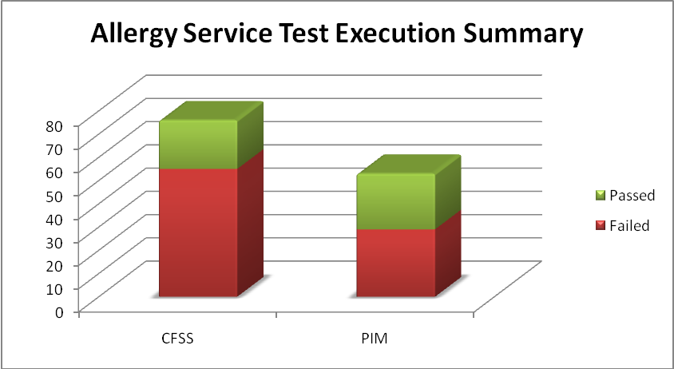
Artifacts | Failed | Fail % | Passed | Pass % | Total
CFSS | 55 | 72% | 21 | 28% | 76
PIM | 29 | 55% | 24 | 45% | 53
Total | 84 | 65% | 45 | 35% | 129

Defect Summary
The defect summary is:
Defects Fixed for this Sprint | Defects Closed in this Sprint | Defects Re-opened in this Sprint
10 | 9 | 1

The defects for this sprint are attached below:
