
Center for Biomedical Informatics and Information Technology

caBIG® Clinical Information Suite
QA Test Summary Report
Sprint: RC3-I2-S1
November 24, 2010
Table of Contents

Summary 3
i. Code Validation 3
ii. Specification Validation 3
iii. Sprint Deliverables 3
Test Case Creation 4
Referral Management Business Capability 4
1. Referral Consult Service 5
2. Allergy Service 6
3. Common Artifact Test Cases 7
4. Other Services 8
Test Case Execution 9
Referral Management Business Capability 9
1. Referral Consult Service 10
2. Other Services 11
Defect Summary 12

Summary

Code Validation
  - ESD delivered RC3-I1-S2 ESD tag on November 12, 2010
  - The artifacts from the Architecture drop of RC2-I2 was used in this tag
  - 5 operations (createReferralOrder, withdrawReferralOrder , queryReferralOrderStatus, queryReferralResult and reviseReferralOrder) were delivered to QA.
  - Regression testing was performed for createReferralOder , withdrawReferralOrder, queryReferralOrderStatus, queryReferralResult and reviseReferralOrder based on the Priority Levels:
    - All Level 1 and Level 2 test cases were executed
    - All test cases affected by fixed defects and release notes were executed
  - 10 new defect was raised in this sprint

Specification Validation
- The Architecture specification/artifact documents for the following services were validated from the RC2-I3 drop
  - Referral Consult
  - Document Exchange
  - Patient Registry
  - Provider Registry
  - Organization Registry
  - Family History
  - Medication List
- The analysis artifacts for the Referral Consult service were validated from the RC3-IT1
- 174 new defects were raised in this sprint

Sprint Deliverables
Test Summary Report
http://caehrorg.jira.com/svn/CACIS/trunk/documents/QA/Test_Reports/caBIGClinicalInformationSuite_RC3I2S1_Test_Summary_Report.doc
Test Cases
http://caehrorg.jira.com/svn/CACIS/trunk/documents/QA/Test_Cases/caBIGClinicalInformationSuite_TestCases_RC3I2S1.xls
Test Execution Report
http://caehrorg.jira.com/svn/CACIS/trunk/documents/QA/Test_Cases/caBIGClinicalInformationSuite_TestExecutionReport_RC3I2S1.mht
Soap Test Scripts
http://caehrorg.jira.com/svn/CACIS/trunk/documents/QA/soapUI_test_scripts/caBIGClinicalInformationSuite_RC3I2S1_TestScripts.zip

Test Case Creation

Referral Management Business Capability
Total test case distribution for this business capability
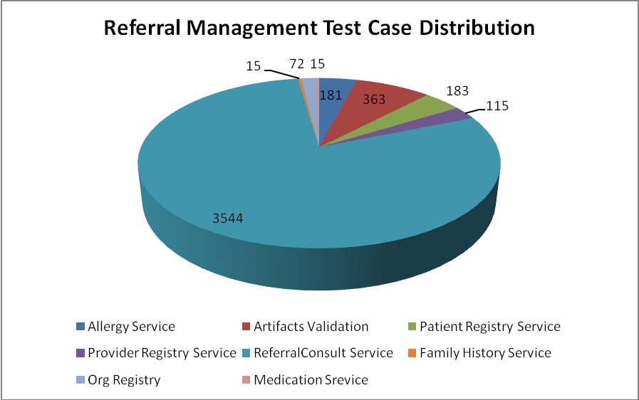
Service | Total
Allergy Service | 181
Artifacts Validation | 363
Patient Registry Service | 183
Provider Registry Service | 115
Referral Consult Service | 3544
Family History Service | 15
Org Registry | 72
Medication Service | 15
Total | 4488

Referral Consult Service
The test case distribution by category for this sprint is as follows:
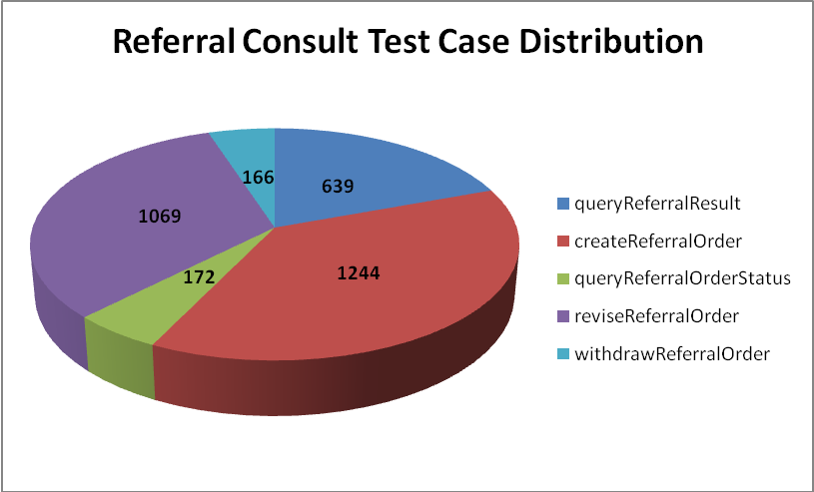
Operations | Cardinality | Does Not Exist | Invalid Value | Multiple Values | Null Value | Valid Value | Total
queryReferralResult | 86 | 79 | 185 | 24 | 186 | 79 | 639
createReferralOrder | 163 | 158 | 345 | 88 | 325 | 165 | 1244
queryReferralOrderStatus | 21 | 19 | 46 | 15 | 49 | 22 | 172
reviseReferralOrder | 146 | 150 | 286 | 14 | 321 | 152 | 1069
withdrawReferralOrder | 21 | 20 | 33 | 14 | 59 | 19 | 166
Total | 437 | 426 | 895 | 155 | 940 | 437 | 3290

Allergy Service
The test case distribution by category for this sprint is as follows:
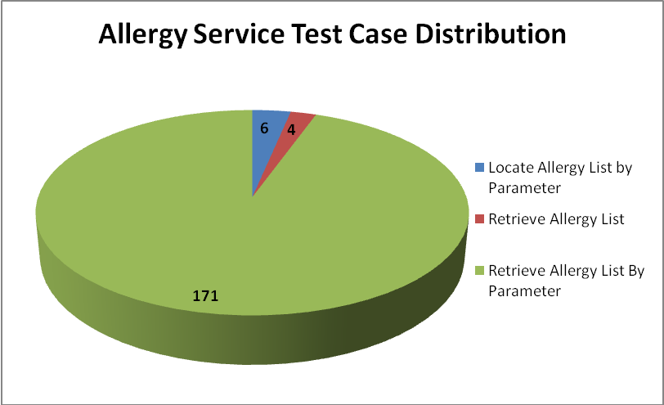
Operations | Cardinality | Does not exist | Invalid value | Multiple values | Null value | Valid value | Total
Locate Allergy List by Parameter |  |  | 3 |  |  | 3 | 6
Retrieve Allergy List |  |  | 2 |  |  | 2 | 4
Retrieve Allergy List By Parameter | 22 | 20 | 61 | 10 | 36 | 22 | 171
Total | 22 | 20 | 66 | 10 | 36 | 27 | 181

Common Artifact Test Cases
The test case distribution by artifacts for this sprint is as follows
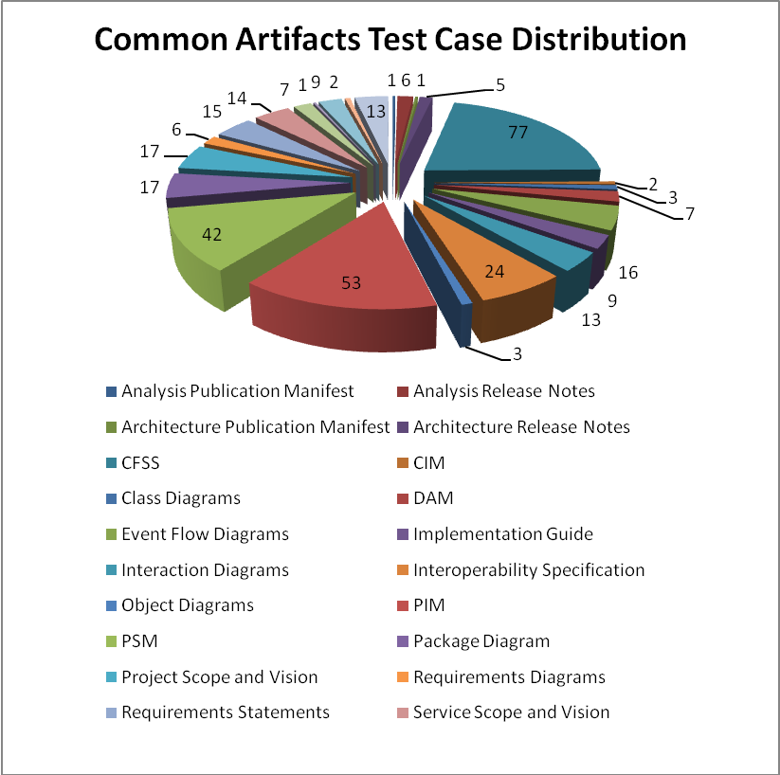
Artifacts | Count | Artifacts | Count
Analysis Publication Manifest | 1 | Object Diagrams | 3
Analysis Release Notes | 6 | PIM | 53
Architecture Publication Manifest | 1 | PSM | 42
Architecture Release Notes | 5 | Package Diagram | 17
CFSS | 77 | Requirements Diagrams | 6
CIM | 2 | Requirements Statements | 15
Class Diagrams | 3 | Service Scope and Vision | 2
DAM | 7 | State Machine Diagrams | 7
Event Flow Diagrams | 16 | Terminology Worksheet | 1
Implementation Guide | 9 | Use Case Diagrams | 9
Interaction Diagrams | 13 | Use Case Narrative | 2
Interoperability Specification | 24 | Use Cases | 13
Project Scope and Vision | 17
Total |  |  | 363

Other Services
Test case distribution for other services is as follows
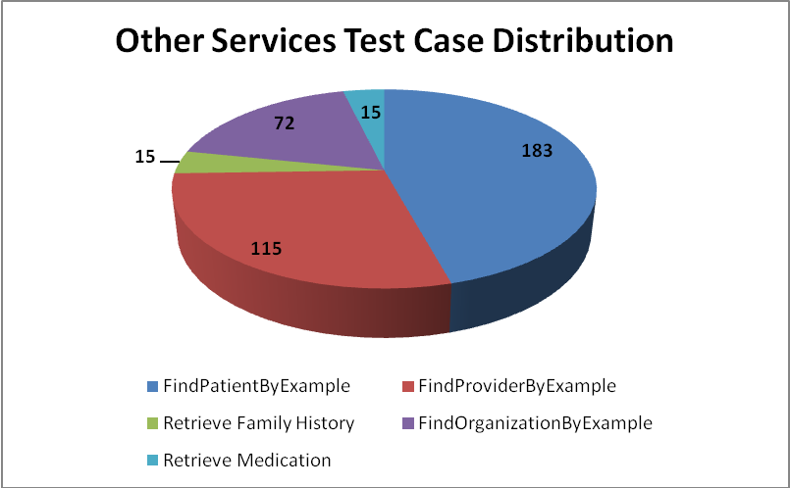
Service | Total
Patient Registry
FindPatientByExample | 183
Provider Registry
FindProviderByExample | 115
Family History Service
Retrieve Family History | 15
Organization Registry
FindOrganizationByExample | 72
Medication Service
Retrieve Medication | 15
Total | 400

Test Case Execution

Referral Management Business Capability
The test execution summary for this business capability:
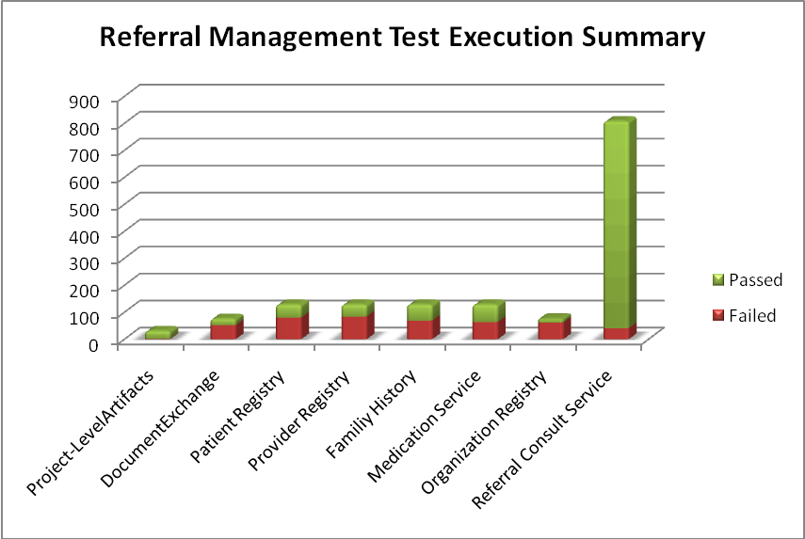
Sections/Services | Failed | Fail % | Passed | Pass % | Total
Project-LevelArtifacts | 2 | 6% | 29 | 94% | 31
DocumentExchange | 52 | 68% | 24 | 32% | 76
Patient Registry | 80 | 62% | 49 | 38% | 129
Provider Registry | 84 | 65% | 45 | 35% | 129
Familiy History | 69 | 53% | 60 | 47% | 129
Medication Service | 64 | 50% | 65 | 50% | 129
Organization Registry | 62 | 82% | 14 | 18% | 76
Referral Consult Service | 41 | 5% | 767 | 95% | 808
Total | 454 | 30% | 1053 | 70% | 1507

Referral Consult Service
The test execution summary for this service is:
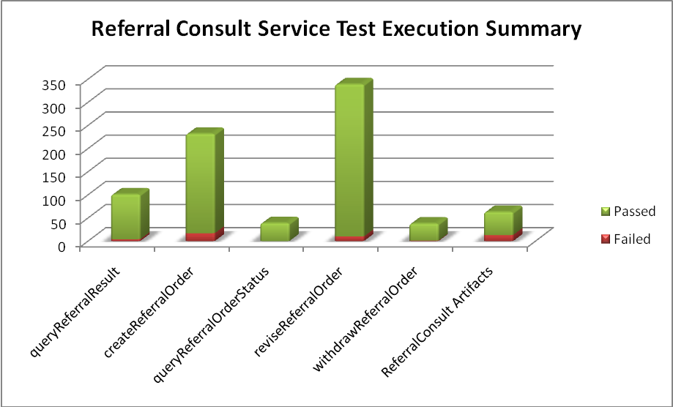
Sections | Failed | Fail % | Passed | Pass % | Total
Operations
createReferralOrder | 17 | 7% | 215 | 93% | 232
queryReferralResult | 4 | 4% | 97 | 96% | 101
queryReferralOrderStatus |  | 0% | 39 | 100% | 39
reviseReferralOrder | 10 | 3% | 329 | 97% | 339
withdrawReferralOrder | 1 | 3% | 37 | 97% | 39
Artifacts
CIM |  | 0% | 2 | 100% | 2
DAM |  | 0% | 1 | 100% | 1
Event Flow Diagrams |  | 0% | 3 | 100% | 3
PIM | 13 | 24% | 40 | 76% | 53
State Machine Diagrams | 0 | 0% | 2 | 100% | 2
Use Cases | 0 | 0% | 2 | 100% | 2
Total | 45 | 6% | 767 | 94% | 812

Other Services
The test execution summary for this service is:
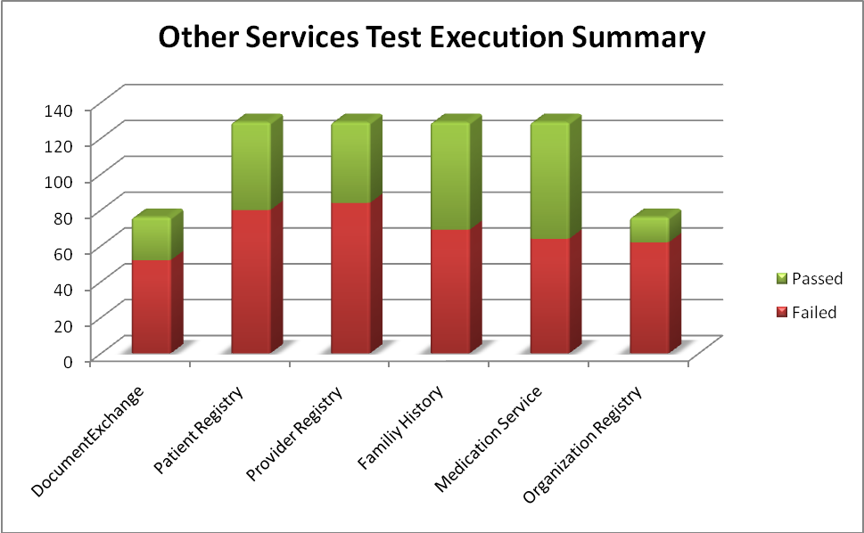
Services | Fail | Fail % | Pass | Pass % | Total
Document Exchange
CFSS | 52 | 68% | 24 | 32% | 76
Patient Registry
CFSS | 59 | 78% | 17 | 22% | 76
PIM | 21 | 40% | 32 | 60% | 53
Provider Registry
CFSS | 62 | 82% | 14 | 18% | 76
PIM | 22 | 42% | 31 | 58% | 53
Organization Registry
CFSS | 62 | 82% | 14 | 18% | 76
Family Registry
CFSS | 50 | 66% | 26 | 34% | 76
PIM | 19 | 36% | 34 | 64% | 53
Medication Service
CFSS | 47 | 62% | 29 | 38% | 76
PIM | 17 | 32% | 36 | 68% | 53
Total | 411 | 62% | 257 | 38% | 668

Defect Summary
The defect summary is:
ESD Defects Fixed for this Sprint | ESD Defects Closed in this Sprint | ESD Defects Re-opened in this Sprint
2 | 2 | 0

The defects for this sprint are attached below:
