
Center for Biomedical Informatics and Information Technology

caBIG® Clinical Information Suite
QA Test Summary Report
Sprint: RC3-I2-S2
December 10, 2010
Table of Contents

Summary 3
i. Code Validation 3
ii. Specification Validation 3
iii. Sprint Deliverables 3
Test Case Creation 5
Referral Management Business Capability 5
1. Referral Consult Service 6
2. Allergy Service 7
3. Common Artifact Test Cases 8
4. Other Services 9
Demonstration Pilot 9
Test Case Execution 10
Referral Management Business Capability 10
1. Referral Consult Service 11
2. Other Services 12
Defect Summary 13

Summary

Code Validation
  - ESD delivered RC3-I2-S1 ESD tag on November 30, 2010
  - The artifacts from the Architecture drop of RC2-I3 was used in this tag
  - The following were delivered in this tag:
    - 5 operations (createReferralOrder, withdrawReferralOrder , queryReferralOrderStatus, queryReferralResult and reviseReferralOrder) from Referral Consult Service
    - 1 operation (findProviderByExample) from Provider Registry mock service
    - 1 operation (findPatientByExample) from Patient Registry mock service
    - Demonstration Pilot Diagnosis Screen
  - Regression testing was performed for createReferralOder , withdrawReferralOrder, queryReferralOrderStatus, queryReferralResult and reviseReferralOrder based on the Priority Levels:
    - All Level 1 and Level 2 test cases were executed
    - All test cases affected by fixed defects and release notes were executed
  - Since Demo Pilot code was not a part of the CI build, this will be tested in the next tag when it is integrated into the CI build
  - 14 new defect was raised in this sprint

Specification Validation
- The specification/artifact documents for the following services were validated from the RC3-I1 drop
  - Referral Consult
  - Allergy
  - Immunization
  - Social History
  - Vital Signs
  - Problem List
  - Document Exchange
  - Organization Registry
- 18 new defects were raised in this sprint

Sprint Deliverables
Test Summary Report
http://caehrorg.jira.com/svn/CACIS/trunk/documents/QA/Test_Reports/caBIGClinicalInformationSuite_RC3I2S2_Test_Summary_Report.doc
Test Cases
http://caehrorg.jira.com/svn/CACIS/trunk/documents/QA/Test_Cases/caBIGClinicalInformationSuite_TestCases_RC3I2S2.xls
Test Execution Report
http://caehrorg.jira.com/svn/CACIS/trunk/documents/QA/Test_Cases/caBIGClinicalInformationSuite_TestExecutionReport_RC3I2S2.mht
Soap Test Scripts
http://caehrorg.jira.com/svn/CACIS/trunk/documents/QA/soapUI_test_scripts/caBIGClinicalInformationSuite_RC3I2S2_TestScripts.zip

Test Case Creation

Referral Management Business Capability
Total test case distribution for this business capability
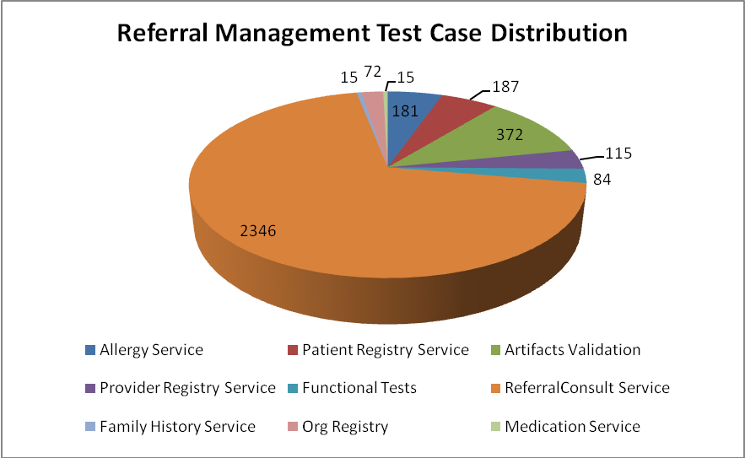
Service | Total
Allergy Service | 181
Artifacts Validation | 372
Patient Registry Service | 187
Provider Registry Service | 115
Referral Consult Service | 2346
Family History Service | 15
Org Registry | 72
Medication Service | 15
Functional Tests | 84
Total | 3387

Referral Consult Service
The test case distribution by category for this sprint is as follows:
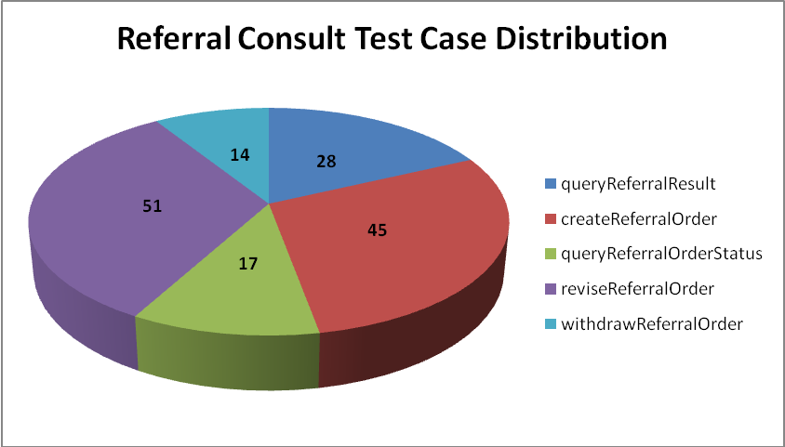
Operations | Cardinality | Does Not Exist | Invalid Value | Multiple Values | Null Value | Valid Value | Total
queryReferralResult | 46 | 43 | 91 |  | 108 | 47 | 335
createReferralOrder | 130 | 129 | 274 | 66 | 263 | 138 | 1000
queryReferralOrderStatus | 2 | 2 | 10 | 6 | 9 | 8 | 37
reviseReferralOrder | 128 | 133 | 263 | 5 | 272 | 146 | 947
withdrawReferralOrder | 2 | 2 | 9 |  | 8 | 6 | 27
Total | 308 | 309 | 647 | 77 | 660 | 345 | 2346

Allergy Service
The test case distribution by category for this sprint is as follows:
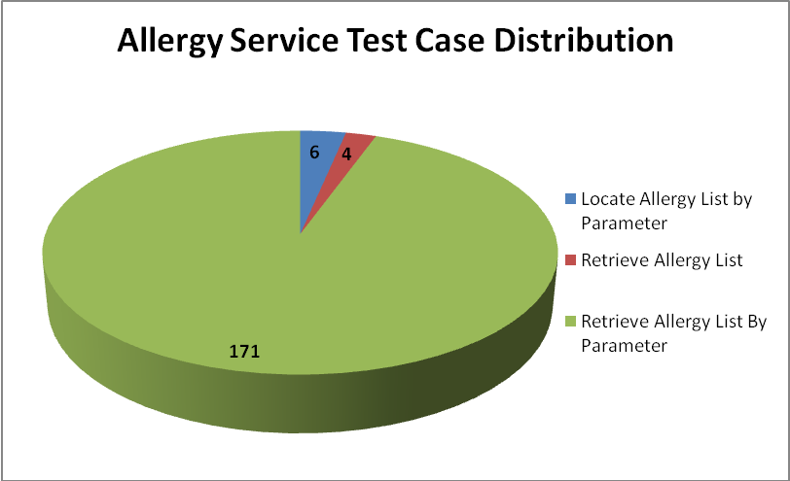
Operations | Cardinality | Does not exist | Invalid value | Multiple values | Null value | Valid value | Total
Locate Allergy List by Parameter |  |  | 3 |  |  | 3 | 6
Retrieve Allergy List |  |  | 2 |  |  | 2 | 4
Retrieve Allergy List By Parameter | 22 | 20 | 61 | 10 | 36 | 22 | 171
Total | 22 | 20 | 66 | 10 | 36 | 27 | 181

Common Artifact Test Cases
The test case distribution by artifacts for this sprint is as follows
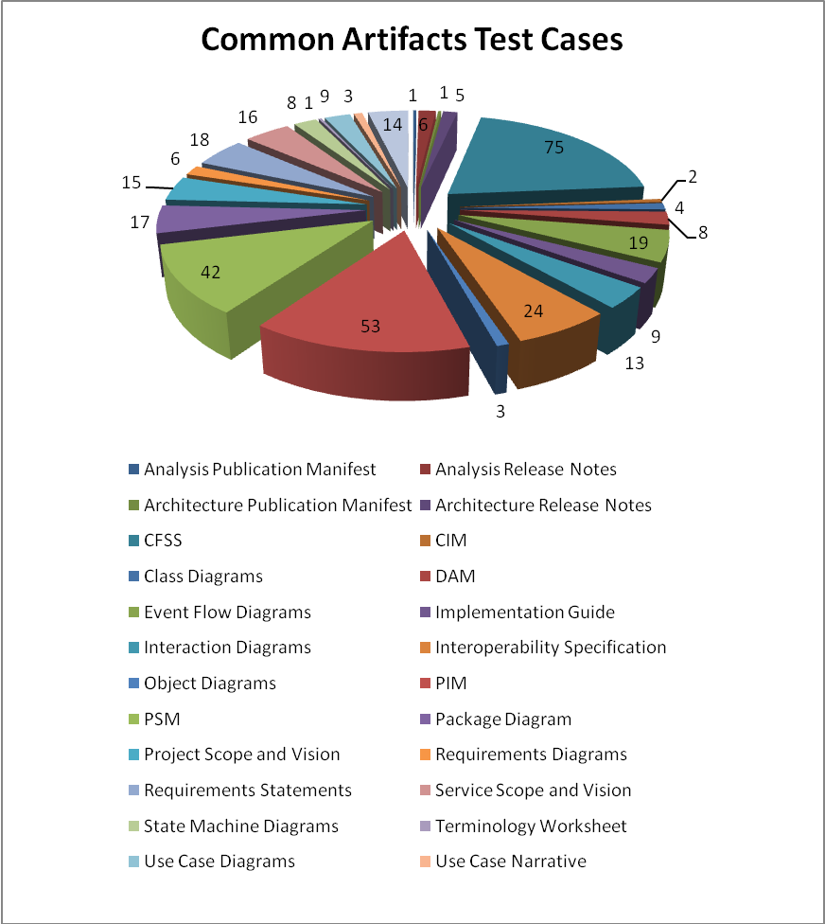
Artifacts | Count | Artifacts | Count
Analysis Publication Manifest | 1 | Object Diagrams | 3
Analysis Release Notes | 6 | PIM | 53
Architecture Publication Manifest | 1 | PSM | 42
Architecture Release Notes | 5 | Package Diagram | 17
CFSS | 75 | Requirements Diagrams | 6
CIM | 2 | Requirements Statements | 18
Class Diagrams | 4 | Service Scope and Vision | 16
DAM | 8 | State Machine Diagrams | 8
Event Flow Diagrams | 19 | Terminology Worksheet | 1
Implementation Guide | 9 | Use Case Diagrams | 9
Interaction Diagrams | 13 | Use Case Narrative | 2
Interoperability Specification | 24 | Use Cases | 14
Project Scope and Vision | 15
Total |  |  | 372

Other Services
Test case distribution for other services is as follows
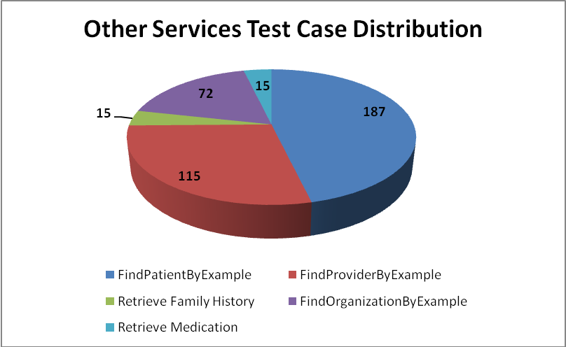
Service | Total
Patient Registry
FindPatientByExample | 187
Provider Registry
FindProviderByExample | 115
Family History Service
Retrieve Family History | 15
Organization Registry
FindOrganizationByExample | 72
Medication Service
Retrieve Medication | 15
Total | 404

Demonstration Pilot
Test case distribution is as follows
Section | Total
Diagnosis Screen | 9

Test Case Execution

Referral Management Business Capability
The test execution summary for this business capability:
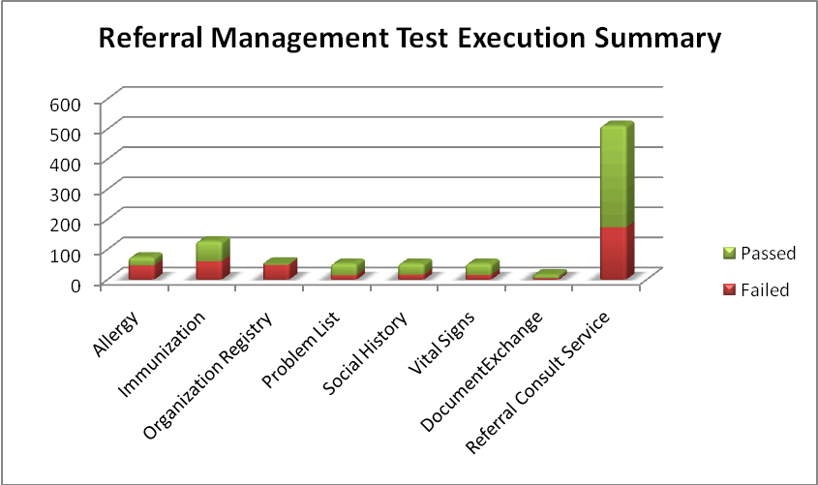
Service | Failed | Fail % | Passed | Pass % | Total
Allergy | 47 | 64% | 27 | 36% | 74
Immunization | 61 | 48% | 66 | 52% | 127
Organization Registry | 49 | 92% | 4 | 8% | 53
Problem List | 15 | 28% | 38 | 72% | 53
Social History | 17 | 32% | 36 | 68% | 53
Vital Signs | 16 | 30% | 37 | 70% | 53
DocumentExchange | 5 | 31% | 11 | 69% | 16
Referral Consult Service | 174 | 34% | 337 | 66% | 511
Total | 384 | 41% | 446 | 47% | 940

Referral Consult Service
The test execution summary for this service is:
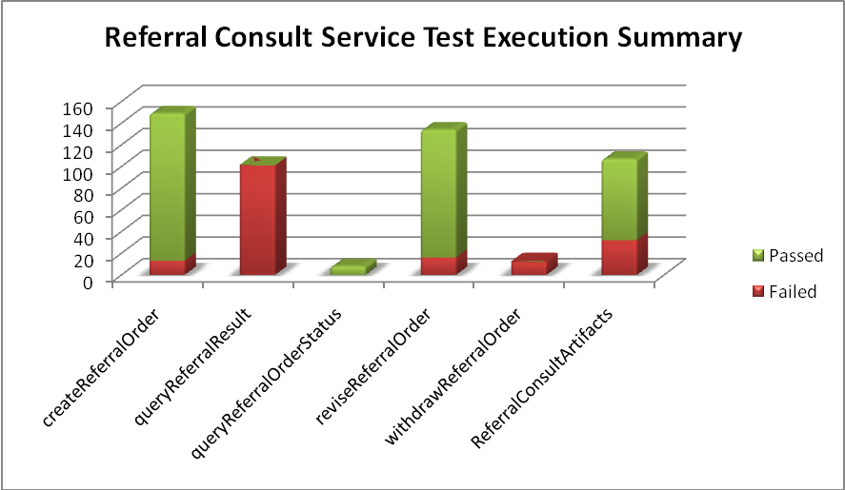
Sections | Failed | Fail % | Passed | Pass % | Total
Operations
createReferralOrder | 13 | 9% | 136 | 91% | 149
queryReferralResult | 101 | 100% | 0 | 0% | 101
queryReferralOrderStatus |  | 0% | 8 | 100% | 8
reviseReferralOrder | 16 | 12% | 118 | 88% | 134
withdrawReferralOrder | 12 | 100% | 0 | 0% | 12
Artifacts
CFSS | 21 | 28% | 53 | 72% | 74
Implementation Guide | 1 | 11% | 8 | 89% | 9
Interoperability Spec | 10 | 42% | 14 | 58% | 24
Total | 174 | 34% | 337 | 66% | 511

Other Services
The test execution summary for this service is:
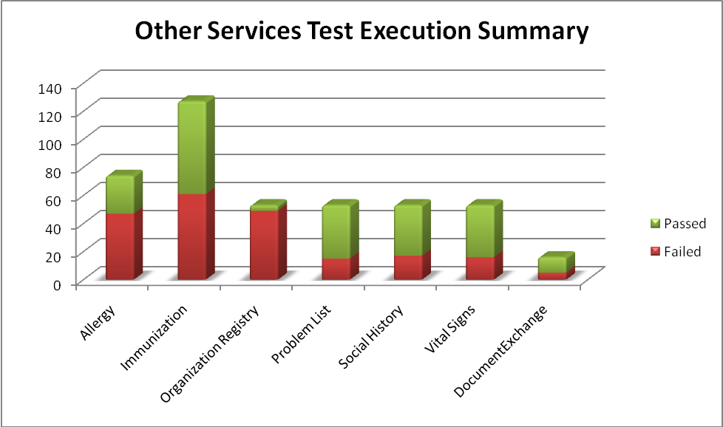
Service | Failed | Fail % | Passed | Pass % | Total
Allergy
CFSS | 47 | 64% | 27 | 36% | 74
Immunization
CFSS | 44 | 59% | 30 | 41% | 74
PIM | 17 | 32% | 36 | 68% | 53
Organization Registry
PIM | 49 | 92% | 4 | 8% | 53
Problem List
PIM | 15 | 28% | 38 | 72% | 53
Social History
PIM | 17 | 32% | 36 | 68% | 53
Vital Signs
PIM | 16 | 30% | 37 | 70% | 53
Document Exchange
Service Scope and Vision | 5 | 31% | 11 | 69% | 16
Total | 210 | 49% | 219 | 51% | 429

Defect Summary
The defect summary is:
ESD Defects Fixed for this Sprint | ESD Defects Closed in this Sprint | ESD Defects Re-opened in this Sprint
2 | 2 | 0

The defects for this sprint are attached below:
