
Center for Biomedical Informatics and Information Technology

caBIG® Clinical Information Suite
QA Test Summary Report
Sprint: RC3-I3-S1
January 3, 2011
Table of Contents

Summary 3
i. Code Validation 3
ii. Specification Validation 3
iii. Sprint Deliverables 3
Test Case Creation 5
Referral Management Business Capability 5
1. Referral Consult Service 6
2. Allergy Service 7
3. Common Artifact Test Cases 8
4. Other Services 9
Demonstration Pilot 10
Test Case Execution 11
Referral Management Business Capability 11
1. Referral Consult Service 12
2. Other Services 13
Demonstration Pilot 14
Defect Summary 15

Summary

Code Validation
  - ESD delivered RC3-I3-S1 ESD tag on December 13, 2010
  - The artifacts from the Architecture drop of RC2-I3 was used in this tag
  - The following were delivered in this tag:
    - 5 operations (createReferralOrder, withdrawReferralOrder , queryReferralOrderStatus, queryReferralResult and reviseReferralOrder) from Referral Consult Service
    - 1 operation (findProviderByExample) from Provider Registry mock service
    - Demonstration Pilot
  - Regression testing was performed for createReferralOrder , queryReferralOrderStatus, and reviseReferralOrder based on the Priority Levels:
    - All Level 1 and Level 2 test cases were executed
    - Certain L3 test cases were executed
    - All test cases affected by fixed defects and release notes were executed
  - Since Demo Pilot code was not a part of the tag, this will be tested when a tag is cut for Demo Pilot and the Tolven installation is integrated into the CI Build
  - Demo Pilot installation was blocked due to ESD-1865
  - Provider Registry deployment was blocked due to ESD-1878
  - queryReferralResult testing was blocked due to ESD-1918
  - 22 new defect was raised in this sprint

Specification Validation
- The specification/artifact documents for the following services were validated from the RC3-I2 drop
  - Referral Consult
  - Document Builder
  - Document Exchange
  - Lab Results
  - Provider Registry
- Demonstration Pilot specification artifacts were also validated
- 45 new defects were raised in this sprint

Sprint Deliverables
Test Summary Report
http://caehrorg.jira.com/svn/CACIS/trunk/documents/QA/Test_Reports/caBIGClinicalInformationSuite_RC3I3S1_Test_Summary_Report.doc
Test Cases
http://caehrorg.jira.com/svn/CACIS/trunk/documents/QA/Test_Cases/caBIGClinicalInformationSuite_TestCases_RC3I3S1.xls
Test Execution Report
http://caehrorg.jira.com/svn/CACIS/trunk/documents/QA/Test_Cases/caBIGClinicalInformationSuite_TestExecutionReport_RC3I3S1.mht
Soap Test Scripts
http://caehrorg.jira.com/svn/CACIS/trunk/documents/QA/soapUI_test_scripts/caBIGClinicalInformationSuite_RC3I3S1_TestScripts.zip

Test Case Creation

Referral Management Business Capability
Total test case distribution for this business capability
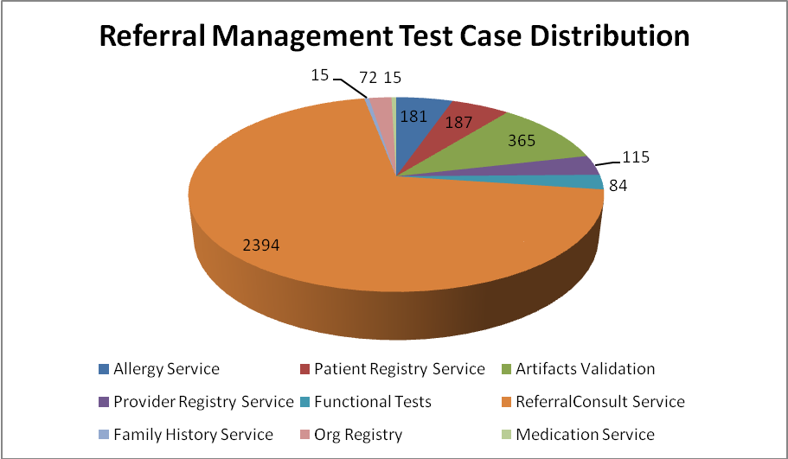
Service | Total
Allergy Service | 181
Artifacts Validation | 365
Patient Registry Service | 187
Provider Registry Service | 115
Referral Consult Service | 2394
Family History Service | 15
Org Registry | 72
Medication Service | 15
Functional Tests | 84
Total | 3428

Referral Consult Service
The test case distribution by category for this sprint is as follows:
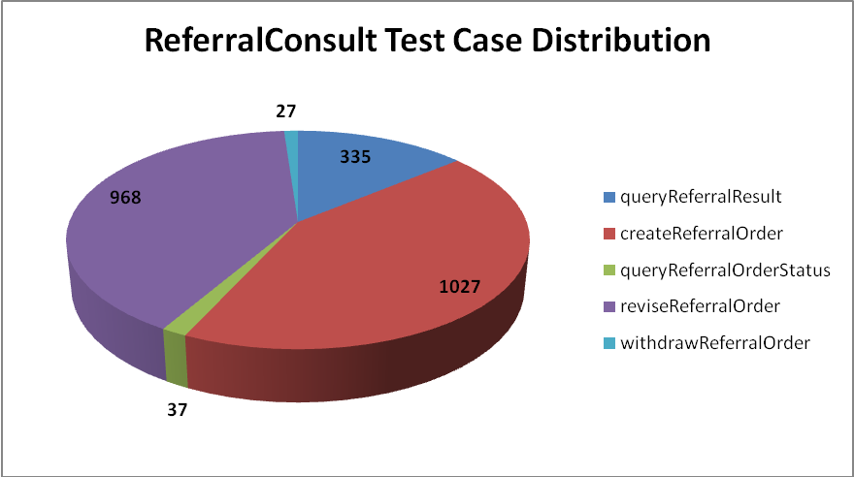
Operations | Cardinality | Does Not Exist | Invalid Value | Multiple Values | Null Value | Valid Value | Total
queryReferralResult | 46 | 43 | 91 |  | 108 | 47 | 335
createReferralOrder | 133 | 130 | 274 | 66 | 262 | 162 | 1027
queryReferralOrderStatus | 2 | 2 | 10 | 6 | 9 | 8 | 37
reviseReferralOrder | 128 | 131 | 263 | 26 | 274 | 146 | 968
withdrawReferralOrder | 2 | 2 | 9 |  | 8 | 6 | 27
Total | 311 | 308 | 647 | 98 | 661 | 369 | 2394

Allergy Service
The test case distribution by category for this sprint is as follows:
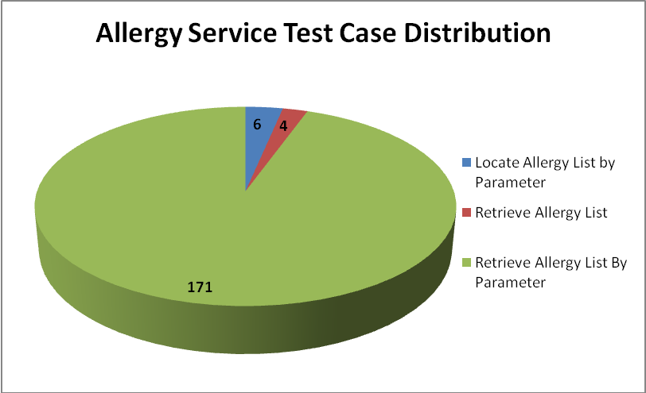
Operations | Cardinality | Does not exist | Invalid value | Multiple values | Null value | Valid value | Total
Locate Allergy List by Parameter |  |  | 3 |  |  | 3 | 6
Retrieve Allergy List |  |  | 2 |  |  | 2 | 4
Retrieve Allergy List By Parameter | 22 | 20 | 61 | 10 | 36 | 22 | 171
Total | 22 | 20 | 66 | 10 | 36 | 27 | 181

Common Artifact Test Cases
The test case distribution by artifacts for this sprint is as follows
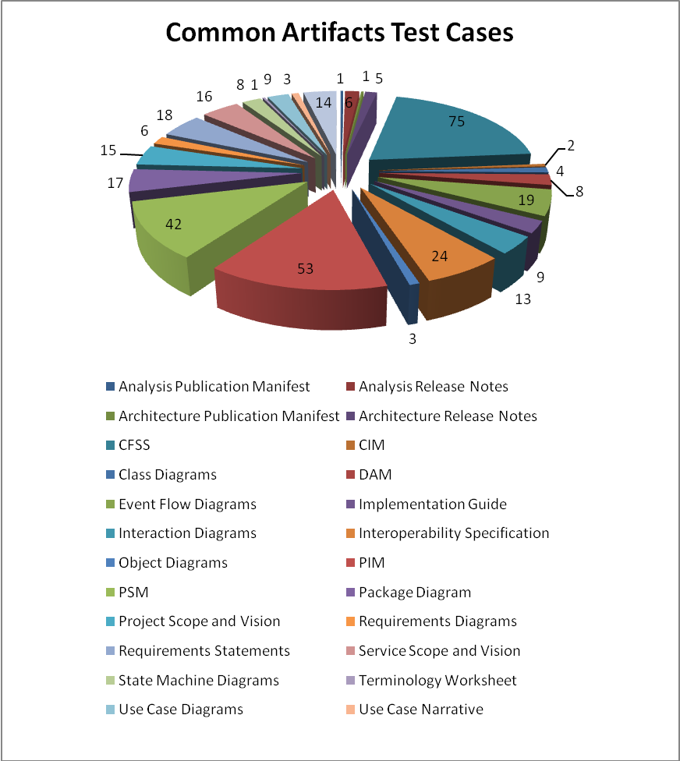
Artifacts | Count | Artifacts | Count
Analysis Publication Manifest | 2 | Object Diagrams | 3
Analysis Release Notes | 6 | PIM | 53
Architecture Publication Manifest | 1 | PSM | 42
Architecture Release Notes | 5 | Package Diagram | 9
CFSS | 75 | Requirements Diagrams | 4
CIM | 2 | Requirements Statements | 17
Class Diagrams | 4 | Service Scope and Vision | 16
DAM | 9 | State Machine Diagrams | 8
Event Flow Diagrams | 19 | Terminology Worksheet | 1
Implementation Guide | 9 | Use Case Diagrams | 9
Interaction Diagrams | 10 | Use Case Narrative | 3
Interoperability Specification | 24 | Use Cases | 12
Project Scope and Vision | 15 | Wireframe Diagrams | 8
Total |  |  | 365

Other Services
Test case distribution for other services is as follows
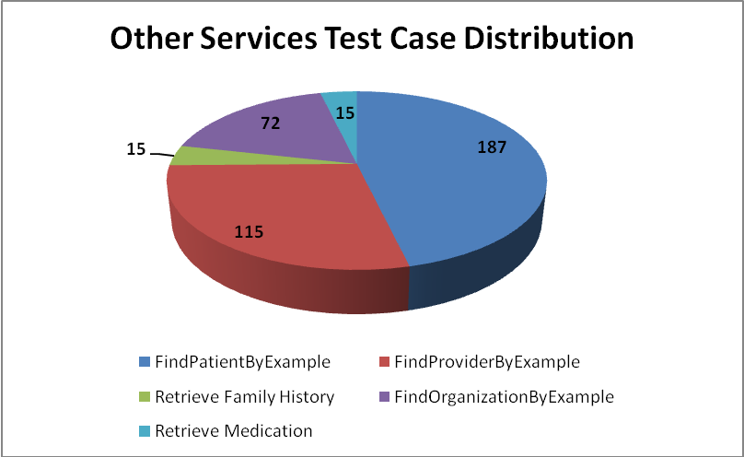
Service | Total
Patient Registry
FindPatientByExample | 187
Provider Registry
FindProviderByExample | 115
Family History Service
Retrieve Family History | 15
Organization Registry
FindOrganizationByExample | 72
Medication Service
Retrieve Medication | 15
Total | 404

Demonstration Pilot
Test case distribution is as follows

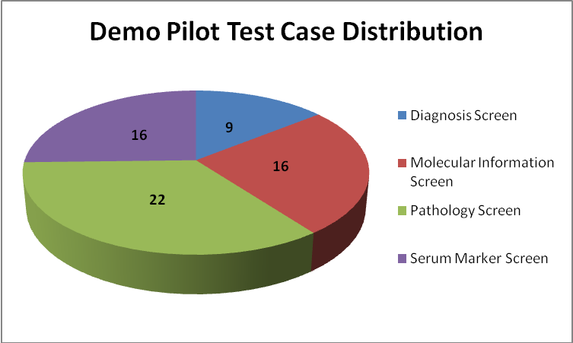
Screens | Total
Diagnosis Screen | 9
Molecular Information Screen | 16
Pathology Screen | 22
Serum Marker Screen | 16
Total | 63

Test Case Execution

Referral Management Business Capability
The test execution summary for this business capability:
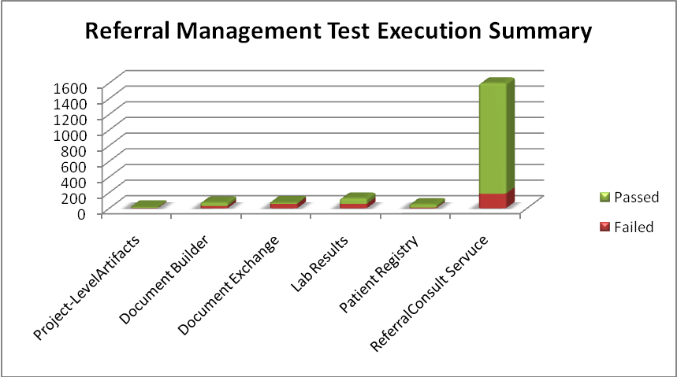
Section | Failed | Fail % | Passed | Pass % | Total
Project-LevelArtifacts | 5 | 31% | 11 | 69% | 16
Document Builder | 29 | 39% | 45 | 61% | 74
Document Exchange | 56 | 76% | 18 | 24% | 74
Lab Results | 56 | 44% | 71 | 56% | 127
Provider Registry | 10 | 20% | 41 | 80% | 51
ReferralConsult Service | 186 | 12% | 1411 | 88% | 1597
Total | 342 | 18% | 1597 | 82% | 1939

Referral Consult Service
The test execution summary for this service is:
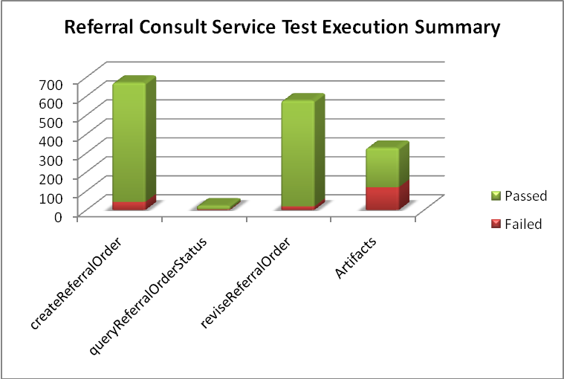
Sections | Failed | Fail % | Passed | Pass % | Total
Operations
createReferralOrder | 43 | 6% | 628 | 94% | 671
queryReferralOrderStatus | 4 | 18% | 18 | 82% | 22
reviseReferralOrder | 19 | 3% | 558 | 97% | 577
Artifacts
CFSS - Referral Consult | 22 | 30% | 52 | 70% | 74
CIM - Referral Consult |  | 0% | 2 | 100% | 2
Class Diagrams - Referral Consult | 2 | 50% | 2 | 50% | 4
DAM - Referral Consult | 9 | 100% |  | 0% | 9
Event Flow Diagrams - Referral Consult | 5 | 26% | 14 | 74% | 19
Implementation Guide - Referral Consult | 2 | 22% | 7 | 78% | 9
Interaction Diagrams - Referral Consult | 5 | 50% | 5 | 50% | 10
Interoperability Specification - Referral Consult | 3 | 13% | 21 | 88% | 24
Object Diagrams - Referral Consult | 1 | 33% | 2 | 67% | 3
PIM - Referral Consult | 15 | 28% | 38 | 72% | 53
PSM - Referral Consult | 10 | 24% | 32 | 76% | 42
Package Diagram - Referral Consult |  | 0% | 9 | 100% | 9
Requirements Diagrams - Referral Consult | 3 | 75% | 1 | 25% | 4
Requirements Statements - Referral Consult | 18 | 100% |  | 0% | 18
Service Scope and Vision - Referral Consult | 16 | 100% |  | 0% | 16
State Machine Diagrams - Referral Consult | 2 | 29% | 5 | 71% | 7
Use Case Diagrams - Referral Consult | 1 | 11% | 8 | 89% | 9
Use Case Narrative - Referral Consult | 3 | 100% |  | 0% | 3
Use Cases - Referral Consult | 3 | 25% | 9 | 75% | 12
Total | 186 | 12% | 1411 | 88% | 1597

Other Services
The test execution summary for this service is:
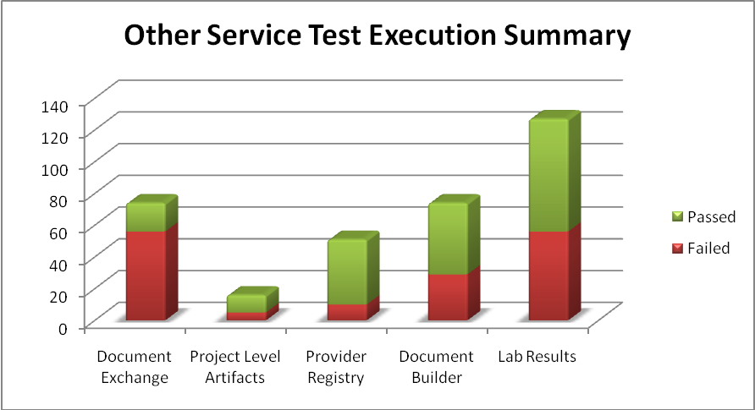
Services | Failed | Passed | <Total>
Document Exchange
CFSS | 56 | 18 | 74
Project Level Artifacts
Analysis Publication Manifest | 2 |  | 2
Analysis Release Notes |  | 6 | 6
Architecture Publication Manifest | 1 |  | 1
Architecture Release Notes | 2 | 4 | 6
Terminology Worksheet |  | 1 | 1
Provider Registry
PSM | 10 | 32 | 42
Implementation Guide | 0 | 9 | 9
Document Builder
CFSS | 29 | 45 | 74
Lab Results
CFSS | 44 | 30 | 74
PIM | 12 | 41 | 53
Total | 156 | 186 | 342

Demonstration Pilot
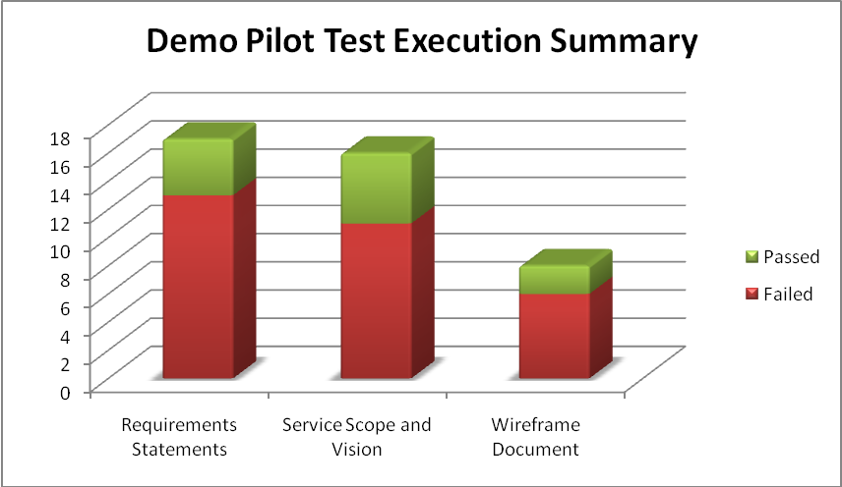

Artifacts | Failed | Fail % | Passed | Pass % | Total
Requirements Statements | 13 | 76% | 4 | 24% | 17
Service Scope and Vision | 11 | 69% | 5 | 31% | 16
Wireframe Document | 6 | 75% | 2 | 25% | 8
Total | 30 | 73% | 11 | 27% | 41

Defect Summary
The defect summary is:
ESD Defects Fixed for this Sprint | ESD Defects Closed in this Sprint | ESD Defects Re-opened in this Sprint
1 | 1 | 0

The defects for this sprint are attached below:
