
Center for Biomedical Informatics and Information Technology

caBIG® Clinical Information Suite
QA Test Summary Report
Sprint: RC3-I3-S2
January 18, 2011
Table of Contents

Summary 3
i. Code Validation 3
ii. Specification Validation 3
iii. Sprint Deliverables 3
Test Case Creation 5
Referral Management Business Capability 5
1. Referral Consult Service 6
2. Allergy Service 7
3. Common Artifact Test Cases 8
4. Other Services 10
Demonstration Pilot 11
Test Case Execution 12
Consolidated Test Execution Summary 12
Referral Management Business Capability 13
1. Referral Consult Service 14
Other Services 15
Demonstration Pilot 17
Defect Summary 18

Summary

Code Validation
  - ESD delivered RC3-I3-S2 ESD tag on January 4, 2011
  - The artifacts from the Architecture drop of RC2-I3 was used in this tag
  - The following were delivered in this tag:
    - 5 operations (createReferralOrder, withdrawReferralOrder , queryReferralOrderStatus, queryReferralResult and reviseReferralOrder) from Referral Consult Service
    - 1 operation (findProviderByExample) from Provider Registry service
    - 1 operation (findPatientByExample) from Patient Registry service
    - 1 operation (retrieveMedication) from Medication List service as a mock service
    - Demonstration Pilot
  - Regression testing was performed for all operations based on the Priority Levels:
    - All Level 1 and Level 2 test cases were executed
    - Certain L3 test cases were executed
    - All test cases affected by fixed defects and release notes were executed
  - All Release 3 in-scope screens for Demo Pilot were tested
  - Provider Registry deployment was blocked due to ESD-1878
  - 35 new defect was raised in this sprint

Specification Validation
- The specification/artifact documents for the following services were validated from the RC3-I2 drop
  - Referral Consult
  - Medication List
  - Document Exchange
  - Patient Registry
  - Provider Registry
  - Cancer Staging
  - Chemo and Treatment plan
- Demonstration Pilot specification artifacts were also validated
- 24 new defects were raised in this sprint

Sprint Deliverables
Test Summary Report
http://caehrorg.jira.com/svn/CACIS/trunk/documents/QA/Test_Reports/caBIGClinicalInformationSuite_RC3I3S2_Test_Summary_Report.doc
Test Cases
http://caehrorg.jira.com/svn/CACIS/trunk/documents/QA/Test_Cases/caBIGClinicalInformationSuite_TestCases_RC3I3S2.xls
Test Execution Report
http://caehrorg.jira.com/svn/CACIS/trunk/documents/QA/Test_Cases/caBIGClinicalInformationSuite_TestExecutionReport_RC3I3S2.mht
Soap Test Scripts
http://caehrorg.jira.com/svn/CACIS/trunk/documents/QA/soapUI_test_scripts/caBIGClinicalInformationSuite_RC3I3S2_TestScripts.zip

Test Case Creation

Referral Management Business Capability
Total test case distribution for this business capability
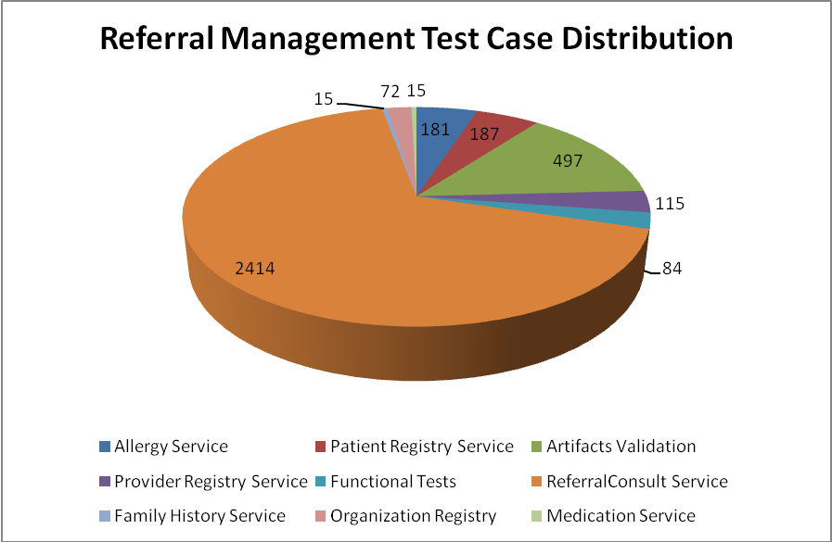
Service | Total
Allergy Service | 181
Artifacts Validation | 497
Patient Registry Service | 187
Provider Registry Service | 115
Referral Consult Service | 2414
Family History Service | 15
Org Registry | 72
Medication Service | 15
Functional Tests | 84
Total | 3580

Referral Consult Service
The test case distribution by category for this sprint is as follows:
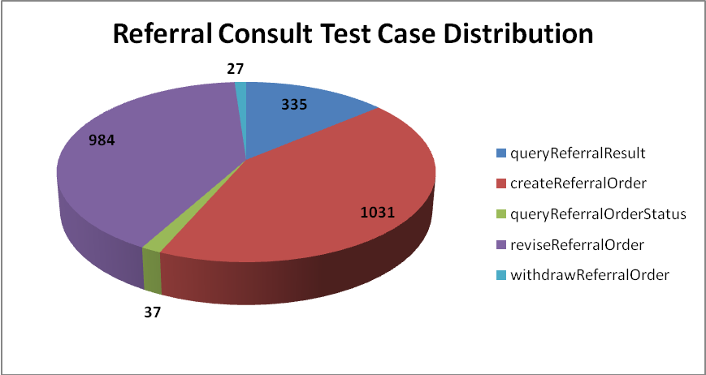
Operation | Cardinality | Does not exist | Invalid value | Multiple values | Null value | Valid value | Total
queryReferralResult | 46 | 43 | 91 |  | 108 | 47 | 335
createReferralOrder | 133 | 130 | 278 | 66 | 262 | 162 | 1031
queryReferralOrderStatus | 2 | 2 | 10 | 6 | 9 | 8 | 37
reviseReferralOrder | 128 | 131 | 264 | 26 | 274 | 161 | 984
withdrawReferralOrder | 2 | 2 | 9 |  | 8 | 6 | 27
Total | 311 | 308 | 652 | 98 | 661 | 384 | 2414

Allergy Service
The test case distribution by category for this sprint is as follows:
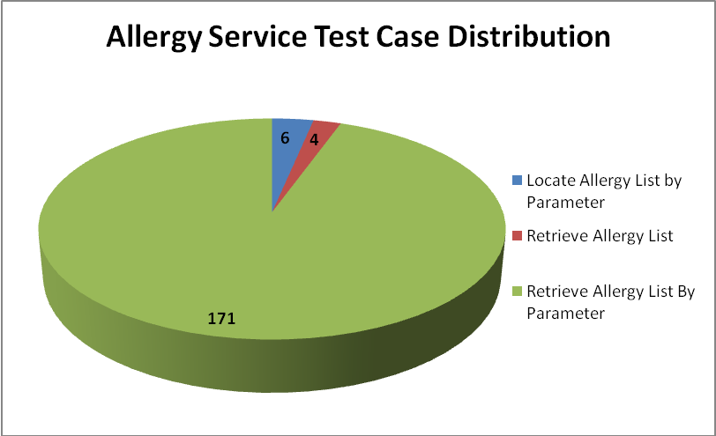
Operations | Cardinality | Does not exist | Invalid value | Multiple values | Null value | Valid value | Total
Locate Allergy List by Parameter |  |  | 3 |  |  | 3 | 6
Retrieve Allergy List |  |  | 2 |  |  | 2 | 4
Retrieve Allergy List By Parameter | 22 | 20 | 61 | 10 | 36 | 22 | 171
Total | 22 | 20 | 66 | 10 | 36 | 27 | 181

Common Artifact Test Cases
The test case distribution by artifacts for this sprint is as follows
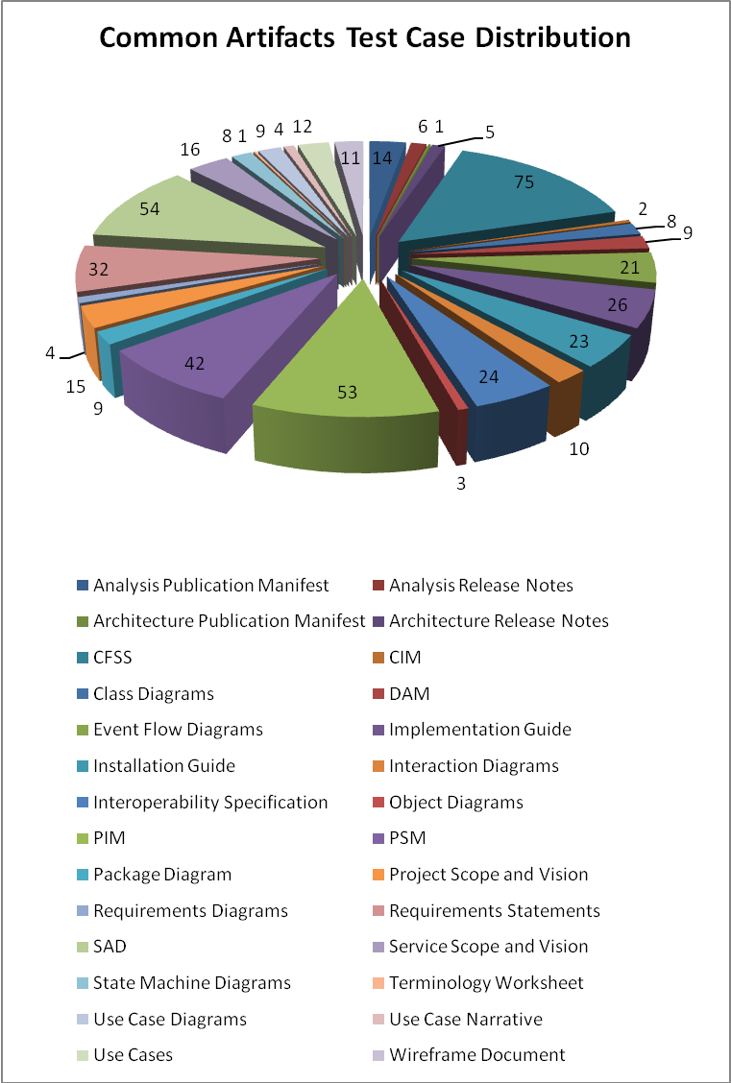

Artifacts | Count | Artifacts | Count
Analysis Publication Manifest | 14 | PIM | 53
Analysis Release Notes | 6 | PSM | 42
Architecture Publication Manifest | 1 | Package Diagram | 9
Architecture Release Notes | 5 | Project Scope and Vision | 15
CFSS | 75 | Requirements Diagrams | 4
CIM | 2 | Requirements Statements | 32
Class Diagrams | 8 | SAD | 54
DAM | 9 | Service Scope and Vision | 16
Event Flow Diagrams | 21 | State Machine Diagrams | 8
Implementation Guide | 26 | Terminology Worksheet | 1
Installation Guide | 23 | Use Case Diagrams | 9
Interaction Diagrams | 10 | Use Case Narrative | 4
Interoperability Specification | 24 | Use Cases | 12
Object Diagrams | 3 | Wireframe Document | 11
Total |  |  | 497

Other Services
Test case distribution for other services is as follows
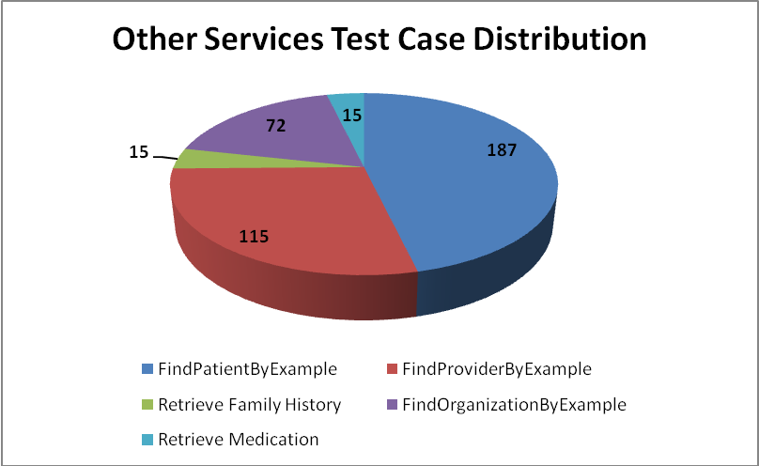
Service | Total
Patient Registry
FindPatientByExample | 187
Provider Registry
FindProviderByExample | 115
Family History Service
Retrieve Family History | 15
Organization Registry
FindOrganizationByExample | 72
Medication Service
Retrieve Medication | 15
Total | 404

Demonstration Pilot
Test case distribution is as follows
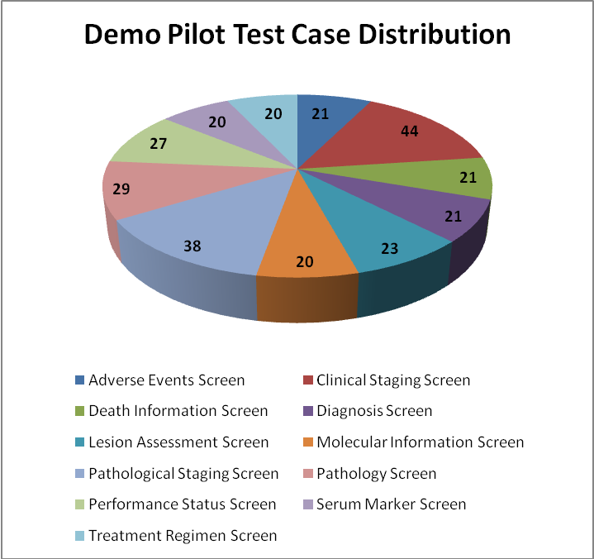
Sections | Total
Adverse Events Screen | 21
Clinical Staging Screen | 44
Death Information Screen | 21
Diagnosis Screen | 21
Lesion Assessment Screen | 23
Molecular Information Screen | 20
Pathological Staging Screen | 38
Pathology Screen | 29
Performance Status Screen | 27
Serum Marker Screen | 20
Treatment Regimen Screen | 20
Total | 284

Test Case Execution

Consolidated Test Execution Summary
The overall test execution summary for this sprint:
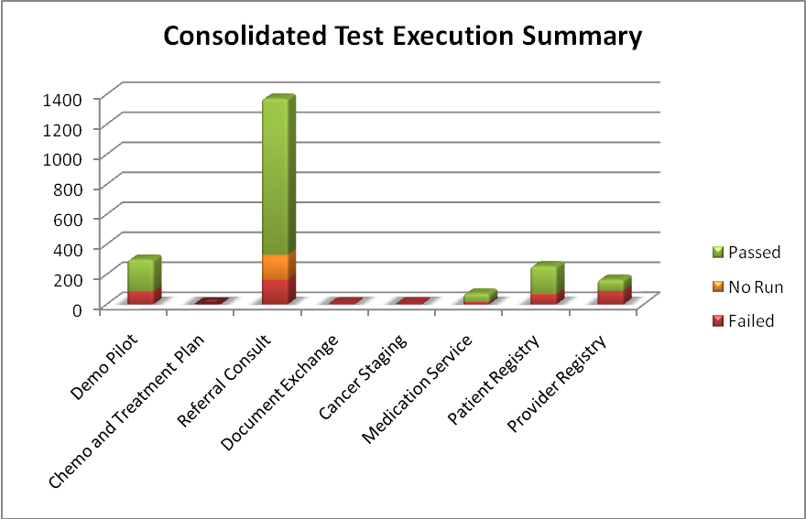
Services | Failed | Fail % | No Run | No Run % | Passed | Pass % | Total
Demo Pilot | 86 | 29% |  | 0% | 212 | 71% | 298
Chemo and Treatment Plan | 1 | 100% |  | 0% |  | 0% | 1
Referral Consult | 163 | 12% | 167 | 12% | 1041 | 76% | 1371
Document Exchange | 3 | 100% |  | 0% |  | 0% | 3
Cancer Staging | 3 | 100% |  | 0% |  | 0% | 3
Medication Service | 16 | 23% |  | 0% | 55 | 77% | 71
Patient Registry | 68 | 27% | 2 | 1% | 184 | 72% | 254
Provider Registry | 89 | 54% |  | 0% | 75 | 46% | 164
Total | 429 | 20% | 169 | 8% | 1567 | 72% | 2165

Referral Management Business Capability
The test execution summary for this business capability:
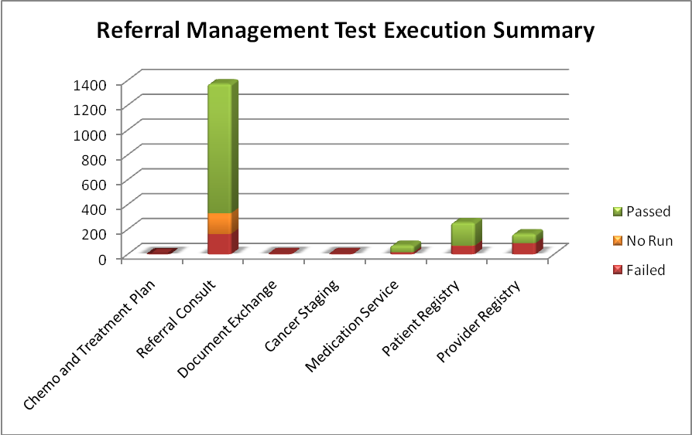
Services | Failed | Fail % | No Run | No Run % | Passed | Pass % | Total
Chemo and Treatment Plan | 1 | 100% |  | 0% |  | 0% | 1
Referral Consult | 163 | 12% | 167 | 12% | 1041 | 76% | 1371
Document Exchange | 3 | 100% |  | 0% |  | 0% | 3
Cancer Staging | 3 | 100% |  | 0% |  | 0% | 3
Medication Service | 16 | 23% |  | 0% | 55 | 77% | 71
Patient Registry | 68 | 27% | 2 | 1% | 184 | 72% | 254
Provider Registry | 89 | 54% |  | 0% | 75 | 46% | 164
Total | 343 | 18% | 169 | 9% | 1355 | 73% | 1867

Referral Consult Service
The test execution summary for this service is:
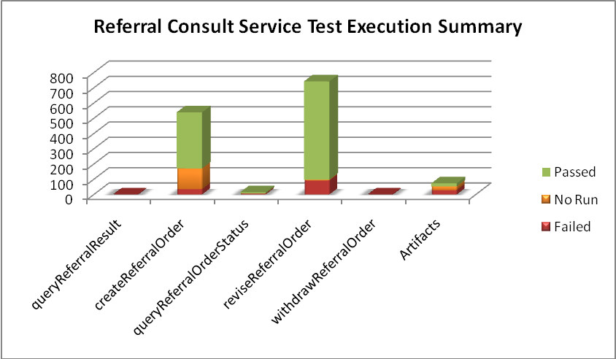
Sections | Failed | Fail % | No Run | No Run % | Pass | Pass % | Total
Code Validation
queryReferralResult | 1 | 100% |  | 0% |  | 0% | 1
createReferralOrder | 35 | 6% | 136 | 25% | 368 | 68% | 539
queryReferralOrderStatus | 6 | 40% | 1 | 7% | 8 | 53% | 15
reviseReferralOrder | 92 | 12% | 5 | 1% | 645 | 87% | 742
withdrawReferralOrder | 1 | 100% |  | 0% |  | 0% | 1
Sub-Total | 135 | 10% | 142 | 11% | 1021 | 79% | 1298
ArtifactsValidation
Analysis Publication Manifest | 8 | 57% |  | 0% | 6 | 43% | 14
Analysis Release Notes | 2 | 33% |  | 0% | 4 | 67% | 6
Class Diagrams | 6 | 75% |  | 0% | 2 | 25% | 8
DAM | 4 | 44% |  | 0% | 5 | 56% | 9
Event Flow Diagrams | 2 | 100% |  | 0% |  | 0% | 2
Implementation Guide | 1 | 4% | 25 | 96% |  | 0% | 26
Requirements Statements | 4 | 100% |  | 0% |  | 0% | 4
Use Case Narrative | 1 | 25% |  | 0% | 3 | 75% | 4
Sub-Total | 28 | 38% | 25 | 34% | 20 | 27% | 73
Total | 163 | 12% | 167 | 12% | 1041 | 76% | 1371

Other Services
The test execution summary for this service is:
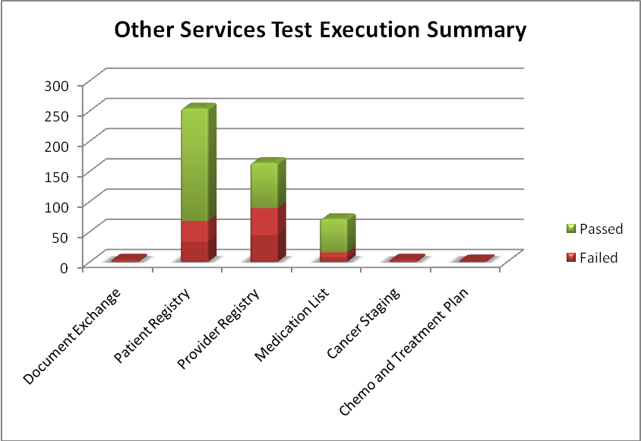
Services | Failed | Fail % | Passed | Pass % | Total
Document Exchange
CIM | 2 | 100% |  |  | 2
PIM | 1 | 100% |  |  | 1
Sub-Total | 3 | 100% |  |  | 3
Patient Registry
findPatientByExample | 57 | 31% | 129 | 69% | 186
Implementation Guide | 2 | 8% | 24 | 92% | 26
PSM | 9 | 21% | 33 | 79% | 42
Sub-Total | 68 | 27% | 186 | 73% | 254
Provider Registry
findProviderByExample | 86 | 75% | 29 | 25% | 115
Implementation Guide | 3 | 12% | 23 | 88% | 26
Installation Guide |  | 0% | 23 | 100% | 23
Sub-Total | 89 | 54% | 75 | 46% | 164
Medication List
retrieveMedication | 1 |  | 2 |  | 3
Implementation Guide | 4 | 15% | 22 | 85% | 26
PSM | 11 | 26% | 31 | 74% | 42
Sub-Total | 16 | 23% | 55 | 77% | 71
Cancer Staging
Event Flow Diagrams | 3 | 100% |  |  | 3
Chemo and Treatment Plan
Analysis Publication Manifest | 1 | 100% |  |  | 1
Total | 180 | 36% | 316 | 64% | 496

Demonstration Pilot
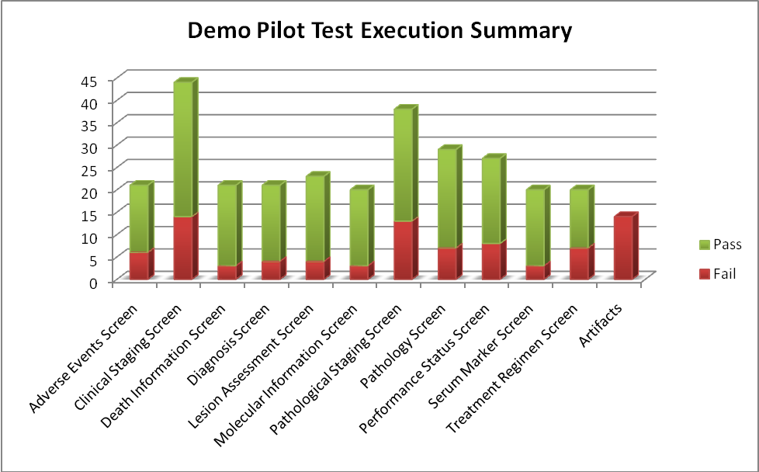
Sections | Fail | Pass | Total
Screens
Adverse Events Screen | 6 | 15 | 21
Clinical Staging Screen | 14 | 30 | 44
Death Information Screen | 3 | 18 | 21
Diagnosis Screen | 4 | 17 | 21
Lesion Assessment Screen | 4 | 19 | 23
Molecular Information Screen | 3 | 17 | 20
Pathological Staging Screen | 13 | 25 | 38
Pathology Screen | 7 | 22 | 29
Performance Status Screen | 8 | 19 | 27
Serum Marker Screen | 3 | 17 | 20
Treatment Regimen Screen | 7 | 13 | 20
Sub-Total | 72 | 212 | 284
Artifacts
Requirements Statements | 11 |  | 11
Wireframe Document | 3 |  | 3
Sub-Total | 14 |  | 14
Total | 86 | 212 | 298

Defect Summary
The defect summary is:
ESD Defects Fixed for this Sprint | ESD Defects Closed in this Sprint | ESD Defects Re-opened in this Sprint
1 | 1 | 0

The defects for this sprint are attached below:
