
Center for Biomedical Informatics and Information Technology

caBIG® Clinical Information Suite
QA Test Summary Report
Sprint: RC3-I3-S3
February 8, 2011
Table of Contents

Summary 3
i. Code Validation 3
ii. Specification Validation 3
iii. Sprint Deliverables 3
Test Case Creation 5
Referral Management Business Capability 5
1. Referral Consult Service 6
2. Allergy Service 7
3. Common Artifact Test Cases 8
4. Other Services 10
Demonstration Pilot 11
Test Case Execution 12
Consolidated Test Execution Summary 12
Referral Management Business Capability 13
1. Referral Consult Service 14
2. Patient Registry Service 15
3. Provider Registry 16
4. Family History Service 17
5. Medication List Service 18
6. Other Services 19
Demonstration Pilot 20
Defect Summary 21

Summary

Code Validation
  - ESD delivered
    - RC3-I3-S2 ESD tag on Jan 19, 2011
    - RC3-I3-S3 ESD tag on Feb 2, 2011
  - The artifacts from the Architecture drop of RC2-I3 was used in this tag
  - The following were delivered in the tags:
    - 6 operations (createReferralOrder, withdrawReferralOrder , queryReferralOrderStatus, queryReferralResult , queryReferralOrder and reviseReferralOrder) from Referral Consult Service
    - 1 operation (findProviderByExample) from Provider Registry service
    - 1 operation (findPatientByExample) from Patient Registry service
    - 1 mock service (retrieveMedication) from Medication List service
    - 1 mock service (retrieveFamilyHistory) from Family History service
    - Demonstration Pilot Export Functionality
  - Regression testing was performed for all operations based on the Priority Levels:
    - All Level 1 and Level 2 test cases were executed
    - Certain L3 test cases were executed
    - All test cases affected by fixed defects and release notes were executed
  - All Release 3 in-scope screens for Demo Pilot were tested
  - 45 new defect was raised in this sprint

Specification Validation
- The specification/artifact documents for the following services were validated from the RC3-I2 drop
  - Referral Consult
  - Allergy
  - Medication List
  - Family History
  - Immunization
  - Document Exchange
  - Patient Registry
  - Provider Registry
- Demonstration Pilot specification artifacts were also validated
- 24 new defects were raised in this sprint

Sprint Deliverables
Test Summary Report
http://caehrorg.jira.com/svn/CACIS/trunk/documents/QA/Test_Reports/caBIGClinicalInformationSuite_RC3I3S3_Test_Summary_Report.doc
Test Cases
http://caehrorg.jira.com/svn/CACIS/trunk/documents/QA/Test_Cases/caBIGClinicalInformationSuite_TestCases_RC3I3S3.xls
Test Execution Report
http://caehrorg.jira.com/svn/CACIS/trunk/documents/QA/Test_Cases/caBIGClinicalInformationSuite_TestExecutionReport_RC3I3S3.mht
Soap Test Scripts
http://caehrorg.jira.com/svn/CACIS/trunk/documents/QA/soapUI_test_scripts/caBIGClinicalInformationSuite_RC3I3S3_TestScripts.zip

Test Case Creation

Referral Management Business Capability
Total test case distribution for this business capability
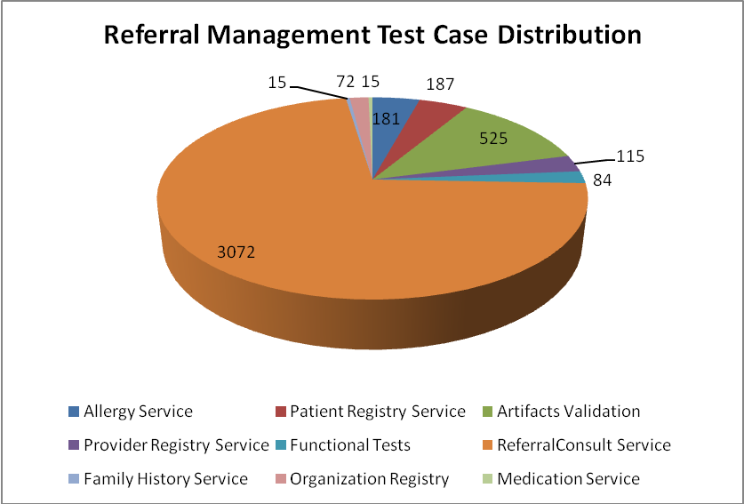
Service | Total
Allergy Service | 181
Artifacts Validation | 525
Patient Registry Service | 187
Provider Registry Service | 115
Referral Consult Service | 2988
Family History Service | 15
Org Registry | 72
Medication Service | 15
Functional Tests | 84
Total | 4266

Referral Consult Service
The test case distribution by category for this sprint is as follows:
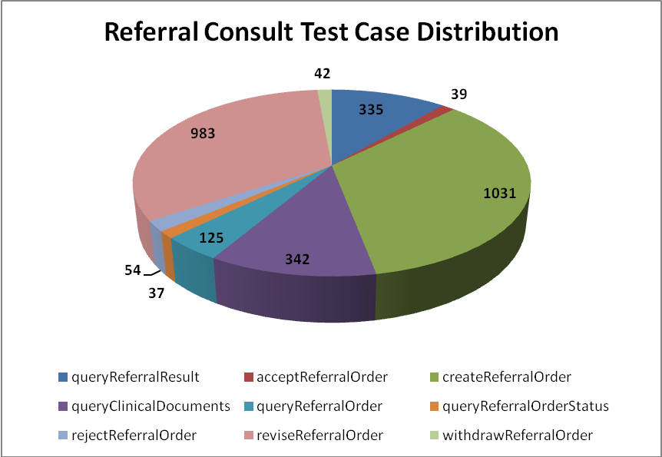
Operation | Cardinality | Does not exist | Invalid value | Multiple values | Null value | Valid value | Total
ReferredTo Profile
queryReferralResult | 46 | 43 | 91 |  | 108 | 47 | 335
createReferralOrder | 133 | 130 | 278 | 66 | 262 | 162 | 1031
queryReferralOrder | 15 | 14 | 38 |  | 36 | 22 | 125
queryReferralOrderStatus | 2 | 2 | 10 | 6 | 9 | 8 | 37
reviseReferralOrder | 128 | 131 | 263 | 26 | 274 | 161 | 983
withdrawReferralOrder | 3 | 3 | 14 |  | 15 | 7 | 42
Sub-Total | 327 | 323 | 694 | 98 | 704 | 407 | 2553
ReferredFrom Profile
acceptReferralOrder | 2 | 2 | 15 |  | 13 | 7 | 39
rejectReferralOrder | 3 | 3 | 20 |  | 20 | 8 | 54
queryClinicalDocuments | 45 | 42 | 94 |  | 115 | 46 | 342
Sub-Total | 50 | 47 | 129 | 0 | 148 | 61 | 435
Total | 377 | 370 | 823 | 98 | 852 | 468 | 2988

Allergy Service
The test case distribution by category for this sprint is as follows:
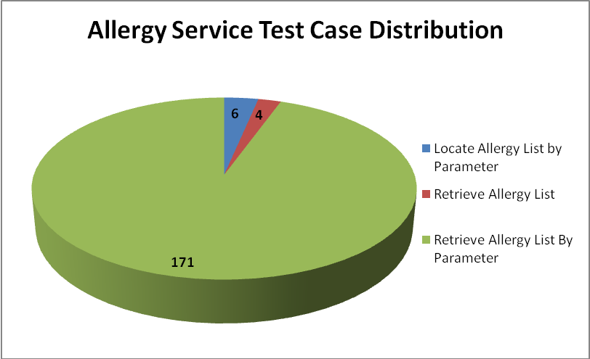
Operations | Cardinality | Does not exist | Invalid value | Multiple values | Null value | Valid value | Total
Locate Allergy List by Parameter |  |  | 3 |  |  | 3 | 6
Retrieve Allergy List |  |  | 2 |  |  | 2 | 4
Retrieve Allergy List By Parameter | 22 | 20 | 61 | 10 | 36 | 22 | 171
Total | 22 | 20 | 66 | 10 | 36 | 27 | 181

Common Artifact Test Cases
The test case distribution by artifacts for this sprint is as follows
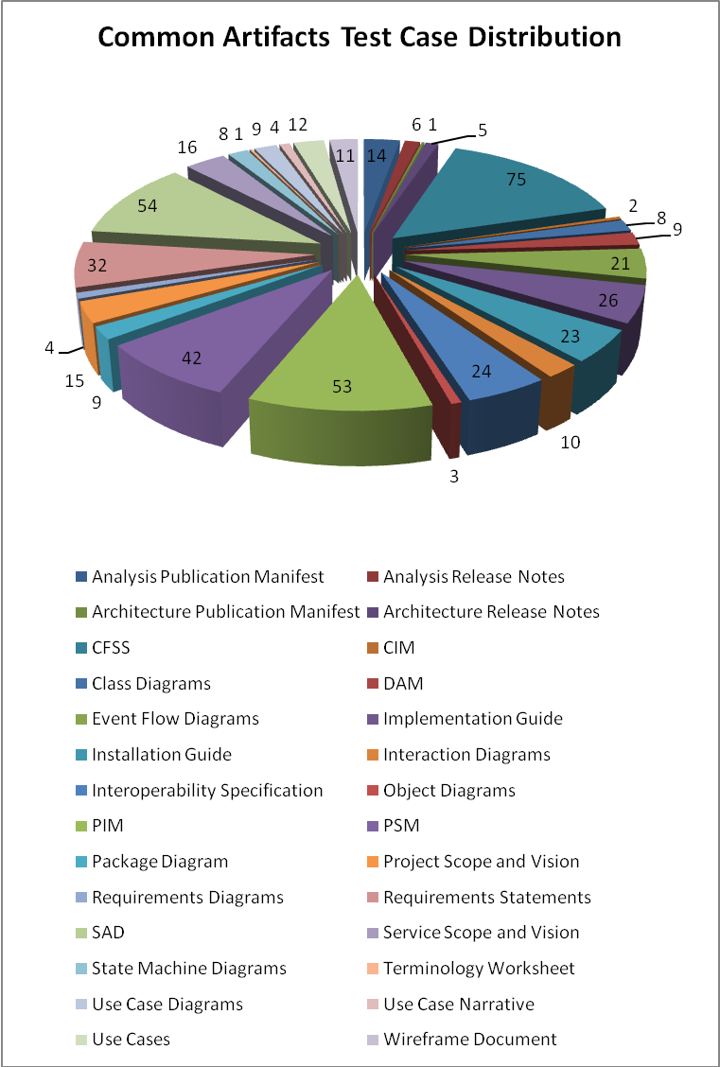

Artifacts | Count | Artifacts | Count
Analysis Publication Manifest | 16 | PIM | 53
Analysis Release Notes | 7 | PSM | 42
Architecture Publication Manifest | 3 | Package Diagram | 9
Architecture Release Notes | 5 | Project Scope and Vision | 15
CFSS | 74 | Requirements Diagrams | 4
CIM | 2 | Requirements Statements | 31
Class Diagrams | 10 | SAD | 54
DAM | 9 | Service Scope and Vision | 16
Design Specification Document | 17 | State Machine Diagrams | 8
Event Flow Diagrams | 21 | Terminology Worksheet | 1
Implementation Guide | 26 | Use Case Diagrams | 10
Installation Guide | 23 | Use Case Narrative | 4
Interaction Diagrams | 10 | Use Cases | 12
Interoperability Specification | 24 | Wireframe Document | 15
Object Diagrams | 4
Total |  |  | 525

Other Services
Test case distribution for other services is as follows
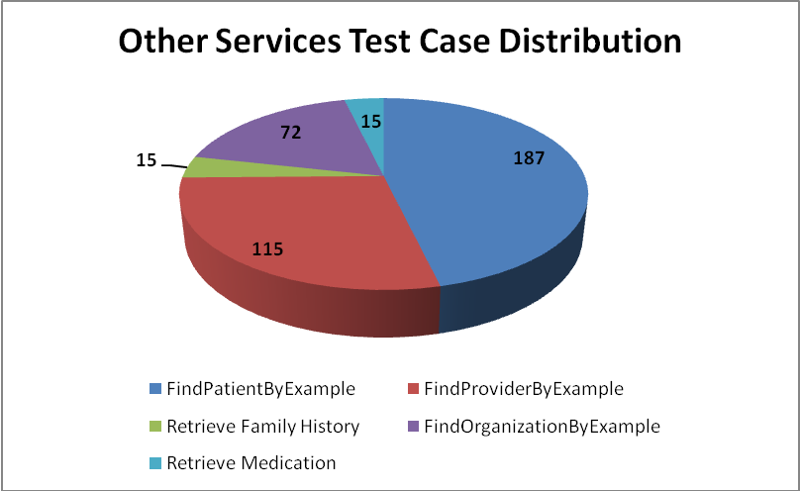
Service | Total
Patient Registry
FindPatientByExample | 187
Provider Registry
FindProviderByExample | 115
Family History Service
Retrieve Family History | 15
Organization Registry
FindOrganizationByExample | 72
Medication Service
Retrieve Medication | 15
Total | 404

Demonstration Pilot
Test case distribution is as follows
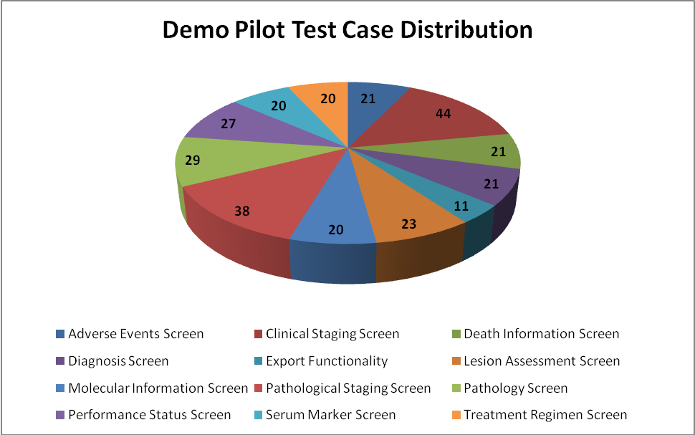
Sections | Total
Adverse Events Screen | 21
Clinical Staging Screen | 44
Death Information Screen | 21
Diagnosis Screen | 21
Export Functionality | 11
Lesion Assessment Screen | 23
Molecular Information Screen | 20
Pathological Staging Screen | 38
Pathology Screen | 29
Performance Status Screen | 27
Serum Marker Screen | 20
Treatment Regimen Screen | 20
Total | 295

Test Case Execution

Consolidated Test Execution Summary
The overall test execution summary for this sprint:
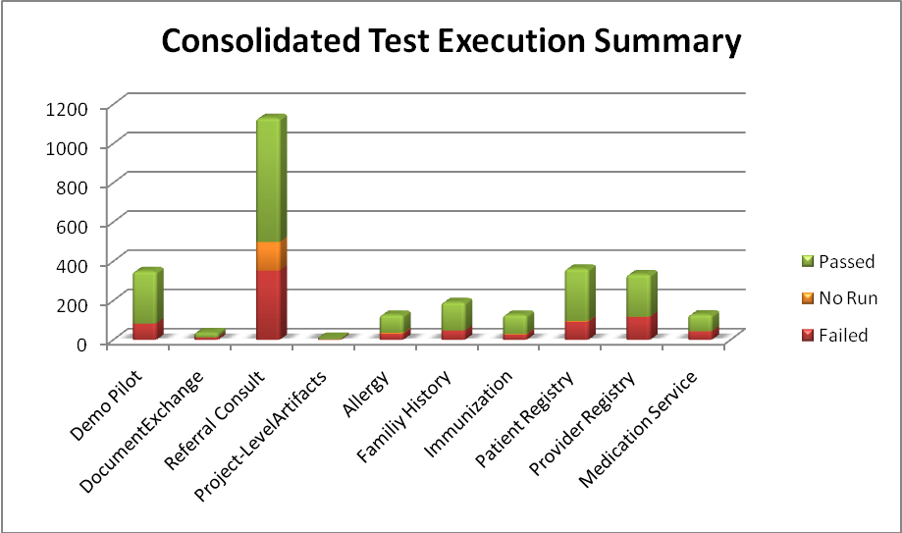
Services | Failed | Fail % | No Run | No Run % | Passed | Pass % | Total
Demo Pilot | 83 | 24% |  |  | 266 | 76% | 349
DocumentExchange | 13 | 36% |  |  | 23 | 64% | 36
Referral Consult | 353 | 31% | 146 | 13% | 631 | 56% | 1130
Project-LevelArtifacts | 3 | 38% |  |  | 5 | 63% | 8
Allergy | 30 | 24% | 6 | 5% | 91 | 72% | 127
Familiy History | 47 | 25% |  |  | 144 | 75% | 191
Immunization | 26 | 20% | 4 | 3% | 97 | 76% | 127
Patient Registry | 92 | 25% | 4 | 1% | 266 | 73% | 362
Provider Registry | 117 | 35% | 1 | 0% | 215 | 65% | 333
Medication Service | 43 | 34% | 1 | 1% | 84 | 66% | 128
Total | 807 | 29% | 162 | 6% | 1822 | 65% | 2791

Referral Management Business Capability
The test execution summary for this business capability:
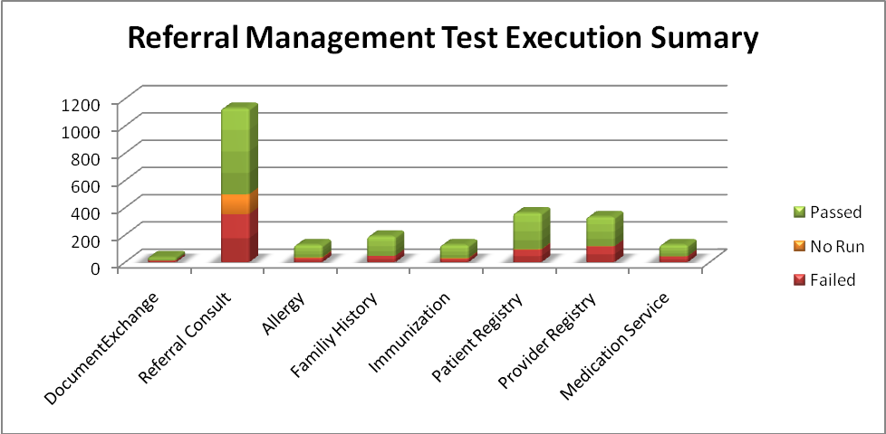
Services | Failed | Fail % | No Run | No Run % | Passed | Pass % | Total
DocumentExchange | 13 | 36% |  |  | 23 | 64% | 36
Referral Consult | 353 | 31% | 146 | 13% | 631 | 56% | 1130
Allergy | 30 | 24% | 6 | 5% | 91 | 72% | 127
Familiy History | 47 | 25% |  |  | 144 | 75% | 191
Immunization | 26 | 20% | 4 | 3% | 97 | 76% | 127
Patient Registry | 92 | 25% | 4 | 1% | 266 | 73% | 362
Provider Registry | 117 | 35% | 1 | 0% | 215 | 65% | 333
Medication Service | 43 | 34% | 1 | 1% | 84 | 66% | 128
Total | 721 | 30% | 162 | 7% | 1551 | 64% | 2434

Referral Consult Service
The test execution summary for this service is:
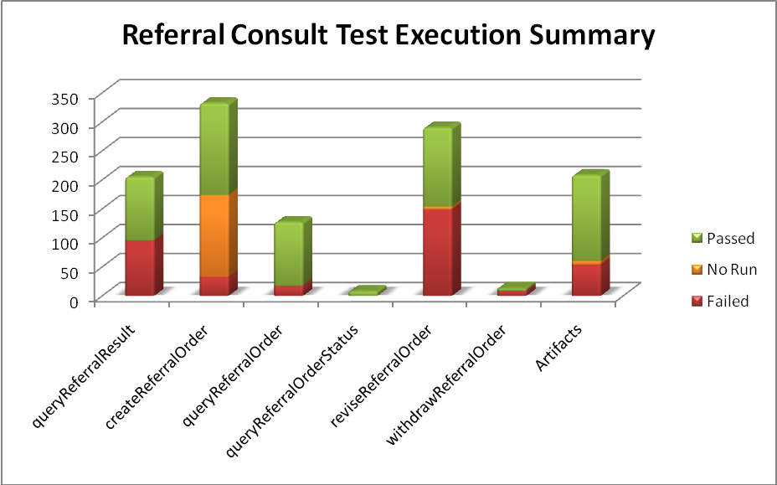
Section | Failed | Fail % | No Run | No Run % | Passed | Pass % | Total
Operations
queryReferralResult | 96 | 47% |  |  | 109 | 53% | 205
createReferralOrder | 33 | 10% | 141 | 42% | 158 | 48% | 332
queryReferralOrder | 18 | 14% |  |  | 109 | 86% | 127
queryReferralOrderStatus |  |  |  |  | 8 | 100% | 8
reviseReferralOrder | 149 | 51% | 5 | 2% | 136 | 47% | 290
withdrawReferralOrder | 9 | 69% |  |  | 4 | 31% | 13
Sub-total | 305 | 31% | 146 | 15% | 524 | 54% | 975
Artifacts
Analysis Publication Manifest | 7 | 44% |  |  | 9 | 56% | 16
Analysis Release Notes |  |  |  |  | 6 | 100% | 6
CIM |  |  |  |  | 2 | 100% | 2
Event Flow Diagrams | 6 | 29% |  |  | 15 | 71% | 21
Implementation Guide | 1 | 4% |  |  | 25 | 96% | 26
Interaction Diagrams | 7 | 70% |  |  | 3 | 30% | 10
PIM | 6 | 11% | 6 | 11% | 41 | 77% | 53
PSM | 2 | 5% |  |  | 40 | 95% | 42
Requirements Statements | 25 | 78% |  |  | 7 | 22% | 32
Sub-total | 54 | 26% | 6 | 3% | 148 | 71% | 208
Total | 359 | 30% | 152 | 13% | 672 | 57% | 1183

Patient Registry Service
The test execution summary for this service is:
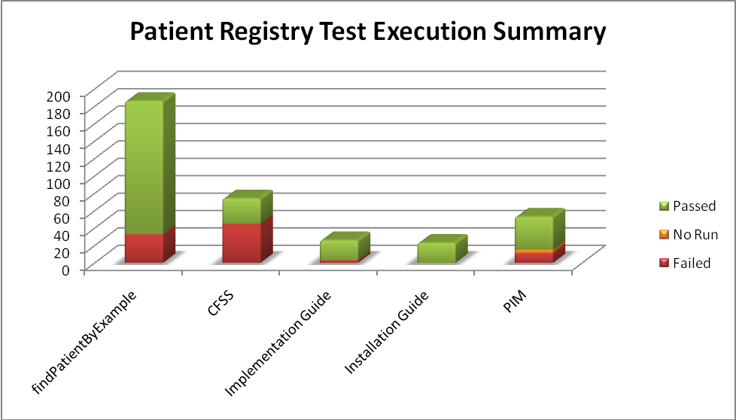
Section | Failed | Fail % | No Run | No Run % | Passed | Pass % | Total
Operation
findPatientByExample | 33 | 18% |  |  | 153 | 82% | 186
Artifacts
CFSS | 45 | 61% |  |  | 29 | 39% | 74
Implementation Guide | 3 | 12% |  |  | 23 | 88% | 26
Installation Guide |  |  |  |  | 23 | 100% | 23
PIM | 11 | 21% | 4 | 8% | 38 | 72% | 53
Sub-total | 59 | 34% | 4 |  | 113 | 64% | 176
Total | 92 | 25% | 4 | 1% | 266 | 73% | 362

Provider Registry
The test execution summary for this service is
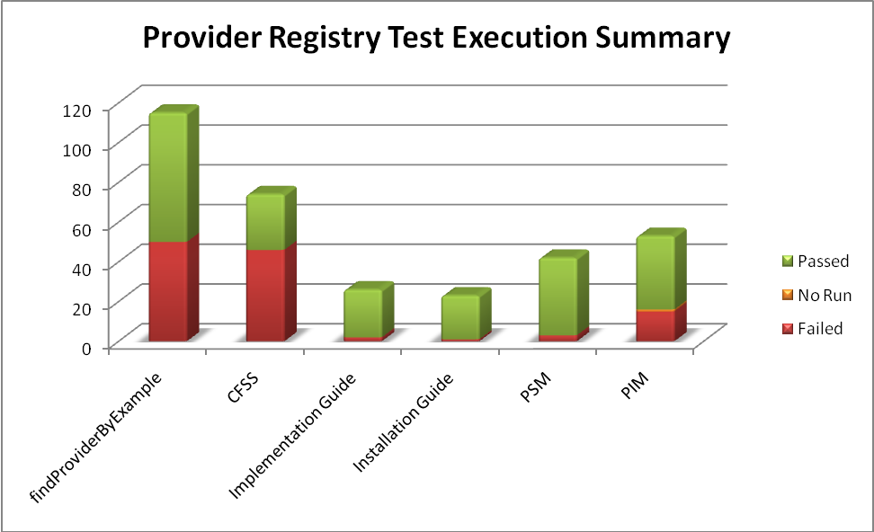
Section | Failed | Fail % | No Run | No Run % | Passed | Pass % | Total
Operation
findProviderByExample | 50 | 43% |  |  | 65 | 57% | 115
Artifacts
CFSS | 46 | 62% |  |  | 28 | 38% | 74
Implementation Guide | 2 | 8% |  |  | 24 | 92% | 26
Installation Guide | 1 | 4% |  |  | 22 | 96% | 23
PSM | 3 | 7% |  |  | 39 | 93% | 42
PIM | 15 | 28% | 1 | 2% | 37 | 70% | 53
Sub-total | 67 | 31% | 1 | 0% | 150 | 69% | 218
Total | 117 | 35% | 1 | 0% | 215 | 65% | 333

Family History Service
The test execution summary for this service is
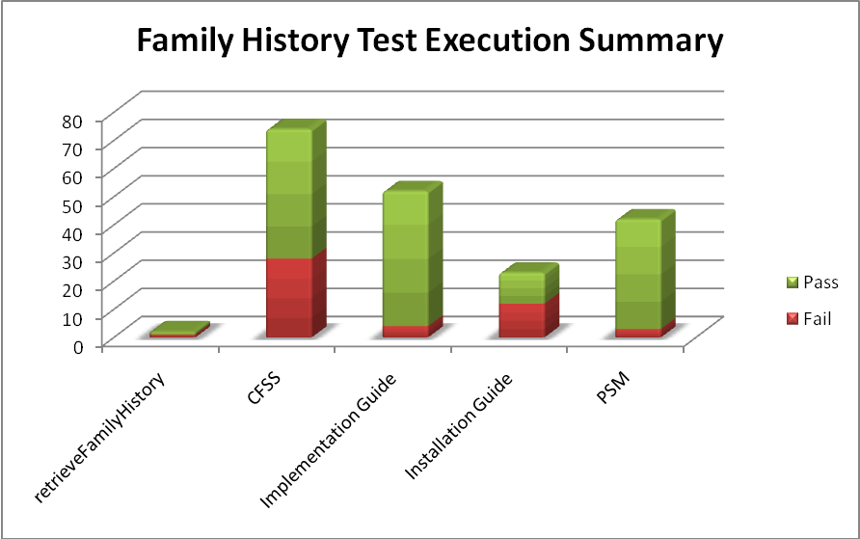
Section | Failed | Fail % | No Run | No Run % | Passed | Pass % | Total
Operation
retrieveFamilyHistory | 1 | 1% |  |  | 1 | 1% | 115
Artifacts
CFSS | 28 | 38% |  |  | 46 | 62% | 74
Implementation Guide | 4 | 15% |  |  | 48 | 185% | 26
Installation Guide | 12 | 52% |  |  | 11 | 48% | 23
PSM | 3 | 7% |  |  | 39 | 93% | 42
Sub-total | 47 | 28% |  |  | 144 | 87% | 165
Total | 48 | 17% |  |  | 145 | 52% | 280

Medication List Service
The test execution summary for this service is:
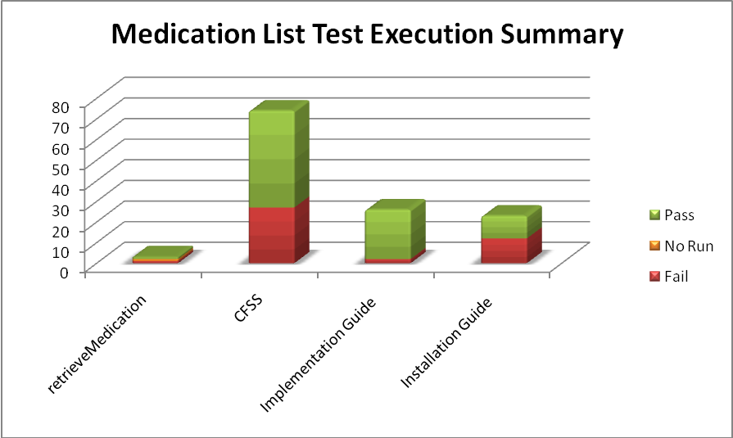
Section | Failed | Fail % | No Run | No Run % | Passed | Pass % | Total
Operation
retrieveMedication | 1 | 33% | 1 | 33% | 1 | 33% | 3
Artifacts
CFSS | 27 | 36% |  |  | 47 | 64% | 74
Implementation Guide | 2 | 8% |  |  | 24 | 92% | 26
Installation Guide | 12 | 52% |  |  | 11 | 48% | 23
Sub-total | 41 | 33% |  |  | 82 | 67% | 123
Total | 42 | 33% | 1 | 1% | 83 | 66% | 126

Other Services
The test execution summary for this service is:
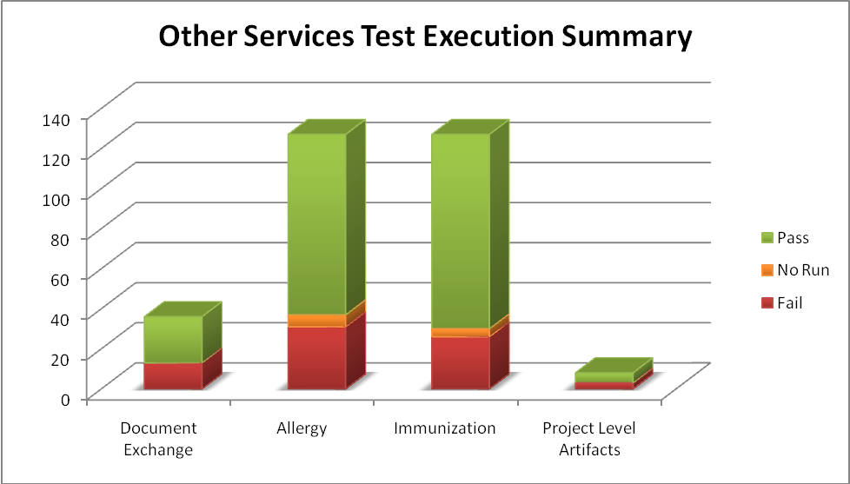
Service | Failed | Fail % | No Run | No Run % | Passed | Pass % | Total
Document Exchange
Analysis Publication Manifest | 4 | 25% |  |  | 12 | 75% | 16
Analysis Release Notes | 1 | 17% |  |  | 5 | 83% | 6
Object Diagrams | 2 | 50% |  |  | 2 | 50% | 4
Class Diagrams | 6 | 60% |  |  | 4 | 40% | 10
Sub-total | 13 | 36% |  |  | 23 | 64% | 36
Allergy
CFSS - Allergy | 20 | 27% |  |  | 54 | 73% | 74
PIM - Allergy | 11 | 21% | 6 | 11% | 36 | 68% | 53
Sub-total | 31 | 24% | 6 | 5% | 90 | 71% | 127
Immunization
CFSS - Immunization | 20 | 27% |  |  | 54 | 73% | 74
PIM - Immunization | 6 | 11% | 4 | 8% | 43 | 81% | 53
Sub-total | 26 | 20% | 4 | 3% | 97 | 76% | 127
Project Level Artifacts
Architecture Publication Manifest | 3 | 100% |  |  |  |  | 3
Architecture Release Notes |  |  |  |  | 5 | 100% | 5
Sub-total | 3 | 38% |  |  | 5 | 63% | 8
Total | 365 | 30% | 15 | 1% | 835 | 69% | 1215

Demonstration Pilot
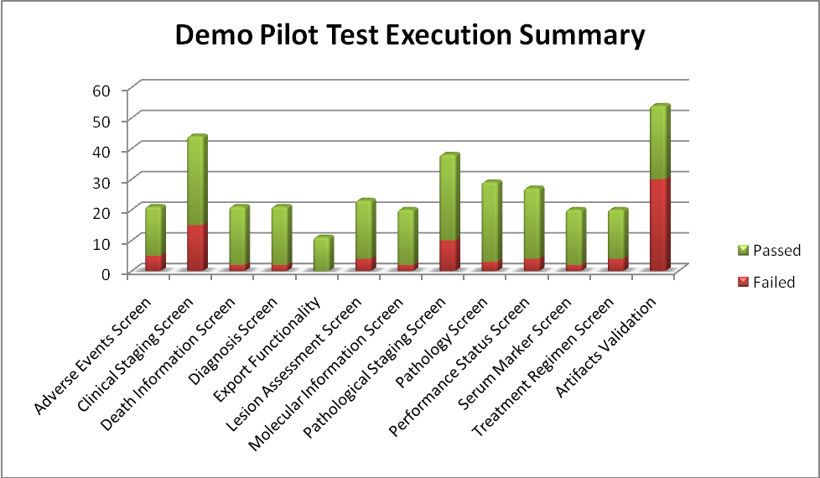
Section | Failed | Passed | Total
Screens
Adverse Events Screen | 5 | 16 | 21
Clinical Staging Screen | 15 | 29 | 44
Death Information Screen | 2 | 19 | 21
Diagnosis Screen | 2 | 19 | 21
Export Functionality |  | 11 | 11
Lesion Assessment Screen | 4 | 19 | 23
Molecular Information Screen | 2 | 18 | 20
Pathological Staging Screen | 10 | 28 | 38
Pathology Screen | 3 | 26 | 29
Performance Status Screen | 4 | 23 | 27
Serum Marker Screen | 2 | 18 | 20
Treatment Regimen Screen | 4 | 16 | 20
Sub Total | 53 | 242 | 295
Artifacts
Analysis Publication Manifest | 9 | 7 | 16
Analysis Release Notes | 1 | 6 | 7
Class Diagrams | 5 | 5 | 10
Design Specification Document | 12 | 5 | 17
Object Diagrams | 3 | 1 | 4
Sub Total | 30 | 24 | 54
Total | 83 | 266 | 349

Defect Summary
The defect summary is:
ESD Defects Fixed for this Sprint | ESD Defects Closed in this Sprint | ESD Defects Re-opened in this Sprint
41 | 40 | 1

The defects for this sprint are attached below:
