
Center for Biomedical Informatics and Information Technology

caBIG® Clinical Information Suite
QA Test Summary Report
Sprint: RC4-I1-S1
March 8, 2011
Table of Contents

Summary 3
i. Code Validation 3
ii. Specification Validation 3
iii. Sprint Deliverables 3
Test Case Creation 5
Referral Management Business Capability 5
1. Referral Consult Service 6
2. Allergy Service 7
3. Common Artifact Test Cases 8
4. Other Services 10
Demonstration Pilot 11
Test Case Execution 12
Consolidated Test Execution Summary 12
Referral Management Business Capability 13
1. Referral Consult Service 14
2. Patient Registry Service 15
3. Provider Registry 16
4. Family History Service 17
5. Medication List Service 18
6. Other Services 19
Demonstration Pilot 20
Defect Summary 21

Summary

Code Validation
  - ESD delivered
    - RC4-I1-S1 ESD tag on Feb 10, 2011
    - RC4-I1-S2 ESD tag on Mar 1, 2011
  - The artifacts from the Architecture drop of RC2-I3 was used in this tag
  - The following were delivered in the tags:
    - 6 operations (createReferralOrder, withdrawReferralOrder , queryReferralOrderStatus, queryReferralResult , queryReferralOrder and reviseReferralOrder) from Referral Consult Service
    - 1 operation (findProviderByExample) from Provider Registry service
    - 1 operation (findPatientByExample) from Patient Registry service
    - 1 mock service (retrieveMedication) from Medication List service
    - 1 mock service (retrieveFamilyHistory) from Family History service
    - 6 operations (addOrganization, activateOrganization, findOrganization, findOrganizationByExample, inactivateOrganization and updateOrganization) from the Organization Registry Service
  - Regression testing was performed for all operations based on the Priority Levels:
    - All Level 1 and Level 2 test cases were executed
    - Certain L3 test cases were executed
    - All test cases affected by fixed defects and release notes were executed
  - 43 new defect was raised in this sprint

Specification Validation
- The specification/artifact documents were validated from the RC3-I3 drop
- 23 new defects were raised in this sprint

Sprint Deliverables
Test Summary Report
http://caehrorg.jira.com/svn/CACIS/trunk/documents/QA/Test_Reports/caBIGClinicalInformationSuite_RC4I1S1_Test_Summary_Report.doc
Test Cases
http://caehrorg.jira.com/svn/CACIS/trunk/documents/QA/Test_Cases/caBIGClinicalInformationSuite_TestCases_RC4I1S1.xls
Test Execution Report
http://caehrorg.jira.com/svn/CACIS/trunk/documents/QA/Test_Cases/caBIGClinicalInformationSuite_TestExecutionReport_RC4I1S1.mht
Soap Test Scripts
http://caehrorg.jira.com/svn/CACIS/trunk/documents/QA/soapUI_test_scripts/caBIGClinicalInformationSuite_RC4I1S1_TestScripts.zip

Test Case Creation

Referral Management Business Capability
Total test case distribution for this business capability
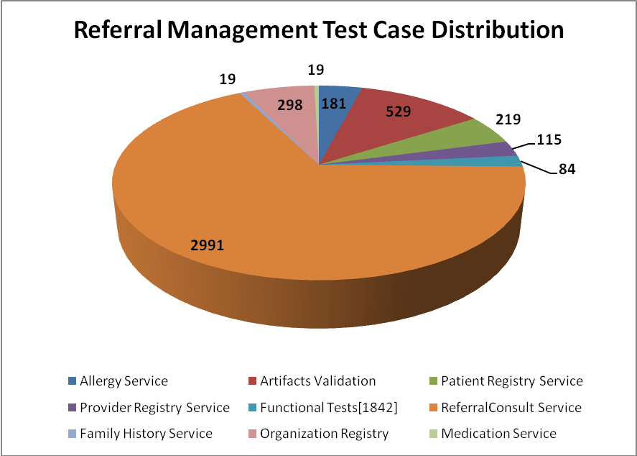
Service | Total
Allergy Service | 181
Artifacts Validation | 529
Patient Registry Service | 219
Provider Registry Service | 115
Referral Consult Service | 2991
Family History Service | 19
Org Registry | 298
Medication Service | 19
Functional Tests | 84
Total | 4455

Referral Consult Service
The test case distribution by category for this sprint is as follows:
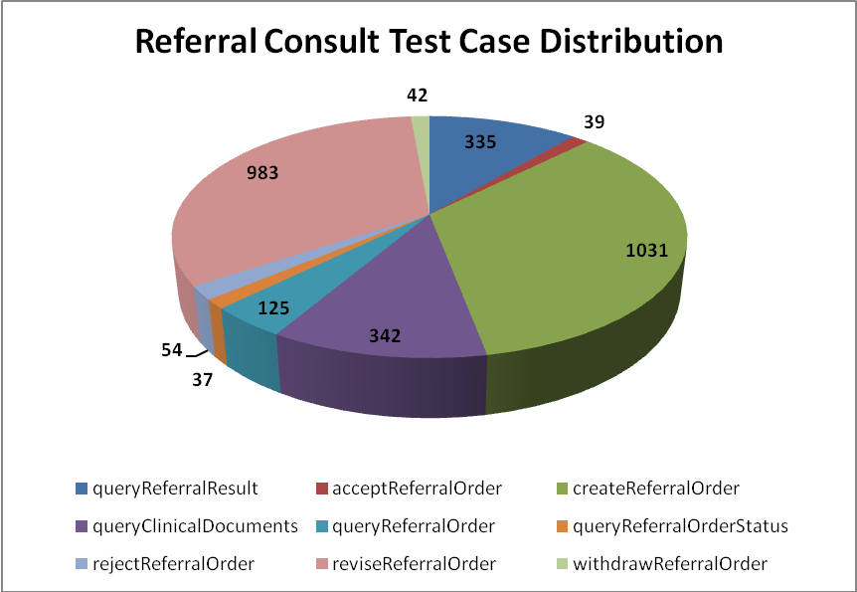
Operation | Cardinality | Does not exist | Invalid value | Multiple values | Null value | Valid value | Total
ReferredTo Profile
queryReferralResult | 46 | 43 | 91 |  | 108 | 47 | 335
createReferralOrder | 133 | 130 | 278 | 66 | 262 | 162 | 1031
queryReferralOrder | 15 | 14 | 38 |  | 36 | 22 | 125
queryReferralOrderStatus | 2 | 2 | 10 | 6 | 9 | 8 | 37
reviseReferralOrder | 128 | 131 | 263 | 26 | 274 | 161 | 983
withdrawReferralOrder | 3 | 3 | 16 |  | 17 | 6 | 45
Sub-Total | 327 | 323 | 696 | 98 | 706 | 406 | 2556
ReferredFrom Profile
acceptReferralOrder | 2 | 2 | 15 |  | 13 | 7 | 39
rejectReferralOrder | 3 | 3 | 20 |  | 20 | 8 | 54
queryClinicalDocuments | 45 | 42 | 94 |  | 115 | 46 | 342
Sub-Total | 50 | 47 | 129 | 0 | 148 | 61 | 435
Total | 377 | 370 | 825 | 98 | 854 | 467 | 2991

Allergy Service
The test case distribution by category for this sprint is as follows:
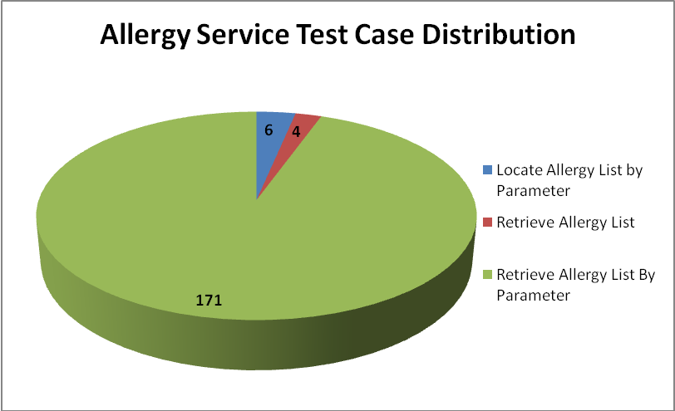
Operations | Cardinality | Does not exist | Invalid value | Multiple values | Null value | Valid value | Total
Locate Allergy List by Parameter |  |  | 3 |  |  | 3 | 6
Retrieve Allergy List |  |  | 2 |  |  | 2 | 4
Retrieve Allergy List By Parameter | 22 | 20 | 61 | 10 | 36 | 22 | 171
Total | 22 | 20 | 66 | 10 | 36 | 27 | 181

Common Artifact Test Cases
The test case distribution by artifacts for this sprint is as follows
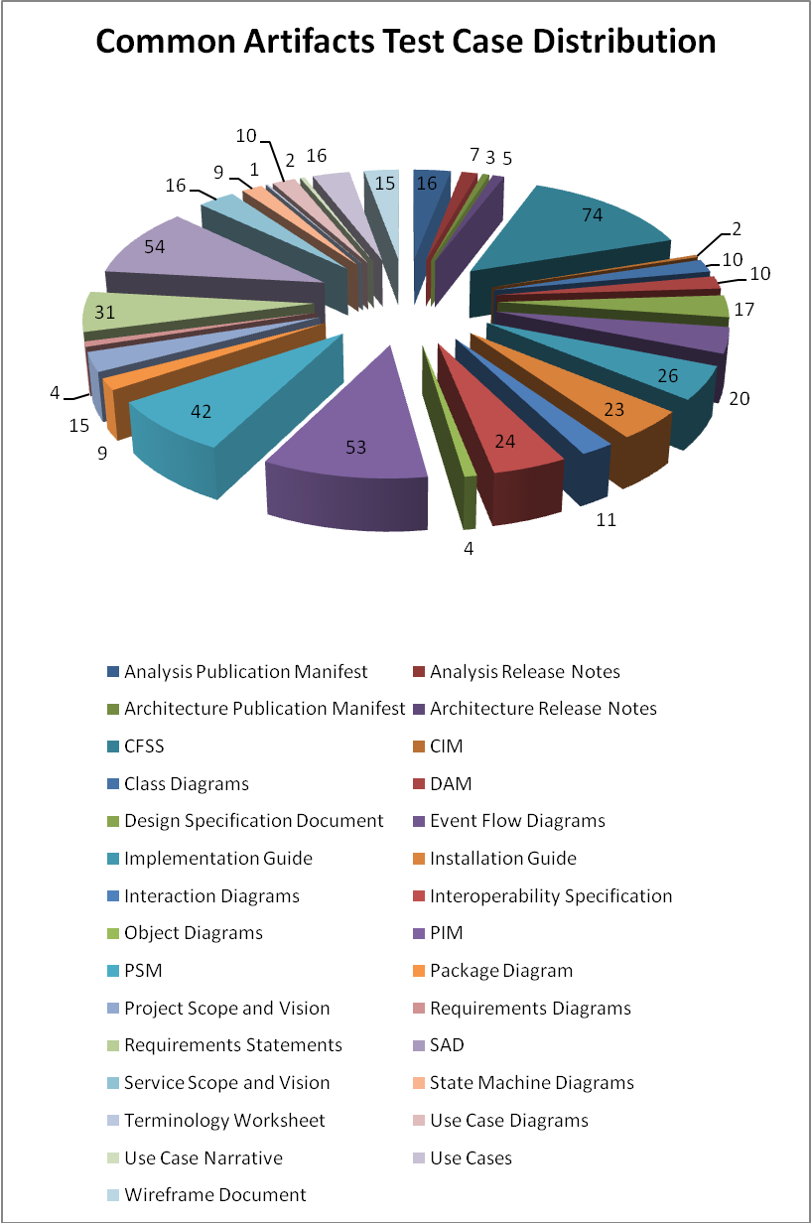

Artifacts | Count | Artifacts | Count
Analysis Publication Manifest | 16 | PIM | 53
Analysis Release Notes | 7 | PSM | 42
Architecture Publication Manifest | 3 | Package Diagram | 9
Architecture Release Notes | 5 | Project Scope and Vision | 15
CFSS | 74 | Requirements Diagrams | 4
CIM | 2 | Requirements Statements | 31
Class Diagrams | 10 | SAD | 54
DAM | 10 | Service Scope and Vision | 16
Design Specification Document | 17 | State Machine Diagrams | 9
Event Flow Diagrams | 20 | Terminology Worksheet | 1
Implementation Guide | 26 | Use Case Diagrams | 10
Installation Guide | 23 | Use Case Narrative | 2
Interaction Diagrams | 11 | Use Cases | 16
Interoperability Specification | 24 | Wireframe Document | 15
Object Diagrams | 4
Total |  |  | 529

Organization Registry
Test case distribution for other services is as follows
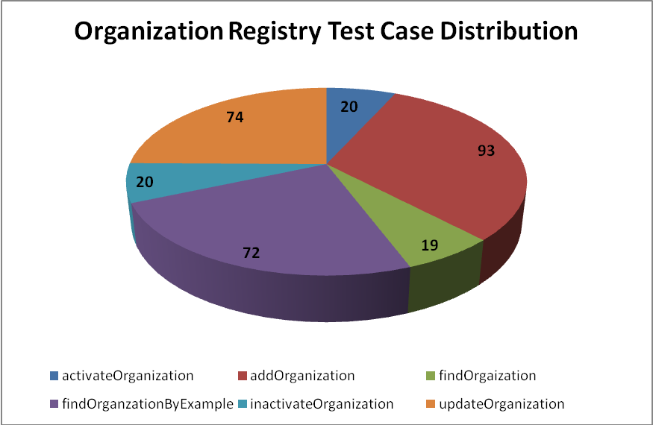
Operations | Cardinality | Does not exist | Invalid value | Null value | Valid value | Total
activateOrganization | 1 | 5 | 5 | 6 | 3 | 20
addOrganization | 16 | 16 | 20 | 28 | 13 | 93
findOrgaization | 1 | 5 | 4 | 6 | 3 | 19
findOrganzationByExample | 12 | 8 | 15 | 25 | 12 | 72
inactivateOrganization | 1 | 5 | 5 | 6 | 3 | 20
updateOrganization | 13 | 11 | 16 | 22 | 12 | 74
Total | 44 | 50 | 65 | 93 | 46 | 298

Other Services
Test case distribution for other services is as follows
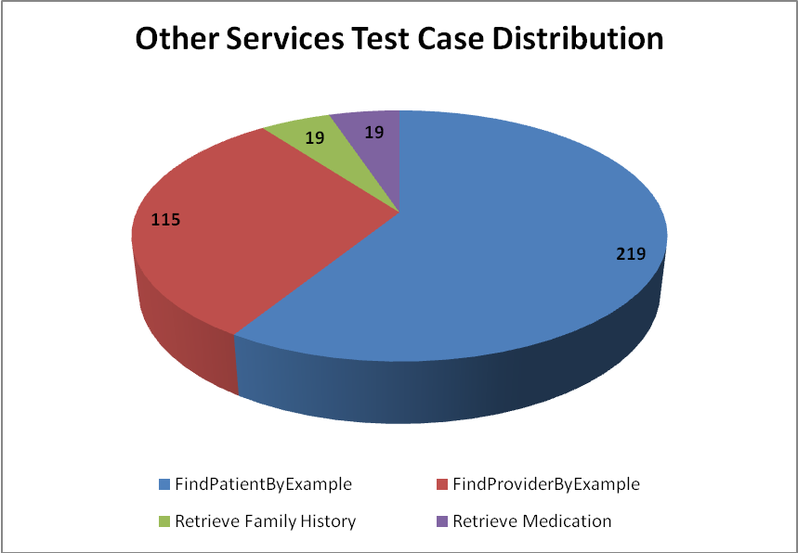
Service | Total
Patient Registry
FindPatientByExample | 219
Provider Registry
FindProviderByExample | 115
Family History Service
Retrieve Family History | 19
Medication Service
Retrieve Medication | 19
Total | 372

Demonstration Pilot
Test case distribution is as follows
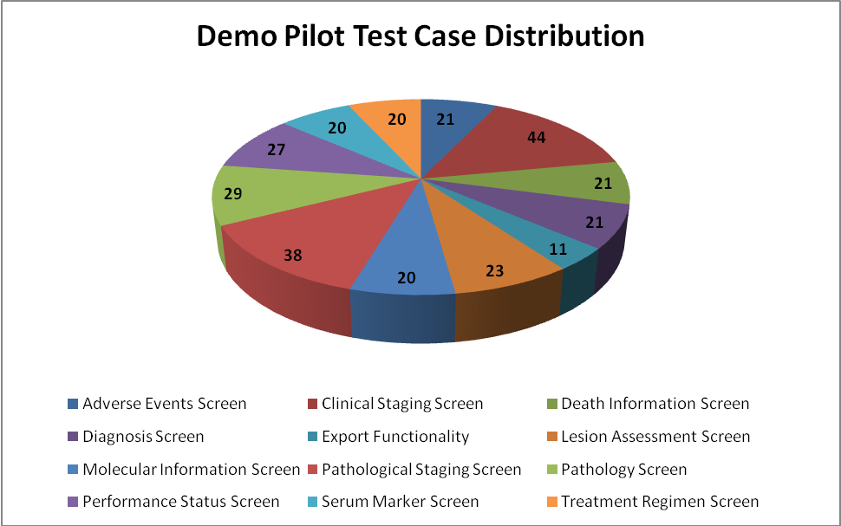
Sections | Total
Adverse Events Screen | 21
Clinical Staging Screen | 44
Death Information Screen | 21
Diagnosis Screen | 21
Export Functionality | 11
Lesion Assessment Screen | 23
Molecular Information Screen | 20
Pathological Staging Screen | 38
Pathology Screen | 29
Performance Status Screen | 27
Serum Marker Screen | 20
Treatment Regimen Screen | 20
Total | 295

Test Case Execution

Consolidated Test Execution Summary
The overall test execution summary for this sprint:
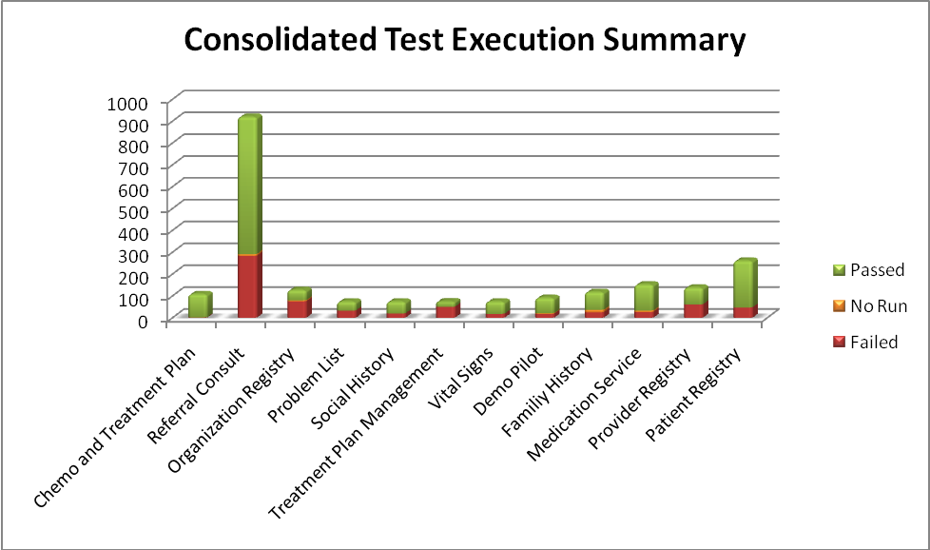
Services | Failed | Failed % | No Run | No Run % | Passed | Passed % | Total
Chemo and Treatment Plan | 2 | 2% |  |  | 106 | 98% | 108
Referral Consult | 283 | 31% | 8 | 1% | 629 | 68% | 920
Organization Registry | 75 | 59% | 5 | 4% | 47 | 37% | 127
Problem List | 33 | 45% |  |  | 41 | 55% | 74
Social History | 20 | 27% |  |  | 54 | 73% | 74
Treatment Plan Management | 50 | 68% |  |  | 24 | 32% | 74
Vital Signs | 18 | 24% |  |  | 56 | 76% | 74
Demo Pilot | 18 | 20% | 3 | 3% | 70 | 77% | 91
Familiy History | 25 | 21% | 11 | 9% | 82 | 69% | 118
Medication Service | 26 | 17% | 7 | 5% | 119 | 78% | 152
Provider Registry | 61 | 44% |  |  | 77 | 56% | 138
Patient Registry | 47 | 18% |  |  | 214 | 82% | 261
<Total> | 658 | 30% | 34 | 2% | 1519 | 68% | 2211

Referral Management Business Capability
The test execution summary for this business capability:
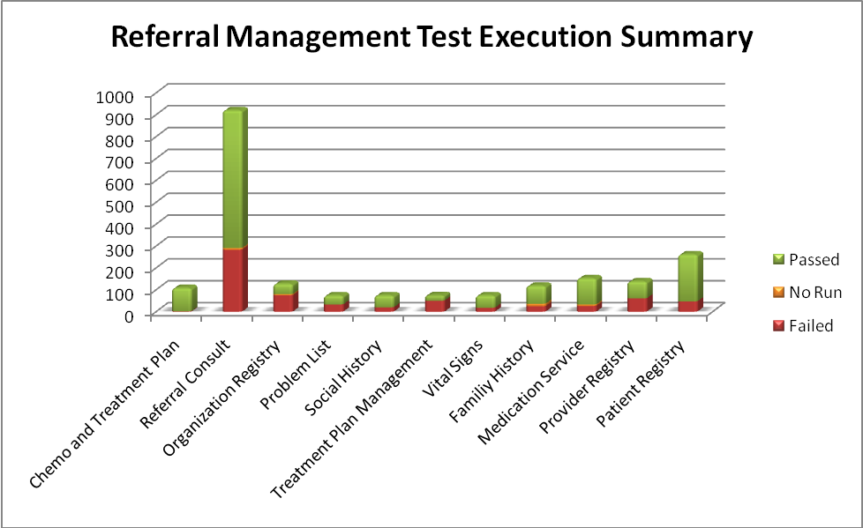
Services | Failed | Failed % | No Run | No Run % | Passed | Passed % | Total
Chemo and Treatment Plan | 2 | 2% |  |  | 106 | 98% | 108
Referral Consult | 283 | 31% | 8 | 1% | 629 | 68% | 920
Organization Registry | 75 | 59% | 5 | 4% | 47 | 37% | 127
Problem List | 33 | 45% |  |  | 41 | 55% | 74
Social History | 20 | 27% |  |  | 54 | 73% | 74
Treatment Plan Management | 50 | 68% |  |  | 24 | 32% | 74
Vital Signs | 18 | 24% |  |  | 56 | 76% | 74
Familiy History | 25 | 21% | 11 | 9% | 82 | 69% | 118
Medication Service | 26 | 17% | 7 | 5% | 119 | 78% | 152
Provider Registry | 61 | 44% |  |  | 77 | 56% | 138
Patient Registry | 47 | 18% |  |  | 214 | 82% | 261
<Total> | 640 | 30% | 31 | 1% | 1449 | 68% | 2120

Referral Consult Service
The test execution summary for this service is:
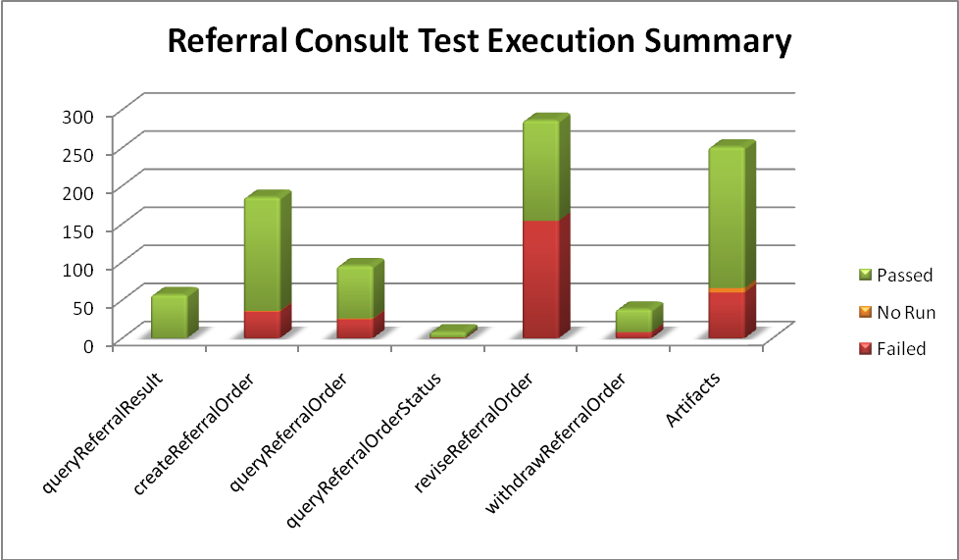
Operations | Failed | Fail % | No Run | No Run % | Passed | Pass % | Total
queryReferralResult |  |  |  |  | 57 | 100% | 57
createReferralOrder | 35 | 19% | 1 | 1% | 149 | 81% | 185
queryReferralOrder | 25 | 26% | 1 | 1% | 69 | 73% | 95
queryReferralOrderStatus | 1 | 13% |  |  | 7 | 88% | 8
reviseReferralOrder | 154 | 54% |  |  | 132 | 46% | 286
withdrawReferralOrder | 8 | 21% |  |  | 30 | 79% | 38
Sub-Total | 223 | 33% | 2 | 0% | 444 | 66% | 669
Analysis Publication Manifest | 2 | 13% |  |  | 14 | 88% | 16
Analysis Release Notes |  | 0% |  |  | 7 | 100% | 7
CFSS | 19 | 26% |  |  | 55 | 74% | 74
Event Flow Diagrams | 7 | 35% |  |  | 13 | 65% | 20
Installation Guide | 12 | 52% |  |  | 11 | 48% | 23
Interaction Diagrams | 6 | 55% |  |  | 5 | 45% | 11
Object Diagrams |  | 0% |  |  | 4 | 100% | 4
PIM | 6 | 11% | 6 | 11% | 41 | 77% | 53
Package Diagram |  | 0% |  |  | 9 | 100% | 9
State Machine Diagrams | 4 | 44% |  |  | 5 | 56% | 9
Use Case Diagrams | 1 | 10% |  |  | 9 | 90% | 10
Use Cases | 3 | 20% |  |  | 12 | 80% | 15
Sub-Total | 60 | 24% | 6 | 2% | 185 | 74% | 251
Total | 283 | 31% | 8 | 1% | 629 | 68% | 920

Patient Registry Service
The test execution summary for this service is:
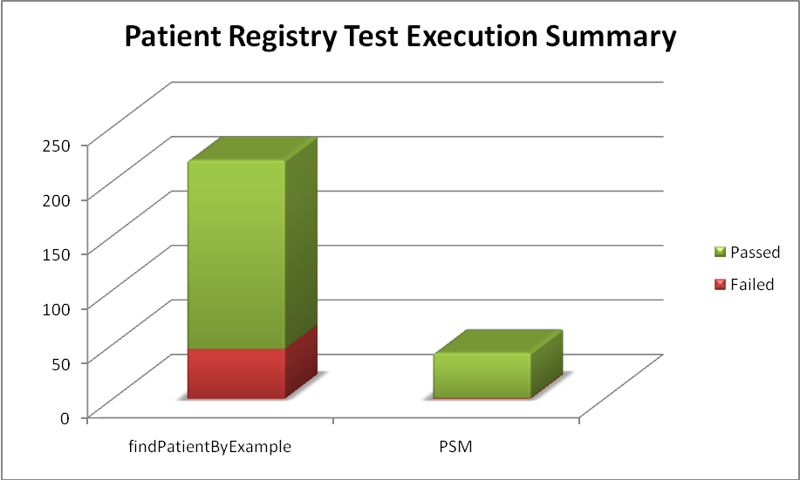
Section | Failed | Fail % | Passed | Pass % | Total
Operation
findPatientByExample | 46 | 21% | 173 | 79% | 219
Artifacts
PSM | 1 | 2% | 41 | 97% | 42
Total | 47 | 18% | 214 | 82% | 261

Provider Registry
The test execution summary for this service is
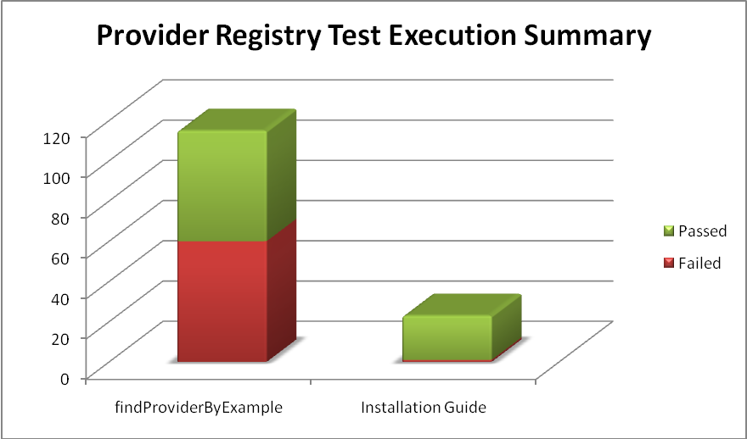
Section | Failed | Fail % | Passed | Pass % | Total
Operation
findProviderByExample | 60 | 52% | 55 | 48% | 115
Artifacts
Installation Guide | 1 | 4% | 22 | 96% | 23
Total | 61 | 44% | 77 | 56% | 138

Family History Service
The test execution summary for this service is
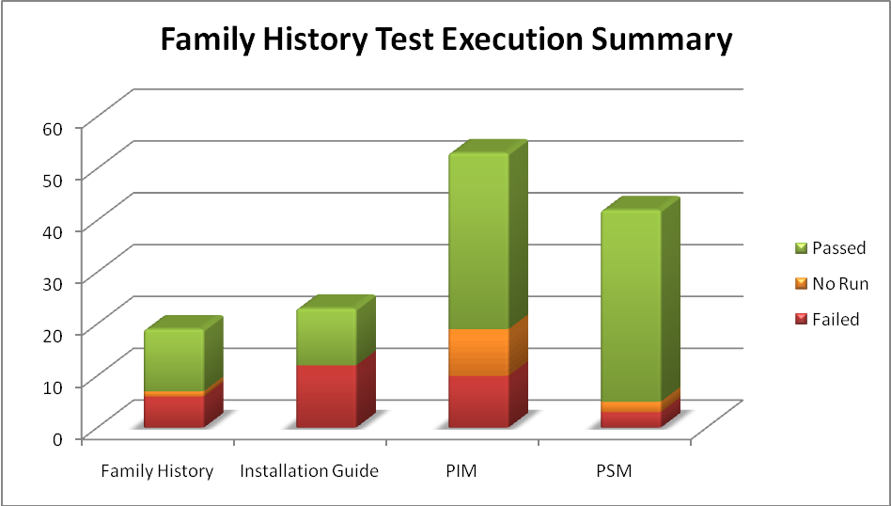
Section | Failed | Fail % | No Run | No Run % | Passed | Pass % | Total
Operation
retrieveFamilyHistory | 6 | 32% | 1 | 5% | 12 | 63% | 19
Artifacts
Installation Guide | 12 | 52% |  |  | 11 | 48% | 23
PIM | 10 | 19% | 9 | 17% | 34 | 64% | 53
PSM | 3 | 7% | 2 | 5% | 37 | 88% | 42
Sub-total | 25 | 21% | 11 | 9% | 82 | 70% | 118
Total | 31 | 22% | 12 | 9% | 94 | 69% | 137

Medication List Service
The test execution summary for this service is:
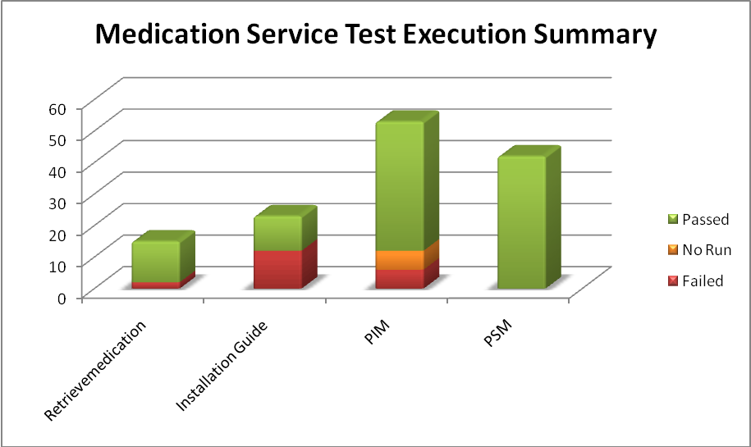
Section | Failed | Fail % | No Run | No Run % | Passed | Pass % | Total
Operation
Retrievemedication | 2 | 13% |  |  | 13 | 87% | 15
Artifacts
Installation Guide | 12 | 52% |  |  | 11 | 48% | 23
PIM | 6 | 11% | 6 | 11% | 41 | 77% | 53
PSM |  | 0% |  |  | 42 | 100% | 42
Sub-Total | 18 | 15% | 6 | 5% | 94 | 80% | 118
Total | 20 | 15% | 6 | 5% | 107 | 80% | 133

Other Services
The test execution summary for this service is:
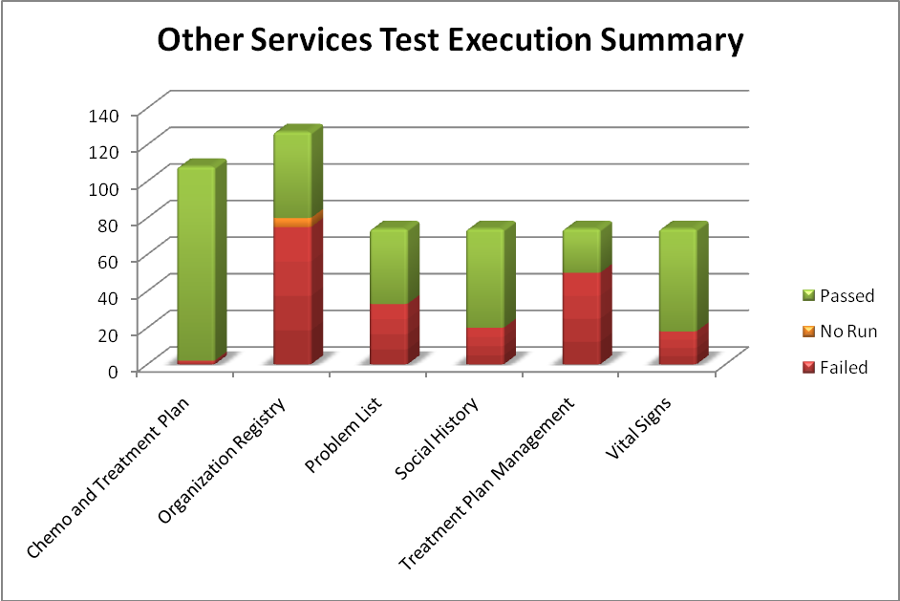
Services | Failed | Fail % | No Run | No run % | Passed | Pass % | Total
Chemo and Treatment Plan
Analysis Publication Manifest |  |  |  |  | 16 | 100% | 16
Analysis Release Notes |  |  |  |  | 7 | 100% | 7
CIM |  |  |  |  | 2 | 100% | 2
Class Diagrams |  |  |  |  | 10 | 100% | 10
Event Flow Diagrams | 1 | 5% |  |  | 20 | 95% | 21
Service Scope and Vision |  |  |  |  | 16 | 100% | 16
State Machine Diagrams | 1 | 10% |  |  | 9 | 90% | 10
Use Case Diagrams |  |  |  |  | 10 | 100% | 10
Use Cases |  |  |  |  | 16 | 100% | 16
Sub-Total | 2 | 2% |  |  | 106 | 98% | 108
Organization Registry | 75 | 59% | 5 | 4% | 47 | 37% | 127
CFSS | 53 | 72% |  |  | 21 | 28% | 74
PIM | 22 | 41% | 5 | 9% | 26 | 48% | 54
Sub-Total | 75 | 59% | 5 | 4% | 47 | 37% | 127
Problem List
CFSS | 33 | 45% |  |  | 41 | 55% | 74
Social History
CFSS | 20 | 27% |  |  | 54 | 73% | 74
Treatment Plan Management
CFSS | 50 | 68% |  |  | 24 | 32% | 74
Vital Signs
CFSS | 18 | 24% |  |  | 56 | 76% | 74
Total | 198 | 37% | 5 | 1% | 328 | 62% | 531

Demonstration Pilot
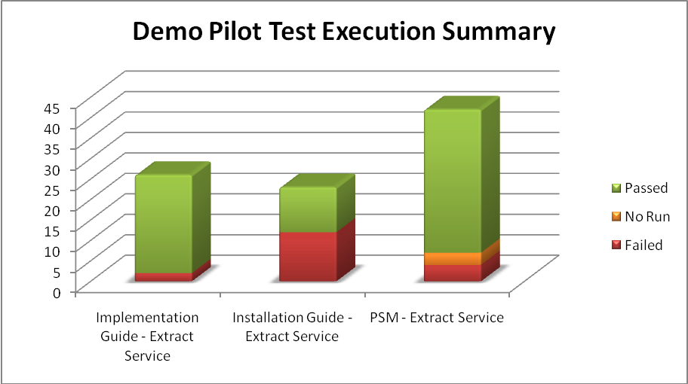
Artifacts | Failed | Fail % | No Run | No Run % | Passed | Pass % | Total
Implementation Guide - Extract Service | 2 | 8% |  |  | 24 | 92% | 26
Installation Guide - Extract Service | 12 | 52% |  |  | 11 | 48% | 23
PSM - Extract Service | 4 | 10% | 3 | 7% | 35 | 83% | 42
Total | 18 | 20% | 3 | 3% | 70 | 77% | 91

Defect Summary
The defect summary is:
ESD Defects Fixed for this Sprint | ESD Defects Closed in this Sprint | ESD Defects Re-opened in this Sprint
21 | 21 | 0

The defects for this sprint are attached below:
