Cancer Clinical Information System (caCIS)
Mirth Deployment Options

Version 0.3
July 28, 2011

Authors | Kunal Modi
Reviewers | Santosh Joshi, Harsh Marwaha

Document History
Document Version | Date | Author | Changes
0.1 | 07/26/2011 | Kunal Modi | Initial Draft
0.2 | 07/28/2011 | Kunal Modi | Updated draft to incorporate internal feedback
0.3 | 07/28/2011 | Santosh Joshi | Additional updates to Assumptions and other sections

Table of Contents

1. Introduction 5
2. Mirth Security Offerings 5
2.1. Mirth Connect SSL Plug-in 5
2.2. Mirth Appliance 5
3. Open Issues / Assumptions 5
4. Deployment Option 1: Using SSL Tunnel 7
4.1. Impact Assessment 8
5. Deployment Option 2: Using Proxy Web Services 9
5.1. Impact Assessment 10
6. Deployment Option 3: Using Mirth Appliance 11
6.1. Impact Assessment 12

- Introduction
Mirth Connect is an open source standards-based healthcare integration engine. Mirth Connect facilitates the routing, filtering, and transformation of messages between health information systems over a variety of protocols. The caCIS Integration Solution uses Mirth Connect as the underlying middleware for the purpose of connecting various systems using different protocols and also transforming the data exchanged between them.
The Open Source Mirth Connect doesn’t come with any security features. All the inbound interfaces on the open source Mirth Connect are unsecured and require either the use of SSL Plug-in, Mirth appliance or custom workarounds to be developed.
This document details multiple deployment options to address security and highlights how various components of the caCIS Integration Solution will work in these options.

- Mirth Security Offerings

Mirth Connect SSL Plug-in
The Mirth Connect SSL Plug-in is available as part of the Mirth Connect’s Silver Support Package. This SSL Plug-in is supposed to add security to various interfaces supported by Mirth. However, based on the discussion with Mirth’s Support team and information available on the forum, the SSL is currently available only for the HTTP Connector and is not available for the SOAP based Web Services interface until future date (v2.2 – estimated release date - End of October, 2011). Also, it is not certain if the SSL plug-in will help on the outbound side to invoke SOAP based web service in a secured manner and whether it supports secure file transfer.

Mirth Appliance
Mirth also offers a hardware component, called Mirth Appliance, which comes with pre-installed Mirth Connect software. Based on the documentation on Mirth website, Mirth Appliance is capable of providing secured interfaces for HTML, SOAP, TLS, and LLP interface both on the inbound as well as outbound side. It also supports Secure FTP (SFTP) out of the box.

- Open Issues / Assumptions
- For all deployment options listed below, since SSL is not established by the Mirth Connect directly, end user credentials are not available to Mirth Connect container and hence cannot be leveraged for further authorization or any other security or logging features. However, caCIS Architecture currently does not envision a need to authorize individual Semantic Adapters (SA) requesting a connection with Integration Platform (IP) (only mutual authentication is employed between SA and IP such that the IP will trust only pre-configured endpoints). So, this may not be an issue.
- Although this document refers to the Source System to Semantic Adapter interface as a web service, there are other possible approaches such as JMS, FTP and Database Connector.
- We are awaiting response from the Mirth team regarding support for mutual authentication on inbound services as well as outbound calls within the Mirth Appliance. For SSL plug-in, mutual authentication is supported only for the HTTP Connections (both inbound and outbound).
- Deployment Option 1: Using SSL Tunnel

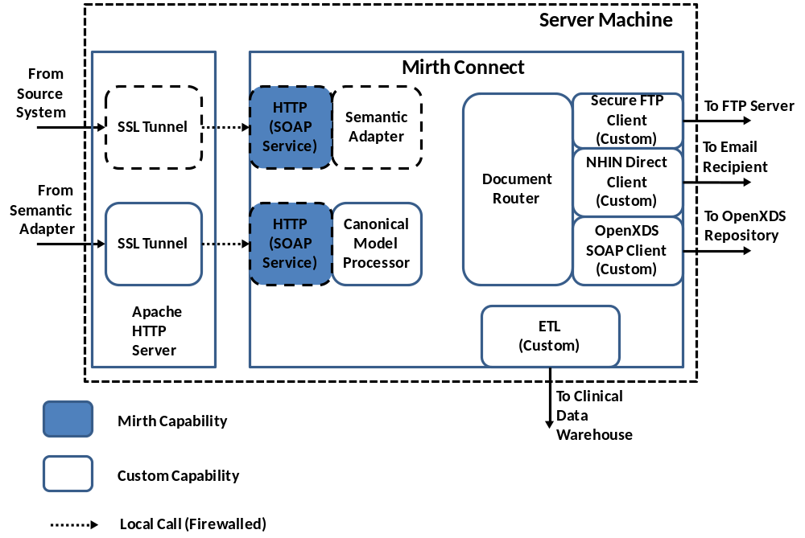

This solution leverages a HTTP Server in front of Mirth connect to provide SSL capabilities. The HTTP Server will be configured to enable SSL for various inbound ports required by Mirth Connect. It will then tunnel the HTTP request to Mirth Connect locally. Firewall will be configured to restrict access to the unsecured service on Mirth Connect to local calls only. Also due to lack of inbuilt SSL support, custom clients will be developed to call FTP, SOAP and other clients in a secured manner. Following are the components in this solution:
Inbound Services:
- Semantic Adapter Service (Optional)
- Canonical Model Processor
These services will be hosted as unsecured SOAP services on Mirth Connect with SSL Tunnel in front of them providing mutual authentication capabilities. NOTE: Semantic Adapter is an optional component since it can also be deployed on a separate Mirth Connect instance.
Document Routing:
- SFTP – The Document Router will use a custom FTP client to transfer files securely to the FTP Sites.
- NHIN Direct Client - The Document Router will leverage a custom client which embeds NHIN Direct client to send out emails securely over S-MIME to email recipients.
- OpenXDS Client - The Document Router will use a custom SOAP Client to connect to OpenXDS Service in order to store documents securely.
Clinical Data Warehouse:
- ETL – A custom ETL process will be deployed which transforms the canonical data and loads it into the Clinical Data Warehouse using Virtuoso APIs.

Impact Assessment
- No additional development required
- Requires deployment and configuration of the HTTP server to create SSL tunnels
- Deployment Option 2: Using Proxy Web Services
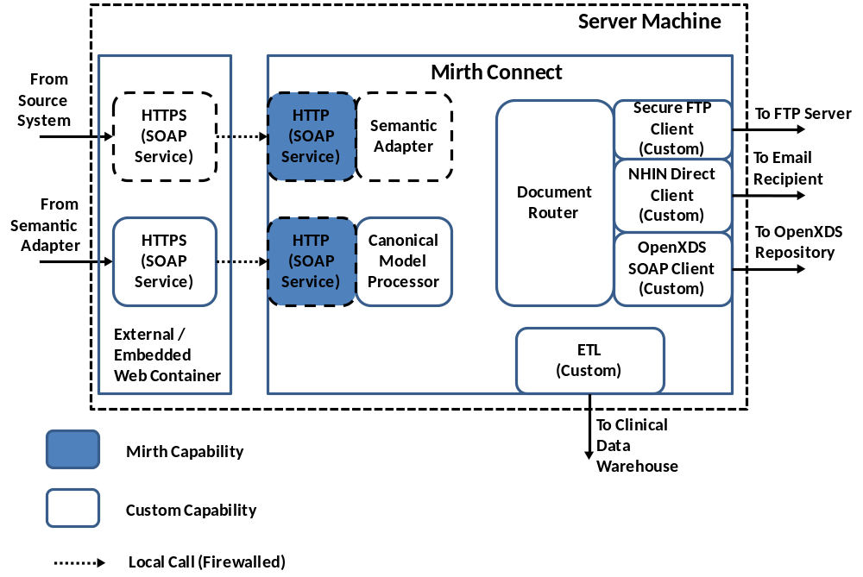
This solution uses a separate Web Container in front, to house secured inbound services which then routes the call locally to Mirth Connect. This container can either be an external container like Tomcat or Mirth’s embedded Jetty container. In either case, this container will house the externally available secured services which will then route the call to unsecured SOAP services hosted on the Mirth Connect. Firewall will be configured to restrict access to the unsecured service on Mirth Connect to local calls only. Also due to lack of inbuilt SSL support, custom clients will be developed to call FTP, SOAP and other clients in a secured manner. Following are the components in this solution:
Inbound Services:
- Semantic Adapter Service (Optional)
- Canonical Model Processor
These services will be hosted as secured SOAP services on a separate web container and also unsecured services on Mirth Connect. The Secured Web Services will act as proxy and route the calls to the unsecured services on Mirth.
NOTE: Semantic Adapter is an optional component since it can also be deployed on a separate Mirth Connect instance.

Document Routing:
- SFTP – The Document Router will use a custom FTP client to transfer files securely to the FTP Sites.
- NHIN Direct Client - The Document Router will use a custom client which embeds NHIN Direct client to send out email securely over S-MIME to email recipients.
- OpenXDS Client - The Document Router will use a custom SOAP Client to connect to OpenXDS Service in order to store documents securely.
Clinical Data Warehouse:
- ETL – A custom ETL process will be deployed which converts the canonical data and loads it into the Clinical Data Warehouse using Virtuoso APIs.

Impact Assessment
- Requires creation and maintenance of proxy web services which need to be in sync with the actual web services on Mirth Connect
- Requires deployment and configuration of a web application container to host these proxy services in a secured manner
- Deployment Option 3: Using Mirth Appliance

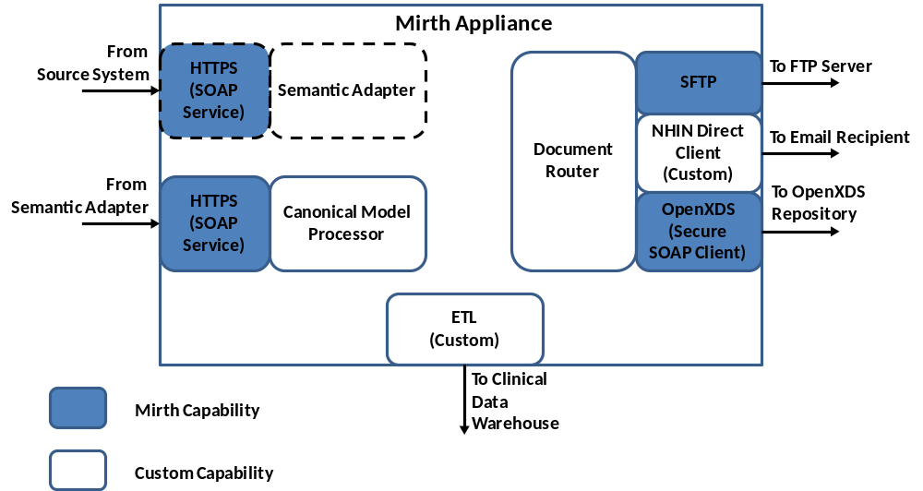
This solution leverages Mirth Appliance ($2k for P1000 Pico to $40k for E2000 Enterprise) which houses a Mirth Connect container with a web server in the front to provide security via SSL Tunneling. Mirth Appliance will provide SSL-secured SOAP based inbound web service interface as well as provide the SFTP client on the outbound side. Following are the details about the components in this solution:
Inbound Services:
- Semantic Adapter Service (Optional) – This will be hosted as a SSL-secured SOAP service on Mirth Appliance. NOTE: This service is optional since it can be deployed on a separate Mirth appliance container.
- Canonical Model Processor - This will be hosted as a SSL-secured SOAP service on Mirth Appliance.
Document Routing:
- SFTP – The Document Router will leverage the SFTP Client provided by Mirth to transfer files securely to the FTP Sites.
- NHIN Direct Client - The Document Router will leverage the custom client which embeds NHIN Direct client to send out email securely over S-MIME to email recipients.
- OpenXDS Client - The Document Router will use Mirth secure SOAP Client to connect to OpenXDS Service in order to store documents securely.
Clinical Data Warehouse:
- ETL – A custom ETL process will be deployed which converts the canonical data and loads it into the Clinical Data Warehouse using Virtuoso APIs.

Impact Assessment
- Requires purchase of Mirth Appliance
- Installation (hardware) and Configuration of Mirth Appliance

