caBIG® Clinical Information Suite
Clinical Data Warehouse (CDW)
User Guide
01/20/2012

Version History

Version  Number | Implemented  By | Revision  Date | Description of Change
0.5 | Lloyd McKenzie | 12/25/2011 | Initial version
0.7 | Santosh Joshi | 01/20/2012 | Updated to incorporate feedback
0.8 | Harsh Marwaha | 01/29/2012 | Added additional query examples

Table of Contents
1 Introduction/Overview 4
2 Information Sources 4
3 Information Content 6
3.1 Raw source system data 7
3.2 Canonical data representation 7
3.2.1 Limitations 8
3.2.2 CDA 8
3.2.3 CCD 12
3.2.4 Extensions 12
3.3 Metadata 13
3.4 Triple-Store representation 14
3.5 Data limitations 15
3.6 Pilot Implementation 15
4 Data retrieval 16
4.1 Data Mart 16
4.2 SPARQL 16
4.2.1 Security 17
4.2.2 Namespaces and URIs 17
4.2.3 Graphs 17
4.3 Example Queries 18
4.3.1 Example 1 – List of graph ids that are part of a specified graph group 18
4.3.2 Example 2 – Retrieve RDF for a specified graph id 19
4.3.3 Example 3 – Find graph ids that have been routed to a particular recipient 19
4.3.4 Example 4 – Find patient names whose family history includes the word “Lung” 20
4.3.5 Example 5 – Find patient names which have a recorded body temperature over 35 Celsius 20
4.3.6 Example 6 – Patient Demographics 21
4.3.7 Example 7 – Provider Id and Name 22
4.3.8 Example 8 – Patient Diagnosis 23
4.3.9 Example 9 – Patient Pathology Grade 24
5 References 27

Introduction/Overview

The caCIS Clinical Data Warehouse is a secured repository of patient-specific healthcare data collected as part of clinical trials. It is populated by participating clinical applications using the caCIS Integration Platform (IP). This data is normalized on submission to align with the HL7 CDA specification, specifically the CCD standard. This process also supports the normalization of identifiers and terminologies. The result is a collection of data to support post-trial clinical analysis of patient-specific data both within the context of a single trial and across trials.
This document provides an overview of how the repository is used. Specifically:
- How the repository is populated (data sources and population mechanism)
- How the data is organized within the repository
- How the data in the repository may be queried and analyzed

Target audience for this document is informaticists supporting the clinical trial since the document assumes certain knowledge about the information models, databases and database queries on part of the reader.

Information Sources
The caCIS Clinical Data Warehouse (CDW) is one of several components that make up the caCIS Integration Platform. This set of infrastructure is intended to enable data sharing between participating clinical applications. These clinical applications might be EMR systems, data repositories for particular clinical trials or even other data warehouses.
The data can be shared in two ways:
- It can be transmitted to one or more target clinical systems by one of the supported data exchange protocols
- It can be passed to the clinical data warehouse for persistence, analysis and potential export
Data passed by a clinical system to the caCIS interoperability infrastructure may use either or both of these sharing mechanisms. The decision of whether received data is sent to the CDW is made by the IP based on configuration specific to the source application as well as information provided by the source including the “type” of record and the intended recipients, if any.
Prior to transmission to the CDW, the data undergoes a transformation process by a component called the Semantic Adapter (SA). The SA has several responsibilities:
- It converts the data from whatever native format is exposed by the clinical data source into the canonical representation used by the Integration Platform.
- It translates study, study site, patient, and potentially other identifiers to standardized identifiers, allowing matching of identifiers across data sources.
- Where possible, and supported, it translates codes from the local code systems used by the source systems into standardized code systems, allowing comparison of data across data sources.
- Semantic adapters can be configured to combine data from multiple source systems together prior to submission to the Integration Platform. This allows a complete patient record to be constructed when the data is stored in disparate locations.
The overall flow of information can be seen below in Figure 1 - caCIS Information Flow.
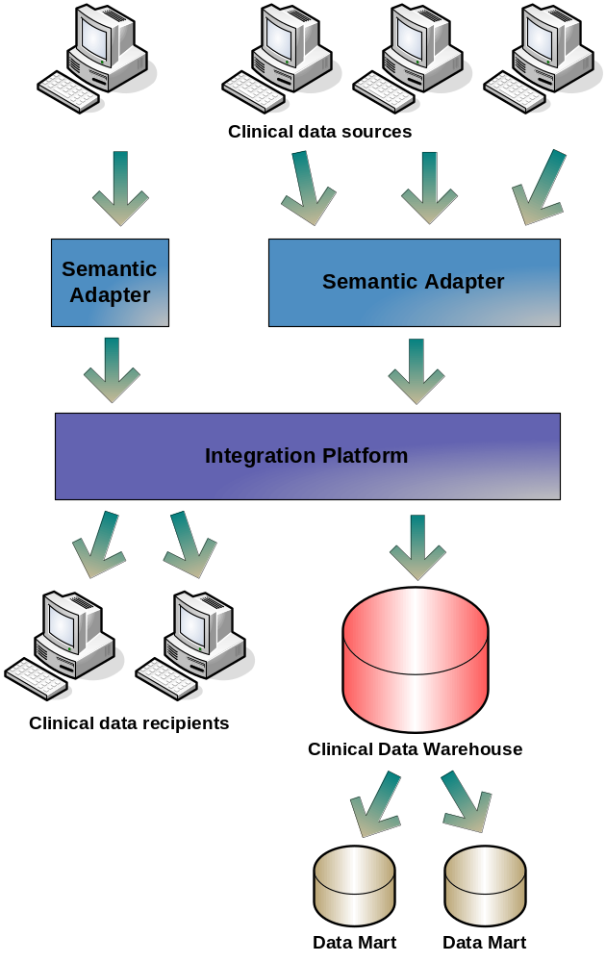
Figure 1 - caCIS Information Flow

Information Content
The data stored in the CDW includes three main components:
- The original source system data
- The canonicalized representation of that data
- Metadata relating to the submission of the data to the Integration Platform
All of this information is then encoded in RDF (Resource Description Framework) for persistence in the CDW as “triples”.
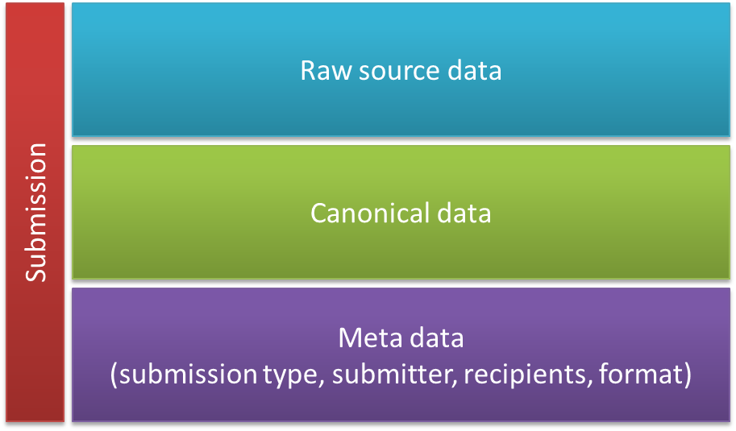Following sections describe each of these aspects in greater detail:
Figure 2 - Data submission structure

Raw source system data
The raw data may exist in a variety of formats – XML, character-delimited text, HL7 v2 or other formats. Because of the variation of the formats in which this data exists, it will be difficult to query it within the CDW. However, the main purpose of persisting this information is not to support querying the data, but rather to allow the data to be “re-canonicalized” at some point in the future.
The canonical format will not necessarily capture all data elements exportable from all source systems. And for those that are supported, it is possible that the mappings performed to translate from source to canonical and to convert identifiers and code systems will evolve over time. Storing the original data in association with the “canonicalized” data makes it a straight-forward matter to re-convert the data in the future should this ever be required. As well, in rare cases, analysis considerations may need to be driven by properties of the raw data that do not persist in the canonicalized representation. The retention of the raw source data enables this sort of analysis, either through direct query, or through transformation and export into an analysis data mart.
For the TRANSCEND pilot implementation, the source data is in the form of TRANSCEND “Trim” files which is an HL7 v3-based XML syntax.

Canonical data representation
The canonical representation is the “primary” representation of data within the repository. It is intended to support query and export and provides the cross-site, cross-study, cross-source analysis capability that drove the creation of the CDW.

Limitations
The canonical representation is a standardized organization of the clinical data such that the same data elements captured by different systems should be organized in the same way and accessible via the same “paths”. In practice, there are several limitations on how closely captured data will adhere to this ideal:
- Not all systems capture data at the same granularity. For example, one system may capture a patient’s blood panel as a single observation with a textual or even PDF report as the “value” for the observation. Another system might capture each discrete measurement from the panel as a distinct observation with its own value.
- Not all systems (or even all users) will capture or represent the same clinical “fact” in the same way. For example, one user might capture medications using the manufactured product name while another might record the generic name even though the patient was given the same drug.
- Perfect translation may not be possible due to mismatches in semantics between source and canonical code systems. For example, one system might capture pain as “mild”, “moderate”, “severe” and “extreme”. Another might represent the same semantic using a 10-point scale.
Those limitations aside, the canonical representation provides the best possible representation to allow comparison of data across studies and data sources.

CDA
The canonical model organizes data according to HL7’s Clinical Document Architecture (CDA) standard. This approach was chosen for several reasons:
- It is quite flexible in terms of the types of data that can be captured.
- It covers the target space of “clinical data captured about a given patient” quite well.
- The U.S. “Meaningful Use” guidelines and other U.S. interoperability initiatives make significant use of CDA, meaning that many clinical systems already have or are actively working on the ability to create and consume CDA instances.
- CDA includes an expectation that all data be conveyed not only as discrete data bat also as rendered text. This means that CDA content will, at minimum, provide a means for human-to-human interoperability.
CDA is itself based on the HL7 version 3 standard, meaning it draws its structures from the HL7 Reference Information Model (RIM), Vocabulary and Data types specifications. This provides significant clinical expressivity and should allow the CDW to collect information from a variety of sources without modifying the base canonical format. However, it does mean that the representation is considerably more complex than it would be if the CDW were optimized to represent the clinical data from only one source system.
CDA consists of two major components – the Header and the Body.
The CDA header contains information that provides context for the overall document. This includes things like the patient, document type, author, study identifier and study site. The CDA body contains the clinical details captured within that context including observations, drug administrations, clinical procedures, etc. The body is subdivided into a number of sections and sub-sections that group related clinical information together. Examples of sections include “family history”, “vital signs”, “medications”, etc. Each clinical data record within a section is called an Entry. The overall structure of a CDA instance looks like this:
CDA Document
Header
Section 1
Sub-section 1
Entry 1
Entry 2
Entry n
Sub-section 2
Sub-section n
Section 2
Section n
Figure 3 - CDA Structure

CDA makes use of the R1 release of HL7’s datatypes specification. Datatypes in HL7 version 3 are complex structures that each define numerous properties and that may nest several levels deep. For example, the Address (AD) datatype has a property that identifies how the address is intended to be used which in turn is expressed as a collection of coded values. The Concept Descriptor datatype (CD) then identifies the code, code system and other information for each intended usage.
While the HL7 abstract datatype specification is defined recursively – the properties of each complex type are themselves defined in terms of other complex types – in order to store data instances, some datatype properties are represented using simple w3c schema types. For example, xs:integer, xs:string, etc. The point at which a schema type is invoked rather than another complex datatype structure is generally aligned with how datatypes are represented in the HL7 Datatypes ITS 1.0 specification.
An example of a datatype structure can be seen below:
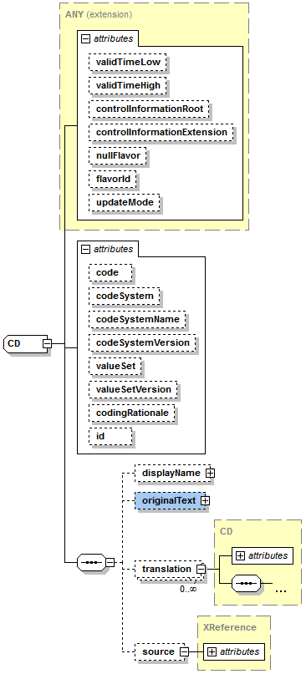
Figure 4 - Sample ISO Datatype Structure (CD - Concept Descriptor)
There is one place in the CDW data representation where the HL7 R1 datatypes are not used. This is where the GTS specification is referenced. Datatypes R1does not describe GTS in a manner that is amenable to representation in a triple-store. Therefore, the GTS type is represented using the HL7 R2 datatypes specification, also known as the ISO 31062 specification.
Finally, CDA’s basis on HL7 v3 means that both attributes and associations in the CDA specification have the potential to be represented with a null flavor indicating that the element on which the null flavor is placed is not available in its proper form for some reason.
In some cases, rather than persisting a single CCD document, multiple documents will instead be stored – each collecting a set of information that has a particular context.

CCD
The CDA specification allows for a wide variety of data to be captured. It also frequently allows the same data element to be conveyed in multiple ways. This latter aspect is problematic as it makes data comparison difficult. To ensure consistency of data capture within the CDA structure, a standard “template” needs to be used.
For the caCIS project, the C32 – CCD template was selected. This specification is maintained by the Health Information Technology Standards Panel (HITSP) and defines the sections, subsections and the entries allowed within a given subsection. It was chosen due to the prevalence of its use within the U.S. environment and because it is designed to capture a complete summary of the patient’s record, thus meeting the use-case for the CDW.

Extensions
In opting to use CDA and the C32 specification as the basis for the Canonical representation for caCIS data, there’s a risk that one or more of the data elements to be shared and exposed might not fit cleanly within the chosen specifications. For this reason, the Canonical model is not defined to be strictly a CDA or CCD specification. Instead, it is identified as “based on” CDA and CCD. If necessary, additional sections and/or attributes may be added. In circumstances where a required element is required that is not properly a part of the CDA specification, additional “extension” attributes can be conveyed by adding additional RIM attributes and associations and marking them as extensions by placing them in a foreign namespace, in accordance with the HL7 v3 extension process.
In practice, in the TRANSCEND pilot implementation, no extensions were required as all data elements fit cleanly into both CDA and the C32 specification.
The complete profile describing how data is represented in the CDW canonical form can be found in the caCIS Canonical Model Implementation Guide.

Metadata
Each Canonical instance is accompanied by additional metadata that describes the submission from the source system(s) that resulted in the creation of the canonical record. This metadata includes:
- What are the patient, study and study site identifiers?
- What kind of data is being conveyed?
- What systems or providers was the data also sent to at the time it was placed in the CDW and in what formats was it sent?
- Who initiated the data transfer?
While not strictly necessary for query and analysis, this information helps provide provenance for the persisted information and gives context about how the information was produced.
The metadata section is structured as follows:
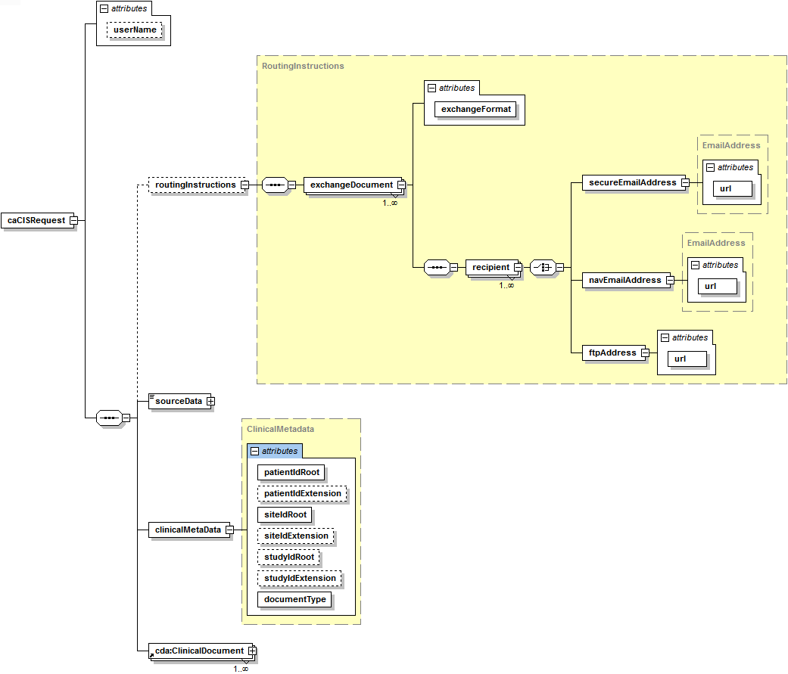
Figure 5 - Request meta-data

Triple-Store representation
To maximize the ability to use the data in the CDW for analysis purposes, the data is stored using triples (object, property, value) in a database solution called Virtuoso. The use of triples enables data to be exposed as SPARQL end-points for analysis by remote systems. It also supports the use of logical assertions to simplify the query and extract processes. The conversion to triples works as follows:
- Each XML type is represented as an object. This includes the “classes” and datatypes from the CDA specification as well as the implicit objects in the metadata.
- Each XML element is represented as an object property. This includes attributes, associations and datatype properties from the canonical model as well as elements from the metadata and source data structures.
- Collections of elements are nested inside rdf:Bag or rdf:Seq collections to differentiate between order-sensitive and non-sensitive collections.
These triples are then persisted into the Virtuoso database grouped together by a “group identifier” that identifies all triples from a single submission. This grouping also allows security privileges to be enforced on the basis of the patient, study and study site associated with the submission. Refer to the caCIS IP to CDW Design document for more information.

Data limitations
In addition to the limitations identified in section 3.2.1, there is another consideration that will affect queries made against the CDW:
Data placed in the CDW is not merged or reconciled.
This means that it is possible for multiple versions of the same clinical record to exist in the repository at one time. Each of these versions may have been submitted by different clinical solutions. Alternatively, the multiple versions could have been submitted by the same application at different times, possibly as part of submissions for different document renderings of the clinical content.
Performing such merging requires detailed clinical knowledge of each type of record to appropriately determine what records are duplicates and what are merely similar records recording distinct clinical facts. This expertise is also needed to determine what version of a record to retain or whether information from multiple records should be combined into a single consolidated record.
In some cases, logic to perform such merging and reconciliation may need to be done as part of the export process from the CDW into an analysis data mart.

Pilot Implementation
The TRANSCEND pilot implementation populates the CDW using 5 distinct data feeds:
- Baseline Note
- Clinical Staging Note
- Medical Study Visit Note
- Surgical Study Visit Note
- Patient Centric Outcomes (PCO)
While the first four are clinical notes from TRANSCEND Tolven eCHR, the last data feed (PCO) is a set of multiple TRIM files containing various clinical data for a patient captured throughout the course of the clinical trial. Once a patient’s status changes to “Off-treatment”, these TRIM files are sent to caCIS for loading into the CDW. caCIS Semantic Adapter extracts the Patient Centric Outcomes related data out of this data set and loads it into the CDW.

Data retrieval
The primary purpose of the CDW is to allow data to be analyzed. This means the data in the CDW will need to be queried. There are two approaches to performing analysis on the CDW – direct query and extraction to data marts.

Data Mart
Extracting information into distinct analysis data marts is the preferred mechanism for analysis of caCIS clinical data. There are several reasons for this:
- The data structure in the CDW is very complex. While this complexity is necessary to support full representation of data from numerous sources and to align with standard representations familiar to clinical system vendors, it adds significantly to the effort of authoring queries.
- The names used for the objects and properties in the triple store are determined by the CDA standard and HL7 v3 methodology and are therefore not intuitive to clinical users who may wish to perform analysis.
- While data is somewhat normalized as part of the conversion to canonical form, no merging of duplicate records will have occurred and translations may not be consistent and will require correction prior to analysis. This correction can be performed as part of the extract process to load the data mart.
- The CDW will be extraordinarily large due to the volume of data it is expected to maintain. Performing complex queries on such a large store run a significant risk of performance issues.
- Data within the CDW is patient-identifiable. If data is to be accessed by public sources, anonymization is required. This anonymization step is best performed as part of the ETL process to extract information into a data mart.
The process for extracting content from the CDW into a data mart involves the use of simple ETL tools. In most cases, the ETL tool shipped as part of the Integration Platform and used to manage the loading of RDF data into the Virtuoso repository can also be used to manage the extraction of data from the CDW and loading it into one or more data marts.

SPARQL
SPARQL is the query language used for retrieving information from triple store repositories. It serves the same functions as SQL does when querying against a relational database. For guidance on the use of SPARQL, refer to http://www.w3.org/2004/Talks/17Dec-sparql. Section 4.3 provides some example queries that expose the capabilities of the SPARQL language as well as how to construct queries against the complexity of the CDW database.

Security
Because the CDW contains patient-specific information as well as study-specific information that may be considered proprietary or sensitive, the CDW restricts what data a given user can access. All users wishing to query data within the CDW must be registered as authorized users and must explicitly be granted permission to view particular patients, studies and/or study sites.

Namespaces and URIs
Data is loaded into the CDW in a format called RDF (Resource Description Framework). RDF files make use of a mechanism called namespaces to keep track of the meaning of different elements. Elements with the same “name” but different namespaces can have different meanings. In the caCIS CDW, at least two namespaces are used:
http://www.w3.org/1999/02/22-rdf-syntax-ns# | This is the namespace for RDF itself and is used when collections are encountered.
http://cacis.nci.nih.gov | This is the namespace for the metadata associated with the CDW record
urn:hl7-org:v3/owl/DEFN/UV/DT/1.0# | This is the namespace used for HL7 v3 datatype content
urn:hl7-org:v3/owl/DEFN/UV/CD/MT/000040# | This is the namespace used for CDA content

If the source data is also XML, there may be a namespace associated with it as well. For the initial Tolven implementation, the source TRIM data has a namespace of urn:tolven-org:trim:4.0.

Graphs
The Virtuoso product stores each RDF structure loaded at a single time as a “graph”. A graph is a set of triples that are defined together and represents the lowest level of access control. Each graph has a unique identifier, consisting of the base URI “http://cacis.nci.nih.gov/UUID/”, followed by a GUID.
Each of these graphs are the organized into a series of “graph groups”. There is a hierarchy of groups, with groups defined for each study, for each site within a study and for each patient within a site. The format of the URIs for each of these graph groups is:
http://cacis.nci.nih.gov/[studyId]
http://cacis.nci.nih.gov/[studyId]/[siteId]
http://cacis.nci.nih.gov/[studyId]/[siteId]/[patientId]
These groups will commonly be referenced in the FROM clause of SPARQL queries to easily limit the results of the query to a particular area of interest. However, if desired, specific graph ids can also be referenced in FROM clauses, though the specific graph ids would first need to be determined from a query.

Example Queries
This section provides a number of sample queries that demonstrate how data within the CDW can be accessed. In particular, they attempt to show some of the capabilities that can be used in querying the CDW.
Several of these queries take advantage of short-cuts, to make the query shorter and more easily understandable. The PREFIX option is an official part of the SPARQL syntax and allows prefixes to be used in place of common URLs within the query expression. The second short-cut is called “property paths” and is a custom extension supported by Virtuoso (though the idea of it is part of the w3c’s working list for future SPARQL enhancements). It allows simplifying navigating long chains of properties in WHERE clauses and works as follows:
Instead of saying:
?a property1 ?b .
?b property2 ?c .
?c property3 ?d .

You can say:
?a+>property1+>property2 property3 ?d .

Essentially it acts as a database “join” and eliminates the need to declare unneeded properties.
Virtuoso defines a number of other extensions that may also be of interest. Information on Virtuoso extensions can be found here: http://docs.openlinksw.com/virtuoso/sparqlextensions.html.
In all of the examples, parameters that will need to be changed to suit the actual data in the CDW are identified in bold.
Note: All queries in the examples below have been designed without any specific input or business requirements or validation of query results by clinicians. Their sole purpose is to demonstrate to CDW users of what kind of queries could be written to retrieve data from the CDW. Users must review and validate these queries and their output in a Test environment and update them as necessary, before using them in a Production environment.

Example 1 – List of graph ids that are part of a specified graph group
This is a simple query that uses the metadata of the registered canonical instances to identify all instances that have been registered for a particular study, site and patient combination. This is the same combination of variables used to determine the id of the graph group, so it’s effectively a means of finding out what graph ids are associated with a particular patient graph group. As a bit of extra information, the query will also return what “document type” is stored in each graph.
SPARQL
PREFIX ca: <http://cacis.nci.nih.gov#>
SELECT ?graph ?type
WHERE {
?graph ca:clinicalMetaData ?a .
?a ca:documentType ?type ;
ca:studyIdRoot "2.3.4.2" ;
ca:studyIdExtension "study_id" ;
ca:siteIdRoot "2.3.4.0" ;
ca:siteIdExtension "site_id" ;
ca:patientIdRoot "2.3.4.1" ;
ca:patientIdExtension "patient_id" .
}

Example 2 – Retrieve RDF for a specified graph id
This example returns the complete RDF content of a single graph registered in the CDW, referenced by its URL. Depending on the query engine, the response may be cut off, as a typical submission contains hundreds of thousands or even millions of triples. However, in theory, this is a way of extracting a full submission from the repository. (Using an Extract/Transform/Load tool would generally be a more recommended approach though.)
SPARQL
SELECT ?a ?b ?c
FROM <http://cacis.nci.nih.gov/31ee84ab-c6fa-4bed-9d2e-2667f0401f59>
WHERE {
?a ?b ?c
}

Example 3 – Find graph ids that have been routed to a particular recipient
This query also examines the metadata, though this time focusing on the document routing aspect. It identifies all graphs that have been sent to a particular recipient.
SPARQL
PREFIX ca: <http://cacis.nci.nih.gov#>
SELECT ?request
WHERE {
?request+>ca:routingInstructions+>ca:exchangeDocument+>ca:recipient
?routing ?a.
?a ca:url 'mailto:x@x.x' .
}

Example 4 – Find patient names whose family history includes the word “Lung”
One of the features supported by Virtuoso is the use of text searches within property values. This will be an important means of querying the CDW, as significant portions of clinical data may be captured as text. All content in the CDW that is declared as ST (string), including data type properties of type ST are enabled to use text searching.
This specific example searches the family history “text” summary of all documents, looking for those that contain the word “lung” using the bif:contains extension. While this isn’t a terribly clinically interesting example, it does demonstrate the feature.
SPARQL
PREFIX rdf: <http://www.w3.org/1999/02/22-rdf-syntax-ns#>
PREFIX cda: <urn:hl7-org:v3/owl/DEFN/UV/CD/MT/000040#>
PREFIX dt: <urn:hl7-org:v3/owl/DEFN/UV/DT/1.0#>
SELECT DISTINCT ?request ?patIdRoot ?patIdExtension ?firstName ?lastName
WHERE {
?request cda:ClinicalDocument ?doc .
?doc+>cda:ClinicalDocument.recordTarget ?member1 ?a .
?a cda:RecordTarget.patientRole ?pat .

?pat+>cda:PatientRole.id ?member2 ?id .
?id dt:II.root ?patIdRoot;
dt:II.extension ?patIdExtension .
?pat+>cda:PatientRole.patient+>cda:Patient.name ?member3 ?name .
?name dt:EN.parts ?nameParts .
?nameParts+>rdf:_1 dt:ED.value ?firstName .
?nameParts ?member4 ?lastNamePart .
?lastNamePart dt:ED.value ?lastName .
?lastNamePart+>dt:ENXP.partType dt:CD.code 'FAM' .

?doc+>cda:ClinicalDocument.component
+>cda:Component2.structuredBody
+>cda:StructuredBody.component ?member5 ?b .
?b cda:Component3.section ?section .
?section+>cda:Section.code dt:CD.code '10157-6' ;
dt:CD.codeSystem '2.16.840.1.113883.6.1' .
?section+>cda:Section.text dt:ED.value ?value
FILTER ( bif:contains ( ?value, '"Lung"' ) )
}

Example 5 – Find patient names which have a recorded body temperature over 35 Celsius
This example shows how a “simple” clinical query might be performed. As can be seen, navigating the canonical syntax is complex, particularly when dealing with the deep nesting and repeating elements. This emphasizes the importance of using data marts for most query purposes. However, when necessary, queries such as these can be formulated directly against the CDW.
SPARQL
PREFIX rdf: <http://www.w3.org/1999/02/22-rdf-syntax-ns#>
PREFIX cda: <urn:hl7-org:v3/owl/DEFN/UV/CD/MT/000040#>
PREFIX dt: <urn:hl7-org:v3/owl/DEFN/UV/DT/1.0#>
SELECT DISTINCT ?request ?patIdRoot ?patIdExtension ?firstName ?lastName
WHERE {
?request cda:ClinicalDocument ?doc .
?doc+>cda:ClinicalDocument.recordTarget ?member1 ?a .
?a cda:RecordTarget.patientRole ?pat .

?pat+>cda:PatientRole.id ?member2 ?id .
?id dt:II.root ?patIdRoot;
dt:II.extension ?patIdExtension .
?pat+>cda:PatientRole.patient+>cda:Patient.name ?member3 ?name .
?name dt:EN.parts ?nameParts .
?nameParts+>rdf:_1 dt:ED.value ?firstName .
?nameParts ?member4 ?lastNamePart .
?lastNamePart dt:ED.value ?lastName .
?lastNamePart+>dt:ENXP.partType dt:CD.code 'FAM' .

?doc+>cda:ClinicalDocument.component
+>cda:Component2.structuredBody
+>cda:StructuredBody.component ?member5 ?b .
?b cda:Component3.section ?section .
?section+>cda:Section.code dt:CD.code '8716-3' ;
dt:CD.codeSystem '2.16.840.1.113883.6.1' .
?section+>cda:Section.entry ?member6 ?entry .
?entry+>cda:Entry.organizer+>cda:Organizer.component ?member6 ?c .
?c cda:Component4.observation ?tempObs .
?tempObs+>cda:Observation.code dt:CD.code '8310-5' ;
dt:CD.codeSystem '2.16.840.1.113883.6.1' .
?tempObs cda:Observation.value ?value .
?value+>dt:PQ.unit dt:CD.code 'Cel' .
?value+>dt:PQ.value dt:REAL.value ?temp
FILTER (?temp > 35)
}

Example 6 – Patient Demographics
This example shows how to query patient identifier, name, birth date, ethnicity and gender. The “from” clause can be updated to query patient demographics for a particular study or a particular site or just a particular patient.
PREFIX cda: <urn:hl7-org:v3/owl/DEFN/UV/CD/MT/000040#>
PREFIX rdf: <http://www.w3.org/1999/02/22-rdf-syntax-ns#>
PREFIX dt: <urn:hl7-org:v3/owl/DEFN/UV/DT/1.0#>
SELECT DISTINCT ?patientId ?name ?nameType ?birthTime ?raceCode ?ethnicGroupCode ?genderCode
FROM <http://cacis.nci.nih.gov/UUID-5>
WHERE {
OPTIONAL {?cda+>cda:RecordTarget.patientRole+>cda:PatientRole.patient cda:Patient.name ?p_name .
?p_name+>rdf:_1 dt:EN.parts ?enparts .
?enparts ?ENXPpart ?ENXP .
?ENXP dt:ED.value ?name .
?ENXP+>dt:ENXP.partType dt:CD.code ?nameType .}
OPTIONAL {?cda+>cda:RecordTarget.patientRole cda:PatientRole.id ?patientIdBag .
?patientIdBag ?patientIdItems ?patientIdItem .
?patientIdItem dt:II.extension ?patientId }
OPTIONAL { ?cda+>cda:RecordTarget.patientRole+>cda:PatientRole.patient+>cda:Patient.birthTime dt:TS.value ?birthTime .}
OPTIONAL { ?cda+>cda:RecordTarget.patientRole+>cda:PatientRole.patient+>cda:Patient.raceCode dt:CD.displayName ?raceCode }
OPTIONAL { ?cda+>cda:RecordTarget.patientRole+>cda:PatientRole.patient+>cda:Patient.administrativeGenderCode dt:CD.displayName ?genderCode}
OPTIONAL { ?cda+>cda:RecordTarget.patientRole+>cda:PatientRole.patient+>cda:Patient.ethnicGroupCode dt:CD.displayName ?ethnicGroupCode }
}

Sample output:

Example 7 – Provider Id and Name
This example shows how to query provider id and name. The example shows the provider id and name for a particular graph, the “from” clause can be updated to query the data for patient, site or study:
PREFIX cda: <urn:hl7-org:v3/owl/DEFN/UV/CD/MT/000040#>
PREFIX rdf: <http://www.w3.org/1999/02/22-rdf-syntax-ns#>
PREFIX dt: <urn:hl7-org:v3/owl/DEFN/UV/DT/1.0#>
SELECT ?providerId ?providerName
FROM <http://cacis.nci.nih.gov/UUID-6>
WHERE {
OPTIONAL {?c_stmt+>cda:ClinicalStatement.performer+>rdf:_1+>cda:Performer2.assignedEntity+>cda:AssignedEntity.assignedPerson+>cda:Person.name+>rdf:_1+>dt:EN.parts ?enparts ?enpart .
?enpart dt:ED.value ?providerName}
OPTIONAL {?c_stmt+>cda:ClinicalStatement.performer+>rdf:_1+>cda:Performer2.assignedEntity+>cda:AssignedEntity.id rdf:_1 ?assignedEntityId .
?assignedEntityId rdf:type dt:II .
?assignedEntityId dt:II.extension ?providerId}
}

Sample output:
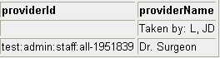

Example 8 – Patient Diagnosis
This example shows how to query patient diagnosis. The query executes against the RDF graph generated for the clinical document “Baseline Evaluation Note” and returns the patient identifier and their breast cancer diagnosis details:
PREFIX cda: <urn:hl7-org:v3/owl/DEFN/UV/CD/MT/000040#>
PREFIX rdf: <http://www.w3.org/1999/02/22-rdf-syntax-ns#>
PREFIX dt: <urn:hl7-org:v3/owl/DEFN/UV/DT/1.0#>
SELECT ?patientId ?diagnosis ?diagnosisOriginalText ?qualifierName ?qualifierValue ?observation ?observationOriginalText ?obsValue ?obsUnit ?diagnosisDate
FROM <http://cacis.nci.nih.gov/UUID>
WHERE {
?request cda:ClinicalDocument ?baselineNote .
?baselineNote+>cda:ClinicalDocument.title dt:ED.value 'Baseline Evaluation Note' .
?baselineNote+>cda:ClinicalDocument.component+>cda:Component2.structuredBody+>cda:StructuredBody.component ?sb_comp2_bag ?sb_comp2_item .
?sb_comp2_item+>cda:Component3.section cda:Section.entry ?entryBag .
?entryBag ?entryItems ?entryItem .
?entryItem rdf:type cda:Entry .
?entryItem+>cda:Entry.act+>cda:Act.code+>dt:CD.originalText dt:ED.value 'Breast cancer history' .
?entryItem+>cda:Entry.act cda:ClinicalStatement.entryRelationship ?entryRelationships .
?entryRelationships ?enrlpItems ?enrlpItem .
?enrlpItem+>cda:EntryRelationship.observation+>cda:Observation.value dt:CD.displayName ?diagnosis .
OPTIONAL {?enrlpItem+>cda:EntryRelationship.observation+>cda:Observation.value+>dt:CD.originalText dt:ED.value ?diagnosisOriginalText }
OPTIONAL {?enrlpItem+>cda:EntryRelationship.observation cda:ClinicalStatement.entryRelationship ?cs_enrlp_bag .
?cs_enrlp_bag ?cs_enrlp_items ?cs_enrlp_item .
?cs_enrlp_item+>cda:EntryRelationship.observation+>cda:Observation.code dt:CD.displayName ?observation
}
OPTIONAL {?cs_enrlp_item+>cda:EntryRelationship.observation+>cda:Observation.code+>dt:CD.originalText dt:ED.value ?observationOriginalText
}
OPTIONAL { ?cs_enrlp_item+>cda:EntryRelationship.observation cda:Observation.value ?cs_obs_value }
OPTIONAL {
{?cs_obs_value rdf:type dt:CD .
?cs_obs_value dt:CD.displayName ?obsValue }
UNION {?cs_obs_value rdf:type dt:ST .
?cs_obs_value dt:ED.value ?obsValue }
UNION {?cs_obs_value rdf:type dt:PQ .
?cs_obs_value+>dt:PQ.value dt:REAL.value ?obsValue .
?cs_obs_value+>dt:PQ.unit dt:CD.code ?obsUnit }
}
OPTIONAL { ?enrlpItem+>cda:EntryRelationship.observation+>cda:Observation.value dt:CD.qualifier ?qualifier_bag .
?qualifier_bag ?qualifier_items ?qualifier_item .
?qualifier_item+>dt:CR.name dt:CD.displayName ?qualifierName }
OPTIONAL { ?qualifier_item+>dt:CR.value dt:CD.displayName ?qualifierValue }
OPTIONAL { ?enrlpItem+>cda:EntryRelationship.observation+>cda:Observation.effectiveTime+>dt:IVL.low dt:TS.value ?diagnosisDate }
OPTIONAL {?baselineNote+>cda:ClinicalDocument.recordTarget+>rdf:_1+>cda:RecordTarget.patientRole cda:PatientRole.id ?patientIdBag .
?patientIdBag ?patientIdItems ?patientIdItem .
?patientIdItem dt:II.extension ?patientId }
}

Sample output: 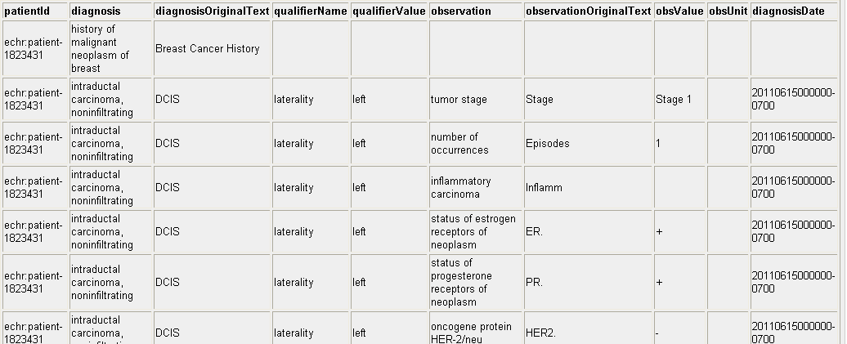

Example 9 – Patient Pathology Grade

Pathology Grade-Baseline Evaluation Note: This example shows how to query clinical document Baseline Evaluation Note for patient histologic grade and value:
PREFIX cda: <urn:hl7-org:v3/owl/DEFN/UV/CD/MT/000040#>
PREFIX rdf: <http://www.w3.org/1999/02/22-rdf-syntax-ns#>
PREFIX dt: <urn:hl7-org:v3/owl/DEFN/UV/DT/1.0#>
SELECT ?patientId ?pathologyGradeScheme ?pathologyGradeValue
FROM <http://cacis.nci.nih.gov/UUID-8>
WHERE {
OPTIONAL {?request cda:ClinicalDocument ?baselineNote .
?baselineNote+>cda:ClinicalDocument.title dt:ED.value 'Baseline Evaluation Note' }
OPTIONAL { ?baselineNote+>cda:ClinicalDocument.component+>cda:Component2.structuredBody cda:StructuredBody.component ?bln_component3Bag .
?bln_component3Bag ?bln_component3Items ?bln_component3Item .
?bln_component3Item+>cda:Component3.section cda:Section.entry ?bln_sectionEntryBag .
?bln_sectionEntryBag ?bln_sectionEntryItems ?bln_sectionEntryItem .
?bln_sectionEntryItem+>cda:Entry.act cda:ClinicalStatement.entryRelationship ?bln_entryBag .
?bln_entryBag ?bln_entryItems ?bln_entryItem .
?bln_entryItem+>cda:EntryRelationship.observation cda:ClinicalStatement.entryRelationship ?bln_entryRlnpBag .
?bln_entryRlnpBag ?bln_entryRlnpItems2 ?histologicGradeEnrlp .
?histologicGradeEnrlp+>cda:EntryRelationship.observation+>cda:Observation.code dt:CD.displayName 'histologic grade' .
?histologicGradeEnrlp+>cda:EntryRelationship.observation+>cda:Observation.code dt:CD.displayName ?pathologyGradeScheme .
?histologicGradeEnrlp+>cda:EntryRelationship.observation+>cda:Observation.value dt:ED.value ?pathologyGradeValue
}
OPTIONAL {?baselineNote+>cda:ClinicalDocument.recordTarget+>rdf:_1+>cda:RecordTarget.patientRole cda:PatientRole.id ?patientIdBag .
?patientIdBag ?patientIdItems ?patientIdItem .
?patientIdItem dt:II.extension ?patientId }
}

Sample output:
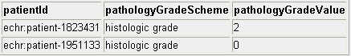

Pathology Grade-Post Surgery Summary: This example shows how to query clinical document Post Surgery Summary for patient SBR grade and value:
PREFIX cda: <urn:hl7-org:v3/owl/DEFN/UV/CD/MT/000040#>
PREFIX rdf: <http://www.w3.org/1999/02/22-rdf-syntax-ns#>
PREFIX dt: <urn:hl7-org:v3/owl/DEFN/UV/DT/1.0#>
SELECT ?patientId ?pathologyGradeScheme ?pathologyGradeValue
FROM <http://cacis.nci.nih.gov/UUID>
WHERE {
OPTIONAL {?request cda:ClinicalDocument ?postSurgerySummary .
?postSurgerySummary+>cda:ClinicalDocument.title dt:ED.value 'Post Surgery Summary' }
OPTIONAL {?postSurgerySummary+>cda:ClinicalDocument.component+>cda:Component2.structuredBody cda:StructuredBody.component ?pss_comp_bag .
?pss_comp_bag ?pss_comp_items ?pss_comp_item .
?pss_comp_item+>cda:Component3.section cda:Section.entry ?pss_entry_bag .
?pss_entry_bag ?pss_entry_items ?pss_entry_item .
?pss_entry_item+>cda:Entry.act cda:ClinicalStatement.entryRelationship ?pss_enrlp_bag .
?pss_enrlp_bag ?pss_enrlp_items ?pss_enrlp_item .
?pss_enrlp_item+>cda:EntryRelationship.observation cda:ClinicalStatement.entryRelationship ?pss_enrlp2_bag .
?pss_enrlp2_bag ?pss_enrlp2_items ?pss_enrlp2_item .
?pss_enrlp2_item cda:EntryRelationship.observation ?pssSBRGradeObs .
?pssSBRGradeObs+>cda:Observation.code+>dt:CD.originalText dt:ED.value 'SBR Grade' .
?pssSBRGradeObs+>cda:Observation.code+>dt:CD.originalText dt:ED.value ?pathologyGradeScheme
}
OPTIONAL {?pssSBRGradeObs+>cda:Observation.value+>dt:CD.originalText dt:ED.value ?pathologyGradeValue }
OPTIONAL {?postSurgerySummary+>cda:ClinicalDocument.recordTarget+>rdf:_1+>cda:RecordTarget.patientRole cda:PatientRole.id ?patientIdBag .
?patientIdBag ?patientIdItems ?patientIdItem .
?patientIdItem dt:II.extension ?patientId }
}

Sample output:
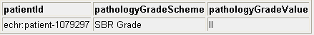

Pathology Grade – On Study Pathology: This example shows how to query clinical document On Study Pathology for patient pathology grade and value:
PREFIX cda: <urn:hl7-org:v3/owl/DEFN/UV/CD/MT/000040#>
PREFIX rdf: <http://www.w3.org/1999/02/22-rdf-syntax-ns#>
PREFIX dt: <urn:hl7-org:v3/owl/DEFN/UV/DT/1.0#>
SELECT ?patientId ?pathologyGradeScheme ?pathologyGradeValue_1 ?pathologyGradeValue_2
FROM <http://cacis.nci.nih.gov/UUID-8>
WHERE {
OPTIONAL {?request cda:ClinicalDocument ?onStudyPathology .
?onStudyPathology+>cda:ClinicalDocument.title dt:ED.value 'On-Study Pathology' }
OPTIONAL {?onStudyPathology+>cda:ClinicalDocument.component+>cda:Component2.structuredBody cda:StructuredBody.component ?osp_component3Bag .
?osp_component3Bag ?osp_component3Items ?osp_component3Item .
?osp_component3Item+>cda:Component3.section cda:Section.entry ?osp_sectionEntryBag .
?osp_sectionEntryBag ?osp_sectionEntryItems ?osp_sectionEntryItem .
?osp_sectionEntryItem+>cda:Entry.act cda:ClinicalStatement.entryRelationship ?osp_entryBag .
?osp_entryBag ?osp_entryItems ?osp_entryItem .
?osp_entryItem+>cda:EntryRelationship.observation+>cda:Observation.code+>dt:CD.originalText dt:ED.value ?pathologyGradeScheme.
?osp_entryItem+>cda:EntryRelationship.observation cda:Observation.value ?osp_ObsValue .
OPTIONAL{?osp_ObsValue rdf:type dt:ST .
?osp_ObsValue dt:ED.value ?pathologyGradeValue_1}
OPTIONAL{?osp_ObsValue rdf:type dt:CD .
?osp_ObsValue+>dt:CD.originalText dt:ED.value ?pathologyGradeValue_2}
FILTER(?pathologyGradeScheme= 'Nuclear grade' || ?pathologyGradeScheme= 'SBR Grade' || ?pathologyGradeScheme= 'Mitotic count' || ?pathologyGradeScheme= 'Tubule / papilla formation' || ?pathologyGradeScheme= 'Total points')
}
OPTIONAL {?onStudyPathology+>cda:ClinicalDocument.recordTarget+>rdf:_1+>cda:RecordTarget.patientRole cda:PatientRole.id ?patientIdBag .
?patientIdBag ?patientIdItems ?patientIdItem .
?patientIdItem dt:II.extension ?patientId }
}

Sample output:
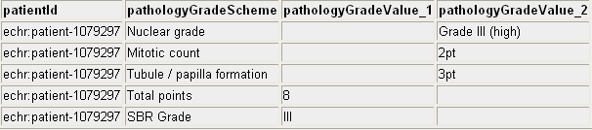

References
caCIS Canonical Model Implementation Guide | https://ncisvn.nci.nih.gov/svn/cacis/CACIS/trunk/technical_artifacts/ig/TRIM_CDA.xls
caCIS IP to CDW Design | https://wiki.nci.nih.gov/display/caEHR/caCIS+IP+to+CDW+Design
Virtuoso Software | http://virtuoso.openlinksw.com/
SPARQL specification | http://www.w3.org/TR/rdf-sparql-query/
HL7 CDA | http://www.hl7.org/implement/standards/product_brief.cfm?product_id=7
C32 CCD | http://www.hitsp.org/ConstructSet_Details.aspx?&PrefixAlpha=4&PrefixNumeric=32
HL7 datatypes | http://www.hl7.org/v3ballot/html/infrastructure/datatypes_r2/datatypes_r2.html
HL7 ISO datatypes | http://www.hl7.org/v3ballot/html/infrastructure/its_r2/ISO%2021090%20Healthcare%20Datatypes.pdf

In the initial TRANSCEND pilot implementation, this functionality was designed but not fully implemented.
In the initial TRANSCEND pilot implementation, this functionality was designed but not implemented.
Adding extension attributes to the canonical syntax will also require modifying the transform used to convert canonical instances into RDF that can be loaded into the triple-store repository.

