
caCIS Scope, Requirements and Use Cases

April 3, 2013
v2.9

Approvals / Signoff:
Robert Shirley
Dr. Christo Andonyadis
Dr. Caterina Lasome
Dr. Ken Buetow
 |  | Signature |  | Date

Document Revisions

Revision | Revised By | Description | Date
Working Draft 1.0 | Kunal Modi, Harsh Marwaha, Vijay Parmar, Raghu Chintalapati, | First Draft | 5/20/2011
Working Draft 1.1 | Kunal Modi, Harsh Marwaha, Vijay Parmar, Raghu Chintalapati, Santosh Joshi | Second Draft | 6/20/2011
1.9 | Lloyd McKenzie, Kunal Modi, Harsh Marwaha, Vijay Parmar, Raghu Chintalapati, Santosh Joshi | Incorporated Internal Review Comments | 6/24/2011
2.0 | Harsh Marwaha, Vijay Parmar, Santosh Joshi | Changes to incorporate reviewer comments:  a. Added Req./Use Case cross reference  b. Unique-numbered use case requirements  c. Updated Glossary  d. Added TRANSCEND – Transmit data to a physician use case  e. Other wording changes, clarifications | 7/8/2011
2.1 | Kunal Modi | Updated to based on design and implementation details | 11/17/2011
2.5 | Santosh Joshi | a. Updated to add Security Administration and SFTP related requirements.  b. Incorporated changes related to transition from Tolven to THE Force (Diagrams have not been updated yet) | 6/29/2012
2.6 | Santosh Joshi | a. Corrected requirements numbering in section 3.1  b. Added use case related to Administration Module Login. Updated other Security Administration use cases appropriately. | 8/30/2012
2.7 | Greg Raley | Added scope assumption that primary browser support is for FireFox | 10/22/2012
2.8 | Greg Raley | Added LLP transport protocol for transmitting Clinical Exchange Instances. Changed the HL7 V2 format for sharing clinical data from HL7 V2 Document to HL7 V2 MDM. Removed limitation that sharing of clinical data in HL7 V2 only applies to the Clinical Staging Note. | 11/14/2012
2.9 | Greg Raley | Replaced clinical notes references with new Trial Summary note. | 4/3/2013

Table of Contents
1. Overview 5
2. Scope 6
2.1. Scope Summary 6
2.2. Scope Assumptions 7
3. Requirements 8
3.1. High-Level Requirements 8
3.2. Derived Functional Requirements 9
3.3. Non-Functional Requirements 10
4. Use Cases 12
4.1. Business Event Flow (using TRANSCEND as an example) 12
4.2. Terms Used in Use Cases 13
4.3. Semantic Adapter Use Cases 15
4.3.1. Transform Data for Integration Platform 15
4.4. Integration Platform Use Cases 27
4.4.1. Accept Data from the Semantic Adapter 27
4.4.2. Make document available (NAV/XDS Retrieve) with security 31
4.4.3. Transmit document (Secure E-mail/Secure FTP) 36
4.5. Clinical Data Warehouse Use Cases 40
4.5.1. Load Data into the warehouse 40
4.5.2. Ad hoc Query with security 43
4.5.1. <Future/TBD > Publically available data (de-identified) 46
4.6. General Use Cases 47
4.6.1. Error Flow 47
4.7. Security Administration User Interface Use Cases 50
4.7.1. Access Security Administration Module 50
4.7.2. Manage XDS Recipients 52
4.7.3. Manage Secure Email Recipients 55
4.7.4. Manage Secure FTP Recipients 57
4.7.5. Manage Clinical Data Warehouse (CDW) Users 60
4.8. TRANSCEND Integration Use Cases 63
4.8.1. Transmit data to a trading partner 64
4.8.2. Transmitting data for warehousing and analysis 69
4.8.3. Transmit data to a physician 72
5. Functional Requirements to Use Case mapping 75
6. Non-Functional Requirements to Use Case Mapping 77

Overview
The caBIG® Clinical Information Suite (caCIS) project is focused on two things: enabling the sharing of clinical data from source Clinical Applications with target EHR systems, in multiple standard formats such as CDA R2, RIM ITS and HL7v2; and transforming the data received from the source Clinical Application into a standard canonical information model and storing it for subsequent analysis by researchers.
While the TRANSCEND's THE Force system will be the first source Clinical Application to use the caCIS solution, the solution will be designed to be generic and extensible such that it can be integrated with other source systems in future.
The purpose of this document is to clearly outline the scope of the caCIS project, functional and non-functional requirements that need to be met by the solution and also to provide system use cases for each component of the solution.

Scope
The following section provides the details regarding the in-scope and out-of-scope items for the project. It also lists assumptions on which the scope is based.

Scope Summary
- Provide the ability for a source system such as TRANSCEND to securely share its clinical data with authorized external trading partners using standards-based formats and terminologies. Initially, data must be sharable as:
  - HL7 Clinical Document Architecture Release 2 (CDA) containing CCD Sections
  - An HL7 XML Implementable Technology Specification (RIM-ITS) instance
  - HL7 v2 MDM
- Provide the ability for the information shared by a source system to be captured and stored such that it can be queried in an ad hoc manner by authorized users.
- Verify the generic solution by configuring and testing these capabilities using TRANSCEND's THE Force system.

Table 1 - In-Scope/Out-of-Scope Items
Items | In-Scope / Out-of-Scope | Source
Receive data from source systems such as TRANSCEND and transform for semantic interoperability | In-Scope | Charter
Ensure caCIS integration solution can transmit the selected standard interoperability formats to trading partners | In-Scope | Scope Statement
Persist data obtained from TRANSCEND or similar source system for research and analysis | In-Scope | Presentation to NCI Management (06/09/11)
Implement Identifier Resolver and Vocabulary Lookup | Out-of-Scope | Presentation to NCI Management (06/09/11)
Ensure TRANSCEND’s integration platform can accept the selected standard interoperability formats | Out-of-Scope | Scope Statement
Ensure one or more external EHRs can accept to the outputs from TRANSCEND | Out-of-Scope | Scope Statement

Scope Assumptions
- Patient consent, user authentication and authorization, and business associate agreements (i.e., HIPAA) for data exchange is sole responsibility of source clinical application.
- Format of the data exported from the source clinical system, such as TRANSCEND xml files in native format, will not be modified during the duration of this project once agreed.
- Source clinical system, such as TRANSCEND’s THE Force, will be modified to allow the user to initiate the export of data and invoke the service call on the Semantic Adapter. This work will be completed by the source clinical system team.
- Proposed solution will include semantic coding of the TRANSCEND data elements (Patient-Centric Outcome + Trial Summary notes).
- HL7 v2 instances will be treated as “documents” – no tight integration around trigger events, acknowledgements, etc.
- Automated configuration of notification paths via publish-subscribe or similar mechanisms is out of scope.
- The minimal granularity of data will be at a section level, support for lower granularity will be handled by custom code in the semantic adapter.
- All exports will be treated as “snapshot”, conveying the minimal set of data needed to populate at least one section in the Canonical format.
- Audit logs are not shared across the enterprise.
- Integration of data from multiple versions of the same sections is the responsibility of the source system (or a customized semantic adapter).
- The data warehouse will not be tuned/ optimized for particular query types.
- De-identified/anonymized access is out of scope and can be handled in future by setting up a separate data mart loaded from the data warehouse.
- While support for all common browsers is desired, browser-based functionality need only work in FireFox 4.x or later
- Security for LLP transport protocol is out of scope. 2TRANSCEND is expected to use VPN tunneling to provide security for messages sent using LLP. Other methods are available.

Requirements

High-Level Requirements
The following are requirements derived from the Project Charter and multiple discussions with NCI management. These requirements have been refined through a series of internal discussions.

Table 2 - High-Level Requirements
REQ# | Requirement Description
0001 | The caCIS solution SHALL provide the ability to accept, transform and send relevant clinical data from from clinical systems, including THE Force, to another system such as an EHR.
0002 | The caCIS solution SHALL provide the ability to share clinical data in CDA R2 format containing CCD Sections.
0003 | The caCIS solution SHALL provide the ability to share clinical data in HL7v2 MDM format.
0004 | The caCIS solution SHALL provide the ability to share clinical data as RIM ITS-compliant XML.
0005 | The caCIS solution SHALL be extendable to support additional exchange formats in future through the creation of additional transforms.
0006 | The caCIS solution SHALL provide ability to share clinical data through an implementation of the XDS-b (Cross Enterprise Document Sharing-b) and NAV (Notification of Document Availability) specifications.
0007 | The caCIS solution SHALL support sending clinical data over Secure FTP, Secure Email, and LLP
0008 | The caCIS solution SHALL support accepting an export from a clinical system such as TRANSCEND, transformation of that data to a standards-based canonical form and persistence of that data for subsequent query.
0009 | The caCIS solution SHALL support ad hoc query on data received from clinical systems, including TRANSCEND, for analysis and research.
0010 | The caCIS solution SHALL provide the necessary transformation to convert TRANSCEND Trial Summary note and patient-centric-outcome related data elements to canonical form.
0011 | The caCIS solution SHALL be capable of storing native TRANSCEND data for ad hoc query to support those data elements which will not be converted to canonical within the scope of this project.
0012 | The caCIS solution SHALL ensure that users are authenticated to query the data and they are able to query only the data they are authorized to query.
0013 | The caCIS solution SHALL have ability to integrate with a business intelligence reporting tool.

Derived Functional Requirements
As a result of analyzing the scope and initial high-level requirements, several additional functional requirements have been derived.
Table 3 - Derived Functional Requirements
REQ# | Requirement Description
DFR-0001 | A source clinical system, such as TRANSCEND, SHALL provide the ability to initiate a request to send clinical data (Data Sharing Request) to another remote EHR system.
DFR-0002 | The caCIS solution SHALL provide the ability to receive data from TRANSCEND or any other clinical system on an “ad hoc” basis.
DFR-0003 | The caCIS solution SHALL transform supported data elements from the source system’s native format as part of the the Data Sharing Request in to the Canonical Data Format instance.
DFR-0004 | A Data Sharing Request SHALL include a Site ID, and a Patient ID.
DFR-0005 | A Data Sharing Request MAY include a Study ID, a Trading Partner ID and additional information based on the source clinical system's business rules.
DFR-0006 | The caCIS solution SHALL determine if the canonical representation of the received Clinical Information is complete and correct via schema and Schematron validation. If it is incomplete or invalid, the system SHALL send an error back to the source clinical system.
DFR-0007 | The caCIS solution SHALL transform clinical information to HL7-aligned datatypes and values in a specified format (Canonical Data Format). The solution must provide the ability to persist this information.
DFR-0008 | The caCIS solution SHALL transform content from Canonical Data Format instances to create Clinical Exchange Instances.
DFR-0009 | The caCIS solution SHALL transmit Clinical Exchange Instances according to XDS/NAV standard profiles.
DFR-0010 | The caCIS solution SHALL transmit Clinical Exchange Instances via secure email, secure file transfers (ftp), and/or LLP as requested by the initiating source system.
DFR-0011 | The caCIS solution SHOULD transmit an error notification to the sender if a Clinical Exchange Instance is NOT valid.
DFR-0012 | The caCIS solution SHALL provide a Clinical Data Warehouse where Canonical Data Format instances and other data shared by clinical systems including TRANSCEND will be persisted.
DFR-0013 | The caCIS solution SHALL store each Canonical Data Format instance into the Clinical Data Warehouse after transforming it from Internal Clinical Format and validating it.
DFR-0014 | The caCIS solution SHALL store each native source instance into the Clinical Data Warehouse, if not all data has been converted to Canonical.
DFR-0015 | For a Data Sharing Request, the Canonical Data Format SHALL at a minimum contain the data that is required to generate the requested document format. If it is invalid, The caCIS solution SHALL report an error to the invoking clinical application.
DFR-0016 | The caCIS solution SHALL transform a Canonical Data Format instance derived from a Clinical Exchange Instance to formats for sharing including CCD, RIM ITS and HL7 V2 MDM.
DFR-0017 | The caCIS solution SHALL provide an interface to execute ad hoc queries against the clinical data persisted in the Clinical Data Warehouse.
DFR-0018 | The caCIS solution SHALL provide an interface for the administration of XDS-NAV recipients.
DFR-0019 | The caCIS solution SHALL provide an interface for the administration of Secure Email recipients.
DFR-0020 | The caCIS solution SHALL provide an interface for the administration of Secure FTP recipients.
DFR-0021 | The caCIS solution SHALL provide an interface for the administration of Clinical Data Warehouse users.

Non-Functional Requirements

Table 4 - Non-Functional Requirements
REQ# | Requirement Description
Security Requirements
NFR-0001 | The caCIS solution SHALL transmit, receive and import files and messages using secure methods.
NFR-0002 | The caCIS solution SHALL encrypt Clinical Exchange Instances as part of the transmission process.
NFR-0003 | The caCIS solution SHALL authenticate the source of a Clinical Exchange Instance prior to further processing.
NFR-0004 | The caCIS solution SHALL authenticate ad hoc query requests against the Clinical Data Warehouse. Users SHALL only see data they are authorized to see.
NFR-0005 | The caCIS solution SHALL provide ability to configure authorization to query data stored in the Clinical Data Warehouse for a Study, Site and/or Patient.
NFR-0006 | The caCIS solution SHALL ensure that access to data in the Clinical Data Warehouse from any service or application interface is secured and users/systems are able to access only the data they are authorized to access.
NFR-0007 | The caCIS solution SHALL ensure that file system hosting the database and the log files is encrypted.
Performance Requirements
 | None identified at this time.
Scalability Requirements
 | None identified at this time.
Persistence Requirements
NFR-0008 | The caCIS solution SHALL provide the ability to persist canonical data instances in the Clinical Data Warehouse
NFR-0009 | The caCIS solution SHALL provide the ability to persist unstructured clinical data (data not in canonical data format) in the Clinical Data Warehouse.
NFR-0010 | The caCIS solution SHALL persist log files, XDS repository file and Clinical Data Warehouse files in an encrypted manner.
Transport Requirements
 | None identified at this time.
Auditing Requirements
NFR-0011 | The caCIS solution SHALL log the following events for all technical components that comprise the solution:  - Receipt of data  - Transmission of data  - Errors
NFR-0012 | The caCIS solution SHALL at a minimum log the following information for each log entry:  - Date and time of the event  - Identification of the system or user request that caused the event  - Type of the event (For example request to share data or transmission of data)
Technical Requirements
NFR-0013 | The caCIS solution SHALL have ability to integrate the Clinical Data Warehouse with a business intelligence reporting tool. (Note: Actual implementation/integration with a BI reporting tool is not in scope)

Use Cases
The following are an elaboration of the use cases identified by NCI. The use cases are system centric and cover all the scenarios currently outlined in the requirements and scope section above. This section provides the overall business flow and individual use cases that outline the functionality of the components in the business flow.

Business Event Flow (using TRANSCEND as an example)

Figure 1: Overall Business Event Flow
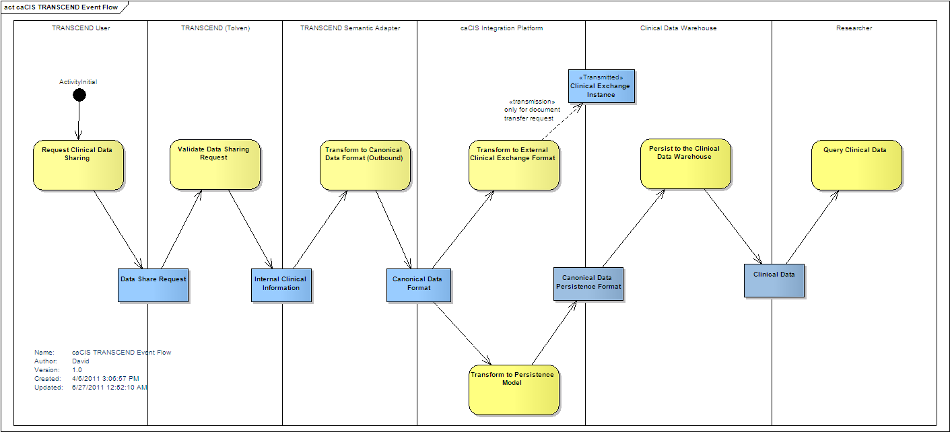

Table 5: TRANSCEND Event Flow Description of Events
Activity | Description
Request Clinical Data Sharing | This is when a TRANSCEND User elects to “push” clinical information to an external EHR, such as EPIC. They will enter information for a Data Share Request to be evaluated by THE Force (TRANSCEND's CDMS).
Validate Data Sharing Request | It is expected that THE Force will validate the user’s authority to make such a request. If it is valid, THE Force will push all relevant content to the Semantic Adapter as a service call with one or more XML documents in the native format as payload. Non-valid requests will go back to the TRANSCEND User for resolution.
Transform to Canonical Data Format (Outbound) | Based on the receipt of Internal Clinical Information, the Semantic Adapter converts the information to the Canonical Data Format. (Each implementation will need a semantic adapter configured to handle that specific internal clinical information characteristics and content.) The information in the Canonical Data Format is passed to the caCIS Integration Platform.
Transform to External Clinical Exchange Format | Based on the desired Trading Partner recipient, the caCIS Integration Platform takes information from the Canonical Data Format to create a Clinical Exchange Instance that is made available to the Trading Partner (the method can vary). For the caCIS Project, this is when TRANSCEND’s CDA, CCD, RIM-ITS, and HL7 V2 MDM documents are generated and communicated.
Persist to the Clinical Data Warehouse | The caCIS Integration Platform persists all the information that it has received in the Canonical Data Format (along with the actual source data) into a Clinical Data Warehouse. This data is then made available to other researchers for analysis

Terms Used in Use Cases
The following are terms commonly used throughout the document:
Table 6 – Terminology used in use case below
Term | Definition
Canonical format | The standards-based target data format that is used as a basis for creation of exchange instances and is also used to populate the Clinical Data Warehouse.
Integration Platform (IP) | The overall caCIS infrastructure component that manages the verification of canonical information, generation and routing of exchange instances and management of transmission of data to the Clinical Data Warehouse. This is the component exposed to external systems involved in data exchange
Semantic Adapter (SA) | The component that transforms Internal Clinical Data into the Canonical format.
Source System | These are clinical systems which are used for either conducting clinical care or clinical research and that may act as data sources. E.g. Tolven, THE Force, Velos, Oracle Clinical, Medidata, EPIC etc.
OpenXDS | OpenXDS implements the Cross-Document Sharing (XDS) Registry and Repository actors. It is used for delivery of data to recipient systems.
Document Router | The caCIS integration platform component responsible for managing the creation of exchange instances and delivering them to their intended recipients.
Canonical Model Processor | The caCIS infrastructure component responsible for receiving information from various source systems (via their individual Semantic Adapter), validating the input data, transforming it into the warehouse persistence format and passing it to the clinical data warehouse.
Clinical Data Warehouse | The repository where the Integration Platform persists clinical data for ad hoc querying.
Identifier Resolver | System/Services with capability to resolve identities from local to standardized identifiers (e.g. CTRP services)
Vocabulary Lookup | Systems/Services able to translate codes to standardized code systems.
Recipient System | These are clinical systems that would like to receive clinical data. These systems could be conducting clinical care, clinical research or regulatory organizations.
User | A human being who interacts with the system to initiate some sort of process, such as the transformation of data, performance of a query, etc.
Clinical Exchange Instance | A generated instance to be sent over the wire (e.g. v2 instance, RIM ITS instance, etc.)

Semantic Adapter Use Cases
The caCIS Semantic Adapter (SA) can receive and transform data from multiple clinical care or clinical research systems into the Canonical format for the caCIS integration platform. This use case is to detail the requirements for the caCIS Semantic Adapter; it does not cover the subsequent persistence and export of the data in different standards-based packaging formats, e.g. CDA, CCD, RIM ITS, etc. The transformations that are used in the Semantic Adapter are system specific. These transformations depend on the data format used by the source systems.

Transform Data for Integration Platform
Description
This use case describes the functionality of the caCIS Semantic Adapter that transforms clinical data from source systems into the canonical format for consumption by the Integration Platform.
BUSINESS/TECHNICAL PRIORITY
The caCIS Integration Platform’s Canonical Model Processor component depends on the Semantic Adapter to provide clinical data in the canonical format.
IDENTIFY REQUIREMENT(S)
- Requirement SA-1: The Semantic Adapter shall be able to transform the clinical data generated by the source system into the canonical format.
- Requirement SA-4: The Semantic Adapter shall be able to accept clinical data in multiple formats including XML, HL7v2, HL7v3, CSV, and other user defined formats.
- Requirement SA-5: The Semantic Adapter shall be able to accept clinical data in multiple transport protocols such as http, jms, and ftp (based on the implementation technology/platform selected). The Semantic Adapter should also be capable of accessing a database to retrieve data.
IDENTIFY RELATED USE CASE(S)
- Integrate with Identifier Resolver
- Integration with Vocabulary Resolver
- Error Flow Use cases
Storyboard
Note: The storyboard is a scenario and can be extrapolated to include other formats and document types.
The Source System wants to share clinical data with a recipient system. The Source system generates HL7v2 based clinical data while the recipient system accepts clinical data in CDA format. The source system sends the clinical data in HL7v2 format to the Semantic Adapter. The Semantic Adapter converts the data into the canonical format and sends it to the Integration Platform for transformation to CDA and transmission to the intended recipient.
Pre-conditionS
- A mapping is defined in the Semantic Adapter to transform incoming clinical data into the Canonical format.
- The Semantic Adapter is configured to retrieve Standard Identifiers using the local study identifier, site identifier and/or other identifiers and embed them in the transformed instance sent to the Integration Platform. This pre-condition will be applicable only when the corresponding use case Integrate with Identity Resolver and requirement SA-2 is implemented.
- The Semantic Adapter is configured to retrieve standards code translations for local codes embed them in the transformed instance sent to the Integration Platform. This pre-condition will be applicable only when the corresponding use case Integrate with Vocabulary Lookup and requirement SA-3 is implemented.
- The source system is interfaced with the Semantic Adapter to send clinical data to it.
- The Semantic Adapter is configured to be able to send data in canonical format to an Integration Platform.
- Security is enabled and trust is established between the Source System and the Semantic Adapter and between the Semantic Adapter and the Integration Platform.
USE CASE ACTORS
- Source System
- Semantic Adapter
- Integration Platform
- Identifier Resolver
- Vocabulary Lookup
FLOW OF EVENTS
- A trigger event occurs in the source system(s) to generate and push all the clinical data for a given patient to the Semantic Adapter.
- Semantic Adapter gets the standard identifiers associated with the data from the Identifier Resolver using the local identifiers from the incoming data.
  - Use Case inclusion: Integrate with Identifier Resolver
- Semantic Adapter gets target (canonical model) vocabulary associated with data from Vocabulary Lookup using the native vocabulary from incoming data.
- Use Case inclusion: Integrate with Vocabulary Lookup
- The Semantic Adapter transforms the data into the canonical format and includes the standard identifiers and codes in the data. At a minimum, the Semantic Adapter will create at least one complete and valid section of the canonical model to be able to transmit the content to the Integration Platform.
- If not provided by the source system then the Semantic Adapter creates the metadata portion of the message based on the transformed data (canonical model), extracting the study, site and patient identifiers.
- The Semantic Adapter constitutes an outbound request containing the following four portions:
- Metadata section
- Original Source data
- Transformed data (in the Canonical format)
- The Semantic Adapter forwards the message to the Integration Platform.
NOTE: A semantic adapter can be configured to receive data from a single source system or multiple source systems. The behavior is exactly the same both the cases. The Semantic Adapter transforms the received source data into the canonical model and transmits it to the Integration Platform.
ALTERNATE FLOW OF EVENTS – Semantic Adapter polls for data
- Semantic Adapter polls the source system for clinical data that is available.
- Semantic Adapter pulls the data from the source system.
- Continue with step #2 of main flow
ALTERNATE FLOW – Semantic Adapter accepts a document transfer request along with input data
- Semantic Adapter accepts the incoming data from Source System which is meant to be exchanged with other recipients. These are generally documents such as clinical or trial summary notes related to a patient.
- Perform steps 2-5 from the main flow
- The Semantic Adapter now constitutes a request containing four portions:
  - Document transfer instructions
  - Metadata section
  - Original Source data
  - Transformed data (in the Canonical format)
- Resume with step 7 of the main flow
ERROR FLOW OF EVENTS
- Source system sends invalid or incomplete data to the Semantic Adapter
  - The Semantic Adapter responds with the error to the Source System.
- Source data cannot be converted into the canonical format
  - The Semantic Adapter responds with an error to the Source System that the data was not transformed and send to the Canonical Model Processor.
- Source System gets an error sending data to the Semantic Adapter
  - The Source system notifies that the transmission of clinical data was not successful.
- There is an error converting local identifiers to standard identifiers in the Identifier Resolver
  - The Semantic Adapter passes the error from the Identifier Resolver process within an error to the Source System that there was a problem converting identifiers to Canonical format.
- There is an error converting local codes to standard identifiers in the Vocabulary Lookup process
  - The Semantic Adapter passes the error from the Vocabulary Lookup process within an error to the Source System that there was a problem converting codes to Canonical format.
- Semantic Adapter is unable to send data to the Integration Platform
  - The Semantic Adapter responds with an error to the Source System that the data was not transformed and send to the Integration Platform.
- Source system does not provide sufficient data to generate a section of the canonical data. This assumes that the canonical data format is the CCD and at a minimum a CCD section is needed to be created for sending to the Integration platform.
  - The Semantic Adapter responds with the error to the Source System.
- Semantic Adapter gets an error polling the source system
  - The Semantic Adapter logs the error.
Post-conditionS
- The caCIS Integration Platform has a copy of the original source data, a Canonical representation of that data, any document routing instructions, and metadata about the transmitted data.
INCLUSIONS
Integrate with Identifier Resolver
Integrate with Vocabulary Lookup
DIAGRAM
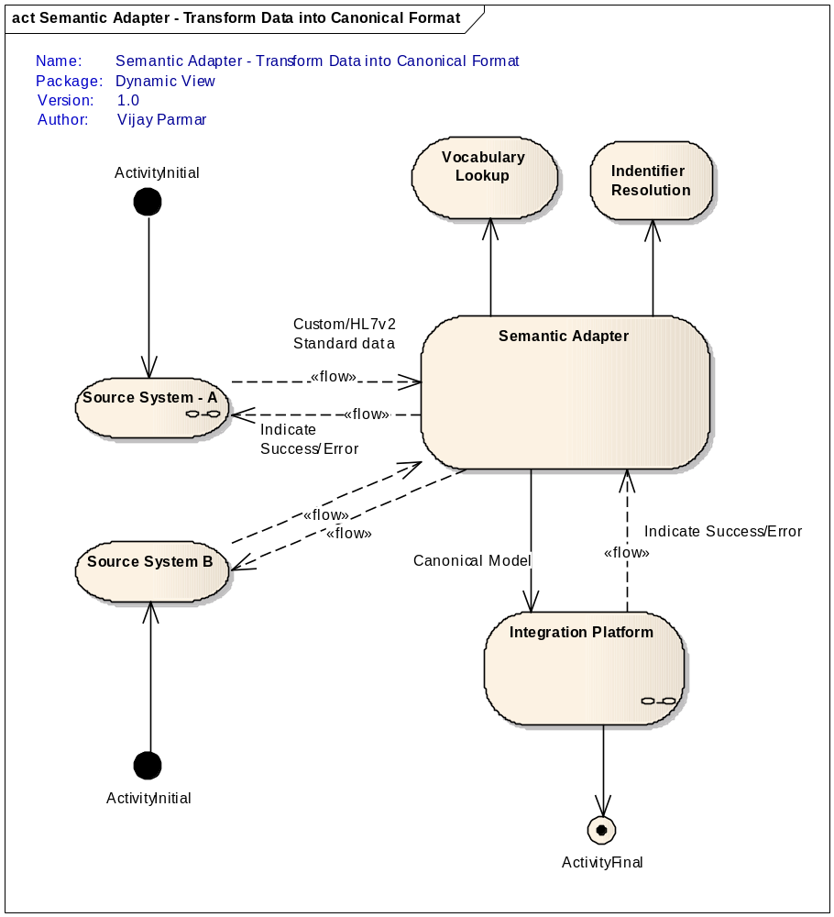

Integrate with Identifier Resolver
Description
This use case describes the functionality of the caCIS Semantic Adapter that provides the capability to resolve identifiers from local to standardized identifiers.
Note: This is an optional use case and will be enabled only if it is needed. Current project scope includes just the design for this use case.
BUSINESS/TECHNICAL PRIORITY
The caCIS Clinical Data Warehouse depends on the Semantic Adapter to generate data in the Canonical format with required standardized identifiers to facilitate cross study/patient analysis.
IDENTIFY REQUIREMENT(S)
- Requirement SA-I-1: The Identifier Resolver shall be able to convert local identifiers to standard identifiers.
- Requirement SA-I-2: The Semantic Adapter shall propagate any errors interacting with the Identifier Resolver.
- Requirement SA-2: The Semantic Adapter shall be able to retrieve standard identifiers and embed them in the transformed Canonical data sent to the Integration Platform.

IDENTIFY RELATED USE CASES(S)
- Transform Data into Canonical format
- Error Flow Use cases
Storyboard
The Source system generates HL7v2 based data while the recipient system accepts data in CDA format. The source system sends the data in HL7v2 format to the Semantic Adapter. The Semantic Adapter converts the data into the canonical format. The Semantic Adapter sends the local identifiers from the data to Identifier Resolver. The Identifier Resolver converts local identifiers to standardized identifiers and sends it to Semantic Adapter. The Semantic Adapter uses the standardized identifiers in the Canonical format and sends the converted data to the Integration Platform.
Pre-conditionS
- The identifiers used by the Source System are verified to match uniquely with Identifier Resolver.
- The Semantic Adapter is configured to retrieve Standard Identifiers using the local study identifier, site identifier and/or other identifiers from the Identifier Resolver.
- The Semantic Adapter is configured to embed the standard identifiers in the transformed data sent to the Integration Platform.
- Security is enabled and trust is established between the Identifier Resolver and the Semantic Adapter.
USE CASE ACTORS
- Semantic Adapter
- Identifier Resolver
FLOW OF EVENTS
- Data in local format is received by the Semantic Adapter.
- The Semantic Adapter obtains the local Identifiers associated with the data.
- The Semantic Adapter sends the local identifiers to the Identifier Resolver
- The Identifier Resolver resolves the local identifiers to standard identifiers.
- The Identifier Resolver returns the standard identifiers to Semantic Adapter
- The Semantic Adapter transforms the data into the canonical format and substitutes the standard identifiers in the data for the corresponding local identifiers.
ERROR FLOW OF EVENTS
- Identifier Resolver is unable to resolve local identifiers to standard identifiers
  - The Identifier Resolver responds with an error to the Semantic Adapter that the identifier is not resolvable.
Post-conditionS
- The local identifiers are converted to standard identifiers
DIAGRAM
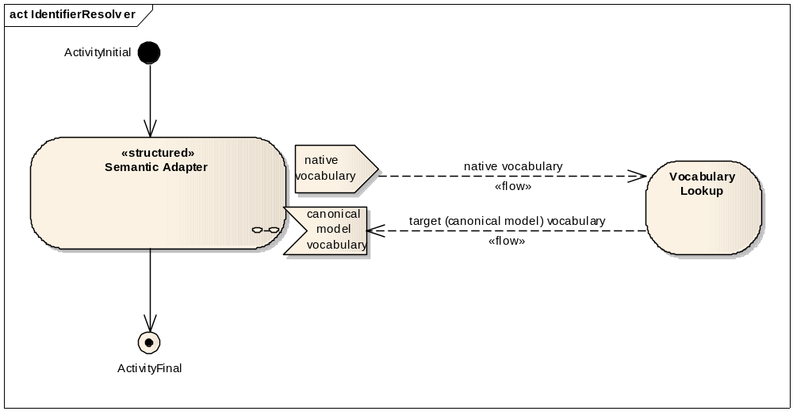

Integrate with Vocabulary Lookup
Description
This use case describes the functionality of Vocabulary Lookup that provides capability to map from native vocabulary to canonical model vocabulary.
Note: This is an optional use case and will be enabled only if it is needed. Current project scope includes just the design for this use case.
BUSINESS/TECHNICAL PRIORITY
The caCIS Integration Platform depends on the Semantic Adapter to generate data in the canonical format with vocabulary mapped from native to Canonical.
IDENTIFY REQUIREMENT(S)
- Requirement SA-V-1: The Vocabulary Lookup shall have the capability to convert the input data which uses the native vocabulary to canonical model vocabulary.
- Requirement SA-V-2: The Semantic Adapter shall propagate any errors interacting with the Vocabulary Lookup.
- Requirement SA-V-3: The Semantic Adapter shall be able to retrieve standard codes and embed them in the transformed Canonical data sent to the Integration Platform.

IDENTIFY RELATED USE CASES(S)
- Transform Data into Canonical format
- Error Flow Use cases
Storyboard
The Source System wants to share data with a recipient system. The Source system generates HL7v2 based data while the recipient system accepts data in CDA format. The source system sends the data in HL7v2 format to the Semantic Adapter. The Semantic Adapter refers the Vocabulary Lookup to convert native vocabulary to canonical model vocabulary. The Semantic Adapter converts the data into the canonical format and sends it to the Integration Platform.
Pre-conditionS
- The codes used by the Source System are known to the Vocabulary Lookup engine.
- The Semantic Adapter is configured to connect to a vocabulary service to perform the vocabulary lookup.
- The Semantic Adapter is configured to embed the standard codes in the transformed data sent to the Integration Platform.
USE CASE ACTORS
- Semantic Adapter
- Vocabulary Lookup
FLOW OF EVENTS
- Data in local format is received by the Semantic Adapter.
- The Semantic Adapter obtains the codes and the associated native code systems from the data that is to be transformed.
- The Semantic Adapter invokes the Vocabulary Lookup service with passing the code and the native code system information as the input. It also provides the target code system (which corresponds to the code system specified in the Canonical model).
- The Vocabulary Lookup returns the corresponding code in the Canonical code system based on the input data.
- The Semantic Adapter uses this code while creating the output data in the Canonical format.
ERROR FLOW OF EVENTS
- Native vocabulary cannot be converted to canonical model vocabulary
  - Vocabulary Lookup responds with an error to the Semantic adapter that the canonical model code system was not found.
Post-conditionS
- The output data from Semantic Adapter will include data converted from native vocabulary to canonical model vocabularies.
DIAGRAM
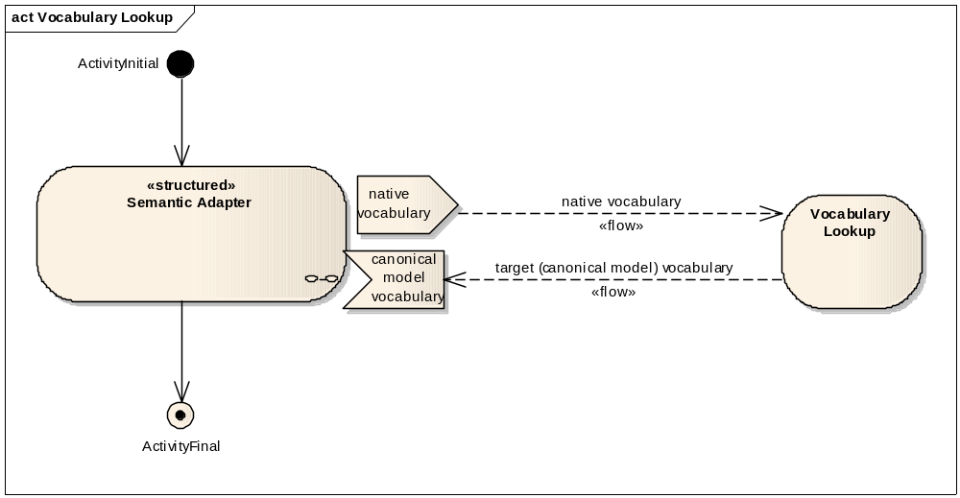

Integration Platform Use Cases
caCIS Integration Platform will accept clinical information from various source systems via semantic adapters. Integration Platform validates the incoming data against the canonical model format. Integration Platform is required to store this information in a clinical data warehouse for subsequent querying and analysis. Once persisted, this information is available for querying via a data warehouse interface in a secured fashion. Document transfer requests cause clinical data to be formatted in various standard exchange syntaxes and sent to desired recipients. Integration Platform provides restricted access to trusted clinical sources only.

Accept Data from the Semantic Adapter
Description
This use case describes the functionality of the caCIS Integration Platform that accepts data from Semantic Adapter(s) in canonical format, validates the incoming data against the canonical model format, persists the data into the warehouse and transmits converted data to intended recipients (if specified).
BUSINESS/TECHNICAL PRIORITY
The Integration Platform is a key component of the caCIS. The Integration Platform provides the interface to accept canonical data from various source systems via respective Semantic Adapters. This data is then made available for comparative analysis via the warehouse or transmitted to the identified recipients as documents.
IDENTIFY REQUIREMENT(S)
- Requirement IP-1: The caCIS Integration Platform shall accept data in the canonical format. This data can be in chunks (which correspond to one or more sections in the Canonical format) or as a complete record.
- Requirement IP-2: The caCIS Integration Platform shall accept data coming from various sources and send it to Clinical Data Warehouse for persistence.
- Requirement IP-3: The caCIS Integration Platform shall accept document transfer requests and create documents in the specified formats and transmit them to identified recipients using specified protocols.
- Requirement IP-4: The caCIS Integration Platform shall restrict access to only allowed Semantic Adapters to provide data the Integration Platforms.
IDENTIFY RELATED USE CASES(S)
- Make Document Available (with Security) use case
- Transmit Document (Secure Email/ Secure FTP/) use case
- Semantic Adapter Use cases
- Clinical Data Warehouse Use cases
- Error Flow Use cases
Storyboard
The Semantic Adapter sends canonical and native format data to the Integration Platform along with the metadata as well as optional document routing instructions. If the Semantic Adapter requested a document transfer request, the Integration Platform creates a document and sends the document based on pre-defined protocol. The recipient system accepts the data. The Integration Platform stores the data in Clinical Data Warehouse.
Pre-conditionS
- The Semantic Adapter is configured to send data in Canonical format to the Integration Platform.
- Security is enabled and trust is established between the Semantic Adapter and the Integration Platform and between the Integration Platform and the Clinical Data Warehouse.
- Integration Platform is configured to persist data in Clinical Data Warehouse
- Integration Platform has been configured to be able transmit documents to the intended recipient systems.
USE CASE ACTORS
- Semantic Adapter
- Clinical Data Warehouse
- Integration Platform
- Recipient System
FLOW OF EVENTS
- The Semantic Adapter invokes the AcceptCanonical interface of the Integration Platform to send the canonical format data, native data and metadata.
- The Integration platform checks if the Semantic Adapter has access privilege to transmit data.
- Integration Platform validates the canonical format data against the Canonical model.
- Integration Platform transforms the canonical and native data from the input message into the warehouse format and persists the data into the Clinical Data Warehouse.
ALTERNATE FLOW – Input message contains document request
- The Semantic Adapter invokes the AcceptCanonical interface of the Integration Platform to send the canonical format data, native data, metadata and document request.
- Perform steps 2 & 3 of the basic flow
- Inclusion: Include Use Case Make document available (NAV/XDS Retrieve) with security and Use Case Transmit document (Secure E-mail/Secure FTP).
- Continue with step 4 of the basic flow.
ERROR FLOW OF EVENTS
- Semantic Adapter is not trusted by the Integration Platform.
  - Integration Platform denies access to Semantic Adapter and returns security error.
- Input data is not in valid canonical format
  - Integration Platform returns an error to the Semantic Adapter indicating the data format is not valid.
- The Integration Platform gets an error while persisting the Canonical model into the warehouse.
  - Integration Platform notifies the Semantic Adapter that the canonical model was not accepted due to internal storage error. If a Document Request was included, the Semantic Adapter notes that the document transmission was still initiated successfully.
- Integration platform is unable to create the document for a document transfer request,
  - Integration platform notifies the Semantic Adapter that the document was not created.
Post-conditionS
- The native and canonical data is persisted in the Clinical Data Warehouse and any requested documents have been sent to their intended recipients.
INCLUSIONS
Make document available (NAV/XDS Retrieve) with security
Transmit document (Secure E-mail/Secure FTP)

DIAGRAM
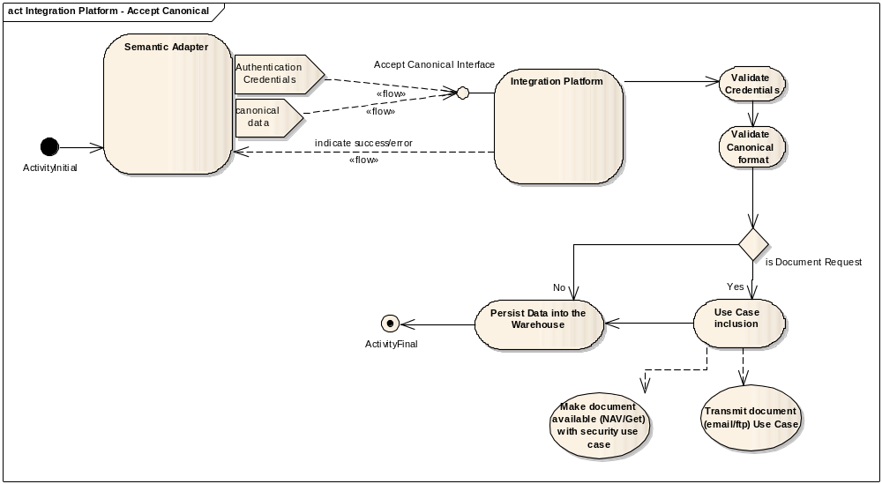

Make document available (NAV/XDS Retrieve) with security
Description
This use case describes the functionality of the caCIS Integration Platform that makes document available via the IHE’s XDS-Retrieve Document Interface and notifies recipients using IHE’s NAV.
BUSINESS/TECHNICAL PRIORITY
The Integration Platform is a key component of the caCIS. The Integration Platform provides the interface to accept canonical data from various source systems via their respective Semantic Adapters. The Integration Platform validates the Canonical format data, persists data into the Clinical Data Warehouse and routes the created documents via XDS. Integration Platform exposes the IHE’s XDS- Retrieve Document Set interface and IHE’s NAV (Notice of Document Availability) interface.
IDENTIFY REQUIREMENT(S)
- Requirement IP-5: The Integration Platform shall be able to transfer the document in multiple ways i.e. using secured email, a secured file transfer or secure web transmission.
- Requirement IP-6: The Integration Platform shall make documents available for retrieval recipients via a secured interface like XDS.
IDENTIFY RELATED USE CASES(S)
- Transmit Document (Secure Email/ Secure FTP) use case
- Clinical Data Warehouse use cases
Storyboard

The Integration Platform accepts canonical format data from Semantic Adapter. Integration Platform inspects the incoming data and determines that the Semantic Adapter provided a document transfer request. If a pre-configured recipient list is available, the Integration Platform proceeds to distribute documents via Secure Email/ Secure FTP. If recipient list is not available, the Integration Platform obtains the recipients email from the incoming data and sends a NAV (Notice of document Availability) to each recipient via email. Integration Platform stores data in Clinical Data Warehouse.
Pre-conditionS
- A list of Recipients is preconfigured in the Integration Platform with Email information for all XDS recipients.
- Integration Platform is configured to convert and send data/documents to recipient system via NAV and XDS-Retrieve Document interfaces.
USE CASE ACTORS
- Integration Platform
- Recipient System
FLOW OF EVENTS
- Integration Platform reads the incoming request which it has received from the Semantic Adapter with document transfer information in the metadata.
- Integration Platform retrieves the recipient list.
  - If present, from the document transfer request.
  - Else, it reads the configuration files to retrieve the recipient list based on the document type.
- The Integration Platform confirms that the specified recipient system is currently authorized to receive documents of the specified type with records of with the associated metadata (study, site and patient)
- Integration Platform determines the document formats for the each of the recipients and the document is transferred into the corresponding format as specified by the document request or as configured in the configuration file for the recipient.
- If the document transmission protocol is NAV/XDS then following steps are performed:
  - Integration Platform persists the document internally in XDS Repository along with the recipient information as well as document metadata
  - Integration Platform sends a NAV (Notice of document Availability) to each recipient via email.
  - The Recipient System receives the notifications that the document is available for retrieval, including the repository id and the document id.
  - The Recipient System invokes the XDS- Retrieve document set interface of the Integration Platform to retrieve the document.
  - The Integration Platform checks if the User is authorized to retrieve the document. The Integration Platform checks if the recipient has study, site and patient level access as well as it checks that the recipient is one of the intended recipients of the document.
  - If the authorization is successful, the Integration Platform returns the requested document to the recipient System.
ALTERNATE FLOW – Document Transfer request is Secure Email/ Secure FTP
- Step 1 - 4 from the main flow
- Integration platform determines that the transmission protocol for the document is Secure Email/ Secure FTP.
- Inclusion: Continue use case by including Use Case - Transmit document (Secure Email/ Secure FTP) Event
ERROR FLOW OF EVENTS
- One or more of the identified recipients is not permitted to receive the document type based on metadata
  - The intended recipient is excluded from those to whom the document is sent
  - If the intended recipient was specified as part of the document request, a warning is returned via the Semantic Adapter indicating that the specified recipient is not authorized to receive the document. (This warning will not prevent other recipients from receiving the data or from storing the data in the Clinical Data Warehouse.)
  - Otherwise, the exclusion of the recipient is merely noted in the log.
- The Document request specifies a document type that is not supported.
  - The Integration Platform notifies the Semantic Adapter that the requested document type is supported.
- The document request or configuration file requests that a document be rendered in a format that is not supported.
  - If part of a document request, the Integration Platform notifies the Semantic Adapter that the requested format is not supported and the associated delivery is skipped. (This does not cause other deliveries or storage in the Clinical Data Warehouse to be skipped.)
- The document request or configuration file requests that the document is delivered by a protocol that is not supported.
  - If part of a document request, the Integration Platform notifies the Semantic Adapter that the requested delivery protocol is not supported and the associated delivery is skipped. (This does not cause other deliveries or storage in the Clinical Data Warehouse to be skipped.)
- Integration Platform has error when storing the document in the XDS repository.
  - The Integration Platform returns an error to the Semantic Adapter that it was unable to store the document in the XDS store.
- Integration Platform has internal error when transmitting the NAV
  - Integration Platform notifies that the Semantic Adapter that NAV was not sent to the Recipient System. (This does not cause other deliveries or storage in the Clinical Data Warehouse to be skipped.)
- Integration Platform has internal error when transmitting the document by Secure Email/ Secure FTP
  - Integration Platform notifies that the Semantic Adapter that the request was not sent to the Recipient System. (This does not cause other deliveries or storage in the Clinical Data Warehouse to be skipped.)
- The Recipient System sends a request for a document that does not exist.
  - The Integration Platform notifies the Recipient system that their request is invalid.
- The Recipient System does not have permission to retrieve a document with the associated metadata or the Recipient System is not the intended recipient
  - The Integration Platform notifies the Recipient system that it does not have permission to retrieve the document.
- The Integration Platform gets an error fulfilling a document request from the Recipient System.
  - The Integration platform notifies the Recipient system that their request cannot be fulfilled.
Post-conditionS
- The clinical data has been delivered to all specified and configured recipients for the document type via a format and protocol supported by those recipients.
DIAGRAM
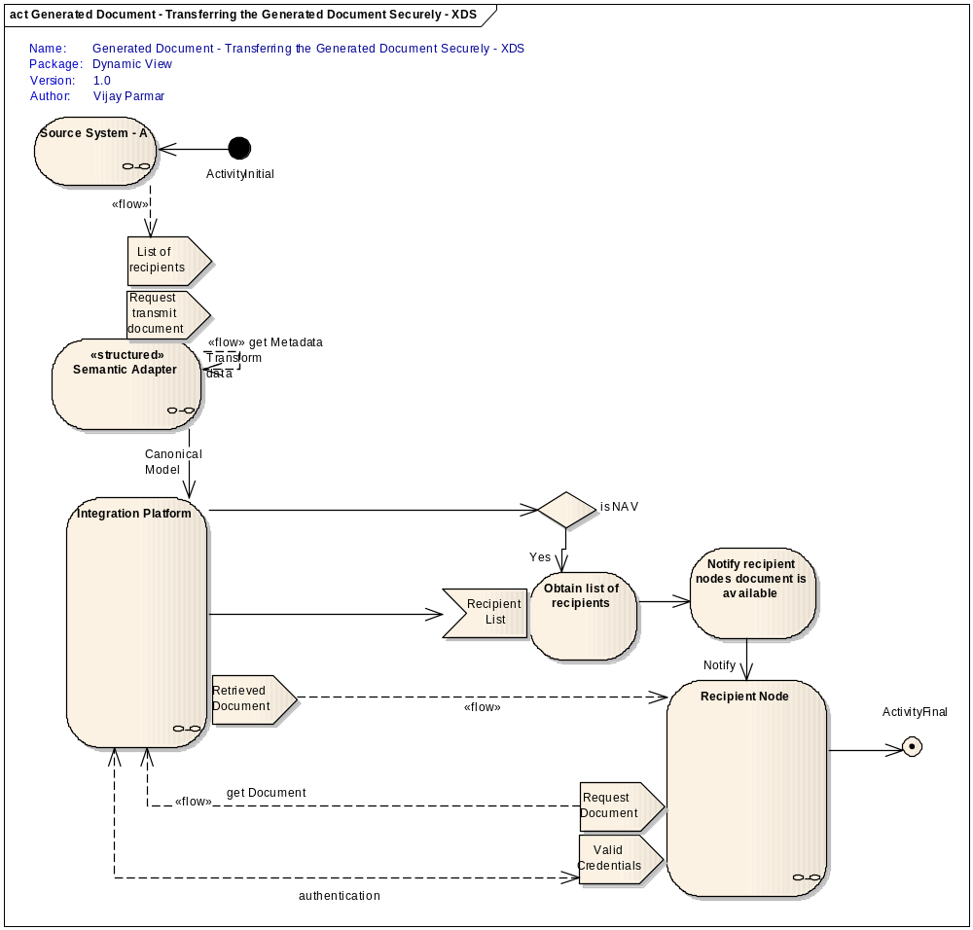

Transmit document (Secure E-mail/Secure FTP)
Description
This use case describes the functionality of Integration Platform that distributes documents as requested by the source system. These documents are distributed using Email or FTP.
BUSINESS/TECHNICAL PRIORITY
The caCIS Integration Platform must transfer documents in a secure mechanism to individual recipients.
IDENTIFY REQUIREMENT(S)
- Requirement IP-7: The caCIS Integration Platform shall transmit document in a secure fashion to recipients
- Requirement IP-8: The caCIS Integration Platform shall provide secure email as an option to transmit documents.
- Requirement IP-9: The caCIS Integration Platform shall provide FTP as option to transmit documents.
- Requirement IP-10: The caCIS Integration Platform shall provide the ability to configure a pre-defined set of recipients for a given document type
IDENTIFY RELATED USE CASES(S)
Make document available (NAV/XDS Retrieve) with security
Storyboard
The source system has identified a document to be sent to a set of recipients (either provided by the source system or configured in the integration platform). Once the document is generated based on the list of the recipients it is transmitted to them. If the recipient list contains email addresses, then the document is transmitted as secured email. If the recipient list contains FTP details, then the document is transmitted via FTP.
Pre-conditionS
- List of recipients is already provided either by the source system or already configured in an underlying configuration file in the Integration Platform.
- The Integration Platform can create the documents which are required for transmission.
- A mechanism exists for sending encrypted email messages to an identified user. The recipient’s certificates are configured within the integration platform.
- For transmitting the file securely, a trust is already established between the integration platform and the recipient FTP server.
USE CASE ACTORS
- Integration Platform
- Recipient System
FLOW OF EVENTS
- Source system has triggered a request to transmit a document. The work flow of actual generation of the document and building of the recipient list is discussed in a separate use case.
- The document is created in the required format as mentioned in the recipient list obtained from the source system or configured in the Integration Platform.
- If the recipient list contains a secure email address
  - The Integration platform attaches the document to an email and encrypts the whole email for each recipient in the list using their configured certificates such that only that recipient can decrypt the email message. It signs the mail to identify itself.
- The Integration platform proceeds to transmit the email message containing the document in an encrypted format to the recipients.
ALTERNATE FLOW OF EVENTS – Secure FTP
- Step 1 & 2 from main flow
- If the integration platform is configured to use file transfer instead of email as a transmission mechanism then the recipient list will contain a list of the recipient servers.
- The Integration platform will transmit the files to the recipient servers using SFTP.
ERROR FLOW OF EVENTS
- Integration platform gets an immediate error sending email
  - Integration Platform notifies that the Semantic Adapter that the documents transfer via email failed. The error includes details of the recipients for which the transmission failed.
- Integration platform gets an delayed error sending email (e.g. bounce, delivery issue)
  - Integration Platform logs error.
- Integration Platform is unable to connect for FTP to the Recipient system.
  - Integration Platform notifies that the Semantic Adapter that the documents transfer via FTP failed. The error includes details of the recipients for which the transmission failed.
- FTP transmission to the Recipient system fails.
  - Integration Platform notifies that the Semantic Adapter that the document transfers via FTP failed. The error includes details of the recipients for which the transmission failed.
Post-conditionS
  - The clinical data has been delivered to all specified and configured recipients for the document type via a format and protocol supported by those recipients
DIAGRAM
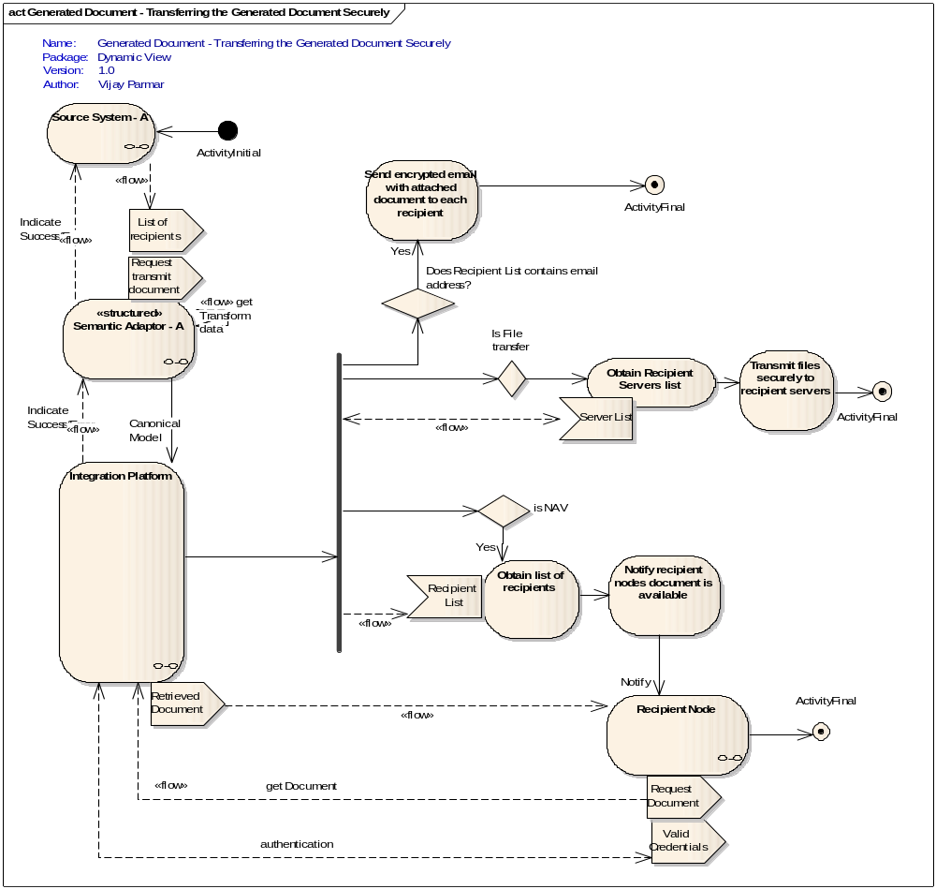

Clinical Data Warehouse Use Cases

Load Data into the warehouse
Description
The caCIS Integration Platform loads the data in the caCIS Requests into a Clinical Data Warehouse for ad hoc querying by the end users possibly for the purpose of further statistical analysis. Since the data contains Patient Identifiable Information as well as Protected Health Information, access is restricted. This requires that access to the data is secured and users can be granted access to the data at study, site and patient levels.
BUSINESS/TECHNICAL PRIORITY
The caCIS Integration Platform component sends the data to a Clinical Data Warehouse. The Clinical Data Warehouse stores the data securely and makes the data available to authorized users for subsequent query and analysis.
IDENTIFY REQUIREMENT(S)
- Requirement CDW-1: The Clinical Data Warehouse Interface shall store the data in a secured manner.
- Requirement CDW-2: The Clinical Data Warehouse Interface shall identify the stored data at study, site and patient level to allow access at those granularity levels.
IDENTIFY RELATED USE CASES(S)
- Integration Platform use cases
Storyboard
The source system sends clinical data to be stored within the Clinical Data Warehouse to be shared with researchers in a secured manner. The Integration Platform initiates the load process which loads this data in the native format supported by the Clinical Data Warehouse. Based on the metadata associated with the clinical data, the Integration Platform identifies and tags the data into appropriate study, site and patient groups. The data is available to researchers who have access to the study, site or patient groups associated with the data..
Pre-conditionS
- Integration platform is configured to write the data into the Clinical Data Warehouse

USE CASE ACTORS
- Semantic Adapter
- Integration Platform
- Clinical Data Warehouse

FLOW OF EVENTS
- The source system transmits clinical data to the Semantic Adapter. The clinical data is either to be transmitted to an intended recipient or just meant to be stored within the Clinical Data Warehouse to Semantic Adapter
- The Semantic Adapter transform the data from the source system format into the Canonical format and transmits it to the Integration Platform
- The Integration Platform accepts this data and transforms this into appropriate format acceptable by the Clinical Data Warehouse. This data contains the following elements
  - Document Exchange Instructions (if present)
  - Metadata about the Clinical Data
  - Transformed Canonical Data
  - Source Data
- The Integration Platform also reads the metadata from incoming data and tags the data into appropriate Study, Site and Patient groups.
- The Integration Platform invokes the Clinical Data Warehouse’s write function at an appropriate time to store the data within the warehouse.
ERROR FLOW OF EVENTS
- The Integration Platform is not configured correctly to write data into the Clinical Data Warehouse.
  - A system error is generated stating that the Clinical Data Warehouse is not configured correctly.
- The Integration Platform is not able to write data into the Clinical Data Warehouse.
  - A system error is generated stating that write of data to the Clinical Data Warehouse failed.
Post-conditionS
- The Clinical Data Warehouse contains the clinical data that was sent by the source system.
  - The Clinical Data is tagged into appropriate study, site and patient groups.

DIAGRAM
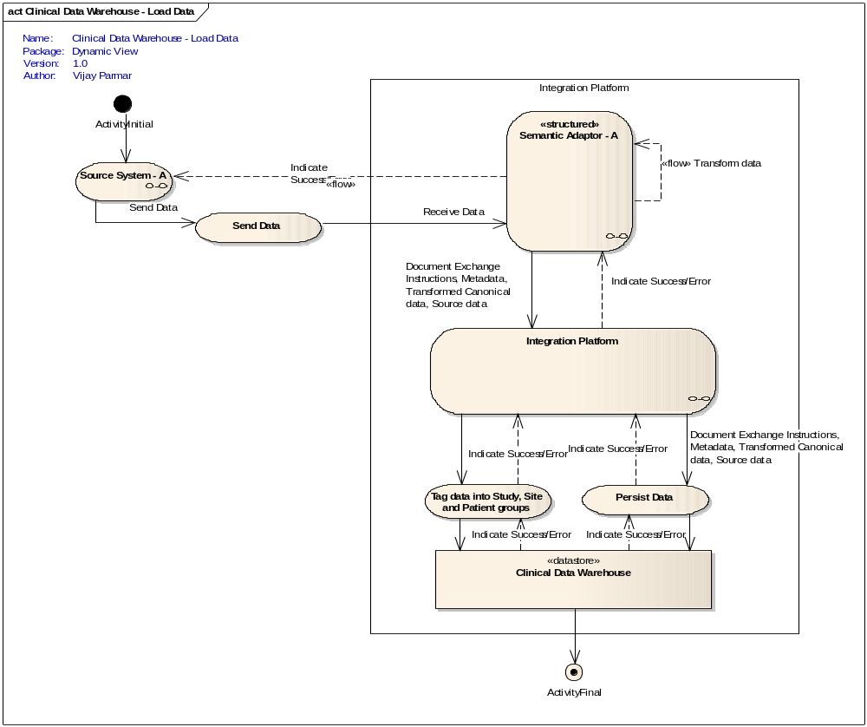

Ad hoc Query with security
Description
The caCIS Integration Platform data into a Clinical Data Warehouse for ad hoc querying by the end users possibly for the purpose of further statistical analysis. Since the data contains Patient Identifiable Information as well as Protected Health Information, access is restricted. This use case describes the details of the access mechanism. Publicly available de-identified data is covered in a separate use case.
BUSINESS/TECHNICAL PRIORITY
The caCIS Integration Platform component uses a Clinical Data Warehouse to store the data available from the source and expose the data for subsequent query and analysis.
IDENTIFY REQUIREMENT(S)
- Requirement CDW-3: The Clinical Data Warehouse Interface shall allow stakeholders to query data for visual analysis and for report generation.
- Requirement CDW-4: The Clinical Data Warehouse Interface shall be secured using the same authorization scheme as the document interface.
- Requirement CDW-5: The Clinical Data Warehouse Ad hoc query interface shall be secured and publicly accessible.
- Requirement CDW-6: The Clinical Data Warehouse shall log any errors in processing the queries.
IDENTIFY RELATED USE CASES(S)
- Integration Platform use cases
Storyboard
The end user wants to query the data stored in the caCIS Integration Platform’s Clinical Data Warehouse for analysis or report generation. The Clinical Data Warehouse exposes an ad hoc query interface. The user formulates the query in the format supported by the Clinical Data Warehouse Interface. The end user fulfills all the authentication needs of the Clinical Data native Warehouse Interface and passes their query to the interface. The interface checks the access permission for the user. If authorized, it retrieves the data from the underlying Clinical Data Warehouse and presents it back to the user; filtering out any data they do not have permission to access.
Alternate: A clinical system or a custom application is configured to retrieve data from the caCIS Integration Platform (on a periodic or ad hoc basis). It queries the interface by passing the query criteria in the supported format and retrieves the data like any other end user.
Pre-conditionS
- User has an account with the Clinical Data Warehouse The Clinical Data Warehouse Interface is restricted to allow access to identified users only.
- User is provisioned with appropriate access privileges to data stored within the Clinical Data Warehouse.
- Granularity of the access can be controlled at
  - Either study level where the user has access to all the data for the allowed study
  - Or at site level where the user has access to all the study data originating from a particular site
  - Or at study subject / patient level, where the user has access only to the data pertaining to a particular subject on a given study
USE CASE ACTORS
- Integration Platform
- Clinical Data Warehouse
- End user
- System
FLOW OF EVENTS
- The user authenticates using the mechanism supported by the Clinical Data Warehouse interface by providing credentials.
- Based on the access permissions granted the query data is filtered at study level, site level and/or at subject level for the user.
- The query is executed and the result set returned to the user.
NOTE: In case a system is trying to retrieve data from the underlying Clinical Data Warehouse, then same flow of events from step 1 to step 3 are applicable for systems as well.
ERROR FLOW OF EVENTS
- The user credentials are invalid.
  - A security error is generated stating that the user cannot be authenticated
- The user doesn’t have access permissions to query the requested data
  - No results are returned to the user
- The Clinical Data Warehouse gets an error fulfilling the user query.
  - The Clinical Data Warehouse query interface notifies the user/system of the error.
- The query at the Clinical Data Warehouse takes a long time.
  - The user/system is able to terminate the query.
Post-conditionS
- End user or system is provided the data that they have queried for.
  - Authenticated / Privileged users are provided the queried data on which they have access with identifiable information
DIAGRAM
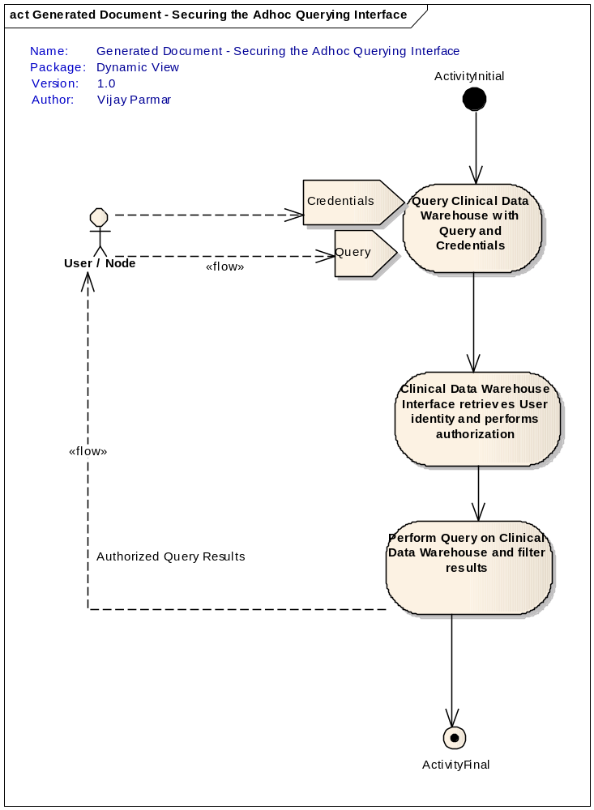

<Future/TBD > Publically available data (de-identified)

General Use Cases

Error Flow
Description
This use case describes the overall error flow scenario for use cases described above. The specific error conditions that can occur in each component are covered under the use cases for those components. This use case describes the overall error handling for an arbitrary error.
BUSINESS/TECHNICAL PRIORITY
The workflow between Source Systems, Semantic Adapter(s), Integration Platform, Clinical Data Warehouse and the end user/system is complex and has many failure points. To address the fail points, error workflow, processing and notification has to be defined.
IDENTIFY REQUIREMENT(S)
- Requirement ER-ADT-1: Error notification shall be synchronous or asynchronous based on the workflow and interaction between components such as Source System, Semantic Adapter, Integration Platform, Clinical Data Warehouse, XDS Repository and the Recipient System.
- Requirement ER-ADT-2: Error scenarios will be logged for auditing.
IDENTIFY RELATED USE CASES(S)
- Semantic Adapter use cases
- Integration Platform use cases
- Clinical Data Warehouse use
Storyboard
The storyboard is a scenario and can be extrapolated to include other formats and document types. A clinician wants to share clinical data with a recipient system. The clinician’s system (Source system) generates HL7v2 based clinical data while the recipient system accepts clinical data in CDA format. The clinician triggers the transmission of the clinical data through the source system user interface. The source system sends the clinical data in HL7v2 format to the Semantic Adapter. The Semantic Adapter converts the data into the canonical format and sends it to the Integration Platform. The Integration Platform creates a clinical document from the canonical data for transmission to the recipient system. The Integration Platform then gets the transmission mechanism for the document. The transmission of the document fails. The Integration Platform logs the error and reports the error back to the semantic adapter that initiated the document transmission request. The semantic adapter logs the error and reports the error back to the source system. The source user interface displays the error to the clinician, notifying them that the document transmission has failed. The Integration Platform stores the data in the Clinical Data Warehouse.
Pre-conditionS
- The source system is integrated with the semantic adapter to handle error notifications on synchronous and/or asynchronous invocations.
USE CASE ACTORS
- Source System
- Semantic Adapter
- Integration Platform
- Clinical Data Warehouse
- Recipient System
FLOW OF EVENTS – Synchronous Invocation
The following flow of events describes the system for one particular error scenario. The error can happen at each step in the flow of events. An error at any step is communicated back to the source system. Specific errors in each of the components are covered under the use cases of those components.
- Clinician triggers a document exchange request on the Source system.
- Source system includes all the data required to fulfill the request and sends it synchronously to the Semantic Adapter.
- The Semantic Adapter transforms the data into canonical format and forwards the document exchange request synchronously to the Integration Platform.
- The Integration Platform creates the clinical document as required for the recipient system.
- The Integration Platform determines the transmission mechanism for the recipient system.
- The Integration Platform transmits the document to the recipient system.
- The transmission of the document to the recipient system fails immediately.
- The Integration Platform logs the error related to the transmission of the document.
- The Integration Platform reports the error back to the Semantic Adapter that initiated the request.
- The Semantic Adapter logs the error related to the transmission of the document.
- The Semantic Adapter then reports the error related to the transmission of the document to the Source system.
- The Source system then reports the error back to the clinician.
- The Integration Platform persists the data in the Clinical Data Warehouse.

ALTERNATE FLOW OF EVENTS – Asynchronous invocation
The source system wants to exchange clinical data with a recipient system as a batch job that runs every night. The source system interfaces with the Semantic Adapter asynchronously.
- Steps 1-11 from Main Flow
- The Source system logs the error.
- Resume at step 13 from Main flow
ALTERNATE FLOW OF EVENTS – Document issue before transmission
The Integration Platform determines there is a problem with the document generation request (bad document type).
- Steps 1-12 from Main flow
- The Integration Platform does not persist the data in the Clinical Data Warehouse.
ALTERNATE FLOW OF EVENTS – Non-immediate transmission error
The Integration Platform sends an e-mail and later receives a “bounce” that the e-mail address was unreachable.
- Steps 1-6 from Main flow
- The Integration Platform persists the data in the Clinical Data Warehouse.
- The Integration Platform notifies the Semantic Adapter that the request was successfully processed
- The Semantic Adapter notifies the Source System that the request was successfully processed.
- The Integration Platform receives an e-mail bounce message on the previously sent e-mail
- The Integration Platform logs the bounce.
Post-conditionS
- All components are operational, error notifications are provided for respective errors.
- Any one of the components is not operational.
  - Error notifications are not guaranteed to be provided.
  - Error flow workflow takes over for particular component.

Security Administration User Interface Use Cases

Access Security Administration Module
Description
The caCIS Integration Platform facilitates exchange of clinical data between the Source system such as TRANSCEND's THE Force and an EHR system at a study site using multiple transfer modes (Secure email, Secure FTP and XDS). Since the data may contain Patient Identifiable Information as well as Protected Health Information, this transfer must take place in a secure manner. caCIS provides a security administration module to set up and maintain the security for each of the transfer modes as well Clinical Data Warehouse (CDW). Only caCIS administrative users will be able to access this module by entering their credentials.
REQUIREMENT(S)
- Requirement LOGIN-SEC-1: The caCIS Security Administrator SHALL be able to login to security administration module by entering user id and password.
- Requirement LOGIN-SEC-2: After a certain preconfigured period of inactivity, the caCIS security administration module SHALL be inaccessible and the administrator SHALL be required to login again.
- Requirement LOGIN-SEC-3: The caCIS Security Administrator SHALL be able to log out of the administration module.

IDENTIFY RELATED USE CASES(S)
Manage XDS Recipients
Manage Secure Email Recipients
Manage Secure FTP Recipients
Manage Clinical Data Warehouse (CDW) Users

Storyboard
caCIS administrator wants to set up a new user in the Clinical Data Warehouse (CDW) and provide him or her access to all data for a particular study. The administrator accesses the Security Administration web application by correctly entering the login credentials. After a successful login, the administrator sets up the new CDW user by navigating to the appropriate screen. After completing the necessary actions, the administrator clicks on the Logout button to log out of the web application.
Pre-conditionS
- caCIS security administrator has the following information available:
a. Administrative user identifier (id)
b. Password for the administrative user id

USE CASE ACTORS
- caCIS Security Administrator
- caCIS Security Administration Module

FLOW OF EVENTS
- caCIS administrator enters the caCIS security administration web application URL in the web browser and is presented with a Login screen.
- The administrator enters correct user id and the corresponding password.
- caCIS administrator successfully logs into the administration module and can access the menu to perform various administrative functions.
- After performing administrative actions, the administrator clicks on the logout button to sign off from the web application.

Post-conditionS
None

ALTERNATE FLOW OF EVENTS
- caCIS administrator logs into caCIS security administration web application using the administrative user id and the corresponding password.
- After a period of inactivity in the web application (i.e. no user actions), that exceeds a pre-configured duration, the administrator clicks on a menu item.
Post-conditionS
- caCIS security administration web application presents the login screen and displays a message informing the administrator that the previous session has expired.
- The administrator cannot perform any other action within the web application, until he/she successfully logs in again.

ERROR FLOW OF EVENTS
- caCIS administrator enters invalid password at the login screen
  - An error message is displayed to the user stating that invalid credentials were entered.
  - The user does not get access to the security administration web application.

Manage XDS Recipients
Description
The caCIS Integration Platform facilitates exchange of clinical data between the Source system such as TRANSCEND's THE Force and an EHR system at a study site using multiple transfer modes (Secure email, Secure FTP and XDS). Since the data may contain Patient Identifiable Information as well as Protected Health Information, this transfer must take place in a secure manner. This security needs to be established between the source system and the target system by the caCIS administrator by storing and associating appropriate digital certificates. This use case describes the functionality of the caCIS security administration module that enables the initial set up and subsequent maintenance of security for XDS transfer mode.
REQUIREMENT(S)
- Requirement XDS-SEC-1: The caCIS security administration module SHALL provide ability to add a new XDS recipient.
- Requirement XDS-SEC-2: The caCIS security administration module SHALL provide ability to delete an existing XDS recipient.
IDENTIFY RELATED USE CASES(S)
Access Security Administration Module
Make document available (NAV/XDS Retrieve) with security

Storyboard
The source system is expected to start sending clinical exchange instances to a new XDS recipient via caCIS. The caCIS administrator accesses security administration module and creates a new XDS recipient by entering the XDS recipient system's email address for receiving the Notification of Availability emails and uploading the digital certificate (in X.509 format) for the XDS recipient system. The source system sends a clinical exchange document to the new XDS recipient. caCIS Integration Platform delivers the Notification of Availability to the appropriate email address. When the target system invokes the caCIS XDS interface to retrieve the clinical exchange document, caCIS validates the digital certificate accompanying that request and then makes the clinical exchange document available.
Pre-conditionS
1. caCIS security administrator has the following information available:
a. XDS NAV Recipient email address
b. XDS Recipient system's X.509 certificate

USE CASE ACTORS
- caCIS Security Administrator
- caCIS Security Administration Module

FLOW OF EVENTS
- caCIS administrator logs into caCIS security administration web application using the administrative user id and the corresponding password.
- caCIS administrator clicks on "Recipient Setup" menu item and then on "Secure XDS/NAV" sub-menu item.
- caCIS administrator enters a valid email address in the NAV Recipient's Email field.
- In the Certificate field, caCIS administrator clicks on "Choose File", selects a valid X.509 certificate file (corresponding to the new recipient) and then hits the "ADD NEW XDS/NAV RECIPIENT" button.

Post-conditionS
- New XDS recipient information is successfully stored in caCIS.
- caCIS security administration web application displays an entry for the newly added XDS recipient.
- The system sends an email to the address entered in "NAV Recipient's Email" field.

ALTERNATE FLOW OF EVENTS
- caCIS administrator logs into caCIS security administration web application using the administrative user id and the corresponding password.
- caCIS administrator clicks on "Recipient Setup" menu item and then on "Secure XDS/NAV" sub-menu item.
- caCIS administrator reviews the list of XDS recipients and pushes the "DELETE" button next to a recipient that is no longer a valid recipient of clinical exchange documents.

Post-conditionS
- XDS recipient information is successfully removed from caCIS.
- caCIS security administration web application no longer displays the deleted XDS recipient.
ERROR FLOW OF EVENTS
- caCIS administrator enters blank or invalid Recipient email address on the Secure XDSNAV Configuration screen.
  - An error message is displayed to the user stating that invalid email address was entered.
- caCIS administrator selects an invalid X.509 certificate file in the XDS recipient certificate field.
  - An error message is displayed to the user stating that an invalid certificate was selected.

Manage Secure Email Recipients
Description
The caCIS Integration Platform facilitates exchange of clinical data between the Source system such as TRANSCEND's THE Force and an EHR system at a study site using multiple transfer modes (Secure email, Secure FTP and XDS). Since the data may contain Patient Identifiable Information as well as Protected Health Information, this transfer must take place in a secure manner. This security needs to be established between the source system and the target system by the caCIS administrator by storing and associating appropriate digital certificates. This use case describes the functionality of the caCIS security administration module that enables the initial set up and subsequent maintenance of security for Secure Email transfer mode.
REQUIREMENT(S)
- Requirement SMIME-SEC-1: The caCIS security administration module SHALL provide ability to add a new Secure Email recipient.
- Requirement SMIME-SEC-2: The caCIS security administration module SHALL provide ability to delete an existing Secure Email recipient.

IDENTIFY RELATED USE CASES(S)
Access Security Administration Module
Transmit document (Secure E-mail/Secure FTP)
Storyboard
The source system is expected to start sending clinical exchange instances to a new Secure Email recipient via caCIS. The caCIS administrator accesses security administration module and creates a new Secure Email recipient by entering the recipient's email address and uploading the digital certificate (in X.509 format) for the new recipient. The source system sends a clinical exchange document to the new Secure Email recipient. caCIS Integration Platform signs and encrypts the exchange document using corresponding digital certificate and delivers it to the secure email address.
Pre-conditionS
- caCIS security administrator has the following information available:
a. Secure Email recipient email address
b. Secure Email recipient's X.509 certificate

USE CASE ACTORS
- caCIS Security Administrator
- caCIS Security Administration Module

FLOW OF EVENTS
- caCIS administrator logs into caCIS security administration web application using the administrative user id and the corresponding password.
- caCIS administrator clicks on "Recipient Setup" menu item and then on the "Secure Email" sub-menu item.
- caCIS administrator enters a valid email address in the Recipient Email address field.
- In the Certificate field, caCIS administrator clicks on "Choose File" button, selects a valid X.509 certificate file (corresponding to the new recipient) and then hits the "ADD NEW EMAIL RECIPIENT" button.
Post-conditionS
- New Secure Email recipient information is successfully stored in caCIS.
- caCIS security administration web application displays an entry for the newly added Secure Email recipient.
- The system sends an email to the address entered in "Recipient Email" field.

ALTERNATE FLOW OF EVENTS
- caCIS administrator logs into caCIS security administration web application using the administrative user id and the corresponding password.
- caCIS administrator clicks on "Recipient Setup" menu item and then on the "Secure Email" sub-menu item.
- caCIS administrator reviews the list of Secure Email recipients and pushes the "DELETE" button next to a recipient that is no longer a valid recipient of clinical exchange documents.
Post-conditionS
- Secure Email recipient information is successfully removed from caCIS.
- caCIS security administration web application no longer displays the deleted Secure Email recipient.

ERROR FLOW OF EVENTS
- caCIS administrator enters blank or invalid email address on the Secure Email Recipient set up screen.
  - An error message is displayed to the user stating that Recipient Email is required or an invalid email address was entered.
- caCIS administrator either does not choose a certificate file or selects an invalid X.509 certificate file in the Secure Email recipient certificate field.
  - An error message is displayed to the user stating that a certificate is required or an invalid certificate was selected.

Manage Secure FTP Recipients
Description
The caCIS Integration Platform facilitates exchange of clinical data between the Source system such as TRANSCEND's THE Force and an EHR system at a study site using multiple transfer modes (Secure email, Secure FTP and XDS). Since the data may contain Patient Identifiable Information as well as Protected Health Information, this transfer must take place in a secure manner. This security needs to be established between the source system and the target system by the caCIS administrator by storing and associating appropriate digital certificates as well as configuring certain properties of the caCIS Integration Platform. This use case describes the functionality of the caCIS security administration module that enables the initial set up and subsequent maintenance of security for Secure FTP mode.
REQUIREMENT(S)
- Requirement FTP-SEC-1: The caCIS security administration module SHALL provide ability to add a new FTP recipient. The new recipient SHALL use either SFTP or FTPS protocol for secure file transfer.
- Requirement FTP-SEC-2: The caCIS security administration module SHALL provide ability to delete an existing FTP recipient.
IDENTIFY RELATED USE CASES(S)
Access Security Administration Module
Transmit document (Secure E-mail/Secure FTP)

Storyboard
The source system is expected to start sending clinical exchange instances to a new FTP recipient via caCIS. The caCIS administrator accesses security administration module and creates a new FTP recipient by entering the recipient's ftp protocol (SFTP or FTPS), host name, port number, ftp user id and ftp password. Additionally, they also upload the digital certificate (in X.509 format) for the new recipient, in case of FTPS protocol. The source system sends a clinical exchange document to the new FTP recipient. caCIS Integration Platform uses the appropriate configured protocol (SFTP or FTPS) to connect to the FTP host at the recipient site and transfer the file in a secure manner.
Pre-conditionS
- caCIS security administrator has the following information available:
a. Recipient FTP Protocol
b. Recipient FTP Hostname
c. Recipient FTP Port number
d. Recipient FTP User Id
e. Recipient FTP Password
f. Recipient FTP Folder

USE CASE ACTORS
- caCIS Security Administrator
- caCIS Security Administration Module

FLOW OF EVENTS
- caCIS administrator logs into caCIS security administration web application using the administrative user id and the corresponding password.
- caCIS administrator clicks on "Recipient Setup" menu item and then on "Secure FTP" sub-menu item.
- caCIS administrator enters a comma separated list of following configuration parameters in the "FTP Configuration Entry" field: ftp protocol type, ftp hostname, ftp port number, ftp user id, ftp password, ftp folder
- If the ftp protocol type is ’ftps’, caCIS administrator clicks on "Choose File" button in the Certificate field, selects a valid X.509 certificate file (corresponding to the new recipient). NOTE: Certificate is not needed for sftp entry.
- caCIS administrator then hits the "Add New FTP Recipient" button.
Post-conditionS
- New FTP recipient information is successfully stored in caCIS.
- caCIS security administration web application displays an entry for the newly added FTP recipient.

ALTERNATE FLOW OF EVENTS
- caCIS administrator logs into caCIS security administration web application using the administrative user id and the corresponding password.
- caCIS administrator clicks on "Recipient Setup" menu item and then on the Secure FTP sub-menu item.
- caCIS administrator reviews the list of FTP recipients and pushes the "DELETE" button next to a recipient that is no longer a valid recipient of clinical exchange documents.
Post-conditionS
- FTP recipient information is successfully removed from caCIS.
- caCIS security administration web application no longer displays the deleted FTP recipient.
ERROR FLOW OF EVENTS
- caCIS administrator enters blank or invalid FTP configuration entry on the "Secure FTP Configuration" screen.
  - An error message is displayed to the user stating that an invalid configuration parameter list was entered.
- For a FTP recipient using ’ftps’ protocol, caCIS administrator selects an invalid X.509 certificate file in the FTP recipient certificate field.
  - An error message is displayed to the user stating that an invalid certificate was selected.

Manage Clinical Data Warehouse (CDW) Users
Description
The caCIS Integration Platform loads the data received from the Source systems into a Clinical Data Warehouse (CDW) for ad hoc querying by the end users for the purpose of further analysis. Since the data may contain Patient Identifiable Information as well as Protected Health Information, access to CDW is restricted. This requires that access to the data is secured and users can be granted access to the data at study, site and patient levels. This use case describes the functionality of the caCIS security administration module that enables the initial set up and subsequent maintenance of security for CDW users.
REQUIREMENT(S)
- Requirement CDW-SEC-1: The caCIS security administration module SHALL provide ability to add a new CDW User.
- Requirement CDW-SEC-2: The caCIS security administration module SHALL provide ability to delete an existing CDW User.
- Requirement CDW-SEC-3: The caCIS security administration module SHALL provide ability to add a permission set for an existing CDW User. A permission set specifies READ access for the user at a Study, Study Site and Patient level. Access could be specified for a specific Study OR for a specific Study and Study Site combination OR for a specific Study, Study Site and Patient combination.
- Requirement CDW-SEC-4: The caCIS security administration module SHALL provide ability to remove a specific permission set for an existing CDW User.
- Requirement CDW-SEC-5: The caCIS security administration module SHALL provide ability to search for an existing CDW User and their corresponding permission set(s).
IDENTIFY RELATED USE CASES(S)
Access Security Administration Module
Ad hoc Query with security
Storyboard
The source system sends clinical data to recipient systems via caCIS Integration Platform. The caCIS Integration Platform loads the data received from the source systems into the Clinical Data Warehouse (CDW). This data can be retrieved from the CDW, by researchers, in a secured manner. The Integration Platform executes the load process which, based on the metadata associated with the clinical data, identifies and tags the data with appropriate study, site and patient group information.
A researcher is authorized by the Study administrator to query CDW data for the entire study. caCIS system administrator accesses security administration module and creates a new CDW user corresponding to the researcher by providing a user id and an initial password. The caCIS system administrator then creates a permission set for the newly created user id such that the new user id will have access to the entire study data in CDW. The researcher is able to execute queries against the entire study data.
Pre-conditionS
- Study administrator has approved Read access for a researcher user, for the entire study.
- caCIS security administrator has the following information available:
a. New CDW User's Id
b. New CDW User's initial password
c. Study Id for which the researcher has been approved access by the Study administrator

USE CASE ACTORS
- caCIS Security Administrator
- caCIS Security Administration Module

FLOW OF EVENTS
- caCIS administrator logs into caCIS security administration web application using the administrative user id and the corresponding password.
- caCIS administrator clicks on "CDW User Setup" menu item.
- caCIS administrator enters username and an initial password for the new researcher user.
- caCIS administrator clicks the "ADD USER" button to save information for the new user in the database.
- caCIS administrator then enters the Study Id (OID Root + extension) in the Permission Set section and then clicks the "ADD PERMISSION" button.
- The new permission set is stored in the database for the new user.
Post-conditionS
- The new CDW user and the corresponding permission set is successfully stored in caCIS.
- The researcher users can log in to CDW using the newly created user id and password and successfully execute a query against the study data.
ALTERNATE FLOW OF EVENTS
- Study administrator has revoked access to data for a specific patient (Patient1) from a researcher user.
- caCIS administrator logs into caCIS security administration web application using the administrative user id and the corresponding password.
- caCIS administrator clicks on "CDW User Setup" menu item.
- caCIS administrator enters the CDW username for the researcher user and clicks the "SEARCH" button.
- caCIS security administration web application displays the permission sets for the user.
- The administrator identifies the permission set(s) corresponding to the patient Patient1 and clicks the "DELETE PERMISSION" button next to a permission set.
Post-conditionS
- Permission set(s) containing patient id Patient1 for the researcher user has(ve) been removed from caCIS.
- caCIS security administration web application no longer displays the permission set for the patient Patient1 in the list of permission sets available for the researcher user.
ALTERNATE FLOW OF EVENTS
- Study administrator has revoked access to the data warehouse for a researcher user.
- caCIS administrator logs into caCIS security administration web application using the administrative user id and the corresponding password.
- caCIS administrator clicks on "CDW User Setup" menu item.
- caCIS administrator enters the CDW username for the researcher user and clicks the "SEARCH" button.
- caCIS security administration web application displays the user entry along with the assigned permission set. Also the "DELETE USER" button is enabled.
- The administrator clicks the "DELETE USER" button.
Post-conditionS
- caCIS security administration web application displays a message that the user is successfully deleted.
- The CDW user is successfully removed.
ERROR FLOW OF EVENTS
- caCIS administrator enters just the username without providing a password while adding a new user
  - An error message is displayed to the user stating that the password is required.
- caCIS administrator enters the username of a non-existent user and presses SEARCH button
  - An error message is displayed to the administrator stating that the user does not exist
- caCIS administrator enters the username of an existing CDW user and a password and presses "ADD USER" button
  - An error message is displayed to the administrator stating that the user already exists in the database.

TRANSCEND Integration Use Cases
TRANSCEND is an architecture which is developed and deployed at UCSF to support the adaptive trial I-SPY. One of the requirements for TRANSCEND is to be able to transmit data to EHRs at trial sites. Also the data which is captured in TRANSCEND needs to be shared for analysis by other researchers. TRANSCEND has decided to leverage the caCIS Integration Solution for the purpose of sharing data with other clinical applications as well as exposing data for analysis. The following uses cases describe these scenarios in detail.

Transmit data to a trading partner
Description
This use case describes the overall workflow between TRANSCEND and the caCIS for the purpose of data transfer to a clinical system. TRANSCEND generates a document transfer request (containing the data to be transmitted) to caCIS which then transmits it to the trading partner.
BUSINESS/TECHNICAL PRIORITY
In order to eliminate the manual copy and paste procedure for transferring Trial Summary notes across systems, TRANSCEND will leverage the caCIS Integration Solution.
IDENTIFY REQUIREMENT(S)
- Requirement TRANSCEND-1: The caCIS system shall accept data from TRANSCEND regarding the Trial Summary note it wants to transmit to a trading partner. This data will contain the actual note as well as routing instructions.
- Requirement TRANSCEND-2: The caCIS System shall provide an interface that TRANSCEND’s THE Force system will invoke to pass the above mention data. TRANSCEND will send the actual note data in the TRANSCEND’s native XML format.
- Requirement TRANSCEND-3: The caCIS System shall convert the input data into a Canonical format so that it can be routed further to the trading partner. In case of TRANSCEND, since the input data format will be in native xml format which will be transformed into canonical data format (CDA R2) by the semantic adapter
- Requirement TRANSCEND-4: The caCIS System shall convert this Canonical data into the requested document format for the recipient. This desired format is identified by TRANSCEND as part of the routing information. This requirement shall be fulfilled as part of the Integration Platform use cases and the related requirements listed above.
- Requirement TRANSCEND-5: The caCIS System shall transmit the document to the recipient using one of the supported protocols. The desired protocol is provided by TRANSCEND as part of the routing information. This requirement shall be fulfilled as part of the Integration Platform use cases and the related requirements listed above.
IDENTIFY RELATED USE CASES(S)
- Semantic Adapter Use cases
- Integration Platform Use cases
  - Accept Data from the Semantic Adapter
  - Transmit document (Secure Email/ Secure FTP) – [In this case the alternate flow for Secure FTP is executed]
  - Make Document Available (with Security) use case
Storyboard
The physician working on TRANSCEND’s THE Force system enters data for the Trial Summary note for the subject. Upon completion, the physician determines that the note needs to be transmitted to the EPIC system located at UPenn. The user initiates a transfer request for the note on THE Force user interface by selecting the recipient (EPIC at UPenn in this case) as well as providing the preferred mode of transfer for that recipient. This information, along with the actual note, is transferred to the Semantic Adapter. The Semantic Adapter then converts the data to Canonical format data which is sent to the Integration Platform. The Integration Platform creates a document and proceeds to send the document based on defined protocol (FTP). The Integration Platform also stores the data in Clinical Data Warehouse. The recipient system receives the data.
Pre-conditionS
- TRANSCEND’s THE Force system is modified to provide users an option to select the preconfigured recipients for transmitting various documents.
- TRANSCEND’s THE Force system is configured to communicate with caCIS (Semantic Adapter component in particular).
- Security is enabled and trust is established between the Source System and the caCIS System’s Semantic Adapter
- Integration Platform is configured to transmit documents to the desired recipient system.
USE CASE ACTORS
- Source System (TRANSCEND - THE Force)
- Semantic Adapter
- Integration Platform
- Recipient System
FLOW OF EVENTS
- The user completes creation of a Trial Summary note in THE Force and saves the data. The user then selects an option to transmit this note to a trading partner.
- User selects UPenn as recipient from the list displayed on the screen. Also (s)he verifies if the pre-configured transmission protocol (FTP) for this recipient is accurate.
- THE Force creates a request to be sent to caCIS. This request contains the following
  - A document request indicating that the type of data is “Trial Summary Note”
  - The routing instructions which provide the end point for the recipient as well as the transmission protocol (FTP). The end point in this case will be the IP address of the FTP server on the UPenn side.
  - The xml file containing the Trial Summary note which is to be transmitted to UPenn.
- This message is then transmitted to caCIS (to the Semantic Adapter component).
- The following uses cases described above are executed in the order described below
  - Transform Data for Integration Platform
  - Accept Data from the Semantic Adapter
  - Transmit document (Secure Email/ Secure FTP) – [In this case the alternate flow for Secure FTP is executed]
ALTERNATE FLOW – For routing via other protocols such as Secure Email or XDS-NAV
- Step 1, 2, 3 and 4 of the main flow
  - Transform Data for Integration Platform
  - Accept Data from the Semantic Adapter
  - One of the following:
    - Transmit document (Secure Email/ Secure FTP) – [In this case the alternate flow for Secure Email is executed]; or
    - Make document available (NAV/XDS Retrieve) with security
ALTERNATE FLOW – caCIS System’s Integration Platform is configured with the routing information
- Step 1 from main flow.
- THE Force creates a request to be sent to caCIS. This request contains the following
  - The xml file containing the Trial Summary note which is to be transmitted to UPenn.
  - A document request indicating that the type of data is “Trial Summary Note”
- Resume at step 4 of the main flow.

ERROR FLOW OF EVENTS
- The ERROR FLOW OF EVENTS for the following uses cases are all applicable and possible in this case
  - Transform Data for Integration Platform
  - Accept Data from the Semantic Adapter
  - Transmit document (Secure Email/ Secure FTP) – [In this case the alternate flow for Secure FTP is executed. Also since the recipient list is not provided by the TRANSCEND, it is read from the configuration files]
Post-conditionS
- The document is transmitted to the trading partner (in this case UPenn’s EPIC system using FTP protocol)
INCLUSIONS
- Transform Data for Integration Platform
- Accept Data from the Semantic Adapter
- Transmit document (Secure Email/ Secure FTP) – [In this case the alternate flow for Secure FTP is executed]

DIAGRAM
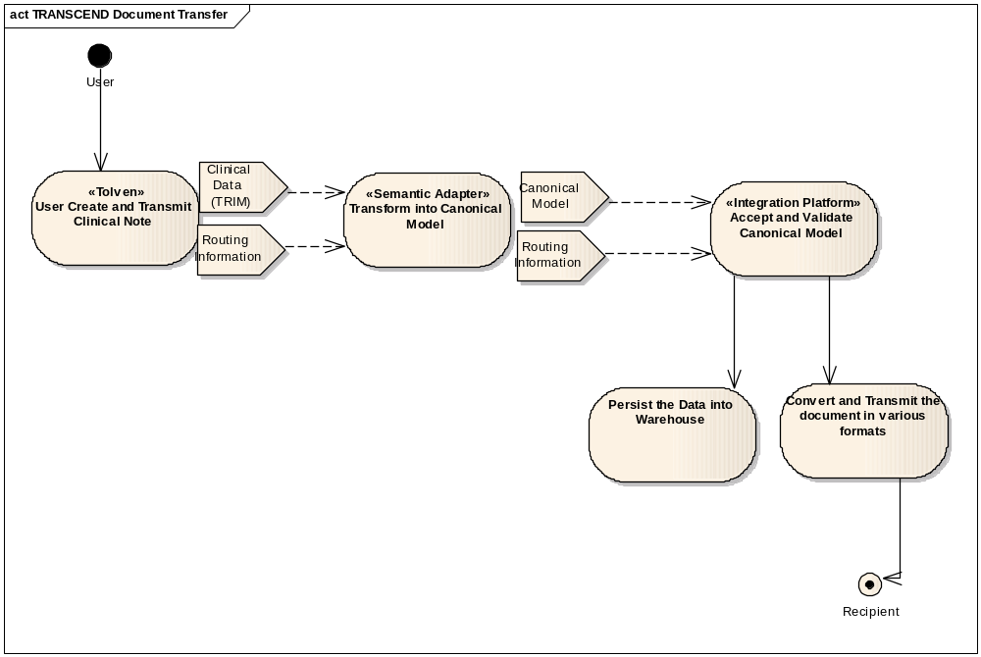

Transmitting data for warehousing and analysis
Description
This use case describes the functionality of the integrated TRANSCEND-caCIS Integration Solution that accepts a data from TRANSCEND for persisting it within the caCIS System.
BUSINESS/TECHNICAL PRIORITY
The data generated from adaptive trials which run on the TRANSCEND’s architecture is of vital importance for research and analysis by the trial administrators as well as other researchers.
IDENTIFY REQUIREMENT(S)
- Requirement TRANSCEND-6: The caCIS system shall accept data from TRANSCEND. This data will include all the clinical information captured for a given subject during the course of the trial.
- Requirement TRANSCEND-7: The caCIS System shall provide an interface that TRANSCEND’s THE Force system will invoke to pass the above-mentioned data. TRANSCEND will send the actual data in native xml format.
- Requirement TRANSCEND-8: The caCIS System shall convert this data from the native xml format into a Canonical format so that it can be persisted in a standardized format.
- Requirement TRANSCEND-9: Only data from Trial Summary notes and PCO will be converted into the Canonical format. Rest of the data elements should be persisted as is to support future conversion.
- Requirement TRANSCEND-10: The caCIS System shall make the data available for analysis in a secured manner. This requirement shall be fulfilled as part of the Clinical Data Warehouse requirements listed above.
IDENTIFY RELATED USE CASES(S)
- Semantic Adapter Use cases
- Integration Platform Use cases
  - Transform Data for Integration Platform
  - Accept Data from the Semantic Adapter
  - Transmit document (Secure Email/ Secure FTP) – [In this case the alternate flow for Secure FTP is executed]
Storyboard
The physician working on TRANSCEND’s THE Force system enters data for the subject using the UI. Upon the visit completion, the physician decides to share the clinical data captured during the visit. (S)he initiates a transfer of this data. THE Force transmits all the information which has been shared by the user to the Semantic Adapter. Since the data is in the native XML format, the Semantic Adapter needs to transform it into the canonical format (CDA R2) and sends it to the Integration Platform. The Integration Platform stores the data in Clinical Data Warehouse and makes it available for research and analysis to authorized users.
Pre-conditionS
- TRANSCEND’s THE Force system is modified to allow users option to share the data with an external system.
- TRANSCEND’s THE Force system is configured to communicated with caCIS System (Semantic Adapter component in particular).
- Security is enabled and trust is established between the Source System and the caCIS System’s Semantic Adapter.
- This Semantic Adapter has the appropriate authorization to invoke that the caCIS System’s AcceptCanonical interface.
- The Integration Platform has been configured to store data in the Clinical Data Warehouse.
USE CASE ACTORS
- Source System (THE Force)
- Semantic Adapter
- Integration Platform
- Clinical Data Warehouse
FLOW OF EVENTS
- THE Force system is configured to push patient data, for patients who have completed their therapy, to the caCIS solution
  - TRANSCEND gathers all of the data that is sharable for the patient. This data is transmitted as collection of xml files in native format
- THE Force creates a request to be sent to caCIS. This request contains the following
  - Collection of xml files in native format containing the all the clinical data to be shared.
  - The document type is set to COMPLETE
- This message is then transmitted to caCIS Semantic Adapter component.
- The following uses cases described above are executed in the order described below:
  - Transform Data for Integration Platform
  - Accept Data from the Semantic Adapter

ERROR FLOW OF EVENTS
- The ERROR FLOW OF EVENTS for the following uses cases are all applicable and possible in this case:
  - Transform Data for Integration Platform
  - Accept Data from the Semantic Adapter
Post-conditionS
- The data transmitted to caCIS is stored within the Clinical Data Warehouse and made available for research and analysis to authorized users.
INCLUSIONS
- Transform Data for Integration Platform
- Accept Data from the Semantic Adapter

DIAGRAM
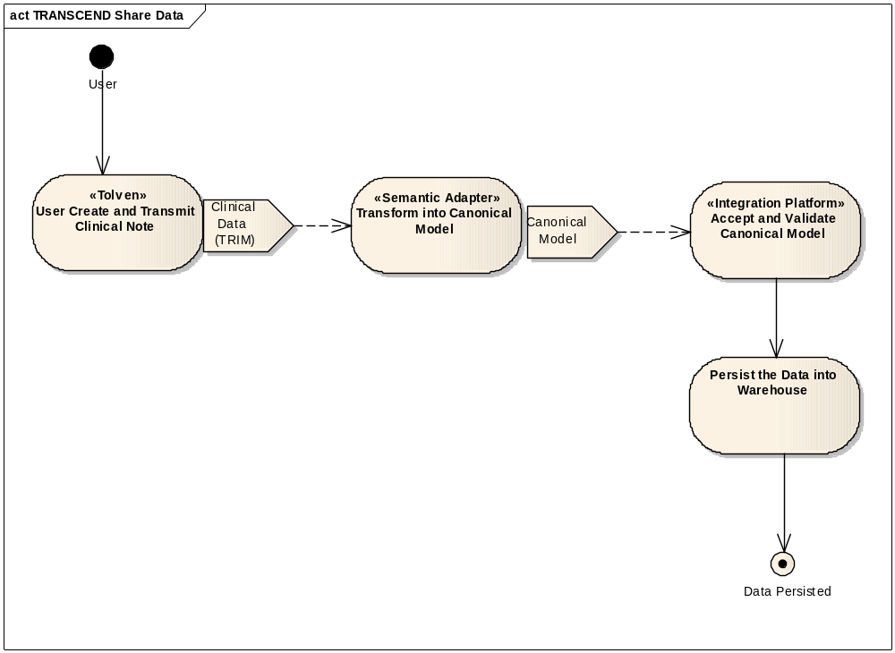

Transmit data to a physician
Description
This use case describes the overall workflow between TRANSCEND and the caCIS for the purpose of document to a physician. TRANSCEND generates a document transfer request (containing the data to be transmitted) to caCIS which then transmits it to a physician.
BUSINESS/TECHNICAL PRIORITY
In order to eliminate the manual copy and paste procedure for transferring Trial Summary notes to physicians, TRANSCEND will leverage the caCIS Integration Solution to enable transfer of documents via secure email.
IDENTIFY REQUIREMENT(S)
- Requirement TRANSCEND-11: The caCIS System shall transmit the document to the recipient via secure email. The email address is provided by TRANSCEND as part of the routing information. This requirement shall be fulfilled as part of the Integration Platform use cases and the related requirements listed above.
IDENTIFY RELATED USE CASES(S)
- Semantic Adapter Use cases
- Integration Platform Use cases
  - Accept Data from the Semantic Adapter
  - Transmit document (Secure Email/ Secure FTP) – [In this case the alternate flow for Secure FTP is executed]
  - Make Document Available (with Security) use case
Storyboard
A physician on iSPY2 wants to send a patient for consultation to another physician. The iSPY2 physician selects the Trial Summary note for the patient and clicks a button in THE Force for sending the data. THE Force presents a list of possible recipients, transfer modes (secure email, secure ftp, XDS NAV, LLP) and document formats (HL7v2 MDM, RIM ITS, CDA R2). The user selects the name of the physician to send the Referral Consult Note to, the desired document format and secure email as the transfer mode. THE Force extracts related data and sends it to TRANSCEND-caCIS Semantic Adapter. Since the data is in the native XML format, the Semantic Adapter converts data into canonical format and sends it to the caCIS Integration Platform. The Integration Platform creates the document in the desired format, looks up the email address for the intended recipient physician and sends the document via secure email to the recipient.
Pre-conditionS
- TRANSCEND’s THE Force system is modified to provide users an option to select the preconfigured recipients for transmitting various documents.
- TRANSCEND’s THE Force system is configured to communicate with caCIS (Semantic Adapter component in particular).
- Security is enabled and trust is established between the Source System and the caCIS System’s Semantic Adapter.
- This Semantic Adapter has the appropriate authorization to invoke that the caCIS System’s AcceptCanonical interface.
- Integration Platform is configured to transmit documents to the desired recipient system.
USE CASE ACTORS
- Source System (THE Force)
- Semantic Adapter
- Integration Platform
- Recipient System
FLOW OF EVENTS
- The user completes creation of one of the Trial Summary note in THE Force and saves the data. The user then selects an option to transmit this note to a physician.
- User selects a physician as recipient from the list displayed on the screen. Also (s)he verifies if the email address information is accurate for this recipient.
- THE Force creates a request to be sent to caCIS. This request contains the following
  - A document request indicating that the type of data is “Trial Summary Note”
  - The email address for the recipient.
  - The xml file in native format containing the note which is to be transmitted to the physician.
- This message is then transmitted to caCIS (to the Semantic Adapter component).
- The following uses cases described above are executed in the order described below
  - Transform Data for Integration Platform
  - Accept Data from the Semantic Adapter
  - Transmit document (Secure Email/ Secure FTP) – [In this case the main flow of events for Secure Email is executed]

ERROR FLOW OF EVENTS
- The ERROR FLOW OF EVENTS for the following uses cases are all applicable and possible in this case
  - Transform Data for Integration Platform
  - Accept Data from the Semantic Adapter
  - Transmit document (Secure Email/ Secure FTP) – [In this case the main flow of events for Secure Email is executed.
Post-conditionS
- The document is transmitted to the intended physician using Secure Email.
INCLUSIONS
- Transform Data for Integration Platform
- Accept Data from the Semantic Adapter
- Transmit document (Secure Email/ Secure FTP) – [In this case the main flow of events for Secure Email is executed]

DIAGRAM
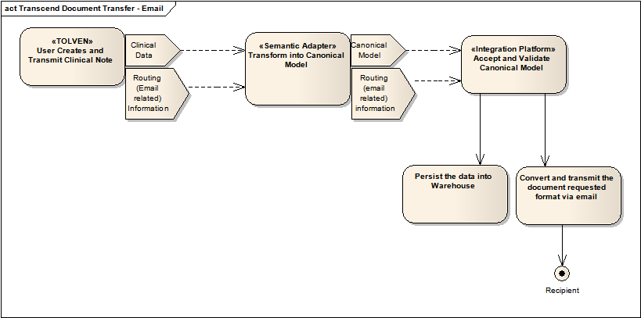

Functional Requirements to Use Case mapping

The following table maps the derived functional requirements listed in section 3.2 to the use case(s) it is related to.
Derived Functional Requirement | Related Use Case(s)
DFR-0001 | Transform data for Integration Platform  Transmit data to a trading partner  Transmit data to a physician
DFR-0002 | Transform data for Integration Platform  Transmitting data for warehousing and analysis
DFR-0003 | Transform data for Integration Platform
DFR-0004 | Transform data for Integration Platform  Accept data from the Semantic Adapter
DFR-0005 | Transform data for Integration Platform  Accept data from the Semantic Adapter
DFR-0006 | Accept data from the Semantic Adapter
DFR-0007 | Transform data for Integration Platform
DFR-0008 | Accept data from the Semantic Adapter  Transmit data to a trading partner  Transmit data to a physician
DFR-0009 | Make document available (NAV/Get) with security
DFR-0010 | Transmit document (Secure E-mail/Secure FTP)
DFR-0011 | Error Flow
DFR-0012 | Accept data from the Semantic Adapter  Load Data into the warehouse  Ad hoc Query with Security
DFR-0013 | Accept data from the Semantic Adapter  Load Data into the warehouse  Ad hoc Query with Security
DFR-0014 | Accept data from the Semantic Adapter  Load Data into the warehouse  Ad hoc Query with Security  Transmitting data for warehousing and analysis
DFR-0015 | Accept data from the Semantic Adapter  Error Flow
DFR-0016 | Accept data from the Semantic Adapter  Transmit data to a trading partner  Transmit data to a physician
DFR-0017 | Ad hoc Query with Security
DFR-0018 | Manage XDS Recipients
DFR-0019 | Manage Secure Email Recipients
DFR-0020 | Manage Secure FTP Recipients
DFR-0021 | Manage CDW Users

Non-Functional Requirements to Use Case Mapping

The following table maps the Non-functional requirements listed in section 3.2 to the use case it is related to.
Non-Functional Requirement | Related Use Cases
NFR-0001 | All use cases
NFR-0002 | All use cases
NFR-0003 | Transform data for Integration Platform  Transmit data to a trading partner  Transmit data to a physician
NFR-0004 | Ad hoc Query with Security
NFR-0005 | Ad hoc Query with Security
NFR-0006 | Ad hoc Query with Security
NFR-0007 | All use cases
NFR-0008 | Accept data from the Semantic Adapter  Load Data into the warehouse  Transmitting data for warehousing and analysis
NFR-0009 | Accept data from the Semantic Adapter  Load Data into the warehouse  Transmitting data for warehousing and analysis
NFR-0010 | All use cases
NFR-0011 | All use cases
NFR-0012 | All use cases
NFR-0013 | N/A

