caBIG® Platform Independent Model and Service Specification

Patient Outcomes Data Service (PODS)

0.0.9

03/07/2010

Authors | Hugh Reinhart  Smita Hastak  Naveen Amiruddin
Reviewers | Kunal Modi  John Speakman  Kalpesh Patel
Architecture Inception Team | Christo Andonyadis

Version Number | Date | Contributor | Description
0.0.1 | 12/09/2009 | Smita Hastak | Initial version
0.0.2 | 12/12/2009 | Hugh Reinhart | Added interface section
0.0.3 | 01/01/2010 | Naveen | Incorporated feedback
0.0.4 | 01/05/2010 | Hugh Reinhart | Incorporated feedback
0.0.5 | 01/05/2010 | Lisa Schick | Incorporated feedback
0.0.6 | 01/05/2010 | Todd Parnell | Incorporated feedback
0.0.7 | 01/13/2010 | Kunal Modi | Incorporated feedback
0.0.8 | 02/01/2010 | Kunal Modi | Incorporated feedback
0.0.9 | 03/07/2010 | Naveen Amiruddin  Hugh Reinhart | Incorporated the Business Services changes and feedback from Kunal Modi, Kalpesh Patel and John Speakman

TABLE OF CONTENTS

1 Introduction 5
1.1 Overview 5
1.2 Relationship to Standards 6
1.3 Relation to the PODS Conceptual Functional Service Specification 7
1.3.1 Conformance and Compliance 8
2 Platform Independent Model and Service Specification 8
2.1 Overview and Architecture 8
2.2 Implementation Considerations 8
2.2.1 Assumptions 8
2.2.2 Deployment Considerations 9
2.2.3 Jurisdictional Domains 9
2.3 Information Model 10
2.3.1 Primary Information Object Type 10
2.3.2 Patient Outcomes Message Information model 10
A unique identifier assigned by the service. 12
2.3.3 Error Implementation Model 26
2.4 Control Data Type Definitions 26
2.4.1 Status/Return Values/Exceptions 26
2.4.2 Error Codes 27
3 Interfaces 27
3.1 UML Model of Interfaces 27
3.2 Operations (Enumeration) 28
3.2.1 Patient outcomes Management Interface 28
3.2.2 Account Management Interface 28
3.3 Operation Behavior Descriptions 28
3.3.1 PO-INF1: Patient Outcomes Management Interface 28
3.3.2 PO-INF6: Account Management Interface 30
Dynamic Model 32
3.4 Collaboration Diagram 32
3.5 Sequence Diagram 34
4 Profiles 35
4.1 Functional Profiles 35
4.1.1 Patient Outcomes Management Profile 35
4.1.2 Account Management Profile 35
4.2 Semantic Profiles 35
5 Relationship with other services 35
6 Conformance Statements 36
7 Appendix A – References 37
8 Appendix B - Glossary 38
9 Appendix C - Cross Reference Tables 38
9.1 Interface to Profile Mapping 38
9.2 Interface Operations to Profile Operations 38
10 Appendix A - Parameter list for Operations 40
10.1 Outcomes Management 40
10.1.1 get 40
10.1.2 get ById 41
10.1.3 write 41
10.2 Appendix B - Parameter list for Account Management Operations 48
10.2.1 createUser 48
10.2.2 getUser 48
10.2.3 updateUser 48
11 Appendix C - Vocabulary Bindings 49
11.1 Valid values 49
11.2 Valid values for Frequency 54
11.3 Valid values for Route of Administration 59
11.4 Valid values for Payment Method code 60
11.5 Valid values for Off Treatment Reason 61

PODS Platform Independent Model and Service Specification

Introduction

Overview

The National Cancer Institute has developed a functional, usable demonstration of the seamless linkage of biomedical research and clinical care via the development of a Patient Outcomes Data Service (PODS) for cancer. Effectively a data repository accessible and reusable via the National Cancer Institute (NCI)’s services-based capacity for interoperability, the Service will represent a “Rapid Learning Healthcare System” on a national and potentially global scale. Enabling collection, analysis, and dissemination in useful forms for cancer research and care, the data repository would be structured with the rigor of – in fact greater rigor than – today’s clinical trial data.
The transformative benefits of such a resource include:
- A massive cancer patient cohort will be available for correlative analysis.
- Physicians at the point of care will be able to engage in real-time data-mining in support of care decisions.
- A method for cancer researchers to request acquisition of tissue samples and other highly-protected information without compromising privacy laws.
- Increased enrollment in clinical trials as cancer researchers can search for potential enrollees in the outcomes database, and doctors can indicate patient interest in enrollment at the point of care.
- A foundation for cultural change in clinical oncology practice whereby local physicians routinely engage the research community to determine and establish the best available care.
- Care provided through treatment plans based on guidelines that share structural characteristics with clinical research protocols
Caregivers and patients will be able to enter clinical outcomes information into the service’s persistence layer for use in care determinations and research, either via a series of data entry screens or via exchange of data with electronic health records and clinical data management systems used in clinical trials (note that, although the Patient Outcomes Data Service is intended to capture outcomes data outside the context of a clinical trial, if a clinical trials system can furnish any of the data, the Patient Outcomes Data Service can consume it). NCI is defining an outcome here as a change in some measured or recorded aspect of a patient health status compared between two or more points in time, often -- but not always -- linked to/the result of one or more interventions (or non-interventions) that were made between those points in time. To put it more succinctly, an outcome is a measure of how a patient (or study subject) feels, functions, or survives.
A key initial component of the Patient Outcomes Data Service is the Response Evaluation Criteria in Solid Tumors (RECIST). Originally developed for measuring tumor response using X-ray, CT and MRI, then extended to provide formalized rules for measurement of general cancer response, RECIST is a voluntary, international standard based on the distillation of former methods used by the World Health organization (WHO) and NCI’s Eastern Cooperative Oncology Group (ECOG) for deriving outcome assessment criteria for measurable disease. RECIST also provides a semantic bridge to findings from clinical research. However, this is only a first step toward the systematic capture of outcomes; the specific data elements are expected to evolve as more stakeholders input and feedback is received. It is also of note that, as the name implies, RECIST applies only to solid tumors.
The first release of this effort focuses on enabling collection of patient outcomes data. It provides an application interface for the managing and reporting of patient outcomes data in a clinical setting and is the first step in the process of building the broader vision of the definitive Patient Outcomes Data Service. Outcomes data can be provided by a consumer, a clinician or an Electronic Health Record (EHR) system. The purpose of this service is to provide specifications for a key set of clinical components that have been identified as part of a patient outcomes data set. Its interface has been implemented as a user-facing application in this first release. It is however envisioned to be integrated with other clinical domain services, such as EHRs.
This service will provide clinicians or administrators at clinician’s offices with the ability to submit outcome data for the cancer patients under their care. It will also provide them with the ability to query the data they submitted.
The development of a common, reusable set of interfaces provided by this service will facilitate standardization of integration and interoperability between systems that collect and report patient outcome data.
This service specification provides a key design component for NCI to support Patient Outcomes information management and integration with other systems. It is anticipated to evolve in future releases to fulfill the goals of NCI’s larger vision of a comprehensive outcome data repository.

Relationship to Standards
.

Standards | Description
BRIDG v 2.1 and 3.0 | The Patient Outcomes Data Service leverages the Biomedical Research Integrated Domain Group (BRIDG; www.bridgmodel.org) v 2.1 and 3.0. BRIDG 3.0 was released during development of this effort and therefore the modified semantic structures from 3.0 that applied to PODS services were implemented.
ISO 21090 | The Patient Outcomes Data Service uses NCI’s constrained version of the implementation of the ISO 21090 standard.

Relation to the PODS Conceptual Functional Service Specification

Conceptual Functional Service Specification Name | Conceptual Functional Service Specification Version | Description & Link to the Conceptual Functional Service Specification
PODS Conceptual Functional Service Specification | 0.0.8 | This Platform Independent Model (PIM) Service Specification is derived from the PODS CFSS document. The CFSS can be found on the NCI Enterprise wiki at  https://gforge.nci.nih.gov/svnroot/ent-services/trunk/specifications/CFSS_Patient_Outcomes_Data_Service_PODS.doc

Conformance and Compliance

Conformance Profile No. | PO-CP1
Conformance Profile Name | PO Submit Outcomes
Functional Profiles
  Functional Profile No. | Functional Profile Name
  PO-FP1 | Patient Outcomes Management
  PO-FP2 | Account Management
Semantic Profiles
  Semantic Profile No. | Semantic Profile Name
  PO-SP1 | Patient Outcomes Message Information Model

Platform Independent Model and Service Specification

Overview and Architecture

Implementation Considerations

Implementation Consideration | Impact
ISO data types may need to be constrained for the implementation | The service developed might not be fully compliant with ISO 21090. It is using NCI’s constrained version of the ISO data types.

Assumptions
Assumptions | Affects
Audit & Logging is assumed to be handled by supporting infrastructure | As a result it is not explicitly referenced in individual operations and assumed to be done automatically.
Authorization checks are enforced | Authorized Application users can access only the data which they created.

Deployment Considerations

Deployment Consideration | Impact
Local Deployment Mode | Service(s) should be able to run locally in the same container as the Patient Outcomes web client application.
Remote Deployment Mode | Service(s) should run remotely and be able to support remote clients.
Performance Requirement | Service should provide a five-second response under regular load.
Scalability | Service should be able to serve at least 100 users simultaneously
Up time | Service can be down during scheduled maintenance windows.
Failover | NA

Jurisdictional Domains

Jurisdictional Domains | Boundary
NCI’s OCIO | The service is going to be deployed within NCI network. Future versions will support federated deployments.

Information Model

Primary Information Object Type
The primary information object type is Patient. Each instance represents an individual who participates in an interventional treatment as a recipient of an investigational product or other therapies, such as surgery, radiation, etc. They may also be individuals who are being screened for studies, or individuals participating in observational or other studies.
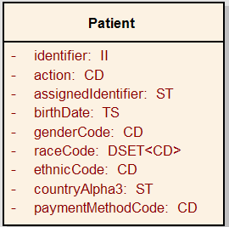

Patient Outcomes Message Information model

Patient Outcomes Message Information Model
The Patient Outcomes message information model is a de-normalized version of the Patient outcomes Information Model. The diagram below shows the various classes of the Message Information model that are applicable to the Patient Outcomes Data Service.
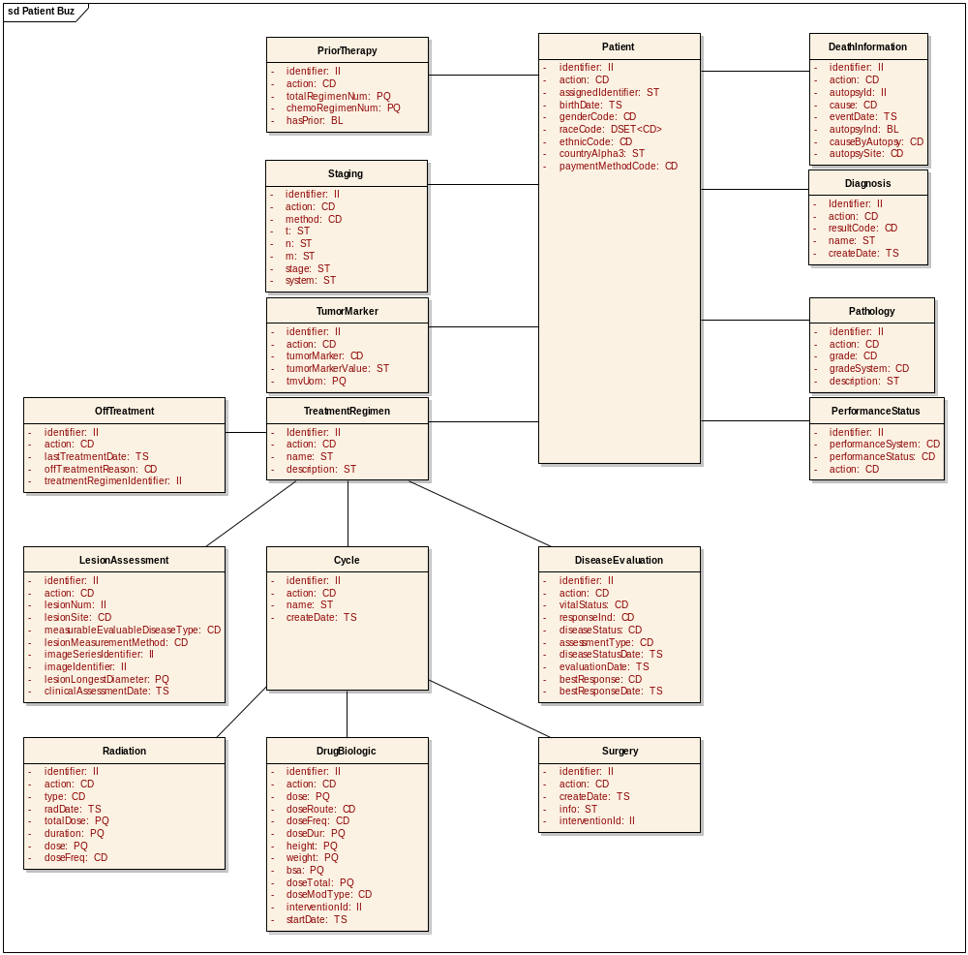

Patient Outcomes Message Information Model

Patient
A role played by a person as a recipient of health care services from a healthcare provider.

Attribute | Description
identifier | A unique identifier assigned by the service.
action | A value representation the type of action such as create/update/delete/retrieve.
assignedIdentifier | A unique identifier assigned by the client
birthDate | The date on which the person was born.
genderCode | Gender code of the patient.
raceCode | A value representing a self-declared racial origination, independent of ethnic origination.  For example, for the National Cancer Institute, this code is based on Office of Management & Budget (OMB) approved categories.
ethnicCode | The self-declared ethnic origination, independent of racial origination.
countryAlpha3 | Three letter ISO code of the country.
paymentMethodCode | The primary payer/insurance carrier information at the time of treatment on a protocol.

DeathInformation
The death information details for a patient.

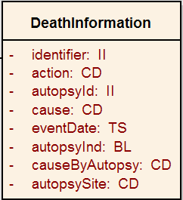

Attribute | Description
identifier | A unique identifier.
action | A value representation the type of action such as create/update/delete/retrieve
autopsyId | A unique identifier of the autopsy
cause | Cause of the death
eventDate | Date on which the person died
autopsyInd | Identifies whether or not autopsy was performed
causeByAutopsy | Death Cause As Determined By Autopsy
autopsySite | Primary Site of Disease Autopsy

Diagnosis
A medical condition or disease identified by its signs, symptoms, and from the results of various diagnostic procedures.

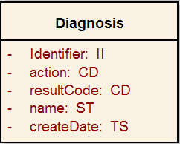

Attribute | Description
identifier | A unique identifier.
action | A value representation the type of action such as create/update/delete/retrieve
resultCode | Coded data or information that is determined by an act of observation.
name | The name of the diagnosis
createDate | The date and time when the first diagnosis began.

Pathology
Pathology is the study and diagnosis of disease through examination of organs, tissues, bodily fluids, and whole bodies (autopsies)

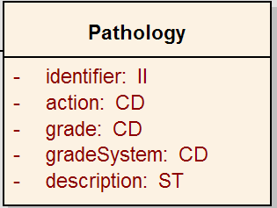

Attribute | Description
identifier | A unique identifier.
action | A value representation the type of action such as create/update/delete/retrieve
grade | The degree of cellular differentiation in a tissue sample.  For example, a brain tumor could be grade 3.
gradeSystem | System used to grade sample.
description | Additional pathology information.

PerformanceStatus
The final result of a determination of how well a patient is able to perform ordinary tasks and carry out daily activities.
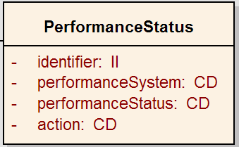

Attribute | Description
identifier | A unique identifier.
action | A value representation the type of action such as create/update/delete/retrieve
performanceSystem | The means or technique used to ascertain the observation. For example, blood pressure measurement method could be arterial puncture or sphygmomanometry.
performanceStatus | Coded data or information that is determined by an act of observation.

PriorTherapy
The type of treatment(s) a patient has received prior to being on the current treatment plan.

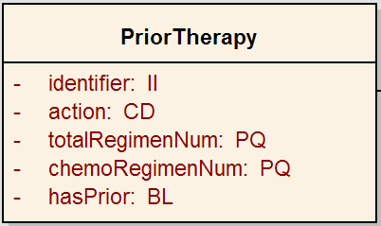

Attribute | Description
identifier | A unique identifier.
action | A value representation the type of action such as create/update/delete/retrieve
totalRegimentNum | Total Number Of Prior Therapy Regimens
chemoRegimenNum | Number of Prior Chemotherapy Regimens
hasPrior | Identifies whether or not the patient has prior therapy

Staging
Staging describes the extent or severity of an individual’s cancer based on the extent of the original (primary) tumor.
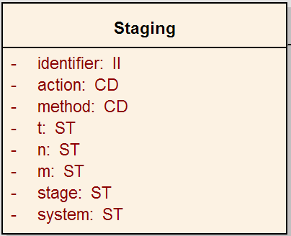

Attribute | Description
identifier | A unique identifier.
action | A value representation the type of action such as create/update/delete/retrieve
method | Method used to determine stage
t | Indicates the extent of the tumor
n | Indicates the extent of spread to the lymph nodes
m | Indicates the presence of metastasis
stage | Current cancer stage
system | The standard staging system on which the result is based

TumorMarker
A biological marker which indicates the presence or status of a tumor in a patient.

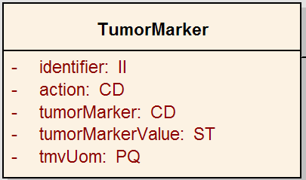

Attribute | Description
identifier | A unique identifier.
action | A value representation the type of action such as create/update/delete/retrieve
tumorMarker | The name of the tumor marker
tumorMarkerValue | Textual data or information that is determined by tumor marker.
tmvUom | Unit of measurement for the tumor marker

TreatmentRegimen
A systematic plan for therapy, including doses, scheduling, and duration of the treatment.

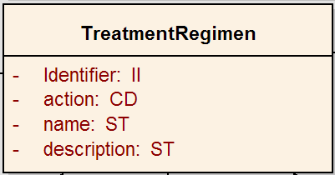

Attribute | Description
Identifier | A unique identifier.
action | A value representation the type of action such as create/update/delete/retrieve
name | The name of the treatment regiment
description | Additional treatment regiment information

OffTreatment
Details on when and why a patient was taken off a treatment regimen.
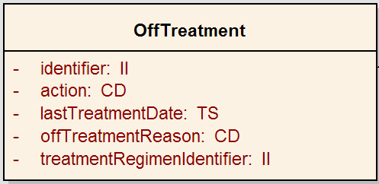

Attribute | Description
Identifier | A unique identifier.
action | A value representation the type of action such as create/update/delete/retrieve
lastTreatmentDate | The date and time of the last treatment.
offTreatmentReason | A code or free text specifying the motivation, cause, or rationale of the treatment.

Disease Evaluation
An assessment or interpretation made by a physician of the state of the disease.
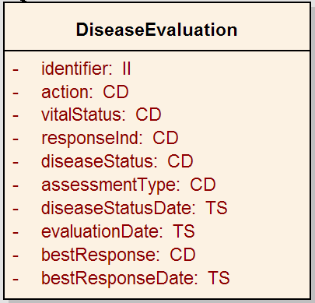

Attribute | Description
identifier | A unique identifier.
action | A value representation the type of action such as create/update/delete/retrieve
vitalStatus | Coded data or information that is determined by evaluating the disease.
reponseInd | Indicates whether or not evaluable for response
diseaseStatus | Coded data or information that is determined by evaluating the disease status
assessmentType | The means or technique used to ascertain the evaluation.
diseaseStatusDate | Date and time of the evaluation of the disease status
evaluationDate | Date and time of the evaluation
bestResponse | Coded data or information that is determined by evaluating the best response of the evaluation
bestResponseDate | Date and time of the best response

Cycle
A course of treatment that lays out the schedule and frequency of the treatment.
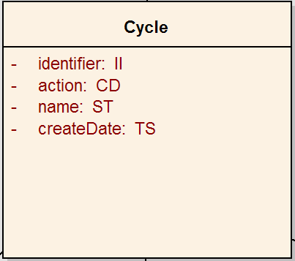

Attribute | Description
Identifier | A unique identifier.
action | A value representation the type of action such as create/update/delete/retrieve
name | The name of the cycle
createDate | Date and time when the cycle was started

LesionAssessment
A clinical or pathological evaluation of the lesion or tumor.
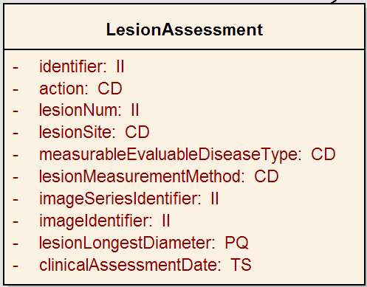

Attribute | Description
Identifier | A unique identifier.
action | A value representation the type of action such as create/update/delete/retrieve
lesionNum | The unique numeric value assigned to a lesion.
lesionSite | The site at which the lesion was performed
mesurableEvaluable  DiseaseType | Measurable evaluable disease type
lesionMeasurement  Method | The means or technique used to ascertain the lesion measurement
imageSeriesIdentifier | Globally unique set of characters which are not human readable used to identify the image series containing referenced instances.
imageIdentifier | The unique symbol that establishes identity of the image.
lesionLongestDiameter | The length of the longest straight line passing through the center of the lesion.
clinicalAssessmentDate | The date and time of the clinical assessment was made

Surgery
A procedure or operation to investigate and/or treat a pathological condition.

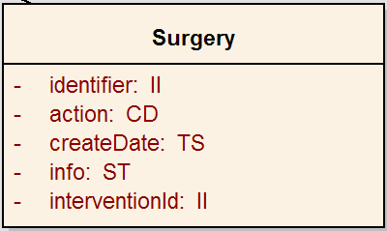

Attribute | Description
Identifier | A unique identifier.
action | A value representation the type of action such as create/update/delete/retrieve
createDate | The date and time of the performed procedure.
info | A free text explanation of the performed procedure.
interventionId | Intervention Identifier

DrugBiologic
The details of applying, dispensing or otherwise giving medications or other substances to a patient.
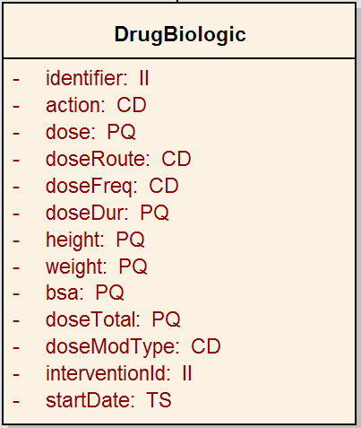

Attribute | Description
Identifier | A unique identifier.
action | A value representation the type of action such as create/update/delete/retrieve
dose | Dose level of a substance or medication, assigned to a study subject.
doseRoute | Route of administration for the substance.
doseFreq | The number of doses given per a specific interval.
doseDur | Actual length of time of the activity performed.
height | Height.
weight | Weight.
bsa | Body Surface Area.
doseTotal | Total daily dose of treatment.
doseModType | A description of the modification of the dose.
interventionId | Intervention Identifier
startDate | Date and time at which the drug was started

Radiation
The details of the radiation therapy administered to a patient.
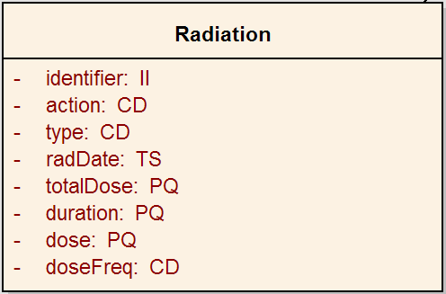

Attribute | Description
Identifier | A unique identifier.
action | A value representation the type of action such as create/update/delete/retrieve
type | The name of the radiation
radDate | The date and time of the radiation
totalDose | Total daily dose of treatment.
duration | Actual length of time of the radiation.
dose | Dose level of a substance or medication, assigned to a study subject.
doseFreq | The number of doses given per a specific interval.

User
Contains information about the Outcomes data submitter’s account including, physician and treating site information.

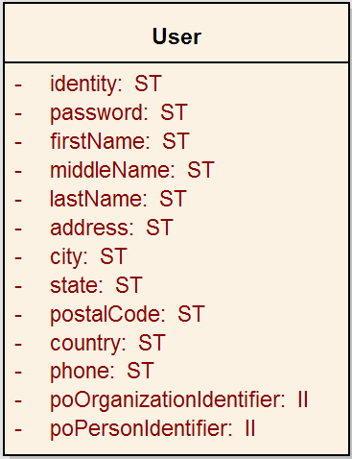

Attribute | Description
identity | Unique identifier, either e-mail account or grid identity
password | Password
firstName | First name
middleName | Middle initial or name
lastName | Last name
address | Address
city | City
state | State
postalCode | Postal code
country | Iso alpha3 country code
phone | Phone number
poOrganizationIdentifier | Treating site organization identifier
poPersonIdentifier | Treating physician identifier

ISO 21090 Data Types (used in PODS objects)

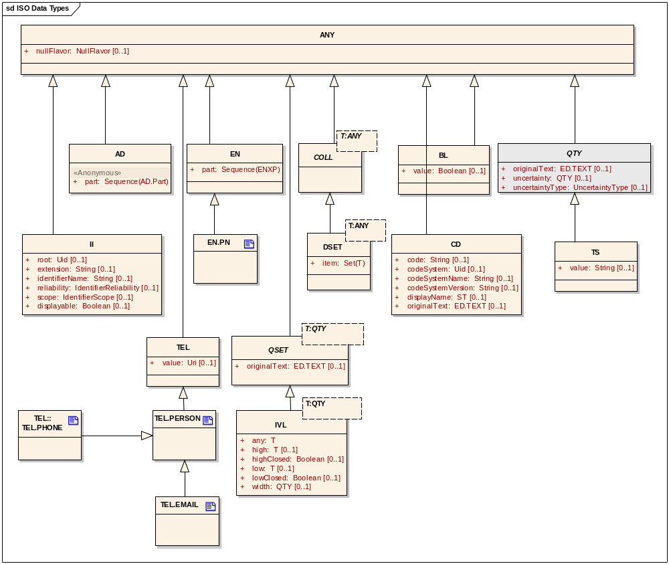
ISO 21090 Data Types subset for PODS

Error Implementation Model

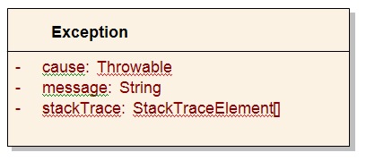

Attribute Name | Type | Attribute Description
cause | Throwable | The cause of this throwable exception
message | String | The detailed error message
stackTrace | StackTraceElement[] | An array of stack trace elements representing the stack trace pertaining to this throwable exception

Control Data Type Definitions

Status/Return Values/Exceptions

Data Type | Type (Status / Return Value / Exception) | Data Type Description
Patient | Return Value | Contains patient information.
User | Return Value | Contains user account information.

Error Codes

Error Code | Error Condition | Error/Exception Description
DataFormatException | Exception | Indicates error with data conversion.
RemoteException | Exception | Indicates for all errors other than DataFormatException.

Interfaces

UML Model of Interfaces

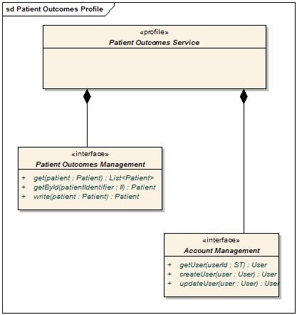

Interface No | Interface Name | Interface Description
PO-INF1 | Patient Outcomes | Provides functionality to manage Patient Outcome to perform various capabilities retrieve, create / update and delete.
PO-INF2 | Account Management | Provides functionality to manage User registration & maintenance.

Operations (Enumeration)

Patient outcomes Management Interface

Operation No. | Operation Name | Interface Name | Operation Description
PO-INF1-OP1 | get | PatientService | Get patient information.
PO-INF1-OP2 | getById | PatientService | Get all information for a given patient.
PO-INF1-OP3 | write | PatientService | Manages the patient information. It can perform create/update/delete depending upon the context.

Account Management Interface

Operation No. | Operation Name | Interface Name | Operation Description
PO-INF2-OP1 | getUser | UserService | Get user account information.
PO-INF2-OP2 | createUser | UserService | Create a new user account.
PO-INF2-OP3 | updateUser | UserService | Update a user account.

Operation Behavior Descriptions

PO-INF1: Patient Outcomes Management Interface

get
Behavior Description | Retrieves a Patient Outcome record
Pre-Conditions
Security Conditions | User must be authenticated and authorized to access the requested patient outcome record.
Inputs | Full or partial patient outcomes object.
Outputs | Patient outcomes object(s) fully or partially populated.
Post-Conditions | None
Exception Conditions | User does not have privilege to access the requested patient outcome record.
Additional Implementation Details | The service will return the complete Patient Information model object or a specific class depending upon the value of the action value
Notes | - Refer Vocabulary binding Appendix for valid values.  - Refer Parameter list Appendix for additional details  - Refer section 2.3 for complete class definition.

getById

Behavior Description | Retrieves all the details related to a specific patient outcome record.
Pre-Conditions
Security Conditions | User must be authenticated and authorized to access the requested patient outcome record.
Inputs | Patient outcomes Identifier
Outputs | Patient outcomes object fully populated.
Post-Conditions | None.
Exception Conditions | User does not have privilege to access the requested patient outcome record.
Additional Implementation Details | The service will return the complete Patient Information model object or a specific class depending upon the value of the action value
Notes | - Refer Vocabulary binding Appendix for valid values.  - Refer Parameter list Appendix for additional details  - Refer section 2.3 for complete class definition.

write

Behavior Description | Creates/updates/delete a patient outcome record depending upon the value of the action value for each class of the patient outcomes message information model.
Pre-Conditions | Must be a registered user.
Security Conditions | User must be authenticated and authorized to access the requested patient outcome record. For update and delete only the user who has created the record is authorized.
Inputs | Full or partially populated patient object with action attributes set.
Outputs | Updated patient outcomes object.
Post-Conditions | A patient outcome is persisted/update/deleted depending upon the action value.
Exception Conditions | Invalid patient outcomes object.
Additional Implementation Details | The service can create/update/delete the complete Patient Information model or specific classes depending upon the value of the action attribute.
Notes | - Refer Vocabulary binding Appendix for valid values.  - Refer Parameter list Appendix for additional details  - Refer section 2.3 for complete class definition.

PO-INF6: Account Management Interface

getUser

Behavior Description | Retrieves a User object for the requesting user
Pre-Conditions | None
Security Conditions | User must be authenticated as a valid Outcomes user.
Inputs | None
Outputs | User
Post-Conditions | None.
Exception Conditions | Authentication failure
Additional Implementation Details
Notes | - Refer Vocabulary binding Appendix for valid values.  - Refer Parameter list Appendix for additional details  - Refer section 2.3 for complete class definition.

createUser
Behavior Description | Creates a User object
Pre-Conditions | Must have a valid user account or valid grid credential.
Security Conditions | None.
Inputs | User Object
Outputs | Created User Object
Post-Conditions | None.
Exception Conditions | Incomplete User object.  Incorrect CD value.  Identifier should not be passed for create operation
Additional Implementation Details
Notes | - Refer Vocabulary binding Appendix for valid values.  - Refer Parameter list Appendix for additional details  - Refer section 2.3 for complete class definition.

updateUser
Behavior Description | Updates a User object
Pre-Conditions | User must already be registered.
Security Conditions | User must be authenticated and authorized to access the requested user accounts.
Inputs | User Object
Outputs | Updated User Object
Post-Conditions | None.
Exception Conditions | Incomplete User object.  Incorrect CD value.  Identifier should be passed for update operation
Additional Implementation Details
Notes | - Refer Vocabulary binding Appendix D for valid values.  - Refer section 2.3 for complete class definition.

Dynamic Model

Collaboration Diagram

The following collaboration diagram shows the other services that the Patient Outcomes service is dependent on. This service interacts with the NES-COPPA services for accomplishing submission of Patient Outcomes data to the NCI. Note that this is just a sample collaboration shown using NCI’s NES. Service implementers can opt to implement their own equivalent services or functionality.

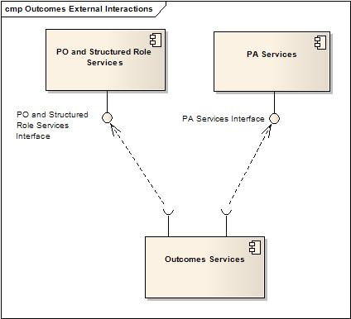
Collaboration Diagram

Sequence Diagram
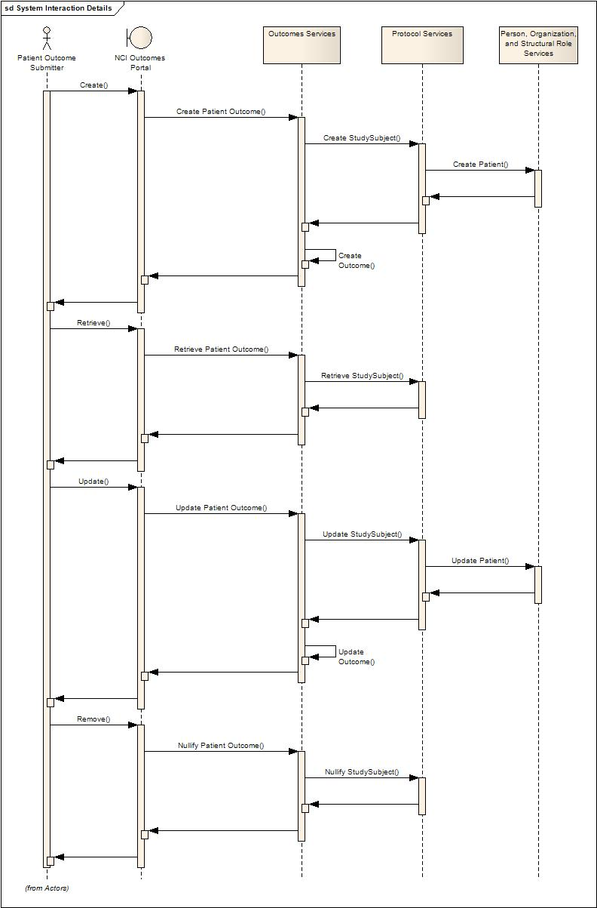

Profiles

Functional Profiles

Patient Outcomes Management Profile
The Patient Outcomes management profile is concerned with the management of instances of the specified patient outcomes.

Account Management Profile
The Account management profile is concerned with the registration of a user for submitting Patient Outcomes data either through the application or through the service.

Profile No. | Profile Name | Profile Description
PO-FP1 | Patient Outcomes Management Profile | This profile provides functionality to manage patient outcomes data.
PO-FP2 | Account Management Profile | Provides functionality to manage User registration.

Semantic Profiles

Semantic Profile No. | Semantic Profile Name | Semantic Profile Description
PO-SP1 | Patient Outcomes Message Information Model | The Patient Outcomes Message Information Model is a domain-oriented model that conforms to the service interface.

Relationship with other services

Following table provides information for other services that are being used by PODS in NCI’s implementation.
Service Name | Dependant / Depends | Data | Description
Person Service | Depends | Person Information | Outcomes Service relies on the Person Service to register a Patient with the Patient Outcomes Service as well as query or create the submitting Physician record.
Organization Service | Depends | Organization Information | Patient Outcomes Service relies on the Organization Service to provide the submitting/treating Organization data during query or create a new Organization when needed.
Structured Role Service | Depends | Physician Information, Patient Administrative Information, Organization Information | Outcomes Services relies on Structured Role Service to query and/or create the Patient role.
Protocol Abstraction Service | Depends | Disease, Intervention, PlannedActivity, etc. | Outcomes Service relies on many different base objects of the Protocol Abstraction Service.

Conformance Statements

No. | Name | Type | Viewpoint | Description | Test method
CS1 | Multiple Jurisdictions | Obligation | Enterprise | The Patient Outcomes Service is currently implemented as a centralized service. | Test cases include central domain scenarios
CS2 | Query Performance | Obligation | Enterprise | The query for outcomes for a patient should return results in 5 seconds | Test cases to include performance testing.
CS3 | Conformance Profiles | Obligation | Computational / Information | In order to claim a minimal level of conformance to the specification, designers/implementers are obligated to support the following mandatory Conformance Profiles (i.e. their contained functional and semantic profiles): PO Submit Outcomes | Test cases to be defined to test each specified profile.
CS4 | Optional Functional Profiles | Permission | Computational | Designers/implementers may implement the additional functional profiles identified in the Functional Profile section 1 not included in the mandatory conformance profiles. | Test cases to be defined to test each specified profile.
CS5 | ISO Data types | Obligation | Information | Designers/implementers are obliged to support the NCI’s localized ISO 21090 data types implementation in all operations | Test cases to include processing of each relevant data type
CS6 | Auditing | Obligation | Engineering | Designers/implementers are obligated to decide on and document the approach for logging or auditing of operation calls. | Design Review
CS7 | Operation Behavior Issues / Assumptions | Obligation | Computational / Information / Engineering | Architects/Designers/Developers are obligated to confirm (or refute) all Assumptions made in the Notes for Service Realization sections of each operation and the overall Assumptions section. | Design Review

Appendix A – References

Name | Description | Location
BRIDG v2.1 & 3.0 | BRIDG model | http://www.bridgmodel.org
Person PIM | Provides an overview of the Person | https://ncisvn.nci.nih.gov/svn/coppa/trunk/documents/analysis_and_design/PIM_OrganizationService.doc
Organization PIM | Provides an overview of the Organization | https://ncisvn.nci.nih.gov/svn/coppa/trunk/documents/analysis_and_design/PIM_PersonService.doc
ISO PIM | Provides an overview of the ISO types | https://gforge.nci.nih.gov/svnroot/coppa/trunk/documents/analysis_and_design/PIM_21090.doc
Structural roles | Provides an overview of the Structural roles | https://ncisvn.nci.nih.gov/svn/coppa/trunk/documents/analysis_and_design

Appendix B - Glossary

Term | Description
BRIDG | The Biomedical Research Integrated Domain Group (BRIDG) has developed a comprehensive domain analysis model representing biomedical/clinical research.
COPPA | Correlation, Organization, Person and Protocol Abstraction (Services).
HL7 RIM | Health Level 7 – Reference Information Model
PO | Patient Outcomes

Appendix C - Cross Reference Tables

Interface to Profile Mapping

Interface No. | Interface | Profile No. | Profile
PO-INF1 | Patient | PO-FP1 | Patient Outcomes Management
PO-INF2 | User | PO-FP2 | Account Management

Interface Operations to Profile Operations

Operation No. | Operation Name | Capability No. | Profile Capability
PO-INF1-OP1 | get | PO-FP1-C1 | Retrieve a Patient Outcomes for a given Patient outcome
PO- INF1-OP2 | getById | PO-FP1-C2 | Retrieve a Patient outcomes for a give Patient Identifier
PO- INF1-OP3 | write | PO-FP1-C3 | Manage a Patient Outcomes (create/update/delete)
PO-INF2-OP1 | getUser | PO-FP2-C1 | Retrieve an User object
PO-INF2-OP2 | createUser | PO-FP2-C2 | Create a User object
PO-INF2-OP3 | updateUser | PO-FP3-C3 | Update a User object

Appendix A - Parameter list for Operations

Outcomes Management

get
Patient Outcomes consist of one business wrapper object which is composed many other classes as defined below.
Class | Mandatory | Comments
Patient | Yes | populate only the patient identifier
Pathology | No | Populate only the Pathology identifier, if pathology to be retrieved as part of the patient outcomes
Diagnosis | No | Populate only the Diagnosis identifier, if pathology to be retrieved as part of the patient outcomes
DeathInformation | No | Populate only the DeathInformation identifier, if DeathInformation to be retrieved as part of the patient outcomes
PerformanceStatus | No | Populate only the Performance identifier, if PerformanceStatus to be retrieved as part of the patient outcomes
PriorTherapy | No | Populate only the PriorTherapy identifier, if PriorTherapy to be retrieved as part of the patient outcomes
TumorMarker | No | Populate only the TurMarker identifier, if TumorMarker to be retrieved as part of the patient outcomes
TreatmentRegimen | No | Populate the collection of TreatementRegimen identifier, if TreatmentRegiment collection to be retrieved as part of the patient outcomes
OffTreatment | No | Populate the offTreatment identifier, if OffTreatment to be retrieved as part of TreatementRegimen
LesionAssessment | No | Populate the LesionAsessment identifier, if LesionAssessment to be retrieved as part of TreatementRegimen
DiseaseEvaluation | No | Populate the DiseaseEvaluation identifier, if DiseaseEvaluation to be retrieved as part of TreatementRegimen
Cycle | No | Populate the cycle identifier, if Cycle to be retrieved as part of TreatementRegimen
Radiation | No | Populate the Radiation identifier, if Radiation to be retrieved as part of Cycle
DrugLogic | No | Populate the DrugLogic identifier, if DrugLogic to be retrieved as part of Cycle
Surgery | No | Populate the Surgery identifier, if Surgery to be retrieved as part of Cycle

get ById
Retrieves a Patient Outcomes for a given Patient Identifier.
Attribute | Mandatory | Comments
Identifier | Yes | Identifier of the patient

write
Patient Outcomes consist of one business wrapper object which is composed many other classes as defined below. Depending upon the value of the action attribute on each class, it will perform create/update/delete and retrieve for the patient outcomes
Class | Mandatory | Comments
Patient | No
Pathology | No
Diagnosis | No
DeathInformation | No
PerformanceStatus | No
PriorTherapy | No
TumorMarker | No
TreatmentRegimen | No
OffTreatment | No
LesionAssessment | No
DiseaseEvaluation | No
Cycle | No
Radiation | No
DrugLogic | No
Surgery | No

Patient
Attribute Name | Type | Mandatory | Comments
identifier | II | No | If action is Create, identifier must be null  If action is update/delete, identifier must be provided
action | CD | Yes | A new patient object is created if the value is Create  A patient object is updated if the value is Update  A patient and the corresponding child are deleted if the value is Delete
assingedIdentifier | II | Yes | Identifier assigned to the patient by the physician, such as MRN.
gender | CD | Yes | Refer to Vocabulary Binding section
race | CD | Yes | Refer to Vocabulary Binding section
ethnicity | CD | Yes | Refer to Vocabulary Binding section
countryAlphaCode | ST | Yes | Three letter iso country code
paymentMethodCode | CD | No | Refer to Vocabulary Binding section

Pathology
Attribute Name | Type | Mandatory | Comments
identifier | II | No | If action is Create, identifier must be null  If action is update/delete, identifier must be provided
action | CD | Yes | A new Pathology object is created if the value is Create  A Pathology object is updated if the value is Update  A Pathology and the corresponding child are deleted if the value is Delete
grade | CD | Yes | Refer to Vocabulary Binding section
GradeSystem | CD | Yes | Refer to Vocabulary Binding section
Description | ST | No

Diagnosis
Attribute Name | Type | Mandatory | Comments
identifier | II | No | If action is Create, identifier must be null  If action is update/delete, identifier must be provided
Action | CD | Yes | A new Diagnosis object is created if the value is Create  A Diagnosis object is updated if the value is Update  A Diagnosis and the corresponding child are deleted if the value is Delete
ResultCode | CD | Yes | Refer to Vocabulary Binding section
name | ST | Yes | Disease Name
CreateDate | TS | Yes | Must be in current or future date

DeathInformation
Attribute Name | Type | Mandatory | Comments
identifier | II | No | If action is Create, identifier must be null  If action is update/delete, identifier must be provided
Action | CD | Yes | A new Death Information object is created if the value is Create  A Death Information object is updated if the value is Update  A Death Information and the corresponding child are deleted if the value is Delete
cause | CD | Yes | Refer to Vocabulary Binding section
EventDate | TS | Yes
AutospyInd | BL | Yes
causeByAutospy | CD | Yes | Refer to Vocabulary Binding section

PerformanceStatus
Attribute Name | Type | Mandatory | Comments
identifier | II | No | If action is Create, identifier must be null  If action is update/delete, identifier must be provided
Action | CD | Yes | A new Performance Status object is created if the value is Create  A Performance Status object is updated if the value is Update  A Performance Status and the corresponding child are deleted if the value is Delete
performanceSystem | CD | Yes | Refer to Vocabulary Binding section
performanceStatus | CD | Yes | Refer to Vocabulary Binding section

PriorTherapy
Attribute Name | Type | Mandatory | Comments
identifier | II | No | If action is Create, identifier must be null  If action is update/delete, identifier must be provided
action | CD | Yes | A new PriorTherapy object is created if the value is Create  A PriorTherapy object is updated if the value is Update  A PriorTherapy and the corresponding child are deleted if the value is Delete
totalRegimenNum | PQ | Yes
chemoRegimenNum | PQ | Yes
hasPrior | BL | Yes

TumorMarker
Attribute Name | Type | Mandatory | Comments
identifier | II | No | If action is Create, identifier must be null  If action is update/delete, identifier must be provided
action | CD | Yes | A new TumorMarker object is created if the value is Create  A TumorMarker object is updated if the value is Update  A TumorMarker and the corresponding child objects are deleted if the value is Delete
tumorMarker | CD | Yes
tumorMarkerValue | ST | Yes
tumorUOM | PQ | No

Staging
Attribute Name | Type | Mandatory | Comments
identifier | II | No | If action is Create, identifier must be null  If action is update/delete, identifier must be provided
action | CD | Yes | A new Staging object is created if the value is Create  A Staging object is updated if the value is Updat  A Staging object is deleted if the value is Delete
method | CD | Yes | Refer to Vocabulary Binding section
T | ST | No
m | ST | No
N | ST | No
stage | ST | Yes
system | CD | Yes | Refer to Vocabulary Binding section

TreatmentRegimen
Attribute Name | Type | Mandatory | Comments
identifier | II | No | If action is Create, identifier must be null  If action is update/delete, identifier must be provided
action | CD | Yes | A new Treatment Regimen object is created if the value is Create  A Treatment Regimen object is updated if the value is Update  A Treatment Regimen object is deleted if the value is Delete
name | ST | Yes
description | ST | Yes

offTreatment
Attribute Name | Type | Mandatory | Comments
identifier | II | No | If action is Create, identifier must be null  If action is update/delete, identifier must be provided
action | CD | Yes | A new Off Treatment object is created if the value is Create  A OffTreatment object is updated if the value is Update  A Off Treatment object is deleted if the value is Delete
lastTreatmentDate | TS | Yes
offTreatmentReason | CD | Yes | Refer to Vocabulary Binding section

LesionAssessment
Attribute Name | Type | Mandatory | Comments
identifier | II | No | If action is Create, identifier must be null  If action is update/delete, identifier must be provided
action | CD | Yes | A new Lesion Assessment object is created if the value is Create  A Lesion Assessment object is updated if the value is Update  A Lesion Assessment object is deleted if the value is Delete
lesionNum | II | Yes
lesionSite | CD | Yes | Refer to Vocabulary Binding section
measureableEvaluable  DiseaseType | CD | Yes | Refer to Vocabulary Binding section
lesionMeasurementType | CD | Yes | Refer to Vocabulary Binding section
imageSeriesIdentifier | II | No
imageIdentifier | II | No
lesionLongestDiameter | PQ | No
clinicalAssessmentDate | TS | Yes

DiseaseEvaluation
Attribute Name | Type | Mandatory | Comments
identifier | II | No | If action is Create, identifier must be null  If action is update/delete, identifier must be provided
action | CD | Yes | A new Disease Evaluation object is created if the value is Create  A Disease Evaluation object is updated if the value is Update  A Disease Evaluation object is deleted if the value is Delete
vitalStatus | CD | Yes | Refer to Vocabulary Binding section
reponseInd | BL | Yes | Refer to Vocabulary Binding section
diseaseStatus | CD | Yes | Refer to Vocabulary Binding section
assessmentType | CD | Yes | Refer to Vocabulary Binding section
diseaseStatusDate | TS | Yes
evaluationDate | TS | Yes
bestResponse | CD | Yes | Refer to Vocabulary Binding section
bestResponseDate | TS | Yes

Cycle
Attribute Name | Type | Mandatory | Comments
identifier | II | No | If action is Create, identifier must be null  If action is update/delete, identifier must be provided
action | CD | Yes | A new Cycle object is created if the value is Create  A Cycle object is updated if the value is Update  A Cycle object is deleted if the value is Delete
Name | ST | Yes
createDate | TS | Yes

Radiation
Attribute Name | Type | Mandatory | Comments
identifier | II | No | If action is Create, identifier must be null  If action is update/delete, identifier must be provided
action | CD | Yes | A new Radiation object is created if the value is Create  A Radiation object is updated if the value is Update  A Radiation object is deleted if the value is Delete
type | CD | Yes | Refer to Vocabulary Binding section
radDate | TS | Yes
totalDose | PQ | Yes
duration | PQ
dose | PQ | Yes
doseFreq | CD | Yes | Refer to Vocabulary Binding section

DrugBiologic
Attribute Name | Type | Mandatory | Comments
identifier | II | No | If action is Create, identifier must be null  If action is update/delete, identifier must be provided
Action | CD | Yes | A new Drug/Biologic object is created if the value is Create  A Drug/Biologic object is updated if the value is Update  A Drug/Biologic object is deleted if the value is Delete
dose | CD | Yes | Refer to Vocabulary Binding section
doseRoute | CD | Yes | Refer to Vocabulary Binding section
doseFreq | CD | Yes | Refer to Vocabulary Binding section
doseDur | PQ
Height | PQ | Yes
weight | PQ | Yes
bsa | PQ
doseTotal | PQ | Yes
doseModType | CD |  | Refer to Vocabulary Binding section
startDate | TS | Yes

Surgery
Attribute Name | Type | Mandatory | Comments
Identifier | II | No | If action is Create, identifier must be null  If action is update/delete, identifier must be provided
Action | CD | Yes | A new Surgery object is created if the value is Create  A Surgery object is updated if the value is Update  A Surgery object is deleted if the value is Delete
createDate | TS | Yes
Info | ST

Appendix B - Parameter list for Account Management Operations

createUser
Create user calls consists of one user account object containing detailed information regarding the user and affiliated physician/treating site. The attributes in this object are defined below. The created object is returned to confirm creation.

Attribute | Data Type | Mandatory | Comments
Identity | ST | Yes | Either e-mail account or caGrid identity
password | ST | Yes
firstName | ST | Yes
middleName | ST | No
lastName | ST | Yes
address | ST | No
city | ST | No
state | ST | Yes
postalCode | ST | No
country | ST | Yes
phone | ST | Yes
affiliateOrg | ST | Yes
prsOrg | ST | No
poOrganizationIdentifier | II | Yes | Identifier for treating site linked to this account. Obtained from PO services
poPersonIdentifier | II | Yes | Identifier for treating physician linked to this account. Obtained from PO services

getUser
Get user does not require any criteria. Information is returned for the current credentialed account. Returned object contains the same attributes as createUser.

updateUser
Update user calls consists of one user account object containing detailed information regarding the user and affiliated physician/treating site. The attributes in this object are the same as for createUser. The updated object is returned to confirm creation.

Appendix C - Vocabulary Bindings

Valid values
Message Information model | Attributes | Valid Values
Patient
 | ethnicCode | Hispanic_or_Latino
 |  | Not_Hispanic_or_Latino
 |  | Not_Reported
 |  | Unknown
 | genderCode | Male
 |  | Female
 |  | Unknown
 | raceCode | White
 |  | American_Indian_or_Alaska_Native
 |  | Asian
 |  | Black_or_African_American
 |  | Native_Hawaiian_or_Other_Pacific_Islander
 |  | Not_Reported
 |  | Unknown
 | paymentMethodCode | Private Insurance
 |  | Medicare
 |  | Medicare and Private Insurance
 |  | Medicaid
 |  | Medicaid and Medicare
 |  | Military or Veterans Sponsored, NOS
 |  | Military Sponsored (Including CHAMPUS & TRICARE)
 |  | Veterans Sponsored
 |  | Self-Pay (No Insurance)
 |  | Managed Care/Medicare
 |  | State Supplemental Health Insurance
 |  | No Means of Payment (No Insurance)
 |  | Other
 |  | Unknown
Staging
 | method | Clinical
 |  | Pathological
 | system | AJCC
 |  | FIGO
 |  | Whitmore-Jewett
Pathology
 | grade | Anaplastic
 |  | High grade
 |  | Intermediate grade
 |  | Low grade
 |  | Moderately differentiated
 |  | Not assessed
 |  | Other
 |  | Poorly differentiated
 |  | Undifferentiated
 |  | Well differentiated
 |  | Undetermined grade
 |  | GX
 |  | G1
 |  | G2
 |  | G3
 |  | G4
 |  | I
 |  | II
 |  | III
 |  | IV
 | gradeSystem | AJCC
 |  | Fuhrman
 |  | Bloom-Richardson
 |  | Gleason
 |  | WHO
PriorTherapiesItem
 | Type | Anti-retroviral therapy
 |  | Antisense
 |  | Bone marrow transplant
 |  | Chemotherapy non-cytotoxic
 |  | Chemotherapy single agent systemic
 |  | Gene transfer
 |  | Chemotherapy multiple agents systemic
 |  | Hormonal therapy
 |  | Oncolytic virotherapy
 |  | Prior therapy NOS
 |  | Surgery
 |  | Vaccine
 |  | Chemotherapy (NOS)
 |  | Radiation therapy
 |  | Therapy (NOS)
 |  | Drug and/or Immunotherapy
 |  | Hematopoietic Stem Cell Transplantation
 |  | Image Directed Local Therapy
Performance
 | performanceSystem | ECOG
 |  | Karnofsky
 |  | Lansky
 | performanceStatus(if ECOG) | 5 - Dead
 |  | 4 - Completely disabled. Cannot carry on any selfcare. Totally confined to bed or chair.
 |  | 3 - Capable of only limited selfcare, confined to bed or chair more than 50% of waking hours.
 |  | 2 - Ambulatory and capable of all selfcare but unable to carry out any work activities. Up and about more than 50% of waking hours.
 |  | 1 - Restricted in physically strenuous activity but ambulatory and able to carry out work of a light or sedentary nature
 |  | 0 - Fully active, able to carry on all pre-disease performance without restriction.
 | performanceStatus(if Karnofsky) | 100 - Normal, no complaints, no evidence of disease
 |  | 90 - Able to carry on normal activity; minor signs or symptoms of disease
 |  | 80 - Normal activity with effort; some signs or symptoms of disease
 |  | 70 - Cares for self, unable to carry on normal activity or to do active work
 |  | 60 - Requires occasional assistance, but is able to care for most of his/her needs
 |  | 50 - Requires considerable assistance and frequent medical care.
 |  | 40 - Disabled, requires special care and assistance
 |  | 30 - Severely disabled, hospitalization indicated. Death not imminent
 |  | 20 - Very sick, hospitalization indicated. Death not imminent
 |  | 10 - Moribund, fatal processes progressing rapidly
 |  | 0 - Dead
 | performanceStatus(if Lansky) | 100 - Fully active, normal
 |  | 90 - Minor restrictions in physically strenuous activity
 |  | 80 - Active, but tires more quickly
 |  | 70 - Both greater restriction of and less time spent in play activity
 |  | 60 - Up and around, but minimal active play; keeps busy with quieter activities
 |  | 50 - Gets dressed, but lies around much of the day; no active play, able to participate in all quiet play and activities.
 |  | 40 - Mostly in bed; participates in quiet activities.
 |  | 30 - In bed; needs assistance even for quiet play.
 |  | 20 - Often sleeping; play entirely limited to very passive activities.
 |  | 10 - No play; does not get out of bed.
 |  | 0 - Unresponsive
DrugBiologic
 | doseModType | Dose Increased
 |  | Dose Not Changed
 |  | Dose Reduced
 |  | Dose Withdrawn
 |  | Not Applicable
 | Height.unit | Feet
 |  | Meters
 |  | Cm
 | Weight.unit | Lbs
 |  | Kg
Radiation
 | Type | External beam
 |  | Low dose rate brachytherapy
 |  | High dose rate temporary brachytherapy
 |  | Permanent prostate brachytherapy
 |  | Pelvic external beam
 |  | Extended field external beam
 |  | Brachytherapy
 |  | Other
 |  | Extensive radiation
 |  | Limited radiation
 |  | None
 |  | Not otherwise specified
OffTreatment
 | offTreatmentReason | Death
 |  | Adverse Event/Side Effects/Complications
 |  | Lost to Followup
 |  | Refused Followup
 |  | Followup Completed
 |  | Other
DiseaseEvaluation
 | vitalStatus | Alive
 |  | Dead
 |  | Unknown
 |  | Unspecified
 | responseInd | Yes
 |  | No
 | diseaseStatus | Complete Remission
 |  | Partial Remission
 |  | Progressive Disease
 |  | Stable Disease
 |  | Disease Progression
 |  | Biologic Progression
 |  | No Disease Progression
 |  | Relapse
 |  | Complete Remission (Post transplant relapse)
 |  | Not Evaluable
 | bestResponse | Clinical Progressive Disease
 |  | Complete Response
 |  | Not Applicable per Protocol
 |  | Not Assessed
 |  | Not Evaluable
 |  | Partial Response
 |  | Radiographic Progressive Disease
 |  | Stable Disease
 |  | Surgical Progressive Disease
 |  | Too Early to Assess per Protocol
LesionAssessment
 | measurableEvaluableDiseaseType | Measurable
 |  | Evaluable
 |  | Both Measurable and Evaluable
 | lesionMeasurementMethod | Cytopathology
 |  | Computed Tomography
 |  | Chest Radiography
 |  | Fludeoxyglucose F 18: C964
 |  | Ultrasound: C17230
 |  | Spiral CT
 |  | Mammogram
 |  | Bone Scan
 |  | Biopsy
 |  | Flow Cytometry, Blood
 |  | Flow Cytometry, Bone Marrow
 |  | Magnetic Resonance Imaging
 |  | Physical Examination
DeathInformation
 | cause | Drug Related
 |  | Infection
 |  | New Primary
 |  | Other
 |  | Tumor
 |  | Unknown
 | autopsyInd | Yes
 |  | No
 |  | Unknown
 | causeByAutopsy | Infection
 |  | Malignant disease
 |  | Toxicity
 |  | Other

Valid values for Frequency

Valid Values | Value Meaning Name
5 times/day | Five times per day
6 times/day | Six times per day
7 times/day | Seven times per day
8 times/day | Eight times per day
q1h | Every one hour
Qwk | Weekly
q10d | Every ten days
q10h | Every ten hours
q11h | Every eleven hours
q12h | Every twelve hours
q14h | Every fourteen hours
q15h | Every fifteen hours
q13h | Every thirteen hours
q17h | Every seventeen hours
q18h | Every eighteen hours
q19h | Every nineteen hours
q16h | Every sixteen hours
q2d | Every two days
q2h | Every two hours
q2month | Every two months
q2wk | Every two weeks
q20h | Every twenty hours
q21h | Every twenty-one hours
q22h | Every twenty-two hours
q23h | Every twenty-three hours
q24h | Every twenty four hours
Ac | Before meals
Hs | At Bedtime
Qd | Every day
Qid | FOUR TIMES A DAY
Tid | THREE TIMES A DAY
q36h | Every thirty six hours
q4d | Every four days
q4month | Every four months
q4wk | Every four weeks
q48h | Every forty eight hours
q5d | Every five days
q5h | Every five hours
q5month | Every five months
q5wk | Every five weeks
q6d | Every six days
q6month | Every six months
q6wk | Every six weeks
q7d | Every seven days
q7h | Every seven hours
q7wk | Every seven weeks
Pc | After Meals
q3d | Every three days
q3h | Every two hours
q3month | Every three months
q3wk | Every three weeks
6 times/day PRN | Six times a day as needed
5 times/day PRN | Five times a day as needed
3 times/week PRN | Three times a week as needed
3 times/week | THREE TIMES A WEEK
2 times/week PRN | Twice a week as needed
2 times/week | Twice a Week
bid qod x6 doses | Two times a day, every other day, for 6 doses
bid qod x3 days | Two times a day, every other day, for 3 days
bid qMWTh | Two times a day every Monday, Wednesday and Thursday
bid qMTW | Two times a day every Monday, Tuesday and Wednesday
bid PRN | Two times a day as needed
ac PRN | Before meals as needed
q3wk PRN | Every three weeks as needed
Tapering Doses | Tapering Doses
Continuous PRN | Continuous as needed
8 times/day PRN | Eight times a day as needed
7 times/day PRN | Seven times a day as needed
hs PRN | At bedtime as needed
q18h PRN | Every 18 hours as needed
q17h PRN | Every 17 hours as needed
q16h PRN | Every 16 hours as needed
q15h PRN | Every 15 hours as needed
q14h PRN | Every 14 hours as needed
q14d | Every 14 days
q13h PRN | Every 13 hours as needed
q12h PRN | Every 12 hours as needed
q11h PRN | Every 11 hours as needed
q10h PRN | Every 10 hours as needed
q10d PRN | Every 10 days as needed
q1-2h PRN | Every 1 to 2 hours as needed
pc PRN | After meals as needed
q24h PRN | Every 24 hours as needed
q23h PRN | Every 23 hours as needed
q22h PRN | Every 22 hours as needed
q21h PRN | Every 21 hours as needed
q20h PRN | Every 20 hours as needed
q2-4h PRN | Every 2 to 4 hours as needed
q2-3h PRN | Every 2 to 3 hours as needed
q1h PRN | Every one hour as needed
q19h PRN | Every 19 hours as needed
q4d PRN | Every 4 days as needed
q48h PRN | Every 48 hours as needed
q4-6h PRN | Every 4 to 6 hours as needed
q4-6h | Every 4 to 6 hours
q3month PRN | Every 3 months as needed
q3h PRN | Every 3 hours as needed
q3d PRN | Every 3 days as needed
q36h PRN | Every 36 hours as needed
q3-4h PRN | Every 3-4 hours as needed
q2wk PRN | Every 2 weeks as needed
q2month PRN | Every 2 months as needed
q2h PRN | Every 2 hours as needed
q2d PRN | Every 2 days as needed
q7h PRN | Every 7 hours as needed
q7d PRN | Every 7 days as needed
q6wk PRN | Every 6 weeks as needed
q6month PRN | Every 6 months as needed
q6h qod x3 days | Every 6 hours every other day, for 3 days
q6h PRN | Every 6 hours as needed
q6d PRN | Every 6 days as needed
q6-8h PRN | Every 6 to 8 hours as needed
q5wk PRN | Every 5 weeks as needed
q5month PRN | Every 5 months as needed
q5h PRN | Every 5 hours as needed
q5d PRN | Every 5 days as needed
q4wk PRN | Every 4 weeks as needed
q4month PRN | Every 4 months as needed
q4h qod x3 days | Every 4 hours every other day, for 3 days
q4h PRN | Every 4 hours as needed
qMWF | Every Monday, Wednesday and Friday
qMTW | Every Monday, Tuesday and Wednesday
q9h PRN | Every 9 hours as needed
q9h | Every 9 hours
q9d PRN | Every 9 days as needed
q9d | Every 9 days
q8wk PRN | Every 8 weeks as needed
q8wk | Every 8 weeks
q8h PRN | Every 8 hours as needed
q8d PRN | Every 8 days as needed
q8d | Every 8 days
q7wk PRN | Every 7 weeks as needed
qd x3 | Once a day for 3 days
qd x7 | Once a day for 7 days
qd PRN | One time a day as needed
qam PRN | Every morning as needed
Qam | Every morning
qd x4 | Every day for 4 days
x8 days | For 8 days
x8 Courses | For 8 Courses (Cycles)
x6 Courses | For 6 Courses (Cycles)
x5 PRN | Five times as needed
x5 Courses | For 5 Courses (Cycles)
x5 | Five times
x4 PRN | Four times as needed
x4 Courses | For 4 Courses (Cycles)
x4 | Four times
x3 PRN | Three times as needed
x3 Courses | For 3 Courses (Cycles)
x3 | Three times
x2 PRN | Two times as needed
x2 Courses | For 2 Courses (Cycles)
x2 | Two times
x12 Courses | For 12 Courses (Cycles)
x1 PRN | One time as needed
x1 Course | For 1 course (cycle)
x1 | One Time
tid qod | Three times in a day, every other day
tid PRN | Three times a day as needed
qwk x4 | Every week for 4 weeks
qwk x8 courses | Every week for 8 courses (cycles)
qwk PRN | Every week as needed
qod x3 days | Every other day for 3 days
qod PRN | Every other day as needed
qmonth PRN | Every month as needed
qmonth | Monthly
qid PRN | Four times a day as needed
qhs PRN | Every night as needed
Qhs | EVERY NIGHT
qd x5 | Once a day for 5 days
q12month | Every 12 months
BID | TWICE A DAY
Q4HR | EVERY 4 HOURS
Q8HR | EVERY 8 HOURS
BIW | TWICE A WEEK
Q6HR | EVERY 6 HOURS
TIW | THREE TIMES A WEEK
Unknown | Unknown
QOD | Every other day
PRN | As Needed
Continuous | CONTINUOUS

Valid values for Route of Administration

Valid Values | Value Meaning Name
Transmucosal | Transmucosal Route
Intraventricular | Intraventricular Route of Administration
Otic | Auricular Route of Administration
ENDOTR | Endotracheal Route of Administration
Interstl | Interstitial Route of Administration
Unknown | Unknown Route of Administration
ID | INTRADERMAL
IV | INTRAVENOUS BOLUS
IVI | INTRAVENOUS INFUSION
CIV | CONTINUOUS INTRAVENOUS INFUSION
IA | INTRA-ARTERIAL
SC | SUBCUTANEOUS
IT | INTRATHECAL
IP | INTRAPERITONEAL
IH | INTRAHEPATIC
IHI | INTRAHEPATIC INFUSION
PO | ORAL
RT | RADIATION
PR | Rectal
Transdermal | Transdermal
Sublingual | Sublingual
IM | INTRAMUSCULAR
NASAL | Nasal
SWSP | SWISH & SPIT
SWSW | SWISH & SWALLOW
TOP | TOPICAL
NG | Nasogastric
Inhalatn | Inhalation
G Tube | Gastrostomy Tube
Oph Each | Ophthalmic, Each Eye
Oph Left | Ophthalmic, Left Eye
Oph Rt | Ophthalmic, Right Eye
INTUM | Intratumoral
Vaginal | Vaginal Route

Valid values for Payment Method code
Valid Values | Value Meaning Name
Private Insurance | Private Insurance
Medicaid | Medicaid
Medicaid and Medicare | Medicare And Medicaid
Military Sponsored (Including CHAMPUS & TriCare) | Military Insurance
Veterans Sponsored | Veterans Administration Sponsor Insurance
No Means of Payment (No Insurance) | No Insurance
Medicare | Medicare
Medicare and Private Insurance | Medicare And Private Insurance
Self-Pay (No Insurance) | Self Payment
Managed Care/Medicare | Managed Care/Medicare
State Supplemental Health Insurance | State Supplemental Health Insurance
Military or Veterans Sponsored, NOS | Military Or Veterans Sponsored Insurance, Not Otherwise Specified
Other | Other
Unknown | Unknown

Valid values for Off Treatment Reason
Valid Values | Value Meaning Name
01 | Treatment completed per protocol criteria
02 | Disease progression, relapse during active treatment
03 | Adverse event/side effects/complications
05 | Patient withdrawal/refusal after beginning protocol therapy
12 | Disease progression before active treatment
13 | No treatment, per protocol criteria
06 | Patient withdrawal/refusal prior to beginning a protocol therapy
07 | Alternative Therapy
10 | LOST TO FOLLOW-UP
11 | Cytogenetic resistance
04 | DEATH ON STUDY
08 | PATIENT OFF-TREATMENT FOR OTHER COMPLICATING DISEASE
98 | Other

