Next Generation caCORE –
Service Development Framework
Software Requirements Specification
Version 1.0

Document Change Record
Version Number | Date | Description
DRAFT | 08/03/10 | Prasad Konka

TABLE OF CONTENTS

1. Introduction 4
1.1 Project Perspective 4
1.2 Users and Characteristics 5
1.3 Document Overview 6
1.4 Definitions 6
2. Release Overview 7
2.1 System scope 7
2.2 Traceability 7
3. SYSTEM Requirements 7
4. Service Development Framework FUNCTIONAL REQUIREMENTS 8
4.1 Service Generator 8
4.2 Service Assembler 9
4.3 Service Synchronizer 9
5. Non Functional requirements 10
5.1 Version control 10
5.2 Software generation and integration 10
6. Assumptions AND Dependencies 10
6.1 Usability 10
6.2 General Assumptions 10
7. RISKS 10

Introduction
This document captures the software requirements for next generation service development framework.

1.1 Project Perspective

The caCORE tools and APIs developed by the National Cancer Institute Center for Bioinformatics and Information Technology (NCI CBIIT) provide the building blocks for development of interoperable information management systems. As the Cancer Biomedical Informatics Grid (caBIG®) community continues to expand along with evolution of technologies, standards and policies – the need for SOA based service generation framework that enables connection and coordinated behavior between different participants has been essential.
Syntactic interoperability enables a consumer (e.g., a client program) to programmatically access a resource (e.g., a service). The major obstacles to syntactic interoperability are the heterogeneity of the programming, messaging and service interface syntax and data structures that encapsulate the same type of data across different systems. That is, a software system cannot access the components of another system unless 1) there are programmatic interfaces to those components, 2) these interfaces and how they can be invoked are well-defined, and 3) the two systems have agreed on the structure of data types exchanged between the components of the two systems.
Syntactic infrastructure facilitates building interoperable systems based on Model Driven Architecture (MDA) principles. Combined with controlled vocabularies and registered metadata, the resulting system is capable of semantically interoperable in a collaborative environment.
Model driven architecture (MDA) has been proposed as an approach to deal with complex software systems by splitting the development process into three separate model layers and automatically transforming models from one layer into the other: 1) The Platform Independent Model (PIM) layer holds a high level representation of the entire system without committing to any specific operating system, middleware or programming language. The PIM provides a formal definition of an application’s functionality without burdening the user with too much detail. 2) The Platform Specific Model (PSM) layer holds a representation of the software specific to a certain target platform such as J2EE, .NET etc. 3) The Code Layer consists of the actual source code and supporting files which can be compiled into a working piece of software. In this layer, every part of the system is completely specified.

Based on MDA and SOA principles, the Service development framework is needed to enable syntactic interoperability by providing a common and easy way to automatically generate standards based deployable enterprise service from a model.
Following use case diagram depicts high levels requirements for the service development framework.

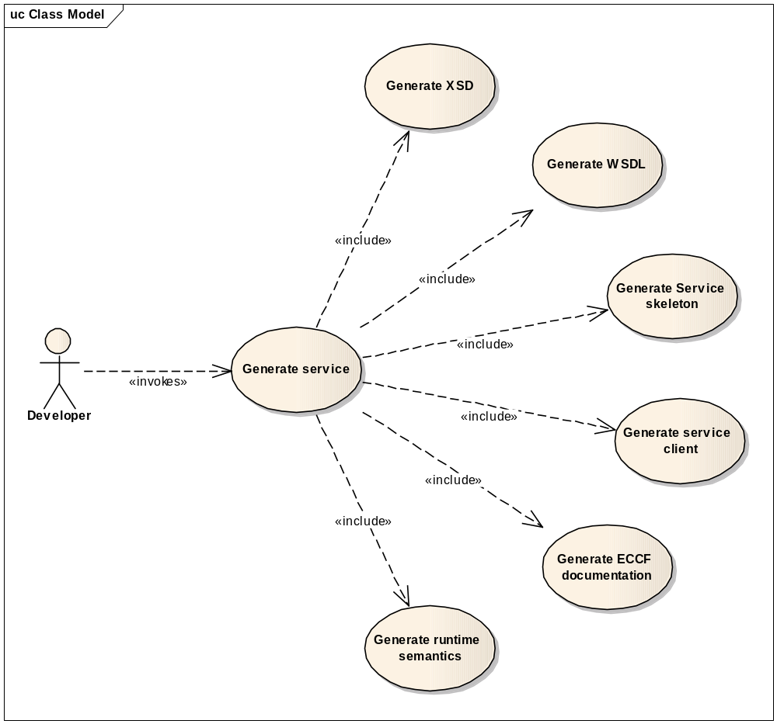

1.2 Users and Characteristics
Developer is the main targeted user for service development framework. A deployable service is a collection of several configuration files, server-side and client-side code based on service standards. It would take longer development cycle for a developer to understand and implement all necessary artifacts manually. Service development framework will provide necessary tools to automatically generate all necessary artifacts and deployable service to foster rapid development cycles.

1.3 Document Overview
This SRS captures all the software requirements for the Service development framework project. The remaining SRS sections are organized as follows:
- Section 3, System Requirements Specification: Describes the requirements specific to ensuring that CLAS conforms to the caBIG guidelines and requirements.
- Section 4, Service Development Framework : Describes the functional requirements of service development framework

1.4 Definitions
MUST - This word means that the definition is an absolute requirement of the specification.
MUST NOT - This phrase means that the definition is an absolute prohibition of the specification.
WILL - This word means that the definition is an absolute future requirement of the specification.
WILL NOT - This phrase mean that the definition is an absolute future prohibition of the specification.
SHOULD - This word means that there may exist valid reasons in particular circumstances to ignore a particular item, but the full implications must be understood and carefully weighed before choosing a different course.
SHOULD NOT - This phrase means that there may exist valid reasons in particular circumstances when the particular behavior is acceptable or even useful, but the full implications should be understood and the case carefully weighed before implementing any behavior described with this label.
MAY - This word means that a requirement is truly optional. The developer may choose to include the item based on the needs of their design.

Release Overview

2.1 System scope
The scope of the requirements is limited to following items:
- Generate various service artifacts
- Provide pluggable business interface implementation to facilitate loose coupling between service and business implementation
- Assemble service artifacts and business implementation to generate deployable enterprise service.

This document will be further expanded and extended to address all other important aspects of enterprise service like security, transaction, composition, orchestration, choreography, service registry and automated certification.

2.2 Traceability
Traceability provides a mechanism to track requirements with use cases and functional specification. Each use case is directly translated into a test script. Traceability is maintained by the name of the file corresponding to the name of the use case. Furthermore, traceability of requirements to use cases to tests is captured in a traceability matrix. Currently, traceability to use cases and tests are not included here. Traceability between requirements and functional descriptions will be addressed in functional specification document.

SYSTEM Requirements

Services, much like components, are intended to be independent building blocks that collectively represent an application environment. Services have number of unique characteristics that allow them to participate as part of a service oriented architecture. This approach results in the creation of isolated units of business functionality loosely bound together by a common compliance to a standard communications framework. Due to the independence that services enjoy with this approach, the programming logic they encapsulate does not need to comply with any one platform or technology set.

The most widely accepted and successful type of service is Web service. This type has two fundamental requirements:
- It communicated via internet protocols (most commonly HTTP)
- It sends and receives data formatted as XML documents

The system requirements for the service development framework can be categorized as follows:
- Support to read a model and its constructs
- High Performance, extensible, intuitive & easy to use
- Support Web service standards like JAX-WS, JAX-RS, JSR-181, SAAJ, SOAP, WSDL, WS-*
- Flexible deployment to work with multiple J2EE application servers, light weight containers or as standalone client/server
- Support for multiple programming languages
- Automated code generation and packaging
- Support to plug business components

Req. ID | Requirement
SDF-1 | SDF must support generating service artifacts, assemble them with business components and build a deployable enterprise service. This is done by reading an information or data model.

Service Development Framework FUNCTIONAL REQUIREMENTS

4.1 Service Generator
Service generator is responsible to generate various service artifacts necessary to build an enterprise service. Following are the requirements:
Req. ID | Requirement
FR-1 | SDF must support reading a UML model
FR-2 | SDF must support validating the UML model
FR-3 | SDF must support generating validation report if there are any failures
FR-4 | SDF must support generating service artifacts automatically. Service artifacts include WSDL, XSD, service stubs, service interface, service implementation, client code, POJOs
FR-5 | SDF generated service artifacts should be based on web service standards
FR-6 | SDF must support generating service artifacts independently
FR-7 | SDF must support generating service artifacts collectively
FR-8 | SDF should be modular and extensible to support any future requirement
FR-9 | SDF must support generating service implementation with provision to plug business components without changing the implementation.

4.2 Service Assembler
Service assembler is responsible to generate configuration files, combine business components with service implementation and package the artifacts to generate a deployable enterprise service. Following are the requirements:
.Req. ID | Requirement
FR-10 | Assemble service implementation with business components
FR-11 | Generate necessary configuration files to deploy a service into a runtime environment
FR-12 | Package service artifacts and dependencies to create a deployable enterprise service.
FR-13 | Service assembler should support generating deployable enterprise service for different runtime environments

4.3 Service Synchronizer
Service synchronizer is responsible to synchronize any changes made to the artifacts generated by service generator back into the model. Following are the requirements:
Req. ID | Requirement
FR-14 | Service synchronizer must read POJOs, compare synchronize any changes into the model. Updating the model is not part of the scope of service development framework. It will need to developed external to this framework.
FR-15 | Service synchronizer must provide comparison results in a text format comparing original model with updated model.
FR-16 | Service synchronizer will use externally developed framework to write model with POJO changes.

Non Functional requirements

5.1 Version control
The source code generated will be kept in CVS on GForge site.

5.2 Software generation and integration
All code produced must be commented and documented. The process for building the finished product and all its sub-components from source code must be documented.

Assumptions AND Dependencies

6.1 Usability
Service generation framework will not provide any UI capabilities by itself. But this could participate in any Eclipse based plug-in environment to facilitate integrated development.

6.2 General Assumptions
Following is a list of assumptions:
- Open source service development framework can be used to achieve listed requirements in this document. Chosen framework should be able support standardized product development in the future.
- Current requirements of Service generation framework are not required to work with data sources. But its architecture should not be limited to analytical services only. It should later be extended easily to support data services.

RISKS
Dependencies
Service generation framework has dependencies on intermediate model format, in-memory model representation, and model writing components being developed outside of its requirements.

