caCORE RESTful WRAPPER
Requirements Definition
Version Number: 1.0
Version Date: 12/7/201
VERSION HISTORY
[Provide information on how the development and distribution of the Requirements Definition will be controlled and tracked. Use the table below to provide the version number, the author implementing the version, the date of the version, the name of the person approving the version, the date that particular version was approved, and a brief description of the reason for creating the revised version.]
Version  Number | Implemented  By | Revision  Date | Approved  By | Approval  Date | Description of  Change
1.0 | Prasad Konka | 12/7/2012 |  |  | Initial Draft
1.0.1 | Prasad Konka | 12/18/2012 |  |  | Changes from Zhengwu comments
1.0.2 | Prasad Konka | 12/19/2012 |  |  | Changes from Robert Shirley comments
1.1 | Prasad Konka | 12/20/2012 | Robert Shirley | 12/20/12 | Approved Version

TABLE OF CONTENTS
1 Introduction 4
1.1 Purpose of the Requirements Definition Document 4
2 Business Requirements Overview 4
2.1 Assumptions / Constraints 5
2.2 System Scope 5
3 Functional Requirements 6
3.1 RESTFul Wrapper UI 6
3.2 RESTFul Wrapper Code generation 13
3.3 Assumptions / Constraints 13
4 Non-Functional Requirements 14
4.1 Design Constraints 14
4.2 Performance Requirements 14
4.3 Reliability Requirements 14
4.4 User Documentation Requirements 14
4.5 Interface Requirements 14
4.6 Compliance and Standards Requirements 14
5 Requirements Traceability Matrix 15
Appendix A: Requirements Definition Approval 16
APPENDIX B: REFERENCES 17
APPENDIX C: Mapping XSD 17
APPENDIX D: Sample Mapping XML 19
APPENDIX E: Requirements Traceability Matrix 20

Introduction

Purpose of the Requirements Definition Document
The Requirements Definition defines the functional, non-functional, and technical requirements. The Requirements Definition document is created during the Requirements Analysis Phase of the project. Its intended audience is the project manager, project team, project sponsor, client/user, and any stakeholder whose input/approval into the requirements definitions process is needed.

FUNCTIONAL Requirements Overview
The caCORE SDK generated runtime system's infrastructure exhibits an n-tiered architecture with client interfaces, server components, backend objects, data sources, and additional backend systems. SDK RESTful interface is built to use existing architecture and based on JAX-RS (Java API for RESTful Web Services) standard to serve client requests over HTTP and return formatted results in XML format. SDK RESTful implementation supports typical CRUD operations:
- GET: Read access of the resource without side-effects.
- PUT: create a new resource.
- DELETE: remove a resource.
- POST: update an existing resource.
The major advantages of SDK RESTful implementation are:
- They are highly reusable across platforms (Java, .NET, and PHP) since they rely on basic HTTP protocol
- They use basic XML instead of the complex SOAP XML and are easily consumable
- Based on MDA and easy to build fully deployable web application
- Built-in security with CSM

SDK RESTful implementation requires users to start with a UML model to generate the application. This step is a potential barrier for many of users in NCIP community to generate a data service and to share data. The community has built data services based on different technologies and development of the data exchange between the applications using these services is not an easy task. RESTful implementation provides a standardized interface and protocol to service client application across platforms. SDK RESTful Wrapper is aimed to lower the barrier to create RESTful services based on existing data sources. The wrapper will provide interface in RESTful manner while it internally maps with existing data source to query data. SDK RESTful Wrapper will provide User Interface where developers can create RESTful resources wrapping existing data services.

Assumptions / Constraints
None

System Scope
RESTful wrapper is a way for legacy applications to take advantage of RESTful features to facilitate applications to share data in a standardized manner. RESTful Wrapper Generator would let a developer to define RESTful resources and map them to existing Simple Object Access Protocol (SOAP) Web service or Enterprise JavaBeans (EJB). The Wrapper generator then would generate a mapping file that will be used by code generator to generate deployable RESTful resources.

The RESTful Wrapper Generator can be divided into three major parts. Each part is described below.

User Interface
RESTful wrapper generator will provide easy to use User Interface to define a RESTful resource and map it to existing data service (SOAP or EJB). RESTful resource generation starts with uploading a Plain Old Java Object (POJO) or Java Archive (JAR) of POJOs. Uploaded POJO(s) shall be presented in a tree view with Create, Upload, Delete and Read methods as children for each resource. UI would let user to remove or edit any uploaded POJOs from the tree structure.

Working with WSDL
User Interface will let user to load a Web Services Description Language (WSDL) that shall open in a new panel in a split window with POJO tree structure on one side. RESTful wrapper generator will parse WSDL to present in tree structure with operations supported by given endpoint. User will now be able to drag an operation from WSDL pane to corresponding resource in POJO pane. Multiple operations can be associated with one RESTful resource operation. Any associations created between RESTful resource and SOAP service operations will be made visible on the UI. The UI will let users to remove any associations created.

Working with EJB
User Interface will let user to upload EJB jar that has Home, Remote, Impl and deployment descriptor. UI will read deployment descriptor and introspect remote interface for EJB operations. These operations will be displayed in tree structure. User will be able to map between EJB operation and RESTful resource operation by drag and drop from one end to another. Any associations created between RESTful resource and EJB operations will be made visible on the UI. The UI would let users to remove any associations created.

Mapping Generation
After mapping is done, user will be able to generate a mapping XML file that shall capture all information about resources, operations, SOAP or EJB service details and mappings. This information will be used by RESTful resource generator to generate necessary artifacts. Operations left without any association will be ignored during mapping generation.

RESTful Resource Generation
RESTful resource generator will validate mapping file for correctness and use it to generate RESTful resources and schema files. It will also generate a project with build script for user to execute and generate a deployable Web Application Archive (WAR) file.

Functional Requirements
Functional requirements are divided into Wrapper UI and Wrapper code generation sections below. The Wrapper UI is responsible for providing rich UI that would let a developer to generate mapping between REST resource and SOAP or EJB service. The Wrapper code generator shall generate RESTful resources based on the mapping
Requirement ID | Requirement
RW-UI-1 | RESTful Wrapper shall provide thick UI that can be launched by a developer

RESTFul Wrapper UI

Open POJO or JAR of POJOs
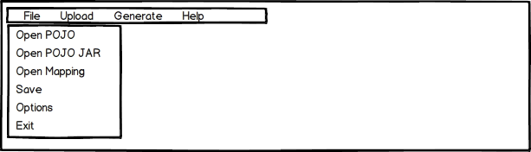
Figure 1: Open POJO or JAR of POJOs

Requirement ID | Requirement
RW-UI-2 | RESTful Wrapper UI shall provide top level Menu items “File”, “Upload”, “Generate” and “Help”.
RW-UI-3 | Clicking on “File” menu item shall open menu dropdown with items “Open POJO”, “Open POJO JAR”, “Open Mapping”, “Save”, “Options” and “Exit”
RW-UI-4 | Clicking on Open POJO shall open a file dialog to select a java class file
RW-UI-5 | POJO loader shall introspect selected class file and report error if invalid
RW-UI-6 | Clicking on Open POJO JAR shall open a file dialog to select a jar file
RW-UI-7 | JAR loader shall inspect selected JAR file and its contents and report error if invalid
RW-UI-8 | Clicking on Open Mapping menu item shall open file dialog to select an existing Wrapper mapping file
RW-UI-9 | Mapping loader shall validate mapping file and report any issues while loading the file.
RW-UI-10 | Clicking on Save shall save the mapping in an XML file. Please see APPENDIX C for Schema of the XML file.
RW-UI-11 | Save button shall be disabled if there is no valid information to save.
RW-UI-12 | Clicking Options menu item shall open a dialog to set options for RESTful Wrapper Generation.
RW-UI-13 | Clicking on Exit menu item shall warn user if mapping is not saved.
RW-UI-14 | Clicking on Exit menu item shall close Wrapper UI window

Display POJO Tree
Requirement ID | Requirement
RW-UI-15 | Upon clicking Open POJO or Open POJO JAR menu item, POJO loader and JAR loader shall parse POJO or JAR of POJOs and present class(es) in a tree structure.
RW-UI-16 | Each class in the tree shall have “Create”, “Read”, “Update”, and “Delete” nodes.
RW-UI-17 | Right clicking on a class name in the tree structure shall show option to remove it. Selecting remove shall remove the class from the tree structure.

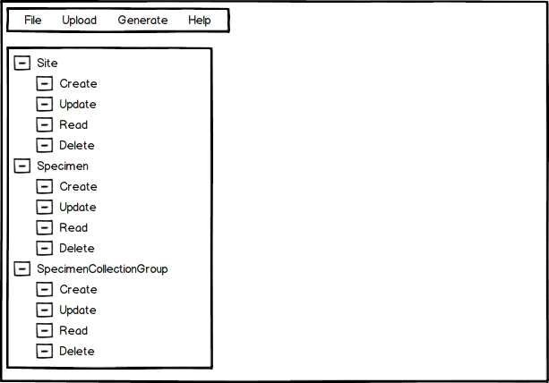
Figure 2: Display POJO tree

Upload WSDL

Requirement ID | Requirement
RW-UI-18 | Clicking on “Upload” top menu item shall show “WSDL”, “EJB JAR” menu items.
RW-UI-19 | Clicking on “WSDL” menu item shall open a file dialog to select a WSDL file.
RW-UI-20 | WSDL Loader shall parse selected WSDL to validate and report any errors. If valid, it shall create an internal data structure representing the WSDL.
RW-UI-21 | If valid, Wrapper UI shall use the data structure to display Web service information on the right side panel as shown in Figure 4 below.
RW-UI-22 | Wrapper UI shall parse WSDL and display Web service operations in a tree structure as shown in Figure 4 below.

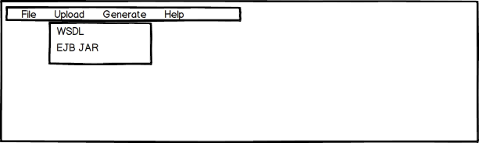
Figure 3: Upload menu

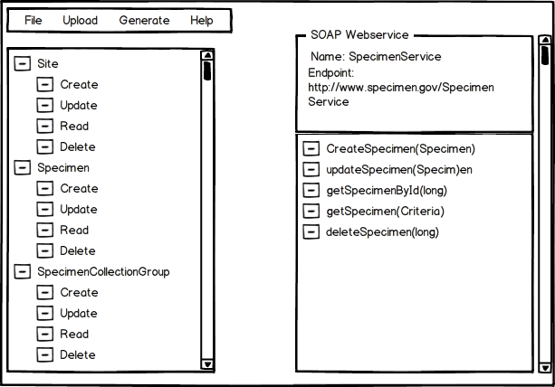
Figure 4: Upload WSDL

Requirement ID | Requirement
RW-UI-23 | User shall be able select an operation from SOAP web service operations tree and drag it to corresponding RESTful resource operation and drop it.
RW-UI-24 | Dropping it shall create a mapping between those two operations and UI shall display a visible line between operations.
RW-UI-25 | User shall be able to drag and drop multiple operations from SOAP web service to one RESTful resource operation.
RW-UI-26 | Wrapper UI shall perform validation for duplicate mapping on RESTful operations.
RW-UI-27 | User shall be able to drop any existing mappings between SOAP webservice operation and RESTful resource operation.  By selecting the association and do mouse right click shall display Delete action item to delete the association.

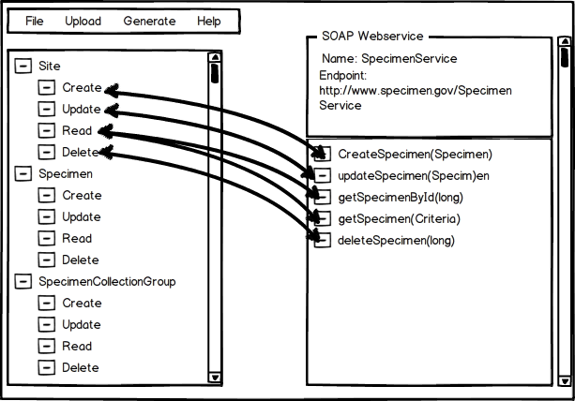
Figure 5: Perform SOAP Webservice Mapping

Upload EJB JAR
Requirement ID | Requirement
RW-UI-28 | Clicking on “EJB JAR” menu item under “Upload” shall open a file dialog to select a JAR file.
RW-UI-29 | EJB Loader shall parse selected JAR to validate and report any errors.If valid, the loader shall store EJB descriptor and Remote Interface information in a data structure.
RW-UI-30 | If valid, Wrapper UI shall use the data structure to display EJB information on the right side panel as shown in Figure 5 below.
RW-UI-31 | Wrapper UI shall parse EJB deployment descriptor, Remote Interface and display EJB operations in a tree structure as shown in Figure 5 below.

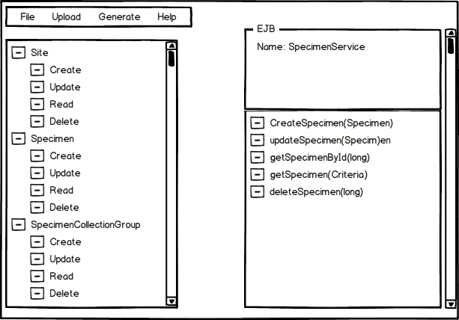
Figure 6: Upload EJB JAR

Requirement ID | Requirement
RW-UI-32 | User shall be able to select an operation from EJB operations tree and drag it to corresponding RESTful resource operation and drop it.
RW-UI-33 | Dropping it shall create a mapping between those two operations and UI shall display a visible line between operations.
RW-UI-34 | User shall be able to drag and drop multiple operations from EJB to one RESTful resource operation.
RW-UI-35 | Wrapper UI shall perform validation for duplicate mapping on RESTful operations
RW-UI-36 | User shall be able to drop any existing mappings between EJB operation and RESTful resource operation.

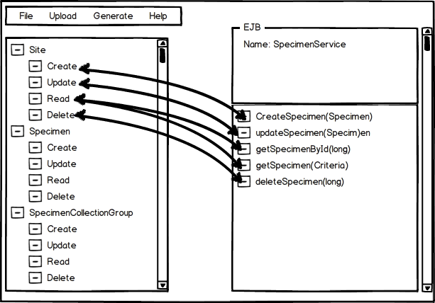
Figure 7: Perform EJB mapping

Generate mapping
Requirement ID | Requirement
RW-UI-37 | Upon a valid mapping, “Save” menu item under “File” shall be enabled.
RW-UI-38 | Clicking on “Save” menu item shall generate XML mapping file. See APPENDIX C for the mapping XML schema.

RESTFul Wrapper Code generation

Code generation

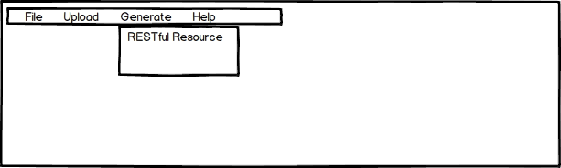

Requirement ID | Requirement
RW-UI-39 | Clicking on “RESTFul Resource” under “Generate” menu shall generate RESTful resource based on the mapping.
RW-UI-40 | If there are any issues reading or using mappings and generating artifacts, code generator shall generate appropriate error messages. Wrapper UI shall capture error messages and display them on a pop up window.
RW-UI-40 | Code generator shall parse the mapping and generate following artifacts  RESTFul resource  XSD
RW-UI-41 | Code generator shall generate necessary client code for SOAP Web service or EJB and include calls in RESTful operations.
RW-UI-42 | After successful code generation, UI shall compile and build deployable WAR file with RESTful resource.

Assumptions / Constraints
ID | Constraint / Assumption
ASMP-1 | UI would connect to SOAP web service to get WSDL. UI will display error message in case of connection failure.
ASMP-2 | UI would not do any validations on correctness or working condition of given SOAP or EJB data services.
ASMP-3 | RESTful Wrapper generator would not provide security in this release. It would not be able to integrate with secured SOAP Web service or EJB services.
ASMP-4 | UI would not support working with EJBs based on v3.0 specification annotations. It supports EJB 2.x version
ASMP-5 | UI would not do any validations on correctness or working condition of given SOAP or EJB data services when loading a mapping file.
ASMP-6 | POJO uploaded to the UI shall correspond to the data service. POJO and generated schema will be used by RESTful service to marshall, unmarshall request and response.

Non-Functional Requirements

Design Constraints
None

Performance Requirements
None

Reliability Requirements
None

User Documentation Requirements
Requirement ID | Requirement
RW-UI-43 | User documentation shall be available on NCI Wiki including User Guide and Release notes

Interface Requirements
Given in the section 3

Compliance and Standards Requirements
None

Section 508 Compliance
Requirement ID | Requirement
RW-UI-44 | RESTful Wrapper UI shall be section 508 complaint.

Requirements Traceability Matrix
[Include the Traceability Matrix as an appendix. In the Requirements Analysis phase, the matrix is populated with requirements identified in the Requirements Definition. It is a living document that should be populated with information throughout design, construction, and test phases, etc.]
See Appendix F – caCORE RESTful Wrapper Requirements Traceability Matrix.
Appendix A: Requirements Definition Approval
The undersigned acknowledge that they have reviewed the caCORE RESTful Wrapper Requirements Definition and agree with the information presented within this document. Changes to this Requirements Definition will be coordinated with, and approved by, the undersigned, or their designated representatives.
[List the individuals whose signatures are desired. Examples of such individuals are Business Owner, Project Manager (if identified), and any appropriate stakeholders. Add additional lines for signature as necessary.]

Signature: |  | Date: | 12/20/12
Print Name: | Robert Shirley
Title: | Director of Engineering
Role: | Project Sponsor

Signature: |  | Date:
Print Name: | Zhengwu Lu
Title: | Technical Project Manager
Role:

Signature: |  | Date:
Print Name:
Title:
Role:

APPENDIX B: REFERENCES
The following table summarizes the documents referenced in this document.
Document Name | Description | Location
RESTful Wrapper Scope Document | Scope Document | <URL or Network path where document is located>

APPENDIX C: Mapping XSD

<xs:schema attributeFormDefault="unqualified" elementFormDefault="qualified" xmlns:xs="http://www.w3.org/2001/XMLSchema">
<xs:element name="mapping">
<xs:complexType>
<xs:sequence>
<xs:element name="resources">
<xs:complexType>
<xs:sequence>
<xs:element name="resource" maxOccurs="unbounded" minOccurs="0">
<xs:complexType>
<xs:sequence>
<xs:element name="operations">
<xs:complexType>
<xs:sequence>
<xs:element name="operation" maxOccurs="unbounded" minOccurs="0">
<xs:complexType>
<xs:sequence>
<xs:element name="implementation">
<xs:complexType>
<xs:sequence>
<xs:element name="operation">
<xs:complexType>
<xs:sequence>
<xs:element name="input">
<xs:complexType>
<xs:simpleContent>
<xs:extension base="xs:string">
<xs:attribute type="xs:string" name="type" use="optional"/>
</xs:extension>
</xs:simpleContent>
</xs:complexType>
</xs:element>
<xs:element name="output">
<xs:complexType>
<xs:simpleContent>
<xs:extension base="xs:string">
<xs:attribute type="xs:string" name="type" use="optional"/>
</xs:extension>
</xs:simpleContent>
</xs:complexType>
</xs:element>
</xs:sequence>
<xs:attribute type="xs:string" name="name" use="optional"/>
</xs:complexType>
</xs:element>
</xs:sequence>
<xs:attribute type="xs:string" name="type" use="optional"/>
<xs:attribute type="xs:string" name="name" use="optional"/>
<xs:attribute type="xs:anyURI" name="endpoint" use="optional"/>
<xs:attribute type="xs:string" name="clientType" use="optional"/>
<xs:attribute type="xs:string" name="path" use="optional"/>
<xs:attribute type="xs:string" name="classpath" use="optional"/>
</xs:complexType>
</xs:element>
</xs:sequence>
<xs:attribute type="xs:string" name="name" use="optional"/>
</xs:complexType>
</xs:element>
</xs:sequence>
</xs:complexType>
</xs:element>
</xs:sequence>
<xs:attribute type="xs:string" name="name" use="optional"/>
</xs:complexType>
</xs:element>
</xs:sequence>
</xs:complexType>
</xs:element>
</xs:sequence>
<xs:attribute type="xs:string" name="name"/>
<xs:attribute type="xs:float" name="version"/>
<xs:attribute type="xs:string" name="description"/>
<xs:attribute type="xs:string" name="createdOn"/>
<xs:attribute type="xs:string" name="lastUpdatedOn"/>
</xs:complexType>
</xs:element>
</xs:schema>

APPENDIX D: Sample Mapping XML

<?xml version="1.0" encoding="UTF-8" standalone="no"?>
<mapping name="xyz" version="1.0" description="xyz" createdOn="2/10/2012" lastUpdatedOn="12/10/2012" >
<resources>
<resource name="Specimen">
<methods>
<method name="create">
<implementation type="SOAP" name="SpecimenService" endpoint="http://www.test.gov/SpecimenService">
<operation name="createSpecimen">
<input type="Specimen "/>
<output type=" Integer "/>
</operation>
</implementation>
</ method >
<method name="read">
<implementation type="EJB" name="SpecimenEJB" clientType="Local|Remote" path="" classpath="">
<operation name="getSpecimen">
<input type="Integer"/>
<output type="Specimen"/>
</operation>
</implementation>
</ method >
< method name="update">
<implementation type="EJB" name="SpecimenEJB" clientType="Local|Remote" path="" classpath="">
<operation name="createSpecimen">
<input type="Specimen"/>
<output type=" Integer "/>
</operation>
</implementation>
</ method >
< method name="delete">
<implementation type="SOAP" name="SpecimenService" endpoint="http://www.test.gov/SpecimenService">
<operation name="createSpecimen">
<input type="Specimen "/>
<output type="Boolean"/>
</operation>
</implementation>
</ method >
</ methods>
</resource>
<resource name="Site">
< methods>
< method name="read">
<implementation type="SOAP" name="SiteService" endpoint="http://www.test.gov/SiteService">
<operation name="getSite">
<input type="Integer"/>
<output type="Site"/>
</operation>
</implementation>
</ method>
</ methods>
</resource>
</resources>
</mapping>

APPENDIX E: Requirements Traceability Matrix
The Requirements Traceability Matrix is attached as a separate document.

