CDE Browser Help
Overview
Searching for Common Data Elements (CDEs)
Downloading CDEs in Excel or XML Format
Using Form Builder to View, Edit, and Create Forms and Templates
Using the CDE Cart to Collect and Manage CDEs
Technical Tips

Overview
The Common Data Element (CDE) Browser is an application for browsing, searching and exporting CDEs from the National Cancer Institute (NCI) Cancer Data Standards Repository (caDSR). CDEs are descriptors of data – metadata – that are used to set up data collection forms for cancer research studies. The caDSR is a database that provides for storage and management of CDEs; the CDE Browser is a user interface to the caDSR. The caDSR divides groups of CDEs into Contexts. Each Context has an administrator with the authority to manage and edit the CDEs that it owns. More information on the caDSR and CDE project can be found at http://ncicb.nci.nih.gov/core/caDSR.

The CDE Browser opens to the Data Element Search page. From this page, users can initiate a search for CDEs, go to the CDE Cart, or open Form Builder.

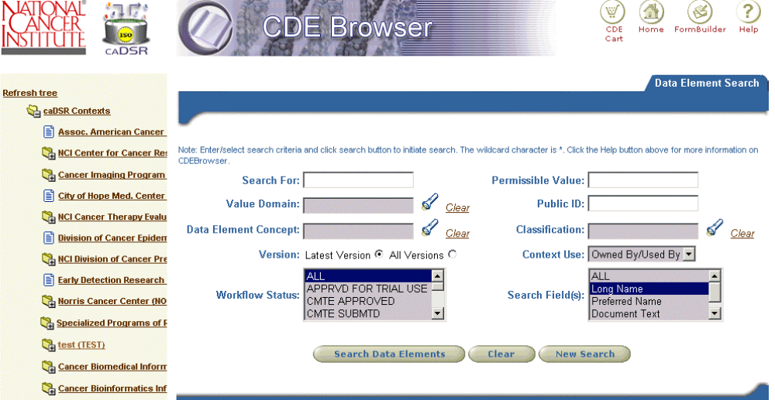
Navigation Menu: Use these icons to navigate to the CDE Cart, Form Builder, or back to Home (that is, back to this page).
caDSR Contexts Tree: Displays all the current caDSR Contexts Users can search for groups of CDEs by navigating the tree.
Data Element Search Pane: Can be used with or without the tree. Provides a variety of criteria that can be used to define a search.

Back to Top

Searching for Common Data Elements (CDEs)
You can use the caDSR Contexts Tree or the data element search pane to help you find the items in caDSR that you are interested in. The caDSR Contexts Tree (which occupies the left pane) allows you to view the names of each of the caDSR Contexts and the various groupings of data elements within each Context. Second, it allows you to restrict the search of data elements to those included in one of those groupings. Clicking on one of the closed folder () icons will open up the tree, but will not restrict the search. Clicking on the brown hypertext in one of the tree branches, however, will restrict search to just those data elements included in the grouping you clicked on.
The Data Element Search pane (which occupies the right pane) allows you to further define your data element search, by entering additional constraints, beyond what is selected in the navigation tree. Any navigation tree restrictions you may have selected still apply. You can see what you have selected from the tree in the “breadcrumb” trail printed near the top of the Search Pane. After you add and execute your additional search constraints, you can download the data elements in either Excel or XML format.
To summarize, the basic way you use the tool is:
- In the tree on the left, click on closed folder () icon to open up the tree and find the groupings of data elements that you seek. Click on open folder icon () to close a branch in the tree.
- Click on the brown hypertext of the tree branch corresponding to the grouping of interest. Groupings can be any of a number of types, including Classification Scheme Items, form templates, or even the entire Context. After you click on the hypertext, the subset you selected will appear in the Data Element Search pane on the right.
- In the Data Element Search pane on the right, enter any additional search terms or constraints into one or more of the searchable fields. Execute the search by clicking on the Search button. The further restricted subset will be returned.
- Download the result set to either Excel or XML by clicking on the appropriate download button.

caDSR Contexts Tree
Top-level nodes in the tree correspond to Contexts in the caDSR. A data element belongs to the owning Context that has administrative authority to edit and update it. In addition to belonging to an owning Context, a data element can be “designated” for use by another non-owning Context. In this version of CDE Browser, it is possible search for data elements that are Used, Owned, or Owned & Used by a particular context. The default is Owned & Used by.
Below the Context level are branches that correspond to some type of grouping of the data elements within the Context. Groupings can be any of the following types:
- Classifications and Classification Scheme Items. A Classification is simply a collection of related Classification Scheme Items i.e. a mini-hierarchy within the tree. Data Elements, in turn, can be assigned to one or more Classification Scheme Items. The actual Classification assignments are managed by the Context administrator. Classification schemes that have workflow status of ‘RELEASED’ are displayed in the tree.
- Protocol Form Templates. Data Elements can be used on a form (for clinical trials, this will be a case report form or CRF). Many of these forms have been generalized into template forms that can be re-used. For the Cancer Therapy Evaluation Program Context (CTEP), these templates have been grouped by Phase and Disease. Within each of these groupings (Phase and Disease), they are further grouped by type of template. Currently, CTEP has templates for Phase III trials only. Clicking on one of these template form names in the tree will return the data elements for that form in the right pane.
- Protocol Forms: They are forms (CRF’s) that are used in a clinical trial. They are composed of data elements. Protocol forms that belong to the CTEP Context are not be shown in the tree.
- Specialized groupings. Other types of groupings can be found in the tree as well. For example, the Cancer Therapy Evaluation Program Context groups data elements based on CDE disease committee decisions into “core” and “non-core” categories that can be found in the tree, under each type of disease classification.

Data Element Search Pane
The right portion of the CDE Browser page is the Data Element Search pane, which includes the following fields that can be used to create a more restrictive search:
- Search For: This is a keyword search term entry field. The search will look for the entered keyword in the fields of the data elements specified by Search Field(s) search criteria. The default is to do an exact match search. You can add an asterisk (*) wildcard character to broaden the search. The wildcard character can be used at the beginning, middle, or end of the search term.
- Value Domain: The Value Domain is the component of the data element that indicates the permissible values that can be collected in an actual research study. To filter data elements based on Value Domain, click on the icon. A popup window will appear that allows you to do a keyword search for the Value Domain of interest. Once the results appear in the popup, click on the particular Value Domain you want to use in your data element search. The Value Domain you selected will automatically be entered into the search criteria box.
- Data Element Concept: The Data Element Concept is the component of the data element that indicates the semantic meaning of the data element. To filter data elements based on Data Element Concept, click on the icon and proceed as described above for Value Domain.
- Version: Data Elements are assigned version numbers by the Context administrator. To filter data elements based on their version, select the Latest Version or All Versions radio button.
- Workflow Status: The Workflow Status is the administrative status of the data element. In most cases you will probably want to search for data elements with a status of RELEASED in the name, but any status is available as a search criterion. To filter data elements based on their Workflow Status, use the multi-selection drop down list) and select the Workflow Statuses of interest. Multiple workflow statuses can be selected from the drop down list by holding the ctrl key.
- Permissible Value: To filter data elements based on their permissible values, enter a value in the field provided. You can add an asterisk (*) wildcard character to broaden the search. The wildcard character can be used at the beginning, middle, or end of the search term.
- Public ID: To filter data elements based on Public ID, enter a valid Public ID in the field provided. Starting with version 2.0, label CDE ID has been replaced with Public ID. You can add an asterisk (*) wildcard character to broaden the search. The wildcard character can be used at the beginning, middle, or end of the search term.
- Classification: Classification Scheme Items are particular classifications that data elements can be assigned to by the Context administrator. To filter data elements based on their Classification Scheme Item assignment, click on the icon to search for and select the Classification Scheme Item of interest, similar to what is described above for Value Domain.
- Context Use: A data element belongs to the owning Context that has administrative authority to edit and update it. In addition to belonging to an owning Context, a data element can be “designated” for use by another non-owning Context. In this version of CDE Browser, it is possible to search for data elements that are Used, Owned, or Owned By/Used By a particular Context. Owned By/Used By is the default setting.
- Search Field(s): This search criterion should be used in conjunction with Search For search criteria. The search will look for the entered keyword in the fields of the data elements specified by this search criterion. To select search fields, use the multi-selection drop down list. Multiple search fields can be selected from the drop down list by holding the ctrl key.
- Alternate Name: A data element is allowed to have multiple alternate names in multiple contexts. This search criterion should be used for searching data elements based on alternate names. It is used in conjunction with alternate name type(s) search criteria.
- Alternate Name Type(s): This drop down displays all the alternate name types. Multiple values can be selected from this list by holding the ctrl key. Alternate name type has to be specified for a search based on alternate name.
Click the Search Data Elements button to execute the search. The screen will display the data elements that match the criteria. Note that these results will be based on both the initial subset that was selected in the tree, plus the additional constraints entered into the Search pane.
To browse the details of any data element in the results set, the click on the hyperlinked Long Name text. This will cause a new browser window to open with the details of the selected data element. This new window includes Data Element, Data Element Concept, Permissible Values, Classifications, and Usage tabs. Clicking on any of these tabs will display the corresponding details for that data element. Please note that when another data element is selected from the search results list, if this Details window is still open it will be refreshed with the newly selected data element’s details. This means that only one data element details window at a time can be displayed.

The Data Element Search Results Table
Data Elements that satisfy the specified search criteria are displayed in a table.
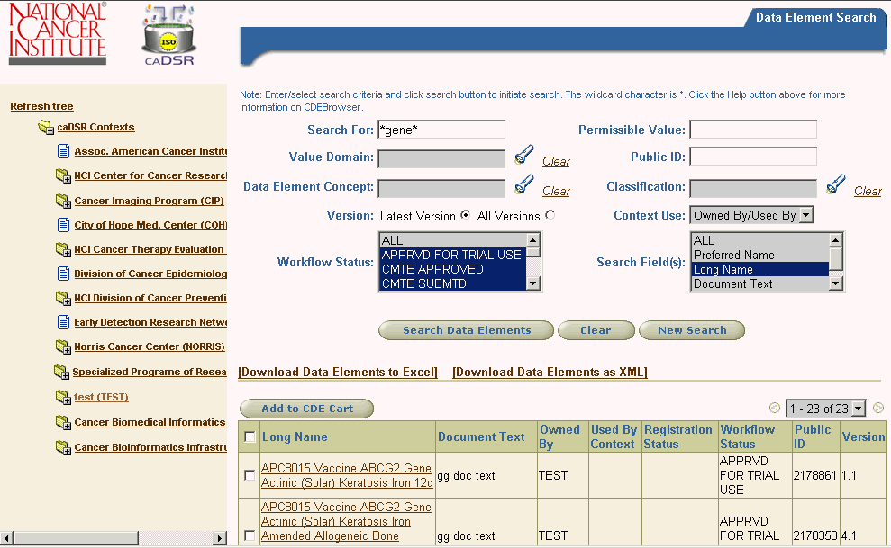
Displays the number of matching data elements. A maximum of 40 records are shown on a page. When the record count is greater than 40, the search results are paginated across multiple pages.
Click on hyperlink to open data element details page.
To add CDEs to the Cart, mark the checkbox and click the Add to CDE Cart button. See Using the CDE Cart for more information.
Search Results Table: Data elements meeting the specified search criteria display in the search results table.

A maximum of 40 records are shown on a page. When the record count is greater than 40, the search results are paginated across multiple pages. A page scroller is displayed at the top and bottom of the search results table. It consists of a drop down list containing available search results pages. It also allows provides functionality to navigate to previous and next pages when they exist. Record count for next and previous pages is also displayed with the next () and previous page () icons. One can navigate to a particular page either by choosing the page from the drop down list or by clicking the next icon (). Next and Previous page icons () are disabled when they do not exist.
Back to Top

Downloading CDEs in Excel or XML Format
The output of the data element search is displayed as a table, and you can page through the table interactively on the web. The entire result set can also be downloaded as an Excel or XML file. Further, if a form template has been previously uploaded into caDSR, it can be downloaded from within the Browser as Word document.
By clicking Download Data Elements to Excel link above the search result table, you can save the data elements to a comma-separated value Excel file. First, a notification window is displayed warning you that the downloading process will take a few seconds. Then, the File Download window is displayed with the Open or Save buttons. When the Open button is pressed, the Excel file is displayed in a separate window. When the Save button is pressed, the Save As window is displayed. You must manually close the notification window after the download process is completed.
By clicking Download Data Elements as XML link above the search result table, you can save the data elements in an XML file. First, the notification window is displayed warning you that the downloading process will take a few minutes. Please wait, as the XML file building process is considerably slower than that for Excel. Then the File Download window is displayed with the Open or Save options. We suggest selecting the Save option rather than Open, since directly opening the XML output appears to crash some browsers. After the file is saved you can view it in your favorite XML tool. You must manually close the notification window after the download process is complete.
Downloading a Form Template: Clicking on a Context folder icon () will display the branches under that Context. One of these is named Protocol Form Templates. Further grouping of template depends on the selected context. For example, in the CTEP Context, these templates have been grouped by Phase and Disease. Within each of these groupings (Phase and Disease), they are further grouped by type of template. Currently, CTEP has templates for Phase III trials only. Clicking on the template hyperlinked text will display all the data elements belonging to the template in the search result table. There also will be a Download/View link above the result table. Clicking on the link will display the Word document of the template in a separate window if the template Word file exists in the database. Otherwise, an error message will be displayed. (Note: Form Builder, a new module added to the CDE Browser in release 2.1, provides a host of additional tools for viewing, downloading, creating, editing, and maintaining forms and templates. For more information, read the Form Builder Help.)

Form Builder Help
Back to Top
Overview
Opening Form Builder
Finding an Existing Form
Editing a Form
Copying a Form
Creating a New Form
Deleting a Form
Printing a Form
Downloading Paper Version of Form
Using the CDE Cart
Technical Tips

Overview
Form Builder is a new module that has been added to the CDE Browser. It is designed to be used by curators to create, update, and maintain forms and templates using the common data elements (CDEs) maintained in the caDSR.

Back to Top

Opening Form Builder
Form Builder is accessed from within the CDE Browser application. To open Form Builder, first open the CDE Browser and then click on the Form Builder icon, which is located in the top right-hand corner on most pages in the CDE Browser.
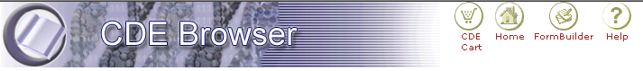
Click here to access Form Builder.

Please note that Form Builder is restricted to Context Administrators and other authorized users. To log into Form Builder, you will need a username, password and be CDE Manager in any of the existing Contexts.

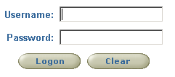

Back to Top

Finding an Existing Form
Form Builder opens to the main Form Search page. From here, users can search the caDSR for existing forms and templates.
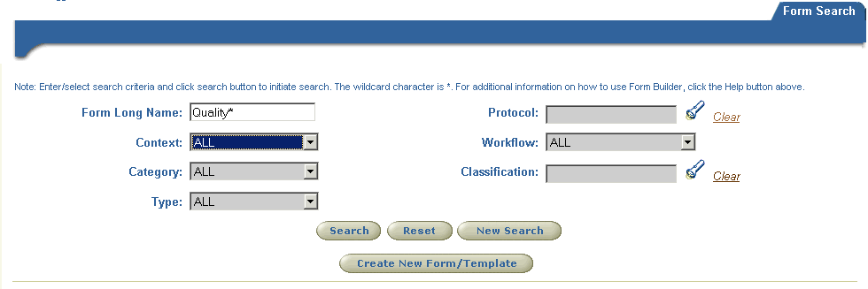
To initiate a search, simply enter the desired search criteria and then click the Search button.
To clear all results and begin new search, click here.

Search Criteria: The following fields are available for specifying the parameters of a search:
- Form Long Name: This field allows you to search for a form by name. Use the wildcard character -- an asterisk (*) -- at the beginning, middle, or end of the name or keyword to help you find what you are looking for. For example, to search for a form or template that has “registration” as part of its name, enter *registration* into this field.
- Context: Select the context you want to search. This is set to ALL by default.
- Category: This is set to ALL by default. Select a Category from the drop down list if you want to narrow your search.
- Type: This is set to ALL by default. Select CRF or Template to narrow your search.
- Protocol: Use the LOV to enter a protocol into this field to restrict your search to a specified protocol. This option is applicable only when searching for CRFs.
- Workflow: This is set to ALL by default. Select a workflow status from the drop down list to narrow your search.
- Classification: Use the LOV to select the classification scheme you wish to search.

Search Results: Forms or templates that satisfy the specified search criteria are displayed in a search results table.

Edit Form
Select for Copy
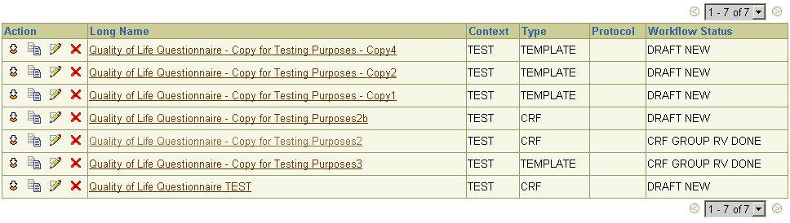
Delete Form
View Form. Click form name to open form in view-only mode.
Shows number of matching records. When the record count is greater than 40, the search results are paginated across multiple pages.
Download. Click here to download a paper version of the form or template. Follow the instructions that appear. If a copy of the form has not been previously uploaded, you will get a message informing you that the form is not available for downloading at this time.

Back to Top

Editing a Form
Form Builder provides a number of editing options. Users can perform the following actions:
- Edit basic form details, including name, definition, context, and workflow status
- Assign a form to a protocol
- Edit classification scheme assignments
- Add, delete, or edit modules
- Change the order in which modules are displayed on the form
- Add or delete questions
- Associate CDEs with questions
Most editing occurs on the Edit Form page. To get to this page, find the form you’re interesting in and then click the Edit icon or button.

Understanding the Form Edit Page
The Form Edit page contains two main sections. The top portion, Form Header, displays a set of basic information, such as form name and version number.

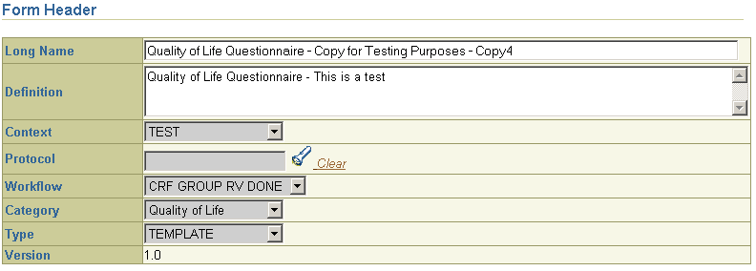
Form Header: Displays basic details about the form or template. All fields are editable except Version.

The bottom section, Form Details, displays the information in the body of the form. This section typically contains a number of different modules. Each module, in turn, typically contains a related set of questions and associated CDEs.

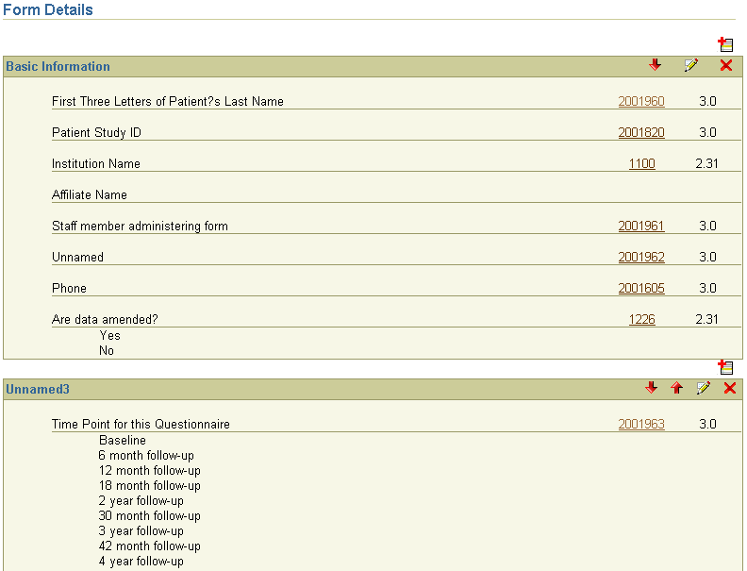
Add New Module: Click to create new module and insert it into form at specified location.

Questions

CDE Public ID. Click on link to open CDE details page.

CDE Version Number
If the Question has valid values, they are displayed below the question text, as shown in these two examples.
If no CDE is currently associated with the question, this cell is blank.

Module

Name

Module

Name

Delete Module

Use Up and Down arrows to reposition module on form.

Click here to edit module, which includes adding, removing, or updating questions.

Adding Modules
You can add as many modules as needed to a form. Adding modules is a two-step process. First, you must name the module. Then, you add questions and associated CDEs to the module.

To add a new module:
- Click the Add New Module icon () at the location on the form where you want to insert the new module.
- Enter a name for the module and then click Done.
- Click the Edit Module icon () next to the new module you’ve created to add questions to the new module.
- Click Save when you are ready to make your changes permanent.

Deleting Modules
You can delete existing modules from a form. The deletion will not become permanent until you click Save.

To delete a module:
- Click the Delete icon () next to the module you want to delete.
- The module will be removed from the form and added to the Add Module pick list ().
- If you want to permanently delete the module, click Save.

Rearranging the order of modules on the form
There are two ways to rearrange modules on the form.

- Use the up () or down () arrow to move a module to the desired location on the form.
- Or, click the Delete Module icon () and then add the module back to the form in the desired location using the Add Module pick list.

Editing Modules

Users can perform the following actions on the Edit Module page:

Rename a module

Edit text of question

Change the link between a question and CDE

Remove or add valid values to questions linked to CDEs with enumerated value domains

Rearrange the display order of questions

Add new questions

Delete existing questions

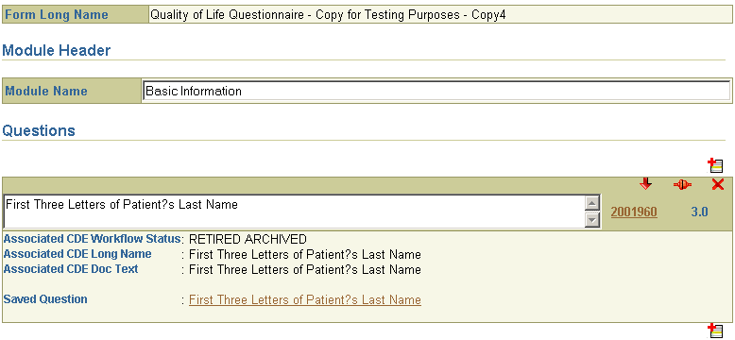
Click Add Question icon to insert new question or set of questions at desired location in module.
Details of CDE appear here. If the displayed text is hyper linked then clicking on the text will copy that text to the question text box.
If appropriate, edit question text.
If appropriate, rename module.
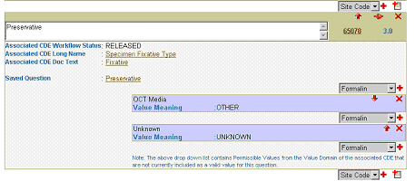
If the associated CDE has permissible values which are not included as valid values for the question, a drop down list appears allowing users to add the missing values, if appropriate.
Valid values for question appear here. Value Meaning is also displayed

Modifying the Association between Questions and CDEs
With Form Builder, you can associate a CDE with a question, modify an existing CDE association, or remove the association altogether.

To change a CDE association:

- Click the Change CDE Association icon () next to the question you want to modify.
- On the next screen, select the CDE you want from the list or click the Add More Data Elements button to find additional CDEs.

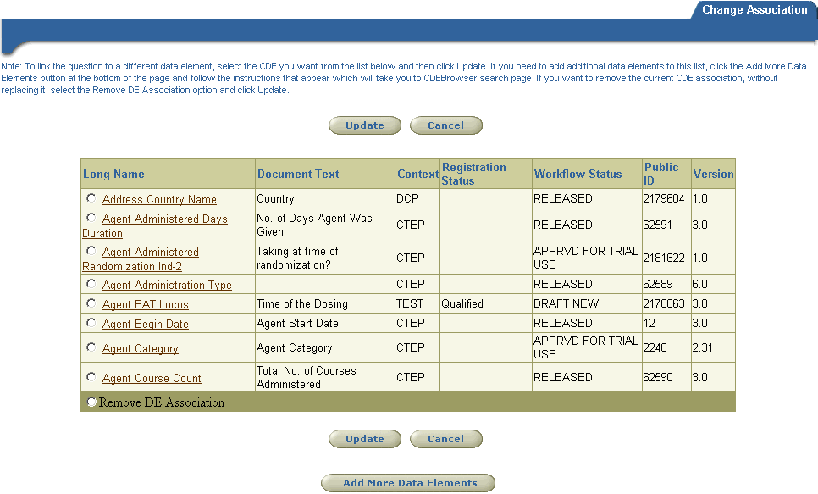
To link the current question to a different CDE: Select a data element from the list and then click Update.
To add CDEs to this list: CDEs that you have previously added to the CDE Cart will appear in this list when the page opens. If the CDEs you want are not listed here, click the Add More Data Elements button. You will then be able to search the caDSR and add more items to this list. See details in section below.

To remove link between question and CDE: If you want to remove the current association, without replacing it with a new CDE, select this option and click Update.

To add more CDEs to the Cart:

- If you want to select a CDE that is not in the current list, click the Add More Data Elements button.
- On the Data Elements Search page, enter the appropriate criteria and then click Search Data Elements.

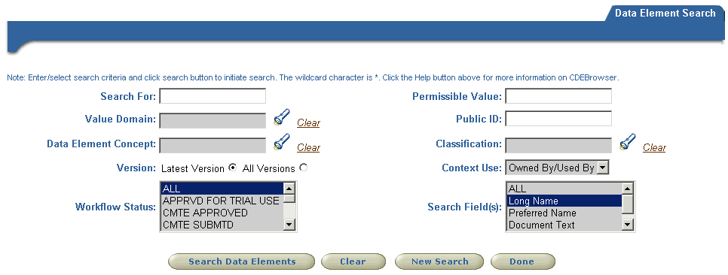

- From the results list, select the CDEs that you want to add to the Cart and then click Add to CDE Cart button.
- If you want to continuing searching for more CDEs to add to the Cart, click New Search. This will clear the current search criteria and results.
- If you are done searching and want to return to the Change CDE Association page, simply click Done.
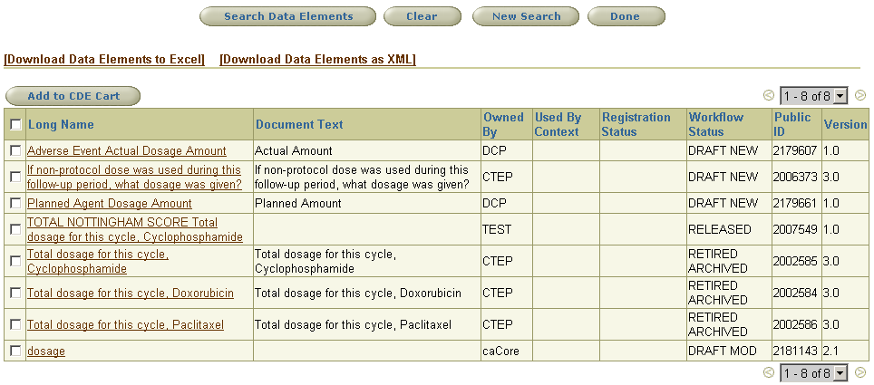
Add a checkmark next to the CDE’s you want to add to the Cart. Then click the Add to CDE Cart button.
After adding CDE’s to the Cart, click Done to return to the Change CDE Association page so you can continue editing your form.

Maintaining Classifications Scheme Assignments

In Form Builder, you can add classification assignments to forms and templates. However, you cannot create new classification schemes from within Form Builder. To do this, you must use the caDSR Administration Tool or the Curation Tool.

To open the Maintain Classifications page in Form Builder, go to the Form Edit page and click the Classifications button. From here, you can view to what, if any, classification schemes the current form or template has been assigned. You can remove these assignments or make as many additional assignments as needed.

In the example below, no classifications are currently assigned to the form.

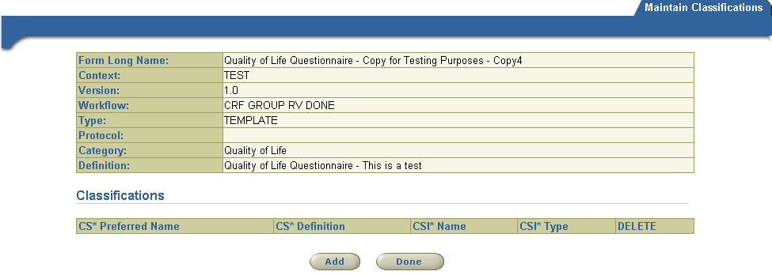
Form Header information displays in top portion of page.
If the form is assigned to any classification schemes, they will be listed here.
To assign the form to a classification scheme, click the Add button.

The screen below provides an example of a form that has been assigned to a classification scheme.

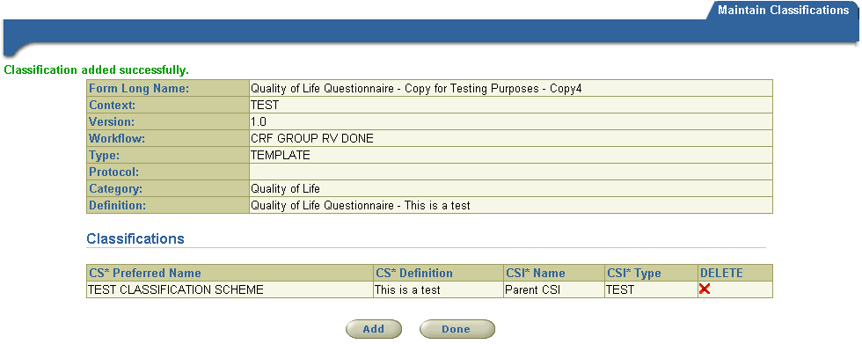
Click the Delete icon to remove an existing classification assignment.
This form is currently assigned to the TEST CLASSIFICATION SCHEME.

To assign the form to additional classification schemes, click Add.

Back to Top

Copying a Form or Template

With Form Builder, it’s easy to copy forms and templates.

To copy a form or template:
- Find the form or template you want to copy.
- Click the Select for Copy icon.
- On the Copy Form page, review the basic form data in the Form Header section and make any necessary changes to the Long Name, Definition, Context, Protocol, Category, or Type fields. Click Copy when you are ready to generate the new form. At this point, Form Builder will create the new copy of the form with the updated information, if any.

If you don’t want to create a copy of this form, click Cancel.
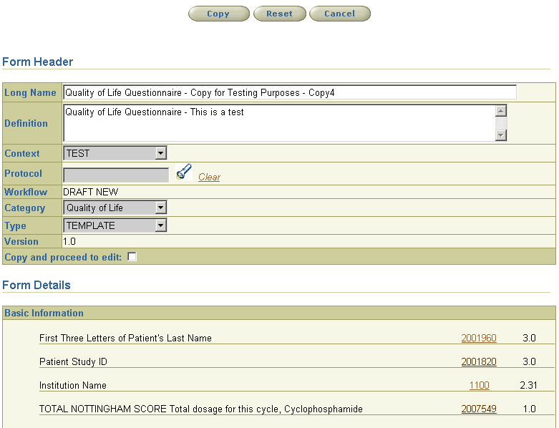
If you plan to edit the new copy, select the Copy and proceed to edit option. After the copy is generated, it will open in the Edit Form page. If this option is not selected, the new copy will open in the View Form page.
Form Builder does not require you to change any of the Form Header details. You can create a copy with the same Header information as the original. Behind the scenes, Form Builder generates a unique ID and Preferred Name for each new copy.
Click Reset to clear any changes you’ve made to the details in the Header section.

Review the information in the Form Details sections to make sure this is the form you want to copy. After creating the copy, you can edit any of the information in this section.

Back to Top

Creating a New Form or Template
Form Builder allows users to create forms or templates from scratch. If you want to create a form by copying an existing form, read the section on copying forms.

- Go to the Form Search page and click the Create New Form/Template button.
- Complete the Form Details section and click Save.
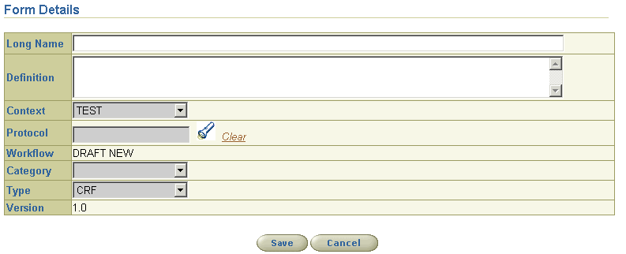
Enter the name for this form. This is a required field. (Note: The system automatically generates the form’s Preferred Name.)
Enter an appropriate definition. This is a required field.
Make sure you specify whether you want to create a form (CRF) or a template. Forms are usually associated with protocols.
Form Builder automatically sets workflow status to Draft New for new forms and templates.
Version is always set to 1.0.
- On the Edit Form page, perform the following actions, as appropriate:
- Review the Header information and make changes if needed.
- Add Modules and questions to the body of the form by clicking the Add Module icon.
- Assign classification schemes to the form.
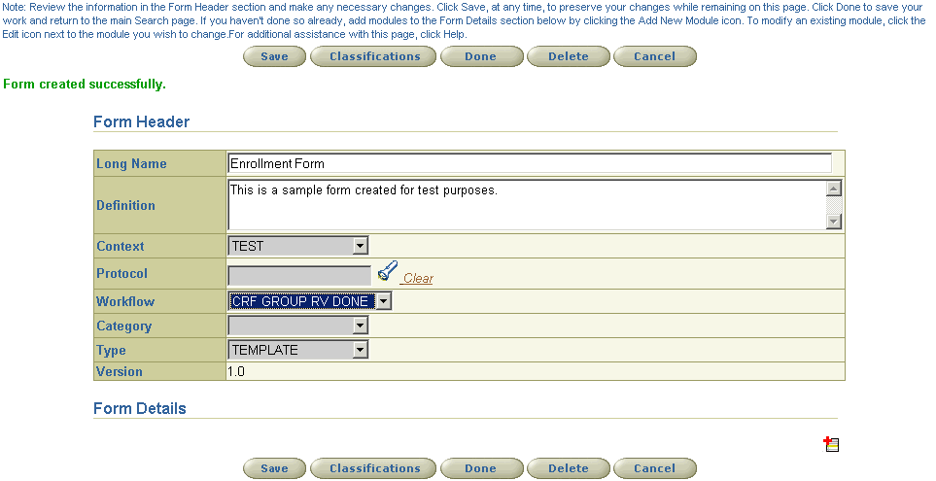
To add modules and questions to the body of the form, click here.
Click Save to save all changes while remaining on this page.

Click Done to return to the main Search Page. The system will prompt you to save your changes.

Back to Top

Deleting a Form or Template
Deleting a form from Form Builder removes the form from the caDSR database. However, the CDEs associated with the form are not deleted.

To delete a form from the Form Search page:
- Go to the Form Search page and enter the appropriate search criteria.
- In the results table, click the Delete icon next to the form you want to delete.
- Click Yes to confirm the deletion. Form Builder will display a message indicating that the form has been successfully deleted. Once a form has been deleted, it cannot be retrieved. Deleting the form does not delete the associated CDEs from the caDSR database.

To delete a form from the Edit Form page:
- Open the form in Edit mode.
- Click Delete.
- Click Yes to confirm the deletion. The form will be permanently removed. The CDEs associated with the form will not be deleted from caDSR.

Back to Top

Printing a Form
For the best results, we recommend using the Printer Friendly Version.

- Go to the Form Search page and find the form you want to print.
- In the search results table, click on the form name to open the form in the View Form mode.
- Click the Printer Friendly Version link. The form will open in a new window.
- From the Browser’s File menu, select Print.

Back to Top

Downloading a Copy of a Paper Version of the Form
If a copy of the paper version of the form has been previously uploaded into caDSR, you can download it from Form Builder. The file will be available in the format it was uploaded in.

- Go to the Form Search page and find the form you want to print.
- Click the Download icon () next to the form you’re interested in.
- Select Save or Open.

Back to Top

Using the CDE Cart
The CDE Cart is a new feature that has been added to the CDE Browser. It functions in many ways like a typical shopping cart used at an online store.

Adding CDEs to the Cart
Data Elements can be moved to the CDE Cart from the Data Elements Search page. The elements in the Cart can then be downloaded in Excel or XML format or used with Form Builder to create or update forms and templates. The CDE Cart provides a convenient way for users to collect a variety of CDEs for downloading or viewing from a diverse set of searches.

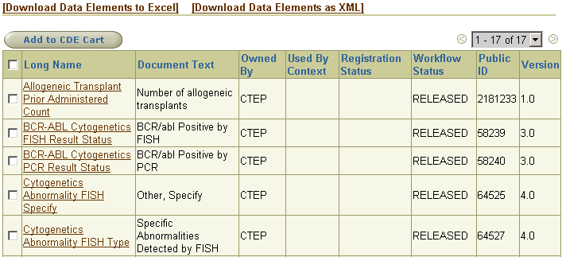
1. From the Data Elements search results table, select the CDEs that you want to move to the Cart.
2. Click Add to CDE Cart. Note: This will not open the Cart. To view the contents of the Cart, click the CDE Cart icon at the top of the page.

Opening the Cart
To open the Cart, simply click the CDE Cart icon in the top right-hand menu.
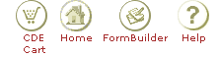

Saving CDEs in Cart for Future Retrieval
The CDE Cart is available in secure and non-secure modes. When used in the secure mode as part of Form Builder, the items in the Cart can be saved to the database so that they remain in the Cart even after you have logged out and exited the Browser. When used in the non-secure mode, the items persist in the Cart only for the duration of the active session.
After adding CDEs to the Cart, you must also save them if you want them to be available during future sessions.
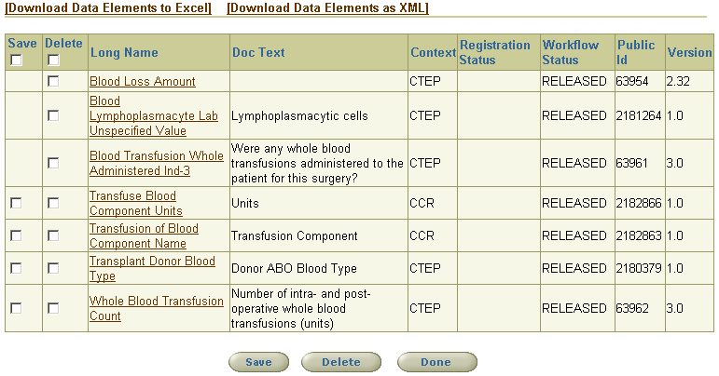
1. Enter a checkmark in the Save column for each recently added CDE that you want to permanently store as part of your cart.
2. Then click Save.

Removing CDEs from the Cart:
Select the CDEs you want to remove from the Cart and then click the Delete button. Note: Removing CDEs from the Cart does not remove them from the caDSR database.

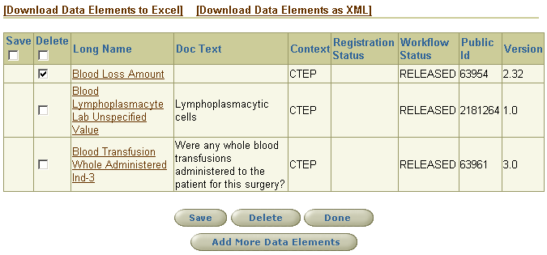
1. Enter a checkmark next to the items you want to remove from the Cart.
2. Then click Delete.

Back to Top

Technical Tips

Standard Browser Navigation Buttons Not Supported
The browser's Back, Forward, and Refresh buttons are not fully supported. Use of these buttons could lead to unexpected results. Users are encouraged to use the navigation tools provided within the CDE Browser application.

Browser Help
The application performs best when used as follows:
- Set the screen resolution to 1024x768
- Use either Netscape 6.x or Internet Explorer version 5.x or higher
- When using Form Builder, use Internet Explorer (v.6 or higher). Form Builder is not fully functional when used with Netscape Navigator.

Search Help
- Enter exact words or phrases on which to search. The default is an exact match search.
- The wildcard search character is *. The wildcard characters can be used at the beginning, middle, or end of words (e.g. '*first*bio*').
- The search mechanism filters on Data Elements based on the tree nodes from which the search is launched. For instance, when browsing Core Data Elements in the Clinical Trials area, a search from this node will return only Core Data Elements. Conversely, a search from the All Data Elements node searches all elements for the entered criteria.

Back to Top

