Implementation Specification

Release 3.0.1

For the following CaDSR Tools:
- CDE Browser
- Form Builder

Submitted to: NCI Center for Bioinformatics

Prepared by:



Date Prepared: May 27, 2005
Date Delivered: May 27, 2005

Revision History

Authors/Responsible Party | Revision Number | Page(s) Effected | Date
Shaji Kakkodi, Jane Jiang, Edmond Mulaire | Original | All | May, 27, 2005

Table of Contents

1 Document Purpose 5
2 Implementation Overview 6
2.1 Team Members 6
2.2 Description of Issues 6
2.2.0 Show OC Relationship Details in CDE Browser 6
2.2.1 Add fields to XML and Excel Download File 6
2.2.2 Download Not Working For DEs containing Special Characters (“”) 6
2.2.3 Display of Alternate Names on DE Details Page 6
2.2.4 Concept Code Hyperlink 7
2.2.5 Saving Forms with CDEs with Large Value Sets 7
2.2.6 Add Note about Default Search Preferences 7
2.2.7 Use of Default Search Preferences With Forms 7
2.2.8 DEs Appearing Multiple Times in Results 8
2.2.9 Error Writing JSP Message 8
2.2.10 Handling of Disabled Users in Form Builder 8
2.2.11 Browser Tree Takes 15 Seconds to Refresh 8
2.2.12 Help Button Not Working from Two Pages 8
2.2.13 Enter key does not work on Login Page 8
2.2.14 Display Long Name instead of Preferred Name 9
2.2.15 Initiating search with Enter Key using Firefox 9
2.2.16 Organizing Forms in Browser Tree 9
2.3 Scope 9
2.3.1 Show OC Relationship Details in CDE Browser 9
2.3.2 Add fields to XML and Excel Download File 10
2.3.3 Download Not Working For DEs containing Special Characters (“”) 11
2.3.4 Display of Alternate Names on DE Details Page 11
2.3.5 Concept Code Hyperlink 11
2.3.6 Saving Forms with CDEs with Large Value Sets 11
2.3.7 Add Note about Default Search Preferences 11
2.3.8 Use of Default Search Preferences With Forms 11
2.3.9 DEs Appearing Multiple Times in Results 12
2.3.10 Error Writing JSP Message 12
2.3.11 Handling of Disabled Users in Form Builder 12
2.3.12 Browser Tree Takes 15 Seconds to Refresh 12
2.3.13 Help Button Not Working from Two Pages 12
2.3.14 Enter key Not Working on Login Page 12
2.3.15 Display Long Name Instead of Preferred Name 12
2.3.16 Initiating Search with Enter Key using Firefox 12
2.3.17 Organizing Forms in Browser Tree 12
2.4 Architecture 13
2.4.1 Show OC Relationship Details in CDE Browser 13
2.4.2 Add fields to XML and Excel Download File 14
2.4.3 Display of Alternate Names on DE Details Page 15
2.4.4 Saving Forms with CDEs with Large Value Sets 15
2.4.5 Browser Tree Takes 15 Seconds to Refresh 16
2.5 Third Party Tools 16
3 Implementation Contents 17
3.1 Servers 17
3.1.1 Software Requirements 17
3.1.2 Batch Processes 17
3.1.3 APIs 17
3.1.4 Error Handling 17
3.1.5 Database Assumptions 17
3.2 Client 17
3.2.1 Software and Hardware Requirements 17
3.2.2 Servlet 18
3.2.3 Error Handling 18
3.2.4 Security 18
3.2.5 Performance 18
3.2.6 Internationalization 18
3.2.7 Installation / Packaging 18
3.2.8 Migration 18
3.3 Documentation Considerations 18
4 Unit Testing 18

Document Purpose
The purpose of this document is to specify the design details for the fixes and enhancements to the CDE Browser and Form Builder tools for the caCORE 3.0.1 Release.

Implementation Overview

Team Members
Role | Name
Development Lead | Shaji Kakkodi
Development Team | Jane Jiang, Prerna Aggarwal
Technical Manager | Ram Chilukuri
Project Manager | Edmond Mulaire
Test Lead | Anwar Ahmad

Description of Issues
The following section describes the issues that will be addressed as part of 3.0.1. For additional information about any of the items below, please refer to the caDSR database in TestTrack Pro, the NCICB’s online issue tracking system.

Show OC Relationship Details in CDE Browser
TestTrack #1125 and #1052: We began capturing Object Class relationship information in the caDSR database with caCORE 3.0. However, the Browser does not yet have a UI for displaying this OC Relationship information. Since UML Model Classes are converted to Object Classes and UML Class relationships modeled as Object Class Relationships, it is important that we display this information in the Browser as part of the 3.0.1 release.

Add fields to XML and Excel Download File
TestTrack #1412: A number of new fields were added to the caDSR data model for DEs for caCORE 3.0. Most of these new fields have not been added yet to the Excel and XML search results download file in the CDE Browser. These new fields should be added for 3.0.1. to bring the download files up-to-date with the 3.0 data model changes.

Download Not Working For DEs containing Special Characters (“”)
TestTrack #500: Format of Excel download file is incorrect if downloaded DE contains double quotes.

Display of Alternate Names on DE Details Page
TestTrack #1516: The Alternate Names field on the DE Details Page in the CDE Browser is currently limited to displaying a maximum of 30 characters (See the diagram below). Alternate Names longer than 30 characters are being truncated. In light of the way that the UML Loader now creates Alternate Names for Data Elements through concatenation, this 30-character display limit makes it difficult under some circumstances to verify that the Alternate Names were accurately created for the new UML-Loaded DEs.

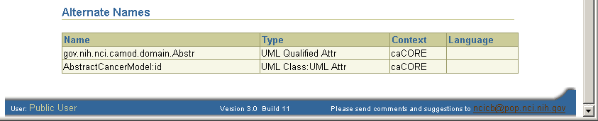
This field is currently limited to 30-character display.
Note: This defect will be fixed and pushed to production as a Change Order.

Concept Code Hyperlink
TestTrack #1504: In the Browser, the Concept Code hyperlink is not working correctly. The first time a concept code is selected, the NCI Thesaurus window appears showing the correct concept. However, whenever another concept code hyperlink is selected in the Browser, the NCI Thesaurus continues to show the concept that was opened first. The only way to correct the problem is to close all browser windows and begin the search again.
Note: This defect has been fixed and pushed to production as a Change Order. It is currently working as designed on the Production server.

Saving Forms with CDEs with Large Value Sets
TestTrack #800: At this time, in Form Builder, users cannot successfully add a CDE to a form if that CDE contains more than 999 valid values. Users are able to add the CDE to the form, but cannot subsequently save the form until they remove the CDE in question. See Test Track #800 for further details.
Note: This defect will be fixed and pushed to production as a Change Order.

Add Note about Default Search Preferences
TestTrack #1449: The Search Preferences feature introduced in caCORE 3.0 contains a number of default filters. In particular, DEs belonging to the TEST or TRAINING contexts are excluded by default from the search results. In addition, DEs with Registration Status of RETIRED or a Workflow Status of CMTE APPROVED, CMTE SUBMTD, CMTE SUBMTD USED, RETIRED ARCHIVED, RETIRED PHASED OUT, or RETIRED WITHDRAWN are excluded by default are also excluded by default. Users have requested that a prominent on-screen message be added to notify users about this change.

Use of Default Search Preferences With Forms
TestTrack #1511: In the Browser, if an existing form or template is selected from the tree, the DEs that appear in the search results window are currently being restricted by the default filters in the Search Preferences filters. For example, if the form is selected from the tree and it contains DEs with a Workflow Status of Retired Archived, then these DEs will not appear in the search results table. As a result, users may get a misleading view of the DE’s contained in the form. Users have requested that the Search Preferences filters not be applied when displaying the DEs in an existing form.

DEs Appearing Multiple Times in Results
TestTrack #1545: If a DE has been assigned to multiple classification schemes/items, it incorrectly appears multiple times in the Browser search results window whenever a relevant classification is selected from the tree. For example, if the C3D Domain classification (CCR>Classifications>C3D Domain) is selected from the tree, the Browser shows that there are 24099 matches – when there are in fact only about 600 true matches. Each DE in the search results is being listed and counted multiple times.

Error Writing JSP Message
TestTrack #1542: This is related to the defect listed above (#1545). An error message is appearing when a user attempts to use the drop down list to paginate through the search results from selecting a classification from the tree.
Steps to reproduce:
1. Open the CDE Browser.
2. From the tree, select caDSR Contexts >> CCR >> Classifications >> C3D Domain
3. Use the drop down pick list next to the search results to select (1200-1240).
The following message will appear: Error Writing JSP result Uncaught Exception in CDEBrowser doPost().

Handling of Disabled Users in Form Builder
TestTrack #1467: Users are able to log onto Form Builder using accounts that have been disabled.

Browser Tree Takes 15 Seconds to Refresh
Test Track #1526: The caDSR Search Tree in the CDE Browser currently requires about 15 seconds to appear when the Browser is first opened or whenever the tree is refreshed. Ideally, the tree should not take longer than 10 seconds under normal circumstances to refresh.

Help Button Not Working from Two Pages
TestTrack #1442: The Help button is not functioning from the pages:
- FB Login page
- CDE Compare Tool page
The Help file does not open. Error on Page javascript error appears in Browser status bar.

Enter key does not work on Login Page
TestTrack #1532: The Enter key does not work on the Form Builder Login page. Fix so that pressing the Enter key works just like pressing the Logon button.

Display Long Name instead of Preferred Name
Test Track #1325: In DE Details window in Browser, VD and DEC Preferred Names are currently being display. Display VD and DEC Long Name instead of Preferred Name in DE Details window.

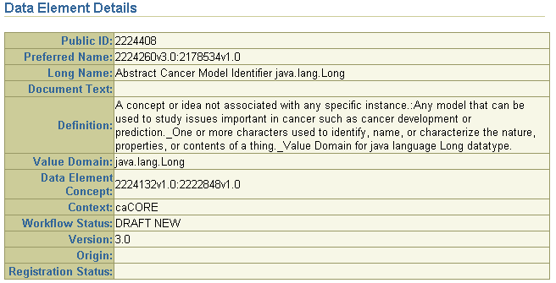
Browser is currently displaying the Preferred Name for Value Domain and for Data Element Concept.

Initiating search with Enter Key using Firefox
TestTrack #1533: When using the CDE Browser with Firefox, the Enter key produces unexpected results. Take the following steps to reproduce the problem:
1. Open CDE Browser using Firefox.
2. Enter any term into the text box. For example, enter gene*
3. Hit the Enter key. All the DEs in caDSR will be returned as matches. Note: If you hit Search rather than the Enter key, you will get only matches for gene*.

Organizing Forms in Browser Tree
TestTrack #1503: Allow users to organize forms and templates into subfolders within Protocol Forms and Protocol Form Templates folders.

Scope
This section describes the scope and proposed solutions for the items listed in Section 2.2.

Show OC Relationship Details in CDE Browser
For this release, we will add two new tabs to the DE Details page: “Object Class” and “Associations.” Each tab will display the following information:
- Object Class details
- Concepts
- Alternate Name
- Alternate Definitions

The Associations tab displays all the Object Class Relationships details for the Object Class. Project, subproject, and package information is displayed for each association. The user will be able to traverse associations clicking on any of the displayed associations. The path user navigates is displayed as breadcrumbs on the top of the page.

Add fields to XML and Excel Download File
The following fields will be added to the XML and Excel download file:
- Object Class Public ID
- Object Class Long Name
- Object Class Preferred Name
- Object Class Context Name
- Object Class Version
- Object class concept(s)
  - Name
  - Code
  - Public ID
  - Definition Source
  - EVS Source
  - Primary Flag
- Property Public ID
- Property Long Name
- Property Preferred Name
- Property Context Name
- Property Version
- Property concept(s)
  - Name
  - Code
  - Public ID
  - Definition Source
  - EVS Source
  - Primary Flag
- Value Domain concept(s)
  - Name
  - Code
  - Public ID
  - Definition Source
  - EVS Source
  - Primary Flag
In addition, the Apache Jakarta Open Source POI API will be used to generate the Excel file. The downloaded Excel file will be formated as an Excel file instead of a CSV file (Note: it is currently formated as a CSV file).
With the new fields, the Excel and XML download files will include 88 fields. The total list of fields in the download files is listed below:
 | Field Name | Existing / New Field
1 | Data Element Preferred Name | Existing
2 | Data Element Long Name | Existing
3 | Data Element Document Text | Existing
4 | Data Element Preferred Definition | Existing
5 | Data Element Version | Existing
6 | Data Element Context Name | Existing
7 | Data Element Context Version | Existing
8 | Value Domain Public ID | Existing
9 | Value Domain Preferred Name | Existing
10 | Value Domain Long Name | Existing
11 | Value Domain Version | Existing
12 | Value Domain Context Name | Existing
13 | Value Domain Context Version | Existing
14 | Value Domain Type | Existing
15 | Value Domain Datatype | Existing
16 | Value Domain Min Length | Existing
17 | Value Domain Max Length | Existing
18 | Value Domain Min Value | Existing
19 | Value Domain Max Value | Existing
20 | Value Domain Decimal Place | Existing
21 | Value Domain Format | Existing
22 | Data Element Concept Public ID | Existing
23 | Data Element Concept Preferred Name | Existing
24 | Data Element Concept Long Name | Existing
25 | Data Element Concept Version | Existing
26 | Data Element Concept Context Name | Existing
27 | Data Element Concept Context Version | Existing
28 | Public ID | Existing
29 | Workflow Status | Existing
30 | Registration Status | Existing
31 | Begin Date | Existing
32 | Source | Existing
33 | Valid Values | Existing
34 | Value Meaning | Existing
35 | Classification Scheme Preferred Name | Existing
36 | Classification Scheme Context Version | Existing
37 | Classification Scheme Context Name | Existing
38 | Classification Scheme Version | Existing
39 | Classification Scheme Item Name | Existing
40 | Classification Scheme Item Type Name | Existing
41 | Alternate Name Context Name | Existing
42 | Alternate Name Context Version | Existing
43 | Alternate Name | Existing
44 | Alternate Name Type | Existing
45 | Document | Existing
46 | Document Name | Existing
47 | Document Type | Existing
48 | Derivation Type | Existing
49 | Derivation Rule | Existing
50 | Derivation Method | Existing
51 | Concatenation Character | Existing
52 | DDE Public ID | Existing
53 | DDE Long Name | Existing
54 | DDE Version | Existing
55 | DDE Workflow Status | Existing
56 | DDE Context | Existing
57 | DDE Display Order | Existing
58 | Object Class Public ID | New with 3.0.1
59 | Object Class Long Name | New with 3.0.1
60 | Object Class Preferred Name | New with 3.0.1
61 | Object Class Context Name | New with 3.0.1
62 | Object Class Version | New with 3.0.1
63 | Object class concept(s) | New with 3.0.1
64 | Name | New with 3.0.1
65 | Code | New with 3.0.1
66 | Public ID | New with 3.0.1
67 | Definition Source | New with 3.0.1
68 | EVS Source | New with 3.0.1
69 | Primary Flag | New with 3.0.1
70 | Property Public ID | New with 3.0.1
71 | Property Long Name | New with 3.0.1
72 | Property Preferred Name | New with 3.0.1
73 | Property Context Name | New with 3.0.1
74 | Property Version | New with 3.0.1
75 | Property concept(s) | New with 3.0.1
76 | Name | New with 3.0.1
77 | Code | New with 3.0.1
78 | Public ID | New with 3.0.1
79 | Definition Source | New with 3.0.1
80 | EVS Source | New with 3.0.1
81 | Primary Flag | New with 3.0.1
82 | Value Domain concept(s) | New with 3.0.1
83 | Name | New with 3.0.1
84 | Code | New with 3.0.1
85 | Public ID | New with 3.0.1
86 | Definition Source | New with 3.0.1
87 | EVS Source | New with 3.0.1
88 | Primary Flag | New with 3.0.1

Download Not Working For DEs containing Special Characters (“”)
By using the Apache Jakarta Open Source POI API to generate the Excel file, we will be able to resolve this and other potential bugs involving DEs containing special characters.

Display of Alternate Names on DE Details Page
The fix will correctly display Alternate names up to 255 characters in length. The caDSR repository schema defines Alternate names to be of 255 characters.

Concept Code Hyperlink
Note: This defect has been fixed and pushed to production as a Change Order. It is currently working as designed on the Production server.
This defect was the result of a bug in the EVS http API that displayed incorrect information due to caching. The EVS team has fixed this issue and we will make corresponding changes to the EVS invocation as per the solution provided by EVS team.

Saving Forms with CDEs with Large Value Sets
Note: This defect will be fixed and pushed to production as a Change Order.
The bug is due to transaction timing out for large transaction that tries to save forms with large set of valid values (1000 or more). The proposed fix will decrease the response time by 70% to 80%.

Add Note about Default Search Preferences
Note: This defect will be fixed and pushed to production as a Change Order.
We propose to add the following message to the CDE Browser Basic and Advanced search pages:
Note: Default settings exclude Test and Training Context views from the tree and certain 'non-released' Workflow and Registration statuses. Click the 'Search Preferences' link above to view or change the exclusion criteria.
This message will be added right below the keyword text box on the Basic and Advanced search pages.
We also propose to add the following message above the search results:
Results fewer than expected? Check Search Preferences

Use of Default Search Preferences With Forms
The solution proposed for this is to ignore all filters related to Search Preferences when a search is initiated for CDEs by clicking on a form or template in the tree. The filters ignored include all search preference and “Retired Deleted” workflow status. This will apply to the default filters as well as to any filters selected by the user.

DEs Appearing Multiple Times in Results
Note: This defect will be fixed and pushed to production as a Change Order.
This bug was introduced in 3.0 due to SQL statement used for the search was missing a join. The proposed solution will add the missing join to the SQL statement.

Error Writing JSP Message
Note: This defect will be fixed and pushed to production as a Change Order.
This is related to the duplicate elements in the search results. The fix described in section 2.3.8 will also rectify this bug.

Handling of Disabled Users in Form Builder
This bug will be fixed when the caDSR Admin Tool disables database user. When a user attempts to login using a disabled account, he or she will not be logged in.

Browser Tree Takes 15 Seconds to Refresh
The scope of this task is to reduce tree-rendering time. The proposed solution will redesign tree implementation to increase performance; this will also make maintenance and configuration of the tree easier. With new nodes (2.3.1.6) being added to the tree in this release we plan to increase the performance at least by 20% to 30%.

Help Button Not Working from Two Pages
This bug will be fixed. Users will be able to open help from the Form Builder Login Page and the CDE Compare page.

Enter key Not Working on Login Page
Users will be hit the Enter key on the Form Builder Login page to initiate login to Form Builder.

Display Long Name Instead of Preferred Name
The CDE Details page will display VD Long Name instead of VD Preferred Name and will display DEC Long Name instead of DEC Preferred Name.

Initiating Search with Enter Key using Firefox
JavaScript function tied to Enter key will be made compatible with Firefox browser

Organizing Forms in Browser Tree
Currently, in the Browser tree, all forms within a protocol are displayed at the same level under each protocol. Similarly, all templates are displayed at the same level under a “Protocol Form Templates” node. For this release, we are introducing new functionality designed to allow context owners to organize forms and templates into subfolders within the protocol and “Protocol Form Templates”. To affect this, a new Classification type (both Classification and Classification Scheme Item ) will be added to caDSR. Users will be able to create classifications of this new type using caDSR admin tool and then assign forms and templates to these new classifications using formbuilder. The system will create subfolders under the protocol and Protocol Form Templates nodes based on these new classifications and will list the appropriately assigned forms under these new subfolders. If a form or template is not classified by any classification belonging to the new classification type, it will be displayed directly under the main protocol node or “Protocol Form Templates” node, within the appropriate context.

Note: Currently, for the CTEP context, custom logic is used for determining the display of folders for templates in the tree. For this release, it has not yet been determined whether we will change the way the tree handles forms and templates within the CTEP context.

Architecture

Show OC Relationship Details in CDE Browser
The application architecture has JSP for UI, Struts for controller/model. and Hibernate at the persistence tier. Spring framework is used for dependency injection along with the Struts plug-in. We have provided a sequence diagram of the OC relationship display below.
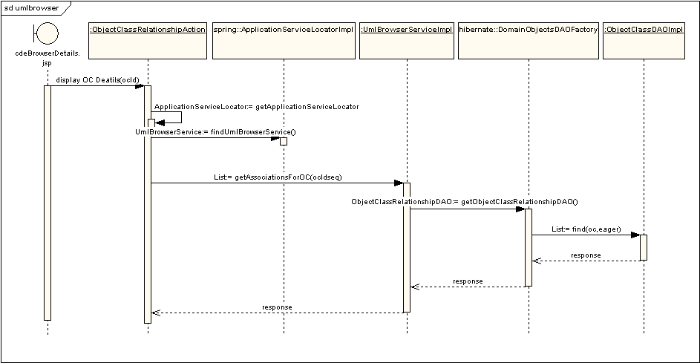

ObjectClassRelationshpAction is subclass of Struts DispatchAction class. ObjectClassRelationshpAction gets reference to the UMLBrowserService through ApplicationServiceLocator. UMLBrowserService defines all the application service methods for UML Browser. At the application startup Struts plugin class “ObjectPlugIn” inserts an instance of ApplicationServiceLocator in the servlet context. ObjectClassRelationshpAction gets the reference to the ApplicationServiceLocator from the servlet context. Current implementation of ApplicationServiceLocator uses spring framework to initialize and locate implementation classes. At the persistence level AbstractDomainObjectsDAOFactory is also initialized using spring framework, all DAO implementation classes are created and inserted using spring. All the DAO are reused from ULM Loader implementation. Use of spring framework for dependency injection makes configuration much easier. Below is the snippet of the spring’s application context configuration file.

<beans>
<bean id="umlBrowserService" class="gov.nih.nci.ncicb.cadsr.umlbrowser.service.impl.UmlBrowserServiceImpl">
<property name="domainObjectsDaoFactory"><ref local="domainObjectsDaoFactory"/></property>
</bean>

<bean id="domainObjectsDaoFactory" class="gov.nih.nci.ncicb.cadsr.persistence.dao.domain.hibernate.DomainObjectsDAOFactory">
<property name="adminComponentDAO"><ref bean="adminComponentDAO"/></property>
<property name="dataElementDAO"><ref bean="dataElementDAO"/></property>
<property name="dataElementConceptDAO"><ref bean="dataElementConceptDAO"/></property>
<property name="valueDomainDAO"><ref bean="valueDomainDAO"/></property>
<property name="propertyDAO"><ref bean="propertyDAO"/></property>
<property name="objectClassDAO"><ref bean="objectClassDAO"/></property>
<property name="objectClassRelationshipDAO"><ref bean="objectClassRelationshipDAO"/></property>
<property name="classificationSchemeDAO"><ref bean="classificationSchemeDAO"/></property>
<property name="classificationSchemeItemDAO"><ref bean="classificationSchemeItemDAO"/></property>
<property name="classSchemeClassSchemeItemDAO"><ref bean="classSchemeClassSchemeItemDAO"/></property>
<property name="conceptDAO"><ref bean="conceptDAO"/></property>
<property name="contextDAO"><ref bean="contextDAO"/></property>
<property name="conceptualDomainDAO"><ref bean="conceptualDomainDAO"/></property>
</bean>

</beans>

Add fields to XML and Excel Download File
Instead of creating a comma separated csv file, we will switch to the Apache POI API to generate Excel files. Also, a subclass will be created to contain all the information about a column. This design will allow us (in a future release) to create a user interface for selecting columns to be included in the Excel download file. The class diagram for the ColumnInfo subclass is provided below.

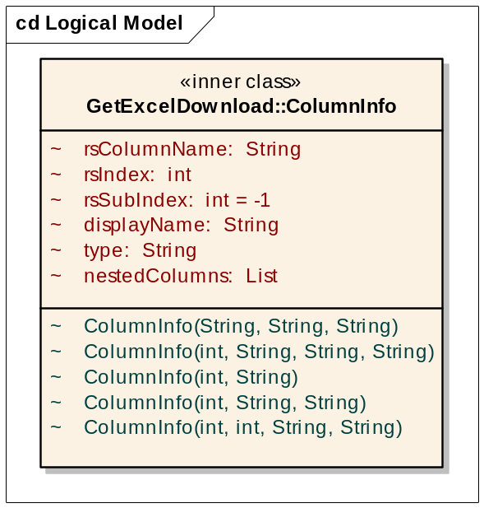

A regular column will have the column name (rsColumnName) of the result set and its corresponding Excel column name (displayName). The rsIndex attribute is used for the columns that map to a field inside a struct in the result set, e.g., valid value and value meaning. The rsSubIndex attribute is used for columns that map to a column that is nested inside two layers of stucts, e.g., the preferred name of a classification scheme. The attribute nestedColumns contains a List of ColumnInfo that define a group of columns, e.g., value domain concepts.

The new design will allow a program to take the result set with the mapping information that stored in a List of ColumnInfo and generate the desired Excel file. When new fields are needed in the future, only the mapping information needs to be changed.

The follow is an interaction diagram that shows how a cell is created based on the result set and the mapping information stored in the ColumnInfo list.

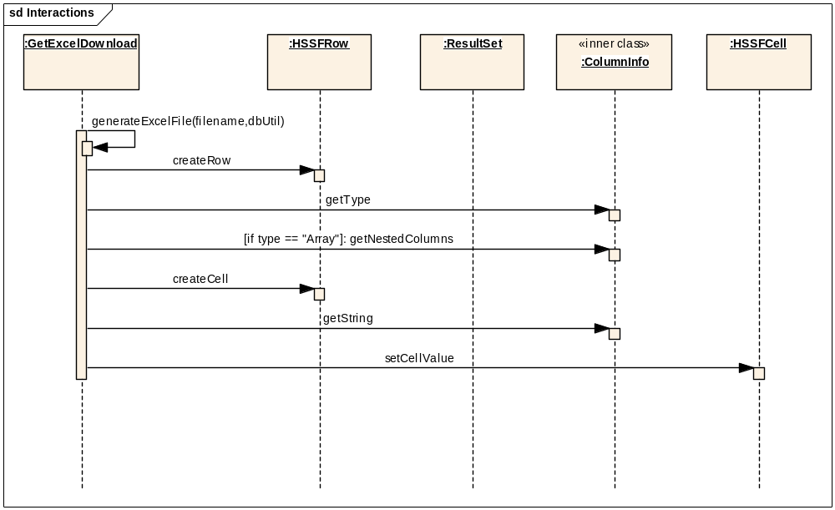

Display of Alternate Names on DE Details Page
Our proposed solution involves synchronizing the OR mapping for “name” field in Designations table.

Saving Forms with CDEs with Large Value Sets
Our proposed solution for this involves performance tuning the database procedures used for saving valid values. This tuning includes disabling a count statement that was used to find the unique ness of preferred name. We will also use database objects to do a bulk update. The valid values and the instructions are passed to the procedure as a collection user defined objects.

Browser Tree Takes 15 Seconds to Refresh
The tree redesign involve moving the architecture more in line with the rest of the application architecture where we have Presentation → Service layer → DAO. We reuse most of the current UI rendering code. The CDEBrowserTreeServiceImpl is injected using Spring framework. We introduced new class CDEBrowserTreeCache as a cache for tree nodes. CDEBrowserTreeService has application methods that return mostly objects of type “DefaultMutableTreeNode” which is a class used by the tree rendering framework to define a tree node. We also redesigned how tree retrieves data for rendering. In 3.0 tree implementation queries database recursively to pull information about each node. This led to large number of database calls. We reduced the number of database calls by pulling information onto the middle tier and the grouping this information at the middle tier e.g. To construct the “Protocol Forms” node one single query retrieves all forms for all contexts and then in the middle tier the service implementation class sifts throw the collection to categorize then by context and protocol.
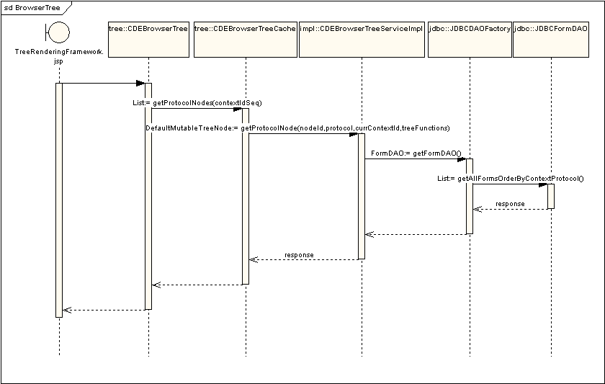

Third Party Tools
Product | Version | Web Site & Notes
JBoss | 4.0 | http://www.jboss.org/downloads/index
JDK | 1.4.2_06 | http://java.sun.com/j2se/1.4.2/download.html  Recommend downloading the J2EE 1.4 SDK.
Struts | 1.2.2 | http://struts.apache.org/
Spring Framework | 1.55 | http://www.springframework.org
POI | 2.5.1 | http://jakarta.apache.org/poi/index.html  Apache Jakarta Open Source project. The POI project consists of APIs for manipulating various file formats based upon Microsoft's OLE 2 Compound Document format using pure Java.
ANT | 1.6.0 | http://ant.apache.org/

Implementation Contents

Servers

Software Requirements
N/A

Batch Processes
N/A

APIs
N/A

Error Handling
Any unrecoverable takes the user to System error page.

Database Assumptions
CaDSR repository have been upgraded to 3.0.1.

Client

Software and Hardware Requirements
Microsoft IE browsers 5.0 or higher

Servlet
N/A

Error Handling
N/A

Security

User Authentication
User is authenticated using Login Module configured in JBoss configuration file “login-config.xml”. For user to be authenticated he should be valid user to caDSR repository and the account should be active.

User Authorization
User is authorized using roles defined for that user in caDSR repository.

Performance
N/A

Internationalization
N/A

Installation / Packaging
In 3.0.1 we have moved to the new version on spring framework 1.15. Also Oracle thin driver also updated to be inline with 9i database upgrade. We also use this driver specific API for bulk save of valid values.

Migration
N/A

Documentation Considerations
The following end user documents will be updated in light of the planned 3.0.1 updates:
- Online Help for CDE Browser and Form Builder
- Release Notes for CDE Browser and Form Builder

Testing
Refer to the CDE Browser and Form Builder Test Plans for 3.0.1.

