National Cancer Institute
Center for Bioinformatics

UML Loader Software Implementation Design Document

Version 1.0

October 18, 2004

Introduction

Description

Design Goals
The purpose of the architecture is to keep UML Loader modular. UML Loader makes extensive use of the strategy pattern, allowing each portion to be replaced by another, if need be. From a design perpective, UML Loader makes no assumption that the data will be read from XMI or persisted to a caDSR model.

Architecture Overview

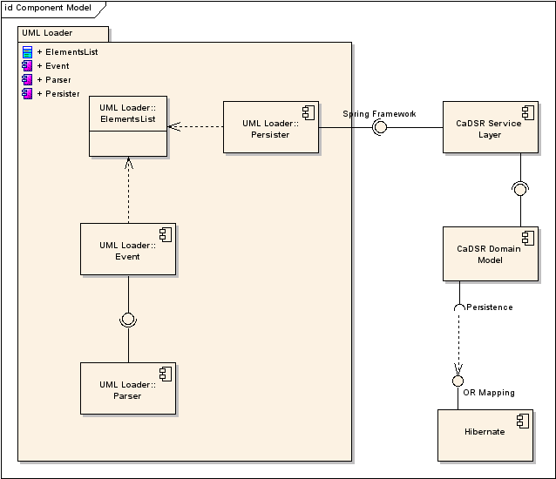
UML Loader consists of four major components:
- The Parser component responsible for opening and parsing the raw UML File
- The Event component manages events sent by the parser component
- The ElementsList component stores in CaDSR format all the UML Element that make up the raw UML file
- The Persister component responsible for sending CaDSR object to the service layer.
UML Loader uses the CaDSR Service layer to interact with the persistence layer. The service layer uses Spring Framework to expose services and Hibernate for persistence.

Design Patterns

Singleton
The singleton pattern solves the issue of having multiple instances of a class within one virtual machine. UMLDefaults implements the singleton pattern since it is essential that UML Loader classes share one and only one instance of UMLDefaults.

Strategy
The strategy pattern is useful when one wants to replace one algorithm by another one without affecting the client using them. XMIParser, UMLDefaultHandler, Validator, UMLDefaults and UMLPersister all implement the strategy pattern. Each one of these classes can be independently replaced by another implemation.

Main Classes

Parser
The parser interface defines the parse(String filename) method. Classes implementing this interface define what technology to use for parsing the input file. XMIParser is currently the only implementing interface and, as the name suggests, expects an XMI file. It uses the Netbeans MDR api to read XMI.
Parser also defines the setEventHandler method. The parser creates events and fires them to a handler. XMIParser creates UML related events, such as NewAttribute or NewAssociation. As such, it expects a UMLHandler generalization of EventHandler.

Event Handler
The Parser creates events and fires them to the EventHandler. Events are UML related, such as NewClassEvent or NewAttributeEvent. The UMLDefaultHandler’s implementation of EventHandler has the task of receiving events and transforming them into caDSR objects.

ElementsList
The ElementsList encapsulates a list of objects to be persisted. The EventHandler populates this list as it receives events from the parser. This is a singleton object.

Persister
The persister interface defines the persist() method. UMLPersister implements Persister and uses the Strategy pattern to delegate work to other Persisters. As the name suggests, Persisters are responsible for sending object to the DAO layer to be persisted. In the case of UMLPersister, calls to other Persiters are also ordered because, for example, Object Classes must be persisted before Object Class Relationships.
It is the responsibility of the Persister to verify wheter objects already exist or not.

Validator
Appropriate validation of the input data is the only way of ensuring that all data will be successfully loaded. Validators can be plugged in after parsing and before persistance. They validate rules such as:
- Concept information must exist for all classes and all attributes
- All associations must have role names and cardinality defined.
Although not limited to the following behavior, validators typically go through the entire ElementsList and report ValidationErrors. Errors are displayed to the user, and it is up to her to decide whether to stop the process or go on with the persistence.

DefaultsLoader

UMLLoader
UMLLoader is the captain of all classes. UMLLoader is responsible for instantiating the parser, listener, persister and validators, thus acting as a factory for those interfaces. It also is responsible for initializing the ElementsList.

UML Diagrams

Sequence Diagram
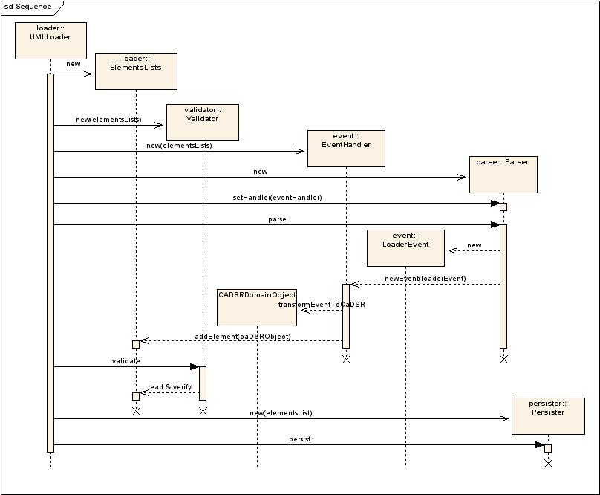

Class Diagram
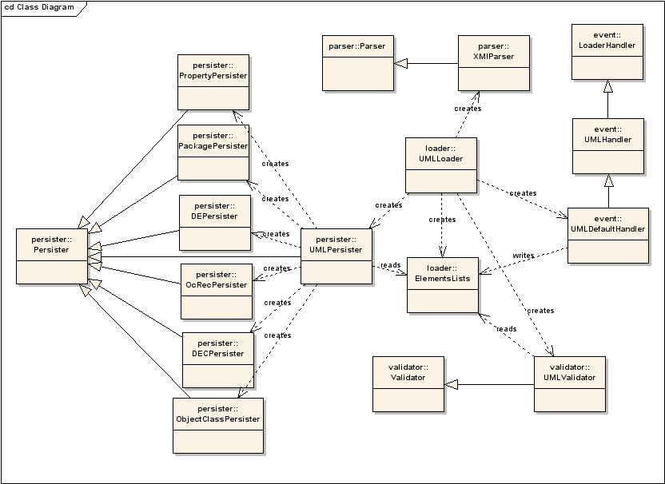

Logging

Log Messages
Messages are logged with Log4J. Log4J allows UMLLoader to layer out logs by levels:
- Info
Info logs are used to report activity back to the user so she can get feedback on the database activity.
- Warning
Warning logs inform the user of suspicious activity. Normaly, the user would still decide to continue and carry on with the load.
- Error
Error messages will most likely end up some or all of the data not being loaded to the database. The user may still be able to continue if, for instance, she knows that part of a UML diagram cannot and shall not be loaded. Errors may occur in the following situations:
- Some data is missing in caDSR. An example of missing data would be a missing ValueDomain (an attribute type). Since UMLLoader does not create ValueDomain, if an attribute is of a type that does not exist in CaDSR, the loader cannot persist that attribute
- The XMI document is missing tagged values. Tagged values with concept information is required for each attribute and each class.
UMLLoader will always attempt to catch errors during validation, before data is persisted. This gives the user a chance to go back to her diagram and make changes.
- Fatal
Fatal errors may happen for many reasons, including:
- The files to load cannot found
- The input document does not conform to the XMI specification or cannot be parsed by the Netbeans MDR API
- There is a bug in CaDSR that prevents it from working properly. A bug report needs to be submitted in that case

Reporting
Users get two types of reports:
- Validation reports.
Validation messages are reported immediately to the user during execution. After parsing but before persistence occurs.
- Log reports
Info logs are output separately from the other logs so that once the load is done, a user can read the log and identify all database activity and updates.
Error and warning logs are appended to another log file. Error messages might indicate that some or all of the data could not be loaded. This gives a chance to the user to go back to its original document, make necessary changes and redo the load.

Authentication and Authorization

Authentication
Authentication is done with through a JAAS login module. Using JAAS allows us to reuse this module in other caDSR appliations. Upon calling the login() method, the login module verifies that the user is a caDSR database user. To do this, an attempt to create a database connection is performed.

Authorization
The application must be able to verify that a particular user has create and read privilege in a particular context. This verification is performed by reusing a component from FormBuilder.

Validation
Validation occurs after parsing and before persistence. Validators can be stacked so that validation rules are kept separate and so that new validation can be added without afflicting the other validation rules.

Concept Codes
ConceptCodeValidator verifies the requirement that all attribute and all classes in the input XMI document have concept tagged values.

User Interface

