SYSTEM ARCHITECTURE
The caEmlir-caTissue-Integration application is comprised of an n-tiered architecture, as depicted in the following figure. The client layer contains applications on the client side that request to perform operations on the server side. The web browser and JAVA HTTP API are two of the client programs in caEmlir-caTissue-Integration. The presentation layer provides a web interface as well as support for the HTTP API. The object layer is the heart of the application, and contains domain objects, model classes and the data access layer. This is the place where all tissue banking related business requirements are fulfilled. The backend of the application is a local database that stores all the tissue banking information.

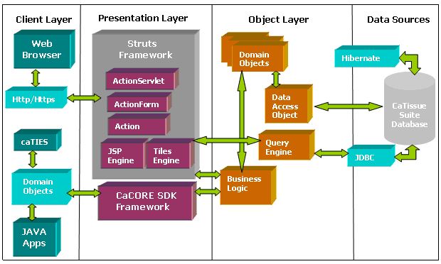
caElmir-caTissue DataBase

The main components of the application are as follows:
- Web interface: Web pages and HTTP APIs
- Business Logic
- Data access object
The web-based user interfaces are designed and developed in a Java/Struts framework. The design follows the Model View Controller (MVC) design approach wherein the view (i.e. the user interfaces) and the model (i.e. the actual application logic) are completely insulated.
The web interfaces communicate with caTissue Core’s database through an intermediate business logic layer. Interaction with the database is performed using either Hibernate or JDBC based on performance requirements. Hibernate is used in cases where simple objects are to be inserted/updated in the database. In cases like query interface where high throughput queries can be expected, JDBC is used. The intent here is to extract the best of both worlds.

