caGrid portal
Requirements Definition
Version Number: 1.0
Version Date: 3/7/2014

Notes to the Author
[This document is a template of a Requirements Definition document for a project. The template includes instructions to the author, boilerplate text, and fields that should be replaced with the values specific to the project.
- Blue italicized text enclosed in square brackets ([text]) provides instructions to the document author, or describes the intent, assumptions and context for content included in this document.
- Blue italicized text enclosed in angle brackets (<text>) indicates a field that should be replaced with information specific to a particular project.
- Text and tables in black are provided as boilerplate examples of wording and formats that may be used or modified as appropriate to a specific project. These are offered only as suggestions to assist in developing project documents; they are not mandatory formats.

When using this template, the following steps are recommended:
- Replace all text enclosed in angle brackets (e.g., <Project Name>) with the correct field document values. These angle brackets appear in both the body of the document and in headers and footers. To customize fields in Microsoft Word (which display a gray background when selected) select File->Properties->Summary and fill in the appropriate fields within the Summary and Custom tabs.
After clicking OK to close the dialog box, update all fields throughout the document selecting Edit>Select All (or Ctrl-A) and pressing F9. Or you can update each field individually by clicking on it and pressing F9.
These actions must be done separately for any fields contained with the document’s Header and Footer.
- Modify boilerplate text as appropriate for the specific project.
- To add any new sections to the document, ensure that the appropriate header and body text styles are maintained. Styles used for the Section Headings are Heading 1, Heading 2 and Heading 3. Style used for boilerplate text is Body Text.
- To update the Table of Contents, right-click on it and select “Update field” and choose the option - “Update entire table”.
- Before submission of the first draft of this document, delete this instruction section “Notes to the Author” and all instructions to the author throughout the entire document.
VERSION HISTORY
[Provide information on how the development and distribution of the Requirements Definition will be controlled and tracked. Use the table below to provide the version number, the author implementing the version, the date of the version, the name of the person approving the version, the date that particular version was approved, and a brief description of the reason for creating the revised version.]
Version  Number | Implemented  By | Revision  Date | Approved  By | Approval  Date | Description of  Change
DRAFT | Prasad Konka | 3/7/2014 | <name> | <mm/dd/yy> | Initial draft
 | Zhengwu Lu | 3/7/2014 |  |  | Comments provided
1.0 | Prasad Konka | 3/10/2014 |  |  | Updated based on TPM comments

TABLE OF CONTENTS
1 Introduction 5
1.1 Purpose of the Requirements Definition Document 5
2 Business Requirements Overview 5
2.1 Assumptions / Constraints 5
2.2 System Scope 5
3 Functional Requirements 5
3.1 Register new user 5
3.2 Login 7
3.3 manage user CONTACT INFO 8
4 Non-Functional Requirements 10
4.1 Design Constraints 10
4.2 Hardware Requirements 10
4.3 Software Requirements 11
4.4 Performance Requirements 11
4.5 Reliability Requirements 11
4.6 Supportability Requirements 11
4.7 User Documentation Requirements 11
4.8 Interface Requirements 11
4.9 Security and Privacy Requirements 11
4.10 Compliance and Standards Requirements 11
Appendix A: Requirements Definition Approval 13
APPENDIX B: REFERENCES 14

Introduction

Purpose of the Requirements Definition Document
The Requirements Definition defines the functional, non-functional, and technical requirements. The Requirements Definition document is created during the Requirements Analysis Phase of the project. Its intended audience is the project manager, project team, project sponsor, client/user, and any stakeholder whose input/approval into the requirements definitions process is needed.

Business Requirements Overview
The caGrid Portal is a Web-based application that enables users to discover and interact with the services that are available on the caGrid infrastructure. The Portal provides an interface that enables users to register for an account with the caGrid Dorian service that is hosted by NCI CBIIT. This service provides a Level of Assurance 1 (LOA1), which means anyone can request an account and the request is automatically approved. Once the request is approved, user can log in to the Portal using registered user name and password. The Portal then uses the grid credentials obtained from Dorian when interacting with secure caGrid services.
The caGrid Portal has been moved behind the CBIIT firewall. This move has removed external (not NCI) users access to the caGrid Portal where they can register with caGrid Dorian IDP to get authenticated and access caGrid hosted services.
The business requirement is to provide caGrid user registration and account management features through caGrid Portal standalone web application that can be hosted at CBIIT data center with no firewall restrictions.

Assumptions / Constraints
[Describe any overall assumptions / constraints related to project requirements]

System Scope
The scope of this project is to provide caGrid user registration on CBIIT hosted Dorian IDP, user login and account update features through caGrid portal that is hosted outside NCI CBIIT firewall. This release is not a replacement for existing caGrid portal that is deployed behind NCI CBIIT firewall.

Functional Requirements

Register new user
This requirement is to let a user register him/her with CBIIT hosted caGrid Dorian IDP.
ID | Requirement | Predecessor
R1.1 | Click the Register link at the top of any caGrid Portal page. A window appears with fields for your contact information.
R1.2 | The user name must be between 4 and 15 characters. | R1.1
R1.3 | A valid password must be between 4 and 15 characters, CANNOT contain a dictionary word, and MUST contain at least one upper case letter, at least one lower case letter, at least one number, and at least one symbol (~!@#$%^&*()_-+={}[]|:;<>,.?). | R1.1
R1.4 | User will be able to enter information for First Name, Last Name, User Name, Password, Retype Password, Email, Phone, Organization, Street1, Street2, City/Locality, State/Province, Postal Code, Country., Required fields will be marked with * next their label.
R1.5 | Clicking on Register button registers the user with CBIIT hosted caGrid Dorian IDP | R1.4
R1.6 | Clicking on Cancel button will take the user back to the main page. | R1.1
R1.7 | After successful registration, the window displays status message. Register and Cancel buttons will be disabled. | R1.5
R1.8 | If user registration is not successful, a message explains the problem and provides steps for user action. Reasons for unsuccessful registration include duplicate user name, invalid user name, invalid password, and invalid email. Any validation errors will be displayed in the window if registration is failed. | R1.5
R1.9 | After successful registration, user will be able to login by clicking on login button in the main page. Login button is visible all users visiting the main page. | R1.8

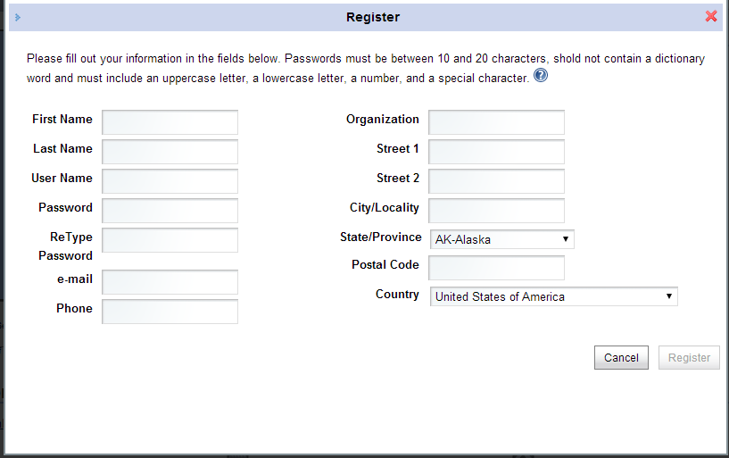

Login
This requirement is to provide login feature where registered users can login to update account profile.
ID | Requirement | Predecessor
R2.1 | The main page shall display link to Login
R2.2 | Clicking on Login link will open a page to login with UserId, Password, IDP from a list box. The identity providers that appear in this list are those that have registered with the caGrid Identity Federation Service. User shall be able to enter login credentials with | R2.1
R2.3 | Clicking on login button shall validate user credentials with selected IDP. | R2.2
R2.4 | After successful authentication, user shall be navigated to main page. | R2.3
R2.5 | Main page shall display user name hyperlinked. | R2.4
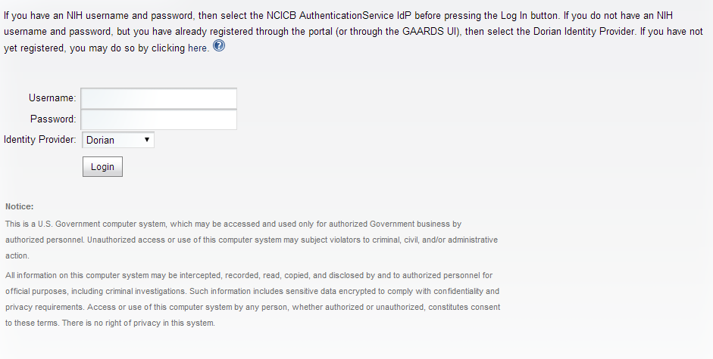

manage user CONTACT INFO
Once a user log in to caGrid Portal, user can click user name at the top of the page to see user profile. User cannot edit anyone else's profile but his/her own.

ID | Requirement | Predecessor
R3.1 | After logging in to the Portal, clicking on user name at the top of the page opens edit page.
R3.2 | User profile name and description shall be editable. This page will be pre populated with available user contact info. | R3.1
R3.3 | Clicking on cancel will not save any changes and navigate to home page. | R3.1
R3.4 | User shall be able to update phone, email, street1, street2, city/locality, state/province, country, website, public phone number?, public email?, public address? fields with information. | R3.1
R3.5 | Clicking on save button shall save changes. | R3.4
R3.6 | Validation errors or message will be displayed on page. | R3.5
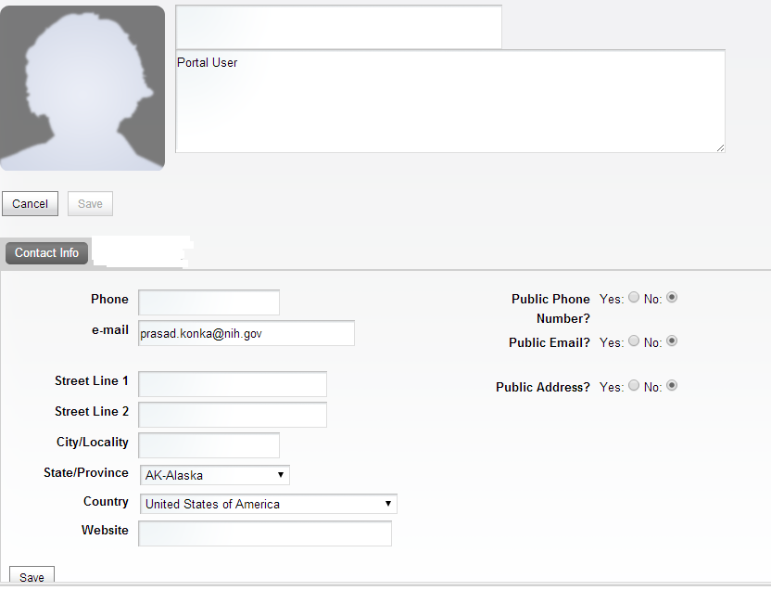

Non-Functional Requirements
[Describe the existing non-functional (also referred to as Quality of Service by the International Institute of Business Analysts, Business Analysis Body of Knowledge), technical environment, systems, functions, and processes. Include an overview of the non-functional requirements necessary to achieve the project’s objectives.]

Design Constraints
[Describe hardware/software requirements that will limit the design or COTS options. These may include laws, regulations, hardware limitations, interfaces, development environment, operational environment, criticality, safety, and/or security. Assign a unique ID number to each requirement.]

Hardware Requirements
[Describe hardware requirements and any related processes. Include a detailed description of specific hardware requirements and associate them to specific project functionality/deliverables. Include information such as type of hardware, brand name, specifications, size, security, etc. Assign a unique ID number to each requirement.]

Software Requirements
Spring MVC Framework will be used as backend framework while Twitter Bootstrap is used as the presentation framework.

Performance Requirements
[Describe performance requirements and any related processes. Include a detailed description of specific performance requirements and associate them to specific project functionality/deliverables. Include information such as system capacity, cycle time, speed per transaction, test requirements, minimum bug counts, speed, reliability, utilization etc. Assign a unique ID number to each requirement.]

Reliability Requirements
[Describe all of the technical requirements that affect availability such as hours of operation, level of availability required, down-time impact, support availability, accuracy, etc. Assign a unique ID number to each requirement.]

Supportability Requirements
[Describe all of the technical requirements that affect supportability and maintainability such as coding standards, naming CONVENTIONS; maintenance access, required utilities, etc. Assign a unique ID number to each requirement.]

User Documentation Requirements
caGrid Portal User guide and Deployment guide will be available on NCI CBIIT Wiki.

Interface Requirements
[Describe all of the user interface (such as user navigation, presentation of application and associated functionality, screen location of interface elements, data display and manipulation, etc), system interface, and technical (hardware and software) requirements that affect interfaces such as look-and-feel, protocol management, scheduling, directory services, broadcasts, message types, error and buffer management, security, etc. Assign a unique ID number to each requirement.]

Security and Privacy Requirements
The caGrid portal web pages will comply with NCI CBIIT App Scan security policy compliance guidelines.

Compliance and Standards Requirements
[Describe the existing compliance environment as it affects project requirements, and the standards the system development must follow. Include an overview of the compliance or standards requirements necessary to achieve the project’s objectives. List all that are applicable to the project. Assign a unique ID number to each requirement.]

Section 508 Compliance
The caGrid portal web pages will comply with HHS Section 508 compliance guidelines.
Appendix A: Requirements Definition Approval
The undersigned acknowledge that they have reviewed the <Project Name> Requirements Definition and agree with the information presented within this document. Changes to this Requirements Definition will be coordinated with, and approved by, the undersigned, or their designated representatives.
[List the individuals whose signatures are desired. Examples of such individuals are Business Owner, Project Manager (if identified), and any appropriate stakeholders. Add additional lines for signature as necessary.]

Signature: |  | Date:
Print Name:
Title:
Role:

Signature: |  | Date:
Print Name:
Title:
Role:

Signature: |  | Date:
Print Name:
Title:
Role:

APPENDIX B: REFERENCES
[Insert the name, version number, description, and physical location of any documents referenced in this document. Add rows to the table as necessary.]
The following table summarizes the documents referenced in this document.
Document Name | Description | Location
<Document Name and Version Number> | <Document description> | <URL or Network path where document is located>

