caGrid Data Services CQL Query Guide

Sections:
1. Schema
a. CQLQuery
b. Target
c. Objects
d. Attributes
e. Associations
f. Groups
2. Examples
a. Return all objects of a given type
b. Objects with a single attribute
c. Objects with a single association
d. Groups
e. Nested groups

1. Schema:

CQL is defined in an XML document conforming to a well defined schema with the URI http://CQL.caBIG/1/gov.nih.nci.cagrid.CQLQuery. This schema can be graphically represented by the following diagram:

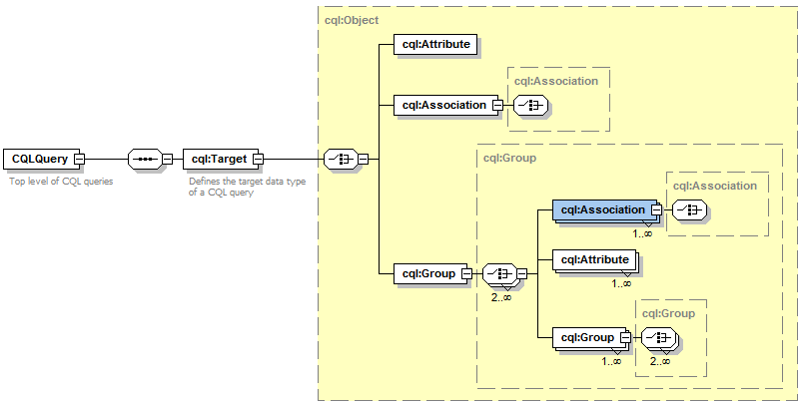

Parts of the CQL schema:

CQLQuery: CQL Query is a simple wrapper element at the head of every CQL query document. It contains the target element.

Target: The Target element is of the type Object, and describes the data type which the query will return.

Object: The Object element contains the required attribute ‘name.’ This attribute’s value defines the caDSR class of the object. When the Object is the top level of a CQL query, it identifies the target data type that will be returned by the caGrid Data Service. The Object allows for a choice between three child elements. The possible child elements are Attribute, Association, and Group. Objects may have at most one of these child elements.

Attribute: An Attribute type in CQL describes a restriction on an attribute of an Object. The Attribute contains three XML attributes, which define the restriction. The attribute ‘name’ defines the name of the attribute to be restricted. The attribute ‘value’ defines the restriction on the attribute. The attribute ‘predicate’ describes what type of restriction the attribute defines. Allowable predicates are defined by the schema’s simple type ‘Predicate’, which defines an enumeration of allowable values. The predicate values are generally self-descriptive: “EQUAL_TO", “NOT_EQUAL_TO", “LIKE", "LESS_THAN", "LESS_THAN_EQUAL_TO", “GREATER_THAN", and “GREATER_THAN_EQUAL_TO." Two additional predicates, "IS_NULL", and “IS_NOT_NULL" check only for the presence or absence, respectively, of an attribute, and do not restrict its value at all. Therefore, any ‘value’ attribute will be ignored when using these predicates.

Association: An association describes a related Object, which defines the associated object’s restrictions for the query, as well as the relationship from one object to another. Specifically, it defines the relationship down the object model tree. The Association complex type is an extension of Object. The Association has a single, optional attribute named ‘roleName.’ This attribute identifies which associated object field the Association is defining. For example, a person may have more than one address, perhaps business and home. To perform a restriction against the home address, a query must specify the home address role name for the associated object. If the query omits the role name, such a query becomes ambiguous, as there is more than one field of Person which has a type of Address. In this case, the data service will throw a MalformedQueryException explaining that the requested association is ambiguous. In the case of an object where there is only one field of a given type, the roleName attribute may be omitted, and the data service will resolve the correct name as the query is processed.

Group: Groups define logical joints of two or more conditions, and operate against the Object to which they are attached. Groups must have two or more children, which may be a mixture of type Attribute, Association, or Group. Groups also have an attribute named ‘logicOperator,’ whose type is defined in the schema’s simple type LogicalOperator. This type is an enumeration of the values “AND” and “OR.” The operator is applied to all children in the group. The “AND” operator requires that all conditions in the group be true for the group to evaluate as true. The “OR” operator requires that any condition in the group evaluate as true.
2. Example Queries:

Return all objects of a given type: The simplest CQL query defines only one Object. The data service will return all objects in its underlying data source of the given type.

This query will return all Gene objects in the data source:
<CQLQuery xmlns="http://CQL.caBIG/1/gov.nih.nci.cagrid.CQLQuery">
<Target name="gov.nih.nci.cabio.domain.Gene"/>
</CQLQuery>

Objects with a single property: A simple extension to the above query is to ask for all Objects with a single attribute restriction. Here, a LIKE restriction is used. Note that the syntax for LIKE queries mimics that of SQL.

This query will return all Genes with a symbol starting with BRCA:
<CQLQuery xmlns="http://CQL.caBIG/1/gov.nih.nci.cagrid.CQLQuery"
<Target name="gov.nih.nci.cabio.domain.Gene">
<Attribute name="symbol" value="BRCA%" predicate="LIKE"/>
</Target>
</CQLQuery>

Objects with a single association: A more involved CQL query defines an object and an association to another object. The data service will return all objects of the requested data type and meeting the restriction on their association.

This query will return all Genes with an associated Taxon whose id is equal to 6:
<CQLQuery xmlns="http://CQL.caBIG/1/gov.nih.nci.cagrid.CQLQuery">
<Target name="gov.nih.nci.cabio.domain.Gene">
<Association roleName="taxon" name="gov.nih.nci.cabio.domain.Taxon">
<Attribute name="id" value="6" predicate="EQUAL_TO"/>
</Association>
</Target>
</CQLQuery>

Groups: Groups are required when more than one restriction on an object is needed. In this example, a groups is made with an AND logical operator, meaning that all conditions defined within the group must be met.

This query will return all Genes with a symbol beginning with BRCA and have an associated Taxon with an id equal to 6:
<CQLQuery xmlns="http://CQL.caBIG/1/gov.nih.nci.cagrid.CQLQuery">
<Target name="gov.nih.nci.cabio.domain.Gene">
<Group logicRelation="AND">
<Attribute name="symbol" value="BRCA%" predicate="LIKE"/>
<Association roleName="taxon" name="gov.nih.nci.cabio.domain.Taxon">
<Attribute name="id" value="6" predicate="EQUAL_TO"/>
</Association>
</Group>
</Target>
</CQLQuery>

Nested groups: Nested groups can be used to build up sophisticated compound queries. The groups may have differing logical relations to express restrictions on various portions of the object.

This query will return all Genes with an associated Taxon that has a scientificName attribute of ‘Mus musculus’ and have either a symbol like BRCA or like ICR:
<CQLQuery xmlns="http://CQL.caBIG/1/gov.nih.nci.cagrid.CQLQuery" >
<Target name="gov.nih.nci.cabio.domain.Gene">
<Group logicRelation="AND">
<Association roleName="taxon" name="gov.nih.nci.cabio.domain.Taxon">
<Attribute name="scientificName" value="Mus musculus" predicate="EQUAL_TO"/>
</Association>
<Group logicRelation="OR">
<Attribute name="symbol" value="BRCA%" predicate="LIKE"/>
<Attribute name="symbol" value="ICR%" predicate="LIKE"/>
</Group>
</Group>
</Target>
</CQLQuery>

