Overview 1
Components 1
Using the Client API 5
Extending the Framework 6

Overview

The role of the AuthenticationService project is to provide an integration point between local identity management and caGrid identify federation. To achieve this goal, we define an interface that should be implemented an Identity Provider (IdP) service, and we provide a framework implementation that exposes the Common Security Module (CSM) as an IdP.

This document describes
- the components that comprise the AuthenticationService project
- how to interact with this API
- how to implement or extend the framework

Components

The following diagram shows the main components of the AuthenticationService.

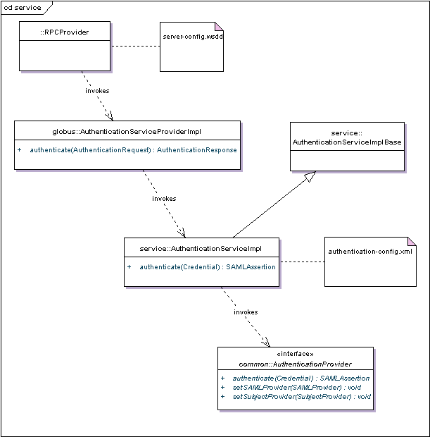
Figure 1: Main AuthenticationService Components

The globus RPCProvider uses information the server-config.wssd to invoke the authenticate operation on AuthenticationServiceProviderImpl, whose main responsibility is to unpack the Credential from the AuthenticationRequest and then to package the SAMLAssertion into an AuthenticationResponse. AuthenticationServiceProviderImpl then invokes the authenticate operation on AuthenticationServiceImpl.

AuthenticationServiceImpl’s responsibility is to instantiate an instance of AuthenticationProvider and interact with it according to the contract defined in that interface. AuthencationServiceImpl uses Spring to instantiate (and configure) an instance of AuthenticationProvider AuthenticationServiceImpl then invokes the authenticate operation on AuthenticationProvider.

The AuthenticationProvider component of Authentication Service was designed as a framework. The following diagram depicts this framework.

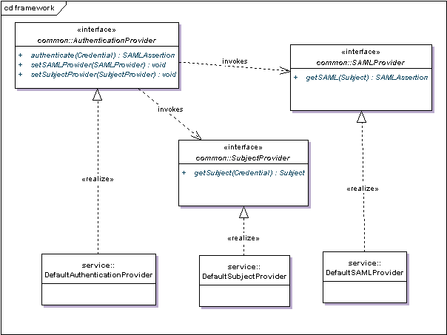
Figure 2: AuthenticationProvider Framework

A simple implementation of AuthenticationProvider is provided in DefaultAuthenticationProvider. This class expects the samlProvider and subjectProvider dependencies to be set before invoking the authenticate method. The implementation of this method invokes SubjectProvider.getSubject(Credential):Subject and SAMLProvider.getSAML(Subject):SAMLAssertion.

The DefaultSubjectProvider implementation of SubjectProvider uses the CSM AuthenticationManager to retrieve the javax.security.auth.Subject, given the user name and password that are pulled out of the Credential object DefaultSubjectProvider expects a fully configured instance of AuthenticationManager to be supplied as its authenticationManager dependency before invoking the getSubject method.

The Credential object is deserialized from XML by the Axis framework. The following is an excerpt from the XSD that defines the XML format of the Credential object.

<xsd:element name="Credential" type="auth:Credential"/>
<xsd:complexType name="Credential">
<xsd:choice>
<xsd:element
name="BasicAuthenticationCredential"
minOccurs="1" maxOccurs="1"
type="auth:BasicAuthenticationCredential"/>
<xsd:element
name="CredentialExtension"
minOccurs="1" maxOccurs="1"
type="xsd:anyType"/>
</xsd:choice>
</xsd:complexType>
<xsd:complexType name="BasicAuthenticationCredential">
<xsd:sequence>
<xsd:element
name="userId" minOccurs="1"
maxOccurs="1" type="xsd:string"/>
<xsd:element
name="password" minOccurs="1"
maxOccurs="1" type="xsd:string"/>
</xsd:sequence>
</xsd:complexType>

As this snippet shows, the Credential element may contain either a BasicAuthenticationCredential element or a CredentiaExtension element. The DefaultSubjectProvider requires that a BaseAuthenticationCredential be provided. The CredentialExtension element is there to support other implementations of SubjectProvider.

The DefaultSAMLProvider implementation of SAMLProvider requires that its certificate, privateKey, and password dependencies be set, and that its loadCertificates method is called before invoking the getSAML method. The Subject that is passed to the getSAML method must contain instances of these four sub classes of java.security.Principal:
- gov.nih.nci.security.authentication.principal.LoginIdPrincipal
- gov.nih.nci.security.authentication.principal.FirstNamePrincipal
- gov.nih.nci.security.authentication.principal.LastNamePrincipal
- gov.nih.nci.security.authentication.principal.EmailIdPrincipal

Using the Client API

The following code demonstrates how to login to the authentication service and use the returned SAML assertion to obtain a proxy from Dorian.

import gov.nih.nci.cagrid.authentication.bean.BasicAuthenticationCredential;
import gov.nih.nci.cagrid.authentication.bean.Credential;
import gov.nih.nci.cagrid.authentication.client.AuthenticationServiceClient;
import gov.nih.nci.cagrid.dorian.bean.SAMLAssertion;
import gov.nih.nci.cagrid.dorian.client.DorianClient;
import gov.nih.nci.cagrid.dorian.ifs.bean.DelegationPathLength;
import gov.nih.nci.cagrid.dorian.ifs.bean.ProxyLifetime;
import gov.nih.nci.cagrid.dorian.ifs.bean.PublicKey;
import gov.nih.nci.cagrid.gridca.common.CertUtil;
import gov.nih.nci.cagrid.gridca.common.KeyUtil;

import java.security.KeyPair;
import java.security.cert.X509Certificate;

import org.globus.gsi.GlobusCredential;

public class SecurityClient {
public static void main(String[] args) throws Exception {

String usr = “username";
String pwd = "password";
String dorianUrl = "https://somehost:443/wsrf/services/cagrid/Dorian";
String authUrl = "https://somehost:443/wsrf/services/cagrid/AuthenticationService";

AuthenticationServiceClient client = new AuthenticationServiceClient(
authUrl);

BasicAuthenticationCredential bac = new BasicAuthenticationCredential();
bac.setUserId(usr);
bac.setPassword(pwd);
Credential cred = new Credential();
cred.setBasicAuthenticationCredential(bac);
String xml = client.authenticate(cred).getXml();
System.out.println(xml);

ProxyLifetime lifetime = new ProxyLifetime();
lifetime.setHours(12);
lifetime.setMinutes(0);
lifetime.setSeconds(0);

DorianClient dClient = new DorianClient(dorianUrl);
KeyPair pair = KeyUtil.generateRSAKeyPair512();
PublicKey key = new PublicKey( KeyUtil.writePublicKey(pair.getPublic()));
SAMLAssertion saml2 = new SAMLAssertion(xml);

gov.nih.nci.cagrid.dorian.bean.X509Certificate list[] = dClient.createProxy(saml2, key, lifetime, new DelegationPathLength(0));
X509Certificate[] certs = new X509Certificate[list.length];
for (int i = 0; i < list.length; i++) {
certs[i] = CertUtil.loadCertificate(list[i]
.getCertificateAsString());
}
GlobusCredential gridCred = new GlobusCredential(pair
.getPrivate(), certs);
System.out.println("Issuer: " + gridCred.getIssuer());
System.out.println("Subject: " + gridCred.getSubject());

}
}

Extending the Framework

As described in the “Components” section and depicted in Figure 1, AuthenticationServiceImpl uses Spring and the authentication-config.xml file to instantiate an implementation of the AuthenticationProvider interface. As shown in Figure 2, the default implementation of AuthenticationProvider will delegate to an instance of SAMLProvider and an instance of SubjectProvider.

To extend the framework, one can choose to plug in a new implementation of AuthenticationProvider, or SAMLProvider, or SubjectProvider simply by editing authentication-config.xml.

