Overview

The main responsibility of the Authz component is to provide an integration point between local authorization policy and grid-wide authorization policy. Authorization policy in caGrid is based on membership in groups that are defined in GridGrouper. While authorization policy within an organization, is usually based in an individual's identity within that organization. The Authz component provides a framework to integrate groups that have been defined in the Commons Security Module (CSM), which is the authorization policy management system used by the NCICB, and GridGrouper groups. The result is that local administrators can extend access privileges to members of the caBIG community based on membership in GridGrouper groups, rather than having to create local identities for each individual.

Since the Authz component has been designed to plug into the CSM framework, caCORE 3.1 systems that use CSM 3.1 can plug in the Authz component without changing code.

This document describes how to configure CSM for a caCORE service to use the Authz component.

JAAS Configuration

No changes are required to be made to CSM’s JAAS configuration.

ApplicationSecurityConfig.xml

caCORE services that are using CSM will have configured configured a the “gov.nih.nci.security.configFile” system property to point to an ApplicationSecurityConfig.xml file. To use the Authz component, specify gov.nih.nci.cagrid.authorization.CSMGridAuthorizationManager as the implementation to use for both the authorization manager and the authentication manager.

The following is an example ApplicationSecurityConfig.xml file.

<security-config>
<upt-context-name>UPT</upt-context-name>
<application-list>
<application>
<context-name>SDK</context-name>
<authentication>
<lockout-time>100</lockout-time>
<allowed-login-time>100</allowed-login-time>
<allowed-attempts>3</allowed-attempts>
<authentication-provider-class>
gov.nih.nci.cagrid.authorization.impl.CSMGridAuthorizationManager
</authentication-provider-class>
</authentication>
<authorization>
<authorization-provider-class>
gov.nih.nci.cagrid.authorization.impl.CSMGridAuthorizationManager
</authorization-provider-class>
<hibernate-config-file>
/my/app/etc/hibernate.cfg.xml
</hibernate-config-file>
</authorization>
</application>
</application-list>
</security-config>

hibernate.cfg.xml

Hibernate must be configured to use the c3p0 connection pool. Add the following properties to the session-factory element in hibernate.cfg.xml

<property name="hibernate.c3p0.min_size">5</property>
<property name="hibernate.c3p0.max_size">20</property>
<property name="hibernate.c3p0.timeout">300</property>
<property name="hibernate.c3p0.max_statements">50</property>
<property name="hibernate.c3p0.idle_test_period">3000</property>

Classpath

The following jars must be added to the web applications classpath.

From the Globus 4.0.3 WS Core distribution

- addressing-1.0.jar
- axis.jar
- cog-axis.jar
- cog-jglobus.jar
- cryptix-asn1.jar
- cryptix.jar
- cryptix32.jar
- jce-jdk13-125.jar
- jgss.jar
- puretls.jar
- wsrf_common.jar
- wsrf_core_stubs.jar
- wsrf_core.jar
- wss4j.jar

From other caGrid 1.0 projects (these end up in cagrid-1-0/ext/lib, when building the authz project).

- caGrid-1.0-core.jar
- caGrid-1.0-gridca.jar
- caGrid-1.0-gridgrouper-client.jar
- caGrid-1.0-gridgrouper-common.jar
- caGrid-1.0-gridgrouper-stubs.jar
- caGrid-1.0-metadata-common.jar
- caGrid-1.0-metadata-security.jar
- caGrid-1.0-ServiceSecurityProvider-client.jar
- caGrid-1.0-ServiceSecurityProvider-common.jar
- caGrid-1.0-ServiceSecurityProvider-service.jar
- caGrid-1.0-ServiceSecurityProvider-stubs.jar
- cglib-nodep-2.1_3.ja
- grouper.jar
- mobius_common_client.jar
- mobius_factories.jar
- mobius_gme_client.jar
- mobius_mako_client.jar
- mobius_tools.jar
- subject-0.2.1.jar

From the authz project’s lib folder:

- c3p0-0.8.5.2.jar
- clm.jar
- csmapi.jar
- hibernate-3.0.5.jar
- spring-core.jar
- spring-beans.jar

Note: The clm.jar and csmapi.jar files are from a pre-CSM 3.2 release. Though the official CSM 3.2 versions should work, at the time of writing, this has not been tested.

Finally, a file named ObjectStateLoggerConfig.xml must be added to the classpath. That file should look like this:

<?xml version="1.0" encoding="UTF-8"?>
<logging-config>
<logger-name>CSM.Audit.Logging.ObjectState.Authorization</logger-name>
<logger-config-file>log4jConfig.xml</logger-config-file>
<log-level>info</log-level>
<messageType>string</messageType>
<domainObjectList>
<object-name>gov.nih.nci.security.authorization.domainobjects.Application</object-name>
<object-name>gov.nih.nci.security.authorization.domainobjects.ApplicationContext</object-name>
<object-name>gov.nih.nci.security.authorization.domainobjects.Group</object-name>
<object-name>gov.nih.nci.security.authorization.domainobjects.GroupRoleContext</object-name>
<object-name>gov.nih.nci.security.authorization.domainobjects.Privilege</object-name>
<object-name>gov.nih.nci.security.authorization.domainobjects.ProtectionElement</object-name>
<object-name>gov.nih.nci.security.authorization.domainobjects.ProtectionElementPrivilegeContext</object-name>
<object-name>gov.nih.nci.security.authorization.domainobjects.ProtectionGroup</object-name>
<object-name>gov.nih.nci.security.authorization.domainobjects.ProtectionGroupRoleContext</object-name>
<object-name>gov.nih.nci.security.authorization.domainobjects.Role</object-name>
<object-name>gov.nih.nci.security.authorization.domainobjects.User</object-name>
<object-name>gov.nih.nci.security.authorization.domainobjects.UserGroupRoleProtectonGroup</object-name>
<object-name>gov.nih.nci.security.authorization.domainobjects.UserProtectionElement</object-name>
<object-name>gov.nih.nci.security.authorization.domainobjects.UserRoleContext</object-name>
<object-name>gov.nih.nci.security.authorization.dao.hibernate.ProtectionGroupProtectionElement</object-name>
<object-name>gov.nih.nci.security.authorization.dao.hibernate.RolePrivilege</object-name>
<object-name>gov.nih.nci.security.authorization.dao.hibernate.UserGroup</object-name>
</domainObjectList>
<loggingEnabled>true</loggingEnabled>
</logging-config>

CSM Administration

This section provides an example scenario to illustrate the steps that a local CSM administrator would take to extend access privileges to caGrid users.

In this scenario, the administrator would like to permit members of the “cabig:researchers” group to query his caCORE system for gov.nih.nci.cabio.domain.Gene objects. The GridGrouper instance in which this group is defined is running at https://some.host:8443/wsrf/services/cagrid/GridGrouper.

Execute the following steps with the UPT.

Create a group named {https://some.host:8443/wsrf/services/cagrid/GridGrouper}cabig:researchers

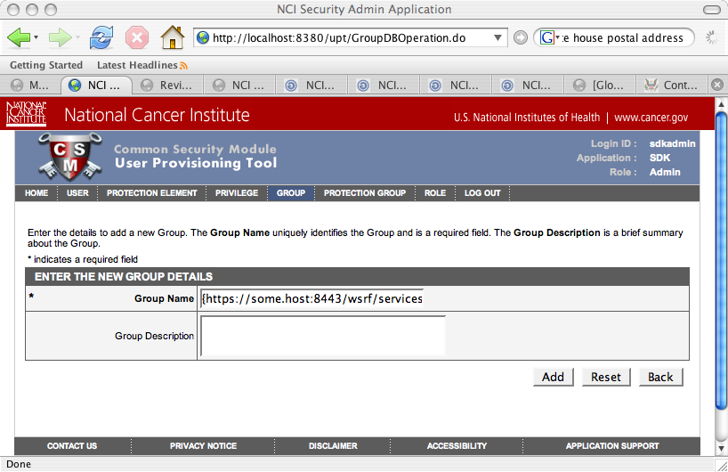

In this scenario, it is assumed that the “gov.nih.nci.cabio.domain.Gene” projection element already exists, and is a member of the “Domain Objects” projection group.

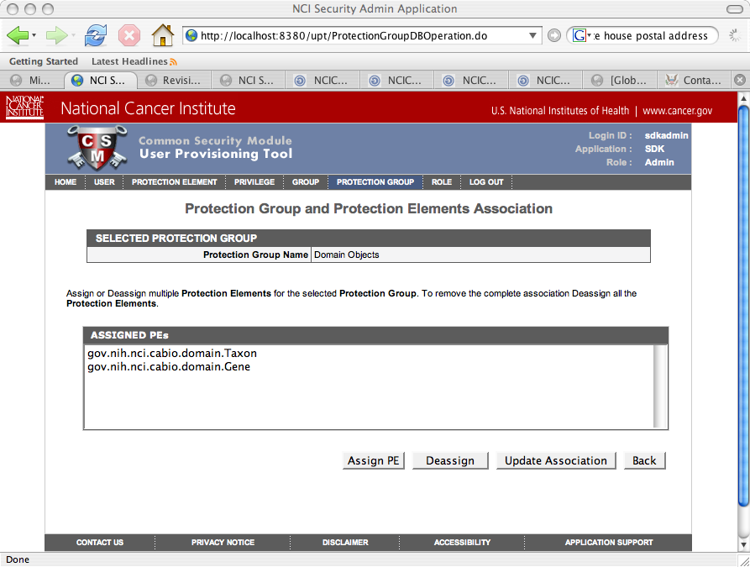

It is also assumed that a role named “Domain Object Readers” exists and has an single “READ” privilege.

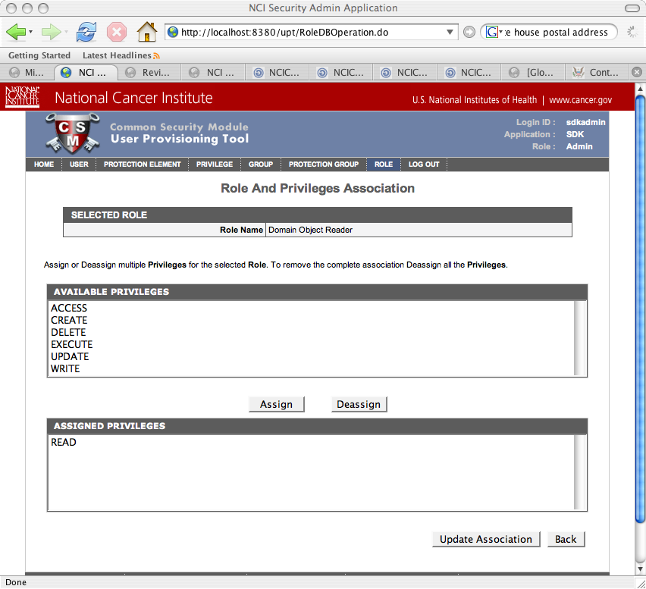

To grant the “READ” privilege to members of the “{https://some.host:8443/wsrf/services/cagrid/GridGrouper}cabig:researchers” group, assign the “Domain Objects” protection group and “Domain Object Readers” role to this group.

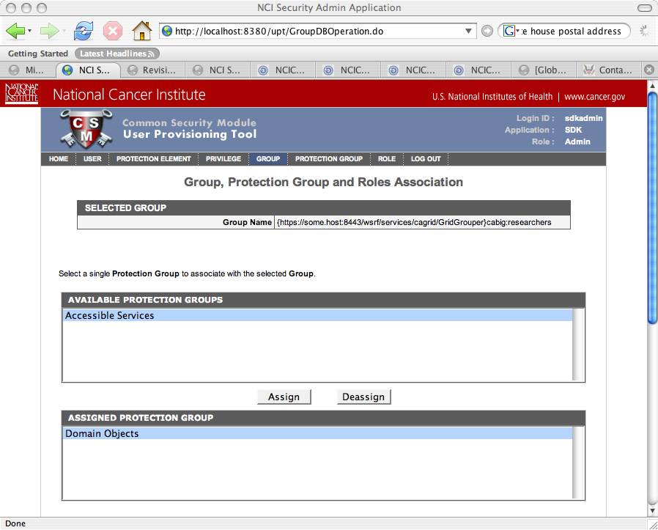

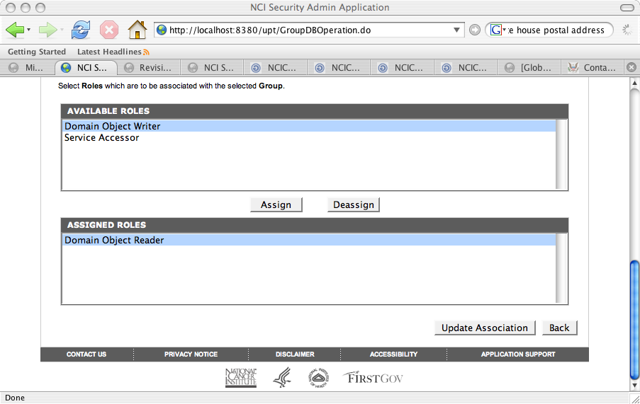

Now, assuming that the following “/O=NIH/OU=NCI/OU=NCICB/OU=DEV/OU=localhost/OU=IdP [1]/CN=george” identity is a member of the “cabig:researchers” group, the following code should print “Authorized: true”.

String identity =
"/O=NIH/OU=NCI/OU=NCICB/OU=DEV/OU=localhost/OU=IdP [1]/CN=george";
String app = "myapp";
String objectId = "gov.nih.nci.cabio.domain.Gene";
String privilege = "READ";
AuthorizationManager mgr = SecurityServiceProvider.getAuthorizationManager(app);
boolean authorized = mgr.checkPermission(identity, objectId, privilege);
System.out.println("Authorized: " + authorized);

