caGrid 1.0 Service Specification

Authors
Shannon Hastings

Required Standards Specifications
- Web Services Description Language (WSDL) Version 2.0:
  - http://www.w3.org/TR/wsdl20/
- Web Services Resource Framework (WSRF) Version 1.2
  - http://www.oasis-open.org/committees/tc_home.php?wg_abbrev=wsrf
- Web Services Resource Properties (WSRF-RP) Version 1.2
  - http://www.oasis-open.org/committees/tc_home.php?wg_abbrev=wsrf
- Web Services Service Groups (WSRF-SG) Version 1.2
  - http://www.oasis-open.org/committees/tc_home.php?wg_abbrev=wsrf
- Web Services Base Faults (WSRF-BF) Version 1.2
  - http://www.oasis-open.org/committees/tc_home.php?wg_abbrev=wsrf
- Web Services Addressing (WS-Addressing)
  - http://schemas.xmlsoap.org/ws/2004/03/addressing
- Web Services Security (WS-SecureConversation)
  - http://www-128.ibm.com/developerworks/webservices/library/specification/ws-secon/

Optional Standards Specifications
- Web Services Resource Lifetime (WSRF-RL) Version 1.2
  - http://www.oasis-open.org/committees/tc_home.php?wg_abbrev=wsrf

caGrid Service Specification
The following specification describes the standards requirements and service specification compatibility for any caGrid service.

Conceptual Service Architecture

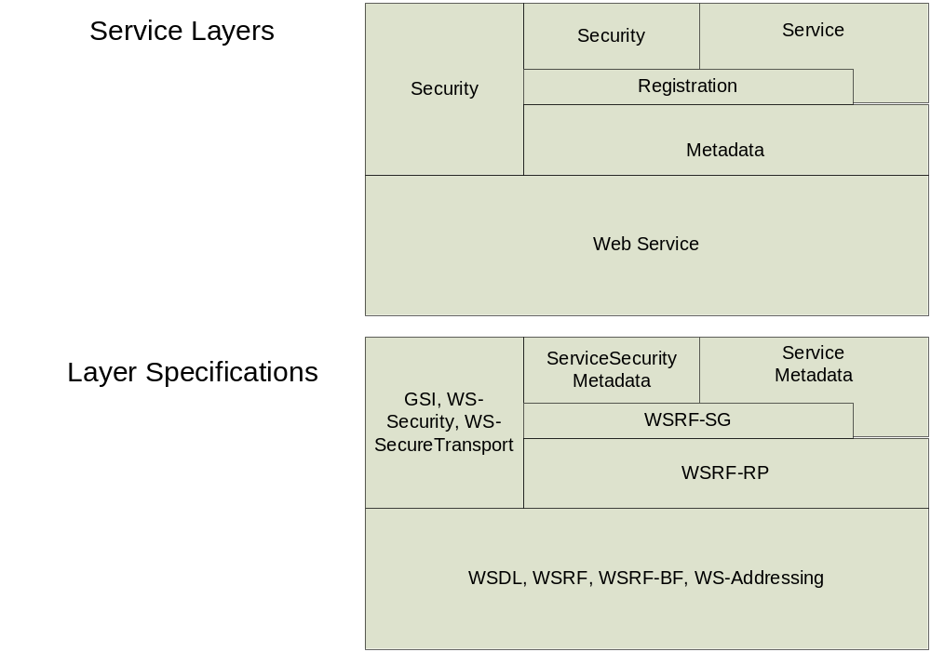

Base Service Specification
caGrid services must comply with standard grid services which are described by the specifications accompanying the WSDL/WSRF standards. All caGrid services also must meet the extensions put forth by the caGrid architecture. This document will describe these added requirements as a specification.

caGrid Service Metadata
caGrid services are required to provide two metadata elements that must be added to the Resource Properties (WSRF-RP) of the PortType(WSDL) and registered to a caGrid index service using the WSRF-SG specification.

…
<element name="HelloWorldResourceProperties" xmlns:ns0="gme://caGrid.caBIG/1.0/gov.nih.nci.cagrid.metadata.security" xmlns:ns1="gme://caGrid.caBIG/1.0/gov.nih.nci.cagrid.metadata">
<complexType>
<sequence>
<element ref="ns0:ServiceSecurityMetadata" minOccurs="1" maxOccurs="1" />
<element ref="ns1:ServiceMetadata" minOccurs="1" maxOccurs="1" />
</sequence>
</complexType>
</element>
…
<portType name="HelloWorldPortType" wsrp:ResourceProperties="HelloWorldResourceProperties" xmlns:wsrp=http://docs.oasis-open.org/wsrf/2004/06/wsrf-WS-ResourceProperties-1.2-draft-01.wsdl”>
</portType>
…

Service Metadata
The service is required to provide service metadata which is compliant with following schema:
http://gforge.nci.nih.gov/plugins/scmcvs/cvsweb.php/cagrid-1-0/caGrid/projects/metadata/schema/cagrid/types/caGridMetadata.xsd?f=u&only_with_tag=caGrid-1_0_release&logsort=date&cvsroot=cagrid-1-0

The service metadata element ServiceMetadata must be provided by the service as a resource property following the WSRF-RP specification. caGrid standard service metadata is used to enable a common discovery mechanisms throughout all services in the caGrid. This metadata is used to describe information about the service provider and the service structure, operations, semantic information about data types as well as other information which may be used for discovering a service.

Security Metadata
The service is required to provide security metadata which is compliant with the following schema:
http://gforge.nci.nih.gov/plugins/scmcvs/cvsweb.php/cagrid-1-0/caGrid/projects/metadata/schema/cagrid/types/security/security.xsd?f=u&only_with_tag=caGrid-1_0_release&logsort=date&cvsroot=cagrid-1-0

The security metadata element ServiceSecurityMetadata must be provided by the service as a resource property following the WSRF-RP specification. This resource property can be accessed by a client in order to determine what the security requirements are defaulted on the service or on a particular method. This will enable the client to configure the connection for operation invocation so the access to the service can be made according to the requirements of the service.

Metadata Registration
The service must be able to register its service and security metadata to the caGrid Index service according to the WSRF-SG specification. This metadata must be re-published at an interval equal to 10 minutes. An example of the Service Group Registration content that is used is below:

<Content xsi:type="agg:AggregatorContent" xmlns:agg="http://mds.globus.org/aggregator/types">
<agg:AggregatorConfig xsi:type="agg:AggregatorConfig">
<agg:GetMultipleResourcePropertiesPollType
xmlns:ns0="http://helloworld.cagrid.nci.nih.gov/HelloWorld/types"
xmlns:ns2="gme://caGrid.caBIG/1.0/gov.nih.nci.cagrid.metadata"
xmlns:xs="http://www.w3.org/2001/XMLSchema"
xmlns:ns1="gme://caGrid.caBIG/1.0/gov.nih.nci.cagrid.metadata.security">
<!-- Specifies that the index should refresh information
every 300000 milliseconds (once every 5 minutes) -->
<agg:PollIntervalMillis>300000</agg:PollIntervalMillis>
<!-- specifies all properties that should be retrieved from the service -->
<agg:ResourcePropertyNames>ns2:ServiceMetadata</agg:ResourcePropertyNames>
<agg:ResourcePropertyNames>ns0:ServiceSecurityMetadata</agg:ResourcePropertyNames>
</agg:GetMultipleResourcePropertiesPollType>
</agg:AggregatorConfig>
<agg:AggregatorData/>
</Content>

The ServiceSecurityMetadata does not have to be registered to the index service if the service adds provides the implementation of the {http://security.introduce.cagrid.nci.nih.gov/ServiceSecurity}getServiceSecurityMetadata operation to their PortType. This operation will be discussed further in the following section.

caGrid Service Security
caGrid services must support the WS-SecureConversation and related specifications. The WS-SecureConversation specification will enable each caGrid service to provide a series of soap based extensions which will enable protection through the use of security tokens.

Service Security Metadata Access:
Access to the services security metadata, as described by the ServiceSecurityMetadata element, can be made available in two ways, either published as metadata to the caGrid index service, or available through a method call. If this data will be available through a grid service method call the service must implement the method getServiceSecurityMetadata as described by the ServiceSecurity WSDL:
http://gforge.nci.nih.gov/plugins/scmcvs/cvsweb.php/cagrid-1-0/caGrid/projects/service-security-provider/schema/ServiceSecurity/ServiceSecurity.wsdl?f=u&only_with_tag=caGrid-1_0_release&logsort=date&cvsroot=cagrid-1-0

Data Service Specification
Any caGrid Data Service must comply with the Base Service Specification as well as the following data service specification additions.

Operations
All caGrid Data Services must implement a single query operation of the type {http://gov.nih.nci.cagrid.data/DataService }query in their PortType. This method is described by the data service WSDL: http://gforge.nci.nih.gov/plugins/scmcvs/cvsweb.php/cagrid-1-0/caGrid/projects/data/schema/Data/DataService.wsdl?cvsroot=cagrid-1-0;only_with_tag=caGrid-1_0_release
This method is responsible for performing any operations on the backend data resource required to locate the data requested by the incoming CQL query and return those results.

Metadata
All caGrid Data Services expose a Domain Model as metadata describing the valid query space for the data service. Domain Models are defined by {gme://caGrid.caBIG/1.0/gov.nih.nci.cagrid.metadata.dataservice}DomainModel. The schema for this type is available: http://gforge.nci.nih.gov/plugins/scmcvs/cvsweb.php/cagrid-1-0/caGrid/projects/metadata/schema/cagrid/types/data/data.xsd?cvsroot=cagrid-1-0;only_with_tag=caGrid-1_0_release
A domain model may be any subset of a data service’s full data object model which the service developer wishes to expose to the grid. If domain model validation is enabled on the default data service implementation, queries which do not fit within this subset will be rejected.

