Data Service Tutorial using caCORE SDK

Overview
This tutorial will explain the steps required to set up a simple grid service using the Data Service extension and caCORE SDK data source in Introduce. The caGrid data service will be set up using the help of the caCORE SDK wizard, deployed to a Tomcat container, and invoked as a test on the service. The sample service will use the caCORE SDK query processor provided with caGrid 1.0 to request Gene data types meeting certain criteria. These values, once returned, will be output to the command line.

The following is an outline of the tutorial:
- Create a new grid service with the Data Service Extension
- Use the caCORE SDK Wizard
- Implement the Grid Service Client
- Deploy the Grid Service
- Test the Grid Service

A. Create a new Grid Service with the Data Service Extension
In this section, a new grid service will be set up using the Introduce toolkit. The new service will be created with the Data Service extension using the caCORE SDK Wizard.

  - Launch the Introduce Grid Service Authoring Toolkit.
  - Select Create caBIG Service from the toolbar or select Tools->Create caBIG Service from the menu. The Create caBIG Grid Service screen will appear. See Figure 1 below.
  - Choose a directory in which to place the generated service. This tutorial will use “C:\DataServiceSDKTutorial”.
  - Type in the Service Name. This tutorial will use “DataServiceSDKTutorial”.
  - Choose a Package Name. This tutorial will use “osu.lib.datadervicesdktutorial”.
  - Choose a Namespace. This tutorial will use “http://dataservicetutorial.osu.lib/DataServiceTutorial”.

  - Select the Data Service radio button from the Customize Service section.
  - Click the Create button located at the bottom of the creation screen.
  - In the configuration dialog that appears, select the caCORE SDK Data Source radio button and select OK.
  - Be patient while Introduce creates the service. This may take a few minutes.

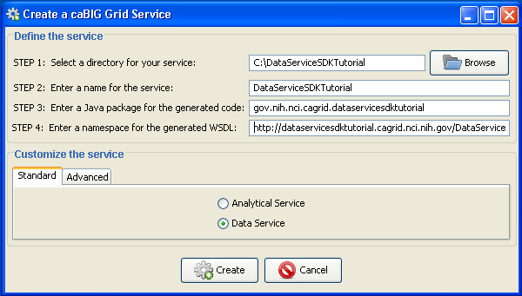
Figure 1: Create caBIG Grid Service dialog

B. Using the caCORE SDK Wizard
The caCORE wizard will step through a five pages to enter information about the grid service. Once complete, the service will be fully ready to be deployed and tested. After selecting the caCORE SDK Data Source option, A dialog will appear explaining the five steps of the wizard. See Figure 2 below.
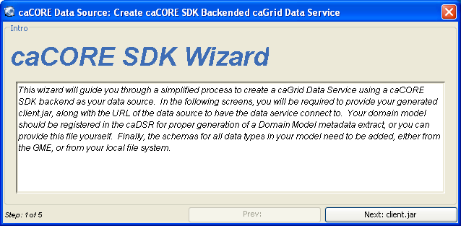
Figure 2: caCORE SDK Wizard, step 1
- Click the Next: client.jar button to continue to the next step of the wizard.
- The second step of the wizard is where jar files are added to the Data Service. Click the Add Jars button to open a file dialog. Find the client.jar file generated by the caCORE SDK and click open to add it to the list. See Figure 3.
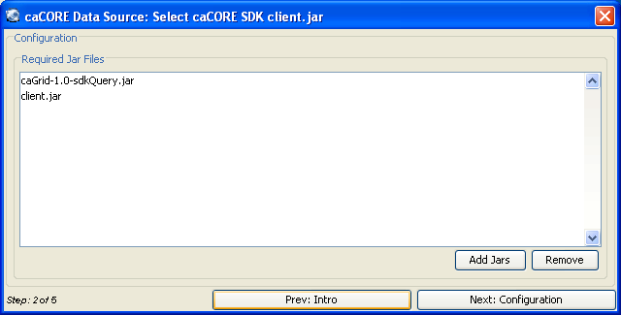
Figure 3: caCORE SDK Wizard, step 2

- The third page of the wizard specifies the configuration options for the caCORE SDK data source. The first of these options is the service URL for the data source application. For this tutorial enter http://cabio.nci.nih.gov/cacore31/http/remoteService in the Service URL textbox. This URL is that of the NCI’s caBIO data source. The Case Insensitive Queries option is for data services which have a backend that might require queries to be performed without regard to case. Leave this option off for now. This page also allows CSM Security to be enabled and the CSM Context Name changed if necessary. This tutorial will not be using CSM Security. See Figure 4.
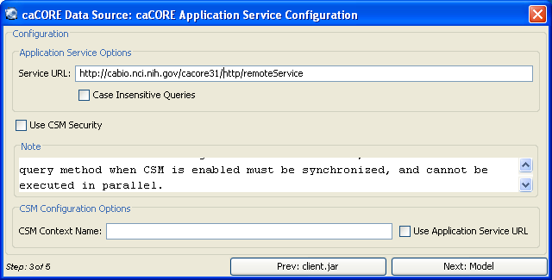
Figure 4: caCORE Wizard, step 3

- The fourth page of the wizard is used to select the Domain Model. In this tutorial, the domain model will be loaded from a file. Select the “Domain Model from File” radio button and click the browse button on the right to navigate to the domain model file provided with this tutorial. See figure 5.
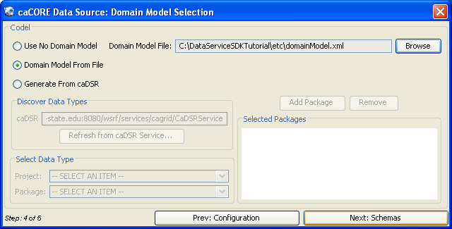
Figure 5: caCORE Wizard, step 4
- In the fifth step, the caBIO schema needs to be resolved manually to the file provided with the tutorial. Click the “Resolve” button for the caBIO package to open the Schema Resolution Dialog. In the dialog select the “browse” button under the File System tab and select the caBIO schema file provided with the tutorial. Then click Load Schemas to close the dialog, and click Done to finish the wizard. See figures 6 & 7.
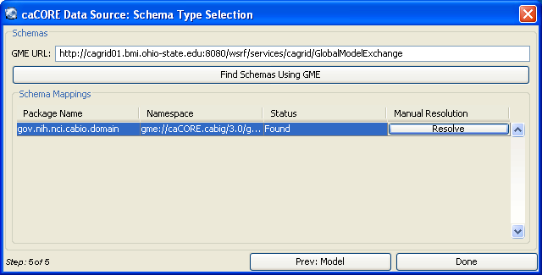
Figure 6: caCORE Wizard, step 5

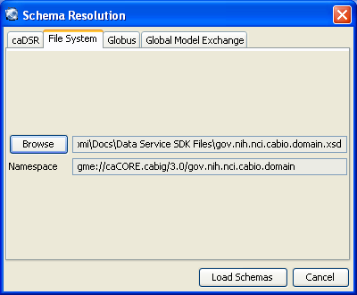
Figure 7: Schema Resolution Dialog

C. Implement the Grid Service Client

This part of the tutorial will implement the actions of the client to invoke the Data Service we created earlier in this tutorial. To do this, some code will be added to the DataServiceSDKTutorialClient.java file to query the data service and output the results for verification.

- Open the file DataServiceSDKTutorialClient.java located in the folder C:\DataServiceSDKTutorial\src\gov\nih\nci\cagrid\dataservicesdktutorial\client\. Replace the contents of the method main with the code below:
System.out.println("Running the Grid Service Client");
try{
if(!(args.length < 2)){
if(args[0].equals("-url")){
DataServiceSDKTutorialClient client =
new DataServiceSDKTutorialClient(args[1]);
gov.nih.nci.cagrid.cqlquery.CQLQuery query =
new gov.nih.nci.cagrid.cqlquery.CQLQuery();
gov.nih.nci.cagrid.cqlquery.Object target =
new gov.nih.nci.cagrid.cqlquery.Object();
target.setName(gov.nih.nci.cabio.domain.Gene.class.getName());
gov.nih.nci.cagrid.cqlquery.Attribute att =
new gov.nih.nci.cagrid.cqlquery.Attribute();
att.setName("symbol");
att.setValue("BRCA%");
att.setPredicate(gov.nih.nci.cagrid.cqlquery.Predicate.LIKE);
target.setAttribute(att);
query.setTarget(target);
gov.nih.nci.cagrid.cqlresultset.CQLQueryResults results =
client.query(query);
java.util.Iterator iter = new
gov.nih.nci.cagrid.data.utilities.CQLQueryResultsIterator(
results,
DataServiceSDKTutorialClient.class.getResourceAsStream(
"client-config.wsdd"));
while (iter.hasNext()) {
Object o = iter.next();
System.out.println(
((gov.nih.nci.cabio.domain.Gene) o).getFullName());
}
System.out.println("Query Complete.");

} else {
usage();
System.exit(1);
}
} else {
usage();
System.exit(1);
}
} catch (Exception e) {
e.printStackTrace();
System.exit(1);
}
- Save DataServiceSDKTutorialClient.java

D. Deploy the Grid Service
A grid service may be deployed to either a Globus or a Tomcat container. In this tutorial, Tomcat will be used.
- Open a Command prompt and change the directory to C:\DataServiceSDKTutorial
- Compile the grid service with the command: ant all
- Verify that the command resulted in a Build Successful message.
- Deploy the grid service to Tocat with the command: ant deployTomcat

Note: To deploy to a Globus container, simply replace the command deployTomcat with deployGlobus.

E. Test the Grid Service
Now that the service has been deployed to the Tomcat directory, the service may be invoked. An ant script located in the grid service directory will run the client and invoke the service.

- Using a command prompt, change to the Catalina Home directory. Do this by entering cd %CATALINA_HOME%.
- Now enter bin/startup.bat to start the Tomcat server. Wait for a new Tomcat console window to appear and finish loading Tomcat.
- Now, at the original command prompt, change directories to C:\DataServiceSDKTutorial\ and enter the command: ant runClient.
- The result of the run should produce the following output:

C:\DataServiceSDKTutorial>ant runClient
Buildfile: build.xml

setGlobus:

checkGlobus:
[echo] Globus: C:\progs\Globus

defineClasspaths:

runClient:
[echo] Connecting to service: http://localhost:8080/wsrf/services/cagrid/Da
taServiceSDKTutorial
[java] JVM args ignored when same JVM is used.
[java] Running the Grid Service Client
[java] Breast cancer 2, early onset
[java] Breast cancer 1, early onset
[java] Query Complete.

BUILD SUCCESSFUL

