caBIO and caArray Grid Services
Design Document

Version No: 0.1
Last Modified: 08/23/2006

Author : Joshua Phillips
Team : caGrid

Client : National Cancer Institute - Center for Bioinformatics,
National Institutes of Health,
US Department of Health and Human Services

Document History

Document Location
The most current version of this document is located in CVS under security/docs.

Revision History
Version Number | Revision Date | Author | Summary of Changes
0.1 | 08/23/06 | Joshua Phillips | Initial draft

Review
Name | Team/Role | Version | Date Reviewed | Reviewer Comments

Related Documents
More information can be found in the following related CSM documents:
Document Name

Table of Contents
1. Introduction 4
1.1 Purpose 4
1.2 Scope 4
2. Use case Scenarios 4
3. Logical design 5
3.1.1 caGrid Service Layer 6
3.1.2 caCORE Service Layer 6
3.2 Class diagram 6
4. Deployment 7
5. Test Cases 7
5.1 caBIO Test Case 7
5.2 caArray Test Case 7

caBIO and caArray Grid Services Design

Introduction
The NCICB’s caCORE is a set of tools, systems, and frameworks designed to assist cancer informatics development. caBIO is a component of caCORE that provides programmatic access to genomic, biological, and clinical trials data that is gathered by the NCICB. The caCORE SDK is another component of caCORE that enables developers to generate caBIO-like systems using a model-driven approach.
Cancer Array Informatics (caArray) is a cancer array informatics project that provides a MIAME-compliant microarray database and microarray data analysis tools. The caCORE SDK was used to generate a caBIO-like system.
The cancer Biomedical Informatics Grid or caBIG™, is an informatics infrastructure based on grid architecture. The architectural and software realization of caBIG has been done through caGrid project. caGrid infrastructure makes it easy for developers to develop data and analytical services. Using caGrid infrastructure, organizations will be able to share their data and services on the grid.
The end-product of the “caBIO and caArray Grid Services” task will be two caGrid services which will enable the rest of the grid to access data and services provided by caBIO and caArray.

Purpose
The purpose of this document is to describe how caGrid tools and infrastructure will be used to implement caGrid services for caBIO and caArray.

Scope
This document will identify different component and their responsibilities. The scope is limited to provide specifics of the design of caBIO and caArray caGrid services only.

Use case Scenarios
The following diagram shows the use cases and actors.

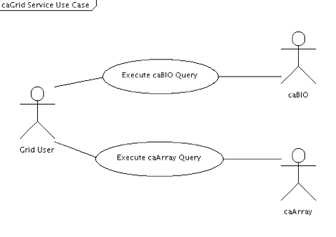

2. 1 Actors
- Grid User: Any entity on caGrid that is capable of generating CQL queries.
- caBIO: Any caBIO instance.
- caArray: Any caArray instance.

2.2 Basic Flows
- Flow #1:
  - Grid User executes a query against caBIO.
  - caBIO returns serialized objects or an error message.

- Flow #2:
  - Grid User executes a query against caArray.
  - caBIO returns serialized objects or an error message.

2.3 Assumptions
Authentication and authorization will not be addressed. So, only public data will be available for query.

Logical design
Following are the logical layers within which the caBIO and caArray caGrid services will operate.
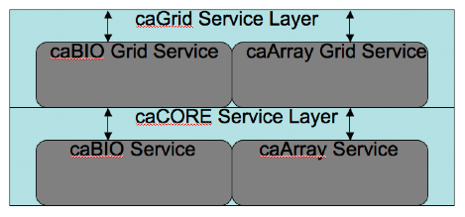
credential
credential
credential
attributes
SAML
SAML
Identity provider Layer
Login Module Layer
credential provider Layer

caGrid Service Layer
The caBIO and caArray grid services accept CQL queries from grid users, translate them to HQL queries and execute those queries against a caBIO or caArray service in the caCORE Service Layer.

caCORE Service Layer
The caBIO and caArray caCORE services execute queries against their respective data sources and return the results.

Class diagram
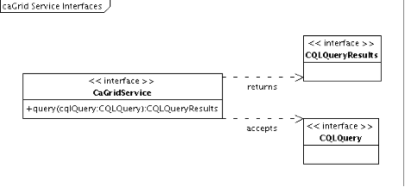

It is likely that the caGrid Introduce tool will be used to generate the implementations of both the caBIO and caArray grid services. Additionally, the sdkQuery component will probably be used to translate CQL queries into HQL queries and interact with the caBIO and caArray caCORE services.
In the class diagram above, the CaGridService represents the interface that must by implemented by the caBIO and caArray grid services according to the caGrid framework for caCORE SDK-generated Data Services.

Deployment
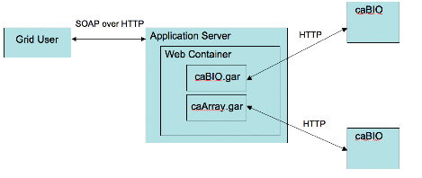

Both the caBIO and caArray grid services run within a container such as Tomcat or the Globus container. They need not run within the same container, of course. SOAP messages sent of HTTP are processed and unmarshalled into Java objects (CQLQuery), which are processed by the grid services. HQL queries are sent to caBIO and caArray services using Java object serialization over HTTP.

Test Cases

caBIO Test Case
- Execute caBIO query through caBIO grid service.
- Execute caBIO query through caBIO service.
- Check that results are equivalent.

caArray Test Case
- Execute caArray query through caArray grid service.
- Execute caArray query through caArray service.
- Check that results are equivalent.

