Bulk Data Transfer Specification
Shannon Hastings
8-14-06

Possible Usage Scenario:

User calls queryWithBulkTransfer(CQLQuery query) on the service. The data service will make the query, create a BDTResource to represent the results of the query, and return back an EPR to a BulkDataTransferService, which is a composition of interfaces representing the different available transfer mechanisms. The user will then be able to make the appropriate calls on the desired 3rd party transfer interface to the bulk data transfer interface. This service side implementation of this interface will use the results resource which was created in order to locate and transfer the data.

Overall Architecture:
Any service which desires to utilize the bulk data transfer service will be required to provide the BDTMetadata. This metadata will describe the methods which provide BDT services for transferring results. The metadata will also describe the available transfer mechanisms. The service must also be able to generate BDTResultsResource’s for each call to any method which is enabling BDT. Any of these methods must return an EPR to the BDTService which will be able to use that resource and properly handle the transferring of the results.

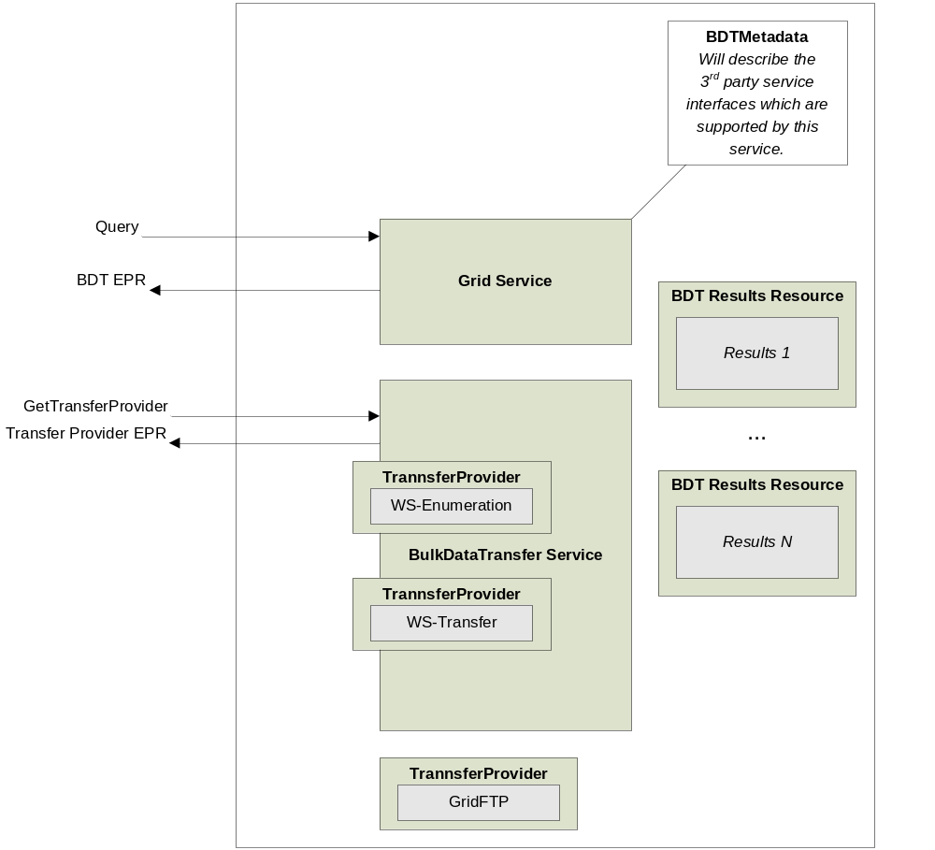
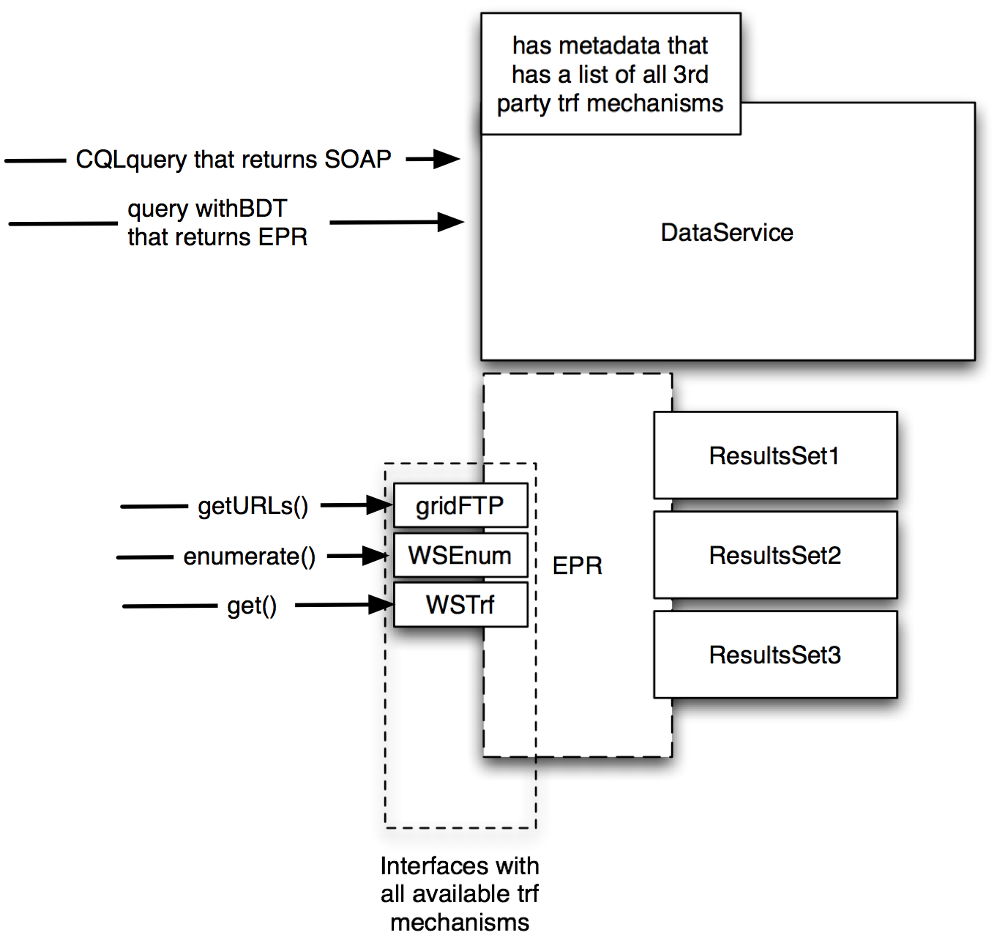

BDTMetadata:

The BDTMetadata, as described above, will accompany any service which has the ability to return BDTService EPRs. The BDTMetadata will describe the available 3rd party transfer capabilities available in the BDTService.

BDTResultsResource:

The BDTResultsResource will be the container class responsible for maintaining information about the results set, how to retrieve it, and what has been transferred. This resource must be created anytime an operation is called which can return a BDTService EPR.

