GAARDS Security Infrastructure

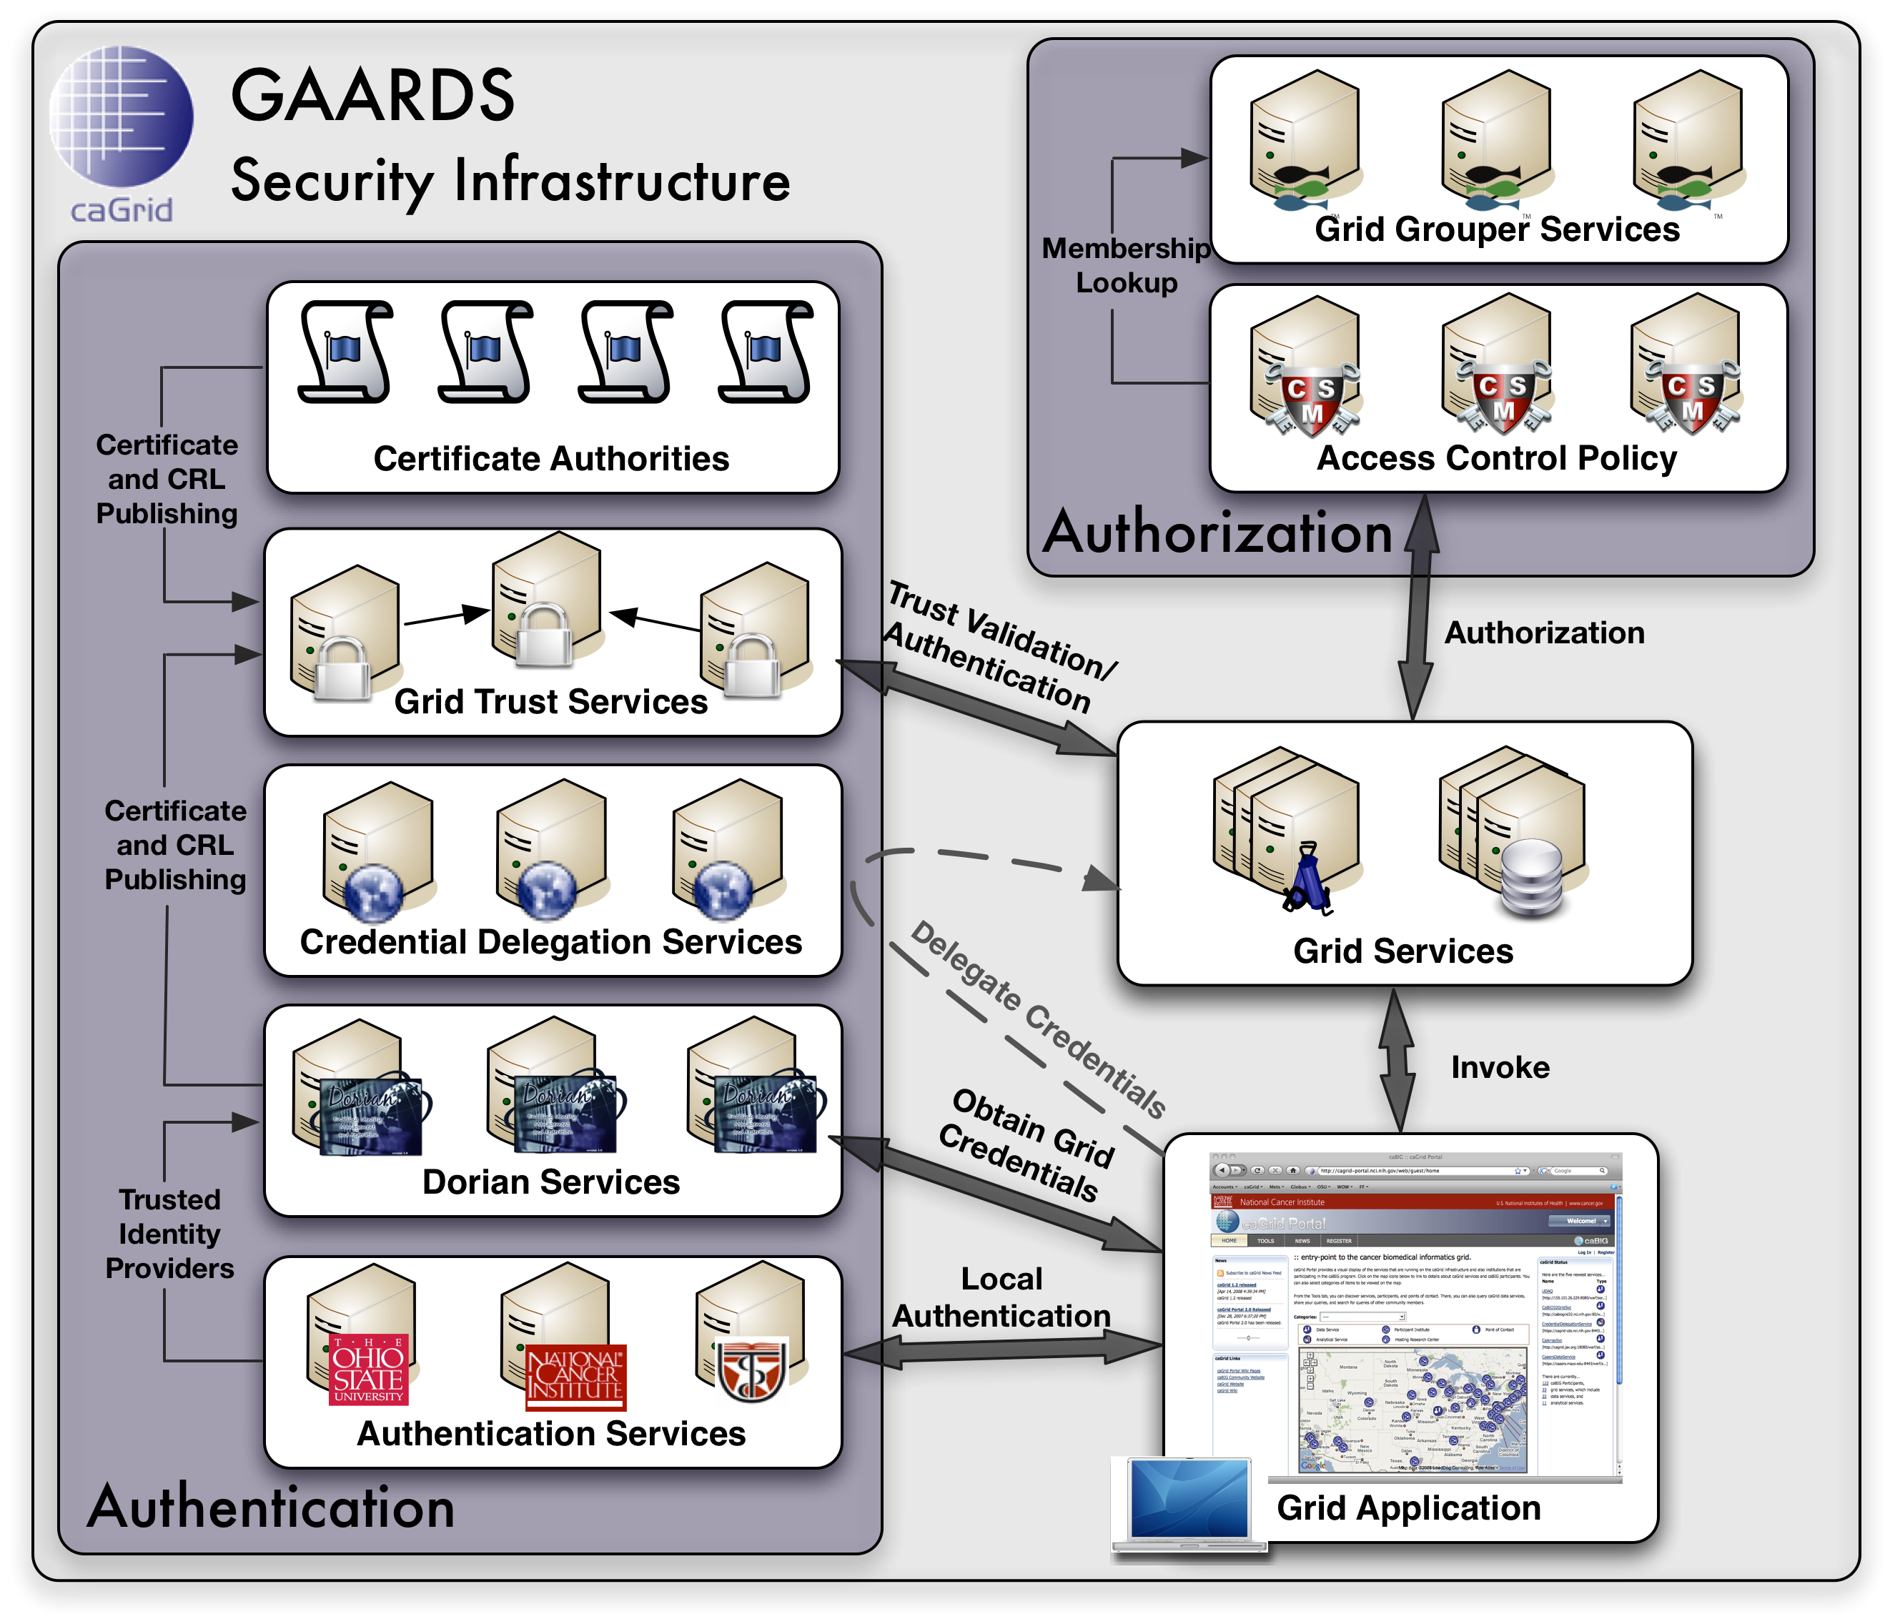
The Grid Authentication and Authorization with Reliably Distributed Services (GAARDS) provides services and tools for the administration and enforcement of security policy in an enterprise Grid. GAARDS was developed on top of the Globus Toolkit to provide enterprise services and administrative tools for: 1) Grid account management, 2) identity federation, 3) trust management, 4) credential delegation, 5) group/VO management, 6) access control policy management and enforcement, and 7) Integration between existing security domains and the grid security domain. GAARDS services can be used individually or grouped together to meet the authentication and authorization needs for Grids. Below is a list of some of the core services provided by GAARDS:

Dorian – A grid service for the provisioning and management of grid users accounts. Dorian provides an integration point between external security domains and the grid, allowing accounts managed in external domains to be federated and managed in the grid. Dorian allows users to use their existing credentials (external to the grid) to authenticate to the grid.

Authentication Service – Provides a framework for integrating existing credential providers into the grid under a standardized grid service interface, providing applications with a unified approach to communicating with credential providers.

Grid Trust Service (GTS) - The Grid Trust Service (GTS) is a grid-wide mechanism for maintaining and provisioning a federated trust fabric consisting of trusted certificate authorities, such that grid services may make authentication decisions against the most up to date information.

Grid Grouper - Provides a group-based authorization solution for the Grid, wherein grid services and applications enforce authorization policy based on membership to groups defined and managed at the grid level.

Credential Delegation Service (CDS) - A WSRF-compliant Grid service that enables users/services (delegators) to delegate their Grid credentials to other users/services (delegatees) such that the delegatee(s) may act on the delegator's behalf.

Web Single Sign-On - Provides a comprehensive, Single Sign On solution for web applications. WebSSO integrates with the GAARDS infrastructure allowing web applications to interact with secure Grid resources on behalf of the user that is logged on.

