To do:
Add text for extension ach
Add text for mutli service multi resource support
Add text for wsdl/method importing/inheritance

Introduce: An Open Source Toolkit for Rapid Development of Strongly-Typed Grid Services.

Shannon Hastings, Scott Oster, Stephen Langella, Tahsin Kurc, Joel Saltz
The Ohio State University Department of Biomedical Informatics
{hastings,oster,langella,kurc,saltz}@bmi.osu.edu

Abstract

In recent years, service-oriented architectures (OGSA and WSRF), standards, and applications have gained acceptance in the Grid computing community. A number of tools and middleware systems have been developed to support Grid Services based application development. Most of these tooling efforts, however, have focused on the core, low-level support for management and execution of Grid services, management of Grid-enabled resources, and deployment and execution of applications that make use of Grid services. As the Grid Services technology is being applied in a larger class of application domains, higher-level, simple-to-use tools, which will allow a Grid service developer to leverage Grid technologies without needing to know low-level details, are becoming increasingly important. Moreover, support for development of strongly-typed services, in which data types consumed and produced by a service are well-defined and published in the Grid, is necessary to enable syntactic interoperability so that two Grid endpoints (e.g., two services, or a client and a service) can interact with each other programmatically and correctly. Enabling strongly typed grid services while lowering the cost of entry to the Grid will have a major impact to the success of the Grid and its wider adoption as a viable technology of choice, not only in the commercial sector, but also in other areas such as academic, medical, and government research. In this paper, we describe the design and implementation of a toolkit, called Introduce, to support easy development and deployment of Grid services. Introduce aims to reduce the service development and deployment effort by hiding low level details of the Globus Toolkit and to enable the implementation of strongly-typed Grid services.

Introduction
Grid computing is quickly becoming the new means for creating distributed infrastructures and virtual organizations for collaborative, multi-institutional research and enterprise applications. Since its inception, the Grid has evolved from being a platform targeted at large-scale computing applications to a new architecture paradigm for sharing information, data, and software tools as well as computational and storage resources. It has been applied in a wide range of application domains ranging from high energy physics to earth systems sciences to biomedical research.
A vast array of middleware systems and tools have been developed to support applications in the Grid. These include middleware and toolkits for application deployment, security (authentication, authorization, and secure communication), remote resource invocation, resource monitoring and scheduling, and workflow management. Earlier tool development efforts, however, focused on providing the core functionality needed by applications to use the Grid environment. As the number of Grid-enabled resources and applications has increased, interoperability has become a major concern. Interoperability is important since applications and resources are heterogeneous, oftentimes deployed and managed autonomously in the Grid, and programmatic access to resources is desired. The need for mechanisms to facilitate interoperability has led to architecture and standardization efforts by several groups, most notably by the Global Grid Forum, which includes both academic researchers and corporate IT leaders.
In the past several years through a community effort (coordinated via the Global Grid Forum and Oasis), the Open Grid Services Architecture (OGSA) has been developed. OGSA presents a service-oriented view of the Grid and implements Grid services standards. These standards adapt and extend Web Services standards for scientific applications. They define mechanisms and guidelines for such additional features as stateful services, service notification, and management of service lifetime. The OGSA effort has evolved into the Web Services Resource Framework (WSRF) standardization, paving the way for closer interoperability and unification between stateful Grid services and Web services.
With the emergence of Grid services framework and standards, we are observing the development of new tools and the adaptation of exiting tools to leverage the standards in application development and deployment. The most widely used reference implementation of the core OGSA and WSRF functionality is the Globus Toolkit (GT); GT 3.2 and GT 4.0, respectively. The GT enables Grid architects to create Grids using standard building blocks. The toolkit also implements support for creation, deployment, and invocation of Grid services, and provides runtime support for common services such as an Index service for service registration and discovery and Globus Security Infrastructure (GSI) for security. These core components enable service providers to stand up Grid services, register them, discover them, and secure them.
The basic services and technologies provided in the GT facilitate the creation of complex grid service. However, creating Grid services using the GT requires a vast knowledge of Grid Services technologies and of the details of the toolkit. We argue that additional tools are needed to enable greater levels of service-to-service interoperability and to reduce the development time and knowledge required to stand up grid services so that the benefits of Grid computing can be harvested easily and quickly by those adopting the Grid as a technology.
In this paper, we present the design and implementation of a toolkit, called Introduce, that provides support for development and deployment of strongly-typed, secure Grid services. The current implementation of Introduce uses the Globus Toolkit as the underlying core Grid infrastructure and the Mobius framework to support strongly-typed Grid service development. The toolkit aims to reduce the time and knowledge required to stand up Grid services while increasing the interoperability between the services in the grid environment. The salient features of Introduce are as follows:
- It provides higher-level functions and graphical user interface that encapsulate and hide away the common complexities and low level command-line tools of the GT for generating a suitable service layout. These include client and server wrappers to encapsulate the “boxed” grid service calls, functions to create configurable service properties, functions to specify resource properties and register metadata, functions to describe the security requirements of the operations or the service, and support to deploy to commonly used grid service containers. The developer can create and modify Grid service interfaces using a graphical user interface (GUI). Not only can developers use the GUI to create their service, they can also write their own service description documents which the Introduce toolkit can use to create the service programmatically.
- It enables development of strongly-typed services. A strongly-typed service is one whose methods take as input and return as output data structures that are registered and published in the Grid environment. The use of these publicly published types enables others to create compatible and interoperable grid services without needing to communicate with other grid service developers.
- It allows for implementation of secure services. It provides support for service developers to optionally turn on authentication and authorization support for individual service methods as well as the entire service itself.
- It manages all the service-specific files and directories required by the GT for correct compilation and deployment. It also generates appropriate, object-oriented client APIs which can be used by client programs to interact with the service.

We believe the availability of tools like Introduce will greatly impact the efficacy of using the Grid in fields where grid style architectures is a great change to the everyday development of management of data and analytical services.

Motivation
The need for the Introduce toolkit is mainly motivated by the caBIG (cancer Biomedical Informatics Grid) program, funded by the National Cancer Institute (NCI). The goal of this program is to implement a nationwide cancer research network in order to significantly enhance basic and clinical research on the cancer disease. This large scale effort is using the Grid Services technology as the underlying infrastructure and motivates the needs for easy development and deployment of strongly-typed, secure services.

Easy Development and Deployment of Secure Grid Services

The principle idea in caBIG is to create software infrastructure, common applications, standards, and data and analytical resources to leverage combined strengths of individual cancer centers and research labs. In the caBIG effort, a core Grid infrastructure, called caGrid, is being developed to support the development and deployment of Grid-enabled applications in order to facilitate sharing of data and analytical resources. The infrastructure is designed as a service-oriented system, building on the WSRF standards. The most widely deployed reference implementation of the WSRF standard is the Globus Toolkit (GT). The GT is hence employed as the Grid middleware backbone and runtime environment in caGrid.
caBIG is envisioned to span several hundreds of institutions and possibly thousands of investigator and research laboratories. These institutions may host information technology infrastructures of different complexity and maturity and consist of users and application developers with varying levels of understanding of distributed systems and the Grid. Thus, one of the goals of caGrid is to provide tools to make it easier for institutions and laboratories to get on the Grid without requiring a great deal of knowledge of the Grid technologies. The GT provides support for core runtime services and tools for developing and deploying Grid services. However, these are low level tools, requiring service developers to understand the details of the GT and how and in what order the tools should be invoked, and to keep track of several files that are required for successful compilation and deployment of services. The Introduce toolkit aims to make it easy for a service developer to execute the various steps of the service development and deployment tools provided by the GT and to manage the necessary directories and files. It abstracts away the details of invoking the various tools so that the developer the developer is freed up to concentrate on the details of implementing his/her domain-specific code.
Security is also a required component both for protecting intellectual property and to ensure protection and privacy of patient related information. In caBIG, a service provider should be able to enforce secure and controlled access to resources based on policies set forth by the owners of the resources. Introduce allows a service developer to configure the service as a secure service. This enables the service to interact with Grid-wide user and attribute management services and local authorization systems for secure communication, authentication, and authorization.

Strongly-Typed Service Development

The caBIG effort also aims to enable syntactic and semantic interoperability across data and analytical resources. The OGSA and WSRF frameworks enable interoperability by defining standards for data and information exchange protocols, service creation and management, and service invocation. In the Grid environment, syntactic and semantic interoperability is also important, when data is exchanged between disparate groups of data providers and consumers. It is critical to ensure that resources can be accessed programmatically in a unified way and the information served by a resource can be interpreted correctly. In the Mobius project, we introduced the notion of strongly-typed services in the context of virtualization of data sources to enable syntactic interoperability. The Mobius framework provides tools and services for coordinated management of XML schemas; a schema defines the data types and structure of a data object. We refer to a service as strongly-typed service, if the input and output parameters of the service methods conform to schemas, which are well-defined and published in the Grid environment. Similarly, in caBIG, syntactic and semantic interoperability is accomplished through coordinated management of metadata and well-defined objects, which are exchanged between entities (i.e., clients and services) in the environment. The structure of a registered object is represented by a registered and published XML schema. The objects are exchanged between two end points in the Grid as XML documents conforming to the corresponding schema.
In addition to providing an easy-to-use environment, Introduce enables the developer to implement strongly-typed services. It provides the required support using the Mobius Global Model Exchange service.

Related Work
Talk about CoG kits, the paper “A user-friendly platform for developing grid services over globus toolkit 3”, the paper “Automation of Grid Service Code Generation with AndroMDA for GT3”, the IBM Grid toolbox, the globus toolkit plug-in for eclipse., WSRF .NET environment, and the Gridbus infrastructure.

Also talk about PSEs that support application development through service composition. Portals and portal toolkits.

Introduce Toolkit
The Introduce toolkit is designed to support service development in four main phases. 1) Creation of Basic Service Structure: The service developer describes at the highest level some basic attributes about the service and the Introduce creation engine generates the most basic service implementation, to which the developer can then add application-specific methods and security options (see Figure VVV). 2) Service Modification. After the service has been created, the developer can modify the service. The modification phase allows the developer to add, remove, and modify service methods. In this phase, the developer creates strongly-typed service interfaces using well-defined, published schemas, which are registered in a system like the Mobius GME, as the type definitions of the input and output parameters of the service interfaces (see Figure DDD). 3) Configuring Service Security. In this optional phase, the developer can configure service and method level security so that authentication and authorization can be enforced when the service is accessed (see Figure DDD). 4) Deployment. The developer can deploy the service which has been created with Introduce to a grid service container such as a Globus or Tomcat service container.
These four phases are supported in four major components in the toolkit: the Graphical Development Environment (GDE), Service Creator, Service Synchronizer, and Service Deployer. In the following sections, we describe these components in greater detail.

External Middleware Systems and Tools

The toolkit assumes the availability of three external components to implement its functionality. 1) A Grid compilation and runtime environment that will provide the support for compiling, advertising, and deploying the services developed; 2) A repository of data types that is accessible remotely so that the toolkit can pull the common data types for strongly-typed services; and 3) Grid-wide user and attribute management to support authentication and authorization at the service and method level. The current implementation of Introduce leverages several open source middleware systems such as the Globus Toolkit, the Mobius GME service, and Dorian to implement the functionality provided by its four main components. However, it is designed as a modular system, where the specific implementations of external components can be replaced.
The Globus Toolkit implements the core Grid runtime functionality. It provides support for secure communication, certificate based security, service advertisement and discovery, service instantiation and management, and service invocation. The Introduce toolkit uses the GT as the underlying Grid runtime environment. It generates the service layout, the service description (WSDL), and the service files such that they are compliant with the GT and can be readily deployed.
The Mobius Global Model Exchange (GME) is one of the core services provided in the Mobius framework. It implements support for coordinated management of XML schemas in a distributed environment. In GME, all schemas are registered under namespaces and can be versioned. A schema can be a new schema, or can contain pointers to other registered schemas and the attributes of schemas, or can be generated by versioning an existing schema (e.g., by adding or deleting attributes). The concept of versioning schemas is formalized in GME; any change to a schema is reflected as either a new version of the schema or a totally new schema under a different name or namespace. In this way, data types can evolve while allowing clients and services to make use of old versions of the data type, if necessary. Namespaces enable distributed and hierarchical management of schemas; two groups can create and manage schemas under different namespaces without worrying about affecting each other’s services, clients, and programs. In the Grid environment, data elements and objects are exchanged as XML documents conforming to a schema. In such a setting, the schema describes the structure of a simple or complex data element (data object) that is consumed or produced by a service and is exchanged between two endpoints in the environment. Introduce uses the Mobius GME service as a repository of XML schemas to support the development of strongly-typed services.
ADD TEXT ON DORIAN.

Graphical Development Environment (GDE)

The Introduce GDE is the graphical user interface that can be used to create a new service, modify an existing one, and deploy a finished one. It is designed to be very simple to use, enable using community excepted data types, and provide easy configuration of service metadata, operations, and security. It also is an extensible framework enabling customized plug-ins to be added for such things as repositories of data types and for creating common service types. The interface contains several screens and options for the developer to 1) create a new service, 2) modify an existing service, 3) use data type discovery plug-ins, e.g., the Global Model Exchange (GME), to create strongly-typed service methods, and 4) configure service metadata and deploy the service.

Service Creation
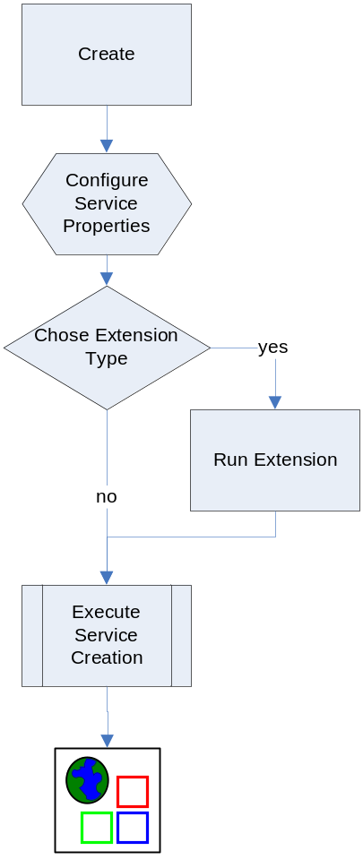
The service creation screen as shown in figure X enables the user to create a new service by providing some basic information such as the name of the service, package name to use for creating the source code, and domain name to use in service description (specified in WSDL), when defining the methods of the service. The user also has the ability to add service extensions. The service extensions are introduce plugins that are designed to add custom additions or setting on the service. These extensions might add pre-defined operations, resources/resource properties, or sercurity settings for example. These extensions are executed during service creation and service synchronization time and enable creating custom service types, such as a data service which might have some predefined methods which must be implemented, and enable Introduce to run the custom code which make modifications to the underlying service which is being created. Service extensions will be described in further detail in later sections.

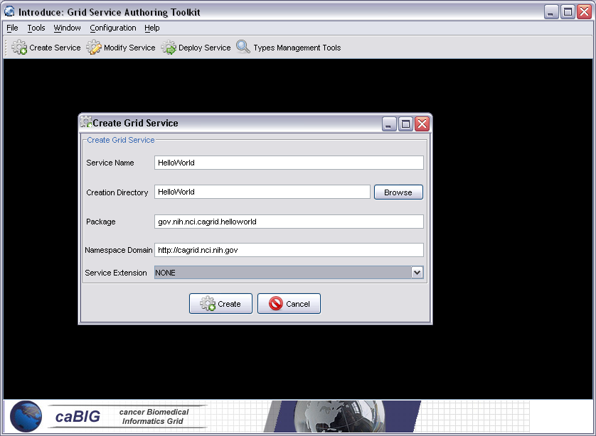

Service Modification
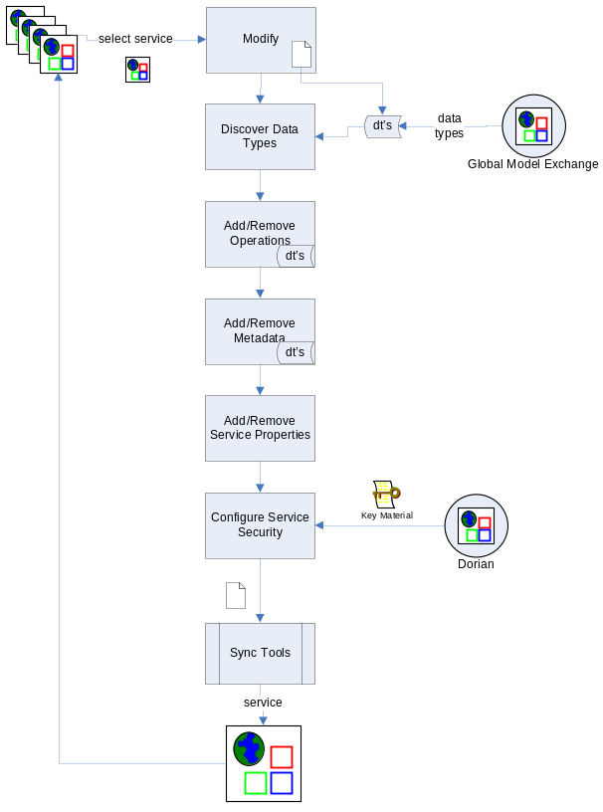
The figure X below shows how the user can add, remove, or modify operations on the Grid service. For each operation added a user needs to set the input parameters, return type, any fault types that can be thrown from the service, and the security configuration of the operation. Service and method level security can be re-configured. Service state information and metadata in the form of resource properties can be added and removed. Service properties, which are set at deployment time and passed into the service, can also be added and default values can be set.

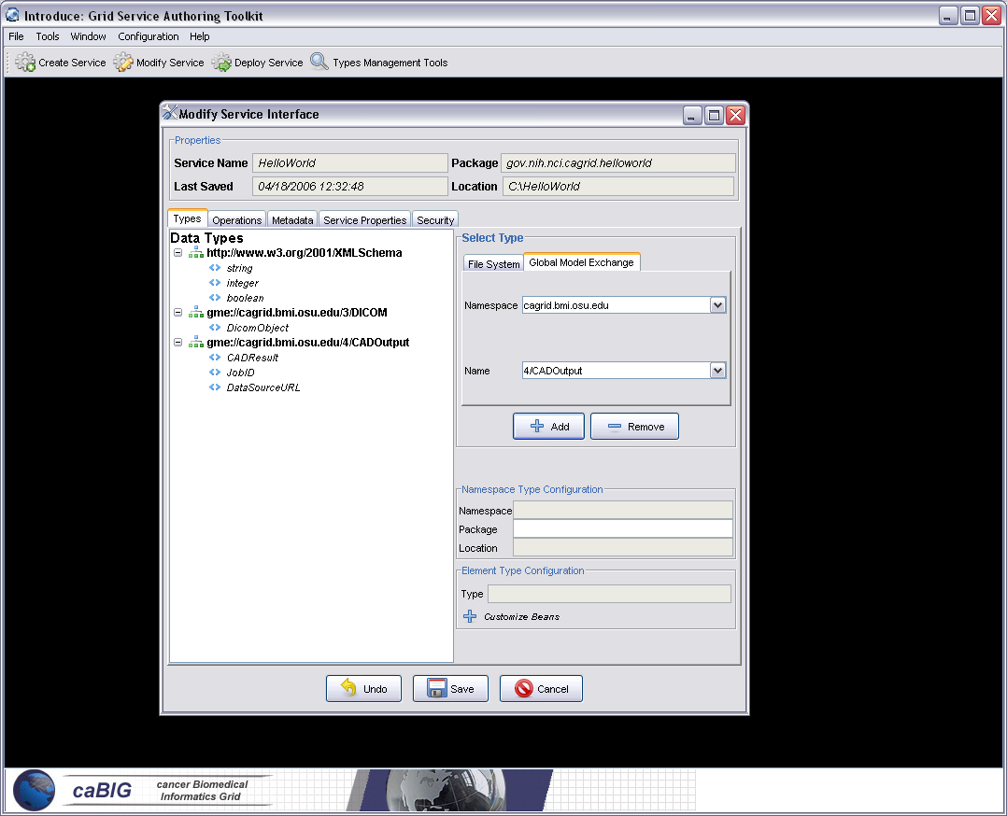

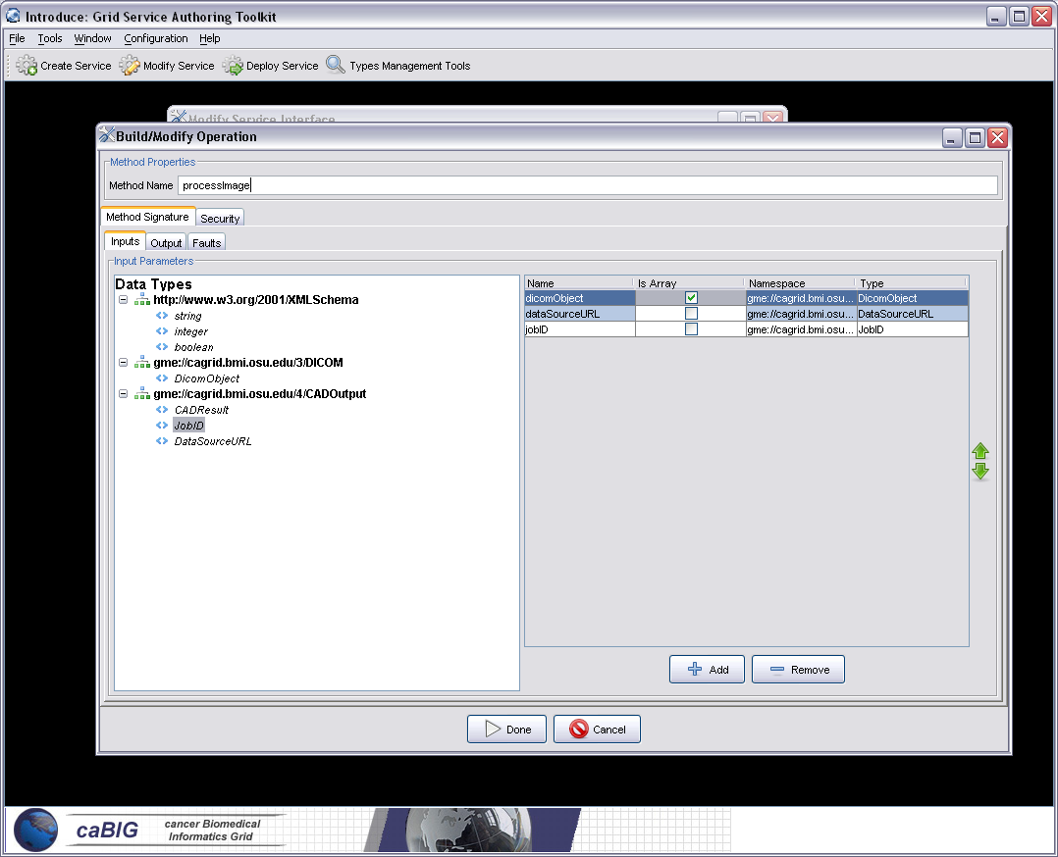

Deployment
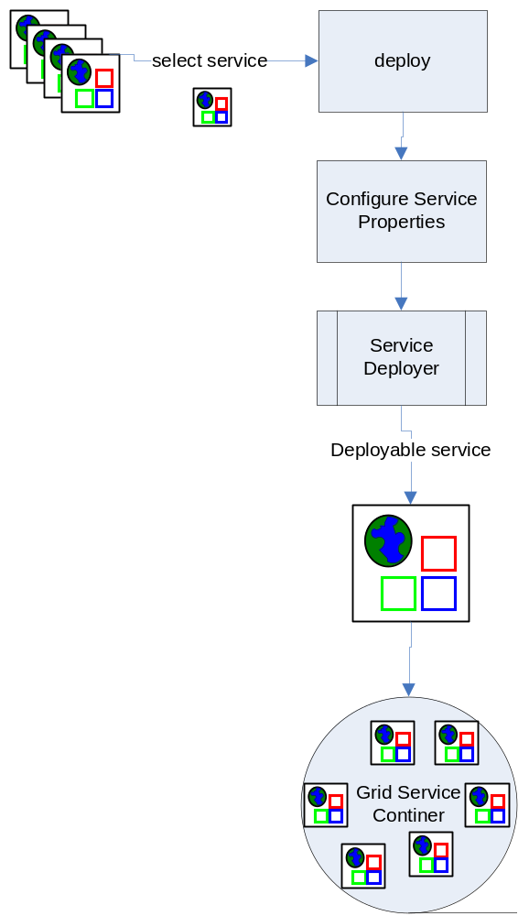
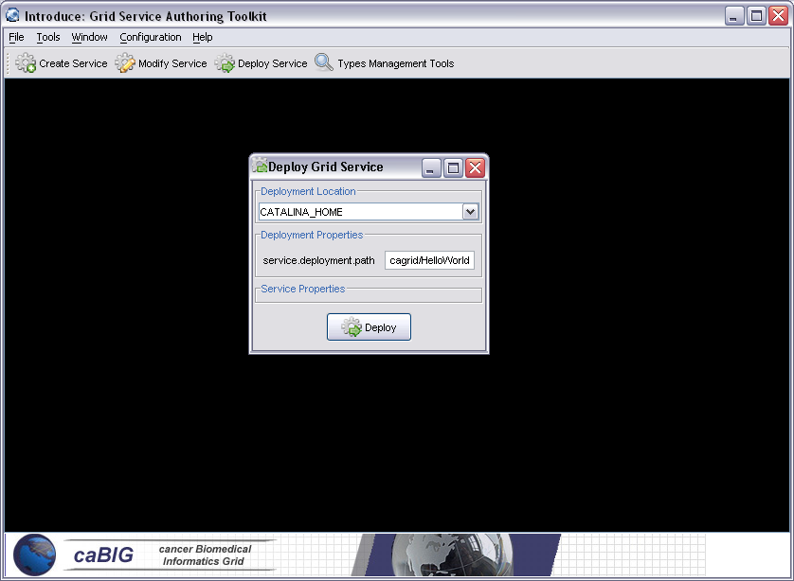

The deployment option of the GDE allows the service developer to deploy the implemented grid service, which has been created with Introduce, to a Grid service container. The toolkit currently supports deploying a service to either a Globus or Tomcat Grid service container; however, support for other deployment options can easily be added to the GDE. The deployment window allows the service deployer to populate service configuration properties which the service will have access to at runtime. Then the service is deployed to the selected container.

Discovery Tools: Support for Strongly-Typed Service Methods

The next component of the GDE is the Discovery tools component. Developers can obtain the types that they want to use for the service parameters and return types from any discovery type plug-in that is running in the GDE. The GDE comes with a set of pre-installed discovery plug-ins, such as the Mobius Global Model Exchange (GME) and a basic file system browser which can be used to locate local schemas. Utilizing data types which are defined outside of a service enables the creation of strongly typed grid service interfaces. Higher levels of data type sharing increase overall service to service interoperability. Once a data type is chosen from the Mobius GME through the Introduce GDE, it is retrieved, written into the schema area of the service, and imported for use in the service WSDL description so that Java beans can be generated and the data types can be programmatically used.
The GME tools component enables developers to browse, upload, and download schemas which are published in a GME. These schemas represent the valid data types which can be used during service creation. The GME upload component takes a schema, creates an editable view for the user, and then submits the schema to the GME. If the namespace of the schema is not managed by the GME being used then the GME tools component will attempt to add the namespace to the GME before submitting the schema. Once the schema has been uploaded, it can be used by anyone in the Grid through the Introduce Toolkit. The GME tools browser window enables browsing through all the GME published types by namespace and schema name. It gives the user a quick view of the schema and the option to download the schema bundle. The schema bundle contains the schema and all other schemas which are referenced by that schema.

Introduce Engine

Service Creator

The service creator is composed by a series of JET templates for generating source code and configuration files and a skeleton set of directories which is used to generate a Grid service that can be compiled and built, is secure, and can be registered in the environment. This creation code uses templated source and configuration files which are used to create all the custom java source code for the client and service, and configuration files required by the GT in order to build and deploy a Grid service. It also provides deployment configuration files, metadata registration configuration files, and security configuration files. The out of the box service that is created has the following functionality:
- Build, Deploy, and Test ANT capability
- Custom configuration files for IDE integration
- Standard interface for both client and service to implement
- Fully implemented client APIs
- Stub implemented service
- Configured to support service metadata resource properties and registration
- Configured for secure service deployment and authorization

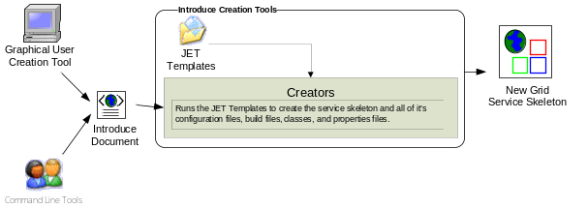

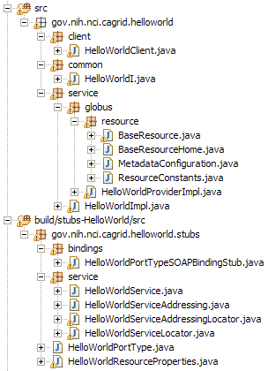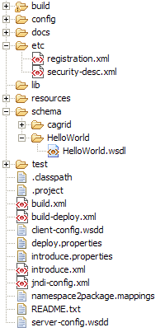
= generated
= built
= developers
contribution

= manages the resources
of this grid service
= implements the port type
and calls into the actual
clean unboxed interface
the developer defined.
= developers implementation
of the defined interface.
= the developer defined grid
service interface
= implements the developer
defined interface and calls into
the generated client port type
stub.

= service metadata registration configuration
= services WSDL file for axis
= configuration files for eclipse development
= ant build files
= client configuration file for axis
= deployment time service properties
= introduce representation of service
= JNDI service resources configuration
= namespace mappings for axis
= server configuration file for axis

The overall service architecture that introduce creates is shown below in figure X. ….

Service Synchronizer
Service resynchronization is the process by which the source code generation tools of the introduce toolkit will analyze the service’s current implementation with that of the desired service description. This process will add/remove and modify any methods which have been added/removed or modified from the service methods description. It will also add/remove any service metadata which have been added or removed form the service metadata description. It will modify the service level and operation level security configurations. The descriptions and configurations for methods, metadata, and security are those that are generated from the GDE, programmatically, or by hand, and that comply with the Introduce service schema. The descriptions are the bases by which the code generation tools add, remove and modify operations, metadata, and security of the service by editing the source code, configuration files, and metadata files. The image X shown below illustrates the overall process of service resynchronization.

The service synchronizer also manages the service WSDL description. If a method has been added or removed, the WSDL file must be update to reflect that. Updating the file requires many auto generated code segments. If the user is using types described in external schemas, via the GME or hand written, these schemas must be imported into the WSDL file so that the data types can be located and used to generate the required Java beans. The WSDL description is basically a another representation of the java based service interface, so not only do the message types representing the data types of the input parameters of return type have to be described, but so does the complete operation which reflects the java based signature of the method which is being exposed. This SyncWSDL operation automatically keeps this file in sync during the development of the service so that the service implantation and the grid service description represented by the WSDL match up, insuring that the methods implemented in the grid service can actually be invoked.

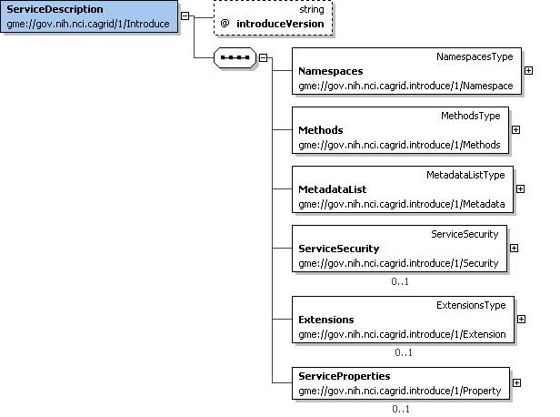
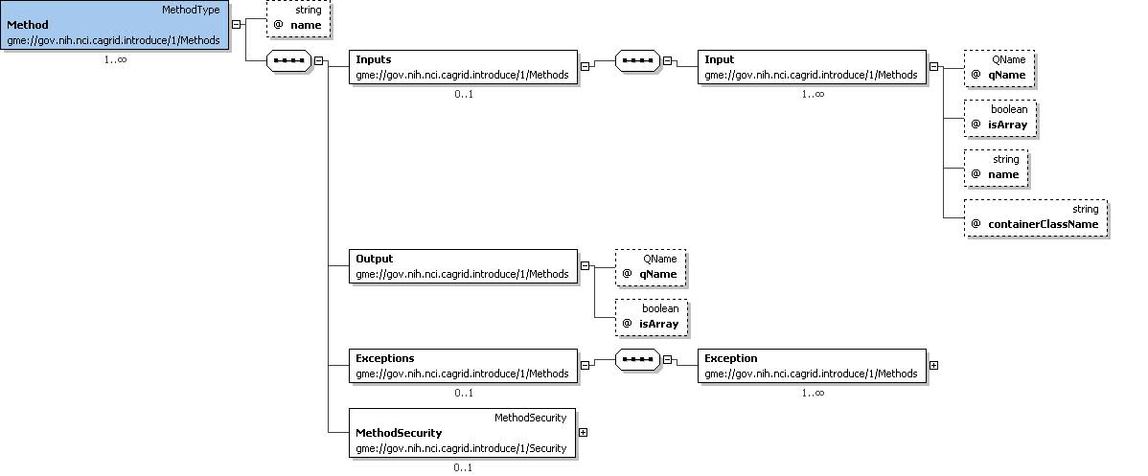
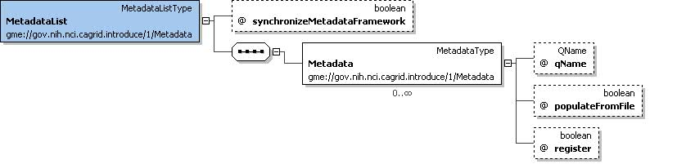
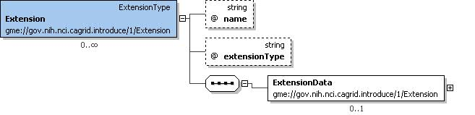
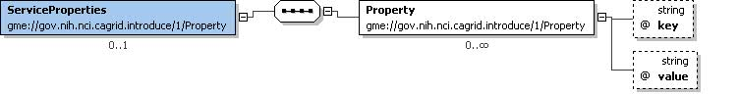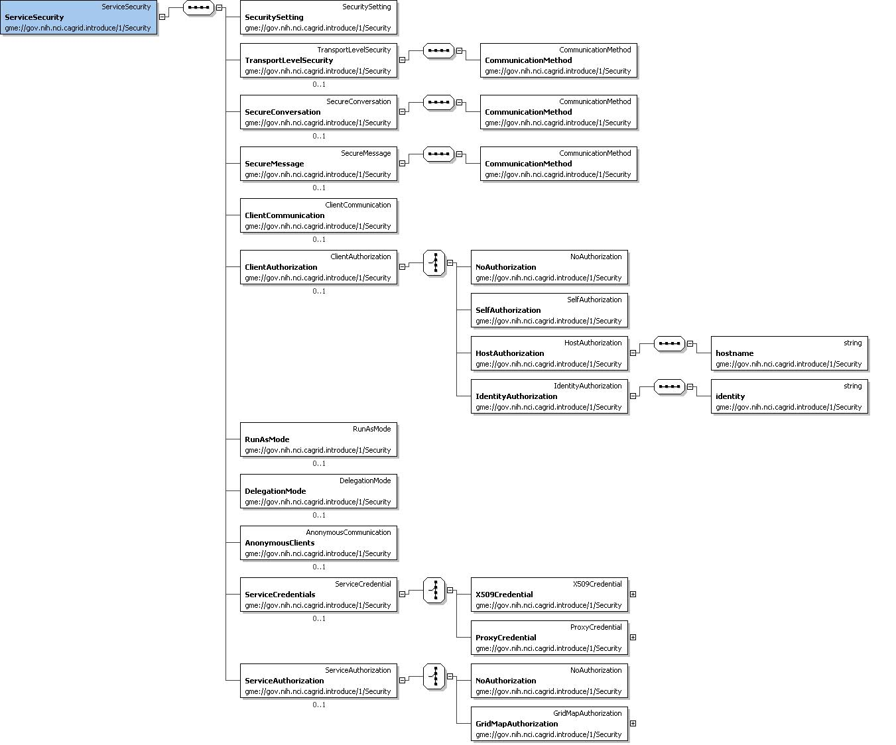

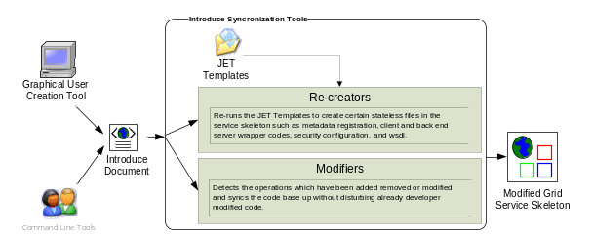

SyncMethods is one of the most complicated synchronization pieces in the toolkit. Its main job is to re-write the basic source code of the service so that the client and the server both agree on the new modified interface which the creator has modified. It deals with interfacing the server side implementation of the interface’s mapping to the actual port type generated by Globus via Axis. The reason this is complicated is that Globus uses the auto-boxing or wrapped style of service bindings when creating the port type of the service. For example, if a user describes a new method shown below:

int foo(int bar1, int bar2);

The port type method that will be created for that java call will look like the one below:

FooReturn foo(FooParameters params);

This boxing or wrapping of the parameters and the return type can be confusing to deal with as the service user and service implementer, especially if it is exposed through the client API or the service. Every client using the service will have to box up the parameters to call the operations of the service and un-box the results. This is not only cumbersome for users, but also is not the interface that was intended to be provided to users. The Introduce tool will hide this boxing and un-boxing by providing an interface to the service, which looks exactly as described by the service developer and not as interpreted by Globus via Axis. In order to do this, the toolkit creates a wrapping layer in the client and service which both implement the clean interface. These wrapper layers auto-box and un-box and map the calls from the clean client to the auto-boxed port type client generated by Globus and visa versa for the service.

The wrapper layer not only hides the Globus complexity from the server side implementation but also form the client. The task of locating and instantiating the port type handle is also hidden from the client side API which is auto generated by the Introduce toolkit. To construct the client handle all that is required is passing in the URL/GSH (Grid Service Handle) to the constructor. Then the clean client API is usable by the user/client application.

SyncMetadata is also quite complex in that it must auto generate and modify the source code and configuration files required to add new resource properties to the service which will represent the service metadata described. This process consists of……

SyncSecurity ……

Service Deployer

Extension Framework
The Introduce Extension framework currently consists of two styles of extensions; service and data type discovery. These extensions are implemented by service or data type discovery parties who whish to add custom functionality to the Introduce framework. Extensions are added to the toolkit in the form or extension plugin which the toolkit will then be able to expose to the user. To provide an extension to Introduce the extension provider must implement the appropriate classes for the style of extension they are provided, and must fill out the extension XML configuration. Once this extension is implemented and configured it can be placed in the extensions directory in Introduce. The extension directory of introduce uses a common library area which enables it to avoid using custom class loaders for each extension. These extensions placed in the extensions directory are loaded by reflection at run time, therefore, introduce does not need any special configuration to find or run and extension.

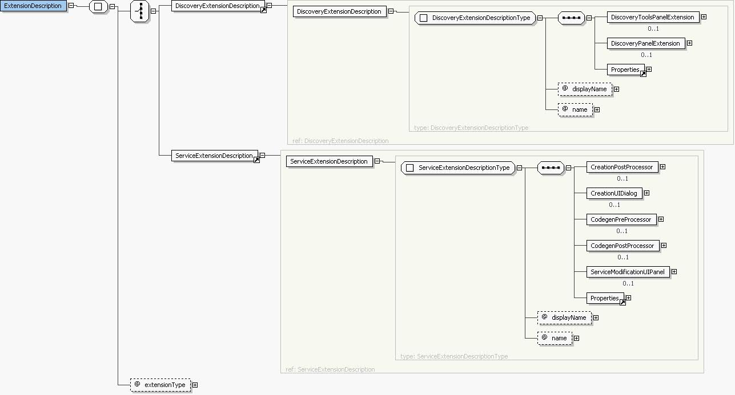

Service Extensions
A service extension is one which enables customization of the service creation and modification process. These extensions can required operations, service resources or resource properties, or security settings just to name a few. The service extension allows the user to create custom code that will be executed at different times throughout the creation and modification process of service development. In order to provide a service extension there are 5 main extension components that can be provided into the custom service extension: CreationPostProcess, CreationUIDialog, CodegenPreProcessor, CodegenPostProcessor, and ServiceModificationUIPanel. Earch of these extension components have a predefined class or interface that you must extend or implement in order to provide the custom extension code for each component. Two of the service extension components, CreationUIDialog and ServiceModificationUIPanel, are graphical plugins to the Introduce GDE, and the other three are Introduce engine plugins. Each service extension component has a special time in the creation or modification where a particular component type will be executed. These different time points for each component execution are critical for making certain changes. For example, when the CreationUIDialog component for a particular extension is executed the service has been created as a blank service and no synchronization or modification has been done on the service. At this point the CreationUIDialog might prompt the user for particular information about the creation processes. This particular componenet would only be ran once for any givin service because it is a creation component. The modification components are ran every time a service is saved and synchronized and the graphical modification component is always available in the Introduce GDE at modification time.

Data Type Discovery Extensions
Data Type Discovery extensions are Introduce GDE components that will be available at service modification time. These components are intended to be able to provide custom data type discovery for the service developer. There custom data type discovery component must allow the developer to browse types and chose to use those types in the developed service. This means that the data type discovery extension will have to be able to copy the schema’s which represent the data types down to the services schema directory and produce a NamespaceType object for each separate data types namespace which will be used. This will enable the grid service to utilize these schemas for describing the data types which will be used in the WSDL messages traveling in and out of the created service.

Examples

Conclusion
The Cancer Biomedical Informatics Grid (caBIG) [1] program lead by the National Cancer Institute (NCI) was launched to meet the challenge and need for a more highly
coordinated approach to informatics resource development, management and dissemination. caBIG is a voluntary network or grid connecting individuals and institutions to enable the sharing of data and tools, creating a World Wide Web of cancer research. The goal is to speed the delivery of innovative approaches for the prevention and treatment of cancer. The caBIG program includes a geographically dispersed large federation of participants from medical centers, universities, government agencies, commercials companies, researchers, and patients.
The caGrid project [2], is the test bed architecture for caBIG, it is driven primarily from the scientific use cases identified from the domain workspaces of caBIG. caGrid provides the core enabling infrastructure necessary to compose the Grid of caBIG. caGrid is a service-oriented architecture and provides the implementation of the required core services, toolkits and wizards for the development and deployment of community provided services, APIs for building client applications, and some sample client applications for interacting with the current test bed installation.

References

[1] Cancer Biomedical Informatics Grid (caBIG), https://cabig.nci.nih.gov.

[2] Cancer Biomedical Informatics Grid (caBIG), https://cabig.nci.nih.gov/workspaces/Architecture/caGrid/

[3] I. Foster, C. Kesselman, S. Tuecke., “The Anatomy of the Grid: Enabling Scalable Virtual Organizations”, International J. Supercomputer Applications, 15(3), 2001.
[4] I. Foster, C. Kesselman, J. Nick, S. Tuecke, “The Physiology of the Grid: An Open Grid Services Architecture for Distributed Systems Integration”, 2002.
[5] The Globus Toolkit, http://www.globus.org

[6] V. Welch, F. Siebenlist, I. Foster, J. Bresnahan, K. Czajkowski, J. Gawor, C. Kesselman, S. Meder, L. Pearlman, S. Tuecke, “Security for Grid Services”, Twelfth International Symposium on High Performance Distributed Computing (HPDC-12), IEEE Press, to appear June 2003.

[7] I. Foster, C. Kesselman, S. Tuecke, J. Volmer, V. Welch, ] A “National-Scale Authentication Infrastructure. R. Butler, D. Engert”, IEEE Computer, 33(12):60-66, 2000.

There are currently more than 50 cancer centers participating in the caBIG effort.
A schema may represent a simple data element such as integer or a more complex object.

