caGrid Portal 2.1

User’s Guide

 |   Center for Biomedical Informatics and Information Technology


This is a U.S. Government work. October 5, 2008

Model caBIG™ Open Source Software License
v.2
Release Date: January 7, 2008
Copyright Notice. Copyright 2008 The Ohio State University Research Foundation (OSURF), Argonne National Labs (ANL), SemanticBits LLC (SemanticBits), and Ekagra Software Technologies Ltd. (Ekagra) (“caBIG™ Participant”). The caGrid 1.2 software was created with NCI funding and is part of the caBIG™ initiative. The software subject to this notice and license includes both human readable source code form and machine readable, binary, object code form (the “caBIG™ Software”).
This caBIG™ Software License (the “License”) is between caBIG™ Participant and You. “You (or “Your”) shall mean a person or an entity, and all other entities that control, are controlled by, or are under common control with the entity. “Control” for purposes of this definition means (i) the direct or indirect power to cause the direction or management of such entity, whether by contract or otherwise, or (ii) ownership of fifty percent (50%) or more of the outstanding shares, or (iii) beneficial ownership of such entity.
License. Provided that You agree to the conditions described below, caBIG™ Participant grants You a non-exclusive, worldwide, perpetual, fully-paid-up, no-charge, irrevocable, transferable and royalty-free right and license in its rights in the caBIG™ Software, including any copyright or patent rights therein, to (i) use, install, disclose, access, operate, execute, reproduce, copy, modify, translate, market, publicly display, publicly perform, and prepare derivative works of the caBIG™ Software in any manner and for any purpose, and to have or permit others to do so; (ii) make, have made, use, practice, sell, and offer for sale, import, and/or otherwise dispose of caBIG™ Software (or portions thereof); (iii) distribute and have distributed to and by third parties the caBIG™ Software and any modifications and derivative works thereof; and (iv) sublicense the foregoing rights set out in (i), (ii) and (iii) to third parties, including the right to license such rights to further third parties. For sake of clarity, and not by way of limitation, caBIG™ Participant shall have no right of accounting or right of payment from You or Your sublicensees for the rights granted under this License. This License is granted at no charge to You. Your downloading, copying, modifying, displaying, distributing or use of caBIG™ Software constitutes acceptance of all of the terms and conditions of this Agreement. If you do not agree to such terms and conditions, you have no right to download, copy, modify, display, distribute or use the caBIG™ Software.
- Your redistributions of the source code for the caBIG™ Software must retain the above copyright notice, this list of conditions and the disclaimer and limitation of liability of Article 6 below. Your redistributions in object code form must reproduce the above copyright notice, this list of conditions and the disclaimer of Article 6 in the documentation and/or other materials provided with the distribution, if any.
- Your end-user documentation included with the redistribution, if any, must include the following acknowledgment: “This product includes software developed by the Ohio State University Research Foundation (OSURF), Argonne National Labs (ANL), SemanticBits LLC (SemanticBits), and Ekagra Software Technologies Ltd. (Ekagra).” If You do not include such end-user documentation, You shall include this acknowledgment in the caBIG™ Software itself, wherever such third-party acknowledgments normally appear.
- You may not use the names “The Ohio State University Research Foundation”, "OSURF", “Argonne National Labs”, “ANL”, “SemanticBits LLC”, "SemanticBits", “Ekagra Software Technologies Ltd.”, “Ekagra”, “The National Cancer Institute”, “NCI”, “Cancer Bioinformatics Grid” or “caBIG™” to endorse or promote products derived from this caBIG™ Software. This License does not authorize You to use any trademarks, service marks, trade names, logos or product names of either caBIG™ Participant, NCI or caBIG™, except as required to comply with the terms of this License.
- For sake of clarity, and not by way of limitation, You may incorporate this caBIG™ Software into Your proprietary programs and into any third party proprietary programs. However, if You incorporate the caBIG™ Software into third party proprietary programs, You agree that You are solely responsible for obtaining any permission from such third parties required to incorporate the caBIG™ Software into such third party proprietary programs and for informing Your sublicensees, including without limitation Your end-users, of their obligation to secure any required permissions from such third parties before incorporating the caBIG™ Software into such third party proprietary software programs. In the event that You fail to obtain such permissions, You agree to indemnify caBIG™ Participant for any claims against caBIG™ Participant by such third parties, except to the extent prohibited by law, resulting from Your failure to obtain such permissions.
- For sake of clarity, and not by way of limitation, You may add Your own copyright statement to Your modifications and to the derivative works, and You may provide additional or different license terms and conditions in Your sublicenses of modifications of the caBIG™ Software, or any derivative works of the caBIG™ Software as a whole, provided Your use, reproduction, and distribution of the Work otherwise complies with the conditions stated in this License.
- THIS caBIG™ SOFTWARE IS PROVIDED "AS IS" AND ANY EXPRESSED OR IMPLIED WARRANTIES (INCLUDING, BUT NOT LIMITED TO, THE IMPLIED WARRANTIES OF MERCHANTABILITY, NON-INFRINGEMENT AND FITNESS FOR A PARTICULAR PURPOSE) ARE DISCLAIMED. IN NO EVENT SHALL THE OHIO STATE UNIVERSITY RESEARCH FOUNDATION ("OSURF"), ARGONNE NATIONAL LABS (“ANL”), SEMANTICBITS LLC ("SEMANTICBITS"), AND EKAGRA SOFTWARE TECHNOLOGIES LTD. (EKAGRA) OR ITS AFFILIATES BE LIABLE FOR ANY DIRECT, INDIRECT, INCIDENTAL, SPECIAL, EXEMPLARY, OR CONSEQUENTIAL DAMAGES (INCLUDING, BUT NOT LIMITED TO, PROCUREMENT OF SUBSTITUTE GOODS OR SERVICES; LOSS OF USE, DATA, OR PROFITS; OR BUSINESS INTERRUPTION) HOWEVER CAUSED AND ON ANY THEORY OF LIABILITY, WHETHER IN CONTRACT, STRICT LIABILITY, OR TORT (INCLUDING NEGLIGENCE OR OTHERWISE) ARISING IN ANY WAY OUT OF THE USE OF THIS caBIG™ SOFTWARE, EVEN IF ADVISED OF THE POSSIBILITY OF SUCH DAMAGE.

Revision History
The following is the revision history for this document.

Date | Version | Description | Revised By
October 3, 2008 | 2.1.1 | caBIG is a registered trademark (except in license agreement). Edits about Diagnostic portlet and target grid. | John Eisenschmidt
October 2, 2008 | 2.1 | Draft 2.1 Revision | Carolyn Kelley Klinger
June 29, 2008 | 2.0.2.3 | Final 2.02 Revision | Carolyn Kelley Klinger
June 26, 2008 | 2.0.2.2 | Updated Revision History, Acknowledgements, and link to this guide. Copyedited text. | John Eisenschmidt
June 23, 2008 | 2.0.2.1 | Updated for caGrid Portal 2.0.2. | Carolyn Kelley Klinger
January 9, 2008 | 2.0.1 | Updated for caGrid Portal 2.0. | Eddie VanArsdall

Contents
Revision History iv
Illustrations vii
About This Guide 1
Purpose 1
Audience 1
Prerequisites 1
Topics Covered 2
Text Conventions Used 2
Credits and Resources 3
Chapter 1 About the caGrid Portal 4
Purpose of the caGrid Portal 4
caGrid Portal Features 4
Discovery 4
Service Metadata Exploration 5
Data Service Query 6
Accessing caBIG® Community Portlets 6
Browsing caBIG® Tools 6
Query Sharing 6
caGrid Account Registration 7
Grid Status Overview 8
News and Events 8
Visual Overview of the caGrid Portal Home Page 9
Chapter 2 Registering and Logging In 11
About Registration 11
Registering for a Login Account 12
Logging in with Your caGrid Portal Account 15
Logging in with Your NIH Account 16
About the Welcome Menu 16
Chapter 3 Using the Map Portlet 17
About the Map Portlet 17
Selecting a Category View 18
Selecting a Service, Participant, or POC 19
Selecting a Data Service. 19
Selecting an Analytical Service. 21
Selecting a Participant Institute. 22
Selecting a Hosting Research Center. 24
Selecting a POC. 25
Chapter 4 Using the Discovery Portlet 27
About the Discovery Portlet 27
Viewing Data in a List or a Map 28
Using the List View Subtab 28
Using the Map View 31
Searching for Services, Participants, and POCs 32
Searching for a Service 32
Searching for a Participant 36
Searching for a POC 37
Viewing Details for Services, Participants, and POCs 39
Viewing Details for Services 39
Viewing Details for a Participant 42
Viewing Details for a POC 43
Using the Service Diagnostics Portlet 43
About the Service Diagnostics Portlet 43
Running Diagnostic Tests 45
Interpreting Results of Diagnostic Tests 45
Chapter 5 Using the Data Service Query Portlet 47
About the Data Service Query Portlet 47
Query-Building Scenarios 49
Scenario 1: Starting without a URL or Query 49
Scenario 2: Starting with a URL but No CQL Query 50
Scenario 3: Starting with a URL and a CQL Query 50
Building a Query Using the Query Builder Tool 51
Building CQL Queries 51
Building DCQL Queries 56
About the History Tab 66
Working with Shared Queries 68
Sharing a Query 68
Searching for a Shared Query 70
Chapter 6 Using the Community Portlet 73
About JSR 168 and the Liferay Portal 73
Accessing the Community Portlet 73
Deploying a Community Portet 74
Chapter 7 Using Other Portal Features 75
Using the News Portlet 75
About the caGrid Links Portlet 77
Using the caGrid Status Portlet 79
Viewing Details for a Recently Registered Service or Participant 79
Viewing a List of Participants or Services 80
About the Calendar Portlet 80
Chapter 8 Using the caBIG® Tools Portlet 83
About the caBIG® Tools Portlet 83
Sorting caBIG® Tools 84
Viewing caBIG® Tool Details 87
Index 89

Illustrations
Figure 1-1. caGrid Portal home page 9
Figure 2-1. Register links 12
Figure 2-2. Registration page 13
Figure 2-3. Successful login message 15
Figure 2-4. Welcome message with Logout link 15
Figure 2-5. Welcome menu 16
Figure 3-1. Map portlet 17
Figure 3-2. Categories list 18
Figure 3-3. Callout balloon for a data service center 20
Figure 3-4. Discovery Portlet showing details for a selected data service 20
Figure 3-5. Callout balloon for a selected participant 22
Figure 3-6. Discovery portlet showing details for a participant institute 23
Figure 3-7. Callout balloon for an analytical service center 24
Figure 3-8. List of hosting research centers with More Details links 25
Figure 4-1. Directory tab > List View subtab – results for All Services category 29
Figure 4-2. Map View subtab 31
Figure 4-3. Services subtab with the Simple search mode selected 33
Figure 4-4. Services subtab with Advanced search mode selected 33
Figure 4-5. Discovered services 34
Figure 4-6. Services subtab with the EVS search mode selected 35
Figure 4-7. Results of an EVS search 35
Figure 4-8. Discovered services 36
Figure 4-9. Participants subtab 37
Figure 4-10. POCs subtab 38
Figure 4-11. Details for a selected data service 39
Figure 4-12. Selecting a UML class for a query 40
Figure 4-13. Details for a selected analytical service 41
Figure 4-14. Details for a selected participant 42
Figure 4-15. Details for a selected POC 43
Figure 4-16. Service Diagnostics portlet on the Services tab 44
Figure 4-17. URL field in the Service Diagnostics portlet 45
Figure 4-18. Successful result in the Service Diagnostics portlet 45
Figure 4-19. Unsuccessful result in the Service Diagnostics portlet 46
Figure 5-1. Starting a query from a selected result 49
Figure 5-2. Working query 50
Figure 5-3. Query Builder subtab with selected UML class ArrayDesign 51
Figure 5-4. Attributes and associations for selected class 53
Figure 5-5. Specifying a predicate and value for a selected attribute 54
Figure 5-6. Query Builder subtab with added criterion 54
Figure 5-7. Query XML tab 55
Figure 5-8. History tab with query information 55
Figure 5-9. Query Builder specifying a service and URL 57
Figure 5-10. Services with the same UML class to aggregate from 57
Figure 5-11. Summary of data services selected for aggregation 58
Figure 5-12. History tab with query information 58
Figure 5-13. Query Builder specifying a service and URL 59
Figure 5-14 Query Builder tool with selected NucleicAcidSequence class 59
Figure 5-15 Tree view of attributes and associations for the NucleicAcidSequence class 60
Figure 5-16 Query criterion tree view for caBIO NucleicAcidSequence class 61
Figure 5-17 Service information for semantically equivalent UML class 61
Figure 5-18 Selecting the join condition 62
Figure 5-19 Entering criterion value for Organism scientificName attribute 62
Figure 5-20 Enter criterion value for Gene name attribute 63
Figure 5-21 Complete federated query for caBIO NucleicAcidSequence class 63
Figure 5-22 XML federated query for caBIO NucleicAcidSequence class 64
Figure 5-23 History Tab with the running DCQL query 64
Figure 5-24 Results of federated query for caBIO NucleicAcidSequence class 65
Figure 5-25. Results tab showing query results 66
Figure 5-26. Form for adding a query name and description 69
Figure 5-27. Saved query 69
Figure 5-28. Shared Queries tab > Find Shared Queries subtab – Search form 70
Figure 6-1. Community Portlet, caBIO Portlet example 73
Figure 7-1. News links 76
Figure 7-2. News page 77
Figure 7-3. Status portlet 79
Figure 7-4. Calendar portlet 80
Figure 8-1.Tools portlet 84
Figure 8-2. caBIG® tools sorted by Area of Focus 85
Figure 8-3. caBIG® tool details 88

About This Guide
This section introduces you to the caGrid Portal 2.1 User's Guide and provides an orientation to using the guide. It also includes support contact information.
Topics in this section:
- Purpose on this page
- Audience on page 1
- Prerequisites on page 1
- Topics Covered on page 2
- Text Conventions Used on page 2
- Credits and Resources on page 3

Purpose
This guide introduces you to the caGrid Portal. It explains how to use the portal features to do the following:
- Discover caGrid services, caBIG® participants, and caGrid points of contact
- Explore the service metadata of a discovered service
- Build queries using the CQL and DCQL query languages
- Share queries and search for shared queries
- Access community portlets
- Register for an account so that you can interact with secure caGrid services
- View the status of caGrid services
- View caGrid-related news using the portal or using an RSS 2.0-compliant news reader
- View a calendar of caGrid-related events.

Audience
This guide is intended for the following users:
- Non-developer members of the caBIG® community
- caGrid service developers
- Anyone interested in caBIG® and caGrid

Prerequisites
To get the most out of this guide, you should have the following skills:
- Ability to browse the Internet using a Web browser
- Understanding of caGrid metadata concepts (for building queries)

Topics Covered
This brief overview explains what you will find in each chapter and appendix.
- Chapter 1, About the caGrid Portal (p. 4), provides an overview of the caGrid Portal and its feature set.
- Chapter 2, Registering and Logging In (p. 11) covers the registration process and the procedures for logging in as a new portal user or an NIH user.
- Chapter 3, Using the Map Portlet (p. 19), explains how to use the Map portlet to select a service or institution and link to more detailed information.
- Chapter 4, Using the Discovery Portlet (p. 29), explains how to use the Discovery portlet to browse, search, and view details for caGrid services, caBIG® participants, and caGrid POCs.
- Chapter 5, Using the Data Service Query Portlet (p. 49), explains how to use the Data Service Query portlet to build and share queries.
- Chapter 6, Using the Community Portlet (p. 75), explains how to access portlets developed by the caBIG® community within the caGrid Portal.
- Chapter 7, Using Other Portal Features (p. 77), covers the News, caGrid Links, Grid Status, and Calendar portlets.
- Chapter 8, Using the caBIG® Tools Portlet (p. 85), explains how to use the caBIG® Tools portlet to sort and browse caBIG® tools.

Text Conventions Used
This section explains conventions used in this guide. The various typefaces represent interface components, keyboard shortcuts, toolbar buttons, dialog box options, and text that you type.
Convention | Description | Example
Bold | Highlights names of option buttons, check boxes, drop-down menus, menu commands, command buttons, or icons. | Click Search.
URL | Indicates a Web address. | http://domain.com
text in Small Caps | Indicates a keyboard shortcut. | Press Enter.
text in Small Caps + text in Small Caps | Indicates keys that you press simultaneously. | Press Shift + Ctrl.
Italics | Highlights references to other documents, sections, figures, and tables. | See Figure 4.5.
Italic boldface monospace type | Represents text that you type. | In the New Subset text box, enter Proprietary Proteins.
Note: | Highlights information of particular importance. | Note: This concept is used throughout this document.
{ } | Surrounds replaceable items. | Replace {last name, first name} with the Principal Investigator’s name.

Credits and Resources

caGrid Portal Development and Management Teams
Development | Quality Assurance | Program and Project Management
Joshua Phillips 2 | Aynur Abdurazik 3 | Krishnakant Shanbhag 1
Manav Kher 2 |  | John Eisenschmidt 4
 | Documentation
 | Carolyn Kelley Klinger 5
- National Cancer Institute Center for Bioinformatics (NCICB) | - SemanticBits, LLC | - Science Applications International Corporation (SAIC)
- 5AM Solutions | - Lockheed Martin Management System Designers

Contacts and Support
NCICB Application Support | http://ncicbsupport.nci.nih.gov/sw/  Telephone: 301-451-4384  Toll free: 888-478-4423

About the caGrid Portal
This chapter introduces you to the caGrid Portal and describes its feature set.
Topics in this chapter:
- Purpose of the caGrid Portal on this page
- caGrid Portal Features on this page
- Visual Overview of the caGrid Portal Home Page on page 9

Purpose of the caGrid Portal
The caGrid Portal is a Web-based application that enables you to discover and interact with the services that are available on the caGrid infrastructure. The portal serves as the primary visualization tool for the caGrid middleware and provides a standards-based platform for hosting caBIG®-related tools. It also serves as a caBIG® information source. Using the caGrid portal, you have instant access to information about caBIG® participants, caGrid points of contact (POCs), and caGrid-related news and events.

caGrid Portal Features
The following sections discuss the various caGrid Portal features:
- Discovery on this page
- Service Metadata Exploration on page 5
- Data Service Query on page 6
- Accessing caBIG® Community Portlets on page 6
- Browsing caBIG® Tools on page 6
- Query Sharing on page 6
- caGrid Account Registration on page 7
- Grid Status Overview on page 8
- News and Events on page 8

Discovery
One of the goals of the caGrid infrastructure is to enable you to easily discover and access services. To achieve this goal, caGrid services register with a central index service. This service allows other applications to locate caGrid services and retrieve the necessary information for interacting with those services.
The caGrid Portal uses caGrid component APIs to provide an interface that you can use to query information gathered from one or more index services. Regardless of whether you are a service developer or non-developer, you can use this interface to determine how to use and benefit from caGrid.
In addition to service information, the portal also provides information about caBIG® participant institutions and caGrid points of contact (POCs). The goal is to enable you to quickly determine who the point of contact is for specific activities and easily obtain contact information for that person.
The process of locating services, participants, and POCs is known as discovery. The portal provides the following modes of discovery: map view, directories, keyword search, and EVS search. The following subsections describe these modes.
Once you discover a service, you can also run diagnostic tests on it to check the service's status in the caGrid Portal, availability of the service, service metadata, and index service.

Map View
The portal home page displays a map of the U.S. that shows the geographic location of services and participant institutions. You can click the icon for a service or institution and link to more detailed information.

Categories
Services, participants, and POCs are grouped into categories. You can browse these categories and click hyperlinks that lead to more detailed information.

Keyword Search
The portal provides an intuitive, keyword search interface that enables you to enter one or more keywords and match them against one or more fields.

EVS Search
This feature allows the user to enter free text that the Portal matches against concepts found in the NCI Thesaurus. As you type characters into the search field, the Portal presents candidate concepts. After you select a concept, the Portal starts the search. Services whose metadata refer to the concept or any sub-concept are presented in the search results.

Service Metadata Exploration
To support the caBIG® goals of syntactic and semantic interoperability, caGrid services expose a rich, standard set of metadata. This metadata not only describes the operations that the services support; it also links the data types that those operations use to concepts defined in the NCICB Enterprise Vocabulary Services (EVS), common data elements defined in the Cancer Data Standards Repository (caDSR), and XML schemas defined in the Global Metadata Exchange (GME) service.
caGrid services that support the caGrid Query Language (CQL) also expose an XML representation of the UML domain model that the service supports. This model is also linked to the EVS, caDSR, and GME. While caGrid services support standard Web service APIs for retrieving metadata, the caGrid project provides client API components that facilitate the process.
The portal uses caGrid client APIs to build an interface that enables you to explore caGrid service metadata. You can view the semantic descriptions that come from the EVS, the data type descriptions from the caDSR, and XML schemas that are registered with the GME. The interface makes it easier for you to determine whether a service meets your needs and what is necessary to interact with the service.

Data Service Query
caGrid services that support CQL are known as data services. They expose a UML domain model, support a query operation that processes CQL queries against that domain model, and return XML documents that contain serialized instances of the UML classes defined in the domain model. These serialized instances conform to the XML schemas that are registered with the GME.
The portal provides an interface that enables you to select a service and target UML class, build a query, execute the query, view the results in tabular form, and export to a Microsoft Excel or XML document. While using the discovery tool or while exploring service metadata, you can select the service and UML class to be queried. You can then use a graphical query-building interface to construct CQL or DCQL, or you can manually type the query text.
If you are a registered caGrid Portal user (discussed under caGrid Account Registration on this page), the portal maintains a complete history of your queries so that you can always retrieve and work with previously executed queries. The results of all queries that you execute during a single session (while your browser is open) are available for viewing.

Accessing caBIG® Community Portlets
Developers in the caBIG® community may create Java Specification Request 168 (JSR 168) compliant portlets and then deploy them to the caGrid Portal. This provides an instant hosting environment for custom applications that may be of value to the entire caBIG® community.

Browsing caBIG® Tools
To increase the cancer research community's access to key bioinformatics tools, platforms, and data, the caGrid Portal exposes the same inventory of applications, software tools, database technologies, and Web-based applications that appear on the caBIG® Community Website. As on the caBIG® website, caGrid users can search for these tools based on name, compatibility level, keyword, area of focus, workspace, and technical specifications.

Query Sharing
Although data service domain models are linked to semantic metadata and data type specifications, you still need to do a fair amount of exploring to construct useful queries. If you have query-building knowledge, the portal enables you to share that knowledge with the rest of the community. Any portal user can publish CQL queries and provide documentation to accompany the query. Others can search for CQL queries based on the target service, the target UML class, the creator of the query, or the associated name and description of the query.
For more information on queries, see Using the Data Service Query Portlet on page 49.

caGrid Account Registration
The caGrid security infrastructure, known as GAARDS, uses an authentication approach that is based on Public Key Infrastructure (PKI). PKI requires that users have an X.509 certificate and private key, also known as grid credentials.
The caGrid Dorian service is used to provide users with grid credentials. To obtain grid credentials, you must register either with the Dorian service or another Identity Provider (IdP) that has established a trust relationship with Dorian.
Secure caGrid services apply an authorization policy to incoming requests based on the identity of the client (i.e., the user who is making the request). The identity is determined through the authentication process by inspecting the client’s grid credentials. So, in order to interact with secure services, caGrid users need to obtain grid credentials.
While nearly all the functionality that the portal provides is available to un-authenticated users, only authenticated users can share queries and maintain a query history across browser sessions. The portal uses GAARDS to authenticate users. So, to use the query sharing and persistent query history features, you need to obtain grid credentials.
The portal provides an interface that enables you to register for an account with the caGrid Dorian service that is hosted by the NCICB. This service provides a Level of Assurance 1 (LOA1), which means anyone can request an account and the request will automatically be approved. Once your request is approved, you can provide log in to the portal using your username and password. The portal will then use the grid credentials obtained from Dorian when interacting with secure caGrid services.

Grid Status Overview
The caGrid Portal provides a quick, visual description of the scale and activity of caGrid. The map on the front page of the portal not only indicates where services are being hosted, but whether those services are currently running. Icons of various colors indicate the service status.
In addition to the map, a status portlet presents up-to-date counts of all participants, all services, data services, and analytical services. It also provides links to more information about the five most recently registered services.

News and Events
A news portlet on the front page of the portal displays a running list of the latest caGrid-related news items. You can click each item to link to the full news article. You can also click a link to subscribe to the news feed using your browser or any other RSS 2.0-compliant news feed reader.
The portal provides a news feed editor application that is available to the portal administrator. This application can be used to maintain one or more RSS news channels.
The portal home page also includes a full-featured calendar application. This application enables you to browse through caGrid-related events by day, week, month, and year. A portal administrator can import and export calendar events using the standard iCal format, which is described at http://tools.ietf.org/html/rfc2445.

Visual Overview of the caGrid Portal Home Page
The caGrid Portal is located at http://cagrid-portal.nci.nih.gov/web/guest/home. This address launches the portal home page, shown in Figure 1-1.
Each numbered callout represents one of the features discussed in caGrid Portal Features on page 4.
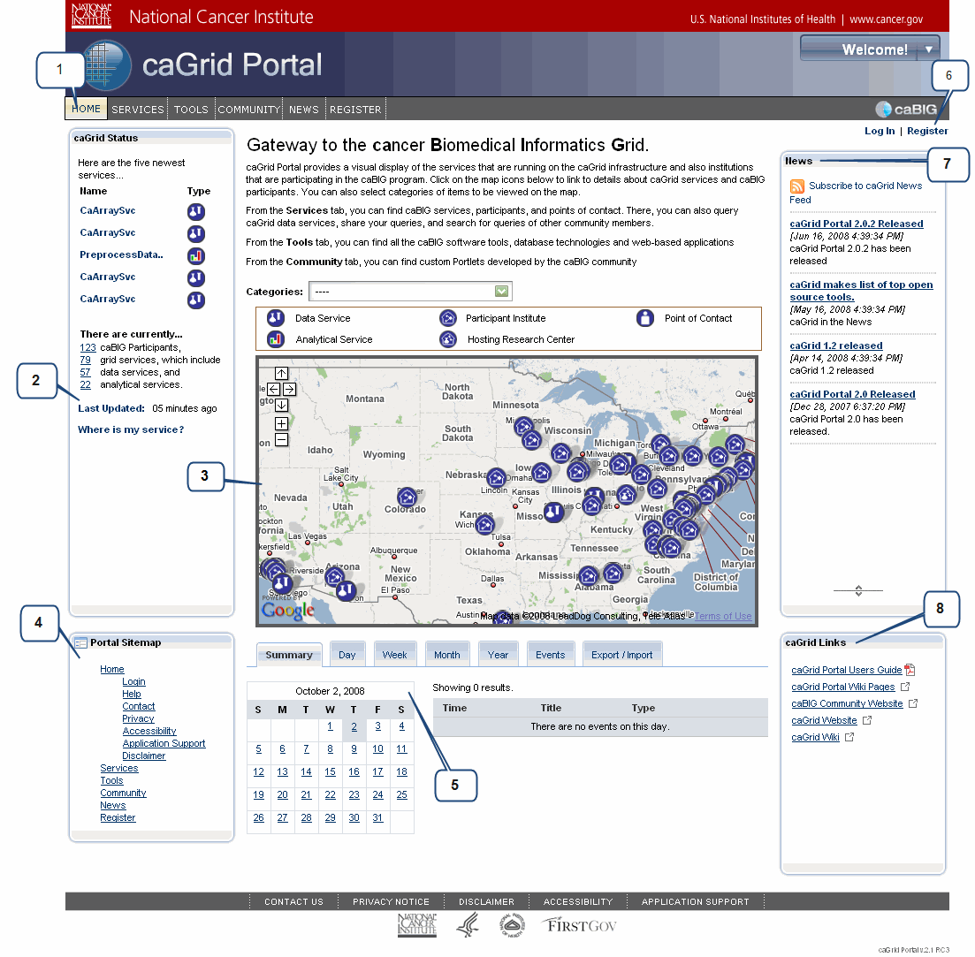
Figure 1-1. caGrid Portal home page
For a description of each numbered callout in Figure 1-1, see Table 1-1 on page 10.

Callout Number | Feature/Description
1 | Main Navigation Bar with four links:  - Home: Returns to the home page from any other portal page.  - Services: Opens the Tools page, where you can use the Discovery and Data Service Query tools to search for services, participant institutions, and POCs, and run diagnostic tests on services. You can also build and share queries from this page.  - Tools: A directory of caBIG® tools is provided here.  - Community: Access community developed portlets.  - News: Displays a News page with announcements and links to caGrid-related news.  - Register page: Enables you to register as a caGrid Portal user.
2 | caGrid Status portlet: Provides a quick, visual description of the scale and activity of caGrid.
3 | Map portlet with legend: Shows the geographic location of services and participant institutions. You can click the icon for a service or institution and link to more detailed information.
4 | Portal Sitemap: Click any link to go to that page of the portal.
5 | Calendar: Enables you to browse through caGrid-related events by day, week, month, and year.
6 | Log In and Register links: Links for logging in with your existing account, or registering as a caGrid Portal user.
7 | News portlet: Enables you to link to caGrid-related news stories and subscribe to the caGrid News Feed.
8 | caGrid Links portlet: Lists links to external caGrid-related sites. Each link destination opens a new window or tab.
Table 1-1. Description of feature callouts in Figure 1-1

Registering and Logging In
Although you can freely browse and use the caGrid Portal without logging in to an established account, consider becoming a registered user. This chapter explains the benefits of registration, the procedure for registering, and the procedures for logging in as a new portal user or an NIH user.
Topics in this chapter:
- About Registration on this page
- Registering for a Login Account on page 12
- Logging in with Your caGrid Portal Account on page 15
- Logging in with Your NIH Account on page 16
- About the Welcome Menu on page 16

About Registration
As discussed in caGrid Account Registration on page 7, becoming a registered caGrid Portal user gives you Grid credentials so that you can interact with caGrid services. If you are a registered user, the portal maintains your query history from previous sessions and enables you to share queries with other users. In addition, future releases of the portal will enable you to further customize your user experience.
Note: If you already have a login account through the National Institutes of Health (NIH), you can log in to the portal using your existing credentials. For more information, see Logging in with Your NIH Account on page 16.

Registering for a Login Account
To register for a caGrid Portal login account, follow these steps:
- Click either of the following Register links:
- The link appearing on the main navigation toolbar, or
- The link appearing in the upper right of the home page.
Figure 2-2 shows pointers to both links.
or here.
Click here...

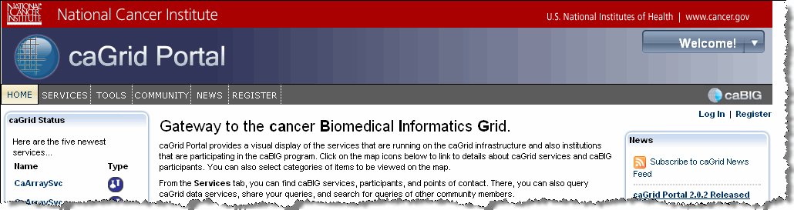
Figure 2-2. Register links
The Registration page appears, as shown in Figure 2-3.
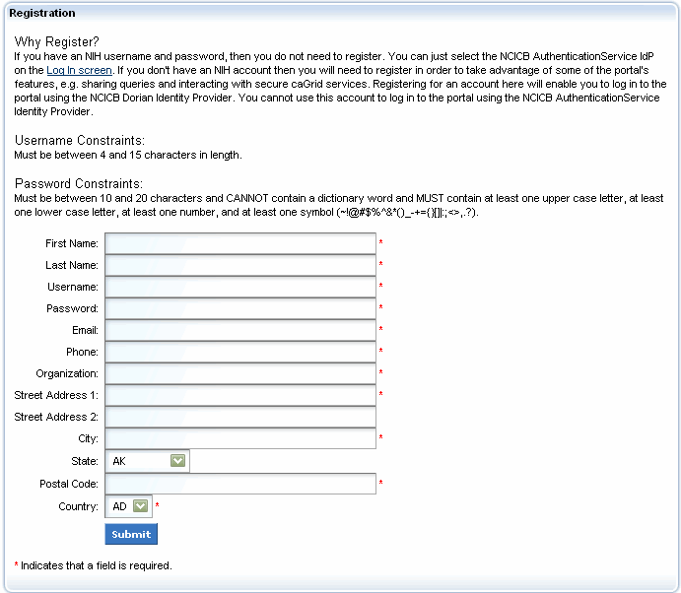
Figure 2-3. Registration page
- Complete the registration fields.
Note: Pay special attention to the password constraints. A password cannot be a dictionary word and must be constructed as follows:
Length: 10 to 20 characters (10-character minimum)
Characters: at least one uppercase letter, one lowercase letter, one number, and one of the following symbols:
~! @ # $ % ^& * ( ) _ { } [ ] | : ; < > , . ?
- When you are finished, click Submit.
- If your username or password did not conform to the required constraints, an invalid username or password message appears in red.
- If your submission was successful, the following message appears in green: Your account was approved, your current account status is Active.
Note: Although you are still on the Registration page, do not click Submit again if you received a successful confirmation message.
- Do either of the following:
- Click the Home link on the navigation bar to return to the home page, or
- Click the Log In link to log in using the account that you just created.
- Log in by following the instructions in Logging in with Your caGrid Portal Account on page 15.

Logging in with Your caGrid Portal Account
To log in with your caGrid Portal (non-NIH) account, follow these steps:
- If you are not currently viewing the home page, click the Home link on the navigation bar.
- Click the Log In link in the upper right corner of the page.
- Enter your username and password.
- Ensure that the Identity Provider field shows NCICB Dorian.
- Click Log In.
- If your login is not recognized, the following message appears:
Invalid username and/or password.
- If your login was successful, the following message appears:
You are logged in as: {your name}
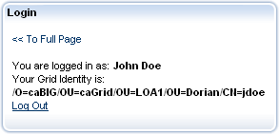
Figure 2-4. Successful login message
- Click the << To Full Page link to return to the home page.
In the upper right corner of the home page, a welcome message confirms that you are logged in.
Note: At the end of your session, be sure to log out by (1) clicking the Log Out link below the welcome message, or (2) clicking the drop-down arrow to the right of the Welcome message and selecting Sign Out.
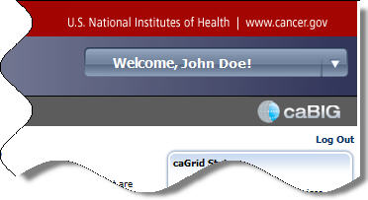
Log Out link
Figure 2-5. Welcome message with Logout link

Logging in with Your NIH Account
To log in with your NIH account, follow these steps:
- If you are not currently viewing the home page, click the Home link on the navigation bar.
- Click the Log In link in the upper right corner of the page.
- Enter your username and password.
- Ensure that the Identity Provider field shows NCICB Authentication Service.
- Click Log In.
- If your login is not recognized, the following message appears:
Invalid username and/or password.
- If your login was successful, the following message appears:
You are logged in as: {your name}
- Click the << To Full Page link to return to the home page.
In the upper right corner of the home page, a welcome message confirms that you are logged in. (See Figure 2-5 on page 15.)
Note: At the end of your session, be sure to log out by clicking the Log Out link below the welcome message.

About the Welcome Menu
The Welcome message in the upper right corner of the caGrid Portal includes a drop-down menu with four commands:
- Home: Returns to the home page
- Sign Out: Logs you out of the caGrid Portal
- My Places: Links to public pages.
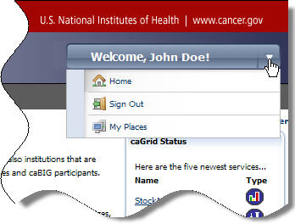
Figure 2-6. Welcome menu

Using the Map Portlet
As discussed in Chapter 1, the caGrid Portal home page includes a Map portlet that shows the geographic location of services and participant institutions in the United States. This chapter explains how to use the Map portlet to select a service or institution and link to more detailed information.
Topics in this chapter:
- About the Map Portlet on this page
- Selecting a Category View on page 20
- Selecting a Service, Participant, or POC on page 21

About the Map Portlet
The Map portlet provides a visual perspective of caGrid services, participants, and POCs. It serves as an access point for getting started with discovery.
As shown in Figure 3-7, the map is preceded by a Categories drop-down list and a legend explaining the map icons. The next two sections explain the list and the icons.
Map navigation
Categories list
Map legend
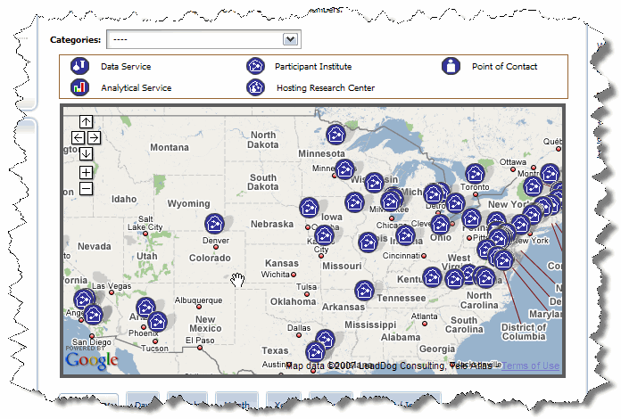
Figure 3-7. Map portlet
The Map portlet uses the Google Maps API and has standard Google Maps navigation features. These include navigation arrows, zoom in (+) and zoom out (-) buttons, and the “grabbing hand” mouse pointer for moving around the map.

Selecting a Category View
The Categories list enables you to filter the map view to show specific categories. The default view, shown as a series of dashes (----), displays all participant institutes.
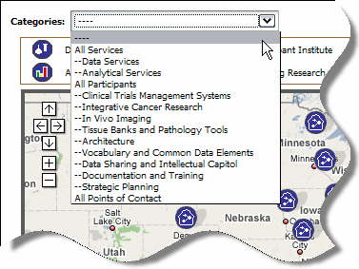
Figure 3-8. Categories list
The list also provides the following views:
- All Services
- Data Services
- Analytical Services
- All Participants
- Clinical Trials Management Systems
- Integrative Cancer Research
- In Vivo Imaging
- Tissue Banks and Pathology Tools
- Architecture
- Vocabulary and Common Data Elements
- Data Sharing and Intellectual Capitol
- Documentation and Training
- Strategic Planning
- All Points of Contact (not currently available)

To select a category view, follow these steps:
- Click the drop-down arrow to the right of the Categories list.
- Select a category from the list.

Selecting a Service, Participant, or POC
Map portlet icons are clickable links. Table 3-2 lists each icon type and includes a cross-reference to the relevant section for working with the selected type.
Note: Icons for active entities appear in dark blue. Identical icons appearing in gray indicate inactive entities. Those appearing in red indicate partially active entities. Table 3-2 shows only icons for active entities.
Icon | Description
Data Service
See Selecting a Data Service on this page.
Analytical Service
See Selecting an Analytical Service on page 23.
Participant Institute:
See Selecting a Participant Institute on page 24.
Hosting Research Center
See Selecting a Hosting Research Center on page 26.
Note: A hosting research center represents one or more services (data or analytical) that are hosted at the same location.
Point of Contact (POC)
The Map portlet does not currently display POC information. For more information on finding and viewing details for a POC, see the following sections:
- Searching for a POC on page 39
- Viewing Details for a POC on page 45
Table 3-2. Map icon descriptions for active entities

Selecting a Data Service.
To locate and view details for a data service, follow these steps:
- Select the Data Services category from the drop-down list.
The map refreshes to show only data services.
- Click a data service icon to select the represented service.
A callout balloon appears above the icon. The balloon displays the following information:
- a link to more details
- the name of the hosting center
- the current status of the hosting center (active, inactive, or partially active).
Figure 3-9 shows the results of clicking the NCICB hosting center GridPIR.
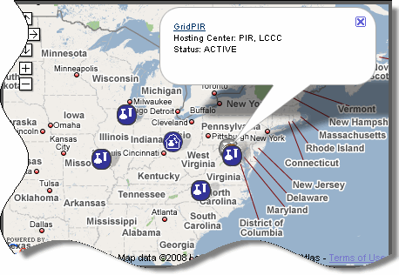
Figure 3-9. Callout balloon for a data service center
- Click the underlined link.
The Services page appears with the Details tab and Service subtab of the Discovery portlet selected, as shown in Figure 3-10.
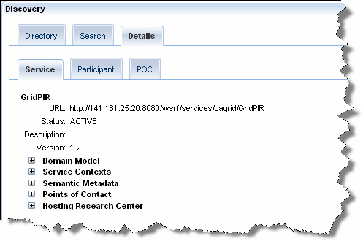
Details tab
Service subtab
Figure 3-10. Discovery Portlet showing details for a selected data service
For more information about the Discovery portlet and the Service subtab, see Viewing Details for Services on page 41.

Selecting an Analytical Service.
- Select the Analytical Services category from the drop-down list.
The map refreshes to show only analytical services.
Note: The portal represents some analytical services using the analytical service icon . Others that are part of a group of services in the same geographic location show a hosting research center icon . You can find analytical services by clicking either icon, but the results will differ slightly, as explained in the next step.
- Click the appropriate icon:
- If you clicked the analytical service icon , the callout balloon displays the same information used for a data service center (shown in Figure 3-9 on page 22):
- a link to more details
- the name of the hosting center
- the current status of the hosting center (active, inactive, or partially active).
Click the details link to view more information on the Service subtab of the Discovery portlet, as shown in Figure 3-10 on page 22.
- If you clicked the hosting research center icon , follow the steps explained in Selecting a Hosting Research Center on page 26.

Selecting a Participant Institute.
- Select the All Participants category from the drop-down list, or select a specific sub-category (for example, Clinical Trials Management Systems).
The map refreshes to show only the selected participant category.
- Click a Participant Institute icon to select the represented service.
A callout balloon appears above the icon. The balloon displays the following information:
- a participant name link
- a URL to the participant’s home page.
Figure 3-11 shows an example of a callout balloon for Lombardi Comprehensive Cancer Center.
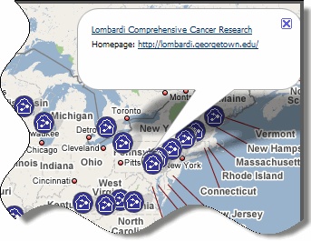
Figure 3-11. Callout balloon for a selected participant
- Click the participant name link (top link).
The Services page appears with the Details tab and Participant subtab selected, as shown in Figure 3-12.
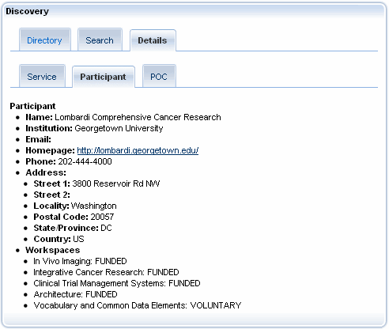
Figure 3-12. Discovery portlet showing details for a participant institute
For more information about the information available on this page, see Viewing Details for a Participanton page 44.

Selecting a Hosting Research Center.
- Find a Hosting Research Center icon , then click the icon.
A callout balloon appears above the icon. The balloon displays the following information:
- the number of services available at the selected location
- a View link.
Figure 3-13 shows an example of a callout balloon for a hosting research center.
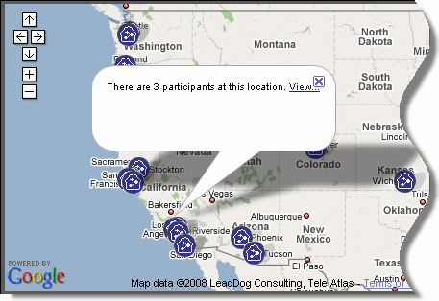
Figure 3-13. Callout balloon for an analytical service center
- Click the View ink.
The Services page appears with the Directory tab and List View subtab selected. The List View subtab displays a list of services.
- In the list at the bottom of the page, do the following:
- Locate the service that you want to view.
- Select the More Details… link on the right, as shown in Figure 3-14.
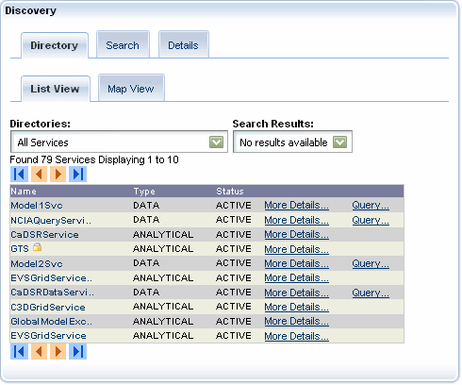
More Details links
Figure 3-14. List of hosting research centers with More Details links
For more information about the information available on the List View subtab, see Viewing Details for an Analytical Service on page 42.
- Click the Home link in the upper left to return to the home page.

Selecting a POC.
As explained in Selecting a Category View on page 20, the Map portlet does not currently display POC information. For more information on finding and viewing details for a POC, see the following sections:
- Searching for a POC on page 39
- Viewing Details for a POC on page 45

Using the Discovery Portlet
In Chapter 1, the Discovery section on page 4 introduced you to the concept of discovery. This chapter introduces the Discovery portlet, which enables you to discover caGrid services, caBIG® participants, and caGrid POCs. It also includes information about the Service Diagnostics portlet, which you can use to learn the status of any caGrid service.
Topics in this chapter:
- About the Discovery Portlet on this page
- Viewing Data in a List or a Map on page 30
- Searching for Services, Participants, and POCs on page 34
- Viewing Details for Services, Participants, and POCs on page 41
- Using the Service Diagnostics Portlet on page 45

About the Discovery Portlet
The Discovery portlet offers a versatile interface for browsing, searching, and viewing metadata. The interface includes drop-down lists, keyword entry fields, and search field selection boxes.
The various Discovery portlet features are available in a series of tabs with subtabs. Table 7-7 describes each tab and its subtabs.
Feature | Description
Directory tab | Enables you to browse for services, participants, or POCs by selecting directories from a drop-down list. You can use a List view or Map view (discussed below).
List View subtab | Displays browsing results in a paginated list. Each result includes a link for viewing more details (metadata). When you hover your mouse over a service result, a popup window appears that displays the service's name, version, type, activity status, URL, and secured status.
Map View subtab | Displays selected items on a map of the U.S. and enables you to link to further information. This tab works the same way as the Map portlet discussed in Chapter 3 on p. 19.
Search tab | Enables you to search for services, participants, and POCs using keywords and search fields.
Services subtab | Used to search for a service by entering one or more keywords and selecting fields to constrain the search. This tab includes both a simple and advanced field set.
Participants subtab | Used to search for a participant by entering one or more keywords and selecting fields to constrain the search.
POCs subtab | Used to search for a POC by entering one or more keywords and selecting fields to constrain the search.
Details tab | Displays metadata for a selected service, participant, or POC.
Service subtab | Displays metadata for a selected service.
Participant subtab | Displays metadata for a selected participant.
POC subtab | Displays metadata for a selected POC.
Table 4-3. Discovery portlet tab descriptions

Viewing Data in a List or a Map
Use the Directory tab when you want to select a category and view its results in a list or on a map. This tab has two subtabs: List View and Map View. The next two sections explain how to use these subtabs.

Using the List View Subtab
The List View subtab enables you to select a category from the Directories list and view the results in a paginated results list. You can also select a saved result set from your current browser session.
Figure 4-15 shows the List View subtab with results displayed for the All Services category. The result list displays ten results per page. Note that each result includes a More Details link. Data services also include a Query link that enables you to build a query for the selected service.
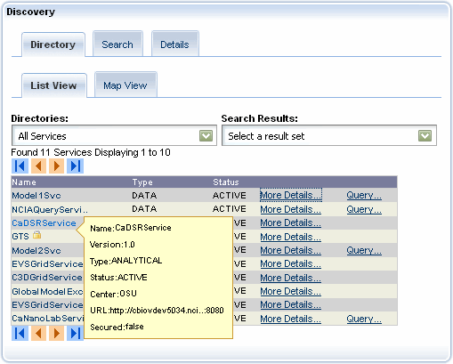
Category: All Services
Result sets
Browse buttons
More Details link
Query link (data service)
Popup window displaying metadata
Figure 4-15. Directory tab > List View subtab – results for All Services category
To view results for a selected category, follow these steps:
- Select the Directory tab.
- Select the List View subtab.
- Do either of the following:
- Select a category from the Directories list; or
- Select a result set from the Search Results list.
The results appear in the lower area of the subtab.
- Use the browse buttons to page through the list:
- Click the Forward button to page forward.
- Click the Back button to page backward.
- Click the Return to return to the beginning of the list.
- Click the Skip to End to skip to the end of the list.
- To view details for a result, click the More Details link.
For more information about viewing details for a result, see Viewing Details for Services, Participants, and POCs on page 41.
- If the results include data services and you want to build a query for a selected service, click the Query link.
For more information about building queries, see Building a Query Using the Query Builder Tool on page 53.

Using the Map View
After you select a category and view the results, you can switch to the Map View subtab for a graphical view of the results. Or, instead of starting with the List View subtab, you can start with the Map View subtab and select a category or result set using its drop-down lists.
To view search results using the Map View subtab, follow these steps:
- Use the List View subtab to select a category and display the results.
For complete instructions, see Using the List View Subtab on page 30.
- Click the Map View subtab.
The map displays the results as shown in Figure 4-16.
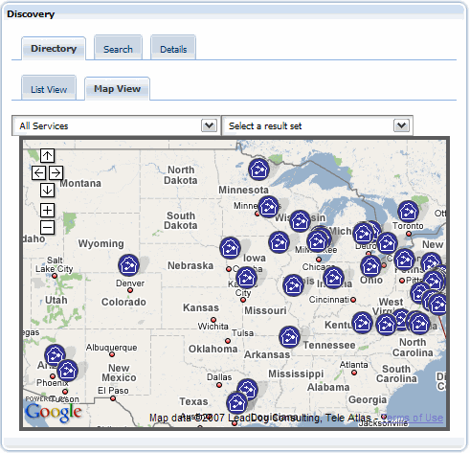
Figure 4-16. Map View subtab
The Map View subtab functions exactly like the Map portlet. For more information, see the following sections in Chapter 3, Using the Map Portlet, on page 19.
- About the Map Portlet on page 19
- Selecting a Category View on page 20
- Selecting a Service, Participant, or POC on page 21

Searching for Services, Participants, and POCs
The Search tab provides a comprehensive solution for finding caGrid services, caBIG® participants, or and caGrid POCs. Each entity has its own search subtab.
The following topics explain how to use each subtab to execute a search:
- Searching for a Service on this page 34
- Searching for a Participant on page 38
- Searching for a POC on page 39

Searching for a Service
Use the Services subtab to search for a service. You have three options for how to perform the search: Simple, Advanced, and EVS.
The Simple and Advanced search modes involve entering one or more keywords and then optionally selecting fields to narrow your results. The Simple search mode includes standard metadata fields while the Advanced search mode expands the available fields by including metadata from the domain model that services expose.
Using the EVS search mode involves entering concept names from the NCI Thesaurus. You can then find services that are related to these concepts. As you type each character in a concept name, the concept-based discovery Portlet suggests concepts that you can select. Results include all services involving the selected concept.
All searches use sub-string, case-insensitive matching.
For more information, see Performing a Simple or Advanced Search on page 34 and Performing an EVS Search on page 36.

Performing a Simple or Advanced Search
To perform a Simple or an Advanced search, follow these steps:
- Click the Search tab.
- Click the Services subtab.
- Select the Simple or the Advanced search option. The Advanced search option includes more fields by which you can narrow your search results.
Figure 4-17 shows the layout of the Services subtab when the Simple search mode is selected.
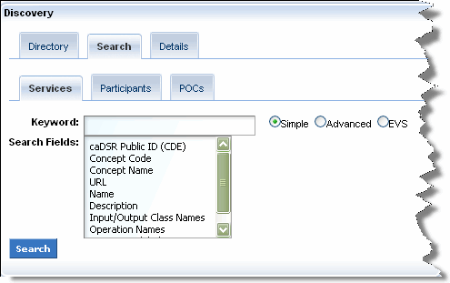
Figure 4-17. Services subtab with the Simple search mode selected
Figure 4-18 shows the layout of the Services subtab when the Advanced search mode is selected.
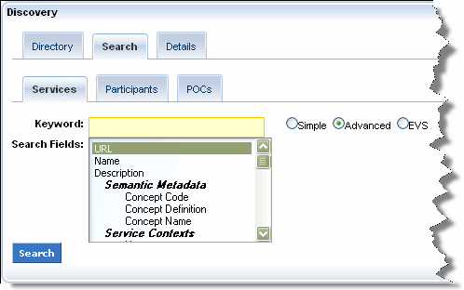
Figure 4-18. Services subtab with Advanced search mode selected
- Enter one or more keywords in the Keyword field.
- Optionally, restrict your search by selecting one or more fields in the Search Fields selection box.
Note: If you do not select any fields in the Simple or Advanced search modes, caGrid Portal includes all fields in its search.
To select consecutive fields in the Search Fields selection box, select a field, press and hold the Shift key, and then select the last field. To select fields that are not consecutive, select a field, press and hold the Ctrl key, and then select additional fields.
- Click Search. The results appear in the lower area of the subtab.
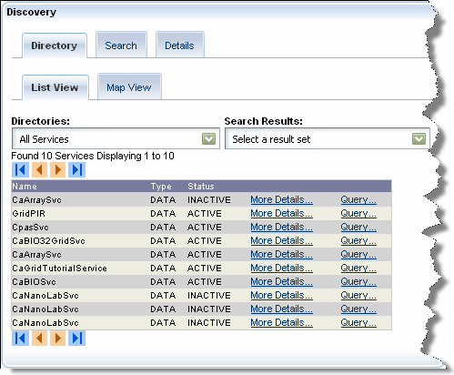
Figure 4-19. Discovered services
- Use the browse buttons to page through the list:
- Click the Forward button to page forward.
- Click the Back button to page backward.
- Click the Return to return to the beginning of the list.
- Click the Skip to End to skip to the end of the list.
- To view details for a result, click the More Details link. For more information about viewing details for a result, see Viewing Details for Services, Participants, and POCs on page 41.
Note: When you hover your mouse over a service result, a popup window appears that displays the service's name, version, type, activity status, URL, and secured status.
- If the results include data services and you want to build a query for a selected service, click the Query link. For more information about building queries, see Building a Query Using the Query Builder Tool on page 53.

Performing an EVS Search
To perform an EVS search, follow these steps:
- Click the Search tab.
- Click the Services subtab.
- Select the EVS search option.
Figure 4-17 shows the layout of the Services subtab when the EVS search mode is selected.
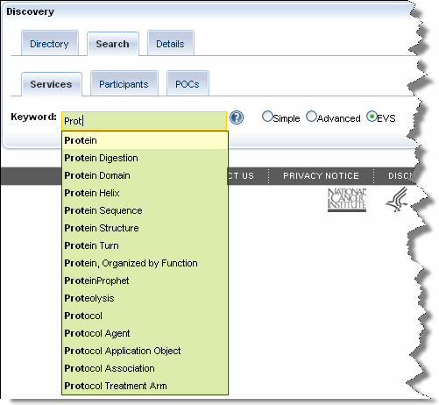
Figure 4-20. Services subtab with the EVS search mode selected
- Discover services by entering concept names into the Keyword field. As you type each letter, the auto completer searches concepts relevant to services in the Portal. If it doesn't find a match, it looks up concepts in the NCI Thesaurus.
- Select the concept matching the services you want to discover and then press Enter. The concept code, concept definition, and relevant services for the selected concept appear in the tab.
Figure 4-21 shows the results of an EVS search.
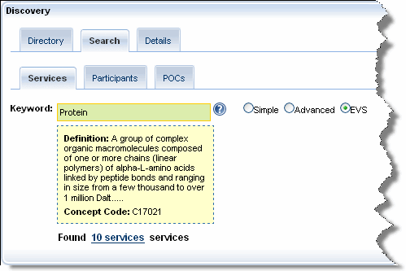
Figure 4-21. Results of an EVS search
- Click the link noting how many services match the concept you selected. The results appear in the lower area of the subtab.
Figure 4-22. Discovered services
- Use the browse buttons to page through the list:
- Click the Forward button to page forward.
- Click the Back button to page backward.
- Click the Return to return to the beginning of the list.
- Click the Skip to End to skip to the end of the list.
- To view details for a result, click the More Details link. For more information about viewing details for a result, see Viewing Details for Services, Participants, and POCs on page 41.
- If the results include data services and you want to build a query for a selected service, click the Query link. For more information about building queries, see Building a Query Using the Query Builder Tool on page 53.

Searching for a Participant
Use the Participants subtab to search for a participant by entering one or more keywords and selecting fields to constrain the search. The search form includes a Keyword field and a Search Fields selection box, as shown in Figure 4-23.
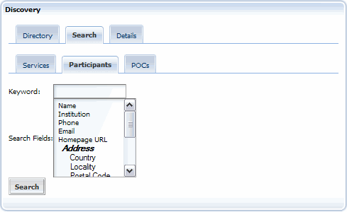
Figure 4-23. Participants subtab
To search for a participant, follow these steps:
- Click the Search tab.
- Click the Participants subtab.
- Enter one or more keywords in the Keyword field.
- Select fields from the Search Fields selection box.
Note: If you do not select search fields, all of the fields are used in the search.
- Click Search.
The results appear in the lower area of the subtab.
- Use the browse buttons to page through the list:
- Click the Forward button to page forward.
- Click the Back button to page backward.
- Click the Return to return to the beginning of the list.
- Click the Skip to End to skip to the end of the list.
- To view details for a result, click the More Details link.
For more information about viewing details for a result, see Viewing Details for Services, Participants, and POCs on page 41.

Searching for a POC
Use the POCs subtab to search for a POC by entering one or more keywords and selecting fields to constrain the search. The search form includes a Keyword field and a Search Fields selection box, as shown in Figure 4-24.
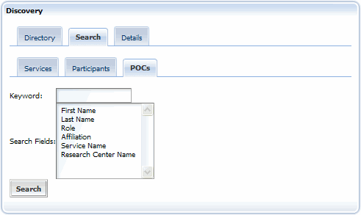
Figure 4-24. POCs subtab
To search for a POC, follow these steps:
- Click the Search tab.
- Click the POCs subtab.
- Enter one or more keywords in the Keyword field.
- Select fields from the Search Fields selection box.
Note: If you do not select search fields, all of the fields are used in the search.
- Click Search.
The results appear in the lower area of the subtab.
- Use the browse buttons to page through the list:
- Click the Forward button to page forward.
- Click the Back button to page backward.
- Click the Return to return to the beginning of the list.
- Click the Skip to End to skip to the end of the list.
- To view details for a result, click the More Details link.
For more information about viewing details for a result, see Viewing Details for Services, Participants, and POCs on page 41.

Viewing Details for Services, Participants, and POCs
The Details tab displays metadata for services, participants, and POCs. The following topics discuss the level of detail for each entity:
- Viewing Details for Services on this page
- Viewing Details for a Participant on page 44
- Viewing Details for a POC on page 45

Viewing Details for Services
caGrid Services provide a standard set of metadata. This metadata includes descriptions of the service’s operations, information about the hosting research center and, if the service is a data service, the complete domain model that is supported by the service.
In addition, data types that the service operations use are defined by XML schemas and are registered with the Global Metadata Exchange (GME) service.

Viewing Details for a Data Service
To view details for a data service, follow these steps:
- Use the Directory or Search tabs to find the desired data service.
For more information, see the following topics:
- Using the List View Subtab on page 30
- Searching for a Service on page 34
- Click the Details tab.
Details for the selected data service appear on the Service subtab, as shown in Figure 4-25.
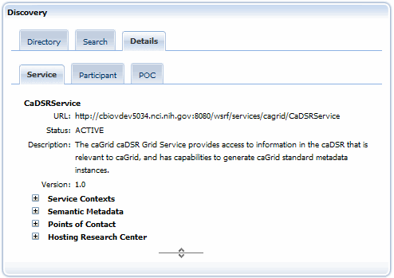
Figure 4-25. Details for a selected data service
- Click the plus sign preceding each top-level of metadata to drill down to the sub-levels.
For example, when viewing details for a data service, you can drill down through the complete domain model that the service supports. You can then select a class for a query by clicking the Select For Query button, as shown in Figure 4-26.
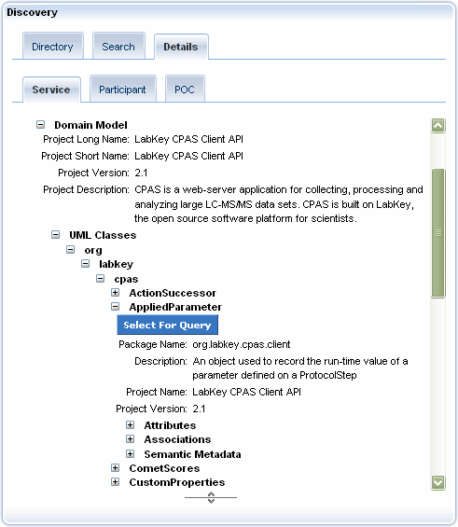
Figure 4-26. Selecting a UML class for a query

Viewing Details for an Analytical Service
To view details for an analytical service, follow these steps:
- Use the Directory or Search tabs to find the desired analytical service.
For more information, see the following topics:
- Using the List View Subtab on page 30
- Searching for a Service on page 34
- Click the Details tab.
Details for the selected analytical service appear on the Service subtab, as shown in Figure 4-27.
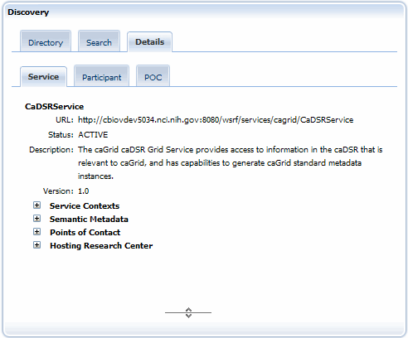
Figure 4-27. Details for a selected analytical service
- Click the plus sign preceding each top-level of metadata to drill down to the sub-levels.
Note: Analytical services do not include a domain model.

Viewing Details for a Participant
To view details for a participant, follow these steps:
- Use the Directory or Search tabs to find the desired participant.
For more information, see the following topics:
- Using the List View Subtab on page 30
- Searching for a Participant on page 38
- Click the Details tab.
Details for the selected participant appear on the Participant subtab, as shown in Figure 4-28.
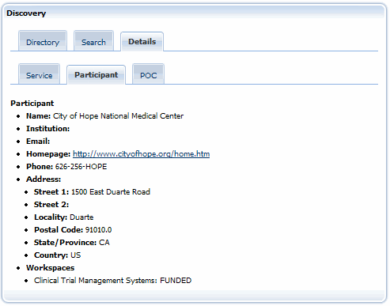
Figure 4-28. Details for a selected participant

Viewing Details for a POC
To view details for a POC, follow these steps:
- Use the Directory or Search tabs to find the desired POC.
For more information, see the following topics:
- Using the List View Subtab on page 30
- Searching for a POC on page 39
- Click the Details tab.
Details for the selected POC appear on the POC subtab, as shown in
Figure 4-29.
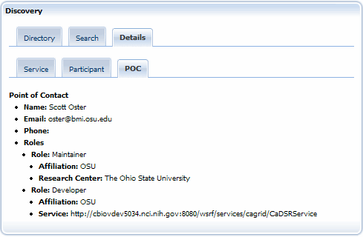
Figure 4-29. Details for a selected POC

Using the Service Diagnostics Portlet
The Service Diagnostics portlet runs basic diagnostic tests on any caGrid service, allowing service developers to check the health of their service or diagnose service advertisement issues.

About the Service Diagnostics Portlet
Access the Service Diagnostics portlet at the bottom of the Services tab.
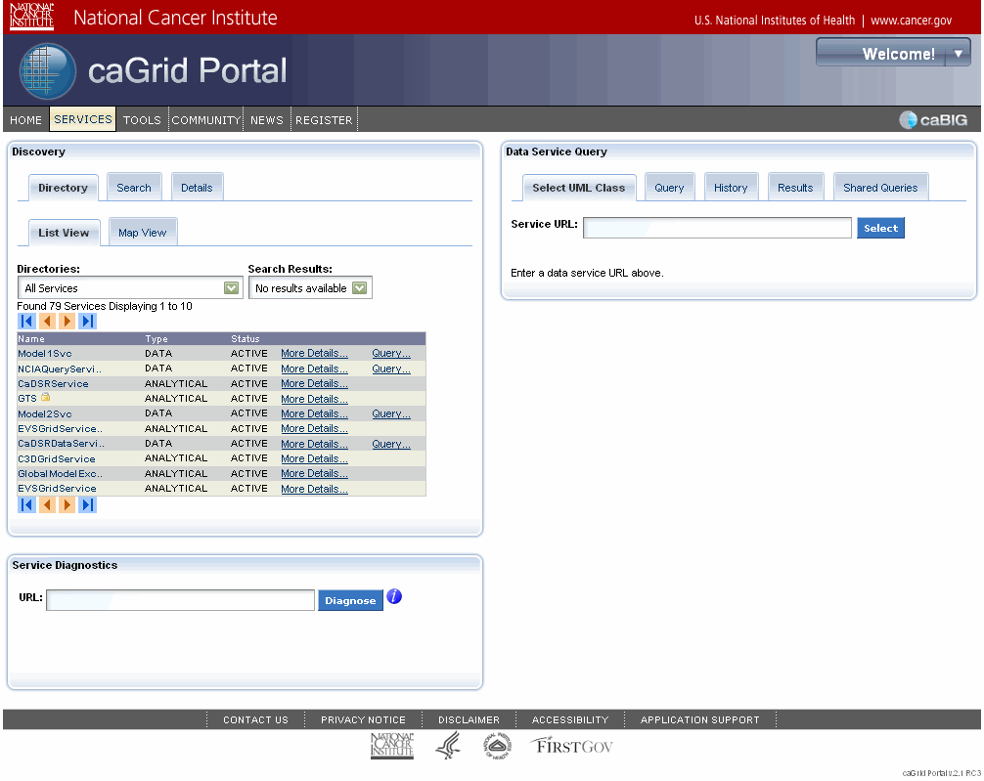
Service Diagnostics portlet
Figure 4-30. Service Diagnostics portlet on the Services tab
The Service Diagnostics portlet runs the following tests:
- Checks the service's status in the caGrid Portal.
- Checks that the service is available, by retrieving and validating the service WSDL (Web Services Description Language).
- Checks the service metadata, by retrieving and validating the service metadata.
- Checks the caGrid Index Service to ensure that the service is advertising correctly.
Note: When the Service Diagnostics portlet checks the status of a service, it checks the status of that service's registration with the Index Service.
Note: The caGrid Portal is only aware of the Index Service it is.

Running Diagnostic Tests
To run diagnostic tests on a service, follow these steps:
- In the URL field, enter the URL of the service you want to check.
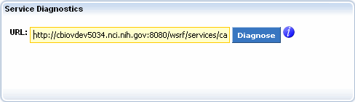
Figure 4-31. URL field in the Service Diagnostics portlet
- Click . The Portal runs diagnostic tests and reports the results.
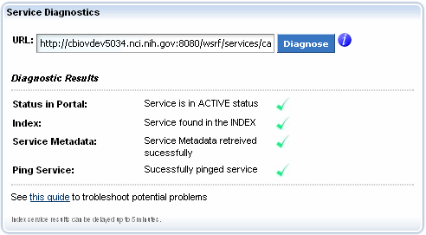
Figure 4-32. Successful result in the Service Diagnostics portlet

Interpreting Results of Diagnostic Tests
If you enter an incorrect or malformed URL for a service, the Service Diagnostics portlet indicates this in the test results. Click where it is available to view more information about a diagnostic result or function in the portlet.
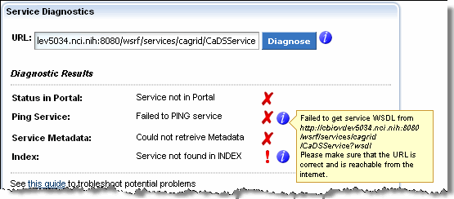
Figure 4-33. Unsuccessful result in the Service Diagnostics portlet
See http://www.cagrid.org/wiki/CaGrid:How-To:TroubleshootIndexService to review problems that can prevent proper advertisement and registration of a service to the Index Service.

Using the Data Service Query Portlet
The Data Service Query portlet enables you to query services that support the CQL query language. This chapter explains how to build and share queries.
Topics in this chapter:
- About the Data Service Query Portlet on this page
- Query-Building Scenarios on page 51
- About the History Tab on page 68
- Working with Shared Queries on page 70

About the Data Service Query Portlet
Using the Data Service Query portlet, you can build and execute a query (CQL or DCQL), view the results in tabular form, and export to Microsoft Excel or XML form. As long as you are a registered portal user, the portal maintains a complete history of your queries so that you can always retrieve and work with your previously executed queries.
The Data Service Query portlet interface is organized in a series of tabs. Table 5-4 describes each tab.
Tab | Description
Select UML Class | Enables you to enter a URL for a selected data service and view a list of UML classes.
Query | Provides two subtabs:  - Query Builder, which provides a graphical interface for building CQL and DCQL queries  - Query XML, which enables you to enter a data service URL and query directly and then execute or share the query
History | Shows all of your stored queries.
Results | Displays query results in tabular or XML form.
Shared Queries | Provides a Find Shared Queries subtab that includes both a Keyword field and a Search Fields selection box. You can use these tools to search for shared queries.
Table 5-4. Data Service Query portlet tab descriptions
Tip: For more information about CQL and DCQL concepts, see http://www.cagrid.org/mwiki/index.php?title=Data_Services:CQL and http://www.cagrid.org/wiki/Federated_Query:DCQL.

Query-Building Scenarios
To execute a query, you need the following:
- The URL of the caGrid data service to which the query will be sent
- The query itself
The portal provides several approaches for specifying these requirements. The following scenarios explain each approach.

Scenario 1: Starting without a URL or Query
If you do not have the service URL or the query, follow these steps:
- Locate a service using either the Directory or Search tab of the Discovery portlet.
For more information, see Searching for a Service on page 34.
- If you want to view metadata for a UML class before selecting it for a query, follow substeps 2a through 2d. Otherwise, skip to step 3:
- Click the More Details link for the desired service.
- Expand the Domain Model.
- Drill down to the metadata for a selected class.
- Click Select for Query.
- To select the desired service from the results list, follow these steps:
- Click the Query link for the desired service.
On the Data Service Query portlet > Select UML Class tab, the Service URL field displays the URL for the selected service. A list of UML classes appears below the field, as shown in Figure 5-34.
Query link
Service URL
UML classes
More Details link

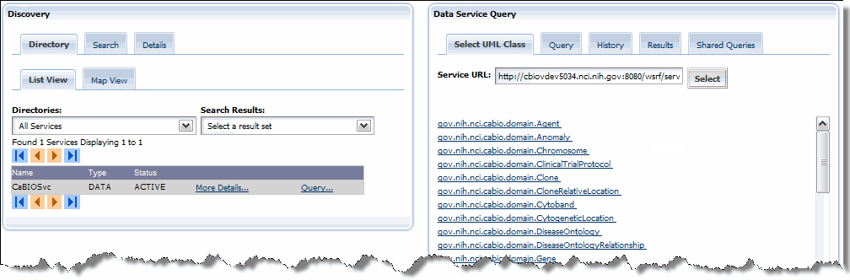
Figure 5-34. Starting a query from a selected result
- Click the desired UML class.
On the Data Service Query portlet, the Query tab > Query Builder subtab displays a working query, as shown in Figure 5-35.
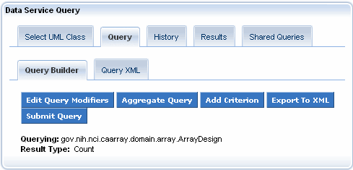
Figure 5-35. Working query

Scenario 2: Starting with a URL but No CQL Query
If you have the service URL but no CQL query, follow these steps:
- On the Data Service Query portlet, click the Select UML Class tab.
- Enter the URL in the Service URL field.
- Click Select.
- Click the desired UML class from the list.
The Query tab > Query Builder subtab displays a working query.

Scenario 3: Starting with a URL and a CQL Query
If you have both the URL and the CQL query, follow these steps:
- On the Data Service Query portlet, click the Query tab.
- Click the Query XML subtab.
- Enter the URL in the URL field.
- Enter the CQL query in the Query text field.
- Click Submit Query.

Building a Query Using the Query Builder Tool
caGrid data services all use a uniform query language, Common Query Language (CQL), to express queries against a data source using an object oriented language.
To express queries over a combination of caGrid data services, you must use Distributed caBIG® Query Language (DCQL) instead. DCQL queries include two types, aggregate and distributed.
You can use the Query Builder tool to create both CQL and DCQL queries.
This section includes the following topics:
- Building CQL Queries, below
- Building DCQL Queries on page 58

Building CQL Queries
The Query tab > Query Builder subtab provides a graphical interface for building queries. Although you can use this tool without knowing CQL, you can more easily use the tool if you understand CQL concepts. You can learn more at http://www.cagrid.org/mwiki/index.php?title=Data_Services:CQL.
To use the Query Builder subtab, you must first select the service and URL as explained in Scenario 1: Starting without a URL or Query on page 51. After you have selected a UML class for the query, the Query Builder tab resembles Figure 5-36.
Figure 5-36. Query Builder subtab with selected UML class ArrayDesign
To modify and submit the query, follow these steps:
- Click Edit Query Modifiers to select one of the options described in
Table 5-5.
Option | Description
Object | Returns full results from the data service.
Count Only (the default) | Returns only the count of objects that match specified criteria.
Distinct Attribute | Returns the unique value of one of the following attributes of the UML class being queried:  - clusterID  - fullName  - id  - symbol  You can select only one of these attributes.
Selected Attributes | Displays the same four attributes offered by the Distinct Attribute option, but enables you to select multiple attributes. If you select this modifier, the results will include only these attribute values for each object in the result set.
Table 5-5. Options for editing query modifiers
- When you have finished editing modifiers, click Update.
The Result Type updates to show the selected attributes.
- To add a criterion to the query, click Add Criterion.
The Query Builder subtab displays a list of attributes and associations for the selected class, as shown in Figure 5-37.
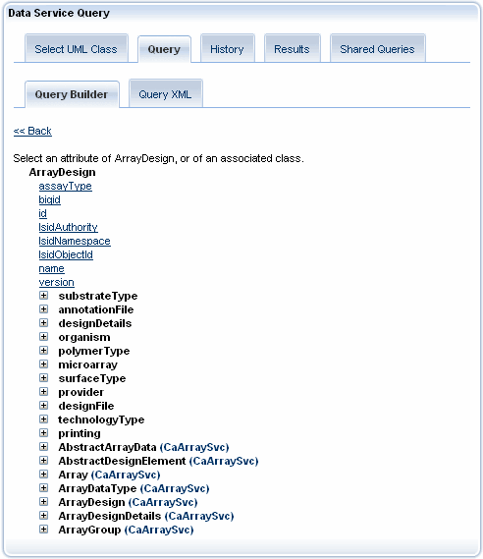
Figure 5-37. Attributes and associations for selected class
- Select an attribute.
A form appears with the name of the selected attribute.
- Set the predicate by selecting it from the drop-down list.
- Enter a value.
The form should now resemble Figure 5-38.
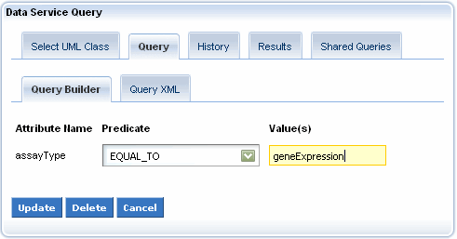
Figure 5-38. Specifying a predicate and value for a selected attribute
- Click Update.
The Query Builder subtab should now resemble Figure 5-39.
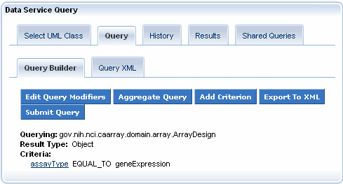
Figure 5-39. Query Builder subtab with added criterion
Although you can add multiple criteria to a query, the Query Builder does not currently support logical OR groupings other than for multiple values specified for the same criterion. Currently, the tool groups all criteria using a logical AND. If you specify multiple values for a specific criterion, the tool creates multiple criteria and groups them by OR. To further edit your query, you can export it to XML format.
Note: Once you export a CQL query to XML, you cannot edit the query and then switch back to using the Query Builder tool.
- (Optional) To export your query to XML format, follow these steps:
- Click Export to XML.
The Query XML tab appears in front. The URL field displays the service URL, and the Query field displays the XML structure for the query.
- Edit the XML structure as needed.
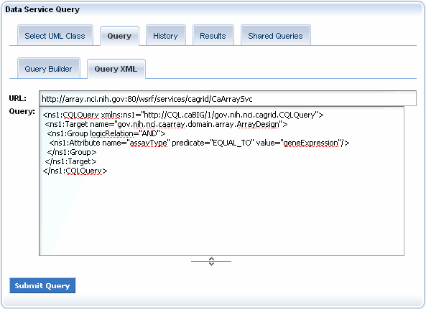
Figure 5-40. Query XML tab
- When you have finished building the query, click Submit Query.
The History tab appears in front. This tab displays the query State, Start Time, Finish Time, and Service, as shown in Figure 5-41.
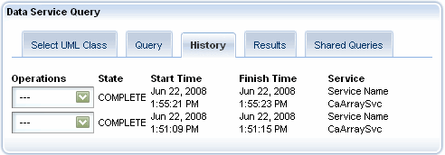
Figure 5-41. History tab with query information
For more information about the History tab, see About the History Tab on page 68.

Building DCQL Queries
caGrid supports federated queries through a infrastructure service called the Federated Query Processor (FQP) and a language known as Distributed caGrid Query Language (DCQL). FQP service supports the execution of DCQL queries.
After you build DCQL queries using the Query Builder tool, the Portal then asynchronously executes them against an available FQP service.
There are two types of DCQL queries that you can construct in the caGrid Portal: aggregate and distributed. Aggregate queries aggregate similar data from multiple services. Distributed queries have distributed joins across multiple services on the grid.
The following sections explain how to create aggregate (below) and distributed join queries using DCQL (on page 60).

Building Aggregate DCQL Queries
Aggregate queries run against two or more data services and return an aggregated result set.
General steps for building an aggregate DCQL query in the caGrid Portal are as follows:
- Discover caGrid Data Services providing a UML Class name.
- Constrain the query using some query criteria.
- Determine possible aggregation scenarios.
- Execute the aggregate query.
For example, an aggregate query might involve retrieving all ArrayDesigns from the caArray data service hosted at Georgetown University and the caArray data service hosted at NCICB.
To build this aggregate DCQL query, follow these steps:
- Select the service and URL for the query as explained in Scenario 1: Starting without a URL or Query on page 51.
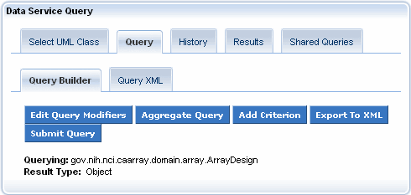
Figure 5-42. Query Builder specifying a service and URL
- Click Aggregate Query. All services with the chosen UML class, in this case ArrayDesign, appear.
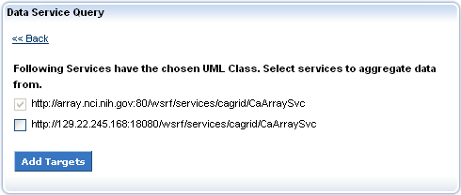
Figure 5-43. Services with the same UML class to aggregate from
- Select the checkboxes for all of the services from which to aggregate the chosen UML class.
- Click Add Targets. A summary of the data services you selected for the aggregate query appears.
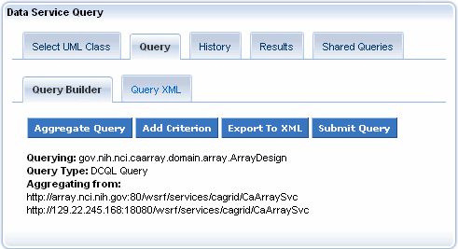
Figure 5-44. Summary of data services selected for aggregation
- Click Submit Query. The History tab appears in front. As shown in Figure 5-45, this tab displays the query state, start time, finish time, and service. The service is in this case is the Federated Query Processor.
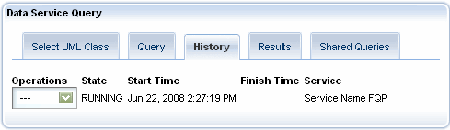
Figure 5-45. History tab with query information
For more information about the History tab, see About the History Tab on page 68.

Building Distributed DCQL Queries
Distributed queries link semantically equivalent domain objects across multiple data services. You can construct DCQL queries manually and execute them through a command line. The caGrid Portal helps in visualizing the possible joins and then providing the tool to build DCQL queries that contain cross-service joins.
The following text describes how the caGrid portal can be used to query a grid service in a federated fashion. See here for a video that covers most of the same information.
The steps involved are:
- Select a caGrid data service.
- Select a UML class from the selected data service to query on.
- Specify query criteria on the selected UML class by specifying join conditions based on a UML class from a second caGrid data service.
- Execute the distributed join query and view the results.
We can correlate data between services by doing a distributed join. For example, we can retrieve all NucleicAcidSequence objects from the caBIO32 grid service hosted at NCI/CBIIT where they are related to the proteins that we retrieve from the GridPIR grid service hosted at Georgetown University.
When building a query against the model of one service, the portal automatically displays UML classes in other models if they have at least on concept code in common. The service name next to the UML class name indicates the source of the UML class. Classes that share a concept code are most likely to also contain attributes that can be used as a join condition.
To build this aggregate DCQL query, follow these steps:
- Select the service and URL for the query as explained in Scenario 1: Starting without a URL or Query on page 51.
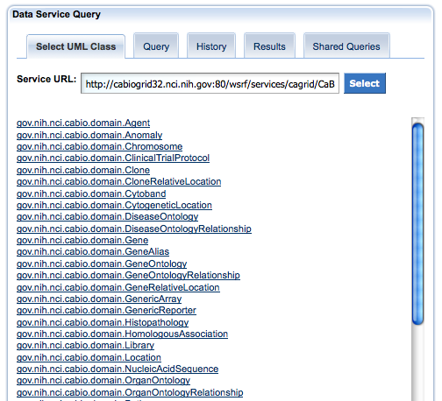
Figure 5-46. Query Builder specifying a service and URL
- Select the gov.nih.nci.cabio.domain.NucleicAcidSequence class.
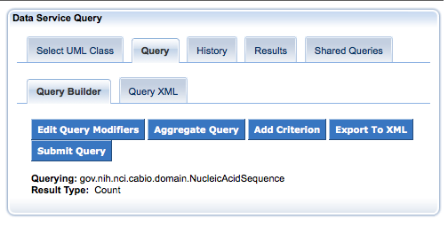
Figure 5-47 Query Builder tool with selected NucleicAcidSequence class
- Click the Add Criterion button. All of the possible criteria (class attributes and associations) appear as shown in Figure 5-49.
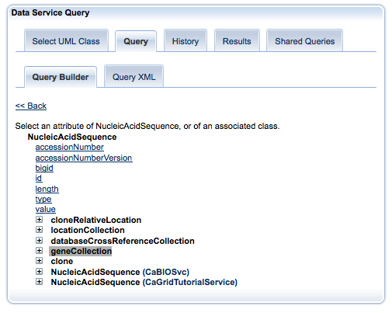
Figure 5-48 Tree view of attributes and associations for the NucleicAcidSequence class
- Expand the NucleicAcidSequence class tree node by selecting the geneCollection association. Further expand the tree by selecting the proteinCollection association as shown in Figure 5-49.
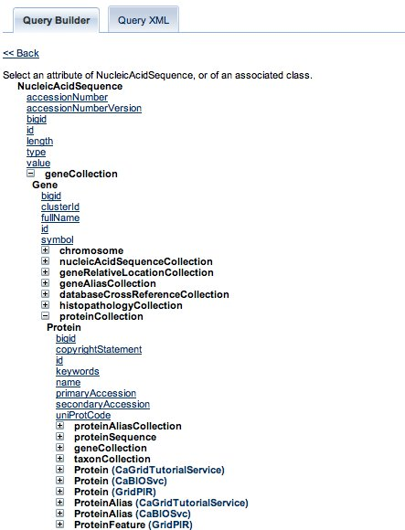
Figure 5-49 Query criterion tree view for caBIO NucleicAcidSequence class
Hovering the mouse over any service name that is next to a UML class provides further information about the service.
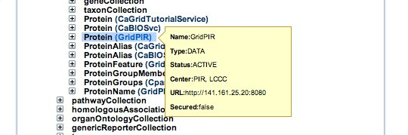
Figure 5-50 Service information for semantically equivalent UML class
- Select the Protein class from the GridPIR service. The Protein class belongs to an external service (GridPIR) and is considered a foreign association in DCQL.
- Expand the “foreign” UML class node. The Join Condition dialog box appears.
- Select the Local Attribute as uniProtCode and the Foreign Attribute as uniprotkbEntryName as shown in Figure 5-51.
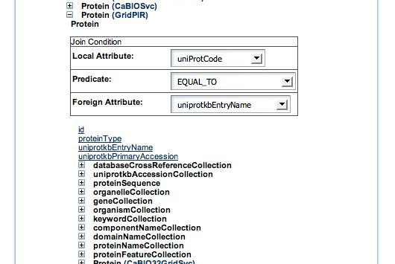
Figure 5-51 Selecting the join condition
- Expand the tree by selecting the organismCollection association tree node on the Protein class. Click the scientficName attribute of the Organism class. This lets you specify a value on the scientificName criterion for the Protein class as shown in Figure 5-52.
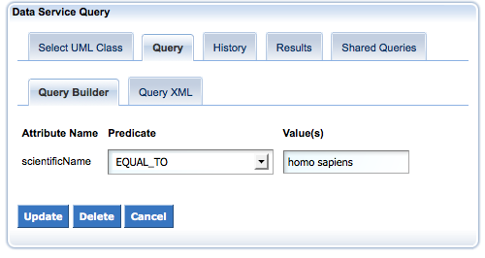
Figure 5-52 Entering criterion value for Organism scientificName attribute
- Repeat steps 3-5. Select the geneCollection association tree node on the Protein class from GridPIR. Click the name attribute and enter brca1 for the criterion as shown in Figure 5-53.
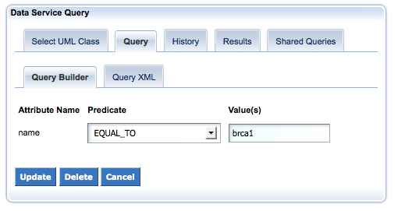
Figure 5-53 Enter criterion value for Gene name attribute
The complete query is shown in Figure 5-54.
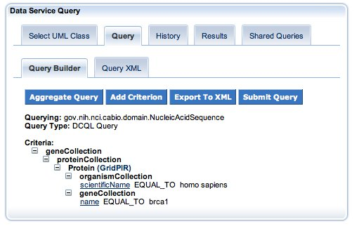
Figure 5-54 Complete federated query for caBIO NucleicAcidSequence class
- Click the Export To XML button. The DCQL query appears in XML format, as shown in Figure 5-55.
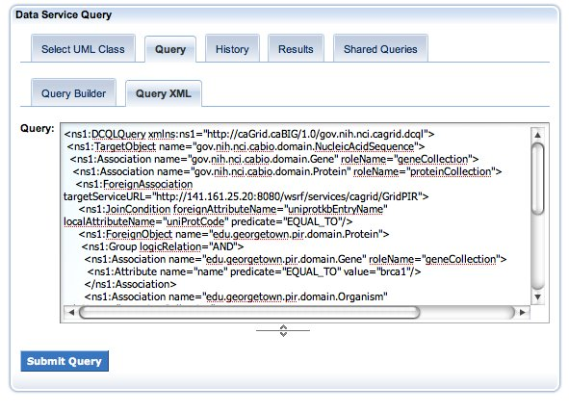
Figure 5-55 XML federated query for caBIO NucleicAcidSequence class
- Click Submit Query. The query starts executing asynchronously. The History tab shows the running query as shown below.
Figure 5-56 History Tab with the running DCQL query
After the query completes, the State text field automatically updates from Running to Complete.
- In the Operations list, select View Results. The Results tab appears where you see the results of the distributed join query as shown in Figure 5-57.
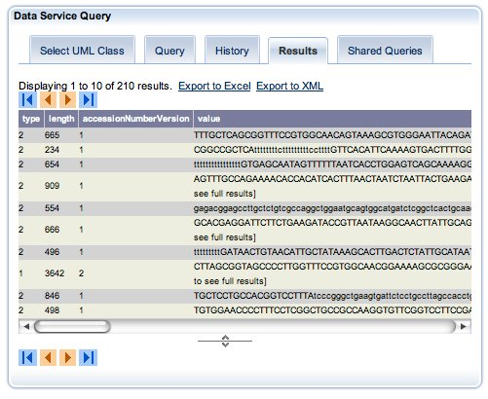
Figure 5-57 Results of federated query for caBIO NucleicAcidSequence class

About the History Tab
As noted in the last section, when you run a query from the Query Builder or Query XML subtabs, the History tab becomes the active tab. This tab displays information about all of the queries you have executed.
If are a registered caGrid Portal user, the History list displays all queries that you have executed since you registered. If you are not registered, then you will see only queries that you have executed during the current browser session. The most recent query appears first.
The History tab also includes an Operations list, which includes the following operations:
- View Results – Displays the query results in the Results tab in tabular format as shown in Figure 5-58. The result list shows ten results at a time and includes buttons for browsing by page, skipping to the end of the list, or skipping to the beginning of the list. The Export to Excel link allows you to open or save the query in an Excel (*.xls) workbook and the Export to XML link allows you to open or save the query in XML format.
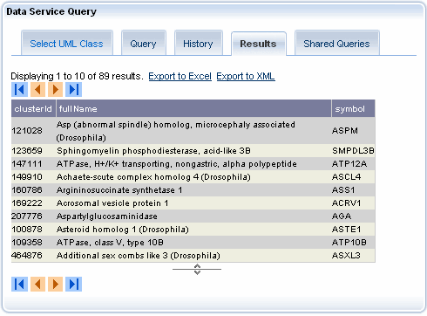
Figure 5-58. Results tab showing query results
- Reload – Reloads the query into the Query XML subtab, where you can edit the query or run it again.
- Delete – Removes the query from the query history.

Table 5-6 describes the remaining information displayed on the History tab.
Option | Description
State | The current state of the query. The next five rows list each status and explain what operations you can perform while each status is in effect.
RUNNING | Indicates that the query is still running. You can cancel or delete the query.
COMPLETE | Indicates that the query completed successfully. You can view results, reload, or delete the query.
ERROR | Indicates that the query failed. You can view the error, reload the query, or delete the query.
CANCELED | Indicates that you canceled the query. You can reload or delete the query
TIMED OUT | Indicates that the system canceled the query. You can reload or delete the query
Start Time | The time that the query started running, displayed in hours, minutes, and seconds.
Finish Time | The time that the query finished running, displayed in hours, minutes, and seconds.
Service | The name of the target service.
Table 5-6. History tab information

Working with Shared Queries
If you are currently logged in, you can share new or previously executed queries with other caGrid Portal users. This section explains how to share a query and how to search for shared queries.
Note: Only CQL queries can be shared. DCQL queries cannot be shared at this time.

Sharing a Query
To share a query, follow these steps:
- If you are not currently using the Data Service Query portlet, click the Services tab on the main navigation bar.
- To share a new query, follow these steps:
- Build the query as explained in Building a Query Using the Query Builder Tool on page 53.
- Skip to step 4.
- To share a previously executed query, follow these steps:
- Click the History tab.
- Select the Re-load command from the Operations drop-down list.
- Continue to the next step.
- On the Query tab > Query Builder or Query XML subtab, click Share Query.
The Shared Queries tab > My Queries subtab becomes the active tab.
- Enter a name and description for the query using the My Queries form shown in Figure 5-59.
Note: The name and description are required.
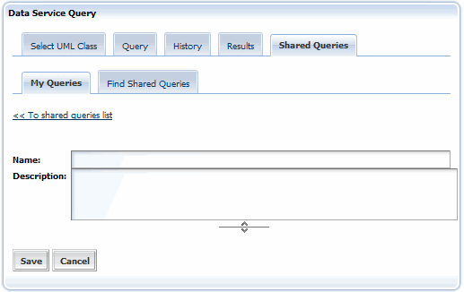
Figure 5-59. Form for adding a query name and description
- Click Save.
A message confirms that the shared query has been successfully saved.
- Click the << To shared queries list link.
The Shared Queries tab > My Queries subtab becomes the active tab. Your saved, shared query is summarized at the bottom of the form.
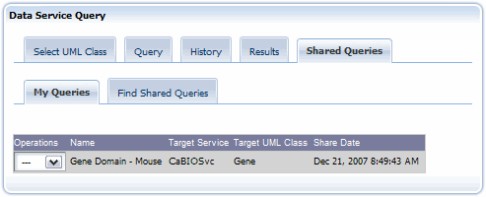
Figure 5-60. Saved query
The query summary shows the following information:
- A slightly different version of Operations drop-down list
(see step 8)
- Name
- Target Service
- Target UML Class
- Shared Date
- (Optional) Select any of the following options from the Operations drop-down list:
- Edit – Returns to the Shared Queries tab > My Queries subtab, where you can edit the query name and description.
- Load – Runs the query and displays the Query tab > Query XML subtab.
- View – Activates the Shared Queries tab > My Queries subtab and shows the query in XML format.

Searching for a Shared Query
You can search for shared queries using a keyword search and selected constraints, including the target service, target UML class, and query creator.
To search for a shared query, follow these steps:
- If you are not currently using the Data Service Query portlet, click the Services tab on the main navigation bar.
- Click the Shared Queries tab.
- Click the Find Shared Queries subtab.
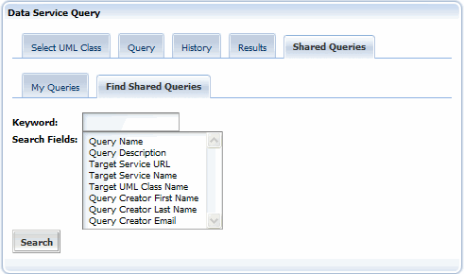
Figure 5-61. Shared Queries tab > Find Shared Queries subtab – Search form
- Enter one or more keywords in the Keyword field.
- Select desired search constraints in the Search Fields selection box.
Note: If you do not select search fields, all of the fields are included in the search.
- Click Search.
The query results appear in a paginated list.
- (Optional) To edit, load, or view a found query, select an option from the Operations list.

Using the Community Portlet
Developers in the caBIG® community may create Java Specification Request 168 (JSR 168) compliant portlets and then deploy them to the caGrid Portal. This chapter provides references to community developers who may want to develop such a portlet.
Topics in this chapter:
- About JSR 168 and the Liferay Portal on this page
- Accessing the Community Portlet on this page
- Deploying a Community Portet on page 76

About JSR 168 and the Liferay Portal
The Java Community Process (JCP), an open, international, community-based organization, created the JSR 168 in 2003 to enable interoperability between portlets and portals.
The caGrid Portal was built on the Liferay Portal, an open-source portal designed to deploy portlets that adhere to JSR 168. The caGrid Portal can therefore host any JSR 168 compliant portlet application.
For more information about JSR 168, see http://jcp.org/en/jsr/detail?id=168/. For more information about Liferay, see http://www.liferay.com/.

Accessing the Community Portlet
You can access all available community portlets on the Community tab.
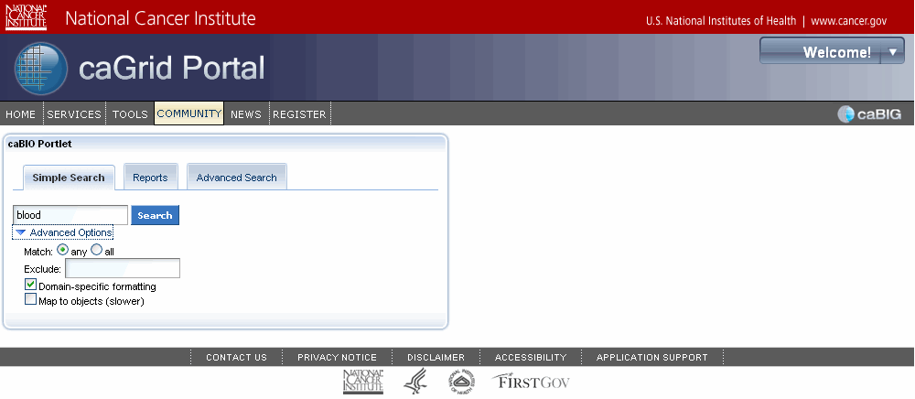
Figure 6-62. Community Portlet, caBIO Portlet example
At this time, only one portlet has been deployed within caGrid. The number of community portlets will expand over time.
Get online help for each community portlet by clicking the question mark icon in the portlet window.

Deploying a Community Portet
More information about developing and deploying a JSR 168 portlet in the caGrid Portal are available in the Community Portlet Guide at http://www.cagrid.org/wiki/Portal:2.1:CommunityPortlets/.
Before submitting your portlet to the caGrid team, be sure to test it locally. Instructions for deploying a JSR 168 compliant portlet into a local installation of caGrid Portal are located in the Community Portlet Guide.

Using Other Portal Features
The previous chapters covered the main caGrid Portal features used for discovering and querying caGrid services, caBIG® participants, and caGrid POCs. The portal includes other useful portlets: News, caGrid Links, caGrid Status, and Calendar. This chapter provides an overview of the portlets.
Topics in this chapter:
- Using the News Portlet on this page
- Using the caGrid Status Portlet on page 81
- About the Calendar Portlet on page 82

Using the News Portlet
The caGrid Portal gives you the latest caGrid-related news through an RSS news feed. You can view the latest news on the portal site using two links:
- The News portlet on the home page
The portlet displays news headlines as links. The posting date and time, as well as a portion of the text follow each headline from the article. Clicking a link opens the News page, where you can read the full article.
- The News link on the main navigation bar
This link takes you directly to the News page, shown in Figure 7-64 on page 79.

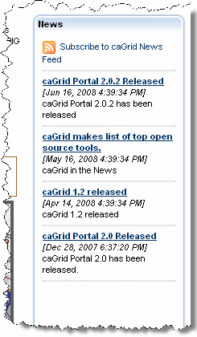
News link
Figure 7-63. News links
On the News page, the main article appears in the middle area of the page. Other article links are listed in the Other News section at the bottom of the page.
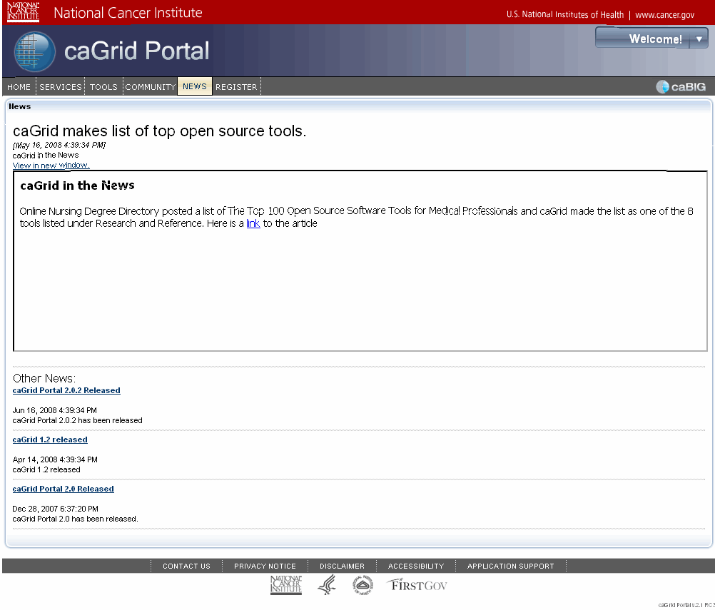
Main article shows here.
Other article links are listed here.
Figure 7-64. News page
Note: You can subscribe to the portal news feed directly from your browser or using any RSS 2.0-compliant news reader.

About the caGrid Links Portlet
The caGrid Links portlet includes links to the following sites:
- The caGrid Portal User's Guide at https://gforge.nci.nih.gov/plugins/scmcvs/cvsweb.php/~checkout~/cagrid-1-0/Documentation/docs/portal/portal2/guides/caGrid-Portal_2.0.2_UsersGuide.pdf?rev=HEAD;content-type=text%2Fplain;cvsroot=cagrid-1-0 is the latest version of this guide.
- caGrid Portal Wiki Pages at http://www.cagrid.org/mwiki/index.php?title=Portal:Portal. caGrid developers maintain these pages and use them to document all of the features of the caGrid Portal.
- The caBIG® Community Website at https://caBIG.nci.nih.gov/. This site provides a comprehensive overview of caBIG®.
- The caGrid Website at https://cabig.nci.nih.gov/workspaces/Architecture/caGrid. This site provides an overview of the caGrid.
- The caGrid Wiki at http://www.cagrid.org/mwiki/index.php?title=CaGrid. This site provides a collaborative environment for caGrid users.

Using the caGrid Status Portlet
The caGrid Status portlet provides a quick, visual description of the scale and activity of caGrid.
As shown in Figure 7-65, the Status portlet is located on the right side of the home page, just below the Login and Register links.
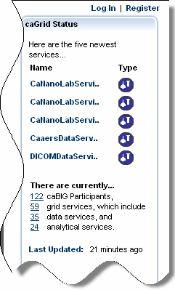
Figure 7-65. Status portlet
The following table explains the information that the portlet provides.
Status Item | Description
Service links | Click the links to the five most recently registered services. Links open the Services page where you can use the Discovery portlet to view details for a specific service or select from a list view.
Service info popup window | Hover your mouse over any service to quickly see the service's name, type, status, hosting center, hosting center URL, and secured status.
Type icons | Icons that denote the service type. See Selecting a Service, Participant, or POC on page 21 for a table explaining each icon.
Counts | Up-to-date counts of all participants, services, data services, and analytical services.
Timestamp | Indicates the last time at which the portal aggregated data from the index service.

Viewing Details for a Recently Registered Service or Participant
The upper half of the Status portlet lists the five most recently registered services or participants with an identifying icon to the right of each listed item.
To view details for an item, click the name of the item. The Services page appears with the Details tab and Service subtab of the Discovery portlet selected. From there you can drill down to more detail as discussed in Chapter 4, Using the Discovery Portlet, on page 29.

Viewing a List of Participants or Services
The lower half of the Status portlet shows current counts for caGrid participants and services. Here you can view totals for all participants, all services, all data services, and all analytical services.
To view a list of services or participants, click the underlined number preceding each item. The Services page appears with the Directory tab and List View subtab of the Discovery portlet selected. The list display varies according to whether you selected a participant or service. You can select a list item and drill down to more detail as discussed in Using the List View Subtab on page 30.

About the Calendar Portlet
Appearing at the bottom of the caGrid Portal home page, the Calendar portlet provides dates of important caGrid-related events. Figure 7-66 shows this portlet as it appears on the home page.
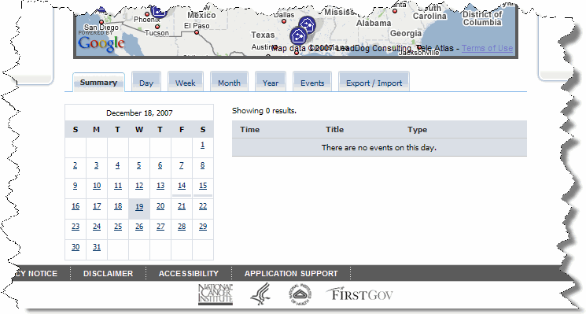
Figure 7-66. Calendar portlet
You can change the view of the calendar by clicking the various tabs described in Table 7-7.
Tab | Description
Summary | Shows a calendar on the left and a list of events on the right.
Day | Shows events for the selected day and enables you to browse forward or backward in one-day increments.
Week | Shows a seven-day view starting with the selected day and enables you to browse forward or backward in seven-day increments.
Month | Shows the current month as a full-sized calendar.
Year | Shows a calendar for each day of the current year.
Events | Shows a listing of events, including the date, time, title, and type. Click the event title to view details for the event.
Export/Import | Enables you to import a file and add an event to your calendar.
Table 7-7. Description of Calendar portlet tabs

Using the caBIG® Tools Portlet
The caBIG® Tools portlet allows you to access the same inventory of tools that are available on the caBIG® Community Website. This chapter explains how to browse those tools.
Topics in this chapter:
- About the caBIG® Tools Portlet on this page
- Sorting caBIG® Tools on page 86
- Viewing caBIG® Tool Details on page 68

About the caBIG® Tools Portlet
To expedite the cancer research community's access to key bioinformatics tools, platforms, and data, the caBIG® Community Website (https://cabig.nci.nih.gov/inventory) lists applications (tools) and their documentation, as well as infrastructure and datasets used to support the caBIG® initiative. The inventory is updated as new items are released.
The caGrid Portal provides another entry point into the tools component of that inventory. When you click the caGrid Tools tab, the most current list of caBIG® tools appears.
The caBIG® tools inventory includes over 40 software tools, database technologies, and Web-based applications in the areas of clinical trials management, biospecimens, imaging, genome annotation, proteomics, microarrays, pathways, data analysis and statistical tools, data sharing, infrastructure, vocabularies, and translational research. They are based on open-source software and free. Download packages include installation elements and documentation. In many cases training is also offered.
As on the caBIG® website, caGrid users can search for these tools based on name, compatibility level, keyword, area of focus, workspace, and technical specifications.
The features of the caGrid Tools portlet are illustrated in Figure 8-67.
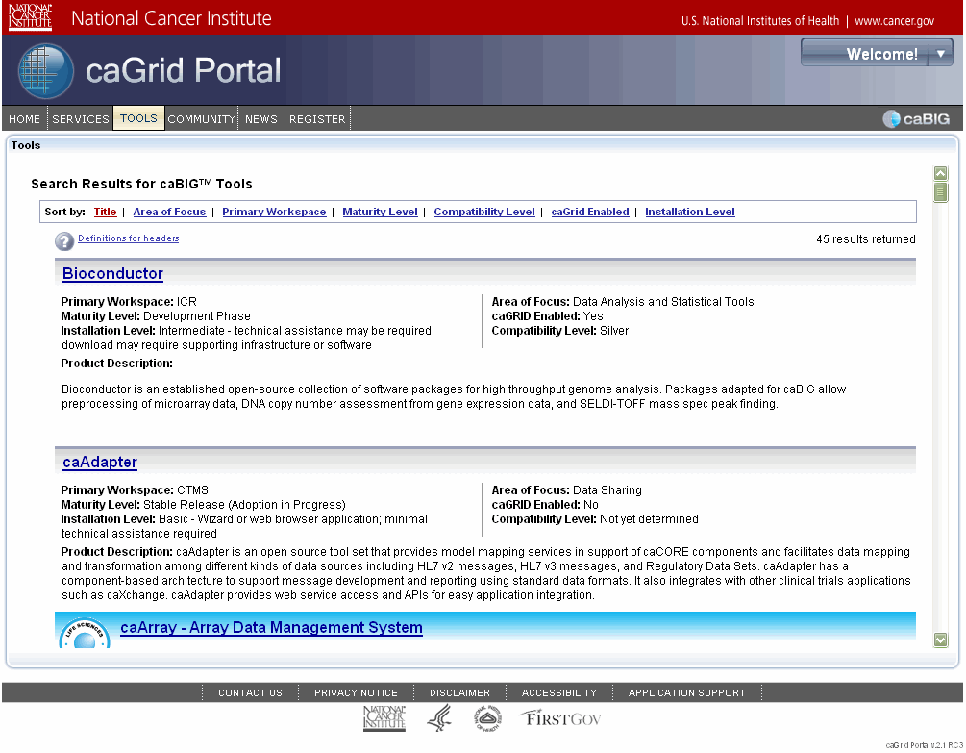
Sort options
Number of caBIG tools currently in the caBIG tool inventory
Tools
Figure 8-67.Tools portlet

Sorting caBIG® Tools
While the caBIG® tools are sorted alphabetically by title by default, you can change the sort order to more easily find and understand each tool.
To sort caBIG® tools, follow these steps:
- If you are not currently using the Tools portlet, click the Tools tab on the main navigation bar. The Tools page appears.
- Click one of the sort headers at the top of the page. See Table 8-8 for a description of each header.
The tools in the list are sorted by the selected header. The sort header currently in effect is highlighted in red.
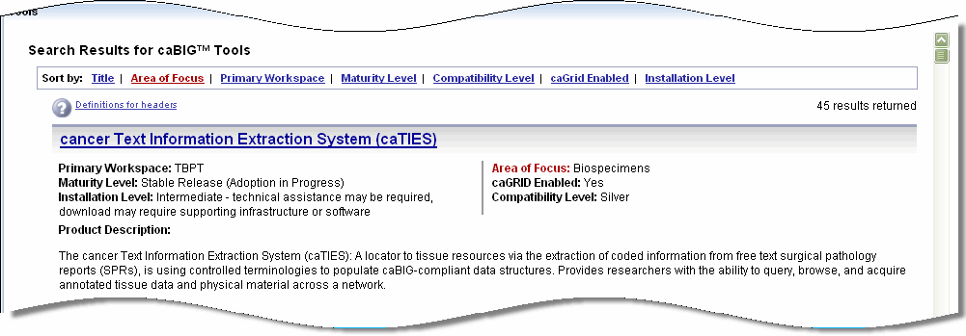
Figure 8-68. caBIG® tools sorted by Area of Focus
The following table explains each of the sort headers available in the caBIG® Tools portlet.
Sort Header | Description
Title | This is the name of the tool as chosen by the development team and the caBIG® Workspace who fostered the development. Tool titles are sorted alphabetically.
Area of Focus | The Area of Focus is the primary domain-specific audience or technical area that the tool serves. Only one area is specified from the following choices:  - Biospecimens  - Data Analysis and Statistical Tools  - Clinical Trials Management  - Genome Annotation  - Data Sharing  - Infrastructure  - Imaging  - Pathways  - Microarrays  - Translational Research  - Proteomics  - Other  - Vocabularies
Primary Workspace | The caBIG® Workspace where the tool was originally developed and maintained. Only one area is specified from the following choices:  - ARCH (Architecture Workspace)  - CTMS (Clinical Trials Management Systems Workspace)  - DSIC (Data Sharing and Intellectual Capital Workspace)  - DT (Documentation and Training Workspace)  - ICR (Integrative Cancer Research Workspace)  - IMAG (Imaging Workspace)  - SP (Strategic Planning Workspace)  - TBPT (Tissue Banks and Pathology Tools Workspace)  - VCDE (Vocabulary and Common Data Elements Workspace)
Maturity Level | Developers of the tool are required to assign a maturity level assessment to the version of the tool. The tool maturity level must be classified as one of the following:  - Development Phase  - Beta-Test or Pilot Release Available (Pre-Adoption)  - Stable Release (Adoption in Progress)  - Mature Product (Successfully Adopted)
Compatibility Level | To aid in the creation of software that will be able to interoperate within the caBIG® program, a set of compatibility guidelines was developed that spells out requirements for interoperability in areas of Interface Integration, Vocabularies/Terminologies and Ontologies, Information Models and Data Elements. Systems that meet the requirements are said to be caBIG® Compatible  The levels of compatibility are:  - Gold Level Compatibility  - Silver Level Compatibility  - Bronze Level Certification  - Legacy  Learn more about compatibility at https://cabig.nci.nih.gov/guidelines_documentation.
caGrid Enabled | caGrid is the distributed infrastructure built upon established standards and technologies that provides the concrete implementation for this interoperability to happen seamlessly. When systems are built following the caGrid specifications, these systems are able to discover, access and use other similarly built services programmatically. These software systems are then called "caBIG® Grid Enabled".  In terms of compatibility guidelines, "caBIG® Grid Enabled" applications would become the "Gold" compatible systems once the caBIG® Cross cutting work spaces start performing "Gold" compatibility reviews.
Installation Level | - Basic - Wizard or web browser application; minimal technical assistance required  - Intermediate - technical assistance may be required, download may require supporting infrastructure or software  - Advanced - technical team required for installation
Table 8-8. Sort header options

Viewing caBIG® Tool Details
Click any tool in the list to view details about that tool. Details about each tool are structured similarly and include the following information next to the tool logo:
- Product Summary
- Demo Files & Exercises
- Documentation & Training
- Tool Download Files
- End User Support Resources
- Related caBIG® Tools.
- Developer Institution(s) & Adopter Institution(s)
- Related Articles
Figure 8-69 shows the home page for one caBIG® tool.
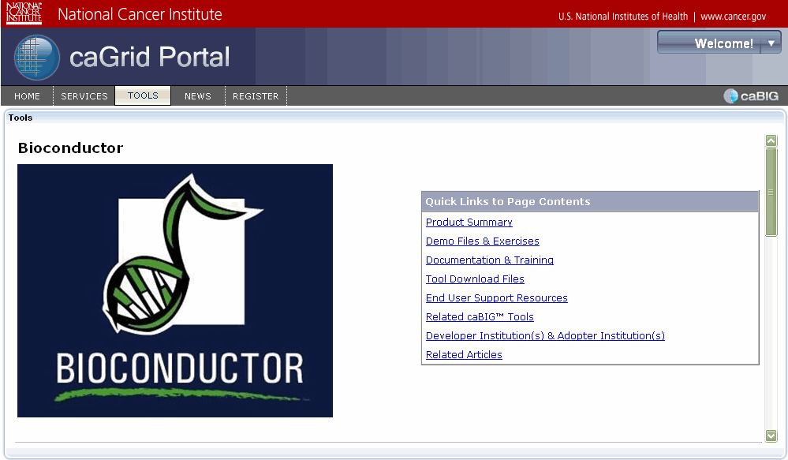
Figure 8-69. caBIG® tool details

Index

A
analytical service
selecting (Map portlet), 21
viewing details for, 40
C
caBIG® tools
sorting, 84
viewing details, 87
caBIG® Tools portlet, 83
Calendar portlet, about, 8, 80
Categories list (Map portlet), 18
Community portlet, about, 73
D
data service
query, about, 6
selecting (Map portlet), 19
viewing details for, 39
Data Service Query Portlet, about, 47
DCQL queries
aggregate, 56
building, 56
distributed, 58
Details tab
Participant subtab, 42
POC subtab, 43
Service subtab, 39
details, viewing
for caBIG® tools, 87
for data service, 39
for new participant, 79
for participant, 42
for POC, 43
diagnostics, service, 43
Directory tab
List View subtab, 28
Map View subtab, 31
Discovery portlet, about, 27
discovery, about, 4–5
E
events. See Calendar portlet
H
History tab, about, 66
home page, about, 9
hosting research center, selecting (Map portlet), 24
I
icons for Map portlet, 19
J
JSR 168, 73
L
Links portlet, about, 77
List View subtab, using, 28
logging in
as NIH user, 16
as registered user, 15
M
Map portlet
about, 17
analytical service, selecting, 21
Categories list, 18
data service, selecting, 19
hosting research center, selecting, 24
icons for, 19
participant institute, selecting, 22
POC, selecting, 25
Map View, using, 31
metadata
for analytical service, 40
for data service, 39
for participant, 42
for POC, 43
for services, 5
N
News portlet, about, 8, 75
P
participant
searching for, 36
viewing details for, 42
participant institute, selecting (Map portlet), 22
POC
searching for, 37
selecting (Map portlet), 25
viewing details for, 43
portlet
Calendar, 80
Community, 73
Data Service Query, 47
Discovery, 27
Links, 77
Map, 17
News, 75
Status, 79
Tools, 83
Q
query
building, 51
building a CQL, 51
building a distributed DCQL, 58
building an aggregate DCQL, 56
for data service, 6
portlet overview, 47
scenarios for building, 49
shared, searching for, 70
sharing
about, 6
procedure for, 68
R
registration
about, 11
procedure for, 12
technical details for, 7
S
Search tab
Participant subtab, 36
POC subtab, 37
Services subtab, 32
searching
for participant, 36
for POC, 37
for service, 32
for shared query, 70
service
analytical, viewing details for, 40
data, viewing details for, 39
searching for, 32
viewing details for, 39
service diagnostics, 43
Status portlet
about, 8
using, 79
W
Welcome menu, about, 16

