Introduce: An Open Source Toolkit for Development of Strongly-Typed Grid Services.

Shannon Hastings, Scott Oster, Stephen Langella, Tahsin Kurc, Joel Saltz
The Ohio State University Department of Biomedical Informatics
{hastings,oster,langella,kurc,saltz}@bmi.osu.edu

Abstract

There is an array of tools and middleware systems to support management and execution of Grid services, management of Grid-enabled resources, and deployment and execution of applications that make use of Grid services in the Grid environment. However, fast and easy creation of grid services is rapidly becoming a limiting factor for the service developer in creating a Grid under limited amount of funds and time. Lowering the cost of entry for the Grid will have a major impact to its success and its wider adoption as a viable technology of choice, not only in the commercial sector, but also in others areas such as academic, medical, and government research. In order to lower this cost without requiring the vast amounts of training will require good tooling and availability of simple-to-use tools that will allow a Grid service developer to leverage Grid technologies without needing to know every low-level detail. In this paper, we describe the design and implementation of a toolkit, called Introduce, to support easy development and deployment of Grid services on top of the Globus Toolkit. Introduce aims to reduce the development effort by hiding low level details of the Globus Toolkit and to enable the implementation of strongly-typed, secure Grid services.

Introduction
Grid computing is quickly becoming the new means for creating distributed infrastructures and virtual organizations for collaborative, multi-institutional research and enterprise applications. Since its inception, the Grid has evolved from being a platform targeted at large-scale computing applications only to a new paradigm for sharing information, data, and applications as well as computational and storage resources. It has been applied in a wide range of application domains ranging from high energy physics to earth systems sciences to biomedical research.
A vast array of middleware systems and tools has been developed to support applications in the Grid. These systems include middleware for application deployment, security (authentication, authorization, and secure communication), remote resource invocation, resource monitoring and scheduling, and workflow management. Earlier tool development efforts, however, focused on providing the core functionality needed by applications to use the Grid environment. As the number of Grid-enabled resources and applications has increased, interoperability has become a major concern. Interoperability is important since applications and resources are heterogeneous, oftentimes deployed and managed autonomously in the Grid, and programmatic access to resources is desired. The need for mechanisms to facilitate interoperability has led to architecture and standardization efforts by several groups, most notably by the Global Grid Forum, which includes both academic researchers and IT companies.
In the past several years and through a community effort (coordinated via the Global Grid Forum), the Open Grid Services Architecture (OGSA) has been developed. OGSA presents a service-oriented view of the Grid and implements Grid services standards. These standards adapt and extend Web Services standards for scientific applications. They define mechanisms and guidelines for such additional features as stateful services, service notification, and management of service lifetime. More recently, the OGSA effort has evolved into the Web Services Resource Framework (WSRF) standardization, paving the way for closer interoperability and unification between Grid services and Web services.
With the emergence of Grid services framework and standards, we are observing the development of new tools and the adaptation of exiting tools to leverage the standards in application development and deployment. The most widely used reference implementation of the core OGSA and WSRF functionality is the Globus Toolkit (GT); GT 3.2 and GT 4.0, respectively. The GT enables Grid architects to create Grids using standard building blocks. The toolkit also implements support for creation, deployment, and invocation of Grid services, and provides runtime support for common services such as Index service for service registration and discovery and Globus Security Infrastructure (GSI) for security. These core components enable service providers to stand up Grid services, register them, discover them, and secure them.
The basic building block services and technologies provided in the GT facilitate the creation of virtually any level of complex grid service. However, creating Grid services using the GT requires a vast knowledge of Grid computing and the details of the toolkit. We argue that additional tools are needed to reduce the development time and knowledge required to stand up grid services so that the benefits of Grid computing can be harvested easily and quickly by those adopting the Grid as a technology.
In this paper, we present the design and implementation of a toolkit, Introduce, that provides support for development and deployment of strongly-typed, secure Grid services. The introduce toolkit aims to reduce the time and knowledge required to stand up Grid services. The salient features of Introduce are as follows:
- It hides away the most commonly used complexities and low level command-line tools of the GT for generating a suitable service layout, creating resource properties and registering metadata, describing the security requirements of the operations or the service, and deploying to commonly used grid service containers. The developer can create and modify Grid service interfaces using a graphical user interface. Not only can developers use the graphical interface to create their service, they can also write their own service description documents which the Introduce toolkit can use to create the service programmatically.
- It manages all the service-specific files and directories required by the GT for correct compilation and deployment. It also generates appropriate, object-oriented client APIs which can be used by client programs to interact with the service.
- It enables development of strongly-typed services. A strongly-typed service is one whose methods take as input and return as output data structures that are registered and published in the Grid environment.
- It allows for implementation of secure services. It provides support for service developers to optionally turn on authentication and authorization support for individual service methods.
Introduce enables service providers to rapidly create well formed grid services and deploy them to their grid without having to become a Globus toolkit expert. We believe the availability of tools like Introduce will greatly impact the efficacy of using the Grid in fields where grid style architectures is a great change to the everyday development of management of data and analytical services.

Motivation

The need for and the design of the Introduce toolkit is mainly motivated by the caBIG (cancer Biomedical Informatics Grid) effort. caBIG is a program funded by the National Cancer Institute (NCI) with the goal of implementing a nationwide cancer research network to significantly enhance cancer research. The principle idea is to create software infrastructure, common applications, data and analytical resources to leverage combined strengths of individual cancer centers and research labs. One of the main goals of the caBIG effort is to enable syntactic and semantic interoperability across data and analytical resources and secure access to heterogeneous resources. Syntactic and semantic interoperability is critical to ensure that resources can be accessed programmatically in a unified way and the information served by a resource can be interpreted correctly. This requires support for coordinated management of metadata and strongly-typed objects, which are exchanged between entities (i.e., clients and services) in the caBIG environment. Security is also a required component both for protecting intellectual property and to ensure protection and privacy of patient related information. In caBIG, a service provider should be able to enforce secure and controlled access to data and analytical resources based on policies set forth by the owners of the resources. In addition to common applications, a core Grid infrastructure, called caGrid, is being developed to support the development and deployment of Grid-enabled applications and Grid services for sharing of data and analytical resources. caGrid is designed to meet all the requirements of caBIG, which include strongly typed data objects, semantically harmonized data types, rich service discovery, secure service invocation, and standardized data and analytical services, just to name a few.
caBIG is envisioned to span several hundreds of institutions, which will host information technology infrastructures of different complexity and maturity and will consist of users with varying levels of understanding of distributed systems and the Grid. Thus, one of the goals of caGrid is to provide tools to make it easier for institutions and laboratories to get on the Grid without requiring a great deal of knowledge of the Grid technologies. caGrid is developed as a service-oriented system, building on the WSRF standards. The most widely deployed reference implementation of the WSRF standard is the Globus Toolkit (GT). The GT is employed as the Grid middleware backbone and runtime environment in caGrid. It provides support for core runtime services and tools for developing and deploying Grid services. However, these are low level tools, requiring service developers to understand the details of the GT and how and in what order the tools should be invoked, and to keep track of several files that are required for successful compilation and deployment of services. The Introduce toolkit aims to make it easy for a service developer to execute the various steps of the service development and deployment tools provided by the GT and to manage the necessary directories and files. It abstracts away the details of invoking the various tools so that the developer the developer is freed up to concentrate on the details of implementing his/her domain-specific code.
In addition to providing an easy-to-use environment, Introduce enables the developer to implement strongly-typed services. We refer to a service as strongly-typed service if the data types of the input parameters of the service’s methods and of the returned data elements are registered and published in the Grid environment. In the Grid environment, strongly-typed services are important, when data is exchanged between disparate groups of data providers and consumers in order to ensure syntactic and semantic interoperability; that is, the data exchanged between two entities is interpreted and interacted with correctly. The Introduce toolkit supports development of strongly-typed services using the Mobius Global Model Exchange service. The support for developing strongly-typed services is discussed in Section IV. Introduce also allows a service developer to configure the service as a secure service. This enables the service to interact with Grid-wide user and attribute management services and local authorization systems for secure communication, authentication, and authorization. The support for secure service implementation is also presented in Section IV.

Related Work
Talk about CoG kits, the paper “A user-friendly platform for developing grid services over globus toolkit 3”, the IBM Grid toolbox, the globus toolkit plug-in for eclipse., WSRF .NET environment, and Gridbus.

Also talk about PSEs that support application development through service composition. Portals and portal toolkits.

Introduce Toolkit
Introduce is designed and implemented to take advantage of many features provided by the Globus Toolkit. It also uses many open source technologies such as JET for source code generation and AXIS for bean to code mapping generation. The toolkit can be broken into four major pieces: the Graphical Development Environment (GDE), Service Creator, Service Synchronizer, and Service Deployer.

Graphical Development Environment

The Introduce GDE is the graphical user interface that can be used to create a new service, modify an existing one, and deploy a finished one. It is designed to be very simple to use, enable using community excepted data types, and provide easy configuration of service metadata, operations, and security. The interface contains several screens and options for the developer to 1) create a new service, 2) modify an existing service, 3) use the Global Model Exchange (GME) tools for strongly-typed service methods, and 3) configure and deploy a service.

Service Creation

The service creation screen as shown in figure X enables the user to create a new service by providing some basic information such as name of the service, package name to use for creating the source code, and domain name to use in the service’s wsdl when defining the operations just to name a few. The user also has the ability to select from a pre defined service template which can be used to add certain operations and service metadata to their service after creating it. This enables the use of predefined service layouts/templates to be re-used and/or standardized.

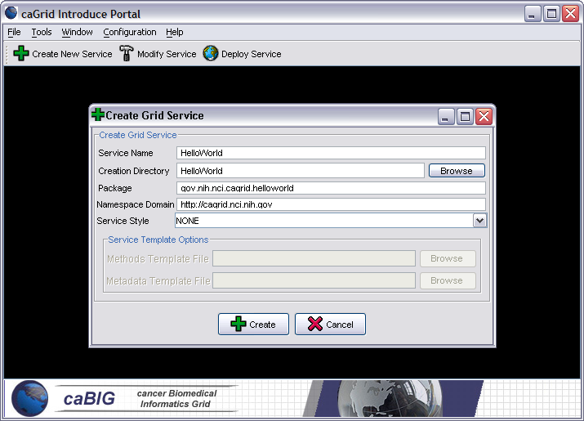

These templates may describe a predefined set of method signatures, metadata, and service and method security settings. The templates will enable reuse of common service compositions while enabling the developer to quickly develop their custom implementation.

Service Modification

After the service has been created a user can then modify the service. The modification process is where operations can be added, removed, and modified. It is also where service and method level security can be configured, and service metadata can be added and removed. The figure X below shows how the user can add, remove, or modify exposed operations on the grid service. For each operation added a user will need to set the input parameters, return type, any fault types that can be thrown from the service, and the security configuration.

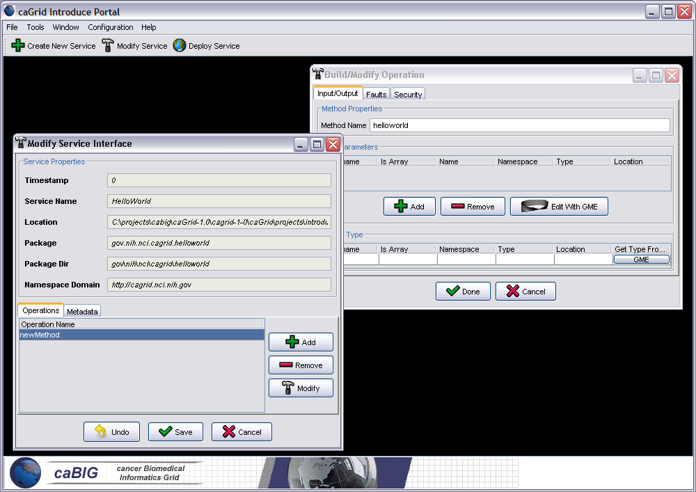

GME Tools: Support for Strongly-Typed Service Methods

The next component of the GDE is the GME tools component. The developer has the ability to obtain the types that it wants to use for the service parameters and return types from the Mobius Global Model Exchange (GME). This enables the creation of strongly typed grid service interfaces using published, and versionable, data type models. The GME is a federated grid service architecture that enables the storage, versioning, discovery, and retrieval of namespaced data types which are modeled in XML Schema. Once a data type is chosen from the GME through the Introduce GDE it is retrieved, written into the schema area of the service, and imported for use in the wsdl so that java beans can be generated and the data types can be programmatically used.
The GME tools component enables developers to browse, upload, and download schemas which are published in a GME. These schemas represent the valid data types which can be used during service creation. The GME upload component will take a user’s schema, create the user an editable view, and then submit the schema to the GME. If the namespace of the schema is not managed by the GME being used then the GME tools component will attempt to add the namespace the GME before submitting the schema. Once the schema has been uploaded its types can be used by anyone in the grid through the Introduce Toolkit. The GME tools browser window enables browsing through all the GME published types by namespace and schema name. It will give the user a quick view of the schema and the option to download the schema bundle. The schema bundle contains the schema and all other schemas which are referenced by that schema.

Service Deployment

The last component of the GUI is service deployment. The user will select a service that has been created by the Introduce Toolkit and has been fully implemented. The user will then be prompted for deployment time configuration parameters such as the service deployment path and which container to deploy the service to. Once these selections have been made introduce will invoke the proper deployment routines to deploy the service to the appropriate container.

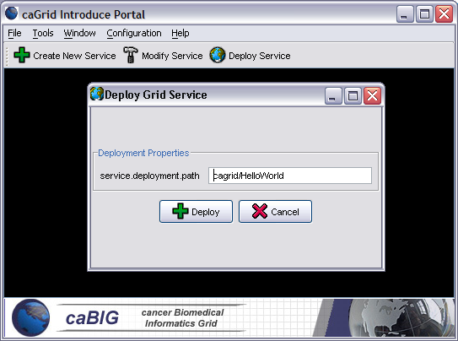

Service Creator
The service creator is composed by a series of JET templates for generating source code and configuration files and a skeleton set of directories which is used to generate a build-able, securable, and registerable grid service. This creation code uses templated source and configuration files which are used to create all the custom java source code for client and service and configuration files required by the Globus toolkit in order to build and deploy a grid service. It also provides deployment configuration files, metadata registration configuration files, and security configuration files. The out of the box service that is created has the following functionality:
- Build, Deploy, and Test ANT capability
- Custom configuration files for IDE integration
- Standard interface for both client and service to implement
- Fully implemented client
- Stub implemented service
- Configured to support service metadata resource properties and registration
- Configured for secure service deployment and authorization

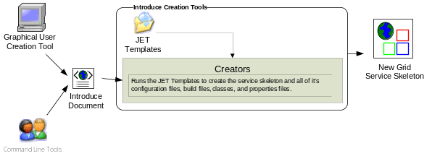

The overall service architecture that introduce creates is shown below in figure X. ….
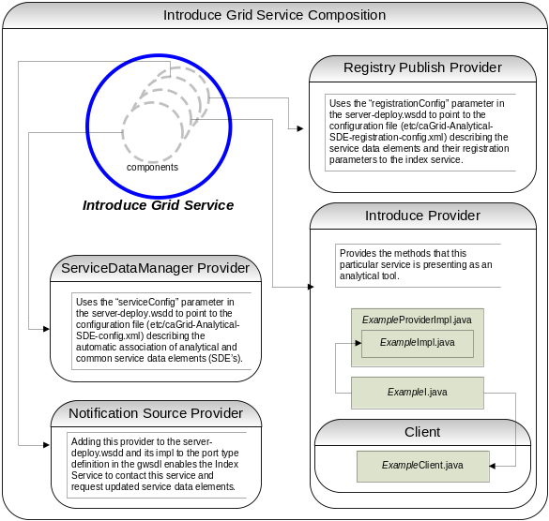

Service Resynchronization
Service resynchronization is the process by which the source code generation tools of the introduce toolkit will analyze the service’s current implementation with that of the desired service description. This process will add/remove and modify any methods which have been added/removed or modified from the service methods description and will add/remove any service metadata which have been added or removed form the service metadata description. It will also handle modifying the service and the operation’s service security configurations. These descriptions for methods, metadata, and security are those which are generated from the GUI, programmatically, or by hand, which comply to the Introduce service schema. The descriptions are the bases by which the code generation tools will add, remove and modify operations, metadata, and security of the service by editing the source code, configuration files, and metadata files. The image X shown below illustrates the overall process of service resynchronization.

The overall sync process is also in charge of managing the services WSDL. If a method has been added or removed the wsdl file must be update to reflect that. Updating the wsdl requires many auto generated code segments. If the user is using types described in external schemas, via the GME or hand written, these schemas must be imported into the wsdl so that the when the message types are described these data types can be located and used to generate the required beans. The wsdl is basically a another representation of the java based service interface, so not only do the message types representing the data types of the input parameters of return type have to be described but so does the complete operation which reflects the java based signature of the method which is being exposed. This SyncWSDL will automatically keep this file in sync during the development of the service so that the service implantation and the grid service description represented by the wsdl match up insuring that the methods implemented in the grid service are actually invokeable.

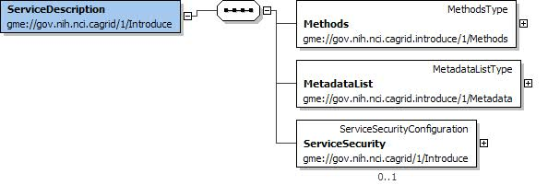
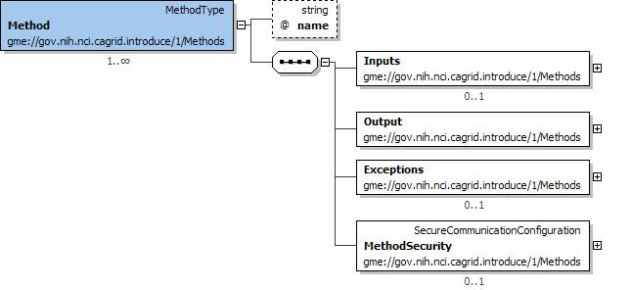
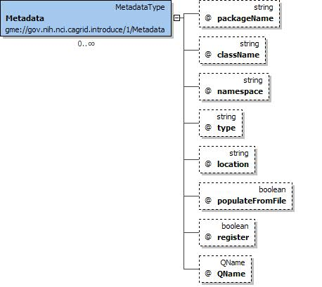

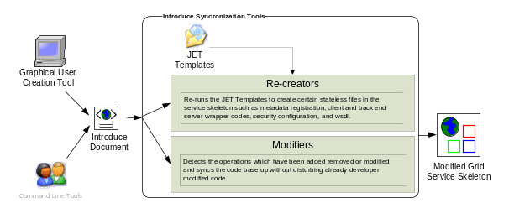

SyncMethods is one of the most complicated synchronization pieces in the toolkit. Its main job is to re-write the basic source code of the service so that the client and the server both agree on the new modified interface which the creator has modified. It deals with interfacing the server side implementation of the interface’s mapping to the actual port type generated by Globus via Axis. The reason this is complicated is that Globus uses the auto-boxing or wrapped style of service bindings when creating the port type. For example, if a user describes a new method shown below:

int foo(int bar1, int bar2);

The port type method that will be created for that java call will look like below:

FooReturn foo(FooParameters params);

This boxing or wrapping of the parameters and the return type can be confusing to deal with as the service user and service implementer, especially if you expose it through the client API that you want to provide with your service. Then every client using your service will have to box up the parameters to call your service’s operation and unbox the results. This is not only cumbersome for users but also is not the interface that you intended to provide to your users. The introduce tool will hide this boxing and unboxing by providing an interface to the service which looks exactly as described by the creator and not as interpreted by Globus via Axis. In order to do this the introduce toolkit creates a wrapping layer in the client and service which both implement this clean interface. These wrapper layers will auto-box and auto-unbox and map the calls from the clean client to the auto-boxed port type client generated by Globus and visa versa for the service.
The wrapper layer not only hides the Globus complexity from the server side implementation but also form the client. The task of locating and instantiating the port type handle is also hidden from the client side API which is auto generated by the introduce toolkit. To construct the client handle all that is required is passing in the URL/GSH (Grid Service Handle) to the constructor. Then the clean client API is usable by the user/client application.

SyncMetadata is also quite complex in that it must auto generate and modify the source code and configuration files required to add new resource properties to the service which will represent the service metadata described. This process consists of……

SyncSecurity ……

Service Deployment

Examples

Conclusion
The Cancer Biomedical Informatics Grid (caBIG) [1] program lead by the National Cancer Institute (NCI) was launched to meet the challenge and need for a more highly
coordinated approach to informatics resource development, management and dissemination. caBIG is a voluntary network or grid connecting individuals and institutions to enable the sharing of data and tools, creating a World Wide Web of cancer research. The goal is to speed the delivery of innovative approaches for the prevention and treatment of cancer. The caBIG program includes a geographically dispersed large federation of participants from medical centers, universities, government agencies, commercials companies, researchers, and patients.
The caGrid project [2], is the test bed architecture for caBIG, it is driven primarily from the scientific use cases identified from the domain workspaces of caBIG. caGrid provides the core enabling infrastructure necessary to compose the Grid of caBIG. caGrid is a service-oriented architecture and provides the implementation of the required core services, toolkits and wizards for the development and deployment of community provided services, APIs for building client applications, and some sample client applications for interacting with the current test bed installation.

References

[1] Cancer Biomedical Informatics Grid (caBIG), https://cabig.nci.nih.gov.

[2] Cancer Biomedical Informatics Grid (caBIG), https://cabig.nci.nih.gov/workspaces/Architecture/caGrid/

[3] I. Foster, C. Kesselman, S. Tuecke., “The Anatomy of the Grid: Enabling Scalable Virtual Organizations”, International J. Supercomputer Applications, 15(3), 2001.
[4] I. Foster, C. Kesselman, J. Nick, S. Tuecke, “The Physiology of the Grid: An Open Grid Services Architecture for Distributed Systems Integration”, 2002.
[5] The Globus Toolkit, http://www.globus.org

[6] V. Welch, F. Siebenlist, I. Foster, J. Bresnahan, K. Czajkowski, J. Gawor, C. Kesselman, S. Meder, L. Pearlman, S. Tuecke, “Security for Grid Services”, Twelfth International Symposium on High Performance Distributed Computing (HPDC-12), IEEE Press, to appear June 2003.

[7] I. Foster, C. Kesselman, S. Tuecke, J. Volmer, V. Welch, ] A “National-Scale Authentication Infrastructure. R. Butler, D. Engert”, IEEE Computer, 33(12):60-66, 2000.

There are currently more than 50 cancer centers participating in the caBIG effort.

