Dorian Overview

Managing users and provisioning accounts in the grid is complex, the Globus Toolkit implements support for security via its Grid Security Infrastructure (GSI). The GSI utilizes X509 Identity Certificates for identifying a user. An X509 Certificate with its corresponding private key forms a unique credential or so-called “grid credential” within the Grid. Since Grid credentials are long term credentials and are not directly used in authenticating users to the grid, rather a short term credential called a grid proxy is used. Grid Proxies consist of a private key and corresponding long term certificate signed by the long term grid credential private key. A grid proxy is an extension to traditional X509 certificates providing the ability to delegate you credentials to other services, for example in the case of workflow. Although this approach is very effective and secure, it is difficult to manage in a multi-institutional environment. Using the base Globus toolkit, the provisioning of grid credentials is a manual process, which is far too complicated for users. The overall process is further complicated if a user wishes to authenticate from multiple locations, as a copy of their private key and certificate has to be present a every location. Not only is this process complicated, securely distributing private keys is error prone and poses a security risk. There are also many complexities in terms of provisioning user accounts in an environment consisting of tens of thousands of users from hundreds of institutions, each of which most likely has a user account at their home institution. A practical solution to this problem, both from the point of view of the users’ and their institutions, is to allow those users to authenticate with the grid through the same mechanism in which they authenticate with their institution. Dorian is a grid user management service that (1) hides the complexities of creating and managing grid credentials from the users and (2) provides a mechanism for users to authenticate using their institution’s authentication mechanism, assuming a trust agreement is in place between Dorian and the institution.
Dorian provides a complete Grid-enabled solution, based on public key certificates and SAML, for managing and federating user identities in a Grid environment. Grid technologies have adopted the use of X509 identity certificates to support user authentication. The Security Assertion Markup Language (SAML) has been developed as a standard for exchanging authentication and authorization statements between security domains. Note that Grid certificates and SAML assertions serve different purposes. SAML is mainly used between institutions for securely exchanging authentication information coming from trusted identity providers. The primary use of the certificates is to uniquely identify Grid users, facilitate authentication and authorization across multiple resource providers, and to enable secure delegation of credentials such that a service or a client program can access resources on behalf of the user. A salient feature of Dorian is that it provides a mechanism for the combined use of both SAML and Grid certificates to authenticate users to the Grid environment through their institution’s authentication mechanism.
One of the challenges in building an identity management and federation infrastructure is to create an architecture that incorporates multiple differing authentication mechanisms used by various institutions. In addressing this challenge we identify two possible approaches. The first is to build an infrastructure that would allow pluggable authentication modules, wherein a module would be developed for each authentication mechanism. In this architecture, a user’s authentication information would be routed to the appropriate module that contains the logic for authenticating the user with its institution. Although this approach solves the problem, it requires at least one module be developed for each authentication mechanism. This would require the Grid infrastructure administrators to become intimately familiar with each institution’s authentication mechanisms, and would increase the system’s complexity with each new module added.
Another approach would be for the infrastructure to accept an institutionally supplied, standard “token” as a method of authentication. In this approach users would first authenticate with their institution’s identity management system. Upon successfully authentication the institution’s identity management system issues a token which can then be given to the federated grid identity management system in exchange for grid credentials. The benefit of this approach over the first is that it does not require writing a plug-in every time a new institutional authentication mechanism comes online. It does, however, require every institutional authentication system to agree upon and be able to provide a common token. As SAML has been adopted by many institutions, we have chosen that token format as the basis of the second approach for Dorian.
The Security Assertion Markup Language (SAML) is an XML standard for exchanging authentication and authorization data between security domains. Generally the exchange of authentication and authorization data is made between an Identity Provider (IdP) and another party. An institution’s authentication system or identity management system is an example of an IdP. Dorian uses SAML authentication assertions as the enabling mechanism for federating users from local institutions to the grid.

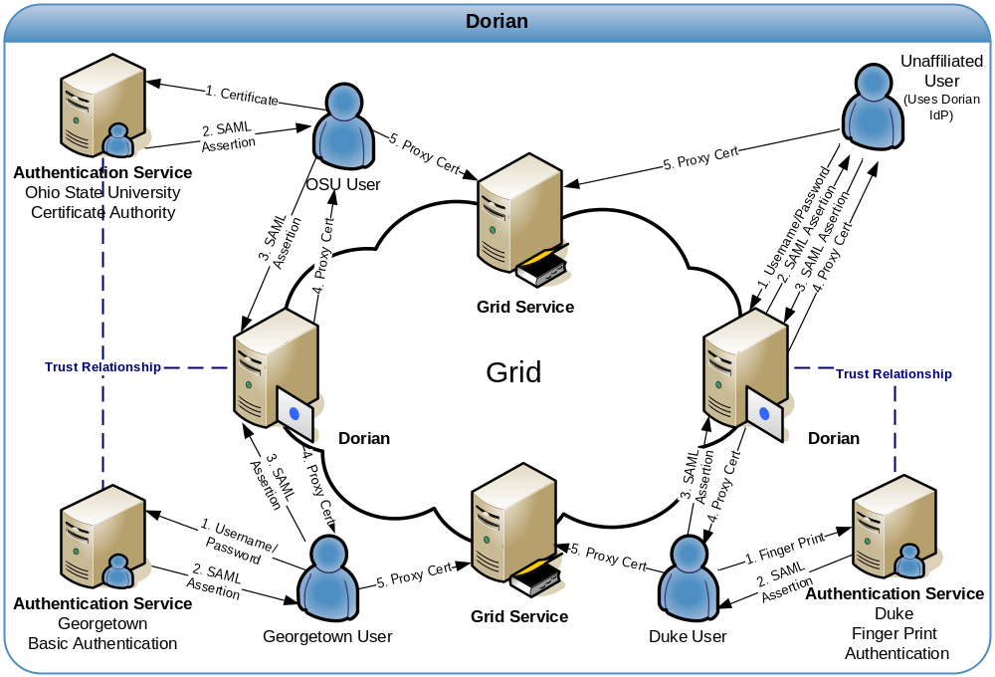
Figure 1 Dorian

Figure 1 illustrates an example usage scenario for Dorian. To obtain grid credentials or a proxy certificate, users authenticate with their institution using the institution’s conventional mechanism. Upon successfully authenticating the user, the local institution issues a digitally signed SAML assertion, vouching that the user has authenticated. The user then sends this SAML assertion to Dorian in exchange for grid credentials. Dorian will only issue grid credentials to users that supply a SAML assertion from a Trusted Identity Provider. Dorian’s grid service interface provides mechanisms for managing trusted identity providers; this will be discussed in greater detail later in this document. For example, in Error: Reference source not found where a Georgetown user wishes to invoke a grid service that requires grid credentials, they first supply the application with their username and password to the Georgetown Authentication Service as they would normally do. The application client authenticates the Georgetown user with the Georgetown Authentication Service, receives a signed SAML assertion which it subsequently passes to Dorian in exchange for grid credentials. These credentials can then be used to invoke the grid services. This illustrates how Dorian can leverage an institution’s existing authentication mechanism and bring its users to the grid.
To facilitate smaller groups or institutions without an existing IdP, Dorian also has its own internal IdP. This allows users to authenticate to Dorian directly, thereby enabling them to access the grid. It provides administrators with facilities for approving and managing users. All of the Dorian IdP’s functionality is made available through a grid service interface. Details of the Dorian IdP are provided later in this document. Figure 1illustrates a scenario of a client using the Dorian IdP to authenticate to the Grid. In this scenario, the unaffiliated User wishes to invoke a grid service. Given that this unaffiliated user has registered and been approved for an account, she is able to authenticate with the Dorian IdP by supplying their username and password. Upon successfully authenticating the user, the Dorian IdP issues a SAML Assertion just like institutional IdPs, which can be presented to Dorian in exchange for grid credentials. The credentials can be used to invoke the grid service.

Creating a Grid Proxy Programmatically

Figure 2 provides an example of how to create a grid proxy programmatically with Dorian. In order to create a grid proxy using Dorian you must first obtain a signed SAML Assertion from an Identity Provider Trusted by Dorian. caGrid’s Authentication Service provides a common interface and client tooling for exposing a local Identity Provider, such that a user may authenticate using their local credentials and obtain a SAML assertion using a common client or AuthenticationClient. Although it is not required to obtain the SAML Assertion from a caGrid Authentication Service, it is the recommended approach and the approach used in Figure 2. Besides obtaining a SAML assertion, Dorian also requires the specification of a proxy lifetime and a delegation path length in order to create a grid proxy. The proxy lifetime specifies the amount of time that the proxy is valid for. A proxy lifetime is specified in terms of hour, minutes, and seconds. The delegation path length specifies how many times a proxy can be delegated to other services. Once you have obtained a SAMLAssertion and specified a ProxyLifetime and delegation path length, you can use Dorian’s IFSUserClient to create a proxy with Dorian.

try{
String authURI = "http://some.service.uri";
String dorianURI = "http://some.dorian.uri";

//Create an instance of my institution provided credentials
Credential localCredential = new Credential();
BasicAuthenticationCredential userPass = new BasicAuthenticationCredential();
userPass.setUserId("MyUserId");
userPass.setPassword("MyPassword");
localCredential.setBasicAuthenticationCredential(userPass);

//User the caGrid common authentication client to authenticate with the local
//IdP and obtain a SAML Assertion

AuthenticationClient auth = new AuthenticationClient(authURI, localCredential);
SAMLAssertion saml = auth.authenticate();

//Specify the lifetime of the desired proxy
ProxyLifetime lifetime = new ProxyLifetime();
lifetime.setHours(12);
lifetime.setMinutes(0);
lifetime.setSeconds(0);

//Specify the delegation path length of the desired proxy
int delegationPathLength = 0;

//Now Create a proxy using the Dorian IFS User Client
IFSUserClient client = new IFSUserClient(dorianURI);
GlobusCredential proxy = client.createProxy(saml, lifetime, delegationPathLength);

//Now specify to Globus to use the aquired proxy as the default credentials
ProxyUtil.saveProxyAsDefault(proxy);
}catch(Exception e){
e.printStackTrace();
}
Figure 2 Programmatically Creating a Grid Proxy with Dorian

