Document Title: | caGrid 1.0 Portal Requirements
Status: | Draft for community review
Author(s): | Colin Freas, Paul Kennedy, Chad La Joie
Publish Date: | March 20th, 2006
Change Log:

Table of Contents
Document Goals 3
Functional Requirements 3
Non-functional Requirements 7
Page Mockups 8
Appendix A: Service Metadata 11

Document Goals
This document should specify the user interaction with the grid portal with as specific information as possible about the experience and about what is shown.
The idea is that this document drive design and testing.

Functional Requirements
- Main display response times should be consistent with standard web page interactions, generally between 1.0-1.5 seconds.
- Search page response times should be on par with other search pages and are expected to be slower than displaying static content, but generally between 1.0-1.5 seconds.
- Portal will be able to take information from one or more caGrid 1.0 index servers.
- Main display requirements:
  - Portal needs to display grid centers on a geographic map. Points on the map are referred to as "nodes" in this document. Locations that house a service or multiple services are referred to as "centers".
  - Portal needs to be accessible to all users and enable reasonable navigation by adhering to Section 508c of the Rehabilitation Act of 1978.
  - Portal should display well at resolutions of 800x600px or greater.
  - Portal will display a Grid level RSS using a URL specified in the portal configuration
  - Portal will expose the Grid center URL as defined in the common service metadata.
  - Portal will display center RSS in the center display (as defined in the common service metadata).
  - Portal will display service RSS in the service display (as defined in the common service metadata).
  - The RSS displays will have configuration option for the maximum number of links displayed.
  - Portal will have top level navigation in the header for each page.
- Visualization:
  - A node on the map should be annotated to indicate the "liveness" of the center. The time quantum need not be smaller than an hour. The granularity of this measure of liveness is:
    - Known: Center is known to portal but there is no other information feeding the portal to indicate that the center is alive or was recently alive.
Red could be a reasonable graphical representation.
    - Intermittent: Center is known to the portal and there is other information feeding the portal to indicate availability of service or services. Portal local state information indicates service availability to be less than 80 per cent for any service within a time period set in the portal configuration.
Orange could be a reasonable graphical representation.
    - Reduced: Center is known to the portal and there is other information feeding the portal to indicate availability of service. Portal local state information indicates service availability in excess of 80 per cent for all services within a time period set in the portal configuration.
Amber could be a reasonable graphical representation.
    - InService: Center is known to the portal and there is other information feeding the portal to indicate availability of service. Portal local state information indicates service availability in excess of 95 per cent for all services within a time period set in the portal configuration for all services.
Green could be a reasonable graphical representation.
    - Colours used in any graphical representation of the nodes need to be distinct for all sighted users (taking into account users with partial sight and colour deficiencies).
- Visualization interaction:
  - Node selection:
    - When a user selects a node from the map, the portal will display a synopsis of the data for the Center drawing on the common service metadata which includes:
Name
Address
Phone number
TDD/TTY number
Description
    - The portal should also display a summary of service availability or availabilities within a time period set in the portal configuration.
  - Node information "drill down":
    - There should be a way to invoke a detailed display. When invoked, the geographical map and information display are replaced with an enumeration of services running at the center with accompanying service availability over a configurable time period.
    - Center level RSS is displayed.
    - The following center data from the common service metadata is displayed:
Name
Homepage URL
RSS News
Address
Phone number
FAX number
TDD/TTY number
Photo/image
Point of contact
Description
  - Center service "drill down":
    - Selecting a service from the center display will display a service availability graph for the selected service over a configurable time period.
    - The portal will display data drawn from the common service metadata including:
Service name
Technical point of contact
Functional point of contact
RSS News
    - Portal will display service functions with return types.
    - When documentation is provided for operations defined in a service WSDL, it will be displayed in the function enumeration.
- caGrid 1.0 Common Service Metadata:
  - The portal will depend upon the common service metadata for caGrid 1.0 as well as information accessible from the caGrid 1.0 index service. The portal will use:
    - Research Center metadata:
Name
Short name - shortened title for display on a map
Homepage URL
RSS News URL - allows for promulgation of Center wide news and announcements.
Address - a complex element type consisting of all the elements necessary to make an international address (street 1, street 2, locality, state/province, postal code, country)
Phone number
FAX number
TDD/TTY number
Photo/image URL
Point of contact
Description
    - Service metadata:
Name
WSDL URL
Technical point of contact
Functional point of contact
RSS News URL - allows promulgation of service specific news (upgrades, scheduled downtimes, etc.)
    - The portal will also require information about the freshness of data from the index server (time of update, and time to live).
- Search option:
  - A "basic" search box will appear on the main page. This search box will search a subset of the fields of the caGrid 1.0 common service metadata.
    - Alphabetic search strings will constrain the search to these fields:
Research center name
Research center short name
Research center point of contact
Research center description
Service name
Service operations as defined in its WSDL
Service technical point of contact
Service functional point of contact
    - Numeric search strings will constrain the search to these fields:
Research center phone number
Research center FAX number
Research center TDD/TTY number
  - An "advanced" search panel can be activated to allow searches constrained to specific caGrid 1.0 common service metadata fields.

Non-functional Requirements
- Must run on JDK 1.4 and 1.5.
- Must run on Servlet containers supporting Servlet 2.3 and JSP 1.2 and better
- Must work with databases that support JDBC 3.0
- Portal relies on being able to interact with at least one caGrid 1.0 index service.
- Portal will cache the results of metadata queries to grid services.
- Portal will cache RSS data.
- Portal will cache information with the further requirement that cached results must:
  - have a configurable lifetime
  - be implemented using weak references to allow memory reclamation

Page Mockups
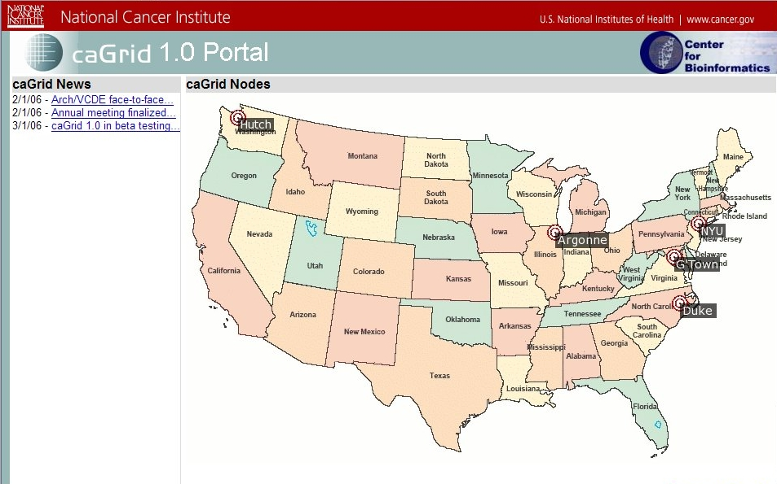Illustration 1: Geographic Map Visualization of Nodes
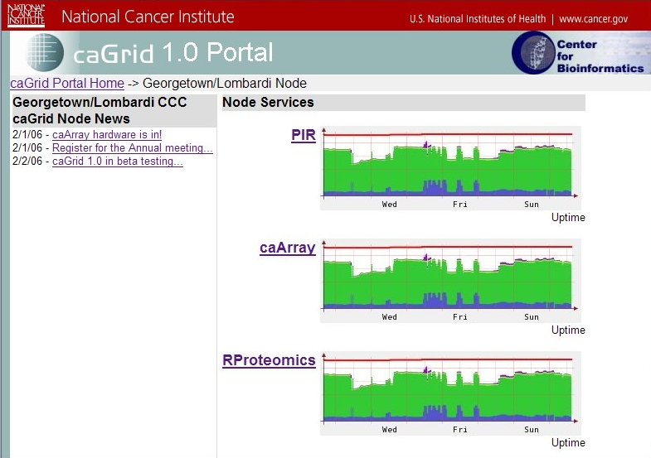Illustration 2: Node Service Uptime Visualization
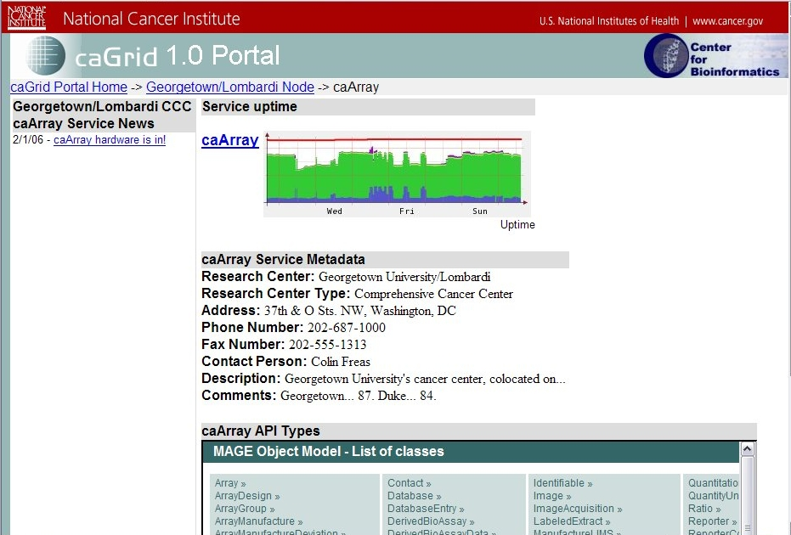Illustration 3: Service Information Page

Appendix A: Service Metadata
The following XML Schema extends the caGrid 0.5 metadata schema to include those elements required by the portal
<?xml version="1.0" encoding="UTF-8"?>
<xs:schema xmlns="http://cagrid.nci.nih.gov/1/CommonServiceMetadata"
xmlns:xs="http://www.w3.org/2001/XMLSchema"
targetNamespace="http://cagrid.nci.nih.gov/1/CommonServiceMetadata"
elementFormDefault="qualified"
attributeFormDefault="unqualified">

<xs:element name="CommonServiceMetadata" type="CommonServiceMetadataType"/>
<xs:complexType name="CommonServiceMetadataType">
<xs:sequence>
<xs:element name="serviceName" type="xs:string"/>
<xs:element name="serviceWSDLURL" type="xs:anyURI"/>
<xs:element name="serviceFunctionalPOCName" type="xs:string"/>
<xs:element name="serviceTechnicalPOCName" type="xs:string"/>
<xs:element name="serviceRSSNewsURL" type="xs:anyURI"/>
<xs:element name="researchCenterInfo" type="ResearchCenterInfoType"/>
</xs:sequence>
</xs:complexType>
<xs:complexType name="ResearchCenterInfoType">
<xs:sequence>
<xs:element name="researchCenterBioDataType" type="xs:string"/>
<xs:element name="researchCenterName" type="xs:string"/>
<xs:element name="researchCenterType" type="xs:string"/>
<xs:element name="researchCenterAddress" type="InternationalAddressType"/>
<xs:element name="researchCenterPhone" type="xs:string"/>
<xs:element name="researchCenterFax" type="xs:string"/>
<xs:element name="researchCenterPOCName" type="xs:string"/>
<xs:element name="researchCenterDescription" type="xs:string"/>
<xs:element name="researchCenterComments" type="xs:string"/>
<xs:element name="researchCenterImageURL" type="xs:anyURI"/>
<xs:element name="researchCenterHomepageURL" type="xs:anyURI"/>
<xs:element name="researchCenterShortName" type="xs:string"/>
<xs:element name="researchCenterTDDTTYNumber" type="xs:string"/>
<xs:element name="researchCenterRSSNewsURL" type="xs:anyURI"/>
</xs:sequence>
</xs:complexType>
<xs:complexType name="InternationalAddressType">
<xs:sequence>
<xs:element name="street1" type="xs:string"/>
<xs:element name="street2" type="xs:string"/>
<xs:element name="locality" type="xs:string"/>
<xs:element name="stateProvince" type="xs:string"/>
<xs:element name="postalCode" type="xs:string"/>
<xs:element name="country" type="xs:string"/>
</xs:sequence>
</xs:complexType>

</xs:schema>
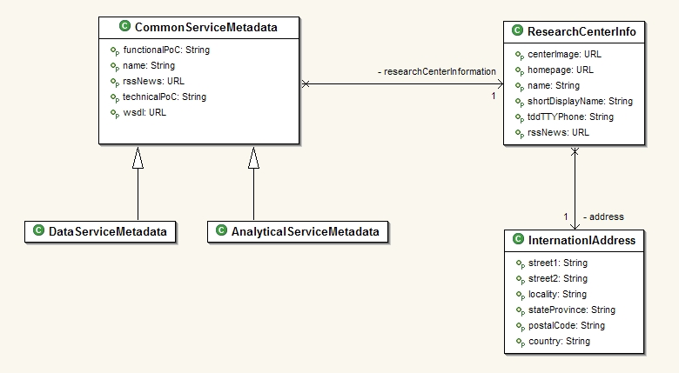Drawing 1: Metadata UML Class Diagram

