Virtual Organization (VO) Provisioning

Design and Architecture

Author: Vinay Kumar
SemanticBits

caBIG™ is an initiative of the National Cancer Institute, NIH, DHHS

Copyright and License page

Insert Names of Development Team(s) here
Development | Programmer’s guide |  | Program Management
Names of developers | Names of technical writers and reviewers |  | Names of program managers
¹ Footnote contributing companies/ contractors/ divisions |  | ³ company
² department or division

Contacts and Support
Enter training contact | name (email address)
Enter customer support contact | Web hyperlink  Telephone: 111-222-3456  Toll free: 888-234-1234

LISTSERV Facilities Pertinent to software teams
LISTSERV | URL | Name
caBIO_Users | https://list.nih.gov/archives/cabio_users.html | caBIO Users Discussion Forum
caBIO_Developers | https://list.nih.gov/archives/cabio_developers.html | caBIO Developers Discussion Forum
caDSR_Users | https://list.nih.gov/archives/cadsr_users.html | Cancer Data Standards Repository
NCIEVS-L Listserv | https://list.nih.gov/archives/ncievs-l.html | NCI Vocabulary Services Information
caArray_Users
Add appropriate listservs and or websites here

Table of Contents

Chapter 1 Introduction 7
Chapter 2 Grid Service, Users and Groups 9
Steps 10
Chapter 3 Component Identification 11
Chapter 4 VO Provisioning, Use Case Scenario. 13
Chapter 5 Web Page Flow 15
Chapter 6 Attribute based authorization 18

Introduction
caGrid 1.0 will see a new approach for authorization framework based on the user groups. After number of design discussions the decision has been made to use user groups at grid level to make authorization flexible, scaleable and federated. This approach will elevate the burden of maintaining grid users in local systems to enable authorization for grid services. Since the services will make access decisions based on the group that a user belongs to a service can handle large number of users for authorization purpose.
To implement this framework will require number of components to be developed. Some of them will be server side components, grid services, client API’s and a user interface for provisioning the user groups. This document will highlight use case scenarios which will lead to the identification of the component and the services to be developed.

Grid Service, Users and Groups
In this new approach Grid Services will depend on access policies based on the groups. In other words, a resource will be protected based on an action that a group can perform on a resource. Typically, a grid service will ask the authorization framework if a grid user can perform action x on resource y. To reach this answer different components will play their role. Components such as Common Security Module (CSM), Virtual Organization(VO) service and PDP will take part in decision making. The VO service can tell what groups a grid user belongs to while CSM can make decision whether a group can perform a certain action on a certain resource whereas PDP will communicate this decision to grid service. The above scenario can be depicted in the following diagram.

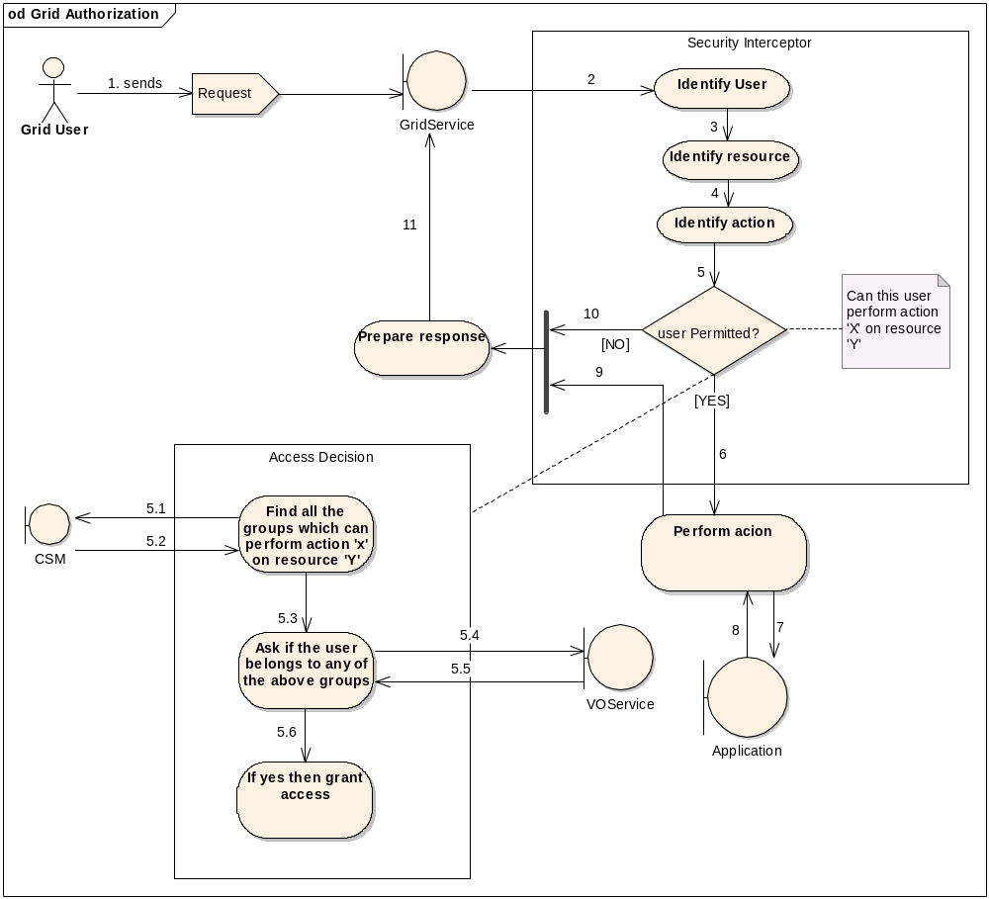

Steps

Step 1 A grid user sends a request to grid service.
Step 2 Security Interceptor identifies the grid user from request.
Step 3 Security Interceptor identifies the resource to be accessed.
Step 4 Security Interceptor identifies the action to be performed on the resource.
Step 5 Policy Decision point takes a decision.
Step 5.1 PDP asks CSM about the groups which can perform action x on resource Y.
Step 5.2 CSM communicates its decision back to PDP by giving the array of groups.
Step 5.3 PDP asks the VO service up.
Step 5.4 Request is sent to VO service to check if this user belongs to any user in the group.
Step 5.5 VO service sends back the response to PDP.
Step 5.6 Depending upon the decision access is granted to the user.
Step 6 If user is permitted the action is performed.
Step 7 The resource is accessed via a request.
Step 8 Application responds back.
Step 9 Action Complete.
Step 10 If user was not permitted it is communicated to grid service.
Step 11 A response is prepared for user request.

Component Identification
To achieve the aforementioned process flow following components are required.

          - Group Management Service
          - VO Service
          - VO Provisioning Tool (VPT)
          - PDP (Security Interceptor)
          - Common Security Module (CSM)

Group Management Service

A group management service will be a grid service which will be used to add and remove a user from a group. There will be numerous group management services and every group management service will have an authority assigned. In other words only that assigned authority can use its group management service to manage groups.

VO Service

Group Management Services will persist the assignments of grid users to the group in some storage. VO services will be used to find the groups that a user belongs to. Again there will be a number of VO services in grid environment. VO services will provide only read only access on this data.

VO Provisioning Tool

VO Provisioning Tool will be used to access different group management services and invoke them. Using VO provisioning tool a normal grid user can search for groups and grid services.

PDP (Security Interceptor)

PDP will be used to make decisions about access on a resource. PDP will in turn use components such as VO service and CSM.

Common Security Module (CSM)

CSM will be used at local level and in VO provisioning tool. At VO provisioning tool level CMS will be used to provision access control on group management services.

VO Provisioning, Use Case Scenario.
The following diagram depicts the actors interactions with VO provisioning tool.

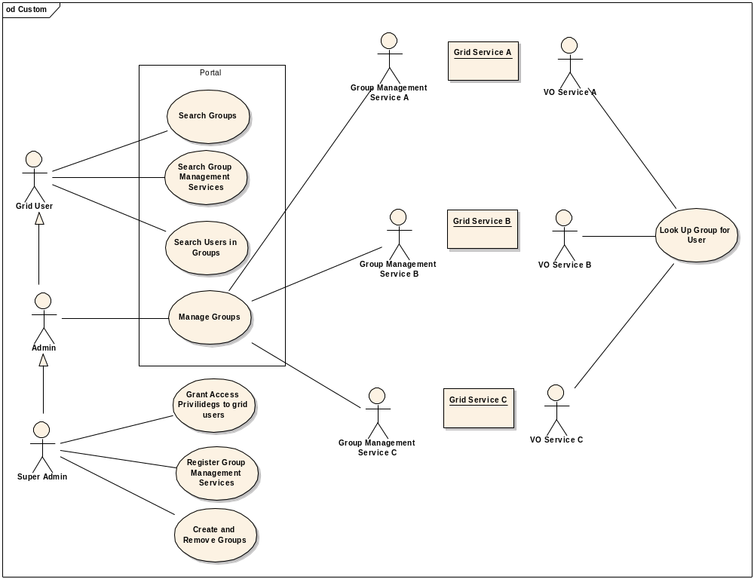

Super Admin: The Super Admin user has all the management privileges such as
Grant Access Privileges to Grid Users
Register Group Management Services
Create and Remove Groups
Grid User: The Grid User has all the search privileges such as
Search Groups
Search Groups Management Services
Search Users in Groups
Admin: The Admin User has the only management privileges for groups i.e.,
Manage Group

Web Page Flow
For Super Admin

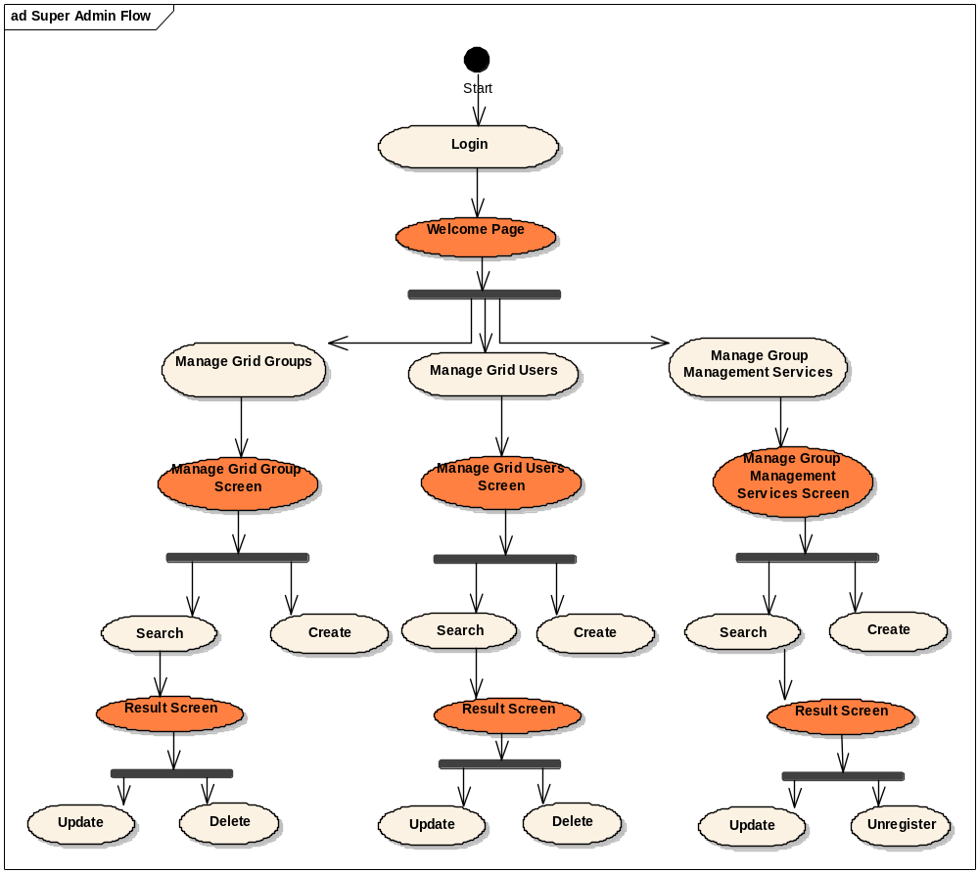

For Admin

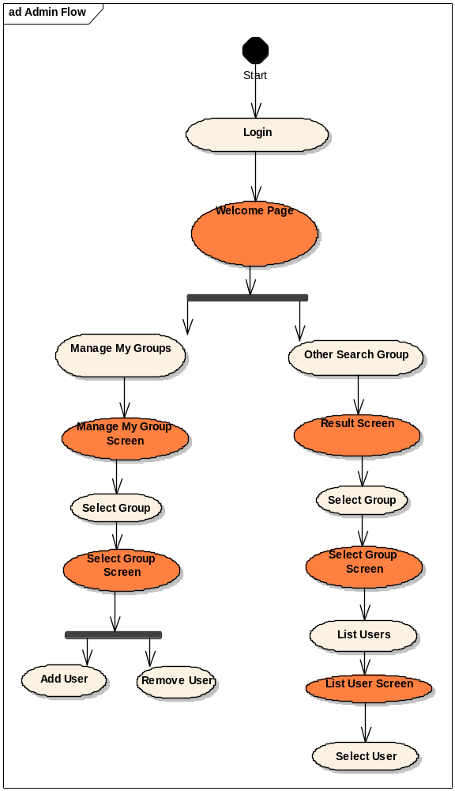

For Grid User
