CSM Requirement
For Grid Integration

Version No: 0.2
Last Modified: 07/19/06

Author : Vinay Kumar
Team : caGrid

Client : National Cancer Institute - Center for Bioinformatics,
National Institutes of Health,
US Department of Health and Human Services

Document History

Document Location
The most current version of this document is located in CVS under security/docs.

Revision History
Version Number | Revision Date | Author | Summary of Changes
0.1 | 07/17/06 | Vinay Kumar | Initial draft
0.2 | 07/19/06 | Vinay Kumar

Review
Name | Team/Role | Version | Date Reviewed | Reviewer Comments

Related Documents
More information can be found in the following related CSM documents:
Document Name

Table of Contents
1. Introduction 4
1.1 Purpose 4
1.2 Scope 4
2. Authentication on Grid 4
3. Authorization on Grid 5
3.1 Can group “A” perform action “X” on resource “Y” 6
3.2 Give me all the groups, which can perform action “X” on resource “Y” 6
3.3 Can a grid user with grid id “iu/jh/kl” perform action “X” on resource “Y” 6
4. Provisioning VOs on Grid 6
4.1 Actors Identified 7
4.1.1 Dorian 7
4.1.2 Super Admin 7
4.1.3 Admin 7
4.1.4 VOService 7
4.2 Things to do on CSM part 8
4.2.1 Customizations for CSM’s UPT Tool 8

CSM Requirements

Introduction
The cancer Biomedical Informatics Grid or caBIG™, is a informatics infrastructure based on grid architecture. The architectural and software realization of caBIG has been done through caGrid project. caGrid infrastructure makes it easy for developers to develop data and analytical services. Using caGrid infrastructure, organizations will be able to share their data and services on the grid.
As the data will be available to larger group pf people, security becomes an obvious concern. Typically organizations have some sort of security infrastructure in place, where users can authenticate themselves. To provide the same authentication infrastructure at grid level is a huge task and has some administrative obstacles. The user management for all the participating organizations at grid level is one of the major challenges.
To address this issue caGrid team has proposed to use federated model for authentication, where the respective participating organizations will be able to leverage their existing authentication infrastructure. Common security module (CSM) is the security infrastructure provided by NCICB. CSM has rich set of APIs can certainly be leveraged for authentication and authorization purpose.

Purpose
The purpose of this document is to illustrate the impact on CSM for its integration with Grid. After several design discussion, some of the key requirements have been identified for CSM and Grid. This document will list that requirement for CSM.

Scope
The scope of this document is limited to the requirement changes for CSM. The requirements are for authentication and authorization only.
The following diagram shows the use cases and actors. The scope of the design is limited to colored use cases.

Authentication on Grid
Authentication on the Grid will be performed using Identity Provider service (IDP). The design for the IDP can be found in CVS at following location
http://gforge.nci.nih.gov/plugins/scmcvs/cvsweb.php/cagrid-1-0/Documentation/docs/security/IDP_Design.doc?cvsroot=cagrid-1-0
A typical authentication scenario is depicted in the following diagram
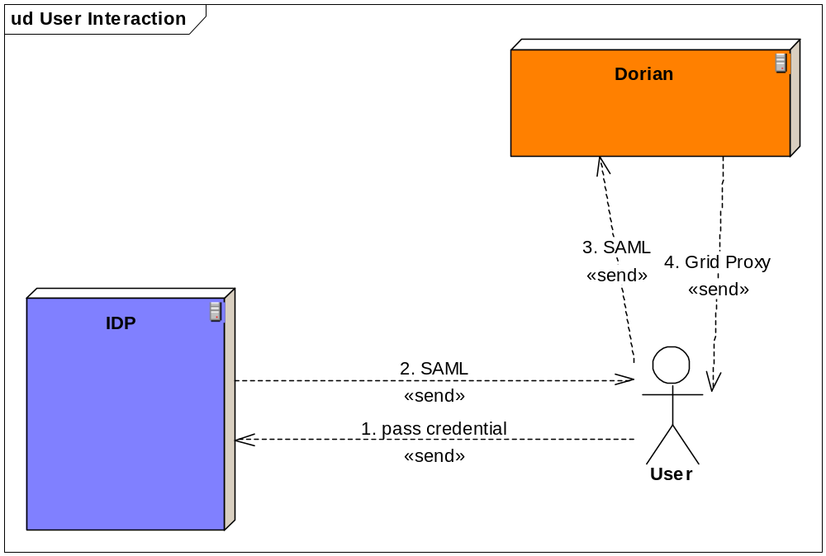
In the diagram above, the IDP will further use CSM for authentication with local credential provider. The idea here is to use the existing authentication mechanism at different institutes leading to minimal changes in existing infrastructure.
From CSM perspective, CSM has to expose the API for login, which can return a JAAS Subject on successful login. The expected attribute to be returned are
- First Name
- Last Name
- Email Id
Once IDP has handle for these attributes, IDP will prepare SAML and send it back to the user. SAML preparation piece will be accomplished by caGrid team.

Authorization on Grid
User id based access control within Grid environment is not a feasible solution for not being scalable. It is not possible to replicate every user on the grid in local system to facilitate the security. To solve this issue and provide the access control at grid level, the caGrid team has taken VO or group based access control approach. In this approach the grid users will belong to groups of their interest. Any particular service will know the groups that it will entertain on order to provide access to the users. In other words, the service will not deal with user id but will control the access on its resources based on the groups a user belongs to.
The above scenario can be depicted as follows
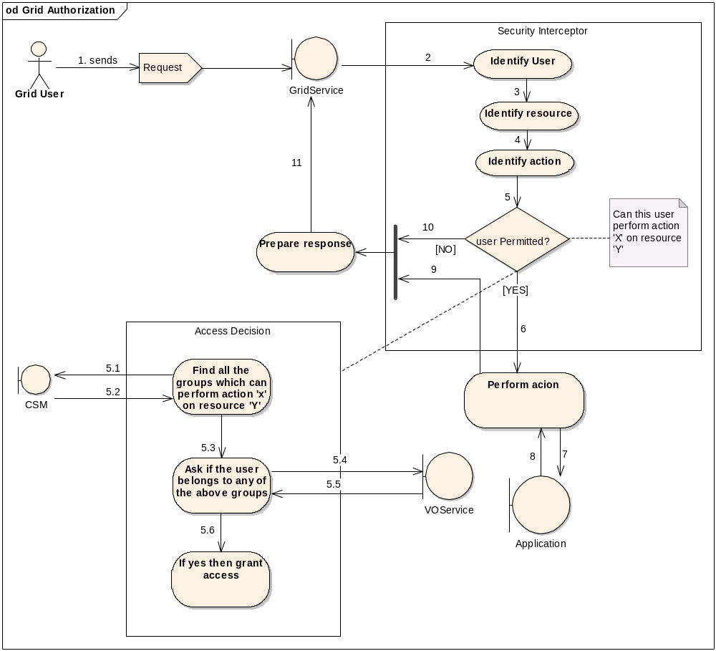
From CSM perspectives, following scenarios are the potential candidates for requirements

Can group “A” perform action “X” on resource “Y”
In this case, CSM API will return true or false indicating the access control.

Give me all the groups, which can perform action “X” on resource “Y”
In this case, CSM API will return an array of group objects.

Can a grid user with grid id “iu/jh/kl” perform action “X” on resource “Y”
In this case, the existing method has be modified to check if the user is grid user or local user. And if the user is the grid user, then communicate with VO service to look for the groups that a user belongs to. This can also be accomplished outside CSM without changing anything.

Provisioning VOs on Grid
caGrid team is willing to leverage CSM UPT for VO provisioning. Rather than creating a completely new tool, it may be good idea to use the work that has been done as a part of CSM effort.
In this approach a new CSM and UPT instance will be hosted centrally at Grid level. We can call this as VO provisioning tool (VPT). VPT will be used for managing grid groups or VOs.

Actors Identified

Dorian
Dorian will interact with VPT for creation and deletion of grid users in VPT. When a user logs in for the first time in grid, Dorian will create the grid user in VPT.

Super Admin
There will be one super admin at grid level for VPT. The super admin will assign admin role to certain users to make them admin for the groups. Super admin can also revoke the admin role from the grid users.

Admin
Once a grid user has the admin role, he or she can manage grid groups. In other words, an admin can create the groups and assign the grid users to certain groups. Admin can also remove the users from the group. Admin will also create or import the references to the grid groups in local security policy. Admin will also provision the authorization data for these groups locally.

VOService
VOService will use VPT to find the groups a user belongs to.
The use case scenario is described in the diagram below.
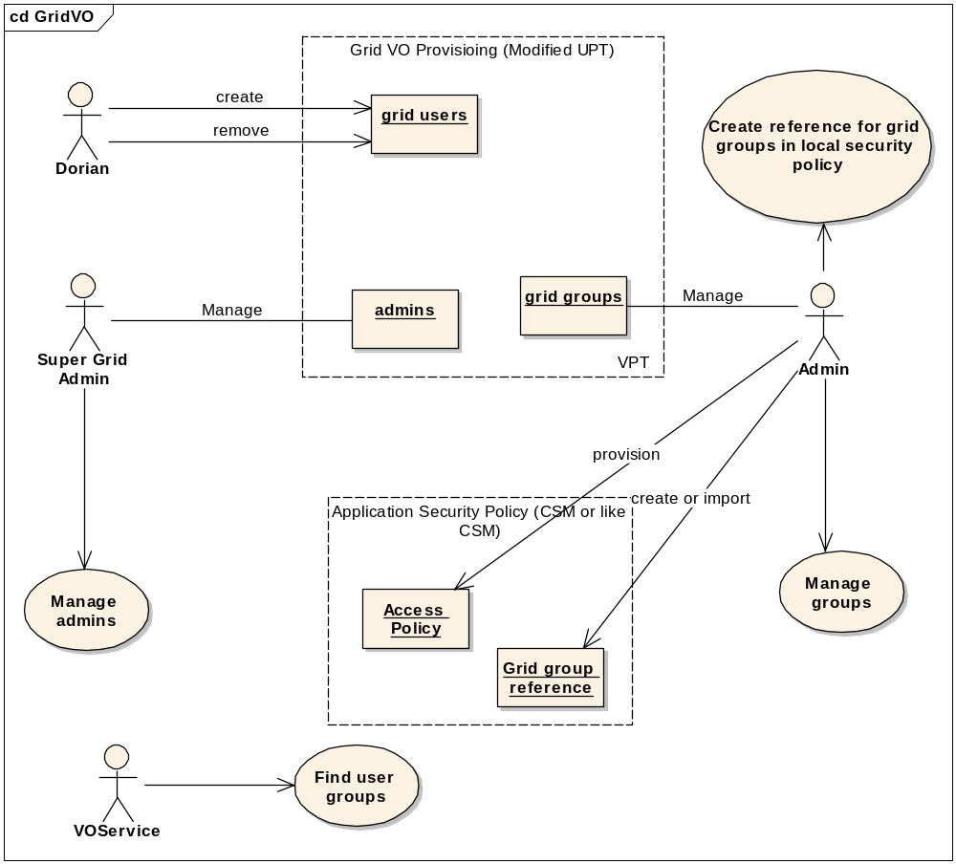

Things to do on CSM part

Customizations for CSM’s UPT Tool
- User
  - Dorain would able to create and delete users programmatically
  - Allow the Admin to Search for User
  - Allow the Admin to Assign the User to a Group
  - All other functionalities to be made not available via UI
- Group
  - Allow the Admin to create a Group
  - Allow the Admin updating a Group’s data
  - Allow the Admin deletion of a Group
  - Allow the Admin Searching of Group
  - Allow assignment of User’s to Group
  - All other functionalities to be made not available via UI
- Application
  - Super Admin can create a new Application (will be done only once to create the common GRID Application)
  - Allow the Super Admin to Assign Admin role to grid users to the common GRID Application
- Protection Element
  - No functionalities will be exposed via UI
- Protection Group
  - No functionalities will be exposed via UI
- Role
  - No functionalities will be exposed via UI
- Privilege
  - No functionalities will be exposed via UI

