Use Case Document

caGrid 1.0 Workflow
Ravi Madduri, Argonne National Labs
Patrick McConnell, Duke Comprehensive Cancer Center

DOCUMENT REVISION HISTORY
Version Number | Date | Description
0.1 | 8/23/2006 | Initial template draft by Patrick

Background/Summary
caBIG aims to bring together disparate data and analytic resources into a “World Wide Web of cancer research.” This will be achieved through common standards and software frameworks for the federation of these resources into “grid” services. Many of the tasks in the collection and analysis of cancer-related data on the grid involve the use of workflow. Here, we define workflow as the connecting of services to solve a problem that each individual service could not solve. In bioinformatics, this is sometimes referred to as a pipeline. This is different than the workflow in wet-lab information management (LIMS), where workflow refers to the steps that a lab sample takes through processing. This is also different than workflow often seen in a clinical trials management system, where patient data is tracked through multiple systems and departments. Furthermore, this is different from modeling of biological processes, where each node in the workflow represents some biological entity and the connections represent the interactions. Instead, analytical workflow involves the consumption of analytic and data services, where data is piped between them, logical decisions are made along the way, and data transformations are common.
It can be useful to think of a workflow as representing a process in the real world. Though this definition has roots in modeling business processes, it has application to modeling bioinformatics processes as well. For example, you can envision a researcher collecting a set of related microarray experiments from various services across various institutions. This process can be modeled as a grid workflow, where the actors are the researcher and the services, and the actions are the invocation of the services and the collation of the results.
In contrast, it is also useful to think of a workflow as a grid-aware scripting language. For example, you can envision a script that takes all of the expressed genes from a microarray experiment, searches for all up-stream genes in pathways, and finally finds gene ontology information for these genes. Here, there is a specific set of steps to be executed that can be expressed in a way natural to a grid environment.

Table of Contents
1 Introduction 3
1.1 Overview (Patrick) 3
1.2 Related Documents (Ravi) 3
2 Actors and Goals (Patrick) 3
2.1 <User Manager> 3
2.2 <Actor 2> 3
3 System Use Cases (Ravi) 3
3.1 <Use Case Name> 4
4 Scientific/Application Use Cases (Patrick) 5
4.1 <Use Case Name> 6
5 Overall Requirements (Patrick) 7
5.1 Requirements Prioritization 7
6 Sign Off 8
6.1 Approval 8

Introduction

Overview
Workflow in caGrid is implemented as a grid service that performs a workflow described by a Business Execution Process Language (BPEL) document. That document contains the endpoints (dynamically or statistically defined) of the services to contact, the formats of the messages to transfer between the services, and the logic in between. Here, we describe the use cases for that engine: both from a system standpoint and a scientific/application standpoint.

Related Documents (Ravi)
<List related documents here with URL>

Actors and Goals (Patrick)
[Actors are classes that define roles that objects external to a system may play. They are used to model users outside of a system that interact directly with the system as part of coherent work units. This include human users and other systems – see 3.1.3, 3.1.4]
<List all the Actors for all use cases here>

Grid node administrator
A grid node administrator deploys and maintains the components necessary to run the workflow service. This includes any services, databases, security components, and other resources required.

Workflow consumer
A workflow consumer composes workflows and submits them to the workflow management service (WMS).

System Use Cases (Ravi)
[Repeat sections 3.X for each Use Case]

<Use Case Name>

Use Case Model
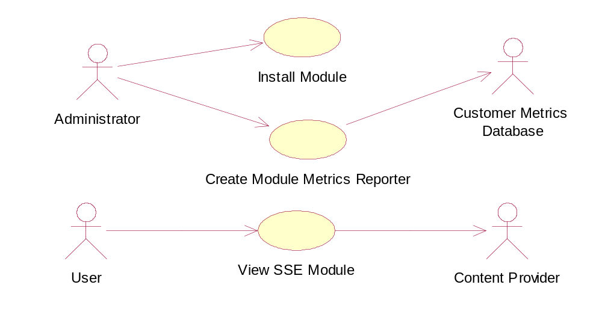

Brief Description
[The description briefly conveys the role and purpose of the use case. A single paragraph will suffice for this description.]

Primary Actor
[The primary actor identifies the primary user of the system for the specified use case. The primary actor always initiates the use case.]

Secondary Actors
[Optional. The secondary actors identify the secondary users of the system for the specified use case.]

Preconditions
[A precondition of a use case is the state of the system that must be present prior to a use case being performed.]

< Precondition One >

Basic Flow of Events
[The use case flow of events starts when the actor performs an action. An actor always initiates use cases. The use case describes what the actor does and what the system does in response. It is phrased in the form of a dialog between the actor and the system.
The use case describes what happens inside the system, but not how or why. If information is exchanged, be specific about what is passed back and forth. For example, it is ambiguous to say that the actor enters customer information if it is not defined. It is better to say that the actor enters the customer’s name and address. A Glossary of Terms (or a more formal Domain Model) is essential to keep the complexity of the use case manageable⎯you may want to define things like customer information there to keep the use case from drowning in details.
Simple alternatives may be presented within the text of the flow of events. If it only takes a few sentences to describe what happens when there is an alternative, do it directly within the flow. If the alternative flow is more complex, use a separate section to describe it. For more information, see Alternative Flow subsection below.
Feel free to paste flow charts, activity diagrams or other figures into the use case, if they improve clarity. Similarly, for state-dependent behavior, a state-transition diagram often clarifies the behavior of a system better than pages upon pages of text. Use the right presentation medium for your problem, but be wary of using terminology, notations or figures that your audience may not understand.]

Postconditions
[A postcondition of a use case is a list of possible states the system can be in immediately after a use case has finished.]

< Postcondition One >

Special Requirements
[A special requirement is typically a nonfunctional requirement that is specific to a use case, but is not easily or naturally specified in the text of the use case’s event flow. Examples of special requirements include legal and regulatory requirements, application standards, and quality attributes of the system to be built including usability, reliability, performance or supportability requirements. Additionally, other requirements⎯such as operating systems and environments, compatibility requirements, and design constraints⎯should be captured in this section.]

< First Special Requirement >

Scientific/Application Use Cases (Patrick)

Proteomics analysis workflow

Use Case Model
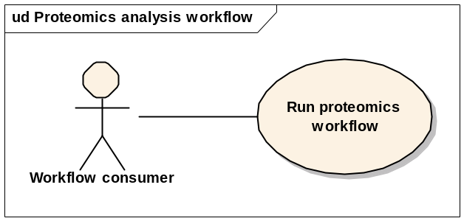

Brief Description
In this use case, a workflow is constructed to perform various analysis steps in the low-level proteomics analysis pipeline. This consists of interpolation, denoising, background removal, alignment, and normalization. The input to the workflow is a set of ScanFeatures documents, and the output is a set of processed ScanFeatures documents. More than one RProteomics services can be used.

Primary Actor
Workflow consumer

Secondary Actors
None

Preconditions

RProteomics service deployed
An RProteomics analysis service is deployed and accessible.

Workflow service deployed
A workflow management service has been deployed and is accessible.

Input data
A set of ScanFeatures documents exists as input.

Basic Flow of Events
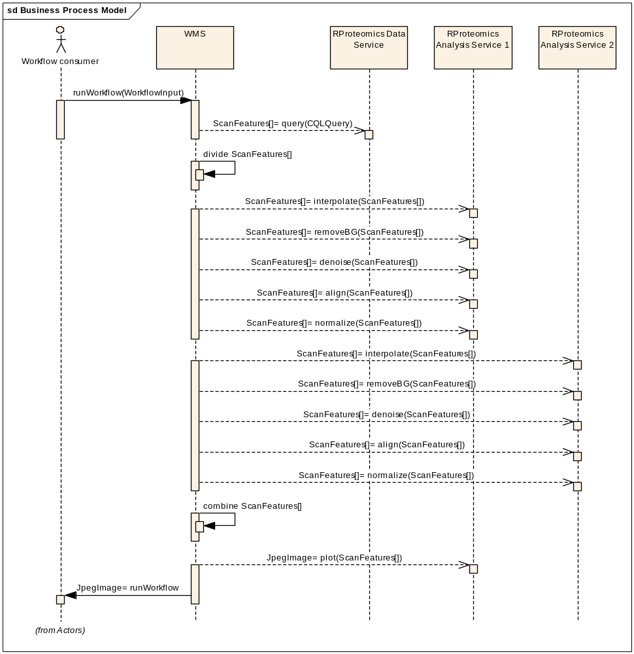

Postconditions

Output data
A JPEG image is available

Special Requirements
None

Microarray analysis workflow

Use Case Model
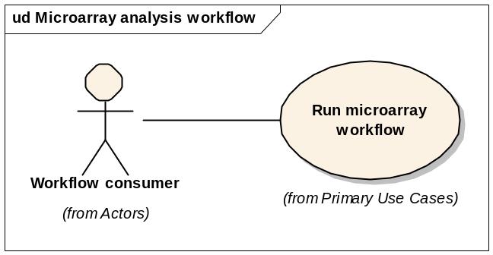

Brief Description
In this use case, a workflow is constructed to perform various analysis steps in the low-level proteomics analysis pipeline. This consists of normalization, background removal, etc. The input to the workflow is a set of ScanFeatures documents, and the output is a set of processed ScanFeatures documents.

Primary Actor
Workflow consumer

Secondary Actors
None

Preconditions

Workflow service deployed
A workflow management service has been deployed and is accessible.

Input data
A set of ScanFeatures documents exists as input.

Basic Flow of Events

Postconditions

Output data
A set of ScanFeatures documents is available

Special Requirements
None

Image analysis workflow

Use Case Model
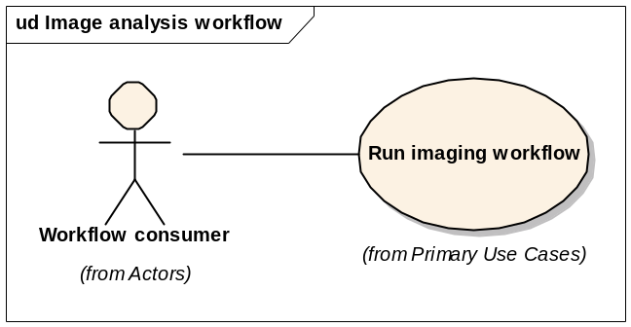

Brief Description
In this use case, a workflow is constructed to perform various analysis steps in the low-level proteomics analysis pipeline. This consists of normalization, background removal, etc. The input to the workflow is a set of ScanFeatures documents, and the output is a set of processed ScanFeatures documents.

Primary Actor
Workflow consumer

Secondary Actors
None

Preconditions

Workflow service deployed
A workflow management service has been deployed and is accessible.

Input data
A set of ScanFeatures documents exists as input.

Basic Flow of Events

Postconditions

Output data
A set of ScanFeatures documents is available

Special Requirements
None

Genomic identifier workflow

Use Case Model
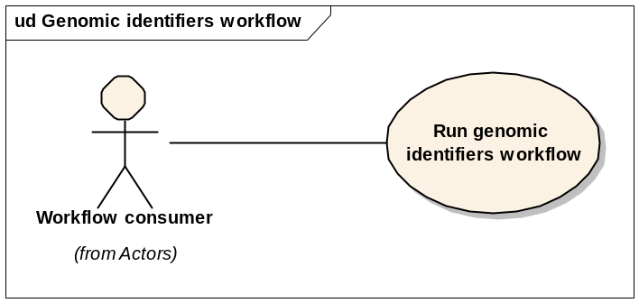

Brief Description
In this use case, a workflow is constructed to perform various analysis steps in the low-level proteomics analysis pipeline. This consists of normalization, background removal, etc. The input to the workflow is a set of ScanFeatures documents, and the output is a set of processed ScanFeatures documents.

Primary Actor
Workflow consumer

Secondary Actors
None

Preconditions

Workflow service deployed
A workflow management service has been deployed and is accessible.

Input data
A set of ScanFeatures documents exists as input.

Basic Flow of Events

Postconditions

Output data
A set of ScanFeatures documents is available

Special Requirements
None

Overall Requirements (Patrick)

Requirements Prioritization

Priority | Use Case Name | Supp Requirement Ref #
<Comments>

Sign Off

Approval

Workspace General Contractor Rep Print Name Date
Architecture Workspace Rep Print Name Date
VCDE Workspace Rep Print Name Date
Workspace Working Group Rep Print Name Date
NCICB Rep Print Name Date

