Notional Architecture
Shown below in Figure 1 and Figure 2 are a notional architecture for the core infrastructure services, and the current infrastructure's placement within. The infrastructure is coursely divided between security, knowledge management, and collaboration services. Figure 2 highlights the current core services provided by caGrid in blue callouts, and in gray callouts, some potential specifications or technologies which could fit into the current infrastructure but are not yet implmented.

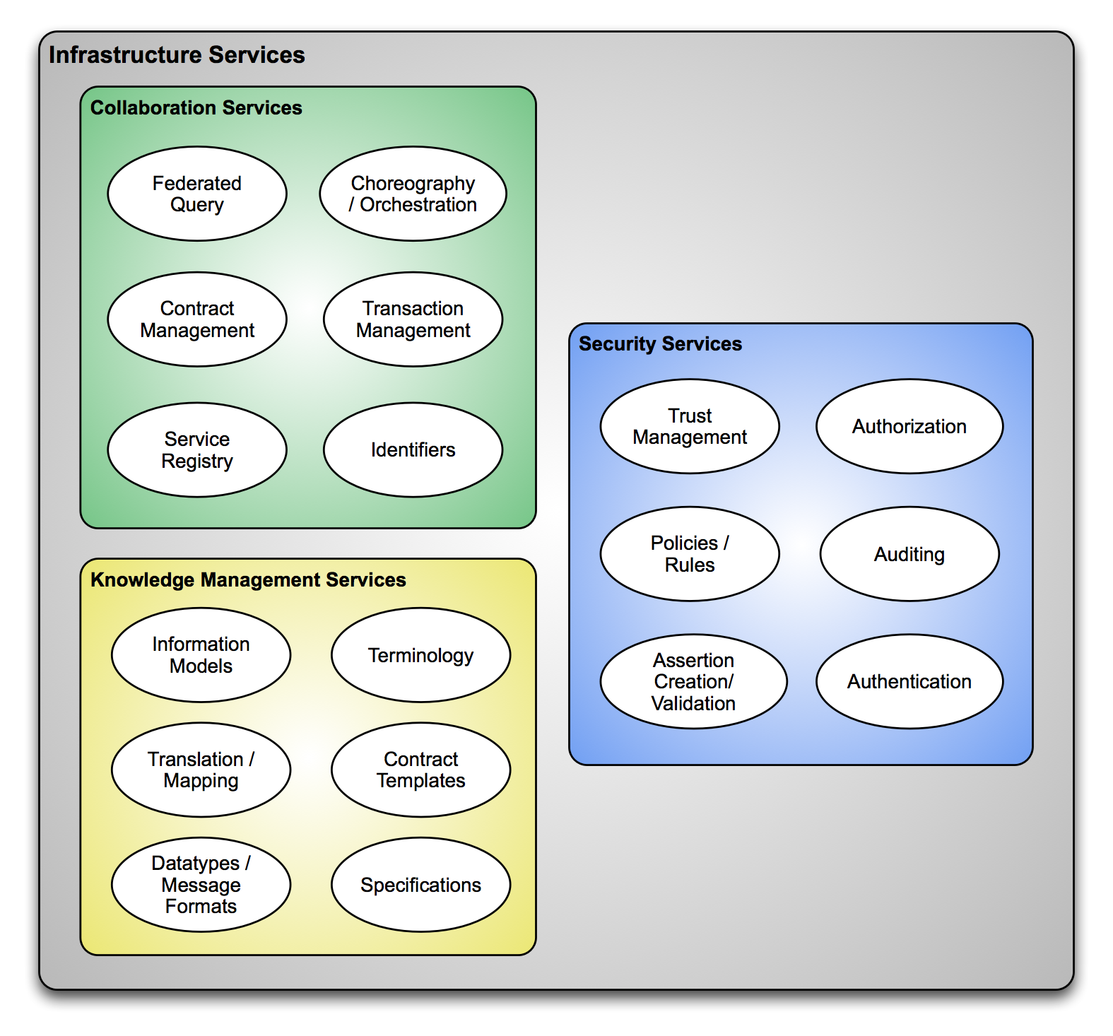
Figure 1 A notional architecture of core infrastructure

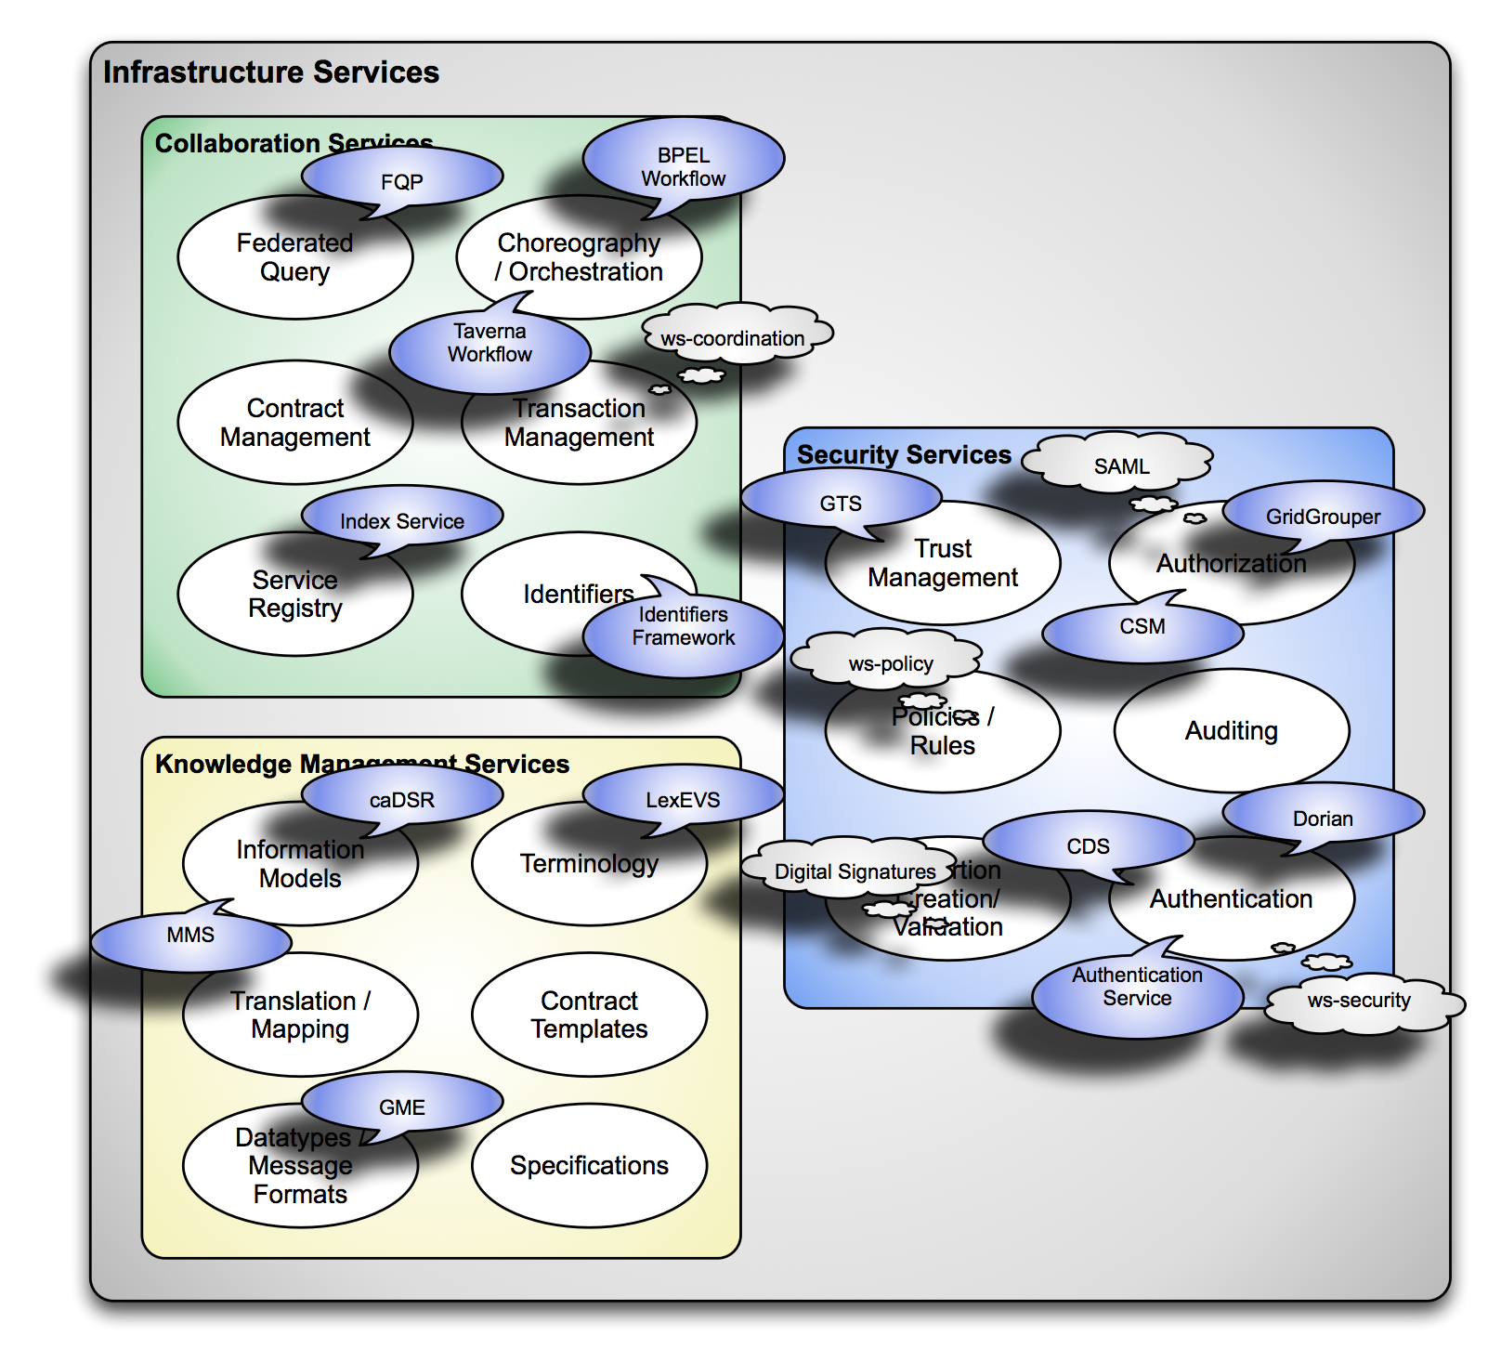
Figure 2 Existing infrastructure's relationship to notional architecture

Service Registry
A primary emphasis of the new approach to translational research is contract-based interactions and behavioral semantics. The current infrastructure provides significant capabilities for managing and utilizing static semantics in a service oriented architecture, but the behavior of the components leveraging the static semantics are either implicit or not defined. This limitation, in the context of a contract-based environment, is most pronounced in the areas of service advertisement, discovery, and orchestration. That is, currently consumers locate and compose available data sources and services based purely upon the semantics of the data models they leverage, and using information not formally represented in the environment (for example, knowing "caTissue services" manage bio-samples). The current infrastructure provides adequate capabilities for locating services of interest based on such information, and for linking them together in data flows, but must be significantly enhanced to support a more formal notion of business interactions, and to empower its users to leverage the significant new information expected to become available which describes these interactions.

Service Advertisement and Registration
It is expected that the existing advertisement pattern of service self-registration to a service registry will still suffice, but the information registered and maintained by the registry will need to be increased, and potentially become more dynamic. Shown below in Figure 3 is a notional representation of information that will be necessary in future service registrations, and supporting aspects of the infrastructure that they will require. Highlighted in gray are areas of infrastructure and information which are at least partially fulfilled by the current infrastructure, whereas the purple and blue areas represent new information and infrastructure that does not currently exist. The current information available for a registered service provides the endpoint information (i.e. network address) of the service, and a service-provided description of the service, including its operations described by reference to the semantically annotated information models (in caDSR). This information will need to be enhanced to support drawing from distributed repositories (both information model and terminology), as well as semantically annotating additional items (for example, service operations and services themselves). Supporting multiple sources of authority for information models and terminologies will minimally require adjustments to the service metadata which currently assumes a single source of authority, and relies on implicit knowledge about how to deference the references to that system (for example, what a "concept code" is and how to find out more about it). The use of a globally unique and resolvable identifier framework, and common identifier usage profile, will be required to reference information from numerous systems and describe how to access more information from those systems.
The additional information required to support the new use cases and approach includes both static (highlighted in purple) and dynamic (highlighted in blue) information. The dynamic information includes computed performance and availability metrics, which may greatly facilitate the evaluation of service fitness to quality of service requirements in contract templates of interest. For example, the registry service could track historical "up time" to generate quantitative metrics, and potentially provide a feedback mechanism where community ratings could feed into qualitative metrics. Some contract templates may specify use of high availability services, or those which can accommodate certain service level agreements; these metrics can facilitate location of such services. The additional static information needed includes the specification of which potential roles the service could play in specified contract templates, information describing the security access policies and protocols of the service, references to various artifacts produced by the ECCF and general development efforts (such as documentation and client libraries), and computable assertions relating to the service's conformance to various functional profiles and policies. An important cross-cutting requirement of many of these new pieces of information is their ability to be asserted by a source of a authority, and systematically validated by consumers. That is, with an increasing reliance on metadata and specification artifacts to initiate business interactions with discovered parties, it is increasingly important that the accuracy of said metadata can be assured and validated. One possible approach to this problem is to use digital signatures on metadata, leveraging the existing security infrastructure's trust fabric and public key infrastructure. For example, it is not feasible that a given institution's authoritative patient registry service can be found solely by self-provided metadata. Successful application of this use case likely requires such a role assertion to come from an authoritative source, and that its binding to a particular endpoint on the grid be done in a tamper-proof manner.
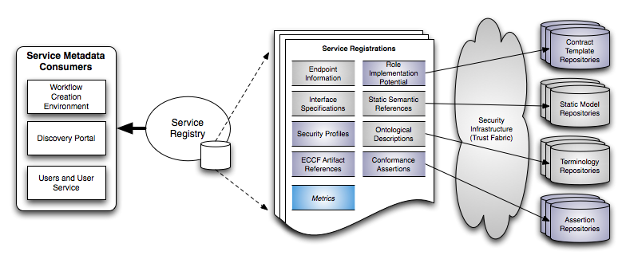
Figure 3 A notional representation of service registration

Service Discovery
With the enhancement of the Service Registery to contain and have access to a richer set of service metadata such as behavioral semantics, assertions, and metrics the current mechanisms for discovering services will need to be enhanced. It is expected the current workflow of service consumers querying the service registry for endpoints of interest will still be applicable, but that both the nature and capabilities of the queries expressed will need to be enhanced. The current infrastructure uses a simple structural query language (XPath) to express value-based queries of the service registry, and requires all data of interest to be present in the service registry, and any advanced processing must be done client-side. For example, while concept-based queries can currently be expressed (e.g. "find data services exposing information about 'lung cancer'"), any concept expansion must be done client-side. That is, the service registry does not understand the terminology, and cannot reason over its relationships. The current infrastructure also does not allow a query to access any information that is "referenced" by the registration; this must be done client-side. It is expected the future registration information will need to make much more use of references, rather than extracts of select information. For example, a registration may just reference a role within a contract template, but the details of that contract would be maintained externally in the contract template repository. Users of the Service Registry will want to query for services utilizing this enhanced metadata. Such queries may include, for example, searching for services which could play roles in particular contracts like "data service query" or that validate against particular assertions like "the Ohio State University patient registry". The use of this enhanced service metadata leads to the need new discovery capabilities available though the Service Registry. The registry will need to provide a query capability which enables the filtering and reasoning over a much broader set of service metadata and will need to be able to further resolve the metadata entities which are referenced in the repositories shown in Figure 3. This data will likely need to be reasoned over in order to satisfy the queries. For example, a potential new query might be "Find a service that adheres to the 'CQL Data Access' contract, provides 'demographic information', is asserted to be an official 'Patient Registry' and is provided by 'Ohio State University'". This type of query will require that the service metadata of a service which satisfies this query will have a reference to the roles it can play in specific contracts, the assertions are provided by a trusted authority, and some reasoning of the terminology be supported (so service's providing specific types of demographic information are found). If a service metadata entry can satisfy the query then the service registry can return the endpoint of the corresponding service. Once this type of query is specified and a service is located which satisfies it, the user of this service can be assured that this service is a Patient Registry and can accept CQL queries to locate patient demographic data within it (provided the appropriated authorization).

Service Composition and Orchestration
This use of the behavioral semantics, assertions, metrics and static semantics will change the way applications can find and use services in an automated and interoperable way. With services describing "what" they can do through the more enhanced metadata described above, services will be able to be located dynamically by utilizing not only the data types but also utilizing what the service can actually do. This type of dynamic discovery is vastly different than the type of interoperability validation that can be done in caBIG today and provides the framework for doing significantly more interesting service compositions in a semi-automated way. Because service consumers will be able to leverage a new more semantically rich Service Registry to locate services that adhear to particular contracts, contain certain ECCF artifacts, and utilize particular roles or policies, a new set of more advanced tools and applications will be able to be created. An example new tool or framwork which can leverage this new information is an advanced workflow framework. Such a framework should enable its users to describe workflows as templates which detail a logical flow of contraints and or assertians on metadata such as behaviorial and static semantic artifacts, specifying quality of service or other policy requirements. The workflow framework should be able to automatically find services utilizing the Service Registry, in order to locate services which can be used to satisfy the constraints and assertions in a specified workflow template. This will enable workflow templates to be created that simply define a workflow template as a set a set of contracts, assertions, queries, etc. conected together through a workflow description language. These templates can be dynamically and automatically instantiated by an workflow engine capable of utilizing the data available through the discovery APIs of the Service Registry. That is, the workflow engine will contact the Service Registry providing queries describing the type of service required to satisfy the workflow template description which will be using behavioral semantics, static semantics, assertions, and policies.
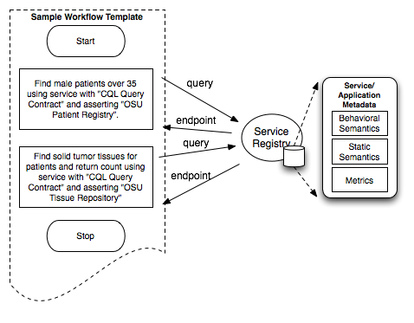
Figure 4 A notional example of a workflow template

The workflow framwork should also support instantiating workflow templates as services and registering them to the service registry and its associated repositories. This type of service composition leads to the ability to create services which are nothing more than a composition of other services. These services will still provide and utilize behavioral and static semantics as well as other enhanced service metadata, however, their implementation will simply be a composition of other services and a workflow description of how the composition is to be instantiated.
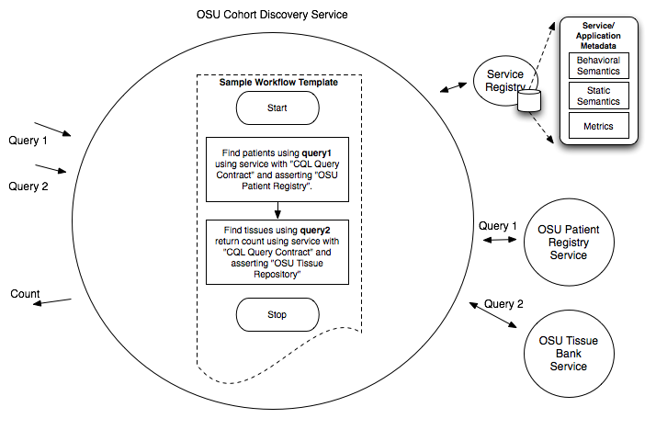
Figure 5 A notional example of service composition

Rules Engines
Being able to reason about conformance assertions, policy rules, and metadata artifacts will become a common requirement in the rich metadata environment that caBIG is heading towards. Utilizing the specification artifacts, assertions, metrics, etc. will require a rules based system to be able to specify and reason about particular service requirements and policies when locating services or looking for and executing workflow and contract templates. Rules engines, such as JBoss drools (http://www.jboss.org/drools/) have the ability to create complex rules and flows which can act apon those rules. These rules can help describe contraints on the service metadata requirements which discovering a service. The rules can create decision descriptions about the assertions and metadata artifacts available in the new metadata environment and the flows can be utilized to represent the queries over the rules which are utilizing various available metadata elements corresponding to service registrations. The execution of these flows will enable the location of services which satisfy the restrictions and assertions describes in the flows and rules used within. Such engines will also provide significant capabilities to initiate and monitor contract execution.
Transactions
A gap in the current caGrid infrastructure is the ability to easily integrate with back end transactional and message bus systems that may exist in an enterprise. Projects, such as caExchange, have attempted to close this gap by creating interfaces that help bridge between service oriented messaging and bus based and transaction messaging. As caGrid moves its specification and technology stack to more industry standard and interoperable technologies, interoperability with enterprise service busses and transaction based systems should be easier. Efforts will need to be undertaken to support ESB integration out of the box with caGrid software. This support should also be able to support the notion of a transaction, that is, the ability to open, persist, commit, and rollback a sequence of events potentially involving multiple participating parties, perhaps across multiple technology deployments. The move towards a specification driven architecture enables this support to be more easily accomplished. The ECCF design constraints will enable the description of the application specification without having to worry about the dependencies that may arise in the platform specific specification which may use an ESB or a SOA based deployment. This emplies that caGrid should also support this clean separation between business logic requirements and platform deployments such as WS-I, REST, or ESB. On the current WS-I based service deployments, transactions could be supported through the use of specifications such as WS-Coordination and WS-AtomicTransaction.

