caBIG® Platform Specific Service Specification Template

caGrid Identifiers Framework

1.0

03/29/2010

Authors | Calixto Melean
Editor | Calixto Melean
Reviewers | Dave Ervin
Architecture Inception Team | Scott Oster
DOCUMENT CHANGE HISTORY

Version Number | Date | Contributor | Description

Table of Contents
1 Executive Summary: 6
1.1 Service Description and Purpose 6
1.2 Scope 6
1.3 Referenced Standards 6
2 Conformance to Platform Independent Model 7
2.1 Conformance Profile 8
2.2 Dynamic Interactions 9
3 Platform Specific Model 9
3.1 Overview 9
3.2 Assumptions and Dependencies 11
3.3 Service Interface 12
3.3.1 Interface Model 12
3.3.2 Operations Details for NamingAuthority Interface 14
3.3.3 Operation Details for MaintainerNamingAuthority Interface 18
3.4 Message Information Model 24
3.4.1 Information Model 24
3.4.2 Information Model Description 25
3.5 Service Interactions 26
3.5.1 Actors 26
3.5.2 Interaction Details 27
3.6 Implementation Considerations 32
3.6.1 Security 32
3.6.2 Auditing 34
3.6.3 Privacy 35
3.6.4 Error Handling 35
3.7 Deployment Details 35
3.8 Constraints 36
4 Recommendations for Conformance and Compliance 36
4.1 Conformance Assertions 36
5 Appendix A - Relevant Standards 38
6 Appendix B - Glossary 40

Executive Summary:

Service Description and Purpose
The functionality provided by caGrid’s Identifier Services Framework is related to having “identifiers” for individual data-objects. The identifier is essentially a forever globally unique name for the data-object such that it can be unambiguously used to refer to the data from different application contexts.
In order to create, modify, delete the name-object bindings, facilities and services have to be defined and provided. Furthermore, in order to find the data-object when only the identifier is known, global resolution services have to be defined to resolve the name to the object.

Scope
The identifiers framework provides a default implementation that allows resolution and management of identifiers.

Referenced Standards
The identifiers framework conforms with existing web standards and protocols, providing a natural approach to identifier adoption and resolution.

- RFC 3305: Uniform Resource Identifier (URI)
- RFC 2616: Hypertext Transfer Protocol (HTTP)
- W3C XML 1.1: Extensible Markup Language (XML)

Conformance to Platform Independent Model

Platform Independent Model Name and Service Specification | Platform Independent Model and Service Specification Version | Description & Link to the Platform Independent Model and Service Specification
caGrid Identifiers Framework Platform Independent Model and Service Specification | 1.0 | https://ncisvn.nci.nih.gov/svn/cagrid/trunk/cagrid/Documentation/core/Identifiers/caBIG_Platform_Independent_Model.doc

Conformance Profile

Conformance Profile No. | NA-CP1
Conformance Profile Name | Naming Authority Resolution Conformance Profile
Functional Profiles
  Functional Profile No. | Functional Profile Name
  NA-FP1 | NA Resolution
Semantic Profiles
  Semantic Profile No. | Semantic Profile Name
  NA-SP1 | NA v1.0 Resolution
Conformance Profile No. | NA-CP2
Conformance Profile Name | Naming Authority Full Administration Profile
Functional Profiles
  Functional Profile No. | Functional Profile Name
  NA-FP2 | NA Administration
Semantic Profiles
  Semantic Profile No. | Semantic Profile Name
  NA-SP2 | NA v1.0 Administration

Dynamic Interactions
All interactions between client applications and the service are standard SOAP/HTTP.

Platform Specific Model

Overview
The identifiers framework software architecture consists of the following components or layers with clearly defined interfaces. In the picture, each layer depends on the interfaces defined by the component immediately below it.
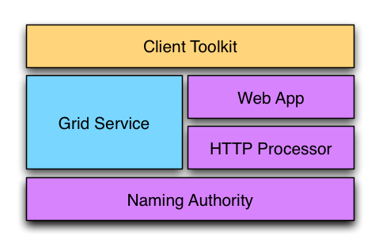

The Naming Authority is the core component. At minimum, it declares an interface to resolve identifiers. This is, accepting an identifier as input, and producing identifier metadata as output. A naming authority could optionally implement interfaces to support creation and maintenance of identifiers and their metadata.

The HTTP Processor component defines an interface to process HTTP requests. It is responsible for handling the HTTP protocol aspects of the resolution process. It understands the components of the identifier URI and responds accordingly. It uses the naming authority’s interface to respond to identifier resolution requests.

The Web App layer provides a component meant to be deployed to an application container (i.e. Tomcat). It wraps and stands up the HTTP processor implementation.

The Grid Service component provides a standard grid (web) service interface to grid clients. The interface availability here depends on the underlying naming authority being used.

The Client Toolkit provides a client library useful to resolve identifiers using the web interface as well as the grid interface. It also provides a framework that can be extended to support data object retrieval from a variety of sources once identifier resolution is complete.

The Naming Authority, HTTP Processor, and Web App are required components and exist in all deployments. They provide basic resolution services for the framework.
The Grid Service is an optional component. However, this is expected to provide the “write” interface to create/update identifiers in deployments where this functionality is supported. The Web App is a resolution-only interface.

The Client Toolkit is a convenience library that clients may use or not.

The identifiers framework provides a default implementation for its interfaces and components. This is expected to meet the needs of most adopters and deployment scenarios.

The framework, however, has been designed to make certain pieces or components replaceable or extended, in order to accommodate different deployment needs. This is accomplished by the use of a powerful configuration system based on the Spring Framework.

The framework is composed of three sub-projects within caGrid: identifiers-namingauthority, identifiers-namingauthority-gridsvc, and identifiers-client.

Technology Stack
Technology | Affects
Globus Toolkit 4.0.3 | GTK is used to develop this WSRF complaint grid service
Tomcat 5.x | Tomcat server will be used to deploy this service
Java JDK 1.5

Assumptions and Dependencies
None

Service Interface

Interface Model

Implemented Interface No. | Supported Interface Name | Interface Description
NA-INF1 | NamingAuthority | Contains functionality to query and retrieve identifiers metadata.
NA-INF2 | MaintainerNamingAuthority | Contains functionality to administer naming authority identifiers.

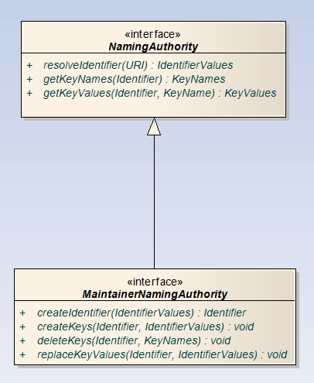

Operations Details for NamingAuthority Interface

resolveIdentifier
Description | This operation returns the metadata associated with the given identifier.
Pre-Conditions | The identifier must exist and the requesting user must be authorized to resolve it.
Security Controls | A user can read a key from an identifier if any one of the below conditions are met:  (a) User is identifier's administrator  (b) User is listed as reader by the key’s policy identifier  (c) Key has no policy identifier and user is listed as reader or the identifier  (d) Key has no policy identifier and identifier has no security settings  Only the keys that the user is authorized to read are returned.  A security exception is thrown if the user can’t read any of the keys associated with the identifier.
Inputs | Identifier (Required)
Outputs | Identifier Metadata (keys and values)
Post-Conditions
Exception Conditions | InvalidIdentifierException  NamingAuthorityConfigurationException  NamingAuthoritySecurityException
Notes

getKeyNames
Description | This operation returns the metadata associated with the given identifier.
Pre-Conditions | The identifier must exist and the requesting user must be authorized to resolve it.
Security Controls | A user can read a key from an identifier if any one of the below conditions are met:  (a) User is identifier's administrator  (b) User is listed as reader by the key’s policy identifier  (c) Key has no policy identifier and user is listed as reader or the identifier  (d) Key has no policy identifier and identifier has no security settings  Only the keys that the user is authorized to read are returned.  A security exception is thrown if the user can’t read any of the keys associated with the identifier.
Inputs | Identifier (Required)
Outputs | Identifier Metadata (keys and values)
Post-Conditions
Exception Conditions | InvalidIdentifierException  NamingAuthorityConfigurationException  NamingAuthoritySecurityException
Notes

getKeyData
Description | This operation returns the metadata associated with the given identifier.
Pre-Conditions | The identifier must exist and the requesting user must be authorized to resolve it.
Security Controls | A user can read a key from an identifier if any one of the below conditions are met:  (a) User is identifier's administrator  (b) User is listed as reader by the key’s policy identifier  (c) Key has no policy identifier and user is listed as reader or the identifier  (d) Key has no policy identifier and identifier has no security settings  Only the keys that the user is authorized to read are returned.  A security exception is thrown if the user can’t read any of the keys associated with the identifier.
Inputs | Identifier (Required)
Outputs | Identifier Metadata (keys and values)
Post-Conditions
Exception Conditions | InvalidIdentifierException  NamingAuthorityConfigurationException  NamingAuthoritySecurityException
Notes

Operation Details for MaintainerNamingAuthority Interface

createIdentifier
Description | This operation returns the metadata associated with the given identifier.
Pre-Conditions | The identifier must exist and the requesting user must be authorized to resolve it.
Security Controls | A user can read a key from an identifier if any one of the below conditions are met:  (a) User is identifier's administrator  (b) User is listed as reader by the key’s policy identifier  (c) Key has no policy identifier and user is listed as reader or the identifier  (d) Key has no policy identifier and identifier has no security settings  Only the keys that the user is authorized to read are returned.  A security exception is thrown if the user can’t read any of the keys associated with the identifier.
Inputs | Identifier (Required)
Outputs | Identifier Metadata (keys and values)
Post-Conditions
Exception Conditions | InvalidIdentifierException  NamingAuthorityConfigurationException  NamingAuthoritySecurityException
Notes

deleteKeys
Description | This operation returns the metadata associated with the given identifier.
Pre-Conditions | The identifier must exist and the requesting user must be authorized to resolve it.
Security Controls | A user can read a key from an identifier if any one of the below conditions are met:  (a) User is identifier's administrator  (b) User is listed as reader by the key’s policy identifier  (c) Key has no policy identifier and user is listed as reader or the identifier  (d) Key has no policy identifier and identifier has no security settings  Only the keys that the user is authorized to read are returned.  A security exception is thrown if the user can’t read any of the keys associated with the identifier.
Inputs | Identifier (Required)
Outputs | Identifier Metadata (keys and values)
Post-Conditions
Exception Conditions | InvalidIdentifierException  NamingAuthorityConfigurationException  NamingAuthoritySecurityException
Notes

createKeys
Description | This operation returns the metadata associated with the given identifier.
Pre-Conditions | The identifier must exist and the requesting user must be authorized to resolve it.
Security Controls | A user can read a key from an identifier if any one of the below conditions are met:  (a) User is identifier's administrator  (b) User is listed as reader by the key’s policy identifier  (c) Key has no policy identifier and user is listed as reader or the identifier  (d) Key has no policy identifier and identifier has no security settings  Only the keys that the user is authorized to read are returned.  A security exception is thrown if the user can’t read any of the keys associated with the identifier.
Inputs | Identifier (Required)
Outputs | Identifier Metadata (keys and values)
Post-Conditions
Exception Conditions | InvalidIdentifierException  NamingAuthorityConfigurationException  NamingAuthoritySecurityException
Notes

replaceKeyValues
Description | This operation returns the metadata associated with the given identifier.
Pre-Conditions | The identifier must exist and the requesting user must be authorized to resolve it.
Security Controls | A user can read a key from an identifier if any one of the below conditions are met:  (a) User is identifier's administrator  (b) User is listed as reader by the key’s policy identifier  (c) Key has no policy identifier and user is listed as reader or the identifier  (d) Key has no policy identifier and identifier has no security settings  Only the keys that the user is authorized to read are returned.  A security exception is thrown if the user can’t read any of the keys associated with the identifier.
Inputs | Identifier (Required)
Outputs | Identifier Metadata (keys and values)
Post-Conditions
Exception Conditions | InvalidIdentifierException  NamingAuthorityConfigurationException  NamingAuthoritySecurityException
Notes

Message Information Model

Information Model

Information Model Description

Object Name |  | MaintainerNamingAuthority
Description of the Object |  | Implements a resolution and management interface for identifiers
Link to the Object Specification |  | https://ncisvn.nci.nih.gov/svn/cagrid/trunk/cagrid/Software/core/caGrid/projects/identifiers-namingauthority/src/org/cagrid/identifiers/namingauthority/MaintainerNamingAuthority.java
Attribute Name | Type | Description
idDao | IdentifierMetadataDao | Controls access to data source for identifiers
idGenerator | IdentifierGenerator | Generator of local identifiers
configuration | NamingAuthorityConfiguration | Maintains the configuration settings for the naming authority.

Service Interactions

Actors

The Data Owner
This is the system or domain where the target data objects reside. These are the objects being identified (pointed at). Data Owners specify how data objects are accessed. The identifier framework uses this information to build tools that automate the retrieval of the corresponding data objects.

The Naming Authority
The Naming Authority (NA) is the entity that issues and manages identifiers and their metadata. This is the mapping between identifiers and data objects. A naming authority is identified by a prefix URI, which is part of the identifier as explained later. It is the authority for identifiers created within its prefix.

The Identifier Curator
This Identifier Curator is responsible for creating identifiers on behalf of the Data Owner. It could be the data owner itself. The curator is expected to understand the semantics of the data objects and knows how to retrieve data objects from the Data Owner. This information is sent to the Naming Authority represented as metadata. In this way, the Identifier Curator is responsible for creating the binding between data object and identifier, using a Naming Authority to store the binding.

The User
The user or consumer “somehow” has obtained access to the data-object’s identifier, and is interested in resolving the identifier and retrieving the data object.

The Prefix Authority
The Prefix Authority binds an identifier domain/prefix to a Naming Authority. The Prefix Authority could maintain prefix binding for multiple naming authorities (e.g. a “foo” domain could be mapped to a naming authority running at http://foo.osumc.edu, and a “bar” domain could be mapped to a naming authority running at http://bar.osumc.edu).

Interaction Details
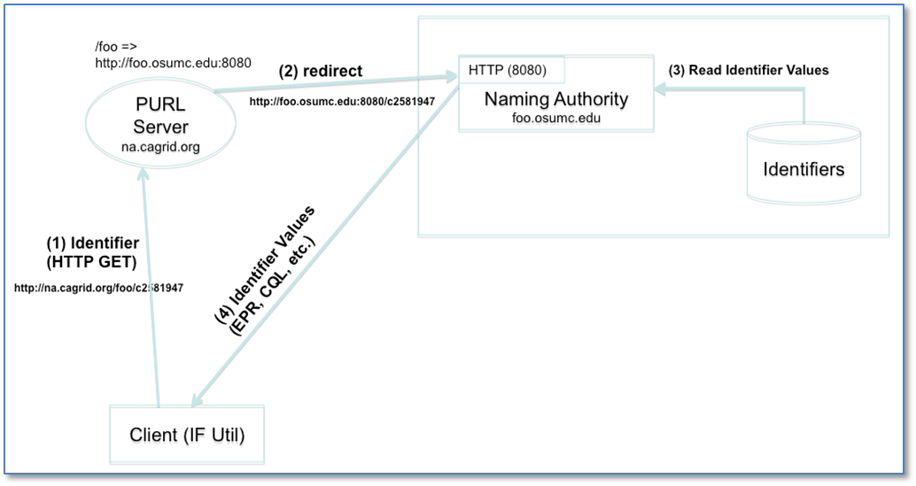

The figure above shows a resolution scenario using HTTP GET. When the identifier (URL) is followed, the PURL server redirects the request to the location (NA) that has been mapped. The NA extracts the local identifier name from the URL (c2581947), looks up the values from the identifiers table, and returns them to the client.
A client could also use the framework’s grid service to resolve an identifier. As shown next.

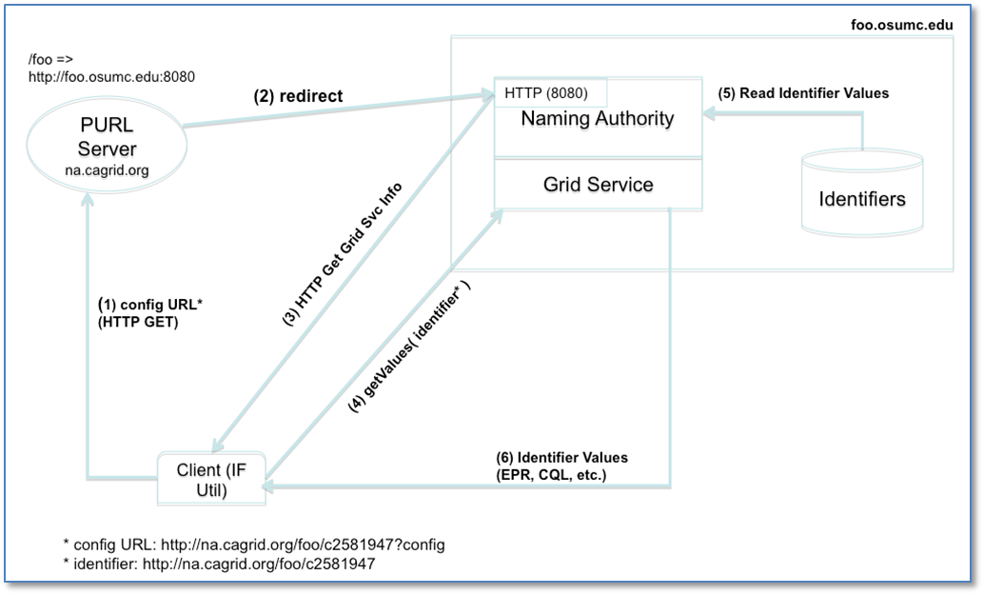

The framework’s client retrieves the naming authority configuration by simply adding ?config to the identifier URL and following it. The NA configuration is needed in this case in order to determine the grid service end point.
For example:
- A user wishes to resolve identifier http://na.cagrid.org/foo/c2581947 using the grid service.

- Client toolkit appends an extra parameter (?config) to the query string, and issues an HTTP GET on http://na.cagrid.org/foo/c2581947?config

- PURL servers redirects to http://foo.osumc.edu:8080/c2581947?config

- NA recognizes that configuration is being requested and returns the information as XML. The response contains the location where the naming authority grid service is running, for example, http://foo.osumc.edu/wsrf/services/cagrid/IdentifiersNAService

- Client now acts as a grid service client and executes the getValues operation on the grid service located at the URL retrieved in the previous step.
In this way, the web (HTTP) is used resolve the identifier to its naming authority, and after the naming authority provides the information about its grid service, the grid is used to actually retrieve the identifier’s metadata.

The flow shows a use case for identifier creation.
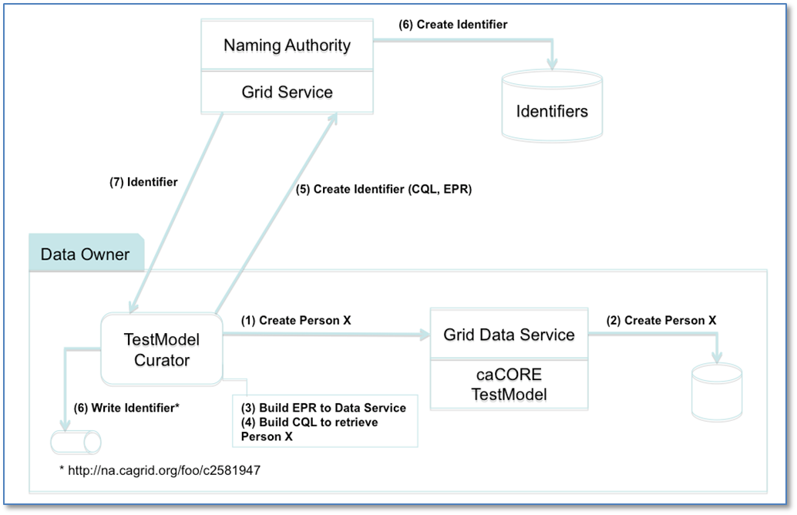

The data owner (also acting as identifier curator) creates identifiers for Person objects that exist in a database application. The data owner provides access to these objects via a grid data service.

A component in the data owner space (TestModel Curator) builds end point references (EPR) to the data service, and serialized CQL queries. This information is sent in the request to create an identifier to the naming authority. The naming authority creates the identifier and persists the EPR and CQL in the identifiers table as metadata. The identifier is returned to the client.

A data retrieval use case is shown below.
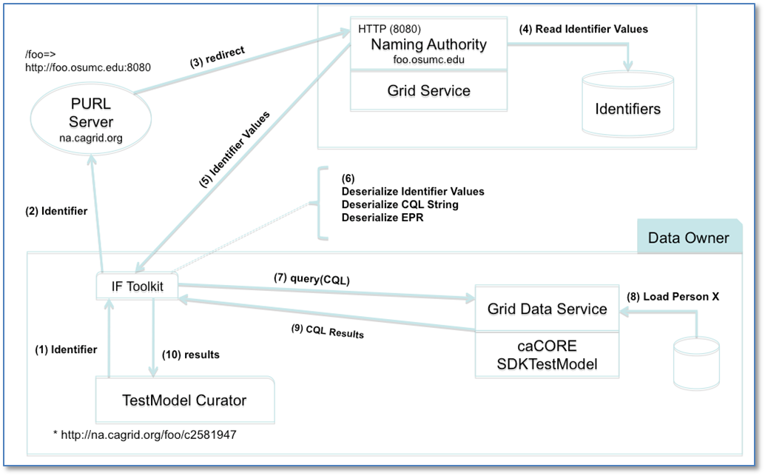

The identifier previously created is used to retrieve a person object. Steps 1 through 5 correspond to the Resolution process as described earlier. In step 6, the retriever class (CQLRetriever.java) de-serializes the CQL and EPR strings, and use the resulting java objects to make the call to the grid data service. The retriever interface returns the CQL result set to the TestModel Curator, where it can be further processed by “casting it” to the expected Person object.

Implementation Considerations

Security

Access Control
Does the Service require Access Control mechanism to be in place to restrict access to only authenticated users or systems? | Yes
If Yes then provide the following in detail:
The service uses standard grid infrastructure to authenticate Globus grid credentials.
Application (Service) Security [Access Policy]
Does the Service incorporate any security controls (Authorization) to ensure that access to information is granted to only the authorized users / systems? | Yes
If Yes then provide the following in detail:
A default security policy has been implemented and included in the appendixes.
Cryptography
Does the Service require encryption of data transmitted to and from it? | No
If Yes then provide the following in detail:
Information Security and Risk Management
Is the information served by the service confidential or privileged? And if yes, is it at risk from any external threats or vulnerabilities? | No
If Yes then provide the following in detail:
Legal, Regulations, Compliance and Investigations
Does the information served by the service fall under any legal / regulatory compliance either at federal, state, local or institutional level ? | No
If Yes then provide the following in detail:
Telecommunications and Network Security
Does the service need any network or transport level security such as SSL, Firewall protection etc. | No
If Yes then provide the following in detail:
The framework does not require encryption, but it can be configured when a secure deployment is required.

Auditing
N/A

Privacy
N/A

Error Handling

Overview
The framework interface throws typed exceptions. The resolution over HTTP may produce standard HTTP errors.

Error Object Details

Error Code | Error/Exception Description
HTTP 403 | HTTP request to resolve identifier has been denied (user is not authorized).
NamingAuthorityConfigurationException | A configuration error has been detected by the naming authority while serving a request.
NamingAuthoritySecurityException | Request denied due to authorization error.
InvalidIdentifierException | The identifier provided is invalid or does not exist.
InvalidIdentifierValuesException | The identifier metadata provided is invalid.

Deployment Details
The service deployment consists of the following components:
- A naming authority web application
- A naming authority grid service
- A prefix authority (PURL)

Refer to section 3.5 for an illustration of this setup. To plan a deployment, one of the most important steps is to carefully choose the domain name associated with the prefix authority (PURL server). Identifiers are permanent URIs by definition; they are always expected to resolve to “something”. The prefix authority (PURL server) provides this element of permanency. In other words, this is the identifier prefix. Following is a summary of high-level steps in a grid identifiers deployment:
- Decide domain name to be used by prefix authority (PURL server). As previously explained, this should be a stable domain. One that is not going to change after identifiers are created.
For example: identifiers-pa.nci.nih.gov
- Choose a domain name and location for the naming authority application. This is a database and web application that enables resolution of identifiers via HTTP. A grid service can be deployed here as well to enable creation and maintenance of identifiers.
For example: identifiers-na.nci.nih.gov
- Deploy a PURL server to identifiers-pa.nci.nih.gov and define a partial redirect PURL that targets the naming authority defined in step 2.
For example: production => http://identifiers-na.nci.nih.gov/namingAuthority/NamingAuthorityService
production is a PURL domain that has to be defined in the PURL server. Once this is done, the redirect PURL can be created as shown to point to the naming authority.
- With the above information, the identifier prefix is now established:
For example: http://identifiers-pa.nci.nih.gov/production
- Configure the naming authority in step 2 to use this identifier prefix. This ensures identifiers are created correctly. Identifiers would look like:
For example: http://identifiers-pa.nci.nih.gov/production/<local_identifier_name>

The naming authority domain name (identifiers-na.nci.nih.gov) can be changed at any time without impacting existing identifiers. In this case, the only action to take to continue resolving identifiers successfully is to update the corresponding redirect PURL (production) in identifiers-pa.nci.nih.gov.
For example: production => http://identifiers-new-na.nci.nih.gov/namingAuthority/NamingAuthorityService
Note that the PURL domain itself (production) cannot be edited. What can change is what it points to, as shown above.
Detailed deployment steps for PURL and the naming authority components are available at https://ncisvn.nci.nih.gov/svn/cagrid/trunk/cagrid/Documentation/core/Identifiers/Identifiers_Admin_Deployment_Guide.docx.

Constraints
None

Recommendations for Conformance and Compliance

Conformance Assertions

No. | Name | Description | Test method
CS1 | Live Identifiers | Identifier URI must be live. They always respond and resolve to something. | “Follow” identifier using standard HTTP (i.e., using a web browser or any other HTTP client)
CS2 | NA Resolution | At minimum, every naming authority offers identifier resolution services via HTTP. | Test NA Resolution Interface.

Appendix A - Relevant Standards
The identifiers framework conforms with existing web standards and protocols, providing a natural approach to identifier adoption and resolution.

- RFC 3305: Uniform Resource Identifier (URI)
- RFC 2616: Hypertext Transfer Protocol (HTTP)
- W3C XML 1.1: Extensible Markup Language (XML)

Appendix B - Glossary

http://www.springsource.org

