caGrid Overview
Extending beyond the basic grid infrastructure, caBIG specializes these technologies to better support the needs of the cancer research community. A primary distinction between basic grid infrastructure and the requirements identified in caBIG and implemented in caGrid is the attention given to data modeling and semantics. caBIG adopts a model-driven architecture best practice and requires that all data types used on the grid are formally described, curated, and semantically harmonized. These efforts result in the identification of common data elements, controlled vocabularies, and object-based abstractions for all cancer research domains. caGrid leverages existing NCI data modeling infrastructure to manage, curate, and employ these data models. Data types are defined in caCORE UML and converted into ISO/IEC 11179 Administered Components, which are in turn registered in the Cancer Data Standards Repository (caDSR). The definitions draw from vocabulary registered in the Enterprise Vocabulary Services (EVS), and their relationships are thus semantically described.

In caGrid, both the client and service APIs are object-oriented, and operate over well-defined and curated data types. Clients and services communicate through the grid using respectively Globus grid clients and service infrastructure. The grid communication protocol is XML, and thus the client and service APIs must transform the transferred objects to and from XML. This XML serialization of caGrid objects is restricted in that each object that travels on the grid must do so as XML which adheres to an XML schema registered in the Global Model Exchange (GME). As the caDSR and EVS define the properties, relationships, and semantics of caBIG data types, the GME defines the syntax of the XML serialization of them. Furthermore, Globus services are defined by the Web Service Description Language (WSDL). The WSDL describes the various operations the service provides to the grid. The inputs and outputs of the operations, among other things, in WSDL are defined by XML schemas (XSDs). As caBIG requires that the inputs and outputs of service operations use only registered objects, these input and output data types are defined by the XSDs which are registered in GME. In this way, the XSDs are used both to describe the contract of the service and to validate the XML serialization of the objects which it uses. Figure 1 details the various services and artifacts related to the description of and process for the transfer of data objects between client and service.

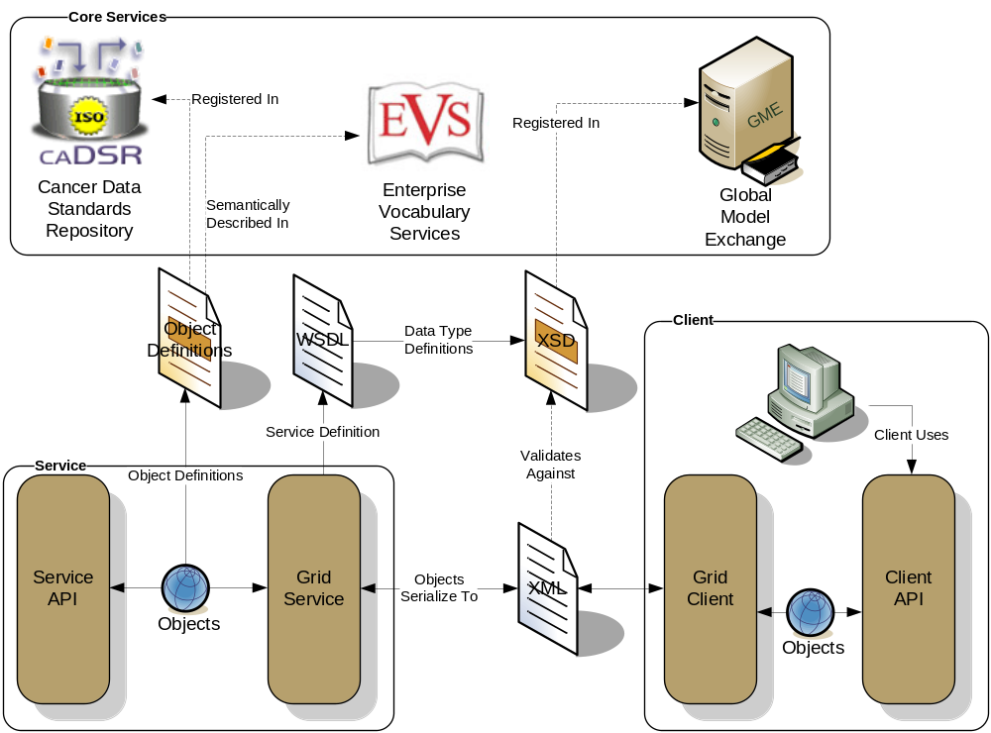
Figure 1 : Data Description Overview

caGrid Client APIs
caGrid services are a standard WSRF (Web Service Resource Framework) services, typically implemented using the Globus toolkit version 4. While it is expected most clients and services will not only use Globus, but use the caGrid-provided tools which build on top of Globus, it is worth noting that caGrid uses on open specification for all communication between client and service. This enables interoperability between toolkits and programming languages, when such is needed. The extent of the caGrid user and programmer documentation will focus on the Java APIs provided by caGrid and, in some cases, Globus. User’s interested in lower level specifications can consult the caGrid Specifications.

Secure Communication
Grid security can be complex, and a detailed discussion on it is out of the scope of this document. The Globus documentation (http://www.globus.org/toolkit/docs/4.0/security/) and tutorials (http://gdp.globus.org/gt4-tutorial) provide a good deal of overview and details on the topic. For the most part, caGrid clients and users need not concern themselves with all the details, but should have a basic understanding of what is happening under the hood, and should understand how to “log in” and obtain credentials for secure communication with services.

caGrid builds on GSI (Globus Security Infrastructure), and hence uses Public Key Cryptography (PKI). Both services and clients may optionally have credentials (certificates), and authenticate and authorize each other. Services and corresponding clients generated from the Introduce toolkit attempt to automatically configure security appropriately, and this behavior is sufficient for most users, however it can be overridden (either by manually configuring this client “stub” or by overriding the provided configureStubSecurity method). Introduce clients will attempt to communicate anonymously with services, as long as the service allows it (as advertised via its caGrid ServiceSecurityMetadata). If a service does not allow anonymous communication, client credentials must be used to authenticate with the service. Introduce created clients will attempt to use the default Globus credentials if present (via a grid-proxy-init, or logging in with Dorian and specifying to set the credentials as the defaults). Alternatively, Introduce created clients have constructors which take credentials (GlobusCredential), and also have an appropriate setter method (setProxy), which can be used after construction. Some services have different security requirements for different operations, so it may not be immediately obvious whether or not credentials are required. As such, when communicating with secure services it is good practice to have a valid grid proxy set as default, or specified on the client; the client APIs will only use it if necessary. For additional information on how to obtain grid credentials and access your grid proxy, consult the caGrid security documentation. For additional information on lower-level security details (such as how clients may perform authorization of services, or configure the communication channel), consult the Globus security documentation.

What is an EPR?
As caGrid is a service-oriented architecture, the majority of the APIs made available are either tools and utilities, or client APIs for communicating with services. There are a number of caGrid-provided “core” services, as well as community provided Data and Analytical services. In order for a client to communicate with a service, it must first know its network end point, or address. In WSRF, this end point is referred to as an End Point Reference, or EPR. A detailed discussion of WSRF and EPRs is out of the scope of this document, but suffice it to say an EPR contains the information necessary to communicate with a service, and optionally identify a resource in that service. EPRs generally take two forms: a resource-qualified end point, and a non resource qualified end point (basically the URL of the service). In caGrid, all services can be communicated, at least initially, using the later, which means clients which know the URL of the service may manually create an appropriate EPR instance. Complex services which manage state on behalf of the client (such as the workflow service and federated query service) have some operations which return a resource-qualified EPR, which can then be used to communicate with an appropriate service-side resource. However, again note, the initial communication with the service originates with a simple URL. Some caGrid APIs that communicate with services will provide convenience methods which take a string representation of a URL and under the hood construct an appropriate EPR. Other methods may require an EPR instance, but it can generally be constructed by just specifying the URL. For client applications, the source of the EPR will either be created from a well-known URL (such as the address of the Index Service), or discovered at runtime using the Discovery API.

Obtaining an EPR for a Service
As mentioned above, the first step in communicating with a caGrid service is obtaining an appropriate EPR (though Introduce-generated clients do provide the shorthand constructors which simply take a string representation of the service’s URL). Often the address of a service of interest is not a “well known” value, and is something that is discovered at runtime. caGrid provides the means to discover services of interest by querying a live registry of available caGrid services. All caGrid services are required to publish standard metadata (described thoroughly in the caGrid metadata design document) that describes their functionality. This information is aggregated in the aforementioned registry (Index Service), and can be used to find out information about the currently running services, including their current EPRs. Building on this information, a Discovery API is provided with caGrid that facilitates the querying of this information toward the aim of discovering service EPRs. An overview of this process is shown below in Figure 2.

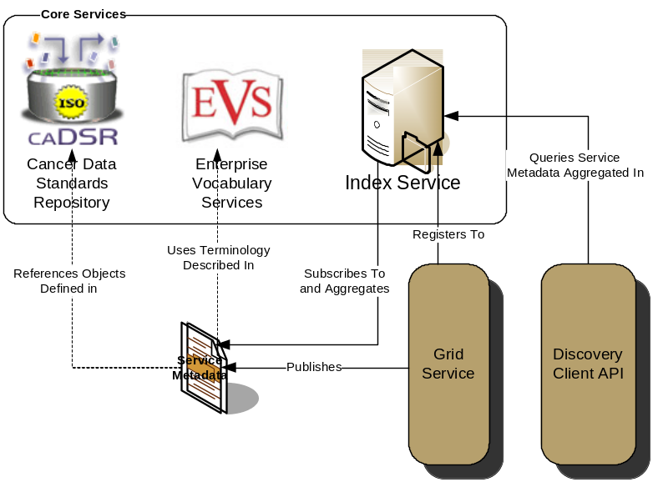
Figure 2 caGrid Advertisement and Discovery Overview

The Discovery API is intended to be used by any applications or services which wish to consume of data, analytics, and core services provided by caGrid. While there are still cases when interacting with a particular instance of a service is desired, the Discovery API provides a means by which applications can locate services by the information or capabilities they provide. One of the key advantages of the grid approach to caBIG is the dynamic discovery of available resources.

In order to make use of the Discovery API, the discovery process must be “bootstrapped” using a well-known service address of an Index Service. The default constructor of the DiscoveryClient, the main interface to the Discovery API, should default to the official NCI Index Service. However, this behavior can be modified by using the constructor which takes the Index Service URL, or by calling the appropriate setter method (setIndexEPR). Additional details on this, as well as all Discovery API information, can be found in the Discovery section of the caGrid Programmer’s Guide.

The simplest discovery scenario, shown in Figure 3, is to just query the Index Service for all registered services. The boolean value specified in line 3, indicates whether services should be ignored if they do not expose the caGrid standard metadata. In most application scenarios, a value of “true” will be used, as services without standard metadata are either: not compliant, not properly configurable, or inaccessible (e.g. behind a misconfigured firewall).

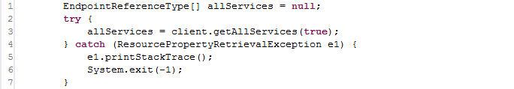
Figure 3 Discovering All Services

As shown in the example on line 3, the method returns an array of EPRs. This is true of all discovery operations. The EPRs in the array represent the services matching the specified criteria (in this case just that it’s a valid caGrid service), and can be used to create clients to invoke operations on the corresponding services (detailed later).

There are many discovery operations available in the DiscoveryClient. They provide a range of capabilities from “full text search” suitable for a freeform webpage-like interface, simple text-based criteria such as specifying operation names or concept code, and complex criteria (“query by example”) such as specification of point of contact information or UML class criteria.

While there are many discovery methods which take an UMLClass prototype, to discover services based on data types, an example is shown below in Figure 4. This method, discoverServiceByOperationInput, locates services which provide an operation that takes, as input, an instance of the specified data type. In the example below, services which provide operations that take caBIO’s Gene instances as input. This prototype object can be as partial populated as desired (such as only specifying the package name, or being more explicit in specifying the exact project name and version).

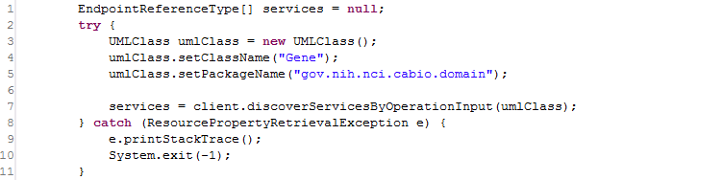
Figure 4 Discover Services by Input

Additionally, there are methods to discover services by “type.” For example, there are several methods named like discoverDataServices* which only return services that implement the standard Data Service operations. Services may also be discovered by the identifying the concept code matching the service type of interest, and invoking the discoverServicesByConceptCode method, which searches for services based on concepts applied to the service. There is a concept representing “Grid Service” in the ontology and derived concepts such as “Analytical Grid Service” and “Data Grid Service.” It is expected additional concepts will be derived in the future, as driven by the community.

Inspecting a Services Metadata
Asdf
Print out some info.. print out service operations

Invoking Operations on a Service
asdf

metadata
-getting from a service
-serializing, deserializing
-resource property helper
-printing out service's operations

fqp
-blocking query
-non blocking
-waiting for resource
-updating status
-getting results
-destroying resource
-non blocking
-set terminatation time, hand off EPR to other process
-printing out results

cadsr (just use stuff in main[])
-annotating service metadata
-generating domainmodel
-walking a project

discovery
-various discovery scenarios
-show getting metadata of resulting services
-show invoking a data service as a result

