Discovery API Usage Overview
The Discovery API provides an abstraction over the standard query operations used to query the Index Service. It provides a number of operations which can be used to discover services of interest. The basic process of use is to construct an instance of the DiscoveryClient, optionally specifying the End Point Reference (EPR) of the Index Service to query, and then invoking the appropriate discovery methods. Each method returns an array of EPRs of the matching appropriate services. These returned EPRs can then be used to invoke the services, or ask them for their metadata for further discrimination. It is worth noting that the Index Service, as an aggregated source of distributed information, inherently operates on out of date information. It is possible that services which are running, do not yet have their metadata aggregated in the Index Service, and it is possible that services present in the Index Service have recently been taken down. caGrid attempts to strike a balance between performance and reliability of information in the Index Service. The information returned by the Discovery API should be accurate within a few minutes, but applications building upon it should be aware of this, and should not assume a service in the Index Service will always be available when it is invoked.

The DiscoveryClient uses the lower level “metadata utils” project to communicate with the Index Service. It exposes the exceptions generated from this lower level API, instead of wrapping them with discovery-specific exceptions. The possible exceptions which discovery methods can throw are detailed below in Figure 1. A non discerning client may simple opt to catch ResourcePropertyRetrievalException, as it is the base checked exception. An additional non-checked exception, InternalRuntimeException, can also be thrown, but it is solely used to represent an internal logic error in the APIs and so it is not expected clients can “recover” from such an exception. As such, client should not attempt to catch this runtime exception for any other reason than to mask the problem. Generic problems caused by the DiscoveryClient itself are thrown in the base ResourcePropertyRetrievalException. A subclass of it, QueryInvalidException, is thrown if an invalid XPath query is issued. Unless the DiscoveryClient is extended, it is not expected that clients should encounter this. Problems originating from remote services are thrown in the subclass, RemoteResourcePropertyRetrievalException. In general use of the metadata utilities, this is the most likely exception clients may see, as it is thrown if a service is not properly exposing the proper metadata. In the context of the DiscoveryClient, it is not expected clients should experience any exceptions unless there is an issue with the Index Service. However, clients leveraging the lower level APIs should take more care to appropriately address each type of exception if they are communicating with other (community provided) services. For example, even though it is a caBIG requirement to expose the standard service metadata, clients should properly handle the case where it is not present. Asking for specific metadata that a service does not provide would yield an InvalidResourcePropertyException.

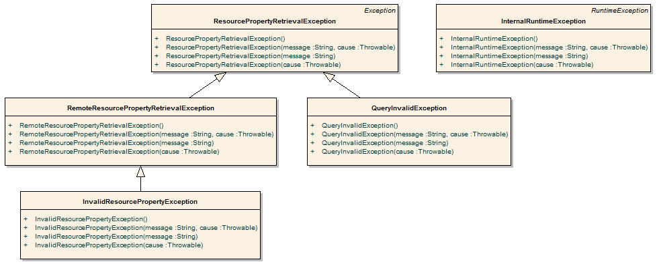
Figure 1 Metadata Exceptions

While the methods in the API are designed around the caGrid standard metadata, it is also acceptable to have services register additional domain or application specific metadata to the Index Service. The Discovery API is designed for easy extensibility, such that additional application or domain specific discovery scenarios can be provided to compliment such additional metadata. The “business logic” of the DiscoveryClient, consists almost entirely of constructing appropriate XPath queries over the appropriate metadata, and leveraging lower-level APIs to actually invoke the queries. These lower-level APIs are made available to extenders of the client, such that they need only construct appropriate XPath queries to implement additional discovery scenarios.

The DiscoveryClient uses commons-logging to log general and debugging information. If configured to DEBUG level, the client will print out the XPaths it is sending to the Index Service, which may facilitate the creation of new discovery operations, or help track down problems.

As with most Globus clients, a properly configured client-config.wsdd file must be accessible by the underlying Axis engine. The simplest way to do this is to either run with your $GLOBUS_LOCATION as the “working directory,” add $GLOBUS_LOCATION to your classpath, or copy $GLOBUS_LOCATION/client-config.wsdd to your working directory or classpath. If you don’t do this, you will most likely see an exception similar to what is shown in Figure 2, when you run the DiscoveryClient.

gov.nih.nci.cagrid.metadata.exceptions.RemoteResourcePropertyRetrievalException: org.xml.sax.SAXException:SimpleDeserializer encountered a child element, which is NOT expected, in something it was trying to deserialize.

Figure 2 Common DiscoveryClient Exception

API Details

gov.nih.nci.cagrid.discovery.client.DiscoveryClient

DiscoveryClient represents the base discovery API. The client should be constructed passing a URL of an Index Service. Services can then be discovered by calling the discover methods, passing in the necessary criteria. The methods all return a EndPointReferenceType[]. See the main method for examples. This should be extended to provide specialized service-type discovery (beyond data services).

Constructor Documentation

gov.nih.nci.cagrid.discovery.client.DiscoveryClient.DiscoveryClient () throws MalformedURIException
Uses the Default Index Service

Exceptions:
MalformedURIException if the Default Index Service is invalid

DiscoveryClient.java.gov.nih.nci.cagrid.discovery.client.DiscoveryClient.DiscoveryClient (EndpointReferenceType indexEPR)
Uses the specified Index Service

Parameters:
iemndexEPR the EPR to the Index Service to use

Member Function Documentation

EndpointReferenceType [] gov.nih.nci.cagrid.discovery.client.DiscoveryClient.getAllServices (boolean requireMetadataCompliance) throws RemoteResourcePropertyRetrievalException, QueryInvalidException, ResourcePropertyRetrievalException
Query the registry for all registered services

Parameters:
requireMetadataCompliance if true, only services providing the standard metadata will be returned. Otherwise, all services registered will be returned, regardless of whether or not any metadata has been aggregated.

Returns:
EndpointReferenceType[] contain all registered services

Exceptions:
ResourcePropertyRetrievalException
QueryInvalidException
RemoteResourcePropertyRetrievalException

EndpointReferenceType [] gov.nih.nci.cagrid.discovery.client.DiscoveryClient.discoverServicesBySearchString (String searchString) throws RemoteResourcePropertyRetrievalException, QueryInvalidException, ResourcePropertyRetrievalException
Searches ALL metadata to find occurance of the given string. The search string is case-sensitive.

Parameters:
searchString the search string.

Returns:
EndpointReferenceType[] matching the criteria

Exceptions:
ResourcePropertyRetrievalException
QueryInvalidException
RemoteResourcePropertyRetrievalException

EndpointReferenceType [] gov.nih.nci.cagrid.discovery.client.DiscoveryClient.discoverServicesByResearchCenter (String centerName) throws RemoteResourcePropertyRetrievalException, QueryInvalidException, ResourcePropertyRetrievalException
Searches research center info to find services provided by a given cancer center.

Parameters:
centerName research center name

Returns:
EndpointReferenceType[] matching the criteria

Exceptions:
ResourcePropertyRetrievalException
QueryInvalidException
RemoteResourcePropertyRetrievalException

EndpointReferenceType [] gov.nih.nci.cagrid.discovery.client.DiscoveryClient.discoverServicesByPointOfContact (PointOfContact contact) throws RemoteResourcePropertyRetrievalException, QueryInvalidException, ResourcePropertyRetrievalException
Searches to find services that have the given point of contact associated with them. Any fields set on the point of contact are checked for a match. For example, you can set only the lastName, and only it will be checked, or you can specify several feilds and they all must be equal.

Parameters:
contact point of contact

Returns:
EndpointReferenceType[] matching the criteria

Exceptions:
ResourcePropertyRetrievalException
QueryInvalidException
RemoteResourcePropertyRetrievalException

EndpointReferenceType [] gov.nih.nci.cagrid.discovery.client.DiscoveryClient.discoverServicesByName (String serviceName) throws RemoteResourcePropertyRetrievalException, QueryInvalidException, ResourcePropertyRetrievalException
Searches to find services that have a given name.

Parameters:
serviceName The service's name

Returns:
EndpointReferenceType[] matching the criteria

Exceptions:
ResourcePropertyRetrievalException
QueryInvalidException
RemoteResourcePropertyRetrievalException

EndpointReferenceType [] gov.nih.nci.cagrid.discovery.client.DiscoveryClient.discoverServicesByConceptCode (String conceptCode) throws RemoteResourcePropertyRetrievalException, QueryInvalidException, ResourcePropertyRetrievalException
Searches to find services based on the given concept code.

Parameters:
conceptCode A concept code the service is based upon.

Returns:
EndpointReferenceType[] matching the criteria

Exceptions:
ResourcePropertyRetrievalException
QueryInvalidException
RemoteResourcePropertyRetrievalException

EndpointReferenceType [] gov.nih.nci.cagrid.discovery.client.DiscoveryClient.discoverServicesByOperationName (String operationName) throws RemoteResourcePropertyRetrievalException, QueryInvalidException, ResourcePropertyRetrievalException
Searches to find services that have a given operation.

Parameters:
operationName The operation's name

Returns:
EndpointReferenceType[] matching the criteria

Exceptions:
ResourcePropertyRetrievalException
QueryInvalidException
RemoteResourcePropertyRetrievalException

EndpointReferenceType [] gov.nih.nci.cagrid.discovery.client.DiscoveryClient.discoverServicesByOperationInput (UMLClass clazzPrototype) throws RemoteResourcePropertyRetrievalException, QueryInvalidException, ResourcePropertyRetrievalException
Searches to find services that have an operation defined that takes the given UMLClass as input. Any fields set on the UMLClass are checked for a match. For example, you can set only the packageName, and only it will be checked, or you can specify several feilds and they all must be equal.
NOTE: Only attributes of the UMLClass are examined (associated objects (e.g. UMLAttributeCollection and SemanticMetadataCollection) are ignored).

Parameters:
clazzPrototype The protype UMLClass

Returns:
EndpointReferenceType[] matching the criteria

Exceptions:
ResourcePropertyRetrievalException
QueryInvalidException
RemoteResourcePropertyRetrievalException

EndpointReferenceType [] gov.nih.nci.cagrid.discovery.client.DiscoveryClient.discoverServicesByOperationOutput (UMLClass clazzPrototype) throws RemoteResourcePropertyRetrievalException, QueryInvalidException, ResourcePropertyRetrievalException
Searches to find services that have an operation defined that produces the given UMLClass. Any fields set on the UMLClass are checked for a match. For example, you can set only the packageName, and only it will be checked, or you can specify several feilds and they all must be equal.
NOTE: Only attributes of the UMLClass are examined (associated objects (e.g. UMLAttributeCollection and SemanticMetadataCollection) are ignored).

Parameters:
clazzPrototype The protype UMLClass

Returns:
EndpointReferenceType[] matching the criteria

Exceptions:
ResourcePropertyRetrievalException
QueryInvalidException
RemoteResourcePropertyRetrievalException

EndpointReferenceType [] gov.nih.nci.cagrid.discovery.client.DiscoveryClient.discoverServicesByOperationClass (UMLClass clazzPrototype) throws RemoteResourcePropertyRetrievalException, QueryInvalidException, ResourcePropertyRetrievalException
Searches to find services that have an operation defined that produces the given UMLClass or takes it as input. Any fields set on the UMLClass are checked for a match. For example, you can set only the packageName, and only it will be checked, or you can specify several feilds and they all must be equal.
NOTE: Only attributes of the UMLClass are examined (associated objects (e.g. UMLAttributeCollection and SemanticMetadataCollection) are ignored).

Parameters:
clazzPrototype The protype UMLClass

Returns:
EndpointReferenceType[] matching the criteria

Exceptions:
ResourcePropertyRetrievalException
QueryInvalidException
RemoteResourcePropertyRetrievalException

EndpointReferenceType [] gov.nih.nci.cagrid.discovery.client.DiscoveryClient.discoverServicesByOperationConceptCode (String conceptCode) throws RemoteResourcePropertyRetrievalException, QueryInvalidException, ResourcePropertyRetrievalException
Searches to find services that have an operation based on the given concept code

Parameters:
conceptCode The concept to look for

Returns:
EndpointReferenceType[] matching the criteria

Exceptions:
ResourcePropertyRetrievalException
QueryInvalidException
RemoteResourcePropertyRetrievalException

EndpointReferenceType [] gov.nih.nci.cagrid.discovery.client.DiscoveryClient.discoverServicesByDataConceptCode (String conceptCode) throws RemoteResourcePropertyRetrievalException, QueryInvalidException, ResourcePropertyRetrievalException
Searches to find services that have an operation defined that produces the or takes as input, a Class with an attribute , attribute value domain , enumerated value meaning, or the class itself based on the given concept code.

Parameters:
conceptCode The concept to look for

Returns:
EndpointReferenceType[] matching the criteria

Exceptions:
ResourcePropertyRetrievalException
QueryInvalidException
RemoteResourcePropertyRetrievalException

EndpointReferenceType [] gov.nih.nci.cagrid.discovery.client.DiscoveryClient.discoverServicesByPermissibleValue (String value) throws RemoteResourcePropertyRetrievalException, QueryInvalidException, ResourcePropertyRetrievalException
Searches to find services that have an operation defined that produces or takes as input, a Class with an attribute allowing the given value.

Parameters:
value The permissible value to look for

Returns:
EndpointReferenceType[] matching the criteria

Exceptions:
ResourcePropertyRetrievalException
QueryInvalidException
RemoteResourcePropertyRetrievalException

String gov.nih.nci.cagrid.discovery.client.DiscoveryClient.createPermissibleValuePredicatedUMLClass (String value, boolean isDataService) [protected]
Creates a UMLClass step that is predicated to contain either an attribute , attribute value domain , enumerated value meaning, or the class itself based on that concept.

Parameters:
conceptCode the code to look for

Returns:

String gov.nih.nci.cagrid.discovery.client.DiscoveryClient.createConceptPredicatedUMLClass (String conceptCode, boolean isDataService) [protected]
Creates a UMLClass step that is predicated to contain either an attribute , attribute value domain , enumerated value meaning, or the class itself based on that concept.

Parameters:
conceptCode the code to look for

Returns:

EndpointReferenceType [] gov.nih.nci.cagrid.discovery.client.DiscoveryClient.getAllDataServices () throws RemoteResourcePropertyRetrievalException, QueryInvalidException, ResourcePropertyRetrievalException
Query the registry for all registered data services

Returns:
EndpointReferenceType[] contain all registered services

Exceptions:
ResourcePropertyRetrievalException
QueryInvalidException
RemoteResourcePropertyRetrievalException

EndpointReferenceType [] gov.nih.nci.cagrid.discovery.client.DiscoveryClient.discoverDataServicesByDomainModel (String modelName) throws RemoteResourcePropertyRetrievalException, QueryInvalidException, ResourcePropertyRetrievalException
Searches to find data services that are exposing a subset of given domain (short name or long name).

Parameters:
modelName The model to look for

Returns:
EndpointReferenceType[] matching the criteria

Exceptions:
ResourcePropertyRetrievalException
QueryInvalidException
RemoteResourcePropertyRetrievalException

EndpointReferenceType [] gov.nih.nci.cagrid.discovery.client.DiscoveryClient.discoverDataServicesByModelConceptCode (String conceptCode) throws RemoteResourcePropertyRetrievalException, QueryInvalidException, ResourcePropertyRetrievalException
Searches to find data services that expose a Class with an attribute , attribute value domain , enumerated value meaning, or the class itself based on the given concept code.

Parameters:
conceptCode The concept to look for

Returns:

Exceptions:
RemoteResourcePropertyRetrievalException
QueryInvalidException
ResourcePropertyRetrievalException

EndpointReferenceType [] gov.nih.nci.cagrid.discovery.client.DiscoveryClient.discoverDataServicesByExposedClass (gov.nih.nci.cagrid.metadata.dataservice.UMLClass clazzPrototype) throws RemoteResourcePropertyRetrievalException, QueryInvalidException, ResourcePropertyRetrievalException
Searches for data services that expose the given class. Any fields set on the UMLClass are checked for a match. For example, you can set only the packageName, and only it will be checked, or you can specify several feilds and they all must be equal.
NOTE: Only attributes of the UMLClass are examined (associated objects (e.g. UMLAttributeCollection and SemanticMetadataCollection) are ignored).

Parameters:
clazzPrototype The protype UMLClass
clazzPrototype

Returns:

Exceptions:
RemoteResourcePropertyRetrievalException
QueryInvalidException
ResourcePropertyRetrievalException

EndpointReferenceType [] gov.nih.nci.cagrid.discovery.client.DiscoveryClient.discoverDataServicesByPermissibleValue (String permissibleValue) throws RemoteResourcePropertyRetrievalException, QueryInvalidException, ResourcePropertyRetrievalException
Searches for data services that expose a class with an attribute allowing the given value.

Parameters:
value The permissible value to look for

Returns:

Exceptions:
RemoteResourcePropertyRetrievalException
QueryInvalidException
ResourcePropertyRetrievalException

EndpointReferenceType [] gov.nih.nci.cagrid.discovery.client.DiscoveryClient.discoverDataServicesByAssociationsWithClass (gov.nih.nci.cagrid.metadata.dataservice.UMLClass clazzPrototype) throws RemoteResourcePropertyRetrievalException, QueryInvalidException, ResourcePropertyRetrievalException
Searches for data services that expose an association to or from the given class. Any fields set on the UMLClass are checked for a match. For example, you can set only the packageName, and only it will be checked, or you can specify several feilds and they all must be equal.
NOTE: Only attributes of the UMLClass are examined (associated objects (e.g. UMLAttributeCollection and SemanticMetadataCollection) are ignored).

Parameters:
clazzPrototype

Returns:

Exceptions:
RemoteResourcePropertyRetrievalException
QueryInvalidException
ResourcePropertyRetrievalException

static String gov.nih.nci.cagrid.discovery.client.DiscoveryClient.buildPOCPredicate (PointOfContact contact) [static, protected]
Builds up a predicate for a PointOfContact, based on the prototype passed in.

Parameters:
contact the prototype POC

Returns:
"*" if the prototype has no non-null or non-whitespace values, or the predicate necessary to match all values.

static String gov.nih.nci.cagrid.discovery.client.DiscoveryClient.buildUMLClassPredicate (UMLClass clazz) [static, protected]
Builds up a predicate for a UMLClass, based on the prototype passed in.
NOTE: Only attributes of the UMLClass are examined (associated objects (e.g. UMLAttributeCollection and SemanticMetadataCollection) are ignored).

Parameters:
clazz the prototype UMLClass

Returns:
"*" if the prototype has no non-null or non-whitespace values, or the predicate necessary to match all values.

static String gov.nih.nci.cagrid.discovery.client.DiscoveryClient.buildDataUMLClassPredicate (gov.nih.nci.cagrid.metadata.dataservice.UMLClass clazz) [static, protected]

static String gov.nih.nci.cagrid.discovery.client.DiscoveryClient.addNonNullPredicate (String name, String value, boolean isAttribute) [static, protected]

Parameters:
name the element or attribute name to check
value the value to add the predicate filter against if this is null or whitespace only, no predicated is added.
isAttribute whether or not name represents an attribute or element

Returns:
"" or the specified predicate (prefixed with " and " )

EndpointReferenceType [] gov.nih.nci.cagrid.discovery.client.DiscoveryClient.discoverByFilter (String xpathPredicate) throws RemoteResourcePropertyRetrievalException, QueryInvalidException, ResourcePropertyRetrievalException [protected]
Applies the specified predicate to the common path in the Index Service's Resource Properties to return registered services' EPRs that match the predicate.

Parameters:
xpathPredicate predicate to apply to the "Entry" in Index Service

Returns:
EndpointReferenceType[] of matching services @

Exceptions:
ResourcePropertyRetrievalException
QueryInvalidException
RemoteResourcePropertyRetrievalException

String gov.nih.nci.cagrid.discovery.client.DiscoveryClient.translateXPath (String xpathPredicate) [protected]
Adds the common Index RP Entry filter, and translates the xpath to IndexService friendly XPath.

Parameters:
xpathPredicate

Returns:
the modified xpath

EndpointReferenceType gov.nih.nci.cagrid.discovery.client.DiscoveryClient.getIndexEPR ()
Gets the EPR of the Index Service being used.

void gov.nih.nci.cagrid.discovery.client.DiscoveryClient.setIndexEPR (EndpointReferenceType indexEPR)
Sets the EPR of the Index Service to use.

Parameters:
indexEPR the EPR of the Index Service to use.

static void gov.nih.nci.cagrid.discovery.client.DiscoveryClient.main (String[] args) [static]
testing stub

Parameters:
args optional URL to Index Service to query.

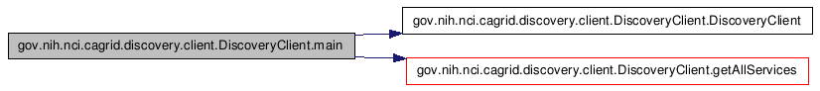

gov.nih.nci.cagrid.discovery.XPathUtils

Member Function Documentation

static String gov.nih.nci.cagrid.discovery.XPathUtils.translateXPath (String prefixedXpath, Map namespaces) [static]
This utility takes an XPath that uses namespace prefixes (such as /a:B/a:C) and converts it to one without prefixes, by using the appropriate operators instead (such as /*[namespace-uri()='http://DOMAIN.COM/SCHEMA' and local-name()='B']/*[namespace-uri()='http://DOMAIN.COM/SCHEMA' and local-name()='C']). The only conceivable use for this function is to write sane XPath and convert it to the insane XPath Globus index service supports.

NOTE: This isn't perfect. The known limitations are: 1) its overly aggressive, and will replace QName-looking string literals, 2) it won't work if you have namespaces attributes 3) it will silently not replace any QNames that you haven't supplied a prefix mapping for

Parameters:
prefixedXpath An xpath [optionally] using namespace prefixes in nodetests
namespaces A Map<String,String> keyed on namespace prefixes to resolve in the xpath, where the value is the actual namespace that should be used.

Returns:
a converted, conformant, xpath

API Usage Examples
The following section describes typical usage of the Discovery API. The exception handling shown in the code examples is not recommended practice, and is simplistic for demonstration purposes. Additional examples can be found in the source code of the discovery project, in the main of the DiscoveryClient itself, as well as in the test source directory.

The main method of the DiscoveryClient can be run from the project’s source folder by typing: ant runClient. The discovery unit tests can also be run by typing: ant test. The unit tests do not actually communicate with the Index Service, rather they simulate it with a Mock object.

Configuring which Index Service to use
The first step in using the Discovery API is constructing an instance of the DiscoveryClient. There are three constructors which can be used. The first, shown in line 7 of Figure 3, takes no arguments, and indicates that the “default” Index Service should be used for discovery queries. A second constructor, shown in line 5 of Figure 3, takes a String as an argument, and the String is expected to represent the service URL of the Index Service to query. The final constructor, not shown, takes an EndPointReferenceType, which can be used to directly indicate the Index Service Resource to query. The standard caGrid Index Service installation is stateless, and so a resource unqualified EPR can be used, but most clients can just use the shortcut String constructor.

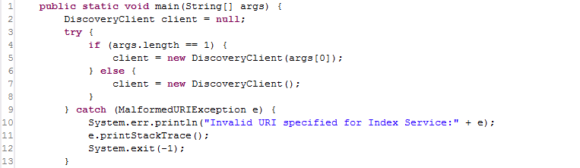
Figure 3 DiscoveryClient constructor example

The Index Service to use can also be reconfigured at runtime, by invoking the setIndexEPR method, shown in Figure 4. Just as specifying the Index Service in the constructor will generate an exception if the Address is not valid, so will the setter method.

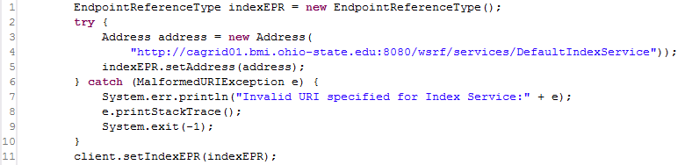
Figure 4 Configuring Index Service code

Discovering Services
Once a DiscoveryClient is configured, it can be continually used to discover services of interest. While the client is technically thread safe as long as the Index Service isn’t reconfigured during use, it is recommended a new DiscoveryClient instance is used in each thread context where discovery operations are performed, as it is an extremely light weight object.

The simplest discovery scenario, shown in Figure 5, is to just query the Index Service for all registered services. The boolean value specified in line 3, indicates whether services should be ignored if they do not expose the caGrid standard metadata. In most application scenarios, a value of “true” will be used, but specifying “false” is useful for identifying all services which are attempting to register. It is common for a service running behind a firewall to maintain registration status with the Index Service, but not have caGrid metadata aggregated, as the Index Service is not able to communicate with the inaccessible service.

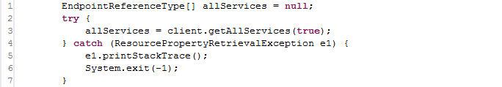
Figure 5 Discovering All Services

