To do:
Add text for custom bean mapping
Add text for mutli service multi resource support

Introduce: An Open Source Toolkit for Rapid Development of Strongly-Typed Grid Services

Shannon Hastings, Scott Oster, Stephen Langella, Tahsin Kurc, Joel Saltz
The Ohio State University Department of Biomedical Informatics
{hastings,oster,langella,kurc,jsaltz}@bmi.osu.edu

Abstract

Service-oriented architectures, standards, and applications have gained wide acceptance in the Grid computing community. A number of tools and middleware systems have been developed to support application development using Grid Services frameworks. Most of these efforts, however, have focused on the low-level support for management and execution of Grid services, management of Grid-enabled resources, and deployment and execution of applications that make use of Grid services. Simple-to-use tools, which will allow a Grid service developer to leverage Grid technologies without needing to know low-level details, are becoming increasingly important. Moreover, support for development of strongly-typed services, in which data types consumed and produced by a service are well-defined and published in the Grid, is necessary to enable syntactic interoperability so that two Grid endpoints can interact with each other programmatically and correctly. In this paper, we describe an open-source, extensible toolkit, called Introduce, to support easy development and deployment of Grid services. Introduce aims to reduce the service development and deployment effort by hiding low level details of the Globus Toolkit and to enable the implementation of strongly-typed Grid services. We expect that enabling strongly typed grid services while lowering the difficulty of entry to the Grid via toolkits like Introduce will have a major impact to the success of the Grid and its wider adoption as a viable technology of choice, not only in the commercial sector, but also in other areas such as academic, medical, and government research.

Introduction
Grid computing is quickly becoming the new means for creating distributed infrastructures and virtual organizations for multi-institutional research and enterprise applications. Since its inception, the Grid has evolved from being a platform targeted at large-scale computing applications to a new architecture paradigm for sharing information, data, and software tools as well as computational and storage resources. It has been applied in a wide range of application domains ranging from high energy physics to earth systems sciences to biomedical research.
A vast array of middleware systems and toolkits has been developed to support applications in the Grid. These include middleware and tools for application deployment, security (authentication, authorization, and secure communication), remote resource invocation, resource monitoring and scheduling, and workflow management. Earlier tool development efforts, however, focused on providing the core functionality needed by applications to use the Grid environment. As the number of Grid-enabled resources and applications has increased, interoperability has become a major concern. Interoperability is important since applications and resources are heterogeneous, oftentimes deployed and managed autonomously in the Grid, and programmatic access to resources is desired. The need for mechanisms to facilitate interoperability has led to architecture and standardization efforts by several groups, most notably by the Global Grid Forum, which includes both academic researchers and corporate IT leaders.
In the past several years, through a community effort (coordinated via the Global Grid Forum and Oasis), the Open Grid Services Architecture (OGSA) has been developed. OGSA presents a service-oriented view of the Grid and specifies Grid Services standards. These standards adapt and extend Web Services standards for scientific applications. They define mechanisms and guidelines for such additional features as stateful services, service notification, and management of service lifetime. The OGSA effort has evolved into the Web Services Resource Framework (WSRF) standardization, paving the way for closer interoperability and unification between stateful Grid services and Web services.
With the emergence of Grid Services framework and standards, we are observing the development of new tools and the adaptation of exiting tools to leverage the standards in application development and deployment. The most widely used reference implementation of the core OGSA and WSRF functionality is the Globus Toolkit (GT); GT 3.2 and GT 4.0, respectively. The GT enables Grid architects to create Grids using standard building blocks. The toolkit also implements support for creation, deployment, and invocation of Grid services, and provides runtime support for common services such as an Index service for service registration and discovery and Globus Security Infrastructure (GSI) for security. These core components enable service providers to stand up Grid services, advertise them, discover them, and secure them.
The basic services and technologies provided in the GT facilitate the creation of complex grid services. However, developing services using the GT requires a vast knowledge of Grid Services technologies and of the details of the toolkit. We argue that additional tools are needed to enable greater levels of service-to-service interoperability and to reduce the development time and knowledge required to implement and stand up Grid Services. In this way, the benefits of Grid computing can be harvested easily and quickly by those adopting the Grid as a technology.
In this paper, we present the design and implementation of an open-source toolkit, called Introduce, which provides support for development and deployment of strongly-typed, secure Grid services. The current implementation of Introduce uses the Globus Toolkit as the underlying core Grid infrastructure and the Mobius framework to support strongly-typed Grid service development. The toolkit aims to reduce the time and knowledge required to stand up Grid services while increasing the interoperability between the services in the grid environment. The salient features of Introduce are as follows:
- It provides high-level functions and graphical user interface that encapsulate and hide away the common complexities and low level command-line tools of the GT for generating a suitable service layout. These include client and server wrappers to encapsulate the “boxed” grid service calls, functions to create configurable service properties, functions to specify resource properties and register metadata, functions to specify the security configurations of the service operations or the service, and support to deploy a service to commonly used Grid service containers. The service developer can create and modify Grid service interfaces using a graphical user interface (GUI). Not only can developers use the GUI to create their service, they can also write their own service description documents which the Introduce toolkit can use to create the service programmatically.
- It enables development of strongly-typed services. A strongly-typed service is one whose methods take as input and return as output data structures that are registered and published in the Grid environment. The use of these publicly published types enables others to create compatible and interoperable grid services without needing to communicate with other grid service developers.
- It allows for implementation of secure services. It provides support for service developers to optionally turn on authentication and authorization support for individual service methods as well as the entire service itself.
- It manages all the service-specific files and directories required by the GT for correct compilation and deployment. It also generates appropriate, object-oriented client APIs which can be used by client programs to interact with the service.
- It is customizable and extensible via the use of extension plug-ins. Plug-ins allow for Introduce to be customized and its base functionality to be extended 1) for custom and common service types in an application domain and 2) to employ customized discovery mechanisms for common data types for strongly-typed services.

We believe the availability of tools like Introduce will greatly impact the efficacy of using the Grid in fields where grid style architectures is a great change to the everyday development of management of data and analytical services.

Motivation
The need for the Introduce toolkit is primarily motivated by the cancer Biomedical Informatics Grid program (caBIG, http://www.cabig.nci.nih.gov), funded by the National Cancer Institute (NCI). The goal of this program is to implement a nationwide cancer research network in order to significantly enhance basic and clinical research on all types of cancer disease. This large scale effort is using the Grid Services technology as the underlying architecture and motivates the need for easy development and deployment of strongly-typed, secure services.

Easy Development and Deployment of Secure Grid Services

The principle idea in caBIG is to create software infrastructure, common applications, standards, and common data and analytical resources to leverage combined strengths of individual cancer centers and research labs. In the caBIG effort, a core Grid infrastructure, called caGrid, is being developed to support the development and deployment of Grid-enabled applications in order to facilitate sharing of data and analytical resources. The infrastructure is designed as a service-oriented system, building on the WSRF standards. The most widely deployed reference implementation of the WSRF standard is the Globus Toolkit (GT). The GT is hence employed as the Grid middleware backbone and runtime environment in caGrid.
caBIG is envisioned to span several hundreds of institutions and possibly thousands of investigator and research laboratories. These institutions may host information technology infrastructures of different complexity and maturity and consist of users and application developers with varying levels of understanding of distributed systems and the Grid. Thus, one of the goals of caGrid is to provide tools to make it easier for institutions, laboratories, and individual researchers to get on the Grid without requiring a great deal of knowledge of the Grid technologies. The GT provides support a suite of core runtime services and tools for developing and deploying Grid services. However, these are low level tools, requiring service developers to understand the details of the GT and how and in what order the tools should be invoked, and to keep track of several files that are required for successful compilation and deployment of services. The Introduce toolkit aims to make it easy for a service developer to execute the various steps of the service development and deployment tools provided by the GT and to manage the necessary directories and files. It abstracts away the details of invoking the various tools so that the developer the developer is freed up to concentrate on the details of implementing his/her domain-specific code.
Security is a required component in caBIG both for protecting intellectual property and to ensure protection and privacy of patient related information. In caBIG, a service provider should be able to enforce secure and controlled access to resources based on policies set forth by the owners of the resources. Introduce allows a service developer to configure the service as a secure service. This enables the service to interact with Grid-wide user and attribute management services and local authorization systems for secure communication, authentication, and authorization.

Strongly-Typed Service Development

The caBIG effort also aims to enable syntactic and semantic interoperability across data and analytical resources. The OGSA and WSRF frameworks enable interoperability by defining standards for data and information exchange protocols, service creation and management, and service invocation. In the Grid environment, syntactic and semantic interoperability is also important, when data is exchanged between disparate groups of data providers and consumers. It is critical to ensure that resources can be accessed programmatically in a unified way and the information served by a resource can be interpreted correctly. In the Mobius project, we introduced the notion of strongly-typed services in the context of virtualization of data sources to enable syntactic interoperability. The Mobius framework provides tools and services for coordinated management of XML schemas; a schema defines the data types and structure of a data object. We refer to a service as strongly-typed service, if the input and output parameters of the service methods conform to schemas, which are well-defined and published in the Grid environment. Similarly, in caBIG, syntactic and semantic interoperability is accomplished through coordinated management of metadata and well-defined objects, which are exchanged between entities (i.e., between services, or between clients and services) in the environment. The structure of a registered object is represented by a registered and published XML schema. The objects are exchanged between two end points in the Grid as XML documents conforming to the corresponding schema.
In addition to providing an easy-to-use environment, Introduce enables the developer to implement strongly-typed services. It provides the required support using the Mobius Global Model Exchange service.

Related Work

Most of the previous work on tooling for Grid Services computing targeted the development of basic, low level functions required to stand up a Grid service, manage it, and execute applications, which interact with Grid services. Our work differs from previous low level middleware development efforts in that it aims to provide a high-level toolkit for development and deployment of strongly-typed, secure Grid services.
The Globus Toolkit (GT) and related technologies such as Axis and Java Naming and Directory Interface (JNDI) are the cornerstone pieces leveraged by the Introduce toolkit. The GT is a software package which aids in the development of WSRF compliant Grid services. The toolkit also provides a suite of common services (e.g., the Index Service for service advertisement and discovery) to create a Grid environment. The GT relies on the Apache Axis infrastructure for service deployment and execution. The Apache Axis is an open source middleware providing the actual Web Services layer, i.e., SOAP based Web Service protocol and support for Java bean generation, resource support via JNDI, and other Web Service middleware components. Introduce uses the GT, Axis, and JNDI as the underlying middleware systems to support development of stateful services, advertisement of metadata in the form of resource properties, and deployment of services for execution.
The Globus Service Build Tools Project (http://gsbt.sourceforge.net/) consists of GT4IDE and globus-build-services components. The GT4IDE component is an Eclipse (www.eclipse.org) plug-in designed to aid in the development of Globus Toolkit 4 (GT4) compatible services -- the predecessor of GT4IDE, the GT3IDE component supports services compliant with the Globus Toolkit version 3 implementation. The plug-in enables a service developer to create a service and add methods to the service. It then generates the stub service to be implemented by the service developer. Unlike the Introduce toolkit, which is a stand-alone application, the GT4IDE plug-in can only be used in the Eclipse environment. While the plug-in offers a great tool for developers, who are experienced in Grid technologies and the GT, it lacks several features found in Introduce. These features include support for strongly-typed services, extensibility, auto-code generation for common interfaces, and ability to leverage advanced features of GT4 such as resource properties framework and compositional inheritance. Moreover, GT4IDE mainly facilitates development of server side capabilities, whereas Introduce can be used to generate both server side and client side functions and APIs. The globus-build-services component is an Ant build file and script to automatically generate GAR files and enable users to create a Grid service build environment. This is a low-level middleware component. Introduce leverages a modified version of the globus-build-services for the services that it creates.
Morohoshi and Huang propose a toolkit designed to support service development on top of the GT3 platform, which is based on the OGSA standards. An application developer can use the graphical user interface of the toolkit to create a basic service by inputting a set of parameters or a service from a template, generate service stub from GWSDL (Grid Web Service Description Language) specification, generate GWSDL from service method interfaces (implemented in Java), set service metadata, build necessary files, and deploy or undeploy the service. The toolkit can generate client packages for a service as well. Mizuta and Huang develop a prototype cartridge for AndroMDA, an open-source model driven architecture (MDA) based code generation framework, to facilitate GT3-compliant service development using UML. In their framework, Grid services are expressed as class diagrams and models in UML. The XMI file generated from the UML diagrams via a tool like Enterprise Architect or Poseidon is processed by the AndroMDA cartridge to generate the source code files and associated settings. Their approach allows a service developer to use existing UML-based modeling systems to design Grid services. It also makes reuse and maintenance of designed services easier, since models based on MDA are platform and language independent. The cartridge implemented for the AndroMDA implements the necessary functions and extensions so that all the files, directories, source codes, and service data elements are generated for a service being developed. One limitation of their work is their tool can be used only in the AndroMDA framework.
These two works and Introduce share common goals; they both aim to make it easier to develop Grid services by providing higher-level functions and easy-to-use user interfaces. However, Introduce has several unique features not available in the previous toolkits. These features include 1) a more comprehensive extensibility framework, which goes beyond just providing service templates and allows complex plug-ins to be integrated to the toolkit, 2) support for strongly-typed services, and 3) ability to leverage resource framework of GT4 and compositional inheritance. On the other hand, Introduce could use a component like AndroMDA and the cartridge as an extension plug-in in the Introduce extension framework (see Section D for more information on the extension framework) so that a service can be designed using UML models.
The IBM Grid Toolbox is a suite of integrated tools to aid with creation and hosting of Grid services using the GT3 platform. It includes tools developed by the Globus project and a set of additional APIs and tools for service creation and deployment. It also provides a suite of common services, both from the open-source Globus Toolkit as well as services implemented by IBM to support common operations in a Grid environment. Unlike Introduce, which provides access to service development and deployment functions from a graphical user interface, the IBM Grid Toolbox Software Development Kit (SDK) consists of command-line tools (e.g., Ant task and XML batch file based tools) and APIs that have to be invoked individually by the service developer. In addition, the toolbox does not provide support for strongly-typed service development.
The Java CoG kit offers a rich set of client side capabilities to develop clients and access Grid functions and services. Only limited functionality is provided for service side capabilities and service development. Introduce implements support for development of both clients and services. The WSRF .NET is a project to develop a reference implementation of the WSRF standards on the .NET platform. It supports creation of services using the ASP.NET and Visual Studio .NET environments and a set of WSRF.NET tools (e.g., the PortTypeAggregator tool for service deployment). The tools are mainly targeted at service side development and provide limited functionality for client side implementation. The Gridbus project provides a set of tools for Grid-enabled application development using the .NET platform, in addition to components for economy driven scheduling of resources and applications, simulation of Grid environments, workflow composition and execution. The Introduce toolkit, on the other hand, is a stand-alone program and consists of self-contained suite of components targeted at service development on the GT4 platform.

Introduce Toolkit
The Introduce toolkit is designed to support four basic functions required for service development: 1) Creation of Basic Service Structure. The service developer describes at the highest level some basic attributes about the service and the Introduce engine generates the basic service implementation, to which the developer can then add application-specific methods and security options (see Figure VVV). 2) Service Modification. After the service has been created, the developer can modify the service. The modification phase allows the developer to add, remove, and modify service methods. In this phase, the developer creates strongly-typed service interfaces using well-defined, published schemas, which are registered in a system like the Mobius GME, as the type definitions of the input and output parameters of the service interfaces (see Figure DDD). 3) Configuring Service Security. In this optional phase, the developer can configure service and method level security so that authentication and authorization can be enforced when the service is accessed (see Figure DDD). 4) Deployment. The developer can deploy the service which has been created with Introduce to a grid service container such as a Globus or Tomcat service container.
A service developer can access these functions through the Graphical Development Environment (GDE) of Introduce. The runtime support for the Introduce functions is provided by the Introduce engine, which consists of the Service Creator, Service Synchronizer, and Service Deployer components. The toolkit provides an extension framework that allows Introduce to be customized and extended for custom service types and discovery of custom data types. In the following sections, we describe the GDE, the Introduce engine, and the extension framework in greater detail.

External Middleware Systems and Tools

Introduce assumes the availability of three external components to implement its functions. 1) A Grid runtime environment that provides the support for compiling, advertising, and deploying Grid services; 2) A repository of data types that is accessible remotely so that the toolkit can pull the common data types for strongly-typed services; and 3) Grid-wide user and attribute management to support authentication and authorization at the service and method level. The current implementation of Introduce leverages several open source middleware systems such as the Globus Toolkit (GT), Apache Axis, the Mobius Global Model Exchange (GME) service, and Dorian. However, it is designed as a modular and extendable system, where the specific implementations of external components can be replaced.
The GT and Apache Axis implement the core Grid/Web Service support. The GT provides support for secure communication, certificate based security, service advertisement and discovery, service instantiation and management, and service invocation. The Introduce toolkit uses the GT as the underlying Grid runtime environment. It generates the service layout, the service description (WSDL), and the service files such that they are compliant with the GT and Axis and can be readily deployed.
The GME is one of the core services provided in the Mobius framework. It implements support for coordinated management of XML schemas in a distributed environment. In GME, all schemas are registered under namespaces and can be versioned. A schema can be a new schema, or can contain pointers to other registered schemas and the attributes of schemas, or can be generated by versioning an existing schema (e.g., by adding or deleting attributes). The concept of versioning schemas is formalized in GME; any change to a schema is reflected as either a new version of the schema or a totally new schema under a different name or namespace. In this way, data types can evolve while allowing clients and services to make use of old versions of the data type, if necessary. Namespaces enable distributed and hierarchical management of schemas; two groups can create and manage schemas under different namespaces without worrying about affecting each other’s services, clients, and programs. In the Grid environment, data elements and objects are exchanged as XML documents conforming to a schema. In such a setting, the schema describes the structure of a simple or complex data element (data object) that is consumed or produced by a service and is exchanged between two endpoints in the environment. Introduce uses the Mobius GME service as a repository of XML schemas to support the development of strongly-typed services.
Dorian implements a complete Grid-enabled solution, based on public key certificates and SAML, for federating user identities in a Grid environment. Grid technologies use X509 identity certificates to support user authentication. The Security Assertion Markup Language (SAML) [9] has been developed as a standard to support exchange between security domains of authentication and authorization statements coming from trusted identity providers. The primary use of the certificates, on the other hand, is to uniquely identify Grid users, facilitate authentication and authorization across multiple resource providers, and enable secure delegation of credentials. Dorian provides a mechanism for the combined use of Grid certificates and SAML to authenticate users to the Grid environment through authentication mechanisms deployed at their institutions. It also hides the complexities of creating and managing Grid credentials from the users. Introduce used with Dorian enable grid service providers to implement secure Grid services in a seamless fashion.

Introduce Graphical Development Environment

The Introduce Graphical Development Environment (GDE) is the graphical user interface that can be used to create, modify, and deploy a service. It is designed to be very simple to use, enable using community excepted data types, and provide easy configuration of service metadata, operations, and security. It also allows customized plug-ins to be added for such things as repositories of data types and for creating custom or common service types. The interface contains several screens and options for the service developer to 1) create a new service, 2) modify an existing service, 3) use data type discovery components (e.g., the Mobius GME) in order to create strongly-typed service methods, and 4) configure service metadata and deploy the service.

Service Creation

The service creation screen as shown in Figure X enables the developer to create a new service. Using the interface, the service developer can provide some basic information such as the name of the service, package name to use for creating the source code, and domain name to use in service description (specified in WSDL), when defining the methods of the service.
The developer also has the ability to add service extensions. A service extension is an Introduce plug-in (see Section D for more details), which is designed to add custom settings on the service. For example, service extensions might add pre-defined operations, resources/resource properties, or security settings. They enable the developer to create custom service types, such as a data service that might have some predefined methods, which must be implemented. They also enable Introduce to run the custom code implemented in the plug-in, which makes modifications to the underlying service being created. Service extensions are executed during service creation and service synchronization steps.

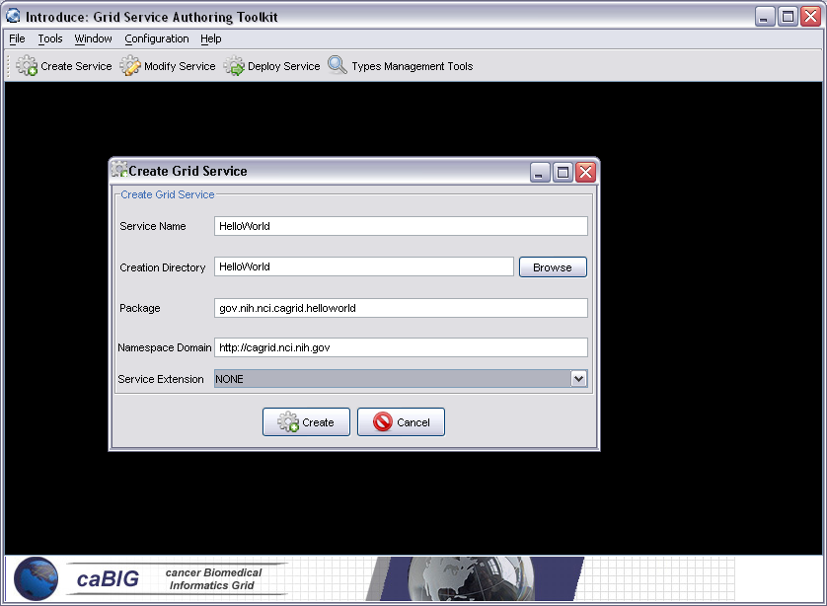

Service Modification

Figure X shows the series of options the service developer can perform in order to generate and customize a grid service. Details of how these changes are used by the Introduce engine to modify the service will be covered in Section C. First, the developer needs to discover the data types that are desired to be used as the input and output types of methods of the service and the data types for describing the resource properties of the service. Second, the developer can add, remove, or modify operations on the service. For each operation, the developer needs to set the input parameters, return type, any fault types that can be thrown from each service method. The security configuration of the service method should also be set.
Service methods can also be imported from other services. For example, if a developer would like all services or a certain type of service to implement a particular method, the corresponding method can be imported from another service. The importing of a method across services will assure not only that each service has completely protocol compatible methods but also that each service’s method can be invoked by the same base client. This enables the notion of basic inheritance in grid services and will be discussed further in Section C.
Service state information and metadata in the form of resource properties can be added, removed and configured to facilitate such operations as registration with an Index Service or deciding if the default values should be loaded from files. Service properties, which are set at deployment time and passed into the service, can also be added and their default values can be set. Service level security configuration can be set at this time as well. The service level security can be superseded by method level security. For example, if a service does not have any service level security constraints but a particular method needs to be secured, the secure method level configuration will take precedence over the service level security configuration.
The last feature which is enabled at modification time is the addition of removal of service contexts. Service contexts are sub-services which this service might be creating. As an example, if an operation on the main service enables the user to query a database, that operation might create a sub-service and return the handle to the sub-service to the user as opposed to the full query result set. This sub-service can then enable the user to iterate through the results. This is accomplished by adding method or resource properties to this sub-service which will be responsible for iteratively giving results to the user. It should be noted that multiple instances of the sub-service can be created and executed concurrently; one for each query that comes in, for example. This style of grid service is supported by WSDL and WSRF specifications. Introduce makes it easier for service developers to create such complex services.

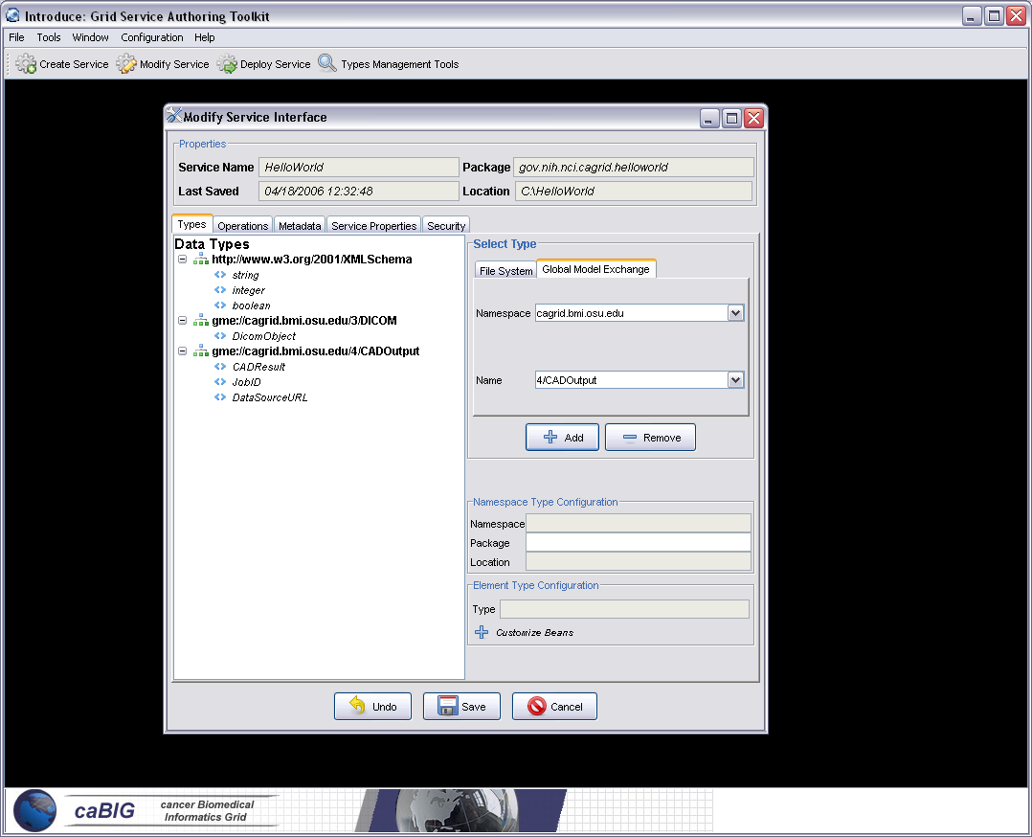

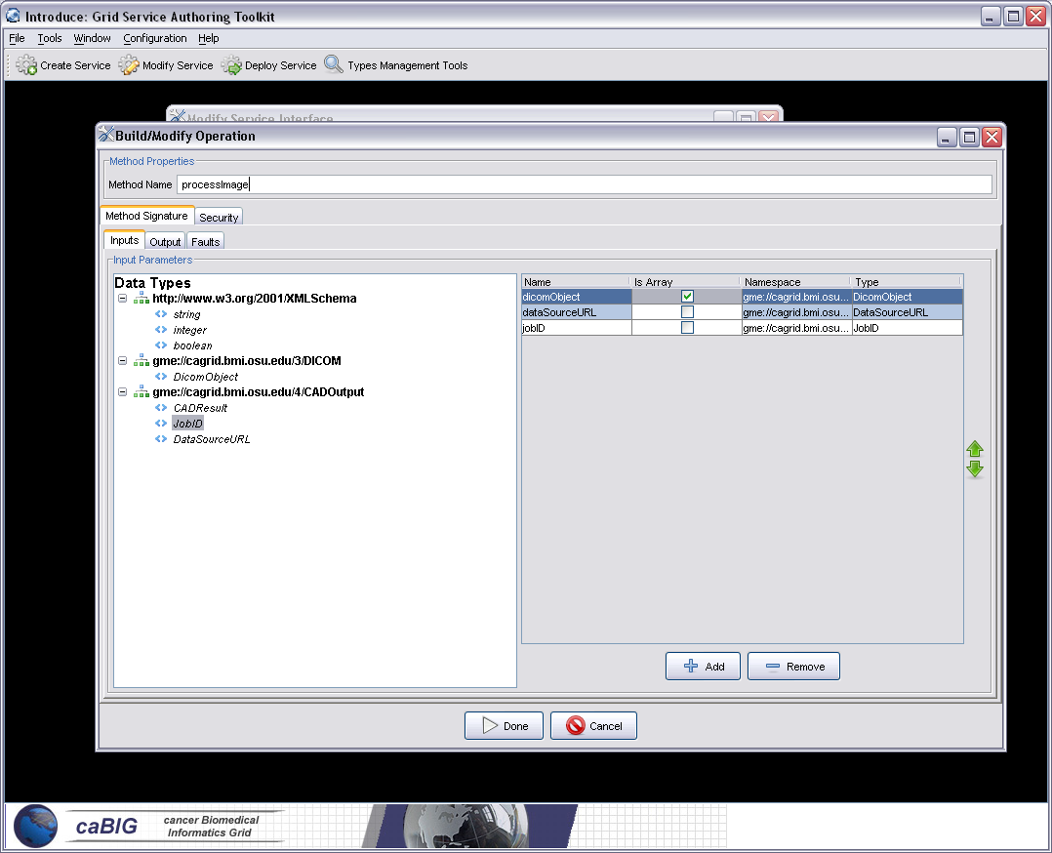

Discovery Tools: Support for Strongly-Typed Service Methods

Using the GDE, developers can obtain the types that they want to use for the service parameters and return types from any data type discovery plug-in (see Section D for more detailed description of discovery plug-ins). The Introduce toolkit comes with a set of pre-installed discovery plug-ins, such as the Mobius GME and a basic file system browser which can be used to locate local schemas. The GME plug-in enables developers to browse, upload, and download schemas published in a GME. These schemas represent the valid data types which can be used during service creation. Using the GME plug-in, a developer can take a schema, create an editable view of the schema, and then submit the schema to the GME. If the namespace of the schema is not managed by the GME, to which the schema is submitted, the plug-in will attempt to add the namespace to the GME before submitting the schema. Once the schema has been uploaded, it can be used by anyone in the Grid through the Introduce toolkit. The GME plug-in browser window enables browsing through all the GME published types by namespace and schema name. It gives the user a quick view of the schema and the option to download the schema bundle. The schema bundle contains the schema and all other schemas which are referenced by that schema.
Utilizing common and standard data types, which are defined outside of any application-specific service, enables the creation of strongly typed grid service interfaces. This increases service-to-service interoperability. Once a data type is chosen (e.g., from the Mobius GME) through the GDE, the data type is retrieved, written into the schema area of the service, and imported for use in the service WSDL description so that Java beans can be generated and the data types can be programmatically used.
In addition to default plug-ins, domain specific plug-ins can be installed in Introduce. For example, in the caBIG environment, a caDSR discovery plug-in is provided with Introduce. This plug-in allows service developers to locate and use data types registered in the cancer Data Standards Repository (caDSR), which is a curated repository of common data elements used in caBIG.

Deployment

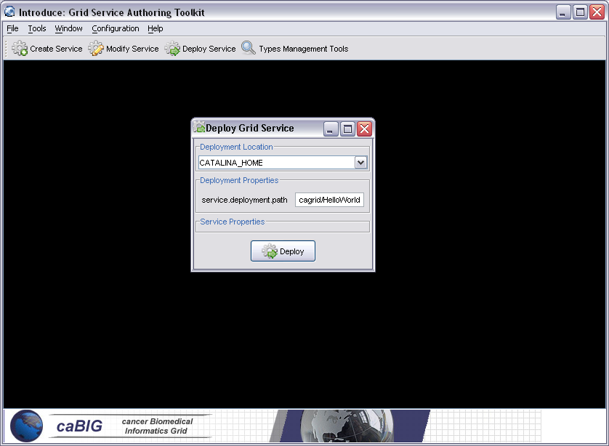

The deployment option of the GDE allows the service developer to deploy the implemented grid service, which has been created with Introduce, to a Grid service container. The toolkit currently supports deploying a service to either a Globus or Tomcat Grid service container; however, support for other deployment options can easily be added to the GDE. The deployment window allows the service deployer to populate service configuration properties which the service will have access to at runtime. Then the service is deployed to the selected container.

Introduce Engine

The runtime support to enable service creation, modification, and deployment is provided by the Introduce engine. In this section, we describe the main components of this engine.

Service Creator

The service creator is composed by a series of templates using the Java Emitter Templates (JET) component, which is part of the Eclipse Modeling Framework (http://www.eclipse.org/emf/), for generating source code and configuration files, and a skeleton set of directories which is used to generate a Grid service that can be built, registered, and deployed in the Grid environment.
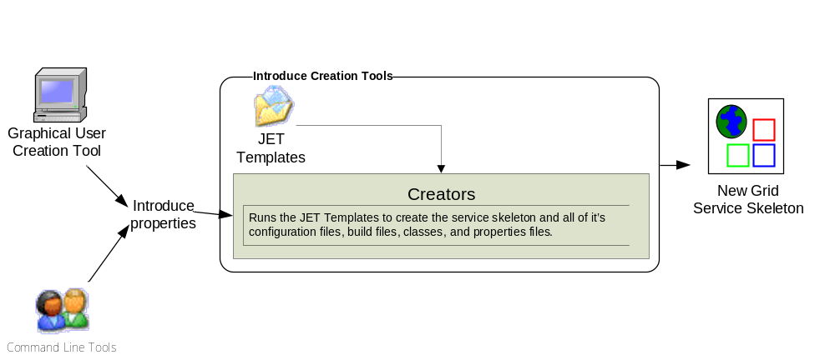

Template source codes and configuration files are used to create all the custom Java source code for the service and the client APIs, and to generate the files required by the GT in order to build and deploy a Grid service. Deployment configuration files are used for resource and resource property configuration in the form of Java Naming and Directory Interface (JNDI), resource property registration configuration, service deployment descriptor in the form of Web Service Deployment Descriptor (WSDD), and security configuration. The basic service created by Introduce has the following components:
- Ant processes for build, deploy, and test operations,
- custom configuration files for IDE integration,
- standard interface for both client and service to implement,
- fully implemented client APIs,
- stub implemented service,
- configuration to support service metadata and resource properties and the registration of metadata and properties,
- configuration for secure service deployment and authorization.

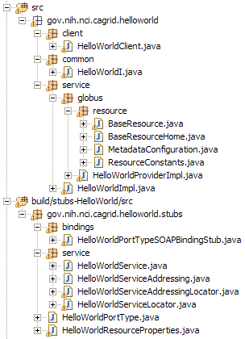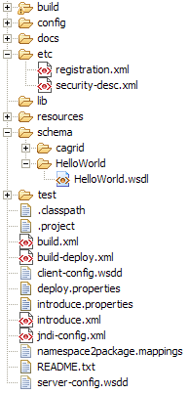
= generated
= built
= developers
contribution

The figure above shows a basic service layout as created by the Introduce Service Creator component. It shows what pieces of this example service are generated by the code generation tools, what pieces are built by the underlying Globus/Axis tools, and what pieces are to be implemented by the service developer.

= manages the resources
of this grid service
= implements the port type
and calls into the actual
clean unboxed interface
the developer defined.
= developers implementation
of the defined interface.
= the developer defined grid
service interface
= implements the developer
defined interface and calls into
the generated client port type
stub.

The image above describes what source files are used for in an example service created by the Introduce engine. It breaks down some of the key source files such as the portType generated by Axis. The portType is then implemented by the Globus provider implementation class HelloWorldProviderImpl which is responsible for unboxing the document literal calls from the portType interface and passing them into the unboxed common Java interface, which is generated by Introduce and implemented by the developer (HelloWorldImpl). The figure also illustrates the example service’s resource and resource home, which are generated to manage the service resource and the service resource properties, respectively.

= service metadata registration configuration
= describes the services security configuration
= services WSDL file for axis
= configuration files for eclipse development
= ant build files
= client configuration file for axis
= deployment time service properties
= introduce representation of service
= JNDI service resources configuration
= namespace mappings for axis
= server configuration file for axis

The figure above shows the use of the different common files of an example Introduce created service. It shows the files used for configuring registration and security for the grid service, as well as those used by Introduce for synchronization, and those used for build and deployment. This example service created by Introduce also contains Eclipse project files so that this service can easily be edited with the Eclipse IDE.

The overall service architecture that introduce creates is shown below in figure X. ….

Service Synchronizer

Service resynchronization is the process by which the source code generation tools of the Introduce toolkit will analyze the service’s current implementation with that of the desired service description. This process will add, remove, and modify any service methods, resource properties, and service settings which have been added, removed, or modified from the service description. The descriptions and configurations for methods, metadata, and security are those that are generated from the GDE, programmatically or by hand, and that comply with the Introduce service schema. The description is the basis by which the code generation tools add, remove and modify operations, metadata, and change the security configuration of the service by editing the source code, configuration files, and metadata files. This is similar to the way that AXIS will use the WSDL to generate the grid stubs of the service. The image X shown below illustrates the overall process of service resynchronization.

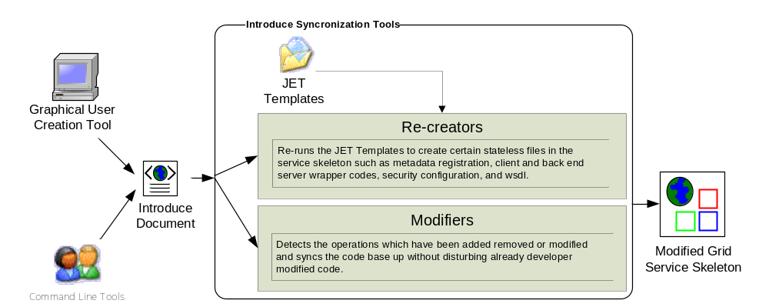
The service synchronizer component manages the service WSDL description. If a service or method has been added or removed, the respective WSDL files must be updated to reflect the changes. Updating the files requires many auto generated code segments. External XML schemas, which describe published data types, must be imported into the respective WSDL files so that the data types can be located and used to generate the required Java beans and SOAP bindings. The WSDL description is basically the Grid layer representation of the Java based service interface. Both the message types, which represent the data types of the input parameters and the return type of a service method, and the complete operation, which reflects the Java based signature of the method being exposed, have to be described in the WSDL file. The SyncWSDL operation automatically keeps this file in sync during the development of services so that the service implementation and the Grid service description represented by the WSDL match up. This ensures that the methods implemented in the Grid service can actually be invoked.
The service can have an inheritance model by adding methods from another service, possibly along with the implementations of those methods. If a method were imported from another Grid service, the service synchronizer component would also pull in the WSDL description of the method and copy it into the portType of the new service. This enables the service to have a completely protocol compatible implementation of the method.

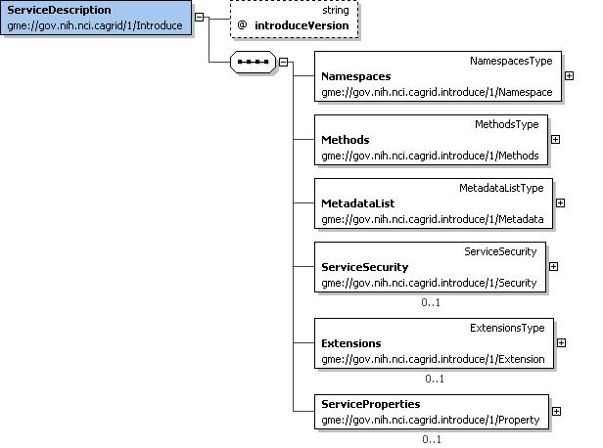
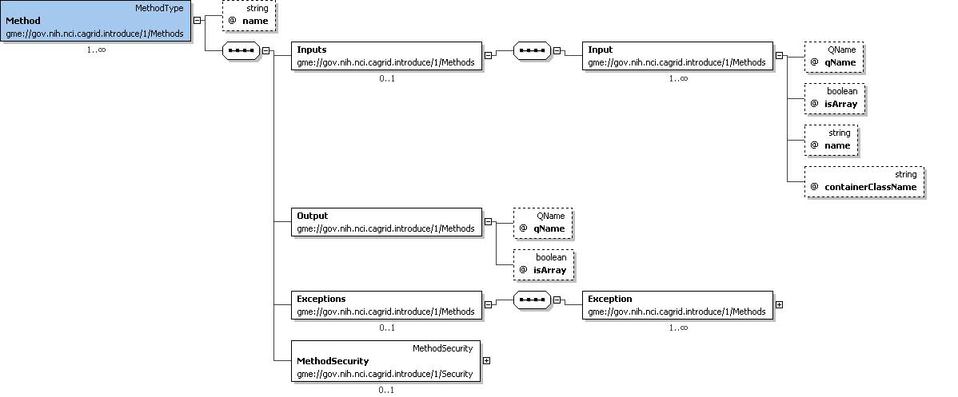
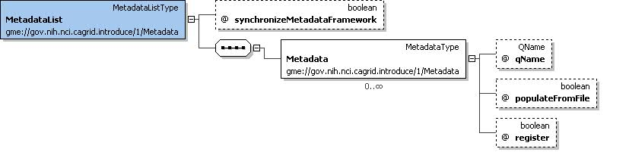
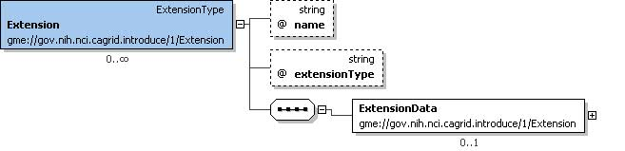
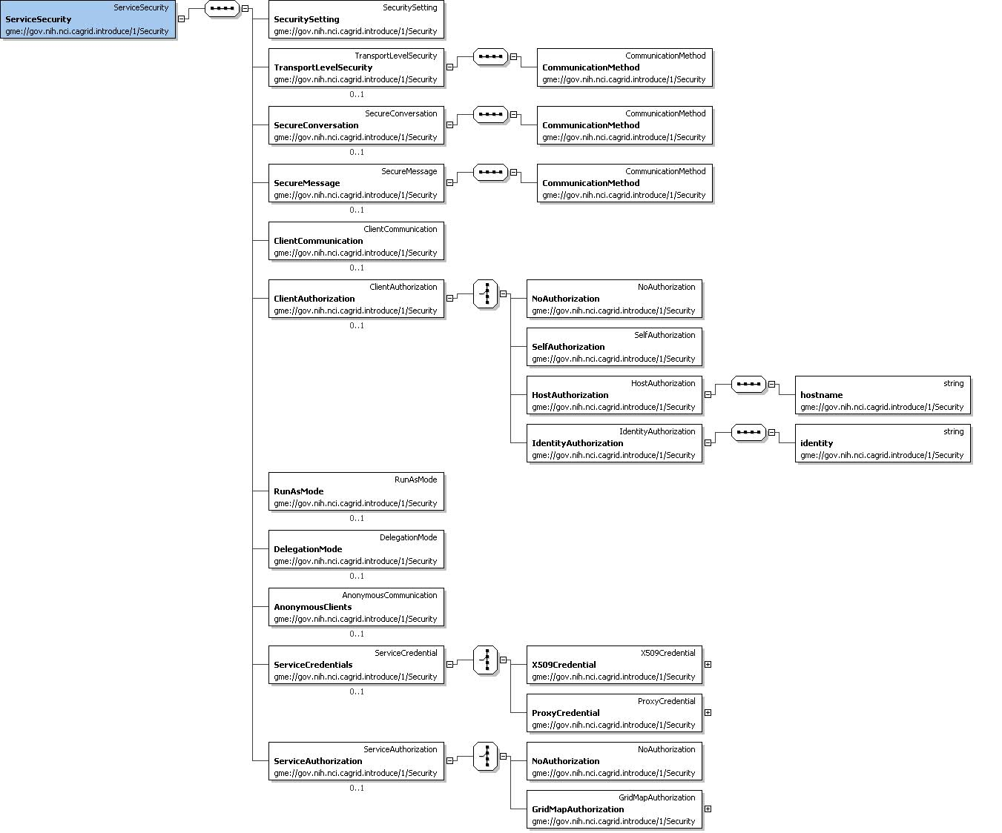
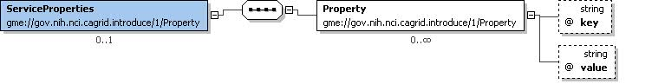

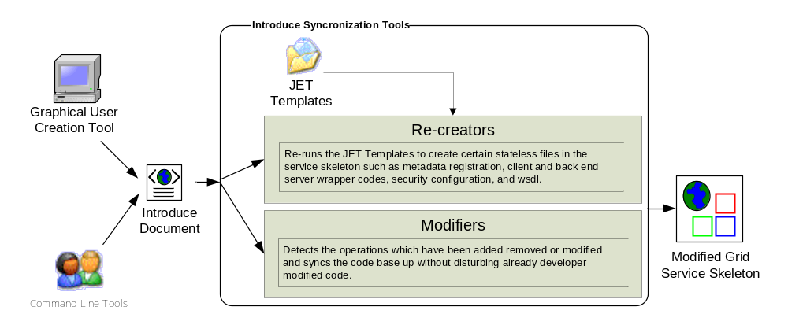

Service Deployer

The service deployment features of Introduce currently support deploying Grid services to a Globus or Tomcat container. The deployment framework can easily be extended to provide deployment capability to other Web Service containers. The deployment framework utilizes the layout of the Grid Archive (GAR) structure to organize and package a deployable service. Once the GAR for a service is generated by the deployment framework, the GAR can be utilized to deploy the service to the appropriate container. The deployment framework also allows for deployment time service properties to be acquired from the application developer or the user deploying the service. These custom service properties allow a service, which might require dynamic configuration based on its particular deployment, to acquire these needed configuration properties at deployment time and be available at service run time.
The deployment process first populates templated files required in deployment (e.g., the WSDD and JNDI of the service) to specify such values as service deployment path or security configuration file locations. The deployment process then gathers the library files required for the service as well as those library files which contain the actual runtime code of the service. All configuration files and service resources are also collected. Finally, a GAR file is generated for this service. Once the GAR file has been generated, it can be handed off to the particular deployment handler for the required container to be used for this deployment.

Other Features of Introduce Engine

Auto-boxing of Service Methods

Grid service code generation and synchronization is one of the most complicated operations in the toolkit. It has to re-write the basic source code of the service so that the client and the server both agree on the new modified interface. It also has to deal with interfacing the server side implementation of the service method mapping to the actual port type generated by Globus via Axis. The overall process is complicated because the GT uses the auto-boxing or wrapped style of service bindings when creating the port type of a service. For example, if a user describes a new method as shown below:

int foo(int bar1, int bar2);

The port type method that will be created for the corresponding Java call will look like the one below:

FooReturn foo(FooParameters params);

This boxing or wrapping of the parameters and the return type of the service method can be confusing to the service user and service developer to deal with, especially if it is exposed through the client API or the service implementation API. Every client using the service will have to box up the parameters to call the operations of the service and un-box the results. This is cumbersome and is not the interface that should be provided to users. The Introduce toolkit will hide the boxing and un-boxing of methods by providing an interface to the service, which looks exactly as described by the service developer and not as interpreted by Globus via Axis. In order to do this, the toolkit creates a wrapping layer in the client and service which both implement the clean interface. These wrapper layers auto-box and un-box and map the calls from the clean client to the auto-boxed port type client generated by Globus and visa versa for the service.
The wrapper layer hides the Globus complexity from the server side as well as form the client. The task of locating and instantiating the port type handle is also hidden from the client side API, which is auto generated by the Introduce toolkit. To construct the client handle, all that is required is to pass in the address of the service to the constructor.

Resource Framework

Introduce provides support for exposing service state and metadata by abstracting away the details of common patterns of use of the WSRF. The WSRF specifications and the GT implementation of these specifications allow the creation of stateful grid services, whilst remaining compatible with existing Web Service standards. A Grid service’s state (and metadata) is maintained in Resources in the WSRF specification, and is exposed to clients by way of Resource Properties. Introduce allows its users to expose state or metadata of their services by managing the definition, creation, and population of the Resources and Resource Properties of a service.
Upon creating a service, a service developer is able to simply select from a list of common resource usage patterns, and Introduce manages the complete generation of the necessary backend code and configuration to implement that pattern. Once the resource pattern is defined, a service developer can then use the existing data type discovery tools (as used to specify operation inputs and outputs) in order to expose state or metadata of its resources by way of Resource Properties. Developers need only select a data type they wish to expose, and Introduce makes it available as WSRF standard Resource Property. Developers are able to either programmatically control the values of the property at runtime (as is common for exposed resource state), or supply the value from a file at service startup (as is common for exposed metadata). Another powerful feature of Resource Properties is that they can be advertised to, and aggregated at, a remote indexing service – an indexing service can be used by clients and other services to discover services in the Grid environment. GT provides such a service in the form of the Index Service. It acts as the white and yellow pages of the grid, providing resource and service discovery.
Introduce allows a service developer to maintain soft-state registration of its resource properties simply by selecting a check box on each property they wish to register. For each such property, Introduce creates all of the necessary source code and configuration necessary to periodically register the property with the Index Service, and ensure the most recent value of the property is made available in the remote Index Service and associated with the service. The combination of these two simple-to-use, yet powerful features, allows a service provider to, for instance, automatically provide and register a description of its service to a central repository when the service is running. In order to do this, they need only select a common data type used to store such a description, set the configuration for registration and loading by setting the appropriate Boolean values, and provide the value of the description in a file which is deployed with the service.

Compositional Inheritance

Introduce enables the service developer to import methods from other services (i.e., from other portTypes). This notion is called compositional inheritance. Services under the new WSDL 2.0 specification cannot extend portType definitions. In order to simulate portType extension Introduce implements the ability to copy operation descriptions from other portTypes and put them in the service’s own description. This, however, brings up several questions that need to be addressed: Is this method intended to actually be implemented again? Is the method provided by an already existing implementation? What namespaces and types is this operation using?
In order to be sure that the operation can be correctly imported and copied into the new portType, the WSDL of this operation and any referenced schemas must be brought into this new service and imported. If the operation is not being provided, the synchronization engine must add this operation to the services base interface, and the unboxing Globus wrapper for this operation must be generated. If the implementation of this operation is being provided, the extra code in the interface, its implementation, and the wrapper do not need to be added. However, the implementation code, in the form of a jar, must be brought into the new service, and the operation class must be added to this services WSDD.

TODO: do we want to discuss multiple services/resources here or elsewhere?

Grid Service Security support ……

Introduce Extension Framework

The Introduce Extension framework currently consists of two styles of extensions; service and data type discovery. These extensions are implemented by service or data type discovery parties who whish to add custom functionality to the Introduce framework. Extensions are added to the toolkit in the form or extension plug-in, which the toolkit will then be able to expose to the user. To provide an extension to Introduce the extension provider must implement or extend the appropriate classes for the style of extension they wish to provide, and must fill out the extension XML configuration document.

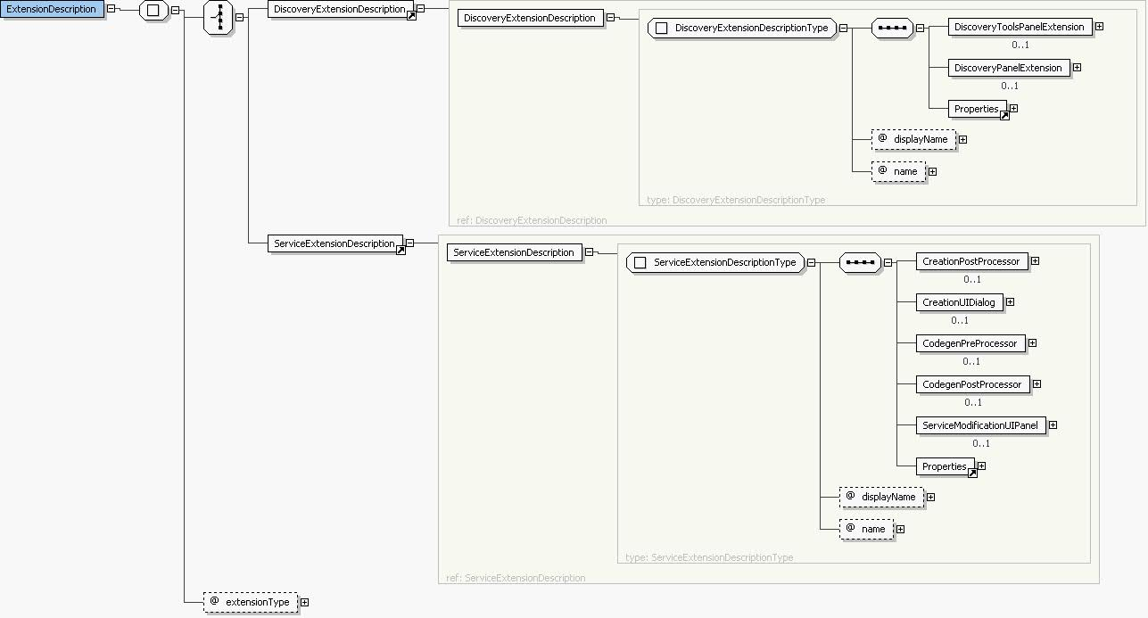

Once this extension is implemented and configured it can be placed in the extensions directory of Introduce. This directory has a common library (lib) area which enables it to avoid using custom class loaders for each extension. These extensions placed in the extensions directory are loaded by reflection at run time, therefore, Introduce does not need any special configuration to find or execute an extension.

Service Extensions

A service extension is one which enables customization of the service creation and modification processes. These extensions can add required operations, service resources or resource properties, or security settings, for example. The service extension allows the user to provide custom code that will be executed at different times throughout the creation and modification processes of service development. In order to provide a service extension, there are 5 main extension components that can be provided by custom service extension: CreationPostProcess, CreationUIDialog, CodegenPreProcess, CodegenPostProcess, and ServiceModificationUIPanel. Each of these extension components have a predefined class or interface that must be extended or implemented. Two of the service extension components, CreationUIDialog and ServiceModificationUIPanel, are graphical components provided to the Introduce GDE, and the other three are Introduce engine plug-ins.

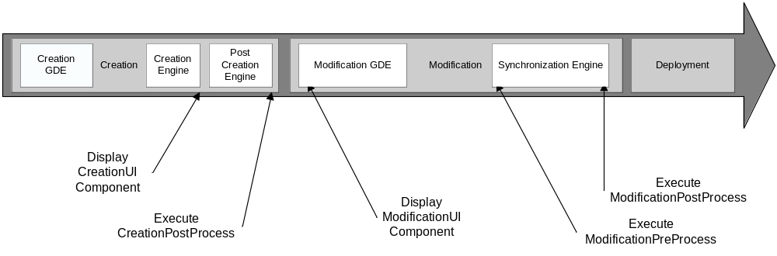

Each service extension component has a special time in the creation or modification where it will be executed. These different time points for each component execution are critical for making certain changes. For example, when the CreationUIDialog component for a particular extension is executed the service has been created as a blank service and no modification or synchronization has been done on the service. At this point the CreationUIDialog might prompt the user for particular information about the creation processes. The CreationUI component would only be executed/displayed once for any given service and it’s non graphical component, the CreationPostProcess, will also only be ran one time after the service has been created and before it will ever be modified.
The modification components are ran every time a service is saved and synchronized. The graphical modification component is always available in the Introduce GDE during modification time. The two service modification engine components, ModificationPreProcess and ModificationPostProcess are executed respectively, before and after the Introduce synchronization engine is executed. This enables ModificationPreProcess to do such things as modify the ServiceDesription, represented by the introduce.xml file, or maybe the WSDL files of the services while the ModificationPostProcess might be able to move in required files, or populated stubbed methods, etc.

Data Type Discovery Extensions

These extensions are Introduce GDE components that will be available at service modification time. These components are intended to be able to provide custom data type discovery for the service developer. The custom data type discovery component must allow the developer to browse types and chose to use those types in the developed service. This means that the data type discovery extension will have to be able to copy the schema’s which represent the data types down to the services schema directory and produce a NamespaceType object for the namespace of each separate data type. This enables the grid service to utilize the schemas for describing the data types which are used in the WSDL messages traveling in and out of the created service.

Examples

Conclusion
The Cancer Biomedical Informatics Grid (caBIG) [1] program lead by the National Cancer Institute (NCI) was launched to meet the challenge and need for a more highly
coordinated approach to informatics resource development, management and dissemination. caBIG is a voluntary network or grid connecting individuals and institutions to enable the sharing of data and tools, creating a World Wide Web of cancer research. The goal is to speed the delivery of innovative approaches for the prevention and treatment of cancer. The caBIG program includes a geographically dispersed large federation of participants from medical centers, universities, government agencies, commercials companies, researchers, and patients.
The caGrid project [2], is the test bed architecture for caBIG, it is driven primarily from the scientific use cases identified from the domain workspaces of caBIG. caGrid provides the core enabling infrastructure necessary to compose the Grid of caBIG. caGrid is a service-oriented architecture and provides the implementation of the required core services, toolkits and wizards for the development and deployment of community provided services, APIs for building client applications, and some sample client applications for interacting with the current test bed installation.

References

[1] Cancer Biomedical Informatics Grid (caBIG), https://cabig.nci.nih.gov.

[2] Cancer Biomedical Informatics Grid (caBIG), https://cabig.nci.nih.gov/workspaces/Architecture/caGrid/

[3] I. Foster, C. Kesselman, S. Tuecke., “The Anatomy of the Grid: Enabling Scalable Virtual Organizations”, International J. Supercomputer Applications, 15(3), 2001.
[4] I. Foster, C. Kesselman, J. Nick, S. Tuecke, “The Physiology of the Grid: An Open Grid Services Architecture for Distributed Systems Integration”, 2002.
[5] The Globus Toolkit, http://www.globus.org

[6] V. Welch, F. Siebenlist, I. Foster, J. Bresnahan, K. Czajkowski, J. Gawor, C. Kesselman, S. Meder, L. Pearlman, S. Tuecke, “Security for Grid Services”, Twelfth International Symposium on High Performance Distributed Computing (HPDC-12), IEEE Press, to appear June 2003.

[7] I. Foster, C. Kesselman, S. Tuecke, J. Volmer, V. Welch, ] A “National-Scale Authentication Infrastructure. R. Butler, D. Engert”, IEEE Computer, 33(12):60-66, 2000.

[8] Globus Service Build Tools Project (http://gsbt.sourceforge.net/)

[9] OASIS Security Services (SAML) TC,
http://www.oasisopen.org/committees/tc_home.php?wg_abbrev=security

The initial release of the caBIG architecture, called caGrid version 0.5, is built using the OGSA standards and Globus Toolkit 3.2. The new release, caGrid version 1.0, is being developed using the WSRF standards and Globus Toolkit 4.
There are currently more than 50 cancer centers participating in the caBIG effort.
A schema may represent a simple data element such as integer or a more complex object.

