caGrid 1.2
Installer Guide

 |   Center for Bioinformatics


This is a U.S. Government work. March 28, 2008

Model caBIG™ Open Source Software License
v.2
Release Date: January 7, 2008
Copyright Notice. Copyright 2008 The Ohio State University Research Foundation (OSURF), Argonne National Labs (ANL), SemanticBits LLC (SemanticBits), and Ekagra Software Technologies Ltd. (Ekagra) (“caBIG™ Participant”). The caGrid 1.2 software was created with NCI funding and is part of the caBIG™ initiative. The software subject to this notice and license includes both human readable source code form and machine readable, binary, object code form (the “caBIG™ Software”).
This caBIG™ Software License (the “License”) is between caBIG™ Participant and You. “You (or “Your”) shall mean a person or an entity, and all other entities that control, are controlled by, or are under common control with the entity. “Control” for purposes of this definition means (i) the direct or indirect power to cause the direction or management of such entity, whether by contract or otherwise, or (ii) ownership of fifty percent (50%) or more of the outstanding shares, or (iii) beneficial ownership of such entity.
License. Provided that You agree to the conditions described below, caBIG™ Participant grants You a non-exclusive, worldwide, perpetual, fully-paid-up, no-charge, irrevocable, transferable and royalty-free right and license in its rights in the caBIG™ Software, including any copyright or patent rights therein, to (i) use, install, disclose, access, operate, execute, reproduce, copy, modify, translate, market, publicly display, publicly perform, and prepare derivative works of the caBIG™ Software in any manner and for any purpose, and to have or permit others to do so; (ii) make, have made, use, practice, sell, and offer for sale, import, and/or otherwise dispose of caBIG™ Software (or portions thereof); (iii) distribute and have distributed to and by third parties the caBIG™ Software and any modifications and derivative works thereof; and (iv) sublicense the foregoing rights set out in (i), (ii) and (iii) to third parties, including the right to license such rights to further third parties. For sake of clarity, and not by way of limitation, caBIG™ Participant shall have no right of accounting or right of payment from You or Your sublicensees for the rights granted under this License. This License is granted at no charge to You. Your downloading, copying, modifying, displaying, distributing or use of caBIG™ Software constitutes acceptance of all of the terms and conditions of this Agreement. If you do not agree to such terms and conditions, you have no right to download, copy, modify, display, distribute or use the caBIG™ Software.
- Your redistributions of the source code for the caBIG™ Software must retain the above copyright notice, this list of conditions and the disclaimer and limitation of liability of Article 6 below. Your redistributions in object code form must reproduce the above copyright notice, this list of conditions and the disclaimer of Article 6 in the documentation and/or other materials provided with the distribution, if any.
- Your end-user documentation included with the redistribution, if any, must include the following acknowledgment: “This product includes software developed by the Ohio State University Research Foundation (OSURF), Argonne National Labs (ANL), SemanticBits LLC (SemanticBits), and Ekagra Software Technologies Ltd. (Ekagra).” If You do not include such end-user documentation, You shall include this acknowledgment in the caBIG™ Software itself, wherever such third-party acknowledgments normally appear.
- You may not use the names “The Ohio State University Research Foundation”, "OSURF", “Argonne National Labs”, “ANL”, “SemanticBits LLC”, "SemanticBits", “Ekagra Software Technologies Ltd.”, “Ekagra”, “The National Cancer Institute”, “NCI”, “Cancer Bioinformatics Grid” or “caBIG™” to endorse or promote products derived from this caBIG™ Software. This License does not authorize You to use any trademarks, service marks, trade names, logos or product names of either caBIG™ Participant, NCI or caBIG™, except as required to comply with the terms of this License.
- For sake of clarity, and not by way of limitation, You may incorporate this caBIG™ Software into Your proprietary programs and into any third party proprietary programs. However, if You incorporate the caBIG™ Software into third party proprietary programs, You agree that You are solely responsible for obtaining any permission from such third parties required to incorporate the caBIG™ Software into such third party proprietary programs and for informing Your sublicensees, including without limitation Your end-users, of their obligation to secure any required permissions from such third parties before incorporating the caBIG™ Software into such third party proprietary software programs. In the event that You fail to obtain such permissions, You agree to indemnify caBIG™ Participant for any claims against caBIG™ Participant by such third parties, except to the extent prohibited by law, resulting from Your failure to obtain such permissions.
- For sake of clarity, and not by way of limitation, You may add Your own copyright statement to Your modifications and to the derivative works, and You may provide additional or different license terms and conditions in Your sublicenses of modifications of the caBIG™ Software, or any derivative works of the caBIG™ Software as a whole, provided Your use, reproduction, and distribution of the Work otherwise complies with the conditions stated in this License.
- THIS caBIG™ SOFTWARE IS PROVIDED "AS IS" AND ANY EXPRESSED OR IMPLIED WARRANTIES (INCLUDING, BUT NOT LIMITED TO, THE IMPLIED WARRANTIES OF MERCHANTABILITY, NON-INFRINGEMENT AND FITNESS FOR A PARTICULAR PURPOSE) ARE DISCLAIMED. IN NO EVENT SHALL THE OHIO STATE UNIVERSITY RESEARCH FOUNDATION ("OSURF"), ARGONNE NATIONAL LABS (“ANL”), SEMANTICBITS LLC ("SEMANTICBITS"), AND EKAGRA SOFTWARE TECHNOLOGIES LTD. (EKAGRA) OR ITS AFFILIATES BE LIABLE FOR ANY DIRECT, INDIRECT, INCIDENTAL, SPECIAL, EXEMPLARY, OR CONSEQUENTIAL DAMAGES (INCLUDING, BUT NOT LIMITED TO, PROCUREMENT OF SUBSTITUTE GOODS OR SERVICES; LOSS OF USE, DATA, OR PROFITS; OR BUSINESS INTERRUPTION) HOWEVER CAUSED AND ON ANY THEORY OF LIABILITY, WHETHER IN CONTRACT, STRICT LIABILITY, OR TORT (INCLUDING NEGLIGENCE OR OTHERWISE) ARISING IN ANY WAY OUT OF THE USE OF THIS caBIG™ SOFTWARE, EVEN IF ADVISED OF THE POSSIBILITY OF SUCH DAMAGE.

Revision History
The following is the revision history for this document.

Date | Version | Description | Revised By
3/28/2008 | 1.2.3 | Formatted and Edited to Match NCI Documentation Standards | Carolyn Kelley Klinger
3/28/2008 | 1.2.2 | Moved from wiki to Word Template | John Eisenschmidt
3/25/2008 | 1.2.1 | Final Draft for wiki: caGrid 1.2 | Scott Oster
3/11/2008 | 1.2.0 | Initial Draft for wiki: caGrid 1.2 | Scott Oster

Contents
Revision History v
Contents vii
Figures ix
Tables xi
About This Guide 1
Purpose 1
Release Schedule 1
Audience 1
Topics Covered 2
Document Text Conventions 2
Credits and Resources 3
Chapter 1 Getting Started with the Installer 5
Introduction 5
Downloading the Installer 5
Running the Installer 6
Usage Scenarios 6
Installation Phases 7
Installation Types 7
Chapter 2 Using the caGrid Installer 11
Creating a Secure Container 11
Environment Settings 16
Unix/Linux and Mac 17
Microsoft Windows 18
Advanced Usage 19
Off-Line Installation 19
Custom Target Grid 20
Troubleshooting 21
Error loading default properties 21
Error initializing: The version of Java is not correct 21
Could not connect to database 21

Figures
Figure 2-1: Select caGrid 12
Figure 2-2: Select target grid 13
Figure 2-3: Required components installed 14
Figure 2-4: caGrid installation complete 14
Figure 2-5: Start up the caGrid security UI 15
Figure 2-6: Container configuration complete 16
Figure 2-7: Setting MS Windows environment variables 18

Tables
Table 1-1 Document Conventions 2

About This Guide
This section introduces you to the caGrid 1.2 Installer Guide. Topics in this section include
- Purpose on this page
- Release Schedule on this page
- Audience on this page
- Topics Covered on page 2
- Document Text Conventions on page 2
- Credits and Resources on page 3

Purpose
The cancer Biomedical Informatics Grid, or caBIG™, is a voluntary virtual informatics infrastructure that connects data, research tools, scientists, and organizations to leverage their combined strengths and expertise in an open environment with common standards and shared tools. The current grid architecture of caBIG™ is dubbed caGrid. The software embodiment and corresponding documentation of this architecture constitute the caGrid release.
This guide describes the caGrid Installer, which simplifies the installation of caGrid. More information about caGrid can be found in the User’s Guide and Programmer’s Guide.

Release Schedule
This guide has been updated for the caGrid 1.2 release. It may be updated between releases if errors or omissions are found. The current document refers to the 1.2 version of caGrid, released in March 2008 by caBIG.

Audience
The primary audience of this guide is the caGrid service developer, client application developer, and service administrator.
This guide assumes that you are familiar with the Java programming language and/or other programming languages, database concepts, and the Internet. If you intend to use caGrid resources in software applications, it assumes that you have experience with building and using complex data systems.

Topics Covered
This brief overview explains what you will find in each chapter of this guide.
- About This Guide, this chapter, provides an overview of the guide.
- Chapter 1, Getting Started with the Installer on page 5, explains how to download, run, and install the caGrid Installer.
- Chapter 2, Using the caGrid Installer on page 11, describes how to install caGrid components into a secure container, installation differences between operating systems, advanced usage scenarios, and troubleshooting options.

Document Text Conventions
The following table shows how text conventions are represented in this guide. The various typefaces differentiate between regular text and menu commands, keyboard keys, and text that you type.
Convention | Description | Example
Bold | Highlights names of option buttons, check boxes, drop-down menus, menu commands, command buttons, or icons. | Click Search.
URL | Indicates a Web address. | http://domain.com
text in Small Caps | Indicates a keyboard shortcut. | Press Enter.
text in Small Caps + text in Small Caps | Indicates keys that are pressed simultaneously. | Press Shift + Ctrl.
Italics | Highlights references to other documents, sections, figures, and tables. | See Figure 4.5.
Italic boldface monospace type | Represents text that you type. | In the New Subset text box, enter Proprietary Proteins.
Note: | Highlights information of particular importance. | Note: This concept is used throughout this document.
{ } | Surrounds replaceable items. | Replace {last name, first name} with the Principal Investigator’s name.
Table 1-1 Document Conventions

Credits and Resources
caGrid 1.2 Installer Guide Development and Management Teams
Development | Support (Systems, QA, Documentation) | Management
Scott Oster  (Lead Architect)¹ | Aynur Abdurazik⁷ | Avinash Shanbhag (Product Manager)⁵
David Ervin¹ | Chet Bochan⁹ | John Eisenschmidt¹⁰
Ian Foster² | Gavin Brennan⁹ | Michael Keller⁶
Shannon Hastings¹ | Carolyn Kelley Klinger⁸ | David Wu⁶
Tahsin Kurc¹ | Wei Lu⁹ | Peter Yan⁷
Manav Kher³ | Ye Wu⁵
Stephen Langella¹
Ravi Madduri²
Kunal Modi⁴
Joshua Phillips³
Joel Saltz¹
- Ohio State University - Biomedical Informatics Department | - University of Chicago/Argonne National Laboratory | - SemanticBits, LLC.
- Ekagra Software Technologies, Ltd. | - NCI - Center for Biomedical Informatics and Information Technology (CBIIT) | - Booz Allen Hamilton
- Science Application International Corporation (SAIC) | - Lockheed Martin Management System Designers | - Terrapin Systems LLC (TerpSys)
- 5AM Solutions

Other Acknowledgements
GeneConnect – Project - Washington University
GridIMAGE – Project - Ohio State University
caBIO – Project - National Cancer Institute Center for Bioinformatics (NCICB)
caArray – Project - National Cancer Institute Center for Bioinformatics (NCICB)
caTRIP – Project – Duke Comprehensive Cancer Center
GenePattern – Project – Broad Institute
geWorkbench – Columbia University
caBiocondutor – Project – Fred Hutchinson Cancer Research Center

Contacts and Support
NCICB Application Support | http://ncicbsupport.nci.nih.gov/sw/  Telephone: 301-451-4384  Toll free: 888-478-4423

LISTSERV Facilities Pertinent to caGrid
LISTSERV | URL | Name
cagrid_users-l@list.nih.gov | https://list.nih.gov/archives/cagrid_users-l.html | caGrid Users Discussion Forum

Getting Started with the Installer
This chapter provides an overview of the caGrid Installer, including how to install it and choosing a custom target grid.
Topics in this chapter include:
- Introduction on this page
- Downloading the Installer on this page
- Running the Installer on page 6
- Usage Scenarios on page 6
- Installation Phases on page 7

Introduction
The caGrid installer provides a graphical, wizard-like interface for installing caGrid dependencies, source code, services, and applications. It was first introduced for caGrid 1.0, and overhauled for caGrid 1.1.
The following features are new in the 1.2 release:
- Small download: under 3MB
- Component installers: install all caGrid services and applications
- Can be used to re-install or re-configure previous installations
- Installer now uses MD5 checksums to verify downloads

Downloading the Installer
The caGrid Installer can only be obtained from the caGrid gforge project page. The caGrid 1.2 installer can be downloaded by clicking caGrid-installer-1.2.zip.
The installer zip file must be saved to your file system. Unzip the file into a directory of your choosing, for example /opt/cagrid/installer. The contents of that directory should look like this:
caGrid-installer-1.2.jar
caGrid-installer-1.2.zip
lib/
caGrid-1.2-wizard.jar
cog-jglobus.jar
commons-logging.jar
jce-jdk13-125.jar
log4j-1.2.8.jar
mysql-connectory-java-3.0.16-ga-bin.jar
xmltask-v1.14.jar
scripts/
build.xml
resources/
spring-beans.dtd
web-app_2_3.dtd
web-facesconfig_1_1.dtd

Running the Installer
caGrid requires the Java 1.5 JDK. If the installer cannot locate this version of Java, an error message will be displayed when you try to run the installer. If you see this error message, see “Environment Settings” on page 16 to learn how to configure your environment on various platforms. You will also need to be connected to the Internet because the installer will download caGrid and its dependencies. If you are behind a firewall or need to install to hosts that have no route to the Internet, see “Off-Line Installation” on page 19.
You will find a Java archive (Jar) file named caGrid-installer-1.2.jar in the directory where you unzipped the downloaded zip file. This is the installer program. On some operating systems (e.g. Microsoft Windows, Macintosh), you can double-click on this file.
Note: Some programs that unzip zip files will display the contents of the zip file in a folder-like view (e.g. Microsoft Windows XP and Vista). Be sure to first extract the zip file before double-clicking on the installer Jar file. Otherwise, the installer will fail to start.
On other systems (e.g. Linux, Unix), you must run this program from the command line. To run this program from the command line, change to the directory where you unzipped the the downloaded file. Then type the following:
java -jar caGrid-installer-1.2.jar
Note: Make sure you have changed to the same directory as the Jar file before running the installer.
When the installer starts, you will see a splash screen which displays the caGrid logo.

Usage Scenarios
The installer has been designed for the following usage scenarios:
- Installing the caGrid source distribution and dependencies.
- Configuring a container into which caGrid services can be deployed.
- Installing any of the caGrid services.
- Installing caGrid applications (portal).
If you are developing your own services that you wish to expose to an existing grid, then you will be interested in only scenarios 1 and 2. If you are creating your own grid or you would like to integrate your institution's security domain into other grids, then you would also be interested in scenario 3. If you would like to be able to use a web interface to discover and view metadata that is exposed by services which do not advertise to the NCICB's index services, then you would be interested in scenario 4.
Scenarios 1 and 2 require essentially no knowledge of how caGrid works. In a matter of minutes, you should be able to download and install caGrid, configure your container, and start using Introduce (and other core caGrid tools) to develop and deploy services. (Refer to the Introduce guide to get started developing services: http://www.cagrid.org/wiki/Introduce)
Scenarios 3 and 4 require knowledge of how caGrid and each of its components work - both on their own and together. You should refer to the caGrid User's Guide for each component. You can also refer to the deployment documentation that describes how the installer is used to deploy the NCICB production grid.
The rest of this chapter will describe usage scenarios 1 and 2.

Installation Phases
Each run of the installer goes through the following phases:
- Select installation type and desired components
- Download/install required components (optional)
- Configure caGrid and container (optional)
- Configure components
- Install components

Installation Types
The first screen displayed by the installer (after the license screen) prompts the user to select one of the following installation types:
- Install caGrid
- Configure Container
- Install caGrid Services
- Install caGrid Portal
If you are interested in usage scenarios 1 and 2 (described above), then you will need to select only Install caGrid and/or Configure Container. If you are interested in usage scenarios 3 and 4, then you would select one or more of the remaining options.
Note: The installer will try to do the "right" thing, based on your selections. If you select only Install caGrid Services, but you haven't yet installed caGrid or configured a container, the installer will detect this and prompt you through the process of establishing a working system.

Install caGrid
If you select Install caGrid and de-select all other options, the installer will do the following:
- Download and extract Ant
- Download and extract Globus
- Download and extract caGrid
- Compile caGrid
- Configure caGrid for a target grid (e.g. NCICB Production Grid)
If your ANT_HOME environment variable already points to the correct version of Ant, the installer will give you the option to us this, or reinstall Ant to the location you choose. Similarly, if your GLOBUS_LOCATION environment variable points to the right version of Globus, you'll be given the same options. If you have already used the installer to install caGrid 1.2, you'll be given the option re-install it as well. You'll also be given the option to reconfigure it for different target grid.

Configure Container
caGrid services can be deployed to either the Globus container or to the Globus web application that has been deployed to a Jakarta Tomcat servlet container. When you select the Configure Container option, you'll be prompted to select the container type: Globus or Tomcat.
If you select the Globus container, the installer will:
- (Re-)Install Ant (optional)
- (Re-)Install Globus (optional)
- (Re-)Install caGrid (optional)
If you select the Tomcat container, the installer will also give you the option to (re-)install Tomcat.
Once the installer has installed (or identified) the appropriate container, it will ask you a series of questions to determine how the container should be configured.

Secure Container
The first question will ask whether the container should be secure. That means, do you want the container to be able to host secure services? Secure services are those that require clients to use one of the Globus Security Infrastructure (GSI) authentication mechanisms. The authentication mechanisms require that the container be provisioned with grid credentials (i.e. a X.509 certificate and key). Grid credentials that are used for a container that is hosting grid services are referred to as host credentials. The GAARDS infrastructure (caGrid's security infrastructure) provides mechanisms to obtain host credentials.
In caGrid, the primary way to obtain host credentials is to request them from the Dorian CA via the GAARDS security UI. That process is described here. The NCICB Production grid includes a Dorian "Level 1" service that will automatically grant host certificates to any grid user, for any host. If you use this approach, your services will be trusted by any other caGrid services that trust the Dorian level 1 CA.
On the other hand, if you just want to experiment with secure grid services, and are not concerned about integrating with an existing trust fabric, you can use the installer to generate both your own CA and host certificates. (The installer just uses the tools found in the caGrid gridca project to generate these certificates.)
- If you choose to install a secure container, the installer will then ask for the host name of the machine. (You can't just make this up. The host name must be a DNS name that resolves to the same IP address as the IP address(es) to which the container is listening on the specified port.). Enter the host name and press Next.
- If you have chosen the Tomcat container, the next screen will prompt you for the Shutdown Port and HTTPS port. If you are installing multiple containers on the same machine, ensure that these are different than the ports that other containers are using.
NOTE: The installer will attempt to remove the existing HTTP Connector element in Tomcat's server.xml. But it will not remove any other Connector elements. If you are running multiple containers on the same machine, you will have to manually modify/remove other Connectors (e.g. the AJP/1.3 Connector) if there are port conflicts.
- If you have chosen the Globus container, you will not be prompted for port information. The port that the Globus container listens to is specified as a command line argument to the container's startup script. See here for further information.
- Next the installer will ask if the service certificate and key (i.e. the host credentials) are present.
- If you have these, select the Yes check box, and click Next. On the next screen, you'll be prompted for the location of these credentials.
- If you don't have host credentials, do NOT select the Yes check box. Then press Next.
- The installer asks if you have a CA certificate and key. These are what the installer will need in order to generate host credentials for you.
- If you have these, select the Yes check box. Then press Next. On the following screen, you'll be prompted for the locations of the CA certificate and key as well as the password for the key. Once you've entered these, press Next. You'll then be prompted for the location to write the host certificates.
- If you don't have a CA certificate and key, do NOT select the Yes check box on the screen that asks if they are present. Then press Next.
- You'll then be prompted for locations to write the certificate and key as well as the CA password, the distinguished name (DN) to be used, and the number of days that the CA certificate will be valid. Once you've entered that information, press Next. The following screen will prompt you for the location to write the host certificates.

Non-secure Container
If you have not chosen to configure a secure container, the installer will just ask you for the host name and, if using Tomcat, the shutdown and HTTP ports.

Install caGrid services
If you choose the Install caGrid Services installation type, the installer will present the following list of caGrid services that can be installed:
- My Introduce Service
- Dorian
- Credential Delegation Service (CDS)
- GTS
- SyncGTS
- AuthenticationService
- GridGrouper
- Index Service
- GME
- EVS
- caDSR
- FQP
- Transfer Service (Tomcat Only)
- Workflow
For details on the configuration of each of these components, see the [TODO: set me caGrid User's Guide]. You could also look here to see how these services have been deployed using the installer at NCICB.
The My Introduce Service option allows you to configure the standard properties of any Introduce-created service and deploy it.
If you choose to install the Workflow service, ActiveBPEL will be downloaded and installed as well, in the same manner as other dependencies such as Tomcat or Ant.

Install caGrid Portal
See here for details on install the caGrid Portal.

Using the caGrid Installer
Topics in this chapter include:
- Creating a Secure Container on this page
- Environment Settings on page 16
- Advanced Usage on page 19
- Troubleshooting on page 21

Creating a Secure Container
This section explains how to create a secure container using the caGrid Installer. The overall process invokes the following basic steps:
- Download, extract, run the installer to install just caGrid.
- Use the caGrid security UI to request host credentials.
- Run the installer again to install the container and point it at the credentials created in the previous step.
To create a secure container using the caGrid Installer:
- Download the Installer. For more information, see Downloading the Installer on page 5.
- Run the installer. For more information, see Running the Installer on page 6.
- Agree to the license.
- Select the Install caGrid option and clear all other options.
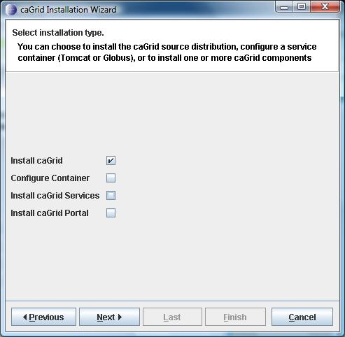
Figure 2-1: Select caGrid
- Click Next. In the following screens, indicate where Ant, Globus and caGrid should be installed. The Select Target Grid screen appears.
- Select the grid that you intend to integrate with. Click Next. The Install Components screen appears.
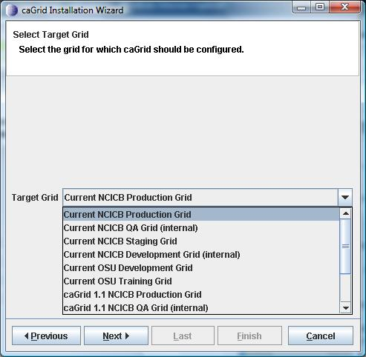
Figure 2-2: Select target grid
- Click Start. The Installed Components screen appears. Wait while the installer downloads and extracts the required components.
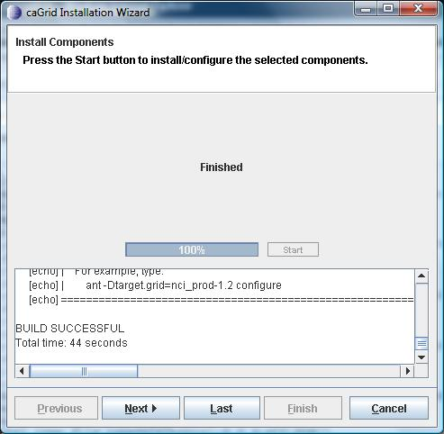
Figure 2-3: Required components installed
- Click Next. The Installation Complete screen appears once caGrid has been successfully installed. It also lists the environment variables that you need to set.
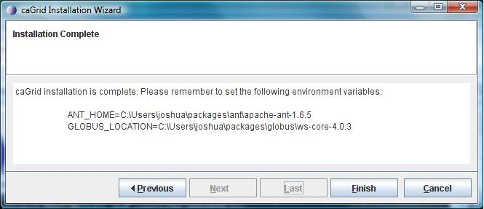
Figure 2-4: caGrid installation complete
- Click Finish, then Close.
The ANT_HOME and GLOBUS_LOCATION variables should now be set as the installer indicated. If you haven't already set the JAVA_HOME variable, the installer will also indicate what that should be set to. See here for instructions on setting environment variables on various operating systems.
- Open a command prompt and change directories to where caGrid has been installed. Type the following command:
ant security
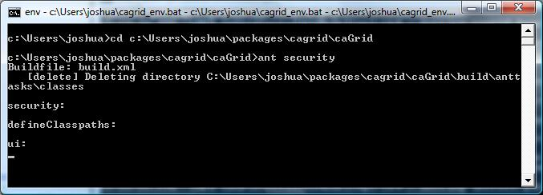
Figure 2-5: Start up the caGrid security UI
- You will need to authenticate to the grid, which requires an account. Anyone can get an account automatically using the caGrid Dorian Level 1 service. If your institution already has an AuthenticationService that is integrated with the NCICB Production grid, you will be able to use the same username and password that you us at your institution. See here for directions on requesting an account. See here for directions on authenticating through the caGrid security UI. Once you have successfully authenticated, follow these instructions for requesting host credentials.
- Once you have obtained host certificates, start up the installer again.
- Agree to the license; then select Configure Container and clear all other options. Click Next.
- Select the Tomcat container type. Click Next.
- Do NOT select the Yes check box on the Reinstall Ant? screen. Click Next.
- On the Tomcat screen, indicate where Tomcat should be installed. Click Next.
- Click Next. Indicate where Tomcat should be installed. Click Next.
- Do NOT select the Yes check box on the Reinstall Globus? screen. Click Next.
- Do NOT select the Yes check box on the Reinstall caGrid? screen. Click Next.
- Do NOT select the Yes check box on the Reconfigure caGrid for target grid? screen. Click Next.
- Click Start on the Install Components screen. When it finishes, click Next.
- On the Secure Deployment screen, select the Yes check box. Click Next.
- On the Service Hostname screen, enter the host name of this machine. Click Next.
- On the Specify Tomcat Ports screen, enter the Shutdown Port and HTTPS port. (In most cases, the defaults should be fine) Click Next.
- On the Service Credentials screeen, select the Yes check box. Click Next.
- On the Service Credentials Information screen, navigate to and select the certificate and key files that you created through the caGrid security UI. Click Next.
- Click Start. The installer deploys Globus to Tomcat and configures Tomcat and the Globus web application accordingly.
- Once the installer is finished, click Next. The installer indicates that the CATALINA_HOME environment variable must now also be set.
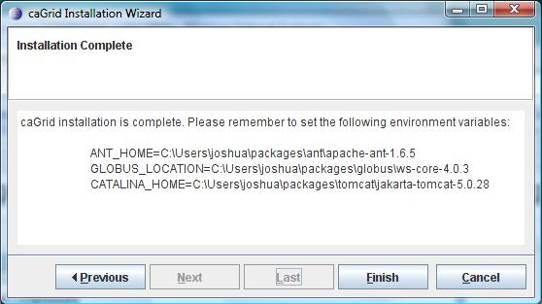
Figure 2-6: Container configuration complete
On some systems, you will also need to modify the file permissions of the components that have been installed. For example, on Mac and *nix type systems, you could run the following commands:
chmod u+x $CATALINA_HOME/bin/*.sh
chmod u+x $ANT_HOME/bin/*.sh
chmod u+x $GLOBUS_LOCATION/bin/*

Environment Settings
In order for the caGrid development environment and deployed caGrid services to work properly, you must set certain environment variables. If these environment variables have not been set, the installer will indicate how they should be set based on the input you provide during the installation process. Also, since the installer is designed to work on systems where caGrid (and some or all of its dependencies) have already been installed, the installer will examine the environment and give the user options to re-use or re-install these components (possibly to a new location on the file system).
The environment variables that the installer looks for are as follows:
- JAVA_HOME: This should point to the Java 1.5 Java Develop Kit (JDK), not the Java Runtime Environment (JRE).
- ANT_HOME: Should point to the Ant 1.6.5 installation directory. The caGrid development environment requires this variable, but running caGrid services do not.
- GLOBUS_LOCATION: Should point to the caGrid Globus 4.0.3 distribution installation directory. This is required by the caGrid development environment and caGrid services that are running in the Globus container.
- CATALINA_HOME: Should point to the Jakarta Tomcat 5.0.28 installation directory. This is required by the caGrid development environment and is necessary to run the Tomcat container.
The next sections provide examples of how to set these variables for various systems.

Unix/Linux and Mac
Suppose you have the following installation:
- Java: /usr/local/jdk1.5.0_12
- Ant: /usr/local/apache-ant-1.6.5
- Globus: /usr/local/ws-core-4.0.3
- Tomcat: /usr/local/jakarta-tomcat-5.0.28
If you are using the Bash shell, then you should add the following to your ~/.bash_profile file:
export JAVA_HOME=/usr/local/jdk1.5.0_12
export ANT_HOME=/usr/local/apache-ant-1.6.5
export GLOBUS_LOCATION=/usr/local/ws-core-4.0.3
export CATALINA_HOME=/usr/local/jakarta-tomcat-5.0.28
export PATH=$JAVA_HOME/bin:$ANT_HOME/bin:$PATH

Microsoft Windows
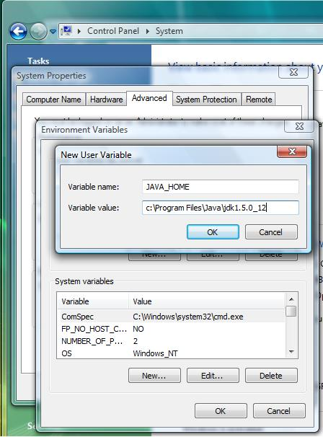
Figure 2-7: Setting MS Windows environment variables
Suppose you have the following installation:
- Java: C:\Program Files\Java\jdk1.5.0_12
- Ant: C:\Users\me\apache-ant-1.6.5
- Globus: C:\Users\me\ws-core-4.0.3
- Tomcat: C:\Users\me\jakarta-tomcat-5.0.28
In the Microsoft Windows operating system, you can set environment variables in the registry using the System administration application that is found in the Control Panel.
To set environment variables in the Windows registry:
- Click the Start button.
- Select Control Panel.
- Double-click the System application.
- Select Advanced System Settings (or the Advanced tab, depending on your version of MS Windows).
- Click Environment Variables.
- Create environment variables as in Figure 2-7 on page 18. These can be either User or System variables.
You could also run a batch file that contains the following from the command prompt:
set JAVA_HOME=C:\Program Files\Java\jdk1.5.0_12
set ANT_HOME=C:\Users\me\apache-ant-1.6.5
set GLOBUS_LOCATION=C:\Users\me\ws-core-4.0.3
set CATALINA_HOME=C:\Users\me\jakarta-tomcat-5.0.28
set PATH=%JAVA_HOME%\bin;%ANT_HOME%\bin;%PATH%
cmd
Note: Environment variables set in this way will only be noticed by programs that are launched from the same command prompt window.

Advanced Usage

Off-Line Installation
The installer can be configured to pull dependencies from the file system (or local network).
Step 1: Create a file named cagrid.installer.properties and enter the following content into it.
cagrid.version=1.2
ant.download.url=http://archive.apache.org/dist/ant/binaries/apache-ant-1.6.5-bin.zip
ant.md5.checksum=50b60129b54fc8f96a84ee60d7599188
ant.temp.file.name=apache-ant-1.6.5-bin.zip
ant.dir.name=apache-ant-1.6.5
tomcat.download.url=http://archive.apache.org/dist/tomcat/tomcat-5/v5.0.28/bin/jakarta-tomcat-5.0.28.zip
tomcat.md5.checksum=4ab725ca651ec0d6b87df78474482f43
tomcat.temp.file.name=jakarta-tomcat-5.0.28.zip
tomcat.dir.name=jakarta-tomcat-5.0.28
globus.download.url=http://gforge.nci.nih.gov/frs/download.php/1334/ws-core-enum-4.0.3.zip
globus.md5.checksum=1771116b144f2bb66c01c99a2af90c1d
globus.temp.file.name=ws-core-enum-4.0.3.zip
globus.dir.name=ws-core-4.0.3
cagrid.download.url=http://gforge.nci.nih.gov/frs/download.php/3685/caGrid-1.2.zip
cagrid.md5.checksum=96025912fe076b41806a50ca435bb468
cagrid.temp.file.name=cagrid.zip
cagrid.dir.name=caGrid
activebpel.download.url=http://64.119.177.125/download/files/3.0/patches/activebpel-3.0.3-all.zip
activebpel.md5.checksum=77da133f689ea9ca37c9f4aadcef0759
activebpel.dir.name=activebpel-3.0.3
activebpel.temp.file.name=activebpel-3.0.3-all.zip

#portal properties
portal.download.url=http://gforge.nci.nih.gov/frs/download.php/3672/cagrid-portal-2.0.1.zip
portal.md5.checksum=c9a88d66aad84f1a5670a9f3b0c66a00
portal.temp.file.name=cagrid-portal.zip
portal.dir.name=cagrid-portal

available.target.grids=nci_prod-1.2,nci_qa-1.2,nci_stage-1.2,nci_dev-1.2,osu_dev-1.2,training-1.2,nci_prod-1.1,nci_qa-1.1,nci_stage-1.1,nci_dev-1.1,osu_dev-1.1,training-1.1
jdbc.driver.path=lib/mysql-connector-java-3.0.16-ga-bin.jar
jdbc.driver.classname=com.mysql.jdbc.Driver

java.version.pattern=1.5.*
Modify the properties that end in "download.url" to point to the location on your file system where you have saved copies of the caGrid dependencies. If you are using different files than the release, you should also update the corresponding properties which end in md5.checksum (you can get these values by running md5sum <file>).
Note: For Globus and ActiveBPEL, you have to use the caGrid-specific, patched versions:
- http://gforge.nci.nih.gov/frs/download.php/1334/ws-core-enum-4.0.3.zip
- http://64.119.177.125/download/files/3.0/patches/activebpel-3.0.3-all.zip
Step 2: Create a file named download.properties and enter the following content:
download.url=file:/home/me/cagrid.installer.properties
Modify the value of download.url to be the path to the cagrid.installer.properties file that you created previously.
Step 3: Point the installer at your modified properties file
java -Ddownload.properties=/home/me/download.properties -jar caGrid-installer-1.2.jar

Custom Target Grid
If you are setting up your own grid, you can configure the installer to provide the option to configure caGrid for your custom target grid.
Step 1: Create a your own custom grid in caGrid/repository/caGrid/target_grid, by copying an example directory and ivy file.
Step 2: Configure the installer to present custom target grid option
Follow these instructions to create a custom cagrid.installer.properties file. In that file, edit the available.target.grids property to include the name of the custom target grid directory that you created in Step 1. For example, if you created...
caGrid/repository/caGrid/target_grid/custom_grid
The property should look like this (or whatever subset of grids you want to present):
available.target.grids=nci_prod-1.2,nci_qa-1.2,nci_stage-1.2,nci_dev-1.2,osu_dev-1.2,training-1.2,nci_prod-1.1,nci_qa-1.1,nci_stage-1.1,nci_dev-1.1,osu_dev-1.1,training-1.1,custom_grid
Step 3: Add a label for your custom target grid.
First...
jar xf caGrid-installer-1.2.jar CaGridInstallerMessages_en_US.properties
...then add this new property to that file:
target.grid.custom_grid.label=My Custom Grid
...then,
jar uf caGrid-installer-1.2.jar CaGridInstallerMessages_en_US.properties
Step 4: Follow Step 3 of these instructions to point the installer at your custom cagrid.installer.properties file.

Troubleshooting
Problems you may encounter include the following errors:
- Error loading default properties
- Error initializing: The version of Java is not correct
- Could not connect to the database
More information about these problems and suggested solutions follow.

Error loading default properties
This error message will be displayed at startup if the host on which the installer is running has no connection to the Internet. Check your network settings.
You may need to specify proxy settings if you are behind a firewall. For example:
java –Dhttp.proxyHost=<your proxy host> -Dhttp.proxyPort=<your proxy host> –Dftp.proxyHost=<your proxy host> -Dftp.proxyPort=<your proxy host> –jar caGrid-installer-1.2.jar
Consult the java network settings for more details.

Error initializing: The version of Java is not correct
This error message will be displayed if the installer could not locate the correct version of Java. You can point it to the correct version by setting the JAVA_HOME environment variable to point to the Java 1.5 JDK. See here for directions on setting environment variables.

Could not connect to database
Several of the caGrid services require a database. During the configuration of these services, the installer will need to interact with the database (i.e. to validate the connection, create/destroy the database, pre-populate the database, etc.) If you are seeing a message like this, check that 1) the database services is running; 2) you have specified the correct connection and user account information; and 3) the user account has privileges to create and drop database, and query/insert/update/delete data.

