Introduce
Introduce Users Guide

Version 1.0

caBIG™ is an initiative of the National Cancer Institute, NIH, DHHS

Copyright and License page

Insert Names of Development Team(s) here
Development | Architecture guide | Program Management
Shannon Hastings¹ | Shannon Hastings¹ | Shannon Hastings¹
Scott Oster¹ | Scott Oster¹ | Scott Oster¹
Stephen Langella¹ | Stephen Langella¹
David Ervin¹ | Tahsin Kurc¹
Tahsin Kurc¹
Joel Saltz¹

Contacts and Support
Enter training contact | Shannon Hastings (hastings@bmi.osu.edu)
Enter customer support contact | ?????

LISTSERV Facilities Pertinent to software teams
LISTSERV | URL | Name
cagrid_users-l@list.nih.gov | https://list.nih.gov/archives/cagrid_users-l.html | caGrid Users Discussion Forum
introduce-dev@globus.org | http://www.globus.org/mail_archive/introduce-dev/threads.html | Introduce Development Discussion
introduce-user@globus.org | http://www.globus.org/mail_archive/introduce-users/threads.html | Introduce Users Discussion
introduce-announce@globus.org | http://www.globus.org/mail_archive/introduce-announce/threads.html | Introduce Announcements
introduce-commit@globus.org | http://www.globus.org/mail_archive/introduce-commit/threads.html | Introduce Commits

Table of Contents

Chapter 1 Introduction 2
Chapter 2 External Middleware Systems and Tools 3
Chapter 3 Introduce Graphical Development Environment 4
Service Creation 5
Service Modification 6
Types 7
Operations 8
Resource Properties 10
Service Properties 10
Service Level Security 11
Service Contexts 11
Discovery Tools: Support for Strongly-Typed Service Methods 13
Deployment 13
Appendix A Tutorial 15
Overview 15
Create a Base Service 16
Create or Locate Data Types 17
Add Methods to the Service 20
Implement the Methods 24
Deploy the Service 27
Implement a Simple Client 29
Start the Globus Container and Run the Client 32
Appendix B References 33
Related Technical Manuals/Papers/Articles 33

Introduction
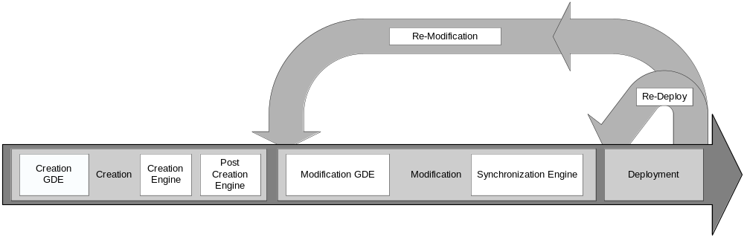 Figure 1. Overall service development process.

The Introduce toolkit is designed to support the three main steps of service development (Figure 1): 1) Creation of Basic Service Structure. The service developer describes at the highest level some basic attributes about the service such as service name and service namespace. Once the user has set these basic service configuration properties, Introduce will create the basic service implementation, to which the developer can add application-specific methods and security options through the service modification steps. 2) Service Modification. The modification step allows the developer to add, remove, and modify service methods, properties, resources, service contexts, and service/method level security. In this step, the developer creates strongly-typed service interfaces using well-defined, published schemas, which are registered in a publicly available grid service registry like the Mobius GME, as the type definitions of the input and output parameters of the service methods. 3) Deployment. The developer can deploy the service which has been created with Introduce to a Grid service container (e.g., a Globus or Tomcat service container).
A service developer can access the functions required to execute these three steps through the Graphical Development Environment (GDE) of Introduce. The runtime support behind the GDE functionality is provided by the Introduce engine, which consists of the Service Creator, Service Synchronizer, and Service Deployer components. The toolkit provides an extension framework that allows Introduce to be customized and extended for custom service types and discovery of custom data types. In the following sections, we describe the GDE, the Introduce engine, and the extension framework in greater detail.

External Middleware Systems and Tools
Introduce assumes the availability of two external components to implement its functions. 1) A Grid runtime environment that provides the support for compiling, advertising, and deploying Grid services; 2) A repository of data types that is accessible locally or remotely so that the toolkit can pull the common data types for strongly-typed services. The current implementation of Introduce leverages several open source middleware systems such as the Globus Toolkit (GT), Apache Axis, and the Mobius Global Model Exchange (GME) service. However, it is designed as a modular system, in which the specific implementations of external components can be replaced.
The GT and Apache Axis implement the core Grid/Web Service support. The Introduce toolkit uses the GT as the underlying Grid runtime environment. It generates the service layout, the service description (WSDL), and the service files such that they are compliant with the GT and Axis and can be readily deployed.
Introduce uses the Mobius GME service as a repository of XML schemas to support the development of strongly-typed services; it also has the ability for custom data type discovery plug-ins, detailed later. The GME[10] is one of the core services provided in the Mobius framework. It implements support for coordinated management of XML schemas in a distributed environment. In the GME, all schemas are registered under namespaces and can be versioned. The concept of versioning schemas is formalized in the GME; any change to a schema is reflected as either a new version of the schema or a totally new schema under a different name or namespace. In this way, data types can evolve while allowing clients and services to make use of old versions of the data type, if necessary. Namespaces enable distributed and hierarchical management of schemas; two groups can create and manage schemas under different namespaces without worrying about affecting each other’s services, clients, and programs. In the Grid environment, data elements and objects are exchanged as XML documents conforming to a schema. In such a setting, the schema describes the structure of a simple or complex data element (data object) that is consumed or produced by a service and is exchanged between two endpoints in the environment.

Introduce Graphical Development Environment
The Introduce Graphical Development Environment (GDE) is the graphical user interface that can be used to create, modify, and deploy a service (see Figure 2). It is designed to be very simple to use, enable using community excepted data types, and provide easy configuration of service metadata, operations, and security. It also allows customized plug-ins to be added for such things as repositories of data types and for creating custom or common service types.
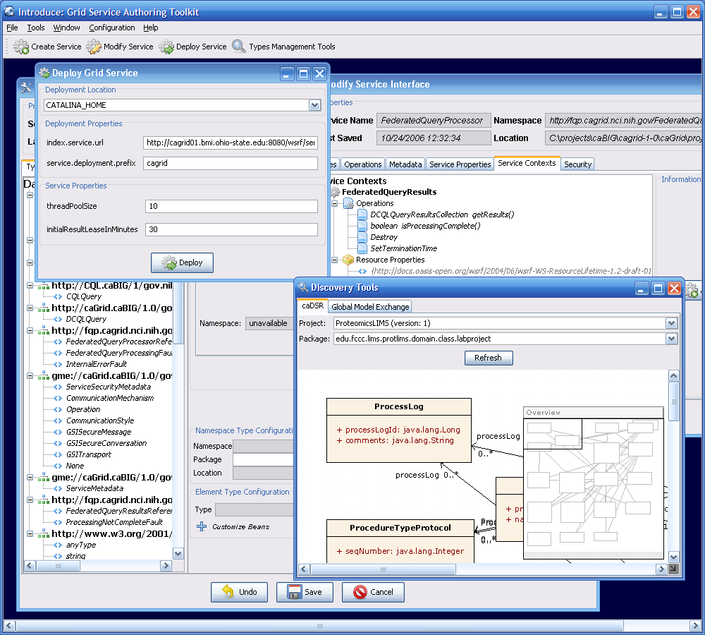
Figure 2. The Introduce Graphical Development Environment (GDE)

The interface contains several screens and options for the service developer to 1) create a new service, 2) modify an existing service, 3) discover and use published data types in order to create strongly-typed service methods, and 4) configure service metadata and deploy the service. Detailed documentation on the use of the graphical authoring tool can be found in the Introduce Users Guide.

Service Creation

General
The service creation component, shown in Figure 3, enables the developer to create a new grid service. Using the creation interface, the service developer can provide basic information about the service such as:
- Creation Directory
  - The creation directory is the location of which the grid service will be generated.
- Service Name
  - Service name is the name that will be used to generate the service. The service name must be a valid java identifier.
- Package Name
  - The package name is the base package to be used when generated the grid service source code.
- Namespace
  - The namespace is the namespace to be used when defining the WSDL of the service.

The developer also has the ability to add service extensions. A service extension is an Introduce plug-in (see Service Extensions), which is designed to add customizations to the service. For example, service extensions might add pre-defined operations, resources/resource properties, or security settings. They enable the development of custom service types with predefined methods, which must be implemented. They also enable Introduce to run the custom code implemented in the plug-in, which makes modifications to the underlying service being created. This capability allows the specialization of Introduce to support domain specific common scenarios, further abstracting the individual service developer from responsibilities related to the deployment of grid technologies in a production environment. Once the information has been entered and extensions, if any, have been selected, the user will select the create button. Once the creation button is selected the Introduce creation engine will begin generating the service. After the service is generated is will be compiled and the Modification component will be displayed.
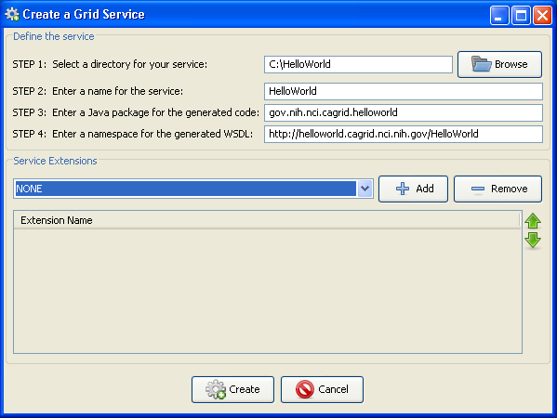
Figure 3. Introduce GDE Service Creation Component.

caBIG
Introduce, when delivered with caGrid, will have a button for creating a caGrid service. This will pop up a custom screen for creating either an analytical service or a data service. This screen is similar to the general creation screen except that in the caGrid create screen the user will not need to worry about choosing which Introduce extensions need to be added to the service as this will be done automatically. By using this creation screen to create a caGrid compatible service a series of extensions will be added to the service to support caGrid metadata, security, and data service components if necessary. The pop up will have the developer choose between analytical or data service. If a data service is chose then the developer will have to follow through a series of screens helping them to describe the data service they wish to create. More information about data services can be found in the users guide for caGrid Data Services.

Discovery Tools: Support for Strongly-Typed Service Methods

Using the GDE, developers can obtain the types that they want to use for the service parameters and return types from any data type discovery plug-in. Utilizing common and standard data types, which are defined outside of any application-specific service, enables the creation of strongly typed grid service interfaces. This increases service-to-service interoperability. Once a data type is chosen through the GDE, the data type is retrieved, written into the schema area of the service, and imported for use in the service WSDL description so that Java beans can be generated and the data types can be programmatically used.
The Introduce toolkit comes with a set of pre-installed discovery plug-ins, such as the Mobius GME and a basic file system browser which can be used to locate local schemas. The GME plug-in enables developers to browse, upload, and download schemas published in a GME. These schemas represent the valid data types which can be used during service creation. Using the GME plug-in, a developer can take a schema, create an editable view of the schema, and then submit the schema to the GME. If the namespace of the schema is not managed by the GME, to which the schema is submitted, the plug-in will attempt to add the namespace to the GME before submitting the schema. Once the schema has been uploaded, it can be used by anyone in the Grid through the Introduce toolkit. The GME plug-in browser window enables browsing through all the GME published types by namespace and schema name. It presents the user a quick view of the schema and the option to download the schema bundle. The schema bundle contains the schema and all other schemas which are referenced by that schema.
In caGrid Introduce installation a discovery plug-in for using caDSR will be provided. This plug-in will enable the use of types from the caDSR when describing and building grid services. For more information on how the caDSR and the GME work together to provide grid usable data types please refer to the caGrid Metadata Design document.

Service Modification

Service modification can be performed on any new or previously modified Introduce generated service. The service developer can perform a series of operations in order to begin to customize the grid service or modify the existing grid service. The overall flow in the modification of a grid service is to first use the namespaces tab to be sure that all the data types that are desired to be used I the grid service have been selected and added to the service. Next the service can choose to either add/remove or modify operations, metadata in the form of resource properties, service properties, security setting, and service contexts. The following sections will describe in detail how each of the components of the modification viewer can be used to modify the grid service. By selecting the “Modify Service” button on the main menu a prompt will be enabled to enable choosing the service to be modified. Once the desired directory containing the service to be modified is selected the modification viewer component will be launched. The modification viewer contains 6 main areas where modifications can occur on the service:

Types

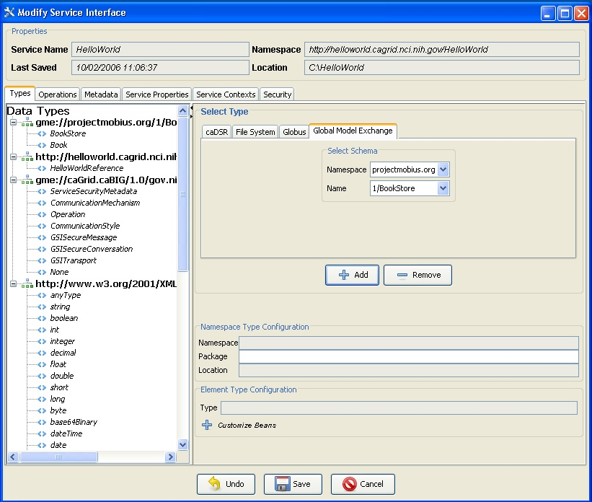

The first task in the modification of a grid service is to discover the data types that are desired to be used as the input and output types of methods of the service and the data types for describing the resource properties of the service. Adding a data types to the service is equivalent to copying schemas into the schema location of the service and importing the schemas into the WSDL file so that the types can be referenced by the service. This is done via the “Types” tab of the Graphical Service Modification Environment. This tab shows the current types the service is using, and provides access to the data type discovery components (such as the Mobius GME), for selecting and configuring additional types. The “Select Type” frame enables several types of ways to locate data types and bring them into the service. Currently there are three main discovery mechanisms (GME, Globus, and File System) that come with introduce, however, this is extensible via the Discovery Extension described in the Extensions section.
Once a set of data types from a namespace are brought into the service the user has the ability to describe how these data types will be mapped into there respective java classes. This can, by default, be done automatically by Introduce via Axis. By default, Axis will create new java beans for each data type and also provide a serializer and deserializer for those objects. If for example, a set of objects already exist for this particular data types then a user can decide to provide there own classes and serialization/deserialization factories.

Operations

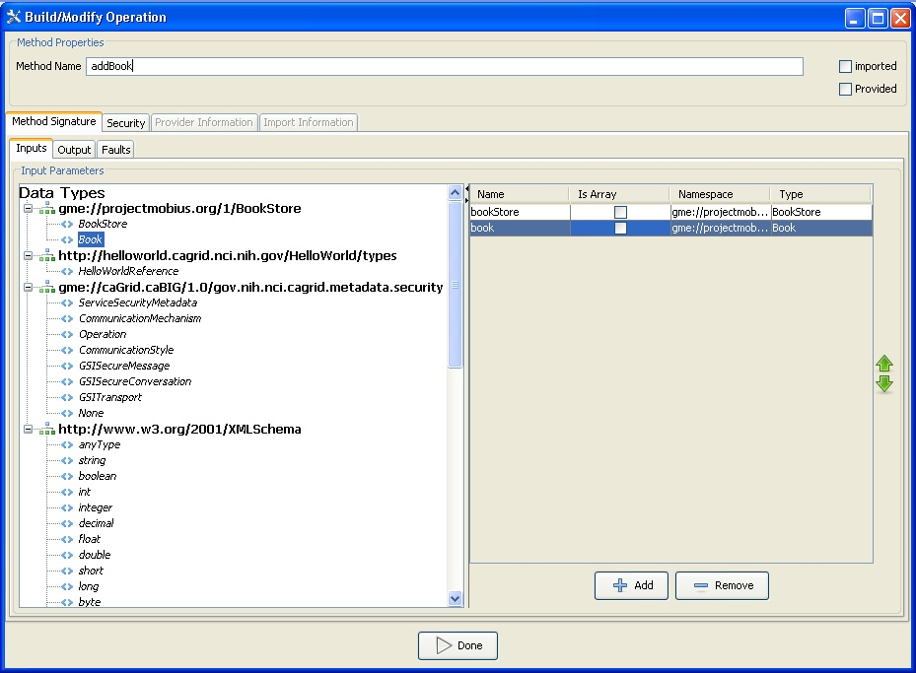

The developer can add, remove, or modify operations on the service, using the “Operations” tab of the GDE Service Modification interface. For each operation, the developer needs to set the input parameters, return type, and any fault types that can be thrown from each service method. The security configuration of the operation should also be set if desired. The input and output types can be selected from the types tree on the left. This tree represents the available data types which can be used by this service. If any input parameter or output type is to be an array the array checkbox must be checked in the table on the right. Also, once an input parameter is added the name of the parameter is defaulted. This name can be edited by the developer by selected the cell in the name column and editing the text. There are two ways to add faults, either choose a type from the types tree which extends WSRF BaseFaultType or create a new fault which will tell Introduce to create you a new fault type which extends the BaseFaultType.
The implementation of a described operation may already exist in another class which is provided by a jar file. You can tell Introduce not to stub this methods server side implementation but instead call this provided method implementation directly in the class provided. In order to use this functionality the “Provided” checkbox must be selected and the Class name attribute must be filled out in the “Provider” tab. The jar file that contains the provided Class which implements this operation must also me copied into the lib directory of the service. This will ensure that the operation will be located at the time the operation is called on the service.
Operations can also be imported from other services. Importing an operation enables the service to implement the exact same operation signature. This enables the service to have an operation which has the exact same WSDL signature of the operation which is being imported. This would enable either client to call this operation on either service. Importing can be done in two ways: (1) from an Introduce generated service, or (2) from a WSDL file. For case 1, importing from an Introduce service, the developer would browse and select the Introduce generated service which contains the operation to be imported. Once the Introduce service is selected a list of services which contain this method will be available to select from. Select the service from which you want to import the operation. The methods signature will be imported and the developer will be prompted to make sure to copy over the WSDL and XSD files needed to import the method into the schema<servicename> directory of the service. For case 2, if a method is described in another WSDL but the developer wants to implement this exact method from this WSDL. The developer must have the WSDL and corresponding XSD’s in the schema/<servicename> directory of the service. Then the developer will be able to browse those WSDL files and select the port type they wish to import the operation from. The importing of a method across services will assure not only that each service has completely protocol compatible methods but also that each service’s method can be invoked by the same base client. This enables the notion of basic inheritance in grid services and is discussed further in Operation Importing.

Resource Properties

Service state information and metadata in the form of resource properties can be added, removed and configured via the “Metadata” tab of the GDE Service Modification interface. The metadata elements which are added to the service can be populated by a file statically or managed dynamically within the service. Also, these metadata entities can be registered with an index service so that users can use the metadata to locate the service.

Service Properties

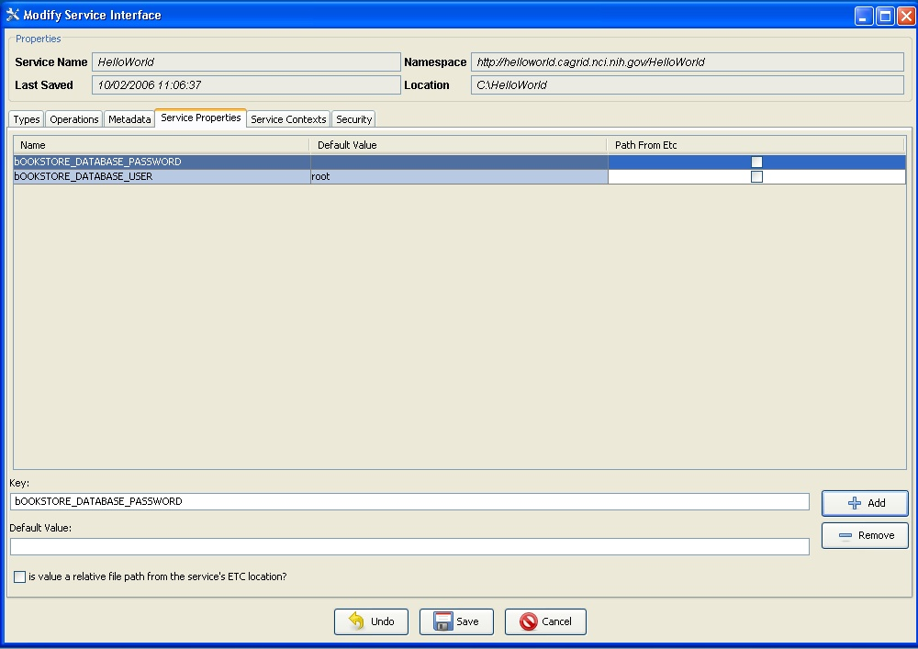
,
Service properties are key value pairs which can be set at deployment time and are available to the server side implementation of the service. This enables passing in configuration variables to the server side of the service at deployment. These key value pair properties can be declared in “Service Properties” tab of the GDE Service Modification interface, and a default value can be given there as well. The properties will be confirmed and/or can be changed at deployment time. The variables can then be accessed inside the user’s implementation of the operations.

Service Level Security

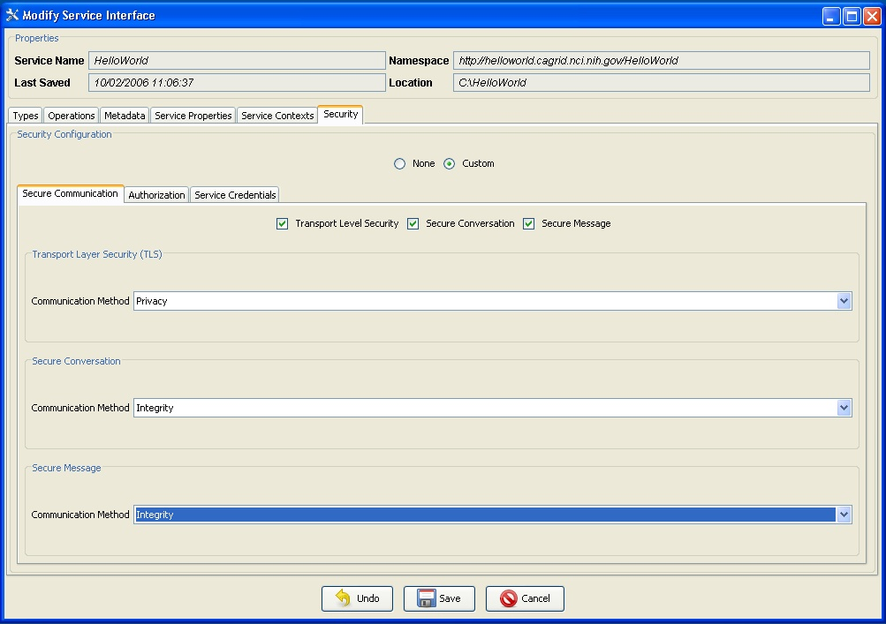

Service level security configuration can be set at this time as well via the “Security” tab of the GDE Service Modification interface. The service level security can be superseded by method level security. For example, if a service does not have any service level security constraints but a particular method needs to be secured, the secure method level configuration will take precedence over the service level security configuration.

Service Contexts

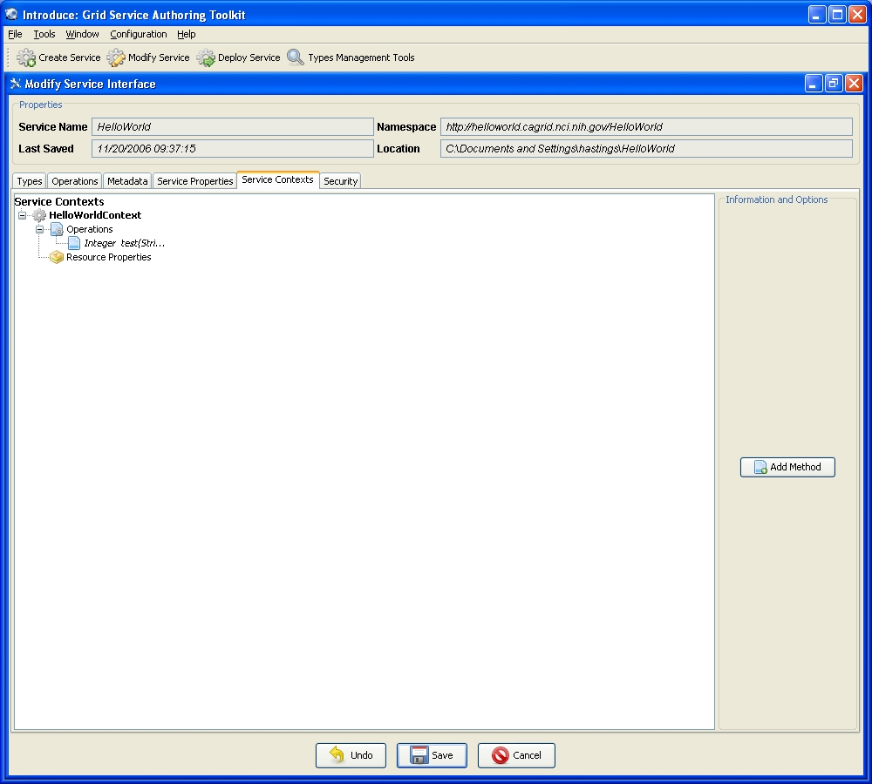

A power user feature which can be enabled at modification time is the addition or removal of service contexts. Contexts can be added via the “Service Contexts” tab of the GDE Service Modification interface Service contexts define additional conceptual contexts of operations needed to support the desired service functionality. This is enabled by using WSRF capabilities of the Globus Toolkit. As an example, if an operation on the main service enables the user to query a database, that operation might create a resource in another context and return the handle to that context to the user as opposed to the full query result set. This secondary context can then enable the user to iterate through the query results. This is accomplished by operations or resource properties to this secondary service context which will be responsible for iteratively giving results to the user. It should be noted that multiple instances of these contexts can be created and executed concurrently; one for each query that comes in, for example. This style of grid service is supported by the WSRF specifications. Though the details of the WSRF-implementation of these concepts are abstracted away from developers its worth noting how they are realized, and this is described in detail in other sections. Introduce makes it easier for service developers to create such complex services, via the GDE, without having to fully understand the underlying service implementations.

Deployment

The deployment option of the GDE (Figure 4) allows the service developer to deploy the implemented grid service, which has been created with Introduce, to a Grid service container. The toolkit currently supports deploying a service to either a Globus or Tomcat Grid service container; however, support for other deployment options can easily be added to the GDE. The deployment window allows the service deployer to populate service configuration properties, which the service will have access to at runtime. Then the service is deployed to the selected container.
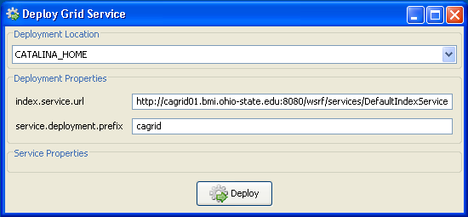
Figure 4. Introduce GDE service deployment component.

- Tutorial
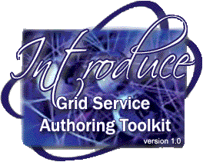

Overview
This section will give a tutorial outlining the steps to build an example book store grid service using the Introduce Grid Service Authoring Toolkit. Further steps will illustrate more advanced tools that configure metadata, set grid level and method level security and deployment options.
IMPORTANT: Add info here on how to download the tutorial and all the associated files!
The following is an outline of the tutorial:
- Create a Base Service
- Create or Locate Data Types
- Add Methods to the Service
- Implement the Methods
- Deploy the Service
- Implement a Simple Client
- Start the Globus Container and Run the Client
- Add Metadata
- Add Security Properties

Create a Base Service

The following will give detailed instructions on how to create a service, add data types, add a method and implement that method.

  - Launch the Introduce Grid Service Authoring Toolkit: invoke ant introduce from the top level of the introduce release.
  - Select Create Service from the toolbar or select Tools->Create Service from the toolbar. The Create Grid Service screen will appear. See Figure 1 below.
  - Choose a Creation directory to place the service. The tutorial will use “C:\BookStore”.
  - Type in the Service Name. Use “BookStore” for this tutorial.
  - Choose a Package. The tutorial will be using “osu.lib.bookstore”.
  - Choose a Namespace. The tutorial will be using “http://bookstore.osu.lib/BookStore”.
  - Click the Create button located at the bottom of the creation screen.
  - Be patient while Introduce creates the service. May take minutes.

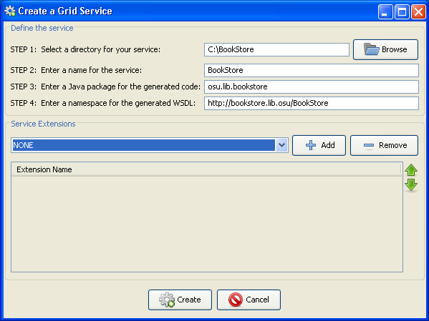
Figure 1. Create Grid Service
This section of the tutorial is complete.

Create or Locate Data Types

The following will give detailed instructions on how to create or locate data types that will be added to the existing base grid service. Complete the Create a Base Service step of the tutorial before proceeding.

From the modification viewer, there are three choices from where to obtain data types if the data types are not listed in the “Data Types” section. The three choices are to create a data type and upload it from the file system, downloading from the GME or importing from Globus. In this tutorial, the data types being used will be found in the GME. Before one can obtain a data type from the GME, the data type has to be uploaded by a user. The following steps will outline the process on how to upload a data type to the GME and obtain it for the current service being built with Introduce.

- Select the Types Management Tools from the menu or select Tools->Types Management Tools from the toolbar. This will launch the Discovery Tools window. Select the Global Model Exchange tab, and then select the Upload tab located within. Click on the Browse button and locate “1_BookStore.xsd” inside the installation directory of the tutorial. Click Open. Click Upload from the Discovery Tools window. A success message will appear and the upload is complete.

The schema will now be accessible from the GME. The following steps will outline how to contact the GME and import the data type into the current service.

- Select Modify Service from the toolbar or select Tools->Modify Service to launch the Select Directory screen. Note: The modification screen will automatically launch after the initial creation of a grid service. In that case, go to step 4.
- Select the root directory where the book store grid service is located. The directory for this tutorial is “C:\BookStore”. This will launch the modification viewer for the book store service. Refer to Figure 2 below.

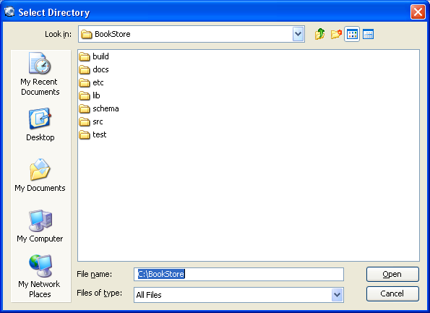
Figure 2. Select Directory

Now that the Modify Service Interface screen is visible, the next step is to import the 1_BookStore schema into the service.

- From the Modify Service Interface, verify the Types tab is active, and then browse to the Select Type section located on the right side of the window. Inside the Select Type window, select the Global Model Exchange tab. From the Namespace drop down menu, select “projectmobius.org” and from the Name drop down menu, select “1/BookStore”. Click the Add button below. Refer to Figure 3.
Note: The types BookStore and Book should be present in the Data Types section on the left hand side of the window.

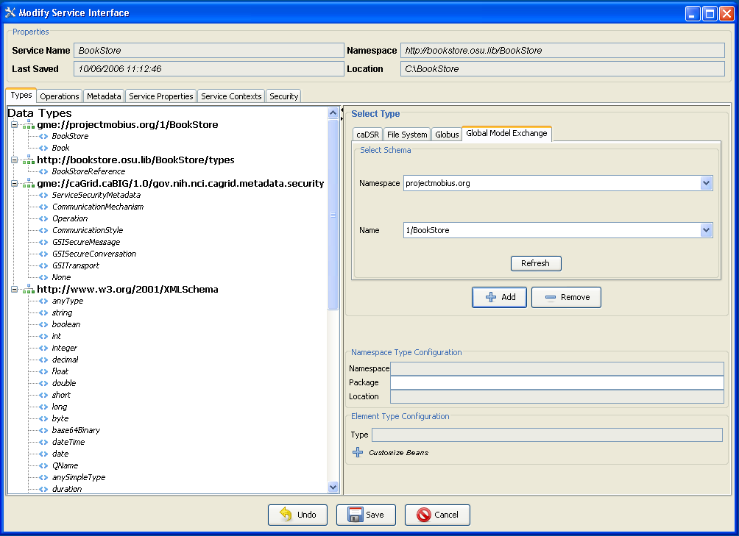
Figure 3. Modify Service Interface

- Click the Save button at the bottom of the Modify Service Interface window.

This section of the tutorial is complete.

Add Methods to the Service

This section of the tutorial will focus on adding two methods, addBook and getBook, to the service. This process includes opening the BookStore service to be modified, browsing to the Operations tab in the Modify Service Interface window, and then adding the methods. The methods to be added will have an input parameter, an output parameter and will throw exceptions. The following will give a detailed outline of how to add the addBook method to the service:

- Open the BookStore service to be modified. Note: Refer to steps 2 and 3 of the Create or Locate Data Types section of the tutorial for help with this.
- Click on the Operations tab in the Modify Service Interface window. Refer to Figure 4.

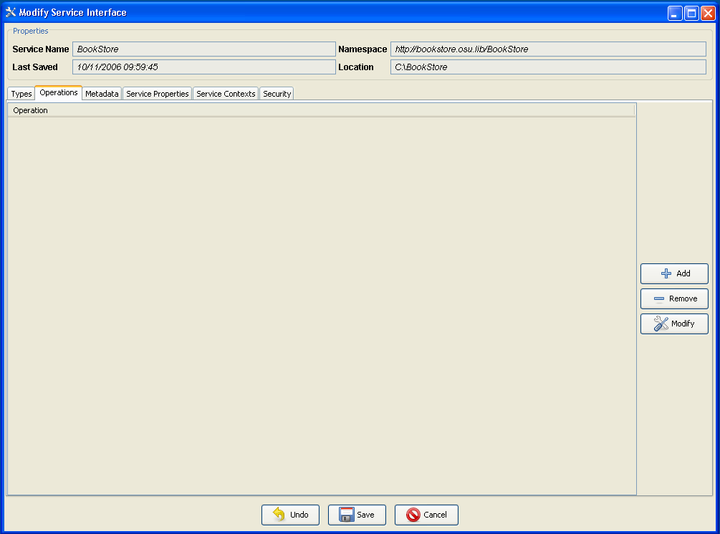
Figure 4. Operations Menu
- From the Operations menu, click Add on the right hand side of the window. Refer to Figure 4. The Build/Modify Operations window will appear.
- From the Build/Modify Operations window, type in “addBook” in place of “newMethod” in the Method Name field. Highlight the Inputs tab (if it is not already) and select Book from the Data Types tree. Click Add from the lower right hand portion of the window. Refer to Figure 5. Note: For the getBook method, the input will be of type string.
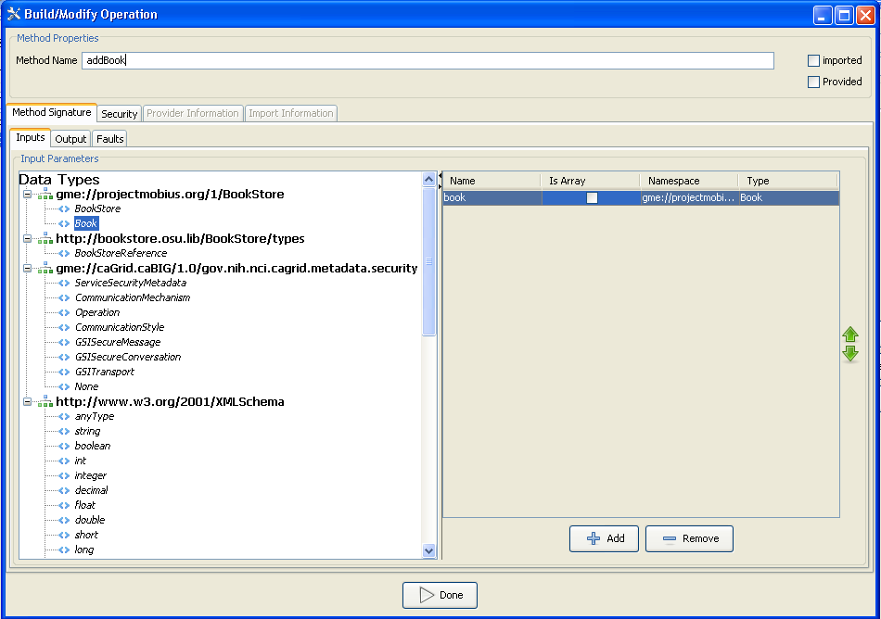
Figure 5. Add Input Parameter
- Next, select the Output tab in the Build/Modify Operation window. By default, the output type is void. For the addBook method there will be no need to specify an output different than void. Refer to Figure 6. Note: For the getBook method, the output type will be of type Book. Double click the data type to set the output type.
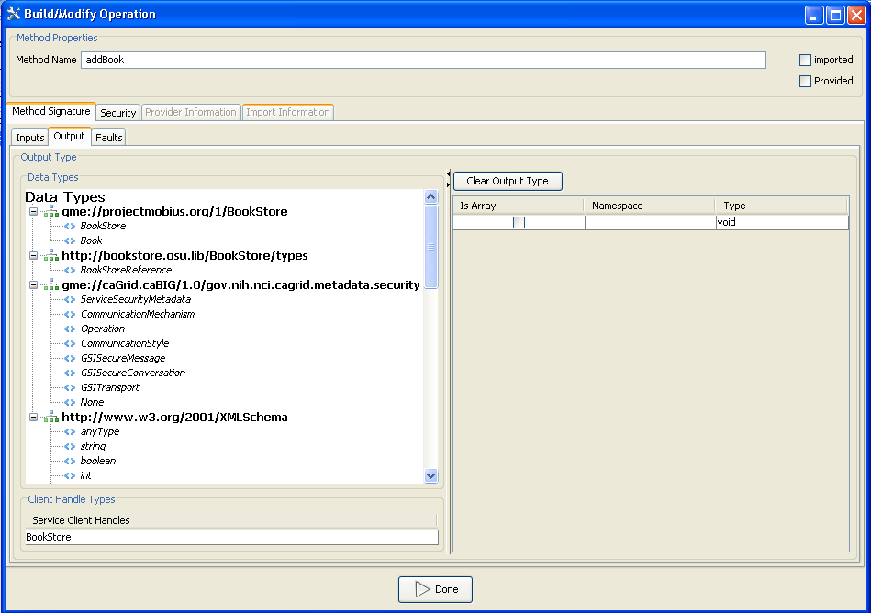
Figure 6. Add Output Parameter
- Finally, select the Faults tab from the Build/Modify Operations window.
- At the bottom of the Faults window, enter “BookAlreadyExists” in the Fault Type Name text box. Click Add New Fault. The fault will populate values for Namespace and Name in the Faults window. Refer to Figure 7.
- Click Done. The Modify Service Interface screen will appear.
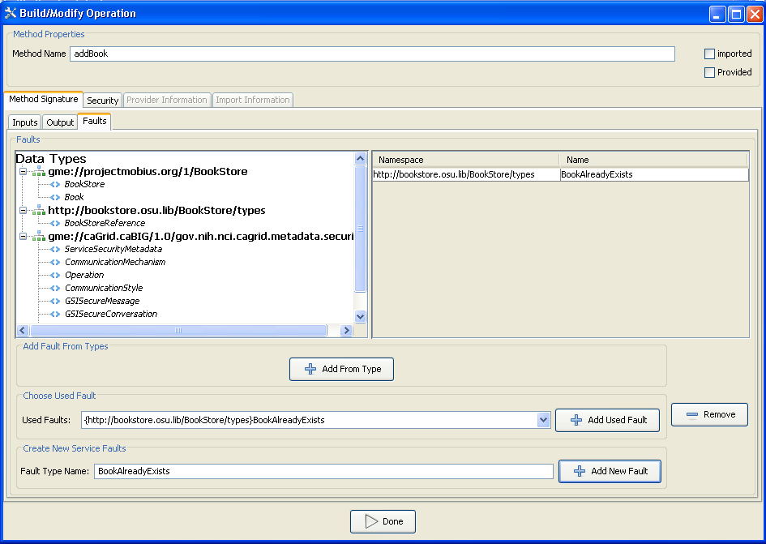
Figure 7. Add Fault

- On your own, add the method getBook with string as the input parameter, Book as the output parameter and “BookDoesNotExist” as the fault. Steps 1-8 should be sufficient to guide you through this.
- Refer to Figure 8 to verify the methods have been added properly.
- Click Save when finished.
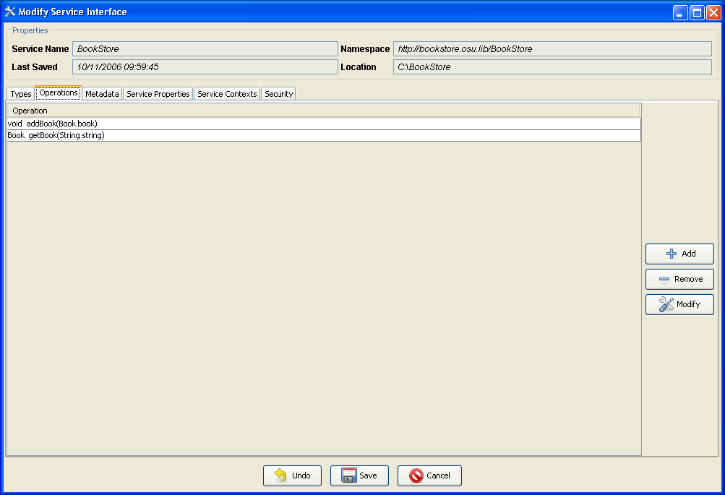
Figure 8. Added Methods

This section of the tutorial is complete.

Implement the Methods

The lone aspect of creating a grid service that Introduce does not automatically generate for the user is the actual implementation for the created methods. This section of the tutorial will provide trivial implementations to the methods created in the previous section. addBook is a method that takes in type Book and is of return type void. getBook is a method that takes in type String and returns type Book. The implementations here will have no functional purpose, but they will demonstrate the process.

- Begin by browsing to the location of the Bookstore service. The tutorial assumes Bookstore is at location “C:\BookStore”. Go to the following location inside the BookStore location: C:\BookStore\src\osu\lib\bookstore\service. This folder contains the file “BookStoreImpl.java” which was automatically generated by Introduce.
- The two methods, addBook and getBook, are located in this file and will need to be implemented. Open “BookStoreImpl.java” with a Java editor or text editor. Copy and paste the following code in for the implementation of the addBook operation:
if(book.getISBN().equals("1234")){
throw new osu.lib.bookstore.stubs.types.BookAlreadyExistsType();
}
else if(book.getISBN().equals(""))
{
throw new RemoteException("Invalid ISBN.");
}

- Copy and paste the following code in for getBook:
bookstore.Book book = null;
book.setAuthor("Shannon Hastings");
book.setDuey("1.1.1.1");
book.setISBN("1234");
book.setPDate("01-06-1999");
book.setPublisher("Generic Publisher");
book.setSection("1");
book.setTitle("Programming Grid Services for Dummies");

if(string.equals(book.getISBN())){
return book;
}
else
throw new osu.lib.bookstore.stubs.types.BookDoesNotExistType();

- Refer to Figure 9 below to validate the previous steps.

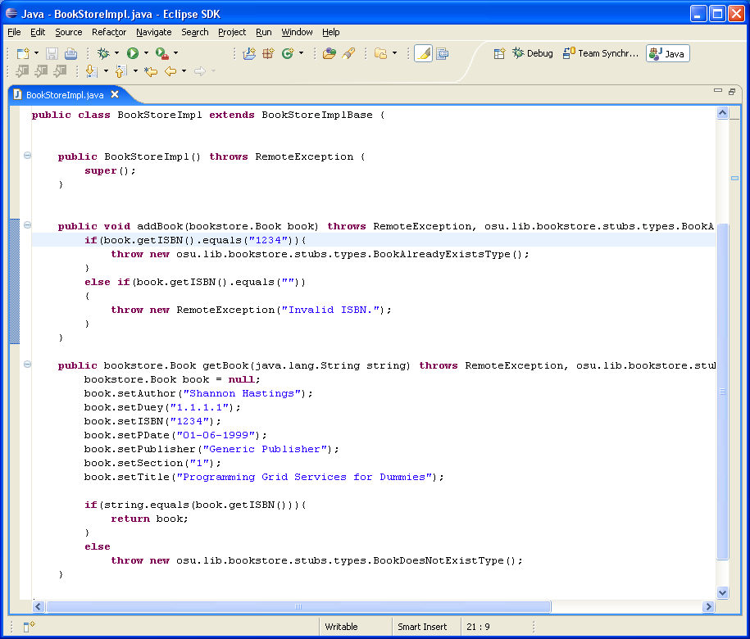
Figure 9. BookStoreImpl.java

- Save the changes.

This section of the tutorial is complete.

Deploy the Service

Deploying a service will create a Gar file and then extract it into a container. Introduce allows a service to be deployed to either Tomcat or Globus. The tutorial will focus on deploying to Globus. For more information, refer to the technical guide. Note!: Environmental variables need to be set for Globus (GLOBUS_LOCATION) and Tomcat(CATALINA_HOME) in order to use Introduce to deploy a service.

- Click Deploy Service or select Tools->Deploy Service from the menu from the main window of Introduce. The Select Directory screen will appear. Select the directory where the BookStore service resides (C:/BookStore for the tutorial). Refer to Figure 10.
Figure 10. Select Directory
- Click Open. The Deploy Grid Servce screen will appear.
- Select GLOBUS_LOCATION under the Deployment Location section.
- Type in “osu” for the service.deployment.prefix under Deployment Properties.
- Click Deploy.
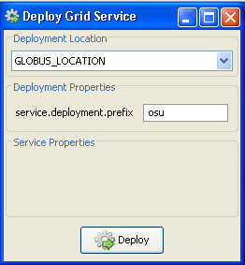
Figure 11. Deploy Grid Service

This section of the tutorial is complete.

Implement a Simple Client

In order to test the service created in this tutorial, a simple client can be created to make remote calls to the deployed service. Introduce creates a template that can easily be filled in to accomplish this task. The following steps will help fill in the template:

- From the BookStore directory (C:/BookStore for the tutorial), open this file with either a java editor or text editor:
C:\BookStore\src\osu\lib\bookstore\client\BookStoreClient.java
- Copy and paste the following code into the main method of the bookstore client as shown in Figure 12:

//Setup the call to addBook
bookstore.Book book = null;
book.setAuthor("Shannon Hastings");
book.setDuey("1.1.1.1");
book.setISBN("1234");
book.setPDate("01-06-1999");
book.setPublisher("Generic Publisher");
book.setSection("1");
book.setTitle("Programming Grid Services for Dummies");
try{
client.addBook(book);
} catch(osu.lib.bookstore.stubs.types.BookAlreadyExistsType b) {
System.out.println("The Book Store already has that book.");
} catch (Exception e){
System.out.println("An unexpected error has occurred in the call for addBook.");
}

//setup the call to getBook
book = null;
String isbn = ("1234");
try{
book = client.getBook(isbn);
} catch (osu.lib.bookstore.stubs.types.BookDoesNotExistType f) {
System.out.println("The book requested does not exist.");
} catch (Exception g) {
System.out.println("An unexpected error has occurred in the call for getBook.");
}
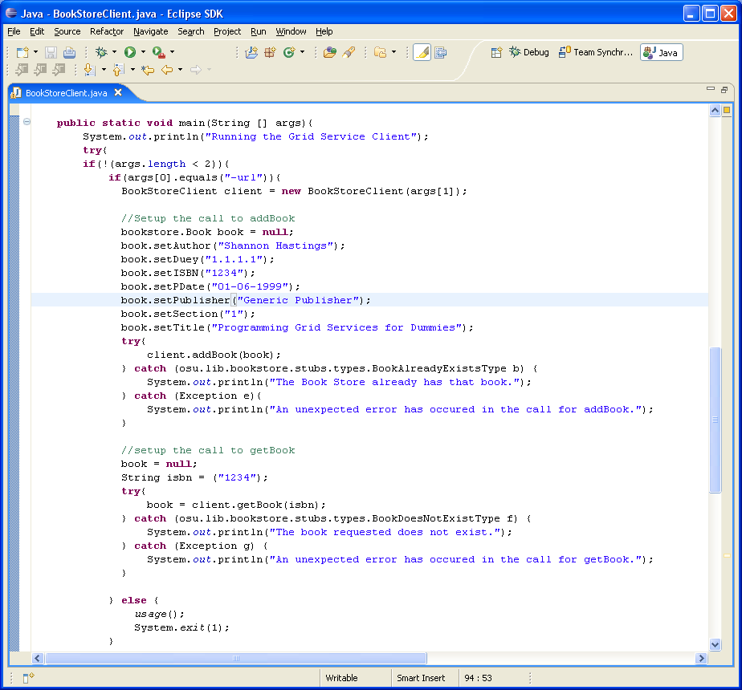
Figure 12. BookStoreClient.java

- Save changes.
- Run ‘ant all’ from the location of the BookStore service. This will rebuild your code. The location for the tutorial is C:\BookStore.

This section of the tutorial is complete.

Start the Globus Container and Run the Client

The tutorial has progressed to a point where something can be run and tested for correctness. As a summary, the tutorial has guided the way through creating a service with two implemented methods, deploying that service to Globus and implementing a client to make remote calls into the BookStore service. Before the client can be run, the Globus container needs to be started up to expose its deployed services. From the Globus location’s bin directory type ‘globus-start-container.bat –nosec’. The container will come up and the BookStore service is ready to receive remote calls from the client. The client can be ran by executing “ant runClient” from the top level of the Introduce created service directory.

- References

Related Technical Manuals/Papers/Articles
Glossary
Term | Definition
WSRF | Web Services Resource Framework
WSDL | Web Services Description Language
GT3 | Globus Toolkit version 3.X
GT4 | Globus Toolkit version 4.X
WSDD | Web Service Deployment Descriptor
XML | Extensible Markup Language
UML | Unified Modeling Language
MDA | Model Driven Architecture
SOA | Service Oriented Architecture

The Ohio State University Department of Bioinformatics

