caGrid Installer and Deployer
Design Document

Version No: 0.1
Last Modified: 06/15/2006

Author : Vinay Kumar
Team : caGrid

Client : National Cancer Institute - Center for Bioinformatics,
National Institutes of Health,
US Department of Health and Human Services

Document History

Document Location
The most current version of this document is located in CVS under security/docs.

Revision History
Version Number | Revision Date | Author | Summary of Changes
0.1 | 06/15/06 | Vinay Kumar | Initial draft

Review
Name | Team/Role | Version | Date Reviewed | Reviewer Comments

Related Documents
More information can be found in the following related CSM documents:
Document Name

Table of Contents
1. Introduction 4
1.1 Purpose 4
1.2 Scope 4
2. Use case Scenarios 4
3. Web Based System Check 5
4. Local Installer 5
5. Logical design 6
6. Technology 6
7. Deployment 6
8. Test Cases and Scenarios 7

Identity provider Design

Introduction
The cancer Biomedical Informatics Grid or caBIG™, is a informatics infrastructure based on grid architecture. The architectural and software realization of caBIG has been done through caGrid project. caGrid infrastructure makes it easy for developers to develop data and analytical services. Using caGrid infrastructure, organizations will be able to share their data and services on the grid.
caGrid infrastructure is a complex infrastructure which needs various sub systems and configurations for successful installation and deployment. A developer or an administration will find it highly cumbersome and error prone to go through the manual steps for installing and deploying caGrid system and sub system. To ensure a smooth installation, it is recommended a caGrid installation and deployment tool is build for easy installation and deployment of caGrid and its sub system.

Purpose
The purpose of this document is to illustrate the design of the caGrid Installer used at the time of installation of the software.

Scope
This document provides the step by step wizard required in order for a successful installation and deployment of caGrid components.

Use case Scenarios
The following diagram shows the use cases and actors. 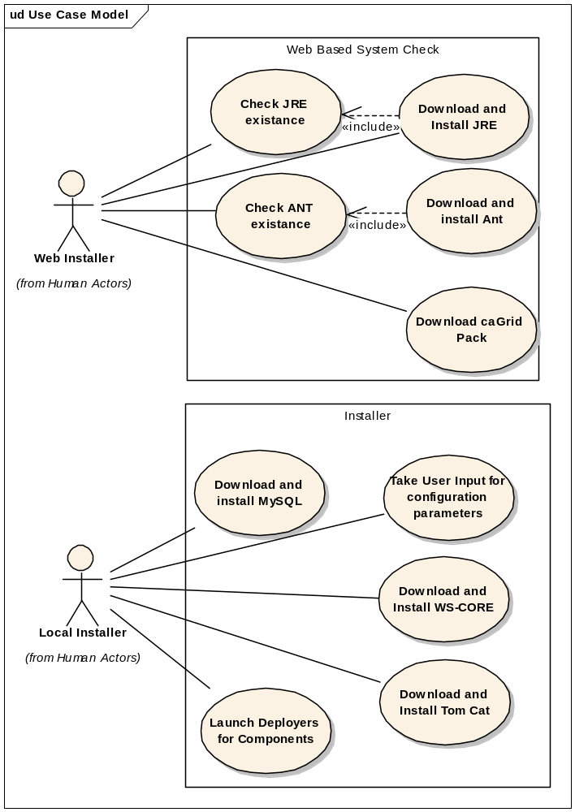

Web Based System Check
There might be a possibility that the systems on which caGrid will be deployed may not have required components such as JRE and ANT. The web based installer will bootstrap the target system with all minimum required components for successful installation and deployment of caGrid system and services.
The web based system check will be performed using a Swing application which will run on JNLP protocol. This application will have a assigned JAR which the target systems have to trust in order to run and give permission to give access on the local file system.

Local Installer
The local Installer will download and install various required and optional software packages depending upon user selection. User has to provide the required configuration parameter input to install these components at required location. There may be instances where for a successful installation and deployment of a service various optional software packages may be required; in that case required packages will be automatically be installed for the successful deployment of the services.

Logical design
The following diagram shows the logical diagram that displays the relationship between different components.

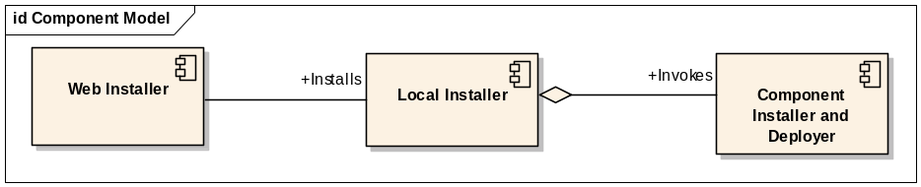

Web Installer will not only bootstrap the target machine but will also download and install the local installer. Whereas, local installer will depend on various component installer and deployer. The local installer will invoke various deployers for the component.

Technology

There are various open source XML based installers available but none of them is mature enough to address the requirement for caGrid installation and deployment process. Two of the following open source frameworks have been considered and used to develop a prototype.
- IZPack
- ANT installer
As mentioned above none of them is mature enough and does not have lot of flexibility. The framework has to be extended in order to address caGrid requirements. The solution will involve using and extending ANT installer and a custom Swing application. The web installer will be developed as Swing application which will be hosted on JNLP protocol whereas various component installer and deployers will be developed using extended ANT installer. The local installer will act as container for all component installers.

Deployment
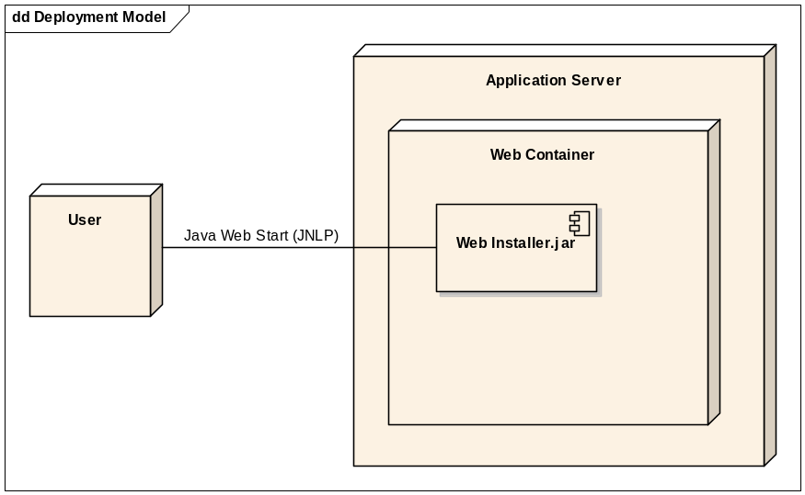

Test Cases and Scenarios
Please refer to << document location for test cases>>

