caGrid Monitoring and Discovery Portal

Design and Architecture

caBIG™ is an initiative of the National Cancer Institute, NIH, DHHS

Development Team
Development | Programmer’s guide |  | Program Management
Names of developers | Names of technical writers and reviewers |  | Names of program managers
Paul A. Kennedy | Paul A. Kennedy |  | Chad LaJoie
Manav Kher | Manav Kher |  | Arumani Manisundaram
¹ Footnote contributing companies/ contractors/ divisions |  | ³ company
² department or division

Contacts and Support
Enter training contact | Manav Kher (kherm@mail.nih.gov)
Enter customer support contact | http://ncicb.nci.nih.gov/NCICB/support  Email: support@nci.nih.gov

LISTSERV Facilities Pertinent to software teams
LISTSERV | URL | Name
caGrid Developers | https://list.nih.gov/archives/cagrid_users-l.html | caGrid Developers List
caGrid-Users | https://list.nih.gov/archives/cagrid_users-l.html | caGrid Users List

Table of Contents

Chapter 1 Introduction 5
Chapter 2 Overview 6
System Requirements 6
Design and Architecture 7
Chapter 4 Portal Requirements 10
Chapter 3 Portal Design and Architecture 14
Design 14
Architecture 14
Aggregators 17
Portal User Interface 19
Chapter 4 Portal Prototype 20
1. References 24
caGrid References 24
Technical Manuals/Articles 24
caBIG Material 24
caCORE Material 24
2. Glossary 25

Introduction
The caGrid Monitoring and Discovery Portal provides an overview of the status of services on the grid. It achieves this through several displays. A geographical view shows the location of services and an indication of the service availability.
Several displays of information are available allow for services to be grouped by either service type (e.g. Data or Analytical), or by service location (e.g. Lombardi Cancer Center). A listing of services by specified search criteria is also possible.
The portal is compatible with caBIG Gold level services. The portal requires information from at least one caGrid 1.0 Index Service to provide information on services publishing caGrid 1.0 common metadata.
The portal provides a near-time view of the grid using cached data for functional and performance concerns. The portal is able to provide this data through the use of several data aggregators that gather data from key grid components.

Overview
The portal is composed of a front end user interface and the backend that feeds it data. The portal's components will be fed data from backend objects and can rely on the existence of certain resources, like the caGrid Index Service or a persistence mechanism, in their functioning. The Monitoring and Discovery Portal will provide an overview of the status all services (Data, Analytical and Infrastructure) based on aggregated information.

System Requirements

Portal is a web based application so it needs to be deployed in an application server. Following are the external software components that Portal depends upon. These will not be packaged with the Portal distribution.

Component | Version
Sun Java JRE | Version 1.4+
MySQL Database | Version 4.0 +
Jakarta ANT | Version 1.6.x +
Tomcat Application Server | Version 4.0 +
Globus Toolkit | Version 4.0.x

Design and Architecture

The Spring Inversion of Control (IOC) container will handle the connections between the portal presentation layer and the interface to the business layer through dependency injection. Presentation layer object will be provided references to the command object which form the interface between the presentation layer and the business logic layer.

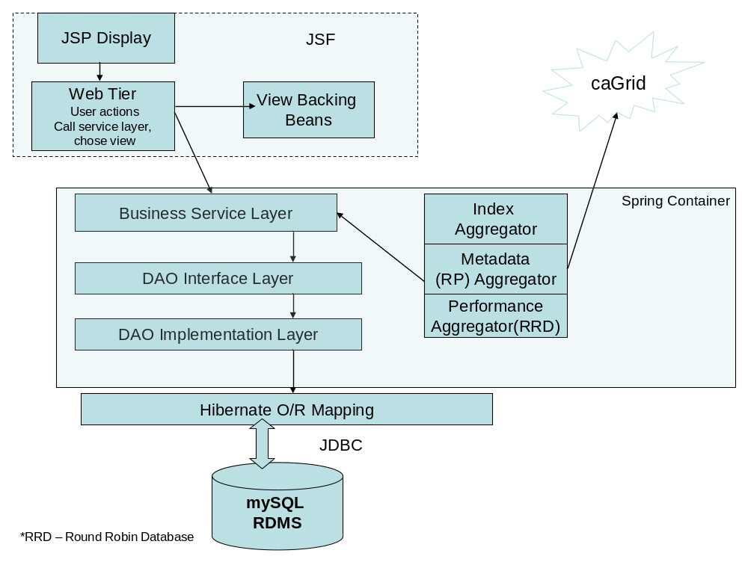
Figure 1: Portal Layered Architecture Diagram

Spring will handle dependency injection in the business layer, by providing all business layer objects with references to data layer objects.
At the data layer, Spring will also be used to configure Hibernate's session factory as well as locate and load all necessary ORM XML files. The database connection will be abstracted through the standard Data Access Object (DAO) pattern. These pieces comprise the persistence layer for the portal.

Java Server Faces (JSF) will be used to build the User Interface for the Monitoring and Discovery Portal. JSF is based on an Java Community standard JSR 168. JSF provides for quick development of web applications by assembling reusable UI components and enables separation between application logic and presentation while making it easy to connect the presentation layer to the application code.

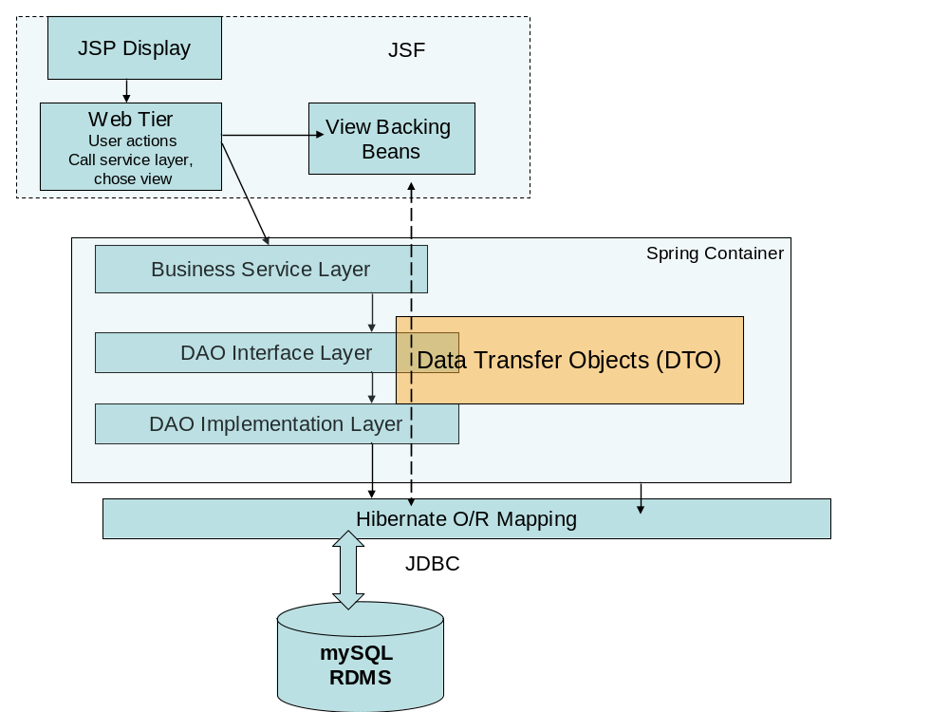
Figure 2: Spring and JSF integration

The datasource for the Portal is continually updated by running automated pre-configured tasks called the Aggregators.

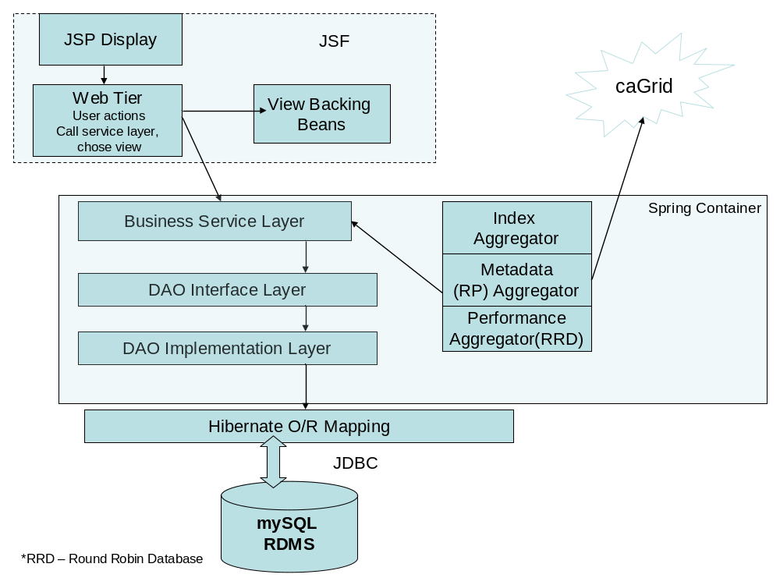
Figure 3: Portal Aggregatosr

Portal Requirements
The caGrid Monitoring and Discovery Portal must meet the following functional requirements:
- Main display response times should be consistent with standard web page interactions, generally between 1.0-1.5 seconds.
- Search page response times should be on par with other search pages and are expected to be slower than displaying static content, but generally between 1.0-1.5 seconds.
- Portal will be able to take information from one or more caGrid 1.0 index services.
- Main display requirements:
  - Portal needs to display grid centers on a geographic map. Points on the map are referred to as "nodes" in this document. Locations that house a service or multiple services are referred to as "centers".
  - Portal needs to be accessible to all users and enable reasonable navigation by adhering to Section 508c of the Rehabilitation Act of 1978.
  - Portal should display well at resolutions of 800x600px or greater.
  - Portal will expose the Grid center URL as defined in the common service metadata.
  - Portal will display center RSS URL in the center display (as defined in the common service metadata).
  - Portal will have top level navigation in the header for each page.
- Visualization:
  - A node on the map should be annotated to indicate the "liveness" of the center. The time quantum need not be smaller than an hour. The granularity of this measure of liveness is:
    - Known: Center is known to portal but there is no other information feeding the portal to indicate that the center is alive or was recently alive.
Red could be a reasonable graphical representation.
    - Intermittent: Center is known to the portal and there is other information feeding the portal to indicate availability of service or services. Portal local state information indicates service availability to be less than 80 per cent for any service within a time period set in the portal configuration.
Orange could be a reasonable graphical representation.
    - Reduced: Center is known to the portal and there is other information feeding the portal to indicate availability of service. Portal local state information indicates service availability in excess of 80 per cent for all services within a time period set in the portal configuration.
Amber could be a reasonable graphical representation.
    - InService: Center is known to the portal and there is other information feeding the portal to indicate availability of service. Portal local state information indicates service availability in excess of 95 per cent for all services within a time period set in the portal configuration for all services.
Green could be a reasonable graphical representation.
    - Colours used in any graphical representation of the nodes need to be distinct for all sighted users (taking into account users with partial sight and colour deficiencies).
- Visualization interaction:
  - Node selection:
    - When a user selects a node from the map, the portal will display a synopsis of the data for the Center drawing on the common service metadata which includes:
Name
Address
Contact information
Description
    - The portal should also display a summary of service availability or availabilities within a time period set in the portal configuration.
  - Node information "drill down":
    - There should be a way to invoke a detailed display. When invoked, the geographical map and information display are replaced with an enumeration of services running at the center with accompanying service availability over a configurable time period.
    - Center level RSS is displayed.
    - The following center data from the common service metadata is displayed:
Name
Homepage URL
RSS News
Address
Contact information
Photo/image
Point of contact
Description
  - Center service "drill down":
    - Selecting a service from the center display will display a service availability graph for the selected service over a configurable time period.
    - The portal will display data drawn from the common service metadata including:
Service name
Contact information
RSS News URL
    - Portal will display service functions with return types.
    - When documentation is provided for operations defined in a service WSDL, it will be displayed in the function enumeration.
- caGrid 1.0 Common Service Metadata:
  - The portal will depend upon elements of the common service metadata for caGrid 1.0 as well as information accessible from the caGrid 1.0 index service. The portal will use:
    - Research Center metadata:
Name
Short name - shortened title for display on a map
Homepage URL
RSS News URL - allows for promulgation of Center wide news and announcements.
Address - a complex element type consisting of all the elements necessary to make an international address (street 1, street 2, locality, state/province, postal code, country)
Contact information
Photo/image URL
Point of contact
Description
    - Service metadata:
Name
Contact information
RSS News URL - allows promulgation of service specific news (upgrades, scheduled downtimes, etc.)
    - The portal will also require information about the freshness of data from the index server (time of update, and time to live).
- Search option:
  - A "basic" search box will appear on the main page. This search box will search a subset of the fields of the caGrid 1.0 common service metadata.
    - Alphabetic search strings will constrain the search to these fields:
Research center name
Research center short name
Research center point of contact
Research center description
Service name
Service operations as defined in its WSDL
Service technical point of contact
Service functional point of contact
    - Numeric search strings will constrain the search to these fields:
Research contact numbers
  - An "advanced" search panel can be activated to allow searches constrained to specific caGrid 1.0 common service metadata fields.

The caGrid Monitoring and Discovery portal also has these non-functional requirements:
- Must run on JDK 1.4 and 1.5.
- Must run on Servlet containers supporting Servlet 2.3 and JSP 1.2 and better
- Must work with databases that support JDBC 3.0
- Portal relies on being able to interact with at least one caGrid 1.0 index service.

Portal Design and Architecture

Design
Sources of information about services running on the grid are available from both the services as well as the Index Service. This data is dynamic in nature and without history. To address the lack of history, the portal has an aggregator framework which is composed of scheduled beans that gather information. These beans interact with a persistence layer through a standard DAO pattern using Hibernate on top of a MySQL database.
Tracking of center status and average availability display is done through the use of a data collection and aggregation library named JRobin that implements a Round Robin Database (RRD). Using JRobin and RRD allow:
- automatic conversion of data collected at irregular intervals to interpolated (and thusly regularly spaced)“primary data points”
- automatic averaging of older data for keeping longer term, but coarse grained data
- aggregation of a large amount of data over a defined time interval in small static space.
To aid in configuration of software components as well as message passing between elements, the portal will run within a Spring container. Spring is an Inversion of Control (IOC) container that provides dependency injection configured through run-time configuration files, a messaging facility, as well as a framework for schedulng beans (Timer Task). We will leverage the facilities of the Spring container to configure the portal objects at startup and deliver notifications between the persistence layer to the upper layers of the application to facilitate efficient updates.
Throughout the design, we have attempted to use weakly coupled components for the greatest flexibility and agility
In the final design, management chose JSF for the presentation layer.

Architecture

The Portal uses the following set of Domain Objects to encapsulate and display information

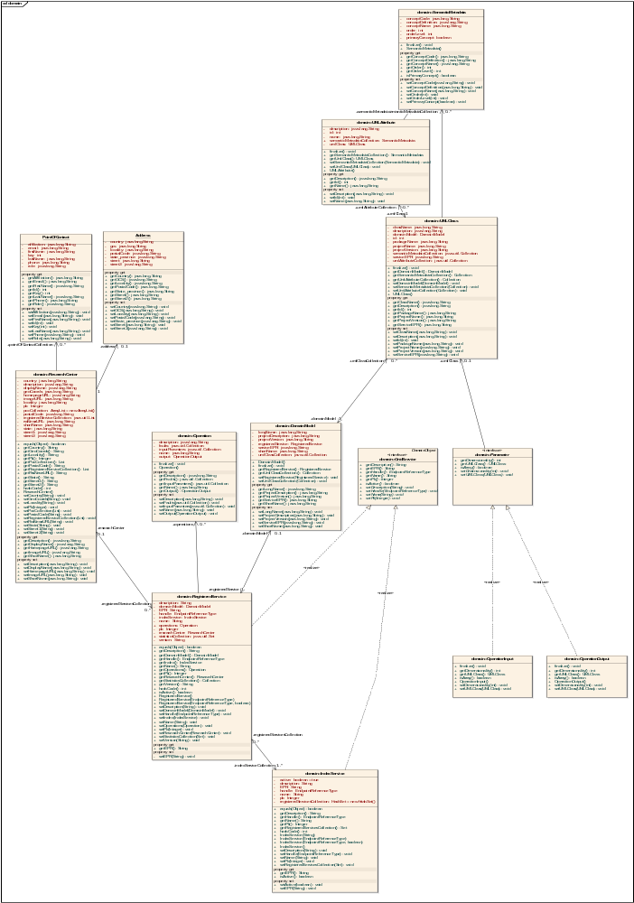
Figure 4: Portal Domain Model

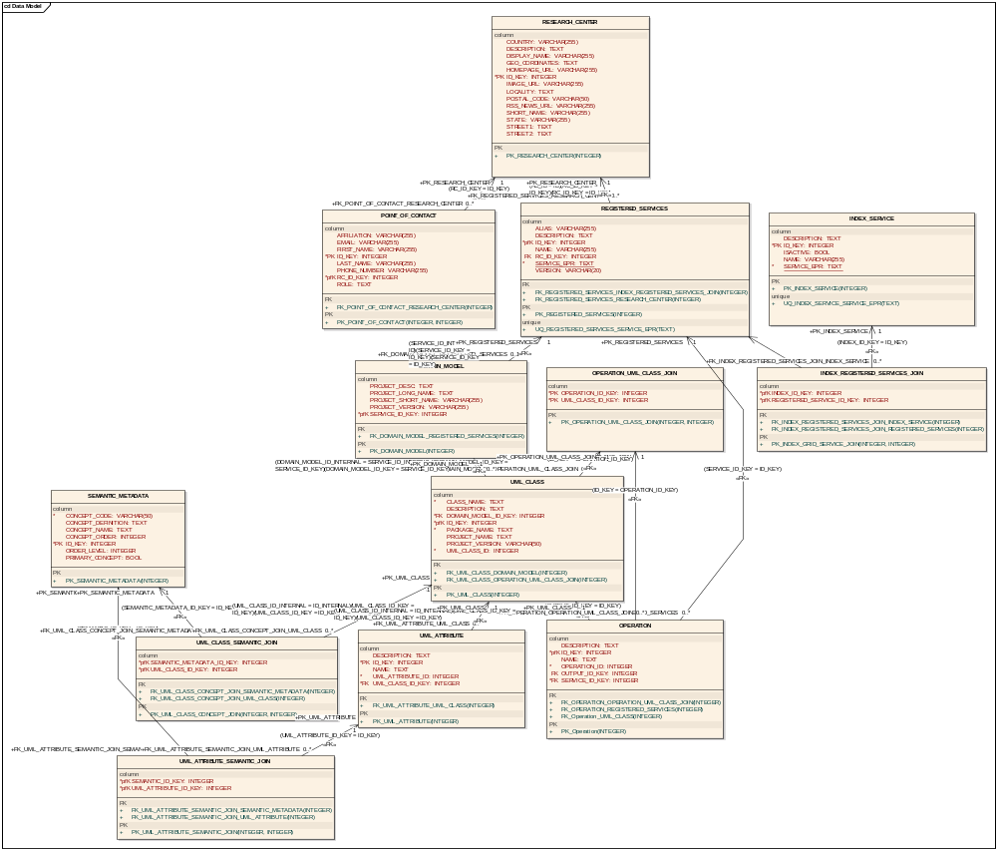
Figure 5: Portal Data Model

Aggregators
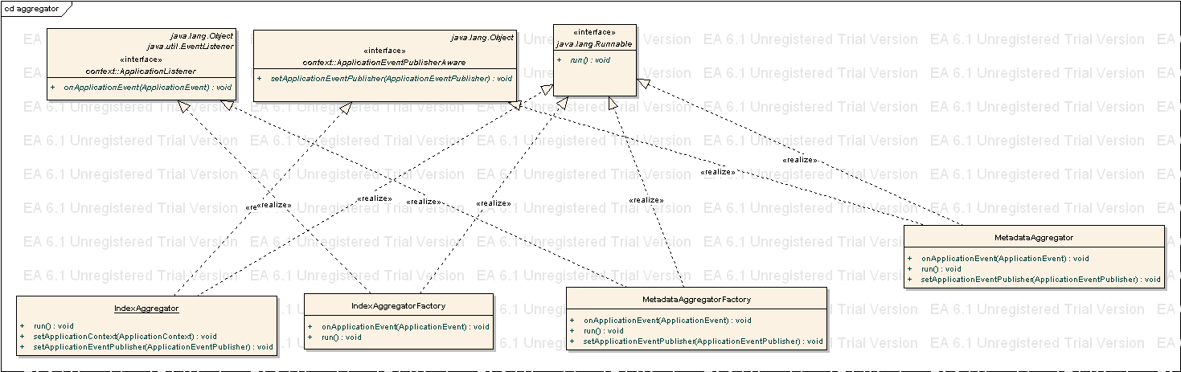
The aggregator framework at the highest level consists of factories listening for events from the persistence layer so to be able to spawn more aggregators.
Figure 7: Aggregator Framework

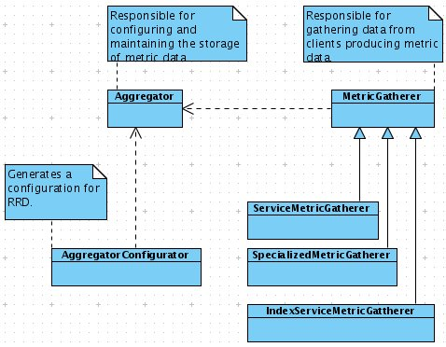
The aggregator framework is further decoupled through the use a a generic MetricGatherer set of classes which the aggregators use as data sources. The aggregators themselves have a configuration object that allows the intelligent configuration of the aggregator at runtime in a decoupled way.

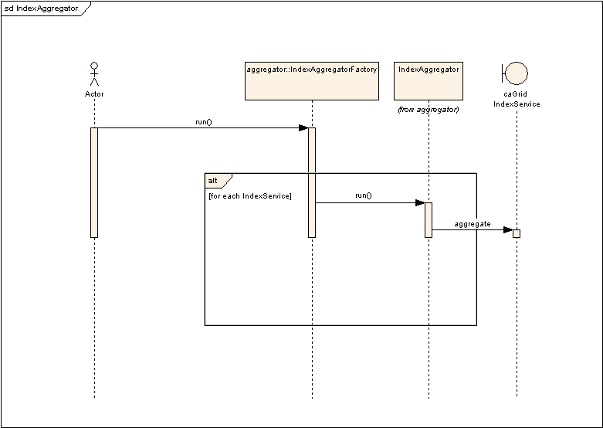
Figure 8: Aggregator Framework interaction diagram (1)

Aggregators will be configured as Java Timer Task beans. This enables us to schedule the aggregation tasks as pre-configured tasks, which can be independently scheduled. The Aggregators will also be configured to be event driven, i.e. one type of aggregator can request another aggregator be started, by publishing an appropriate Event.
The following Aggregators will be developed
- Index Aggregator – A separate Index Aggregator will be started for each caGrid Index Service, which the Portal is configured to aggregate information from. As soon as a new service is found, the Index Aggregator will publish a “New Service Found” Event.
- Metadata Aggregator – Will listen for a “New Service Found” event and start a Metadata Aggregator Thread, which aggregates metadata for the caGrid service (retrieved from the “New Service Found” event).
- Performance Aggregator – Will start a Performance Aggregator Thread for each service in the Portal Database. Performance aggregator will look for some performance specific information for a service (response time etc).

Portal User Interface

This page flow diagram shows the possible traversals of the caGrid Monitoring and Discovery portal.
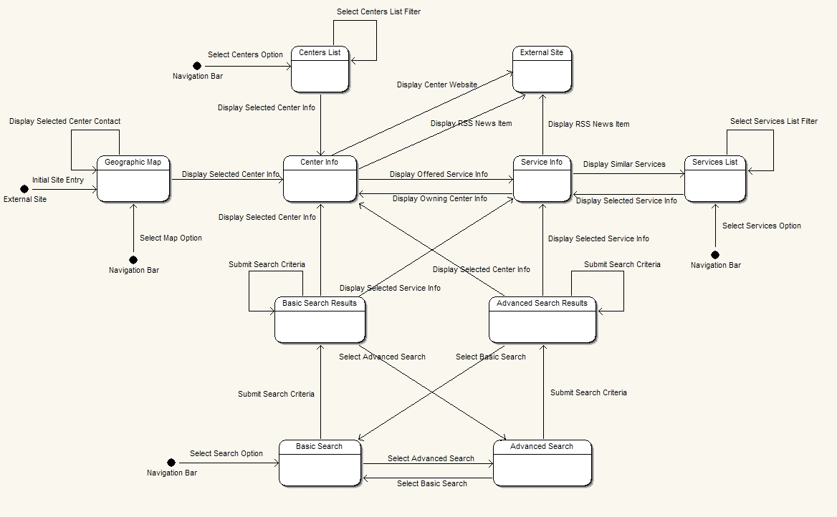
Illustration 1: Page Flow for caGrid Administrative and Monitoring Portal
Figure 6: Portal Page Flow Diagram

This shows the externally visible operation of the portal showing the transitions between pages.

Portal will use the NCICB standard look and feel UI Library for its user interface

Portal Prototype
Following are screenshots from the portal prototype that was created to drive the design of the Portal.

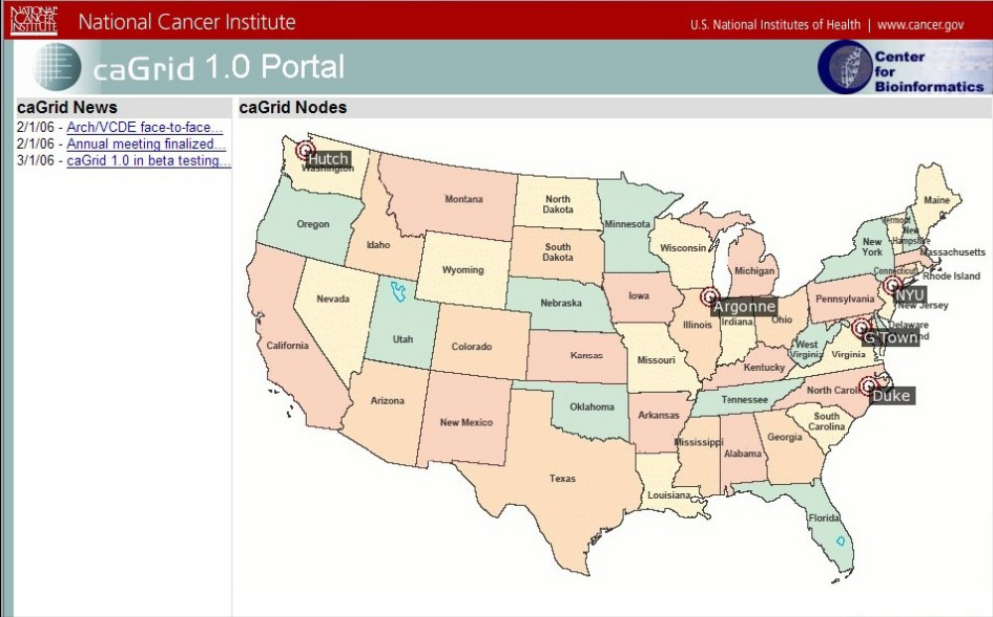
Figure 9: caGrid services Map view
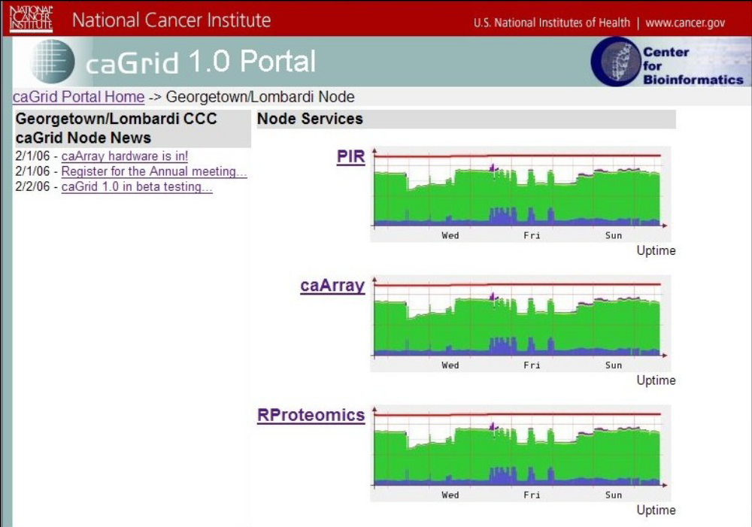
Figure 10: Service Performance information

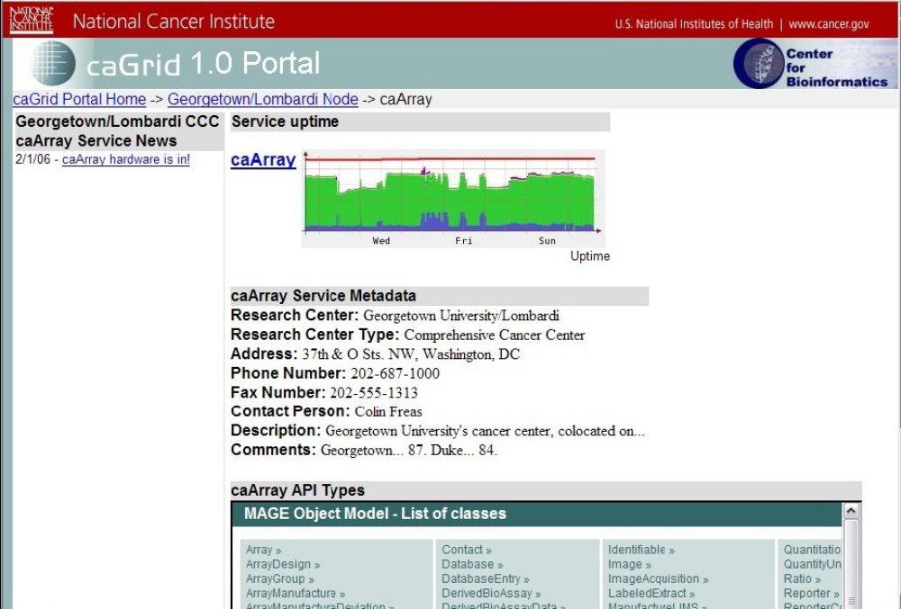
Figure 11: Service Metadata display
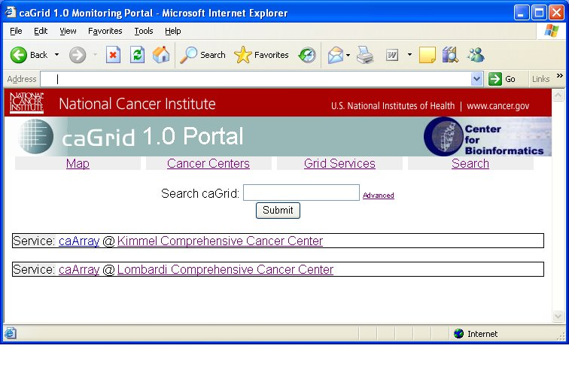
Figure 12: Basic Service Discovery

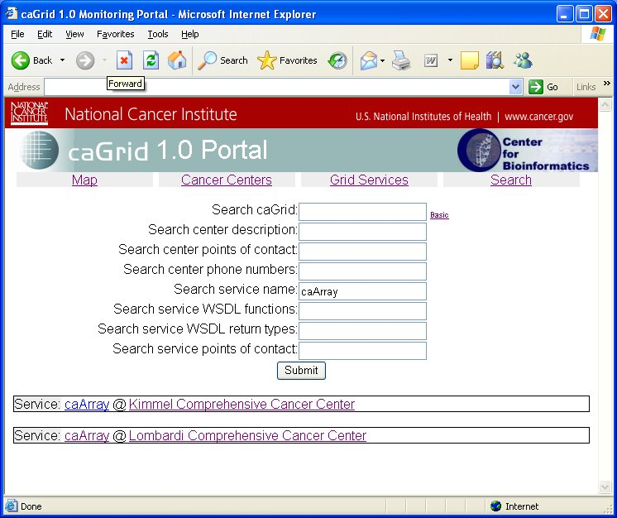
Figure 13: Advanced Service Discovery
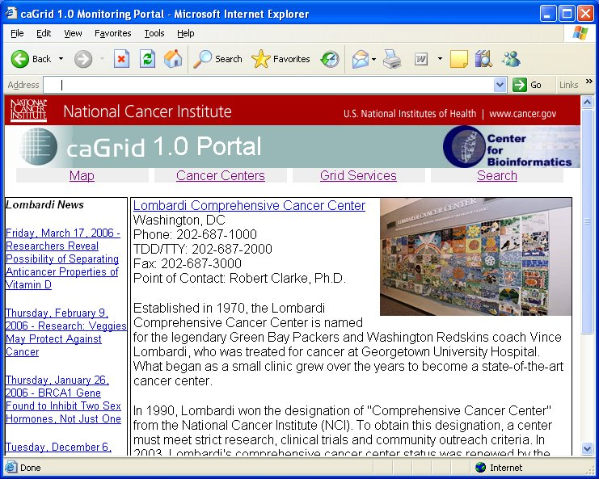
Figure 13: Research Center Details Page

                - References

caGrid References
- Monitoring and Discovery Portal Enterprise Architect Project GForge SCM Link
- caGrid 1.0 Gforge website http://gforge.nci.nih.gov/projects/cagrid-1-0/
- caGrid Homepage https://cabig.nci.nih.gov/workspaces/Architecture/caGrid/

Technical Manuals/Articles
1. Java Timer Tasks http://java.sun.com/j2se/1.3/docs/api/java/util/TimerTask.html
- Spring framework http://www.springframework.org/
- Java Bean Specification: http://java.sun.com/products/javabeans/docs/spec.html
- Foundations of Object-Relational Mapping: http://www.chimu.com/publications/objectRelational/
- Object-Relational Mapping articles and products: http://www.service-architecture.com/object-relational-mapping/
- Hibernate Reference Documentation: http://www.hibernate.org/hib_docs/reference/en/html/
- Basic O/R Mapping: http://www.hibernate.org/hib_docs/reference/en/html/mapping.html
- Java Programming: http://java.sun.com/learning/new2java/index.html
- Javadoc tool: http://java.sun.com/j2se/javadoc/
- JUnit: http://junit.sourceforge.net/
- Extensible Markup Language: http://www.w3.org/TR/REC-xml/

caBIG Material
- caBIG: http://cabig.nci.nih.gov/
- caBIG Compatibility Guidelines: http://cabig.nci.nih.gov/guidelines_documentation

caCORE Material
- caCORE: http://ncicb.nci.nih.gov/core
- caBIO: http://ncicb.nci.nih.gov/core/caBIO
- caDSR: http://ncicb.nci.nih.gov/core/caDSR
- EVS: http://ncicb.nci.nih.gov/core/EVS
- CSM: http://ncicb.nci.nih.gov/core/CSM
                - Glossary
Term | Definition
{jboss-home} | The base directory where JBoss is installed on the server
API | Application Programming Interface
caArray | cancer Array Informatics
caBIG | cancer Biomedical Informatics Grid
caBIO | Cancer Bioinformatics Infrastructure Objects
caCORE | cancer Common Ontologic Representation Environment
caDSR | Cancer Data Standards Repository
caMOD | Cancer Models Database
cardinality | Cardinality describes the minimum and maximum number of associated objects within a set
CDE | Common Data Element
CGAP | Cancer Genome Anatomy Project
CMAP | Cancer Molecular Analysis Project
CN | Common Name
CS | Classification Scheme
CSI | Classification Scheme Item
CSM | Common Security Module
CTEP | Cancer Therapy Evaluation Program
CUI | Concept Unique Identifier
CVS | Concurrent Versions System
DAML | DARPA Agent Markup Language
DAO | Data Access Objects
DARPA | Defense Advanced Research Projects Agency
DAS | Distributed Annotation System
DL | Description Logic
EA | Enterprise Architect
EBI | European Bioinformatics Institute
EVS | Enterprise Vocabulary Services
GAI | CGAP Genetic Annotation Initiative
GEDP | Gene Expression Data Portal
HIPPA | Health Insurance Portability and Accountability Act
HLGT | High Level Group Term
HLT | High Level Term
HTTP | Hypertext Transfer Protocol
ISO | International Organization for Standardization
JAAS | Java Authentication and Authorization Service
JAR | Java Archive
Javadoc | Tool for generating API documentation in HTML format from doc comments in source code (http://java.sun.com/j2se/javadoc/)
JDBC | Java Database Connectivity
JET | Java Emitter Templates
JMI | Java Metadata Interface
JSP | JavaServer Pages
JUnit | A simple framework to write repeatable tests (http://junit.sourceforge.net/)
LDAP | Lightweight Directory Access Protocol
LLT | Lowest Level Term
LOINC | Logical Observation Identifier Names and Codes
MAGE | MicroArray and Gene Expression
MAGE-OM | MicroArray Gene Expression - Object Model
MedDRA | Medical Dictionary for Regulatory Activities
metadata | Definitional data that provides information about or documentation of other data.
MGED | Microarray Gene Expression Data
MMHCC | Mouse Models of Human Cancers Consortium
MO | MGED Ontology
multiplicity | Multiplicity of an association end indicates the number of objects of the class on that end may be associated with a single object of the class on the other end
NCI | National Cancer Institute
NCICB | National Cancer Institute Center for Bioinformatics
OIL | Ontology Inference Layer
OilEd | Ontology editor allowing you to build ontologies using DAML+OIL
OLLT | Obsolete Lower Level Terms
OMG | Object Management Group
ORM | Object Relational Mapping
PT | Preferred Term
RDBMS | Relational Database Management System
SDK | Software Development Kit
Semantic connector | A development kit to link model elements to NCICB EVS concepts.
SOC | System Organ Class
SPORE | Specialized Programs of Research
SQL | Structured Query Language
SSC | Special Search Categories
UI | User Interface
UID | User Identification
UML | Unified Modeling Language
UMLS | Unified Medical Language System
UPT | User Provisioning Tool
URL | Uniform Resource Locators
VD | Value Domain
WAR | Web Application Archive
WSDL | Web Services Description Language
XML | Extensible Markup Language (http://www.w3.org/TR/REC-xml/) - XML is a subset of Standard Generalized Markup Language (SGML). Its goal is to enable generic SGML to be served, received, and processed on the Web in the way that is now possible with HTML. XML has been designed for ease of implementation and for interoperability with both SGML and HTML

