Training Outline and Objectives

A training outline drives training content and ultimately frames and determines the flow of materials. The goal of this step is to organize ideas into a logical form that tracks to the needs of the audience, and shows the relationship between content being taught. The result is an ordered overview of your training.

Building an outline requires understanding how classes break into lessons and objectives. As the figure below shows, a training class (also called a module or session) may be made up of multiple lessons or sections, which are collections of learning objectives. Learning objectives are made up of content, usually organized into slides or screens (for presentation materials). Content can include the presentation of information, scenarios, exercises and/or test questions related to the objective.

Training Classes/Modules/Sessions may either stand independently, or be a module with a broader course (e.g., Introduction to caBIG™).

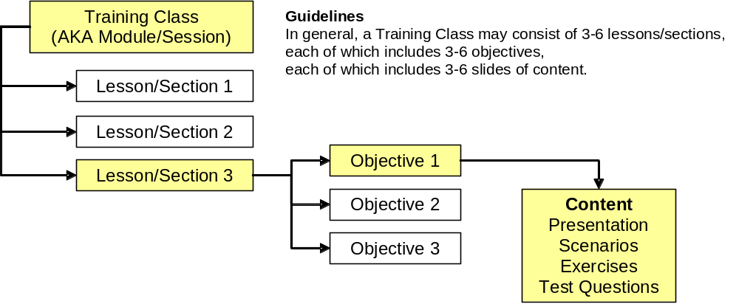

Lesson/Section Outline

Lesson # | Lesson/Section Name | Lesson/Section – Overall Purpose/  General Description (1 sentence)
1
2
3
Etc

SMART Objectives

Next step: Write SMART objectives that fill the needs of your audience, and then map them against the lessons defined above. SMART learning objectives must be specific, measurable, agreed upon, realistic, and tangible. This is important to the success of any training program, especially ones designed for adult learners. SMART objectives are written using words that are concrete and actionable (think “verbs”). Examples:

- Compute
- Demonstrate
- Describe
- Determine
- Distinguish
- Enter
- Establish
- Explain
- List
- Locate
- Practice
- Prepare
- Present
- Provide
- Show

- Use

Examples: Present the skills obtained in today’s lesson to your colleagues.
List the order of operations in which to perform the task.
Explain the differences between caDSR and EVS when searching terms.
Demonstrate the techniques used to annotate a document.

Detailed Outline

Map the SMART objectives developed above against the topic-level outline to result in a detailed outline.

Lesson # | Lesson | SMART Objectives | Content Ideas  and Sources*
1 |  | 1-1
1 |  | 1-2
1 |  | 1-3
2 |  | 2-1
2 |  | 2-2
2 |  | 2-3
3 |  | 3-1
3 |  | 3-2
3 |  | 3-3
4 |  | 4-1
4 |  | 4-2
4 |  | 4-3

* Once written down in outline form, content ideas lead to slides/screens with content (presentation, exercises, scenarios, test questions) that teach the learning objective.

