Introduce aims to reduce the service development and deployment effort by hiding low level details of the Globus Toolkit and to enable the implementation of strongly-typed Grid services. We expect that enabling strongly typed grid services while lowering the difficulty of entry to the Grid via toolkits like Introduce will have a major impact to the success of the Grid and its wider adoption as a viable technology of choice, not only in the commercial sector, but also in other areas such as academic, medical, and government research.

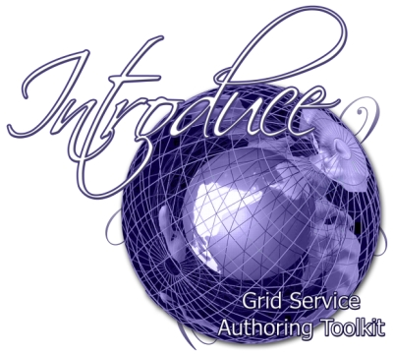
Overview
A number of tools and middleware systems have been developed to support application development using Grid Services frameworks. Most of these efforts, however, have focused on the low-level support for management and execution of Grid services, management of Grid-enabled resources, and deployment and execution of applications that make use of Grid services. Simple-to-use service development tools, which will allow a Grid service developer to leverage Grid technologies without needing to know low-level details, are becoming increasingly important. Moreover, support for development of strongly-typed services, in which data types consumed and produced by a service are well-defined and published in the Grid, is necessary to enable syntactic interoperability so that two Grid endpoints can interact with each other programmatically and correctly. Introduce is an open-source, extensible toolkit to support easy development and deployment of WS/WSRF compliant Grid services. Introduce aims to reduce the service development and deployment effort by hiding low level details of the Globus Toolkit and to enable the implementation of strongly-typed Grid services. We expect that enabling strongly typed grid services while lowering the difficulty of entry to the Grid via toolkits like Introduce will have a major impact to the success of the Grid and its wider adoption as a viable technology of choice, not only in the commercial sector, but also in other areas such as academic, medical, and government research.

Features
- Graphical creation of all aspects of the grid service from describing operations and stateful resources to configuring complex authentication and authorization policy.
- Dynamic schema discovery enabling use of published data types as service parameters and resource properties.
- Creates WSDL2.0 / WSRF Compliant Services utilizing Globus 4.0.X and Axis.
- All client and service code is automatically generated using the Introduce Synchronization engine as well as Axis and JET.
- Supports Creating Multiple Resources/Services using the WSRF family of specifications.
- Utilizes Globus GSI Security and provides graphical Configuration.
- CSM and GridGrouper Authorization Support.
- Resource Properties can be used for service metadata and published using Index Service Registration.
- Rich extension/plug-in framework for creating custom services or adding custom functionality to Introduce.

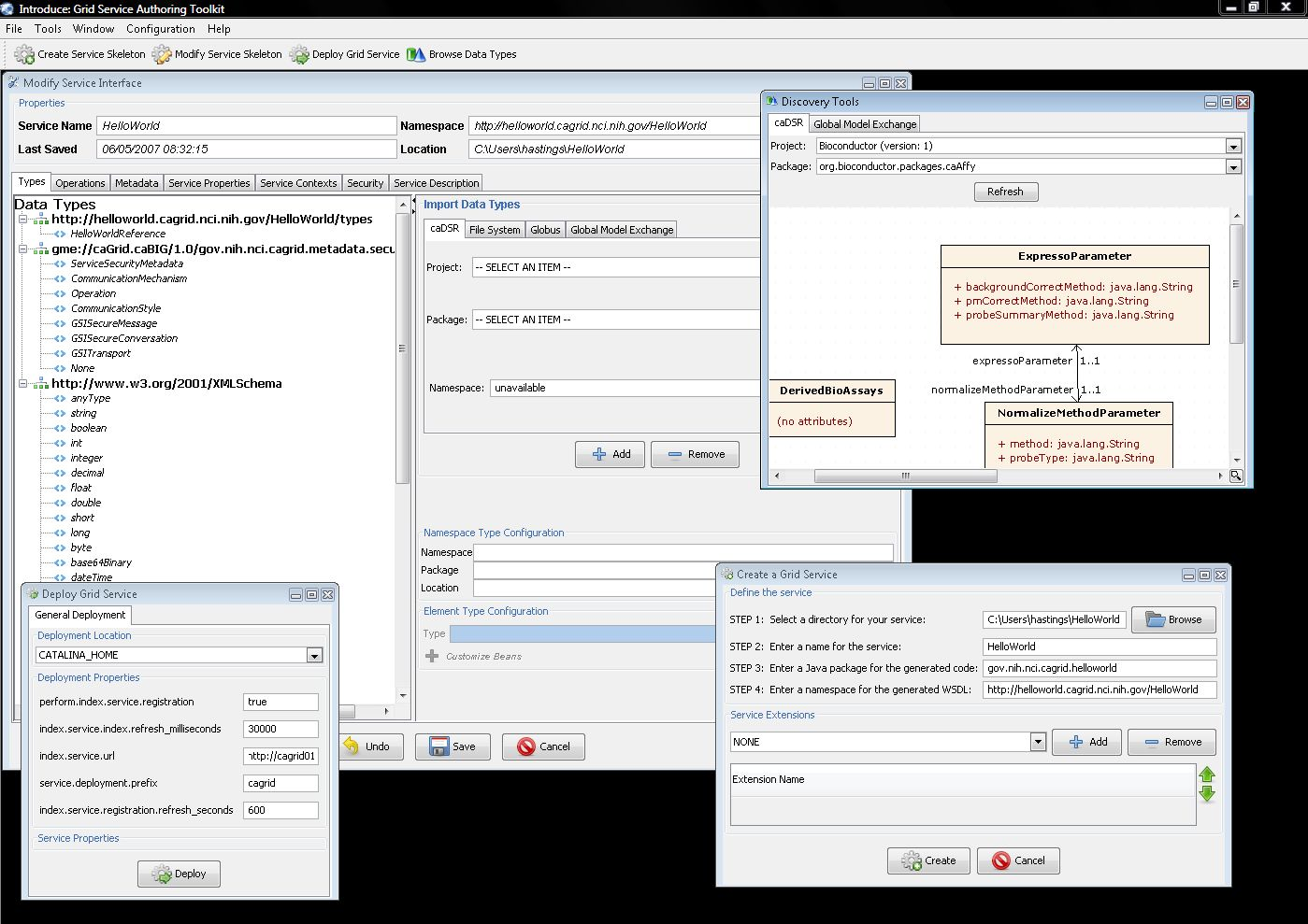

For the Service Developer
The Introduce toolkit is designed to support the three main steps of service development: 1) Creation of Basic Service Structure. The service developer describes at the highest level some basic attributes about the service such as service name and service namespace. Once the user has set these basic service configuration properties, Introduce will create the basic service implementation, to which the developer can then add application-specific methods and security options through the service modification steps. 2) Service Modification. The modification step allows the developer to add, remove, and modify service methods, properties, resources, service contexts, and service/method level security. In this step, the developer can create a strongly-typed service interface using well-defined, published schemas, which are registered in a system like the Mobius GME, as the type definitions of the input and output parameters of the service methods. One the operations are added to the service the developer will then be able to add the logic which implements the methods. 3) Deployment. The developer can deploy the service which has been created with Introduce to a Grid service container (e.g., a Globus or Tomcat service container). A service developer can access the functions required to execute these three steps through the Graphical Development Environment (GDE) of Introduce. The runtime support behind the GDE functionality is provided by the Introduce engine, which consists of the Service Creator, Service Synchronizer, and Service Deployer components. The toolkit provides an extension framework that allows Introduce to be customized and extended for custom service types and discovery of custom data types. In the following sections, we describe the software prerequisites, the Introduce Graphical Development Environment, the Introduce Engine, and the Introduce Extension Framework in greater detail.

Architecture

- Service Model maintains the complete representation of the services, methods, resources, resource properties, data types, security configuration. Index service registration, etc.
- Graphical Development Environment modifies service model and passes the modified model to the engine.
- Introduce Engine re-syncs the service with changes with the modified model.
- Use of Java Emitter Templates (JET) for creation and modification of source code and configuration files required in the service
- Auto generation of unboxed complete client and stubbed service implementation.
- Globus Policy Decision Point (PDP) is automatically generated and hooked in based on the developers described security constraints.

