Identity provider
Design Document

Version No: 0.1
Last Modified: 05/24/2006

Author : Vinay Kumar
Team : caGrid

Client : National Cancer Institute - Center for Bioinformatics,
National Institutes of Health,
US Department of Health and Human Services

Document History

Document Location
The most current version of this document is located in CVS under security/docs.

Revision History
Version Number | Revision Date | Author | Summary of Changes
0.1 | 05/24/06 | Vinay Kumar | Initial draft

Review
Name | Team/Role | Version | Date Reviewed | Reviewer Comments

Related Documents
More information can be found in the following related CSM documents:
Document Name

Table of Contents
1. Introduction 4
1.1 Purpose 4
1.2 Scope 4
2. Authentication on Grid 4
3. Identity Provider Defined (Role and responsibility) 4
4. Logical design 4
4.1 Interfaces 4
4.2 Reference Implementation and CSM 4
5. Deployment (web service) 4
6. Test Scenarios 4

Identity provider Design

Introduction
The cancer Biomedical Informatics Grid or caBIG™, is a informatics infrastructure based on grid architecture. The architectural and software realization of caBIG has been done through caGrid project. caGrid infrastructure makes it easy for developers to develop data and analytical services. Using caGrid infrastructure, organizations will be able to share their data and services on the grid.
As the data will be available to larger group pf people, security becomes an obvious concern. Typically organizations have some sort of security infrastructure in place, where users can authenticate themselves. To provide the same authentication infrastructure at grid level is a huge task and has some administrative obstacles. The user management for all the participating organizations at grid level is one of the major challenges.
To address this issue caGrid team has proposed to use federated model for authentication, where the respective participating organizations will be able to leverage their existing authentication infrastructure.

Purpose
The purpose of this document is to illustrate the design of federated authentication model on grid in general and the design of identity provider in detail.

Scope
This document will identify different component and their responsibilities. The scope is limited to provide specifics of the design of Identity provider only.

Use case Scenarios
The following diagram shows the use cases and actors. The scope of the design is limited to colored use cases.
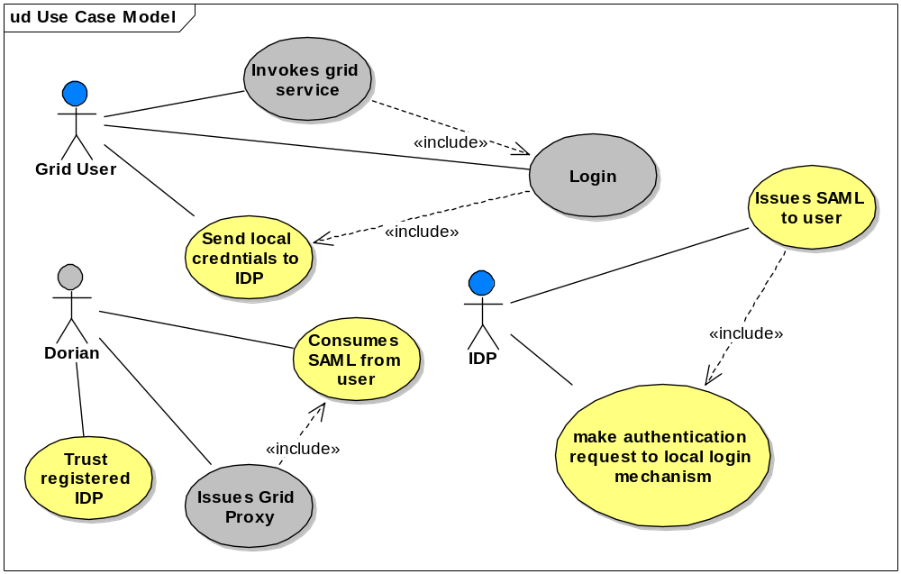

Authentication on Grid
Following UML diagram shows the user interaction with IDP and Dorian. To leverage the existing authentication infrastructure at organization level, caGrid team has proposed the following collaboration strategy.
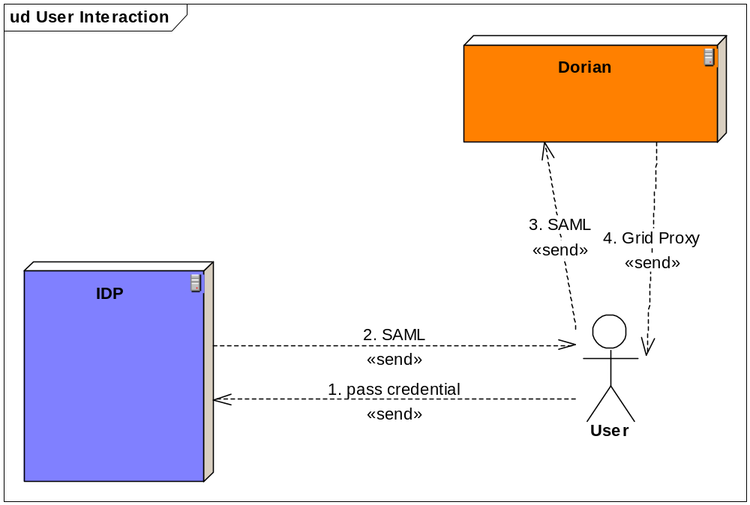
As depicted in the diagram, the user will interact with the collaborating systems in following way:
- User sends it local credential to the IDP
- IDP invokes the local login module (authentication mechanism) and depending upon the success or failure gets back some of users attributes (last name, first name and email Id). Using this information IDP prepares SAML and sends it back to the user.
- Once user receives, the user sends this SAML instance to Dorian.
- Dorian consumes the SAML and issues a Grid Proxy.

Identity Provider’s Role
The identity provider will have following responsibility
- Consumes user’s credentials
- Returns digitally signed (implicit) SAML to user.

Logical design
Following are the logical layers on which Identity provider will depend.
credential
credential
credential
attributes
SAML
SAML
Identity provider Layer
Login Module Layer
credential provider Layer

Identity provider Layer
The identity provider will exist in this layer. This layer will contact Login Module Layer to get back the attributes of the user or SAML itself.

Login Module Layer
Login Module Layer may have different possible modules to talk to the local credential provider. Modules like CSM, shib, Myproxy or PAM will reside in this layer. As can be seen in the diagram, some modules will return attributes of the user after successful authentication whereas other modules may return SAML containing user attributes also.

Credential Provider Layer
This layer has the credential providers from the organizations.

Class diagram
caGrid team proposes interface base design for loose coupling between layers. This will facilitate the plug ability of different modules.
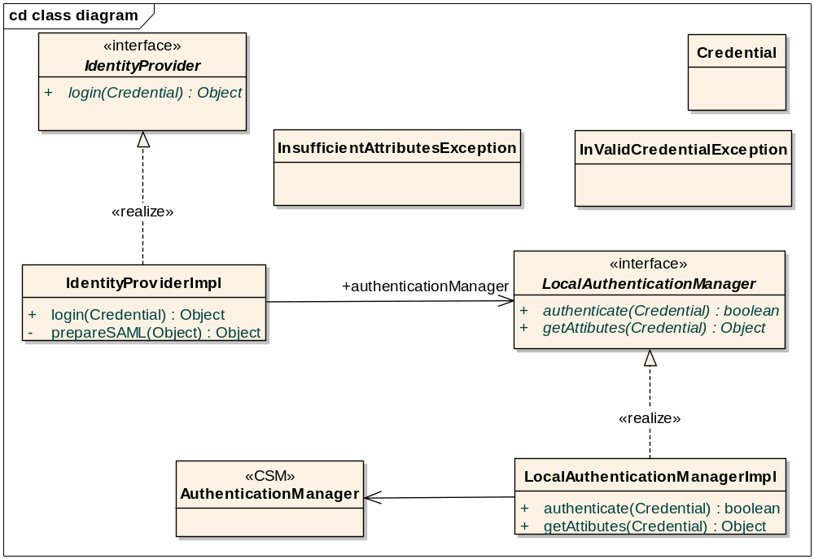
The IdentityProvider interface:
public interface IdentityProvider {
public Object login(credentials Credential) throws InValidCredentialException, InsufficientAttributesException, RemoteException;
}

InValidCredentialException will be thrown when the credentials (typically userid/password ) are not valid.
InsufficientAttributesException will be thrown when enough information (lastname, firstname and emailed) for a user can’t be extracted from the local system.
The LocalAuthenticationManager interface:
public interface LocalAuthenticationManager {
public boolean authenticate(credentials Credential) throws LoginException;
public Object getAttributes(credentials Credential);
}

Depending upon the storage policy, an organization may have credential and attributes in different storage location. Thus authentication mechanism may not return the attributes of the user. A separate call may have to be made to get the attributes of a user after successful authentication. Keeping this scenario in mind, two separate methods have been defined in LocalAuthenticationManager.

TO DO:
Credential object has to be defined

Deployment
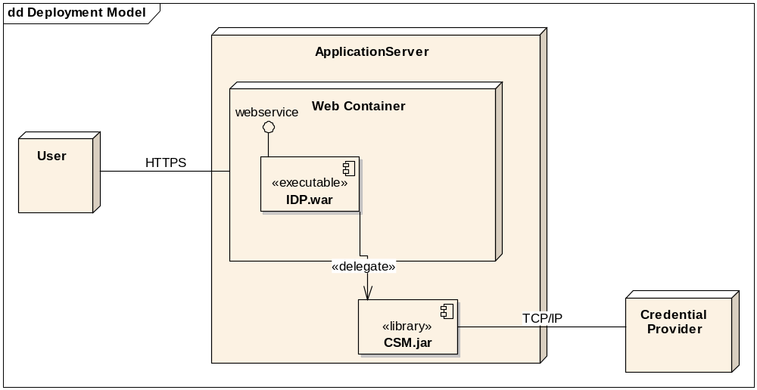

Test Cases and Scenarios
Please refer to << document location for test cases>>

